


Fact Sheet
Capital Grants Program recognition requirements

All schools that receive funding under the Capital Grants Program (CGP) are required to recognise the Australian Government’s support. This fact sheet outlines the requirements for different types of project and what your school must do to meet them. These requirements are established in the Capital Grant Program Guidelines 2025 at paragraph 167 (the Guidelines).
When your school entered into an agreement with the respective Block Grant Authority (BGA) to receive CGP funding, you agreed to comply with the CGP recognition requirements.

Summary of requirements
 | Masterplan | CGP funding under $100,000 | CGP funding of $100,000 or more
Acknowledgement | Yes | Yes | Yes
Plaque | No | Yes | Yes
Ceremony | No | No | Yes
Opening by Australian government representative (as part of ceremony) | No | No | Where CGP funding is 50% or more of total cost

Acknowledgement
All schools that receive funding under the CGP must acknowledge the Australian Government’s funding contribution for the project in all announcements, media coverage and other publicity for the funded project, by referencing ‘the Australian Government’s Capital Grants Program’ and the funded amount. This might include but is not limited to speeches, school newsletters, yearbooks, press releases.

Plaque
Schools must install a plaque acknowledging the Australian Government funding for all CGP funded projects. The only exception is for projects consisting of a masterplan only.
In addition to the acknowledgement requirements, your school must:
- Within 7 months of the physical completion of the project, advise the Department via email to schoolopenings@education.gov.au that the project is complete.
  - Note: if ceremony requirements also apply it is recommended that this be used notification address both.
- Complete the plaque template provided to you by the department and return to the department for approval.
- Only once approval has been provided by the department, arrange for the plaque to be manufactured.
- Either affix the approved plaque to the funded building or display it in an appropriate location, for example main foyer or reception area of the school.
Note: The Department of Education requires that the Australian Government logo is required to sit in the middle at the top of the plaque. Other Government or school logos can sit underneath or on the left or right side.

Ceremony
Schools must arrange an opening or recognition ceremony, and invite the Minister for Education, for all completed projects that received CGP funding of $100,000 or more, excepting projects for masterplans only. The Minister may ask a local MP or duty Senator to represent them at the ceremony. The Minister or the Minister’s representative must be invited to speak at the ceremony.
In addition to the acknowledgement and plaque requirements, your school must:
- Within 7 months of physical completion of the project, and at least 2 months in advance of the first proposed date, send through three possible dates and times for a ceremony to schoolopenings@education.gov.au.
  - The dates proposed must not be days when Parliament is sitting. You will need to check the current Parliamentary Sitting Calendar to ensure that proposed dates do not coincide with Parliamentary sittings.
- Wait for the department to inform you of the approved date and time, and the Australian Government representative who will be attending. At this point the department will provide you with a briefing pack to complete.
  - On occasion, no Australian Government representative will be available to attend, and the department will instead provide a message from the Minister for Education to be read at the ceremony.
- Complete the briefing pack with information on the event, school and project and return to the department for approval by the required due date.
Note:
- Some project types may be eligible for an exemption, see below.
- Your school can request an official opening for a project that received less than $100,000 in CGP funding if preferred.

Opening by Australian Government representative
Schools must invite the Minister for Education or the Minister’s representative perform the official opening at the ceremony for all projects where CGP funding covered more than 50% of the total cost of the project, excepting projects for masterplans only, and projects receiving CGP funding of less than $100,000.
In addition to the acknowledgement, plaque and ceremony requirements, your school must:
- Ensure the name of the Australian Government representative who is opening the project is included on the plaque.
- Provide the Australian Government representative with an appropriate means for officially opening the project, such as unveiling the plaque and/or cutting a ribbon.

Exemptions and deferrals
Schools may request an exemption or deferral from some recognition requirements, noting that these decisions are at the department’s discretion. To be considered your school must submit a written request for an exemption or request for deferral to the department for approval via schoolopenings@education.gov.au.
The following types of projects may be considered for exemption from ceremony requirements:
- Less visible projects such as the replacement of electrical or plumbing systems.
- Projects primarily involving installation of equipment such as fire safety systems, lifts, accessibility equipment and solar systems.
- Projects primarily involving the construction or refurbishment of amenities.
The department will also consider deferring some recognition requirements so that multiple projects can be opened in one ceremony for schools that have multi-stage projects or have received CGP funding for several projects within a short period of time (i.e. 2 years).

Recognition enquiries
All requests and enquiries regarding recognition requirements should be made to the department at schoolopenings@education.gov.au.

Opening ceremony key points in time
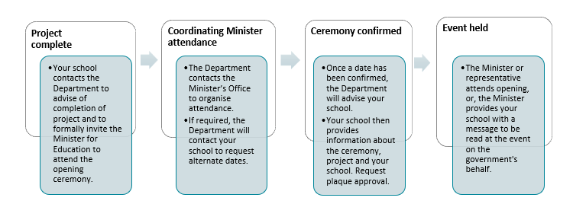

Sample plaque template for projects funded under the Capital Grants Program


School logo and or State government crest
SCHOOL NAME
This plaque commemorates the official opening of the
Project Description
by
Name of Minister/Representative/Other
on
Date
This/these project/s was/were jointly/entirely/principally/partly funded by the Australian Government under the Capital Grants Program (Include other funding sources if relevant/desired, e.g. ‘, and the [State] government’, or ‘, and the [Name of School] community’)
Principal: (Optional) President, School Council: (Optional)

