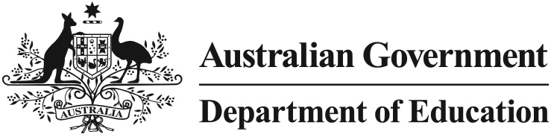

Investing in better science education for Australian school students

## What are the *Primary Connections: Linking Science with Literacy* and *Science by Doing* programmes?

The *Primary Connections: Linking Science with Literacy* and *Science by Doing* programmes are resources that help primary and secondary school science teachers provide interesting and engaging science lessons to improve the quality of, and engagement with, science education in schools.

## Why invest in science programmes?

The government wants to restore the focus on science education as science is an important part of equipping children for modern workplaces. Science literacy underpins many jobs in the modern workforce and is an important part Australia’s economy remaining globally competitive.

We need to invest in teaching young people science effectively and getting them involved in hands-on science at an early age. By increasing the engagement of students studying science at an early age, the benefit will be more students wanting to study science in their senior secondary years and at university.

In the last few years, Australian students’ results in science and mathematics have fallen significantly in international testing. This programme is designed to ensure more Australian school students have access to great teaching and are able to consider further education and a career based on these subjects.

## How will it work?

The *Primary Connections: Linking Science with Literacy* and *Science by Doing* programmes will be delivered by the Australian Academy of Science.

This new funding will train approximately 550 *Primary Connections* Science Leaders and approximately 3 300 Primary Connections Science Specialists, to ensure students are taught by engaged, expert science teachers.

The *Science by Doing* curriculum units will also be extended to develop and interactive electronic workbook for each unit, giving teachers access to more resources and a better chance to encourage students to excel in science.

## Where can I find more information and get involved?

Visit [www.sciencebydoing.edu.au](http://www.sciencebydoing.edu.au/) and [www.primaryconnections.org.au](http://www.primaryconnections.org.au/)