

Smarter Schools National Partnerships

Improving Teacher Quality

Low SES School Communities

Literacy and Numeracy

Australian Capital Territory

Progress Report 2012

(1 January – 30 June 2012)

Due 31 October 2012

INTRODUCTION

In April 2012, states and territories provided an Annual Report to the Department of Education, Employment and Workplace Relations (DEEWR) on Smarter School National Partnerships (SSNP) activity in the 2011 calendar year.

This Progress Report covers SSNP funded activity from 1 January to 30 June 2012. The Progress Report focuses on key highlights, case studies as well as milestone activities, as set out in each state and territory Bilateral Agreements/Final Implementation Plans.

The report also provides important information on SSNP funded activities to support the improvement in educational outcomes for Aboriginal and Torres Strait Islander students.

STRUCTURE OF REPORT

The Progress Report has four sections:

Section 1 - Improving Teacher Quality
Section 2 - Low SES School Communities
Section 3 - Literacy and Numeracy
Section 4 - Milestones

Sections 1 to 3 provide a narrative description of the progress and impact to date for each National Partnership.

The fourth section includes tabulated responses to the relevant milestones indicated in state and territory Bilateral Agreements/Final Implementation Plans.

Where applicable, these milestones have been pre-populated by DEEWR and also include milestones not reported on, or not achieved, from the 2011 Annual Report.

Section 1 – Improving Teacher Quality
Overview/Highlights - 1 January to 30 June 2012
The most noteworthy benefit to the ACT from its involvement in the Improving Teacher Quality National Partnership (NP) is the continuously high level of cross-sectoral collaboration. This is demonstrated through collaboration between the three sectors, local universities and unions on the Improving Teacher Quality NP reforms.
A key achievement in 2012 has been the successful development and implementation of the ACT Teacher Mentor program. This is a five day university-accredited teacher mentor course developed by the Australian Catholic University (ACU), the University of Canberra (UC) and the Teacher Quality Institute (TQI). Day 1 of the program, which focussed on an introduction to mentoring using the National Professional Standards for Teachers, was delivered on five occasions during the first semester and attended by over 275 teachers and school leaders from across the three education sectors. Planning for Days 2-3 of the program commenced during the reporting period. This has involved the contribution of expert consultants from across the three sectors in order to connect mentoring with the standards and other national agendas, to support reform such as the Quality Teaching model and the Australian Curriculum.
The ACT Curriculum Taskforce and Cross Sectoral Australian Curriculum Implementation Committee are working with each of the education sectors to improve teacher quality through professional learning activities engaging with the Australian Curriculum, and providing a mechanism for professional conversations about the implementation of the Australian Curriculum throughout the different educational settings.
Other key reforms which are impacting on schools across the jurisdiction as a result of the Improving Teacher Quality NP include:
- the development of additional classroom classifications in enterprise agreements, aimed at keeping exemplary classroom teachers working in classrooms
- work of the TQI in planning and implementing reforms related to the National Professional Standards for Teachers, national consistency in teacher registration, certification of teachers and accreditation of teacher education courses
- continued implementation of cross-sectoral principal forums and the development of cross-sectoral deputy principal forums
- implementation of local decision making reform in 2012, involving the participation of 23 public schools.
A significant achievement for the ACT has been the planning and implementation of the cross-sectoral certification pilot delivered by the TQI, in partnership with the National Research Centre of Science, ICT and Mathematics Education for Rural and Regional Australia (SiMERR) as a national trial for the Australian Institute of Teaching and School Leadership (AITSL). Significant activity relating to the pilot during this reporting period includes consultation with AITSL in developing the processes to be piloted, delivery of information sessions for interested candidates about the processes to gain certification at Highly Accomplished and Lead Teacher levels, and training of 30 school leaders as assessors. The pilot will inform the implementation of certification nationally in 2013.
Another key highlight for the ACT has been the successful implementation of alternative pathways into teaching through the Teach for Australia and Teach Next programs. In 2012 all five Teach for Australia associates who commenced their placement in ACT public schools at the start of 2011 continued in the second year of the program. Additionally, the ACT placed a further six associates from cohort three in 2012, expanding the number of participating public schools from four to seven. All school principals participating in the program in 2012 reported associates to be highly motivated, quality individuals who are performing extremely well in the classroom. One associate was awarded the ACT Public Education New Educator of the Year award in 2012.
Three Teach Next associates commenced their initial training and will begin their employment based placements in public schools in July 2012. The ACT also participated in recruitment processes for the second intake of the Teach Next program. The Directorate has expressed an interest in acquiring five associates to fill positions in the areas of applied technologies, physics, chemistry, general science and languages other than English.

Support for Aboriginal and Torres Strait Islander Students - 1 January to 30 June 2012
The Aboriginal and Torres Strait Islander Education Matters: Strategic Plan 2010-2013 (the Plan) provides a framework for committed action and innovative responses in ACT public schools to meet the needs of Aboriginal and Torres Strait Islander students, their families and communities. A key action outlined in the Plan includes the Aboriginal and Torres Strait Islander Student Scholarship Program which provides public school students with access to mentoring and the opportunity to develop leadership skills in order to make an informed career decision around teaching. Five scholarships of $5,000 per year are available for students wishing to pursue a career in teaching and who intend to enrol in a tertiary package in 2013. Six of these scholarships have been awarded to year 11 students across four public colleges.
In support of increasing Aboriginal and Torres Straits Islander people entering the teaching workforce the Directorate also provides Aboriginal and Torres Strait Islander Teacher Educations Scholarships of $10,000 per semester. In 2012 four scholarships were awarded to support Aboriginal and Torres Strait Islander students enrolled in pre-service teacher education programs at local universities.
In partnership with UC, the Directorate also continues to support the Charles Perkins Scholarships which provide support for Aboriginal and Torres Strait Islander students studying at the university. Two scholarships are awarded each year. Applications have been received for 2013 and successful recipients will be announced later in the year.
A number of actions undertaken to achieve reward reforms under the Improving Teacher Quality NP are also helping to close the gap in educational outcomes for Aboriginal and Torres Strait Islander students in the ACT. There has been increased provision of professional development for school leaders in 2012 to facilitate learning and reflection around cultural awareness and to develop leadership and teaching strategies to improve the outcomes of Aboriginal and Torres Strait Islander students.
Professional learning activities offered for teachers in the public education sector in semester 1 include:
- participation of ACT principals, deputy principals and aspiring leaders in the Dare to Lead cross-sectoral conference, 2025: Building Strong Aboriginal Students for their future, held in Canberra in May 2012
- participation of 51 school leaders in the Directorate’s Leadership in Aboriginal and Torres Strait Islander Education conference in June 2012. Professor Mark Rose, Director of the Institute of Indigenous Knowledge at Deakin University, delivered the keynote address, On the fringe of curriculum: Silent apartheid as an element in the path of reconciliation, and participants engaged in workshops and planning sessions.
- five school leaders were supported to participate in the Stronger Smarter Leadership Institute training between March and May 2012. Thirteen school leaders in the ACT have completed this training and these leaders have formed a network to provide support to each other in ongoing leadership activity.
- twenty eight school leaders representing 14 schools have commenced the 2012 Aboriginal and Torres Strait Islander Action Inquiry Program. Inquiries that focus on implementing personalised learning strategies, improving literacy, successful transitions and improving attendance are currently being supported through the 2012 program. Reports on inquiries will be finalised in November 2012.
Across the ACT there are 31 ‘focus schools’, identified as schools with the highest Aboriginal and Torres Strait Islander student enrolment, that support local activities around key actions in the national Aboriginal and Torres Strait Islander Education Action Plan 2010-2014. In July 2012 these schools formed a professional learning network of principals and deputy principals in order to share resources, strategies and learning around building stronger community partnerships and improving student outcomes.
Professional learning activities provided by the Catholic Education Office (CEO) for Catholic system schools in semester 1 include:
- a three day Cultural Immersion Program in which teachers from seven Catholic schools were provided with in-depth cultural immersion training and experiences
- teacher contact days which focused on pedagogy for Aboriginal and Torres Strait Islander students
- a workshop offered on pedagogy for Aboriginal and Torres Strait Islander students as part of a Quality Teaching Transforming Teaching and Learning Day.
The Association of Independent Schools (AIS) of the ACT is establishing of an Association Reconciliation Action Plan (RAP). Under the stewardship of a lead school, the plan will incorporate the 17 AIS schools in a shared RAP for independent schools in the ACT.
Progress Against TQNP Facilitation Reforms - 1 January to 30 June 2012
National Professional Standards for Teachers
The ACT has continued collaborative initiatives for implementation of the National Professional Standards for Teachers (the Standards) through a number of TQI led projects with ACT schools, universities and AITSL. Details of work relating to quality placements of pre-service teachers and certification are provided elsewhere in this report.

In May and June 2012 information sessions were provided to teachers on the use of the Standards to support teacher reflection, professional conversations and feedback to pre-service teachers and their associates, and beginning teachers and their mentors and supervisors. Over 500 teachers attended seven sessions, jointly delivered by the TQI and the universities.

In April 2012 the ACT commenced a pilot of the national evidence guide for full registration. This work included collaborative development of the ACT Teacher Quality Institute Teacher Assessment and Support Framework for Progression to Full Registration. ACT schools, universities and the TQI are continuing to jointly develop implementation tools to assist provisionally registered teachers to understand the evidence requirements using the proficient level standards.

Principals of all Catholic system schools participated in a system day in March titled, Leading a High Performance School – Building the Culture. One of the themes for the day was the effective use of the National Professional Standard for Principals and the National Professional Standards for Teachers to build a culture of high performance in the school. Workshops offered on the day supported this theme. Meetings in term 2 between the CEO and Catholic system primary and secondary principals focused on practical ways to implement the National Professional Standards for Teachers and processes for identifying and encouraging exemplary teachers in Catholic system schools.

National Certification of Accomplished and Lead Teachers
An ACT Pilot of Certification of Highly Accomplished and Lead Teachers commenced in June 2012, led by the TQI. This pilot is being undertaken in partnership with AITSL and SiMERR and will inform the national roll-out of the certification process in 2013. It involves teachers from 40 ACT schools across the three sectors and focuses on the evidence requirements for certification as well as against the Highly Accomplished or Lead Level Standards assessor training needs and guidelines.

Nationally Consistent Registration of Teachers
During 2011 teachers currently employed in the ACT completed the initial teacher registration process under the transitional arrangements of the ACT Teacher Quality Institute Act 2010. From October 2011 teachers seeking employment in the ACT were required to complete the online registration process prior to commencing work. As previously reported these processes aligned to the requirements of the framework for nationally consistent registration of teachers.

The final component of teacher registration implementation in the ACT commenced in March 2012 with over 6,400 teachers completing the first annual registration renewal process. The online renewal application included the option for provisionally registered teachers who had completed 180 days of teaching and undertaken a school-based assessment and support process to apply for full registration. In line with the requirements for standards-based assessment for full registration, this transitional process included principal endorsement that the teacher demonstrated a satisfactory level of knowledge, skills and ability and was recommended for full registration.

National Consistency in Accreditation of Pre-service Teacher Education Courses
The ACT has continued to participate in national networks preparing for the accreditation of initial teacher education courses. This work has included preparation for the cross-jurisdictional panels with Victoria, New South Wales and Queensland for the accreditation of teacher education courses for the Australian Catholic University.

Professional Development and Support for Principals
A separate progress report template for Principal Professional Development is included later in this report.
Improved Performance Management and Continuous Improvement in Schools
As previously reported, improved performance management and continuous improvement in schools in the ACT has links to enterprise agreements for public and Catholic school teachers and varies from school to school in the independent sector.
In 2012 annual professional discussions, as reflected in the 2011-2014 Enterprise Agreement, have been implemented. The conversations, conducted by principals, affirm and draw together the recognition of classroom teacher development and also allow for the promotion of a capable and sustainable teaching workforce. The four key elements of the discussions include:
- teaching performance and professional responsibilities
- career plans
- transfer
- incremental progression.
The annual professional discussions have enabled alignment of professional learning needs in schools and provided principals with a deep knowledge of their workforce needs.
School network leaders also conduct these discussions with principals, targeting the same performance management and professional development needs.

New Pathways into Teaching
In 2012 the five Teach for Australia associates who commenced their placement in ACT public schools at the start of 2011 continued in the second year of the program and mentor teachers participated in part two of the mentor course conducted through the Melbourne Graduate School of Education.
A further six associates from cohort three have been placed in public schools in 2012, expanding the number of participating public schools from four to seven. These associates undertook their initial induction with their school and commenced their intensive training in January. Planning for a cohort four intake has also commenced, with the Directorate expressing an interest in taking on a further five associates.
Participating principals, program coordinators and representatives from Teach for Australia are engaging in regular meetings to support the implementation of the Teach for Australia program in the ACT. In 2012 all participating school principals reported associates to be highly motivated, quality individuals who are performing extremely well in the classroom. One associate received the Public Education New Educator of the Year award in 2012. This teacher has been selected to represent the ACT at a Teach for All conference in London in
October 2012.
Better Pathways into Teaching
The ACT has been engaged in the national development of the Teach Next program which has generated a lot of interest from principals due to the success of Teach for Australia program. In 2012 the first of four intakes of participants commenced their training and three Teach Next associates have been placed with three ACT public secondary schools to pursue employment based pathway into teaching.
The ACT has also been involved in tender processes, program delivery arrangements and selection processes for the second intake of the program. The Directorate has agreed to provide up to five placements for participants of the Teach Next program commencing in 2013.
Discussions continued through the Teacher Education Committee about jurisdictional development of local arrangements to target career change teachers in areas of need and potential pathways with the foreshadowed introduction of the two year graduate program requirement.
Under the Better Pathways into Teaching initiative, the Directorate has assisted 77 participants, between 2010 and 2012, to undertake a Graduate Certificate in Early Childhood Education at the University of Canberra. In 2012 the Directorate awarded 25 scholarships of up to $4,400 to teachers who wished to upgrade their teaching qualifications to include Early Childhood.
Improved Quality and Availability of Teacher Workforce Data
All ACT education sectors continued to actively participate in the work of the Australian Education, Early Childhood and Youth Senior Officials Committee sub-committee, the Teacher Workforce Dataset Working Group, to provide improved quality and availability of teacher workforce data. This work has included the development of the data management framework for cross jurisdictional reporting and options for the data reporting model.
Work has continued to align the TQI business system with the data elements and data categorisations specified in the data management framework. The TQI’s first registration renewal process in March 2012 enabled the collection of additional data elements such as current subject teaching areas.
Evolving revisions to school staffing human resource and finance practices and models, and the embedding of these in the context of the phased implementation of the Empowering ACT Schools initiative, has necessitated a review of the Directorate’s Staff Integrated Management System project. Phase 1 remediation work has been successfully undertaken and phase 2 is currently being rescoped. The Directorate’s actions are dependent upon development of a principal portal being set up in relation to ACT Empowering Schools.

Indigenous Education Workforce Pathways
The Aboriginal and Torres Strait Islander Student Scholarship Program is a focus area for improving Indigenous education workforce pathways. It provides public school students with access to mentoring and the opportunity to develop leadership skills in order to make an informed career decision around teaching. Scholarships of $5,000 per year are available for students wishing to pursue a career in teaching and who intend to enrol in a tertiary package. In 2012, six of these scholarships have been awarded to year 11 students across four public colleges.
In support of increasing Aboriginal and Torres Straits Islander people entering the teaching workforce the Directorate provides scholarships of $10,000 per semester. In 2012 four scholarships were awarded to support Aboriginal and Torres Strait Islander students enrolled in pre-service teacher education programs at local universities.
In partnership with UC, the Directorate also continues to support the Charles Perkins Scholarships which provide support for Aboriginal and Torres Strait Islander students studying at the university. Two scholarships are awarded each year. Applications have been received for 2013 and successful recipients will be announced later in the year.
According to data from the Directorate’s quarterly diversity report, an additional two Aboriginal and Torres Strait Islander staff members have joined the Directorate’s workforce in 2012, bringing the total number Aboriginal and Torres Strait Islander employees to 40.
Quality Placements
The ACT continues to place high priority on improving the quality of pre-service teacher placements. The provision of quality placements has been central to the cross-sectoral standards pilot. Changes to placement processes have continued in 2012 to ensure that pre-service teachers receive high level mentoring and performance feedback during placements.
The Professional Experience Committee has continued its work on developing options for promoting quality
pre-service teacher placements in the ACT. This committee was established as a sub-committee of the ACT Teacher Education Committee.
A key achievement has been the collaborative development of common pre-service teacher reflection and assessment tools, using the Graduate Standards, by the UC and the Canberra Campus of the ACU. This work builds on the successful cross-sectoral pilot undertaken in 2011 and supports consistent assessment of pre-service teachers across the school sectors.
New procedures, as released in the Enterprise Agreement in April 2012, have been designed to secure permanency for pre-service teachers, direct to schools. Procedures to implement the Enterprise Agreement were designed for roll-out in August 2012.

School Centres of Excellence
On 29 May 2012 three Directorate staff and two UC personnel attended the Initial Teacher Education National Forum in Melbourne hosted by the Victorian Department of Education and Early Childhood Development. A particular focus was on the experiences of the School Centres for Teaching Excellence (SCTEE) initiatives. The ACT was particularly interested to learn from the experiences of other systems and explore innovations in initial teacher education and how effective practices could be adopted more systematically.
Since the forum the ACT has progressed work around SCTEE through developing a closer connection between the Directorate and UC. Discussions have continued at the Teacher Education Committee (TEC) and Professional Education Committee meetings, around possible future pilots focused on improved university-school partnerships.
There have been some reservations about setting up individual schools as SCTEE in a jurisdiction as small as the ACT. The TEC has therefore pursued avenues which promote the entire jurisdiction as a Centre for Teacher Education Excellence. This approach was taken in designing and implementing the cross-sectoral ACT Teacher Mentor Program.
In 2012 the Teacher Mentor Program was developed and delivery of the five day program commenced as a way of promoting the entire jurisdiction as a ‘School Centre of Excellence’. Day 1 of the program included representation from almost 100% of public, Catholic and independent schools across the ACT. This collaborative, cross-sectoral initiative aims to improve the quality of mentoring in schools as a method for improving overall teacher quality. Teachers who opt to continue with the program and complete Days 2 and 3 will receive a TQI-endorsed ‘Certificate of Mentoring’ with participation in the full five days of the program allowing credit towards a Masters of Education. Due to the success of the program, the program will operate in an ongoing cycle throughout 2012 and into 2013.

Showcase Examples - 1 January to 30 June 2012
ACT Teacher Mentor Program
Since the National Professional Standards for Teachers (the Standards) were endorsed, Australian schools and systems have been conscious of the need to build the professional capacity of teachers in mentoring. All school sectors in the ACT are committed to preparing teachers for mentoring at all levels of the profession, from supervising teacher education students undertaking professional experience to leading professional mentoring programs for senior staff.
The ACT has experienced early success in familiarising teachers with the Standards through the ACT Teacher Mentor Program that commenced in 2012.
This five day program was developed collaboratively by the three ACT school sectors, the TQI, UC, ACU, the Australian Education Union and the Independent Education Union, and was targeted at teachers in school leadership positions and those involved with leading the school’s mentoring program for newly graduated teachers and/or pre-service teachers.

The Day 1 workshop was offered on six separate dates between March and May 2012, and at least two teachers from each of the ACT’s 130 schools participated. A total of 295 teachers attended the workshop. In the introductory mentoring program, there was an emphasis on the role of the Standards, explaining their purpose and the role of the TQI in regard to the Standards, as well as the usefulness of the Standards in the context of mentoring. This highlighted the key role of the Standards to support improvement in teacher quality. To enhance the emphasis on professional practice, teachers from the three ACT school sectors were also invited to share exemplary practices related to mentoring programs in their schools.

Results of the pre- and post- workshop evaluation indicated a statistically significant improvement in participants’ familiarity with the Standards. This was supported by the qualitative feedback from participants, examples of which include:

“I feel far more informed and am now thinking how I need to expose/introduce my staff to the Standards”

”A great day of input as well as time to reflect and grapple with how we will work with the Standards in our schools”

“Thanks for being re-affirming in our roles and clarifying the importance and influence of National Standards”
The program was designed to be delivered over five days with the completion of the full five day program counting towards one unit of a tertiary post-graduate qualification. The remaining days of the program are being rolled out throughout 2012. All participants of the Day 1 workshop were awarded a Certificate of Participation from TQI, UC and ACU. Participants who opt to continue with Days 2-3 will receive a Certificate of Mentoring from TQI. As the ACT is the only Australian state/territory trialling the Standards in 2012, this program and its success has important implications and lessons for other Australian states/territories implementing the Standards in 2013.
Teach for Australia program in Secondary Schools
The ACT’s implementation of the Teach for Australia program in secondary schools, now in its second year, has been successful in developing schools leaders, improving academic outcomes and raising the quality and career profiles of teachers in the ACT.
Seven schools have taken on Teach for Australia associates over 2011 – 2012 and in 2012 all participating school principals reported associates to be highly motivated, quality individuals who are performing extremely well in the classroom. One associate was the recipient of the ACT Public Education Week New Educator of the Year Award and has been selected to travel to London in September 2012 as an ACT representative at the global
Teach for All conference.
In June 2012 Teach for Australia, in conjunction with KPMG, held a Teach for Australia ACT Celebration Event. This event, opened by the ACT Minister of Education and Training, Dr Chris Bourke, acknowledged the contribution of education and industry stakeholders in the successful implementation of the program in the ACT. The partnerships established between the Directorate, schools, local business organisation and academic institutions have contributed to the success of the program in raising the standard and status of the teaching profession under the Improving Teacher Quality NP.
The ACT has demonstrated a commitment to seeking innovative pathways for recruiting and retaining quality teachers and is at the fore nationally in working to confront educational disadvantage in Australia. The benefits of Teach for Australia do not belong only to the associates. Schools have acknowledged the high quality support and professional learning provided to mentors through the Graduate School of Education in Melbourne and clinical specialists based at UC. Feedback from participating schools articulates the outstanding commitment of associates to engaging both students and colleagues in pursuing excellence in teaching and learning. Students are engaged in a deep level of understanding in topics taught by the associates. Additionally the associates are contributing to the work of their schools and the system through professional learning communities.
The ACT is fortunate to be retaining three of the five graduating associates from cohort two, with the remaining two pursuing teaching posts interstate. The Directorate is committed to continue positioning associates in schools to further support reform efforts and improve student outcomes.

Principal Professional Development
The Implementation Plan for Principal Professional Development strengthens and complements the reform activities already being implemented through the Improving Teacher Quality NP Implementation Plan.
Overview of activities and key achievements
School Leadership Frameworks
On 11 April 2012 the Directorate launched a revised School Leadership Strategy. This strategy aligns with professional practices detailed in the National Professional Standard for Principals and supports emerging and existing school leaders throughout their career progression. The strategy includes a new Capability Framework, which is now being utilised in the selection of school leaders. The new framework and strategy supports leaders to undertake self–reflection and identify professional learning needs.
Principal Induction Programs
The Directorate has developed an Induction Program to support new principals in leading their schools. In association with the new leadership strategy and capability framework, a series of 10 modules were designed and programmed to be progressively delivered to new principals and their mentors from February to November 2012. To date, seven of the 10 modules have been delivered.
Principal Professional Development Modules
In 2012 a series of modules have been implemented for school leaders including emerging leaders, middle managers, commencing principals, consolidating principals and experienced principals. These modules were developed in alignment with the five key professional practices identified in the National Professional Standard for Principals. The following professional learning programs have been delivered, or are scheduled, in 2012:
Professional Practice 1 – Leading Teaching and Learning
- Leading Instructional Leadership- this session was replaced with instructional rounds training using the Quality Teaching model (QTm). Whilst both sessions were aimed at supporting principals to lead instructional practice in their schools underpinned by the QTm as the Directorate’s preferred pedagogical framework, the original session was targeted at newly appointed and acting principals. The implemented sessions were delivered separately by each network focussing more specifically on network priorities and provided more in-depth professional development for principals of all levels of experience.
- New Principal Induction Module – Aboriginal and Torres Strait Islander Education and Student Engagement. This module is to be delivered in October 2012.
Professional Practice 2 – Developing Self and Others
- Coaching for School Leaders - supporting principals and deputy principals to implement coaching structures as a one-to-one development methodology for building staff capacity in their schools. This module was delivered in semester 2 with 45 participants.
Professional Practice 3 – Leading Improvement, Innovation and Change
- New Principal Induction Module – School Improvement: using data for school planning and reporting. This module was delivered in April 2012 with nine participants.
Professional Practice 4 – Leading the Management of the School
- Impact Critical Incident Management – a two hour interactive, simulation exercise workshop was delivered in partnership with representatives from the Australian Federal Police to develop school leadership teams’ abilities to effectively manage critical incidents and respond to challenging situations. These workshops are divided into sessions targeted specifically for primary school teams or secondary school teams. One workshop was conducted in semester one and eight have been scheduled for semester two.
- New Principal Induction Module – Financial Management. This module was delivered in March 2012 with nine participants.
- New Principal Induction Module – Human Resource Management. This module was delivered over two days in June and September 2012 with 12 participants attending both Days 1 and 2.
- New Principal Induction Module – Governance and Legal. This module was delivered over two days in July and August 2012 with 25 participants in total.
Professional Practice 5 – Engaging and Working with the Community
- Leadership Exchange Program: Principals – Chief Executive Officers. This joint Directorate and ACT Chamber of Commerce initiative, held in August 2012, aimed at developing productive partnerships between schools and businesses in developing innovative ways to enrich education of students. Thirty principals attended a meeting with the Chamber of Commerce to discuss the initiative and future directions.
- The Directorate’s Leadership Conference, iLead, was held in May 2012 with 297 school leaders attending the 33 key note sessions and workshops. The conference included a number of national and international speakers addressing key areas of professional practice from the National Professional Standards for Principals. A program for the course can be found at: http://www.det.act.gov.au/__data/assets/pdf_file/0004/307453/Leadership_Conference_2012_FA_web.pdf
Evaluations of the 33 presentations were conducted using a rating scale of 1 – 5 with 1 being poor and 5 being excellent. Results of 1,093 participant evaluations submitted revealed that the presentations received an average score of 3.95 out of 5.
These programs reflect the Directorate’s efforts to meet milestone requirements and school leader learning needs in relation to implementation of the Australian Curriculum, change management, cultural competence and engagement with Aboriginal and Torres Strait Islander communities, coaching and mentoring.
Principal Fellowships and Scholarships
The ACT Principal Fellowship and Scholarship program has been set up to provide access for ACT Government principals to undertake further education, training, research, and/or to attend and contribute to conferences of international standing linked to further studies that will lead to an improvement in student learning outcomes across the ACT public education system. Four fellowships are offered annually.

Two Principal Fellowships have been awarded to principals undertaking individual action research projects and study tours whilst the remaining two enabled principals to participate in a study course through the Harvard Graduate School of Education. Four principals travelled to Harvard in April 2012 to participate in a study tour, two as a result of principal fellowships, the remaining two assisted by professional learning funds. On their return the principals shared their learning with colleagues at the iLead Leadership conference and network meetings.

Three leaders also attended an International Baccalaureate Conference in Singapore and two principals were supported to attend a seven day study tour to the Chinese National Training Centre for Secondary School Teachers at East China Normal University in Shanghai.

Another principal travelled to China with the Directorate’s International unit in March 2012 to participate in exhibitions to market international education. The principal participated in demonstration lessons and shared experiences and in agent training and exhibitions, showcasing ACT education.

Teacher Scholarships are also available for emerging principals. Targeted scholarships provide support to undertake further education and training in an area related to the strategic direction and priorities of the Directorate, including leadership development. Individual scholarships are also available to recipients to study in many diverse areas. In 2012, 43 scholarships have been awarded.
Cross Sectoral Professional Development
Cross- sectoral professional development activities are facilitated in the ACT through cross sectoral principals’ forums that are attended by principals and emerging (acting) principals from ACT public, Catholic systemic and independent schools. The forum on 14 June 2012 was hosted by the TQI and focused on Recognising and Promoting Teacher Quality. A second cross sectoral principals’ forum, again hosted by TQI, is scheduled for 22 November 2012. The focus of this forum will be on launching the Continuing Professional Learning framework and the new teacher portal.

Other opportunities to develop shared professional learning for principals across the three sectors are being actively explored. A working group comprising principals from the three sectors has been established to develop a program focussing on leadership development, managing change, coaching, empowering schools, school improvement and problems of practice.

Professional Development by National and International Experts
The ACT has engaged national and international experts in providing high quality professional development programs for principals and emerging school leaders. This is evidenced through the Directorate’s continued partnership with Michael Fullan, Professor Emeritus at the Ontario Institute for Studies in Education at the University of Toronto, who was a keynote speaker at the iLead Leadership Conference in May 2012. Evaluations received by 101 attendees at this key note speech revealed an average rating of 3.11 out of 5. Mr Fullan will be in the ACT on 8-9 November 2012 to continue working with school leaders to build on work commenced in 2011.

Educator, author and consultant, Dr Lynn Sharratt, continued her collaboration with ACT public schools from 2011, returning to work with selected schools and running workshops for each of the four networks at the iLead Leadership Conference. Seventy-eight evaluations were received for Dr Sharratt’s workshops with an average of 3.86 out of 5 recorded for the four presentations given.

Internationally known scholar, author, and speaker, Professor Yong Zhao, returned to the ACT on 23 May 2012 to present a session on Leadership for the 21st Century to 30 school leaders. This seminar supported skills development for leading schools in the context of globalisation and the digital revolution. Professor Zhao’s session was extremely well received with all participant evaluations awarding 5 out of 5 for content and all bar one response giving 5 out of 5 for presentation.

The three education sectors will be participating in a cross sectoral professional learning opportunity for principals linked to the National Professional Standards for Principals on 29 October 2012. This professional learning opportunity will engage the expertise of Dr Dylan Wiliam, Emeritus Professor of Educational Assessment at the Institute of Education, University of London, to support principals’ in leading the embedding of formative assessment in their schools.

Planning has also commenced for a cross-sectoral ACT School Leadership Conference to be held in the first semester of 2013.

Professional Learning Evaluation Framework
Work is continuing on the development of an evaluation framework for professional learning drawing on the Draft Australian Charter for the Professional Learning of Teachers and School Leaders. Evaluation criteria are currently being developed to ensure a consistent approach to evaluation of professional learning is implemented.

Evaluations of the Directorate’s professional learning sessions have continued to be collated with information gathered including participant numbers, ratings on a scale of 1 -5, and written comments. These evaluations allow the Directorate to assess whether the presentation achieved its expected outcomes. All responses to date have been extremely favourable. The five modules of the New Principal Induction Program delivered to date, for example, have achieved ratings between 4.38 and 4.62.

Engagement of non-government sector
School Leadership Frameworks
The ACT Catholic sector developed a new working draft leadership framework for school leaders aligned to the National Professional Standard for Principals. The Catholic Education Office consulted the 28 ACT Catholic system primary principals and emerging (acting) principals regarding the new working draft framework at the Primary Principals Association meeting on 29 May 2012 and with the four ACT Catholic system secondary principals on 31 May 2012. Feedback from these consultations will be incorporated in the final draft of the leadership framework which is planned for publication in late Semester 2, 2012.
Principal Induction Programs
During 2012, seven newly appointed ACT Catholic systemic principals are participating in a tailored Principal Induction, Support and Development Program, which commenced with a two day induction program on 24-25 January 2012.
Principal Professional Development Modules
Catholic Sector
All professional development (PD) provided to Catholic sector principals and emerging principals (assistant principals) is being aligned with the National Professional Standard for Principals. This work will be completed before the end of 2012. The PD will be both capability-based and content specific and will reflect national and ACT Catholic system priorities.

Principals of all Catholic system schools participated in a System Day in March 2012 which focused on Leading a High Performance School – Building the Culture. One of the themes for the day was the effective use of the National Professional Standard for Principals and the National Professional Standards for Teachers to build a culture of high performance in the school. Workshops offered on the day supported this theme. The term 2 meetings in May 2012 between the CEO and Catholic system primary principals and between the CEO and Catholic system secondary principals focused on practical ways to implement the National Professional Standards for Teachers and processes for identifying and encouraging exemplary teachers in Catholic system schools.
Independent Sector
Individual principals access PD through outside agencies including the Association of Heads of Independent Schools of Australia and the Professional Association Institute and Australian Council of Education Leaders.

Professional discussion with all AIS principals occurs through the AISACT Board structure. All independent school principals are members of the AISACT Board and engage in professional discussion and mentoring on issues including national professional standards, teacher quality and professional learning, as examples.

Professional Learning Evaluation Framework
Catholic Sector
The PD modules delivered to principals and emerging principals (assistant principals), which will be aligned with the National Professional Standard for Principals, will be evaluated following the delivery of each module during 2012. The evaluation data will include written evaluations from participants and relevant participant data to enable the tracking of PD completed by each principal and emerging principal (assistant principal). These evaluations will be completed before the end of February 2013.

Progress and achievement against the Implementation Plan for Principal Professional Development in the Australian Capital Territory
Description of Activity | Milestones 2012 | Progress against milestones to date
Map current School Leadership Frameworks (Government and Catholic) against the National Professional Standard for Principals. | Map current School Leadership Frameworks (Government and Catholic) against the National Professional Standard for Principals by February 2012. | Achieved.
Align School Leadership Frameworks to the National Professional Standard for Principals. | Develop and publish new School Leadership Framework aligned to the National Professional Standard for Principals by April 2012. | Achieved.
Develop and implement a series of professional development modules for current and emerging principals and school leaders aligned to the National Professional Standard for Principals.  Develop modules focussed on leading innovation and change to enable implementation of the Australian Curriculum, change management, increasing cultural competence and engagement with the Aboriginal and Torres Strait Islander community. | Provide an Induction Program for newly appointed principals by the end of September 2012. | Achieved.
Cross Sectoral participation in professional development activities for school leaders related to the National Professional Standard for Principals. | Program cross sectoral Principals’ Forums aligned to the national Improving Teacher Quality and School Leadership agenda, at least once each school semester, by July 2012. | Achieved.
Engage national and international experts in providing high quality professional development programs for principals and emerging principals and school leaders | Conduct a School Leadership Conference for ACT principals and emerging principals by June 2012. | Achieved.
Develop an evaluation framework for professional learning drawing on the Draft Australian Charter for the Professional Learning of Teachers and School Leaders | Conduct preliminary evaluations of the professional development modules delivered during 2012, including participant data collection, by March 2013. | Work is continuing on the development of an evaluation framework for professional learning drawing on the Draft Australian Charter for the Professional Learning of Teachers and School Leaders. Evaluation criteria is currently being developed to ensure a consistent approach to evaluation of professional learning is implemented.

Section 2 – Low SES School Communities
Overview/Highlights - 1 January to 30 June 2012
Smarter Schools National Partnership Cross Sectoral Showcase
On 2 April 2012 the four Low Socio-Economic Status School Community (Low SES) National Partnership (NP) schools participated in the Smarter Schools National Partnerships Cross Sectoral Showcase. The Showcase, which was opened by the ACT Minister for Education and Training, Dr Chris Bourke, provided an opportunity to share the work and successes of the three Smarter Schools National Partnerships and was attended by over 230 educators from across the ACT education community.

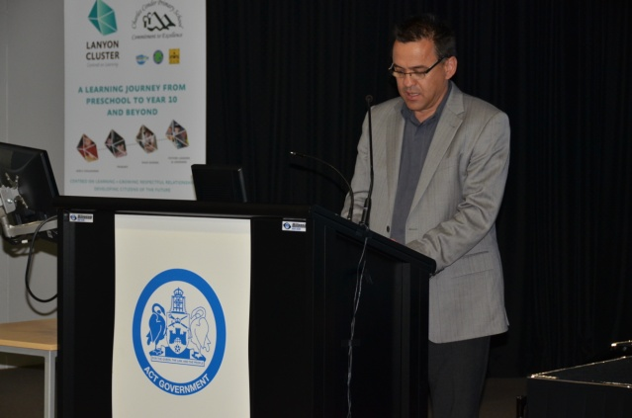
Minister Bourke opens the Smarter Schools National Partnership Cross Sectoral Showcase.

Each of the participating schools presented a display highlighting a particular area of focus relating to their NP work.
Charnwood Dunlop Primary School shared its success in engaging students through:
- music- with a band program for years 5 and 6 and ukulele lessons for years 3 and 4
- the Children’s Opportunity for Resilience Education (CORE) program
- the Homework Club
- The Beach, a time out space where children needing a break from the classroom work with a teacher on a literacy-based program.

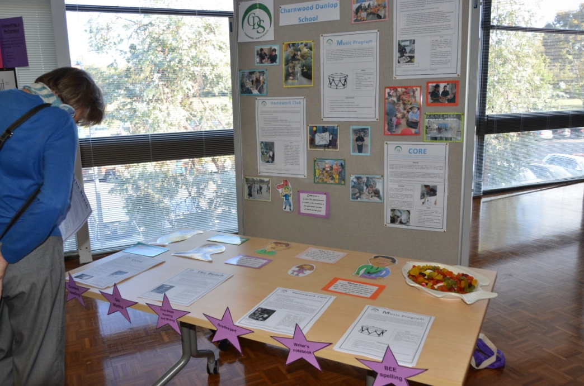


Richardson Primary School shared its experiences in building teacher capacity via professional learning, coaching and evidence-based practice.

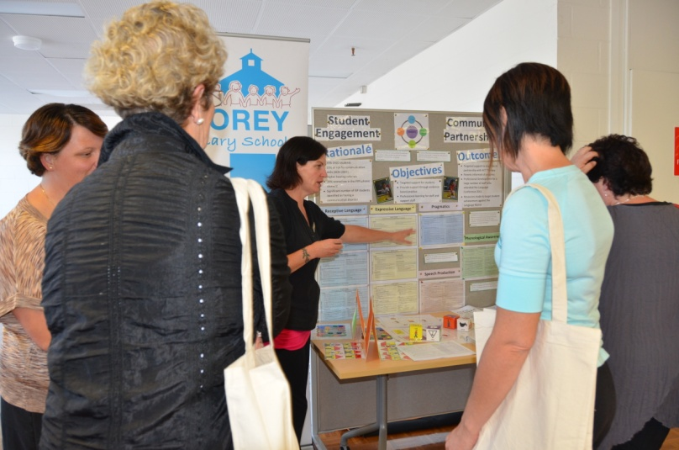
Florey Primary School shared information on their community partnership with Therapy ACT and their use of a school wide data tracker for identifying students at risk of falling behind.

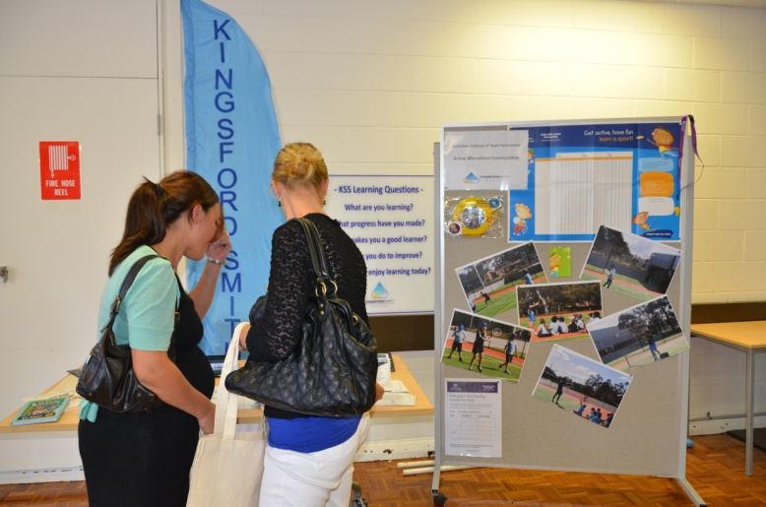

Kingsford Smith School highlighted the opportunities they were providing for student engagement in after school sports activities and their use of ‘learning questions’ to engage and focus students on being responsible for their own learning.

Building on ACT priorities in public schools
Since the 2010 launch of the Directorate’s Strategic Plan for 2010-2013, Everyone matters, a raft of supporting documents have been produced that align with the activities and initiatives of the Low SES NP schools. These include:
- the Everyone Matters: Behaviour Support Protocols. These protocols are based on current understanding that student behaviour is affected not only by personal temperament, background and age but also by the quality of relationships with others, the physical environment and the quality of teaching.
- the Reconciliation Matters: Reconciliation Action Plan. This plan is updated annually to identify real and practical commitments by staff at all levels of the organisation to promote reconciliation.
- School Improvement in ACT Public Schools: Directions 2010-2013.
A Student Engagement Framework is currently being developed to continue the Directorate’s work to support and engage all students and ensure our schools provide the best environment where all young people “learn, thrive and are equipped with the skills to lead fulfilling, productive and responsible lives” (ACT Department of Education and Training Strategic Plan 2010-2013).
The programs being developed by the Low SES School Communities NP schools are shared with other schools at the cluster, network and system levels at events such as the Smarter Schools National Partnerships Cross Sectoral Showcase and through newsletters, newspaper articles and the sharing of Smarter Schools National Partnerships annual and progress Reports.
The field officers and literacy and numeracy coordinators also share their expertise through regular forums which are also a vehicle for disseminating literacy and numeracy information throughout the organisation and for nurturing a professional network of literacy and numeracy educators across the Directorate.

Empowering ACT Schools
In 2011 the ACT embarked on the first phase of the Empowering ACT Schools initiative to give principals the information, tools and flexibility to manage their schools to innovate and further improve teaching and learning. In 2012 Kingsford Smith School joined 14 other schools in the second phase of this initiative, becoming the first of the four Low SES School Community NP schools to be involved in the process.
The Empowering ACT Schools initiative supports the Australian Government’s National Partnership Agreement on Empowering Local Schools and aligns with a number of the Low SES School Communities NP reform areas by:
- enabling greater school-based decision making in the selection, development and management of staff to further develop high performing teaching and support teams
- involving greater transparency of resourcing of schools, and flexibility for principals to direct resources to where they will have the greatest impact
- strengthening community engagement between the school leadership and the school board.
The other three Low SES School Communities NP schools will have the opportunity to join later phases of the Empowering ACT Schools initiative.
Support for Aboriginal and Torres Strait Islander Students - 1 January to 30 June 2012
In 2011 the Australian Government provided funding to support local activities around key actions in the national Aboriginal and Torres Strait Islander Education Action Plan 2010-2014 in ‘focus schools.’ These are schools identified as having the highest number of Aboriginal and Torres Strait Islander students and where effort should be focused to make the greatest difference. The ACT has 31 focus schools that accommodate approximately 75 percent of the Aboriginal and Torres Strait Islander students enrolled in ACT public primary schools.
All the focus schools are working on the Engagement and Connections domain of the Aboriginal and Torres Strait Islander Education Action Plan 2010-2014 to improve relationships and partnerships with parents and caregivers of Aboriginal and Torres Strait Islander students. In addition, clusters of schools across the system have a particular focus on:
- attendance
- literacy and numeracy
- improving relationships and partnerships
- supporting Aboriginal and Torres Strait Islander students at key transition points in
their schooling.
This approach builds on the work already being done in the ACT’s four school networks, such as the transition program that is being piloted as a joint initiative of the North Canberra and Gungahlin networks. In this program, Aboriginal and Torres Strait Islander students are supported through:

- the provision of professional learning for teachers
- regular network meetings each term to share effective strategies and examine progress according to the agreed timeline of actions
- ensuring all schools in the network are using a consistent, effective approach to supporting students and families with transitions
- the appointment of an Aboriginal and Torres Strait Islander transitions contact officer or team at each school for 2012
- student engagement in induction programs in their new schools in semester 1 2012 to supplement the orientation programs of the previous year
- surveying of parents/caregivers and students in semester 1 2012 to ascertain the effectiveness to date of the transitions program so that adjustments to the pilot could be incorporated.
Aboriginal and Torres Strait Islander students who are identified as high achievers by their school and through data collected by the Directorate, can also access an Aspirations Program that provides extension activities based on student interests.
All Aboriginal and Torres Strait Islander students are expected to have a Personalised Learning Plan and training is provided for their development with school follow-ups available on request.
Exemplary Schools and Showcase activities - 1 January to 30 June 2012
CIT program for parents – Skills for Everyday Life
Through surveys and anecdotal feedback it was recognised that many of the parents in the four Low SES School Community NP schools do not have post secondary qualifications and some have not completed year 10. Some parents also reported that they felt unable to act as role models for their children or were struggling to assist their children with homework.
Through an existing partnership with the Canberra Institute of technology (CIT) the Directorate offered a Learning Options Program, Skills for Everyday Life, for interested parents, carers and community members. One of the goals of the program was that it be a catalyst to encourage participants to pursue further learning. It was hoped that with careers information from the CIT, participants would be better equipped to make informed decisions about their future learning options. Some of the aspects that the course
offered include:
- reading and writing for different purposes
- maths for everyday living
- helping with your child’s learning
- basic computer skills
- using the internet
- team work and communication
- workplace preparation—resume writing, interview skills and job searching.
The program was delivered in term 2 by the CIT at Kingsford Smith School and Richardson Primary School. It ran in school time over ten weeks for 2 ½ hours per week at no cost to participants. The CIT had received a $10,000 Adult Community Education grant which was used to fund one program and the second program was funded through the Low SES School Communities NP.
Interested parents and carers were invited to information sessions at the schools where CIT staff talked about the course. While the delivery of this program was to a group, the teacher delivering the program tailored individual programs to meet individual participant needs. During the course of the program each participant completed tasks that were negotiated between the teacher and the participant. Initial surveys on participants’ desired program content were distributed. A follow up survey was conducted near the end of the program.
The program was well received at both schools. There were six participants in the program at Kingsford Smith School including one male, five females and two participants identified as coming from a home where English was the second language. Of the five parents who completed the program:
- one is pursuing possible employment with the aid of Vision Australia
- one is pursuing studies with the Adult Migrant English Program
- one is pursuing training as a home tutor
- one is seeking recognition of prior learning with a view to seeking employment.
All participants stated that the program was of great benefit to them and expressed the desire to do more learning of this type. All participants gained increased confidence in their ability to read, write, research and use ICT skills for a range of purposes. Participants also reported feeling more strongly connected to the school and having an increased understanding of what the school offers, not only for their children but for them as well.
At Richardson Primary School there were eight female participants ranging in age from 19 to 60 years old, who were all parents of school-aged children and one of whom spoke English as a second language. In letters of appreciation, they wrote of “kick starting their brains into gear after being at home for so long” and their desire to continue with their learning. One Richardson participant wrote:

‘the course has given me the opportunity to meet other parents within the Richardson Community and to develop friendships and a support network which I would not have been able to do elsewhere. For example we have started a walking group to get us all up and going, as well as a babysitting co-op to give us the freedom to get out of the house for appointments.’

Participants from both programs wrote letters of appreciation to the schools and the CIT expressing their thanks for the opportunity provided and their appreciation of the high standard of the program. They also expressed a desire for an extension to the program to allow them to further consolidate their learning, and encouraged further collaboration between CIT and the schools in providing programs to support parent learning. The convenience of being at their child’s school made it attractive to parents with one commenting that her child “found it wonderful that we go off to school together”.

This has been an extremely positive program with good outcomes for participants. The goodwill engendered for the schools hosting the program and the positive connection with the CIT has improved participants’ perception of education and their engagement with lifelong learning. The collaboration with the CIT will continue to be expanded with a joint application for grant funding being explored for
the second semester of 2012.
Florey Primary School - Stronger teacher engagement Leading to support student learning
Florey Primary School is a P-6 school with an enrolment of 449 students. The school has an Index of Community Socio-Educational Advantage (ICSEA) of 1059, with 11 (2.4%) students identified as Aboriginal and Torres Strait Islander and 146 (32.5%) identified as Language Background Other Than English (LBOTE) students. The school has relatively strong results as measured against school mean NAPLAN targets and due to its high proportion of LBOTE students the leadership team has focused on data collection and tracking to ensure the needs of all students are being met. By tracking individual students and identified cohorts such as LBOTE and Aboriginal and Torres Strait Islander students, Florey is using student performance to measure the success of classroom programs.
The appointment of a new principal and a new field officer in late 2011 prompted a re-examination and redefinition of the school’s priorities. Priorities of their 2012 NP Plan include:
- analysis of data to inform teaching and learning directions for at risk students and continued development of Individual Learning Plans (ILPs), including for Aboriginal and Torres Strait Islander students
- maintaining implementation of endorsed teaching programs and linking to criterion referenced assessment and the Quality Teaching model (QTm)
- identifying staff expertise/knowledge of the QTm and providing professional learning to staff to meet identified needs
- developing the Florey Primary School Coaching Philosophy, aligned to building capacity in literacy and numeracy pedagogy, including the development of a Professional Learning Community
- providing parent workshops, including reading and mental computation strategies, to support parents in assisting students at home.
These priorities are broken down even further in the 2012 School Annual Operating Plan to articulate the key strategies that will be employed. These strategies include:
- implementation of a differentiated coaching model to build teaching capacity
- implementation of criterion referenced moderation practices K-6
- linking the QTm to quality planning and assessment data P-6
- developing curriculum support documents that clearly articulate school wide expectations, preferred pedagogy and identified assessment tools linked to key learning areas P-6
- developing scope aligned to the Australian Curriculum and QTm
- aligning Aboriginal and Torres Strait Islander histories and cultures to curriculum documentation
- monitoring and evaluating the impact of curriculum delivery.
A key achievement in semester one has been the work around development of the Florey Primary School Coaching Philosophy and the engagement of staff in the coaching strategy. A coaching needs survey was sent to all staff providing an opportunity for them to identify key aspects of their English and mathematics teaching that they would like to strengthen. A staff capacity matrix was also completed to indicate staff strengths and to identify possible coaches and mentors. This early work was revisited in June when the models of coaching, and areas for coaching, were re-examined and a new coaching menu was discussed and new goals set.
Across 2012 the school intends to use NP funding to provide release for teachers to attend professional learning, for peer observations, and to work with experts in the writing of ILPs. They have also bought computers for special needs students and additional resources to support literacy and numeracy programs.
Richardson Primary School - Building on Prior Knowledge - Action Learning Teams 2012
Richardson Primary School is a P-6 school with an enrolment of 231 students. The school has an ISCEA of 914, with 45(19.5%) students identified as Aboriginal and Torres Strait Islander and 51(22%) identified as LBOTE students. There are also 13 students in special classes and two students receiving support from the Student Engagement Section. A new principal and deputy principal were appointed to the school in 2012.

Richardson has made significant progress in engaging their students in schooling after implementing
co-operative learning across the whole school. All teachers have attended a series of professional learning sessions presented by Kagan Australia. These courses aim to help teachers:
- increase student engagement in every lesson
- teach the way the brain best learns
- apply structure to learning experiences that lift academic achievement.
Back at school the staff discussed and brainstormed ways of moving forward. They formed Kagan buddies and after identifying a target Kagan structure, observed and provided each other with feedback. A member of the school leadership team was then invited to observe mastery and fortnightly walk throughs were organised to identify evidence of effective implementation of co-operative learning.
Richardson has also worked on improving attendance with the average attendance across the school increasing from 92.8% in 2010 to 98.3% in 2011, an increase of 5.5%. Aboriginal and Torres Strait Islander attendance has inreased from 90.4% to 97.6%, a 7.2% gain in the same period. Richardson has an Indigenous Homework Club and a Koori Preschool program available to children from three years of age to provide early engagement with schooling and support parent involvement.
Richardson has been on a journey of professional learning over the last three years. They have invested significant time in defining professional learning and what a professional learning community would look like in their context. In term 1, 2012 they ran a session, Looking back to move forward, that examined professional learning at Richardson and asked ‘what’s next?’.
They quote from Dean, Stone, Hubbell and Pitler (2012) in their handout Classroom instruction that works; Building prior knowledge for Action Learning Teams when talking about the nine categories of instructional strategies with which they are working:
We do not claim that these are ‘silver bullets’ or that they will be effective in all circumstances. Rather, they are ‘best bets’ if teachers incorporate them systematically and intentionally as they plan and deliver instruction. Teachers must know what each strategy entails (i.e. its component parts), how and when to use each strategy, and why each works in specific circumstances. To get the most out of this approach, teachers must bring to bear their knowledge of and skill with the instructional strategies, and they must exercise judgement and wisdom with regard to the use of the strategies. As Walberg notes, “the best saw swung as a hammer may do little good” (1999, p.76).
In their action learning teams they examine their teaching practices and the strategies they are using in their classrooms. The field officer introduced the Ontario Literacy and Numeracy Secretariat Capacity Building Series: Collaborative Teacher Inquiry paper to inform their action learning agenda.
In semester one, 2012, the major initiatives have been:
- team building and focused work using Lencioni’s (2002) Team Triangle to strengthen foundations of effective team functioning e.g. trust
- training, resourcing and ongoing implementation of cooperative learning
- action learning, inlcuding:
- the whole staff taking part in Classroom Instruction That Works (2012)
- a comprehensive English program K-3 (Literacy Place); 6 Traits of Writing for years 3-6. Teachers do peer observations and then provide feedback and discuss/debrief.
- writing rubrics, focusing on:
- implementation of rubrics written in 2011 as a diagnostic and formative assessment tool
- implementation of lesson sequence aligned with writing exemplars, as examples of best practice in writing instruction
- selecting Richardson Primary School student work to replace Ontario student work (previously used as exemplars and for moderation)
- introducing a case management approach.
- assessment and use of data involving:
- implementing and analysing Australian Council for Educational Research testing, primarily as a data source providing long term trend data to measure whole school performance and trends, and also to provide teachers with diagnostic assessment data to inform learning programs, where appropriate
- writing rubrics (see above)
- formative assessment as embedded in Literacy Place and the 6 Traits resources (see Action Learning - English projects, above)
- a Learning Options Program to engage parents, working with CIT Vocational College.
The school has also developed an Assessment Overview with a comprehensive list of diagnostic tools and a schedule, a statement on the use of portfolios in assessment, a diagnostic assessment summary and a template for the summary of students requiring support.
Richardson has used their NP money to fund professional learning for teachers, Kagan Co-operative Learning consultants, and teacher release to support action learning, lesson study, cooperative learning and coaching. They have also used funding to purchase professional resources to support their initiatives in coaching, co-operative learning and assessment.
References
Dean, C.B., Stone, B., Hubbell, E. and Pitler, H. (2012). Classroom Instruction that Works: Research-based strategies for increasing student achievement (2nd Ed.). Alexandria, VA: ASCD.
Lencioni, P. (2002).The Five Dysfunctions of a Team. San Francisco: Jossey-Bass.
Walberg, H. J. (1999). Productive teaching. In H. C. Waxman & H. J. Walberg (Eds.), New directions for teaching practice and research (pp. 75–104). Berkeley, CA: McCutchen Publishing Corporation.

Section 3 – Literacy and Numeracy
Overview/Highlights - 1 January to 30 June 2012
Public schools
A Smarter Schools National Partnerships Cross Sectoral Showcase was held on 2 April 2012, providing an opportunity for schools involved in the three Smarter Schools National Partnerships to share their work and successes. Of those schools involved in the Literacy and Numeracy National Partnership, 11 public schools, nine Catholic schools and two independent schools presented displays at the Showcase.

Over 230 educators from across the ACT attended the Showcase to interact with the school stalls and talk with teachers about their programs, changes and successes. Feedback from participants was very positive and indicated the valuable learning that took place and participants’ high regard for the work of the National Partnership schools. Many expressed delight at being able to see what was happening in all sectors across the ACT, and to be able to have access to all of the schools in one place and in a collegial setting.
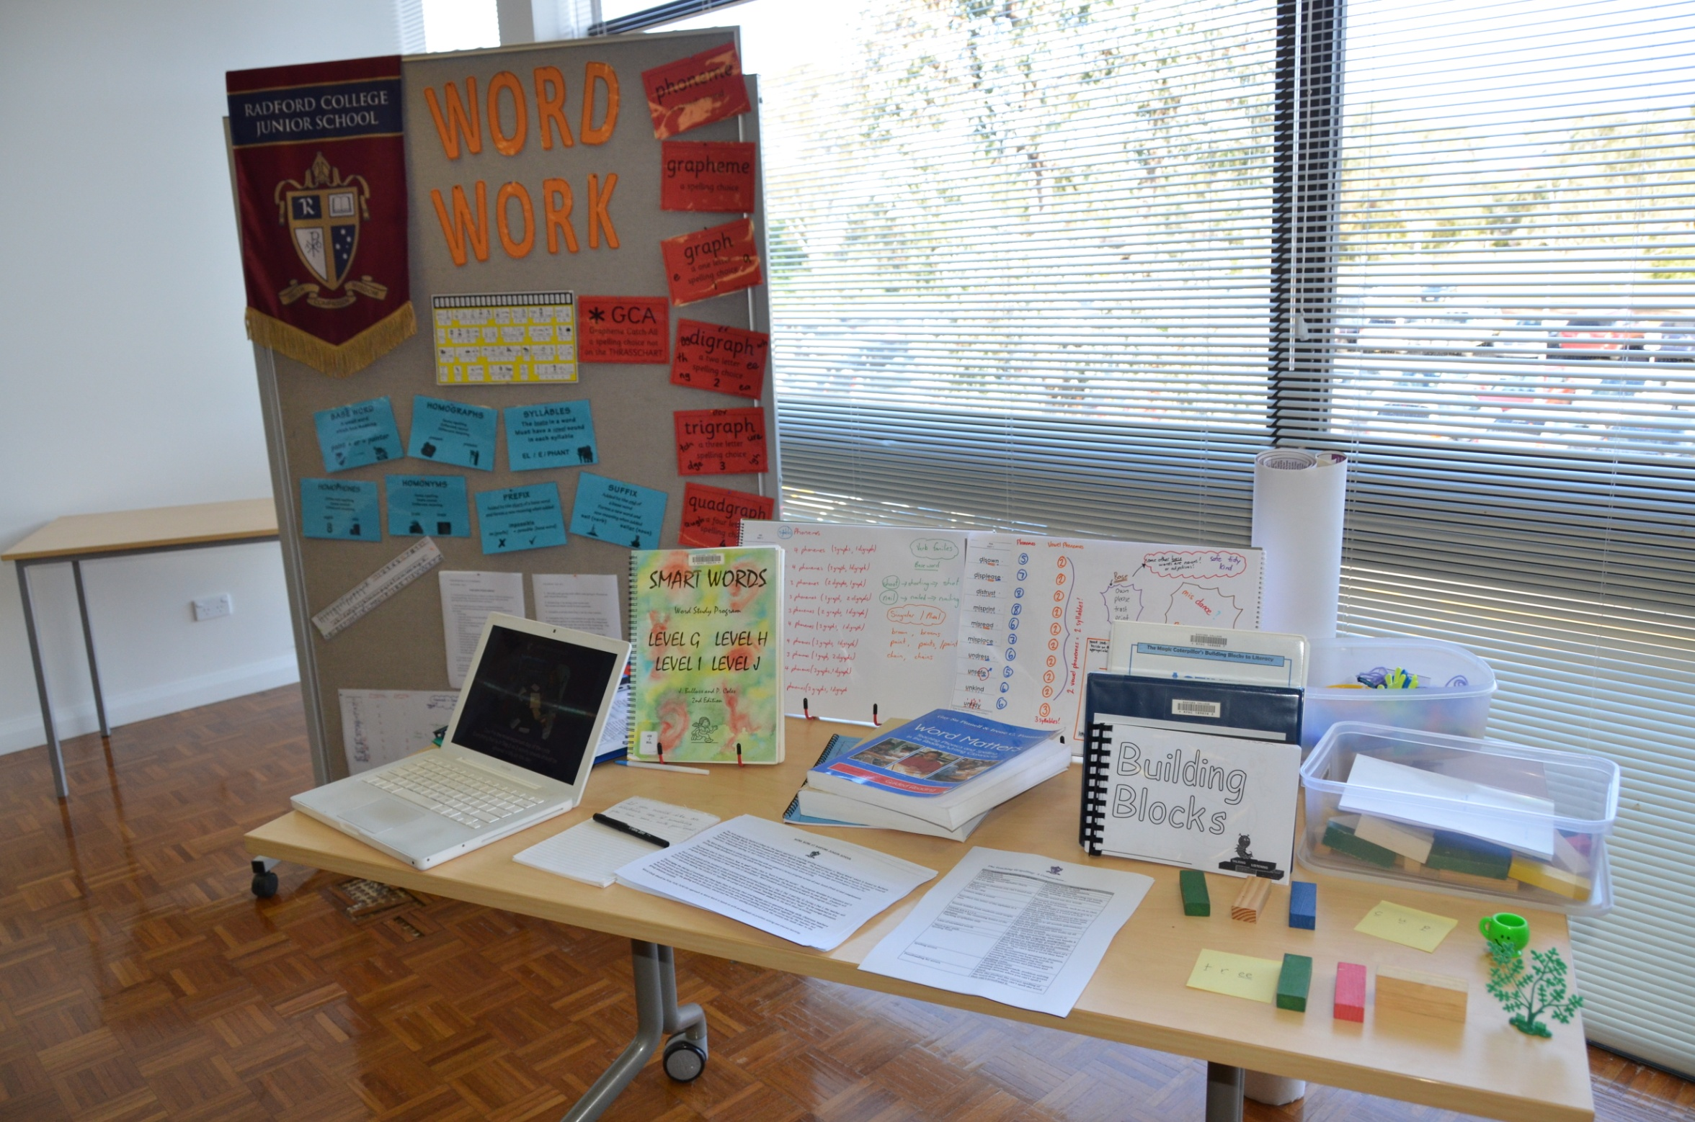
Some of the cross sectoral stalls
displayed at the Showcase
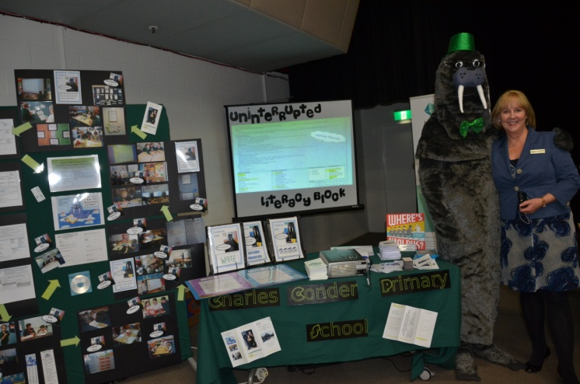
The Showcase format was also popular, with teachers being able to access a large number of schools presenting a range of information. Participants were able to focus on schools with a similar context to theirs, discover new information and chat to teachers about the practical aspects of implementing a range of programs. The Showcase was rated as excellent by 51% of participants and a further 38% rated it
3 out of 4 on a 1-4 point scale. One participant commented that it was “a chance to get together with common goals... to share ideas and hear very valuable work”.
The Literacy and Numeracy National Partnership (LNNP) continues to deliver a range of reforms in schools including a focus on the use of coaching in schools to improve teaching practices and student outcomes.
The close alignment between the LNNP and the ACT Education and Training Directorate’s Literacy and Numeracy Strategy 2009-2013 provides leverage for systemic improvement in literacy and numeracy. The following three priorities of this strategy are aligned with the LNNP reforms and drive system change:
- to strengthen the leadership capacity of school leaders
- to improve teachers’ professional knowledge and skills in teaching literacy and numeracy
- to improve literacy and numeracy learning of every student.
Leadership
The employment of the field officer model of in-school coaching, supported by research, has proven to be successful in the LNNP schools. Field officers act as change agents for classroom and school change of practice. Through the LNNP, funding has already been provided for training in coaching to one staff member from each P-10 public school. In semester 1 of 2012, a procurement process was undertaken to engage a training provider to deliver more training for school leaders and teachers. The Institute of Executive Coaching and Leadership has subsequently been engaged to provide three days of training on instructional leadership to principals and deputy principals, and one day of training to executive teachers or coordinators to assist them in their coaching role.
In 2012 the ACT public system is continuing to strengthen its Network Model for School Improvement. The system is divided into four networks, each with a network leader who is an experienced principal. The networks are working on system improvement priorities utilising expertise within the network. Schools share resources, ideas and learning and practices to progress system and Australian Government initiatives such as the Literacy and Numeracy Strategy and the Australian Curriculum. This collaborative approach and pooling of expertise lessens the load on individual schools. Field officers, as knowledgeable experts in literacy and numeracy and coaching, lead working parties and provide advice in their clusters, networks and across the system. They have become a highly regarded system resource.
Effective teaching
LNNP funding continues to be used to provide training and resources for schools in the system endorsed literacy and numeracy programs and professional learning provided by subject experts from Australia and overseas. In particular, the work started with Dr Lyn Sharratt in 2011 to ‘put the faces on the data’ continued this year. Dr Sharratt presented on case management as a way of catering for students’ individual needs and to assist all children to be successful. Dr Sharratt also presented to school leaders at the iLead Leadership Conference in May 2012, and to school networks following the conference.
Dr Sharratt’s 2012 presentations gave schools the next step after data walls. The ‘so what now?’ and ‘what do we do with this information?’ case management provides a structure for dealing with the questions of what to do for the students that are standing out on the data wall. This includes underperformers, high achievers, individuals or groups. Schools are currently implementing Dr Sharratt’s suggestions as a way of monitoring, identifying and catering for all students in their schools.
Table 3.1 shows participation in professional learning in literacy and numeracy for the period January to June 2012. The majority of schools in the system have been trained in using system endorsed literacy programs and are now embedding these programs in their school plans. There has been an increase in demand for numeracy training this year as many schools move on from their earlier emphasis on literacy.
Table3.1: Participation in literacy and numeracy professional learning programs,
January – June 2012
Professional Learning programs supporting Literacy and Numeracy | Participation
First Steps Reading | 9 schools and one central catch-up course
First Steps Writing | 6 schools
First Steps Speaking & Listening | 2 schools
BEE Spelling | 3 schools
Teaching English as a Second Language in Mainstream Classrooms (TESMC) | 18 participants
ESL in the Mainstream for the Early Learner (ESLMEL) | 17 participants
Middle Years Mental Computation | 24 schools
Count Me In Too - numbers | 12 schools
Count Me In Too - measurement | 1 school
Struggling Readers- Kaye Lowe | 50 participants
Action Learning-Robyn Ewing | 15 schools
Grammar & the Australian Curriculum | 16 participants
Spelling, Phonics & the Australian Curriculum  – David Hornsby  Day 1 –Spelling and phonics in the context of your reading and writing program and the Australian Curriculum  Day 2 - What’s essential for early childhood and primary school leaders to know about spelling and phonics | 100 participants  52 participants
Case Management Workshop – Dr Lyn Sharratt | 95 participants and Leadership Conference
iLead Leadership Conference – Dr Lyn Sharratt | Approximately 288 participants
Big Ideas in Mathematics – Di Siemon  Session 1 - Big ideas in number for classroom teachers, numeracy coordinators and field officer  Session 2 – Taking our mathematical thinking deeper for school leaders, numeracy coordinators and field officers | 70 participants  44 participants
Literacy and Numeracy Coordinator Forums | Two per term
Field Officer Forums | One per term
Monitoring student performance
Schools are continuing to refine their monitoring and data collection processes. All schools have data collection and tracking mechanisms, and use them with NAPLAN results to analyse student performance to inform teaching practices and allocation of resources.
After working with Dr Sharratt, schools have developed data walls using a range of data sources. A large number of schools started with reading levels to provide a snapshot in time, while others used sources such as Count Me In Too’s Schedule for Early Number Assessment (SENA) and First Steps’ Maps of Development phases to provide a more detailed picture. Public schools across the ACT have used data walls to stimulate professional discussions among staff around questions of student performance. The visual nature of the data walls provokes questions about student position relative to their peers and cohort performance as an aspect of the whole school performance and compared to system data.
A number of the LNNP schools are also lead schools in trialling the Australian Curriculum. In the ACT the trialling has involved writing units of work and moderation of work samples. Teachers’ learning through the LNNP has equipped them with the expertise to contribute, especially the cross curricula perspectives of literacy and numeracy.
Catholic systemic schools
Numeracy
National Partnership (NP) funding and activity has occurred in six schools The following schools (referred to as Round 1 schools) were involved from the beginning of the NP:

- Saint Francis of Assisi, Calwell
- Saint Anthony’s, Wanniassa
- Saint Thomas the Apostle, Kambah
- Good Shepherd, Amaroo

Two additional schools (referred to as Reward Phase 1 schools) became involved from 2011, having been allocated Reward funding from Phase 1:

- Saint Clare of Assisi, Conder
- Saint Thomas Aquinas, West Belconnen
In the Round 1 schools, the NP has built on the following existing priorities to support numeracy within the archdiocese:
- The development of whole school Agreed Practices for the targeted and explicit teaching of Numeracy within the school. The whole school reforms were based on the Count Me in Too Framework (CMIT) with emphasis on students’ early numeracy development, David Sousa’s Brain Based Learning research and the Gradual Release of Responsibility (GRR) Model from First Steps. Coordinators were appointed in schools to ensure all students were effectively assessed and plotted on the CMIT Framework continuum. Targeted teaching activities were then programmed mindful of the chunking of time and information in the Brain Based learning model.
- Implementation of the Numeracy Intervention Program was based on the Reading Recovery model. The students are targeted from analysis of collective data as well as teachers’ observations. Students participate in a 12 to 13 week program involving one-to-one 30 minute sessions four times a week with a trained intervention teacher. The purpose is to scaffold the learner through any missed concepts and the big ideas in numeracy.
- The development of Whole School Leadership to encourage reflective practices about the teaching of numeracy in the school. Staff were provided with professional learning on the Team Leadership for School Improvement modules to inform schools’ Management and Strategic Plans with practices to improve the teaching of numeracy for all students. Practices included peer mentoring, coaching, joint planning and programming, sharing of teachers’ strengths, community expertise and knowledge, and parent partnership in the teaching of numeracy for their children.
These three priorities align with the three reform elements for numeracy:
- Effective and evidence-based teaching of numeracy
- Strong school leadership and whole-school engagement with numeracy
- Monitoring student and school numeracy performance to identify where support is needed.
Saint Clare of Assisi, Conder was tasked with the same priorities as earlier schools with some additions. This school was also to focus on problem solving as the tool for teaching numeracy and on experiential activities to introduce concepts. The GRR Model was made more flexible in that the release of responsibility was to occur over the entire conceptual teaching and not all components to occur within one teaching session. Earlier National Partnership schools also adopted these modified practices.
Saint Thomas Aquinas, West Belconnen received funding for a 0.1FTE teacher to look at whole school practice at the school. This school is also trialling programming with the flexible GRR Model. The school’s priorities to date have been to implement school-wide accepted and agreed practices around the assessment and use of mathematical data and the programming of activities around the inquiry approach and problem solving focus.
Literacy
National Partnership (NP) funding and activity has occurred in six ACT Catholic schools. The following three schools (referred to as Round 1 schools) were involved from the beginning of the NP:

- Saint Michael’s Primary, Kaleen
- Saint Thomas Aquinas, West Belconnen
- Saint Matthew’s Primary, Page

Three additional schools (referred to as Reward Phase 1 schools) became involved from 2011, having been allocated Reward funding from Phase 1:

- Saint John the Apostle, Florey
- Saint Clare of Assisi, Conder
- Saint Francis of Assisi, Calwell

Key Reform One: Effective and evidence based teaching of literacy
The Round 1 schools have all implemented the research based pedagogical approach of First Steps in the teaching of reading. In 2012 teaching staff have continued to receive professional learning in First Steps and to receive mentoring through:

- an in-school mentoring program combined with mentoring partnerships with the Catholic Education Office (CEO)
- professional support in teaching and programming through class visits and feedback using the ‘two stars and a wish’ strategy, team programming workshops in year levels and in partnership with Literacy Officers in the CEO
- demonstration lessons in staff meetings and classrooms.

Explicit teaching in reading strategies in modelled, shared, guided and applied teaching procedures within literacy blocks was embedded in all three schools. New staff and early career teachers were mentored in their planning, programming and pedagogy, and consistency of approach from kindergarten to year 6 was monitored by school executive and the CEO Literacy Officer.

Saint Thomas Aquinas, West Belconnen revisited Modelled and Guided Reading through lesson demonstration and co-teaching, while Saint Michael’s Primary, Kaleen and Saint Matthew’s Primary, Page mentored new staff and maintained professional peer mentoring networks.

A major audit of implementation of the Smarter School National Partnership Targeted School Self Evaluation Improvement Report (SSNP TSSEIR) recommendations made in 2009/early 2010 for ACT Archdiocesan schools was conducted at Saint Thomas Aquinas, West Belconnen and Saint Michael’s Primary, Kaleen by the CEO Literacy Officer, in collaboration with school executive. This involved the review of teaching programs, class visits, lesson observations and professional discussions to ascertain teacher understanding, practice and implementation of the First Steps pedagogical reading approaches. This audit will also be conducted at Saint Mathew’s Primary, Page in term four of 2012.

In 2012 Saint Michael’s Primary, Kaleen and Saint Matthew’s Primary, Page began to concentrate on writing and spelling as a whole school focus. Read and Write Gold was investigated by Kaleen and developed and assessed by Page. This is a useful resource for teaching writing, particularly in targeting students in upper bands of writing.

Assessment continued to be a focus in 2012, where analysis of assessment was explored to inform whole class, small group and independent teaching focus, as was use of balanced assessment of observation, conversation and product. Differentiation was the focus of assessment at Saint Michael’s Primary, Kaleen and Saint Matthew’s Primary, Page while Saint Thomas Aquinas, West Belconnen conducted a six month audit of assessment practices and updated literacy assessments to ensure adequate data on students’ literacy achievements was being collected for pre-testing, formative and summative assessments.

Home reading was a continued focus. Saint Michael’s Primary, Kaleen continued to audit and purchase reading resources, maintained the Reading Bags for an ongoing focus on reading strategies between home and school, tracked student achievement via Reading Walls in all classes from kindergarten to year 6, updated the school website and built a new Wiki using the electronic management system, Life. All three Round 1 schools continued to promote home reading and provide parent information sessions in home reading throughout 2012. Saint Matthew’s Primary, Page also focused on purchasing more reading materials, with the interest of boys a particular focus, in order to target underperformance in reading for boys at the school, previously identified in 2009.

The Reward NP Phase 1 schools adopted Reading Recovery as their specific reading intervention program for Year 1 students, based on the success of this program in the Round 1 schools.

Saint John the Apostle, Florey began its focus on assessment in reading through data collection and data analysis. They also began to focus on a whole school pedagogical approach and improved whole school programming approach through the First Steps reading and gradual development of responsibility. This school will also be focussing on gender performance, particularly the disengagement of girls in reading in upper primary.


Class visit at Saint Michael’s Primary, Kaleen, where summarising and paraphrasing were explicitly taught in a modelled reading lesson using Reading Think Alouds, reading strategy summaries and the pedagogical process outlined in First Steps and Read On.

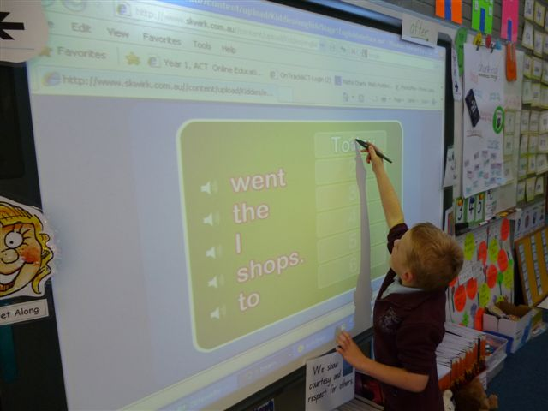

A student at Saint Matthew’s Primary, Page participating in a shared reading lesson.

Key Reform Two: Strong Leadership and whole school engagement with literacy
School executive at the Round 1 schools have monitored mandated timetabling requirements for sustained, uninterrupted Literacy Blocks for years K-6 and have formulated and monitored school Agreed Practice in programming, planning, assessment and teaching and learning. They have continued to promote the Reading Recovery program and have supported ongoing professional learning in First Steps in all NP schools (course participation, staff meetings and workshops) through staffing, timetabling and funding. Tracking assessment data in literacy continued to be a focus within each school and across the NP schools, where pre- and post-test information from 2009 to 2012 was analysed in NAPLAN and PAT R Reading, Kindergarten assessment and year one observation survey data 2010 and 2011 and Reading Recovery levels for students entering the program and discontinued students from 2010 to 2012.

School executive focused on the remaining SSNP TSSEIR Recommendations as a result of the major audits conducted at Saint Thomas Aquinas, West Belconnen and Saint Michael’s Primary, Kaleen and provided staff with professional development, programming support, demonstration lessons and co-teaching networks to address highlighted areas – embedding the Quality Teaching framework into teaching practice and demonstrating whole school Agreed Practice in the Gradual Release of Responsibility.
Key Reform Three: Monitoring student and school literacy performance to identify where support is needed
Round 1 schools continued the Reading Recovery program and increased teacher expertise was shared amongst the teaching staff, particularly in programming, literacy blocks, professional dialogue and professional mentoring. At all schools, discontinued Reading Recovery students continued to be monitored throughout years one, two and three. Tracking of student assessment data using First Steps student profiles, PAT Reading, running records, kindergarten assessment and year one observation surveys ensured that tracking of all student achievement for years K-6 was maintained. Decisions were made based on tracking assessment data, on early literacy requirements for the junior years, and on identification of students with high needs. Students making slow progress were referred for further literacy support. At Saint Michael’s Primary, Kaleen intensive teacher support, through timetabling and staffing arrangements, was provided in literacy blocks in the junior years, where up to five teachers were present in the year one’s literacy blocks. At Saint Thomas Aquinas, West Belconnen school executive support intensified with behaviour management a specific focus to maximise learning during literacy and numeracy blocks.

Quantitative data in all three Round 1 schools show an improvement in NAPLAN data in reading, while data in Reading Recovery for students within the Reading Recovery program in 2011 - 2012 and for discontinued students in years one, two and three demonstrate continued and sustained progress for the majority of students.
At Saint Thomas Aquinas, West Belconnen and Saint Michael’s Primary, Kaleen changes in staffing necessitated retraining in First Steps and further mentoring through programming teamwork, lesson observations and feedback. Teachers reported increased levels of professional trust, confidence and expertise in the teaching and programming of reading and in the analysis of assessments.

Independent schools
Funding through the National Partnership has provided six independent schools the capacity to engage in programs which specifically respond to the identified literacy needs of their communities.

Schools participated in the ACT Smarter Schools National Partnerships Cross Sectoral Showcase in April 2012 and were not only able to inform members of the profession from across the jurisdiction of their work, journey and success, but importantly had the opportunity to explore those of other participating schools as well.

Leadership opportunities continue to be a focus through the schools. Some choices have been to appoint Literacy Coordinators or Network Leaders to support staff in the implementation of programs and gather data to inform the next phases of implementation.

Development of strong professional mentoring amongst staff, and the flow on of whole school engagements with literacy strategies and goals continues to be a common theme among schools. Examples of staff meetings dedicated to investigations of progress in literacy outcomes, professional learning investigating more successful pedagogical approaches, and engagement of parents in an overall strategy abound.

Staff from schools have also taken the opportunity to further develop effective teaching practices by participating in professional learning events offered through the ACT Education and Training Directorate’s professional learning section. These are also tremendous opportunities to further develop cross-sectoral professional learning and conversations.

Support for Aboriginal and Torres Strait Islander Students - 1 January to 30 June 2012
Public schools
All Aboriginal and Torres Strait Islander students are required to have a Personalised Learning Plan (PLP) and schools are provided with the necessary training and support to develop these plans. School Annual Operational Plans also include strategies to ensure the success of Aboriginal and Torres Strait Islander students, particularly in closing any performance gap.
The strategies of ‘putting faces on the data’, data walls and case management are being used to track the Literacy and Numeracy performance of Aboriginal and Torres Strait Islander students across all ACT public schools to ensure their needs are being met and as an aid to schools’ work on closing the gap in outcomes and performance for Aboriginal and Torres Strait Islander students. A case management approach provides for a tailored program to be developed to suit the needs of individuals or groups of students as articulated in their PLP.
The North Canberra/Gungahlin network is piloting a transition program that aims to track and support students across transitions, such as from primary to high school or when moving school, to ensure the transfer of information and the induction of students into their new school.
Catholic systemic schools
PLPs have been written for Aboriginal and Torres Strait Islander students in all NP schools covering student strengths and areas of need to enhance performance. Assistance has also been provided to students not meeting minimum standards through the Numeracy Intervention Program and Reading Recovery.

The use of Numeracy Circles has also provided Aboriginal and Torres Strait Islander students with real life situations that allow them to interpret mathematics using their own cultural tools. Numeracy Circles are small groups of children gathered in a numeracy problem solving task which allows for critical thinking, rationalising, hypothesising, and justifying to foster deep mathematical learning. The rich task is contextualised or based on a familiar theme for Aboriginal and Torres Strait Islander students.

The use of assessment in informing teacher programming, planning and pedagogical decisions according to the First Steps Reading Approach and GRR Model has enabled all NP schools to focus on Aboriginal and Torres Strait Islander students’ specific learning needs in reading at home and at school. At Saint Michael’s Primary, Kaleen for example, the use of Wikis, Polly Pockets and class reading walls has successfully tracked reading progress and allowed for greater collaboration between students, parents and teachers. Polly Pockets are resources that are sent home with students every week to consolidate reading strategies and reading knowledge. They contain home reading books, reading diaries and suggestions for at-home reading activities for parents and their children. The activities were explored with parents during parent reading information sessions. Students are regularly assessed using running records, parent feedback and student feedback via Wikis. Student reading levels are displayed in each class every week on reading walls, allowing teachers to closely monitor home reader book selection, regularly assess current reading levels and differentiate reading during guided reading group work during literacy blocks.

A successful three day cultural immersion program was designed and implemented for NP schools. The program was run by the Canberra Institute of Technology and the Aboriginal contact and early career teachers from each of the National Partnership schools attended.

The Aboriginal contact teachers have met and developed expertise in using SMART goals when writing PLPs, analysed appropriate and authentic resources to improve student outcomes and the explicit program development for Aboriginal and Torres Strait Islander students.

In addition to Aboriginal contact teachers in the schools, Aboriginal education workers (AEWs) support classroom teachers’ implementation of literacy and numeracy teaching goals. Cultural programs, facilitated by the AEW, allow Aboriginal and Torres Strait Islander students to develop an improved appreciation of their culture through music, art and yarning. This has led to higher levels of student self esteem and has resulted in increased student learning.

One of the big successes this year has been the introduction of the Yarning Strong resource. Yarning Strong, published by Oxford University Press, “aims to reach out to young people aged 10 – 14 years old, in order to deepen their awareness and understanding of what it is like to be an Aboriginal or Torres Strait Islander person living in Australia” (Oxford Literacy Project, 2012). It comprises audio books, a teacher resource book, multiple sets of readers, videos and audios of Aboriginal and Torres Strait Islanders in many areas of Australia. Much has been written by Aboriginal and Torres Strait Islanders themselves. The resource is organised into four modules: Identity, Family, Law and Land.

School community feedback indicates Yarning Strong has engaged our Aboriginal and Torres Strait Islander students and deepened teacher understanding of issues that relate to Aboriginal and Torres Strait Islander people. Intensive professional learning on the resource was undertaken and the unit written using the Understanding By Design process (McTighe and Wiggins, 2006).
Independent schools
Schools provide support for Aboriginal and Torres Strait Islander students in a variety of ways which match both the individual and school community needs. While total numbers of students are not proportionally large in these schools, there is a profound desire to meet the needs and maximise the outcomes for these students, a position shared across all independent schools whether they currently have Aboriginal and Torres Strait Islander students or not.

One school has a dedicated position of Indigenous Education Coordinator, others provide this support through already established enrichment and learning support areas of the school. Improving educational achievement is a key component of the National Aboriginal and Torres Strait Islander Education Policy (AEP) which is used as an orientation document.

The support of Aboriginal and Torres Strait Islander students, and schools’ advancement of educational outcomes, is a standing item at AISACT Board meetings.

Exemplary Schools and Showcase activities - 1 January to 30 June 2012
Public Schools
Latham Primary School – Visible Learning
Latham Primary School is a P-6 school with an enrolment of 259 students. The school has 12(4.6%) Aboriginal and Torres Strait Islander students (4.6%), 33 LBOTE students (13%) and 12 students in two autism specific learning support units. A new deputy principal was appointed to the school in the second semester of 2010.
The staff at Latham Primary School have been on a journey that has included self reflection, innovative ideas, collaboration and team work, action learning, incorporating the Australian Curriculum into Learning Targets within their programming and ongoing professional dialogue and feedback. The learning needs of students are at the centre of all discussions.
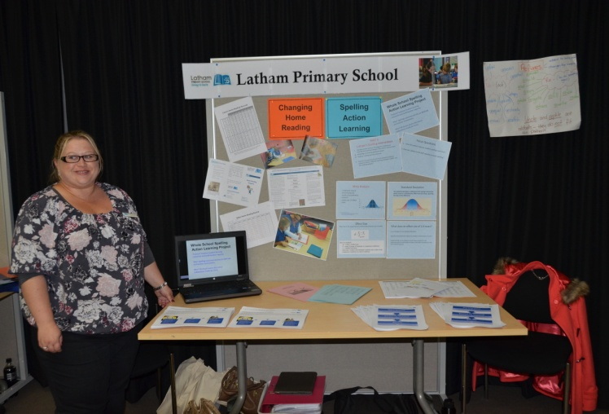
Latham Primary School’s display at the 2012 Smarter Schools National Partnerships Showcase highlighted Action Learning
One of Latham’s major achievements has been around Visible Learning. Inspired by the work of John Hattie, author of Visible Learning, which they used as part of their first action learning around writing in 2011, Visible Learning was introduced to the staff in 2012. Each teacher identified an area of focus and worked with their class to make the learning intentions clear and the steps to success understood by all.
To date the school has embarked on two ‘Visible Learning Safaris’. The first was within the school, where three teaching teams invited the staff into their classroom and shared what was happening, why they chose the selected focus area, their reflections on how well it was working and where to next. For their second ‘safari’ staff visited Bonython Primary School where Learning Intentions are well established, so they could see their literacy block in action. Teachers from Bonython and Latham then shared in teams how learning intentions work daily in their classrooms, throughout their term programs and are integrated into their mid and end of year reports. Back at Latham they reflected on the Bonython experience and discussed how Visible Learning at Latham would progress. The school will conduct a further Visible Learning Safari at the school in term 3.
Figure 3.1 illustrates the writing goals template developed by staff at Latham and implemented in the year 4/5 unit to support the students within the Integrated Support Program. The template was specifically designed to integrate students’ Individual Learning Plans with their everyday learning and clearly articulate their learning intention for writing.

Figure 3.1: Latham Primary School’s writing goals template
Writing Goals
Name Date Task_______________________________________

Learning Intentions
1. To write with all sentences making sense
2. All sentences have correct basic punctuation (. A?! ,) and some advanced punctuation (“ () ’) where appropriate
3. _________________________________________________________________________________________________________
___________________________________________________________________________________________________________

Success Criteria
1. All sentences make sense  Achieved  Not Achieved
2. All sentences have appropriate punctuation  Achieved  Not Achieved
3. ________________________________________________________________________________________________________
❑ Achieved  Not Achieved

The Kindergarten teachers are also involved in a reading action learning project with a focus specifically on intervention. The Kindergarten teachers have concerns about a group of children who have not achieved Level 1 reading standard. By looking at a range of student data including reading levels, sight word recognition and the ability to correctly identify letters and sounds, eight students have been selected to participate in an intensive intervention project. The teachers developed the following focus questions for the project:
- how can Latham Primary School improve reading outcomes for kindergarten students in the bottom 10% in order for them to achieve or exceed ACT Reading Benchmark?
- how can Latham Primary School build staff capacity to teach reading successfully for all kindergarten students?
Measures and a project timeline have been developed to monitor the success of this action learning. The project and participating students will be reviewed in three week cycles. Student progress will be measured using reading levels, and progress towards the ACT NAPLAN Benchmark.
The school has made great progress in NAPLAN results over the last four years. Table 3.2 shows that the difference between the school mean and the state and region mean from 2008 to 2011 has fallen significantly.
Table 3.2 Difference between Latham Primary School mean and state and region means for year 3 and 5 students, 2008-2011
Year 3 | Reading |  |  | Writing |  |  | Spelling |  |  | Grammar and punctuation |  |  | Numeracy
Trend Data | Difference | from Region | from State | Difference | from Region | from State | Difference | from Region | from State | Difference | from Region | from State | Difference | from Region | from State
2008 | Difference | -45.7 | -49.1 | Difference | -42.7 | -50.7 | Difference | -41.9 | -52.3 | Difference | -67.3 | -76.4 | Difference | -16.1 | -17.7
2009 | Difference | -29.3 | -39.1 | Difference | -33.6 | -48.5 | Difference | -42.7 | -52.5 | Difference | -53.2 | -65.6 | Difference | 6.9 | 2.5
2010 | Difference | -24.1 | -31.8 | Difference | 0.8 | -11.3 | Difference | -19.6 | -28.2 | Difference | -24.6 | -35.3 | Difference | 4.0 | -0.8
2011 | Difference | -0.8 | -0.4 | Difference | 7.4 | 10.7 | Difference | -15.1 | -12.7 | Difference | 5.2 | 6.9 | Difference | -0.6 | 1.2
Year 5 | Reading |  |  | Writing |  |  | Spelling |  |  | Grammar and punctuation |  |  | Numeracy
Trend Data | Difference | from Region | from State | Difference | from Region | from State | Difference | from Region | from State | Difference | from Region | from State | Difference | from Region | from State
2008 | Difference | -54.6 | -59.1 | Difference | -43.5 | -51.9 | Difference | -34.3 | -42.7 | Difference | -51.2 | -57.0 | Difference | -45.9 | -49.6
2009 | Difference | -18.0 | -31.1 | Difference | -30.0 | -49.6 | Difference | -28.7 | -40.6 | Difference | -19.1 | -33.3 | Difference | -12.5 | -17.9
2010 | Difference | -40.5 | -44.6 | Difference | -10.1 | -15.5 | Difference | -40.7 | -48.6 | Difference | -38.2 | -45.0 | Difference | -29.4 | -30.7
2011 | Difference | -16.0 | -25.5 | Difference | -18.7 | -25.2 | Difference | -23.6 | -33.7 | Difference | -8.7 | -18.4 | Difference | 13.8 | 10.7
Evatt Primary School – Explicit Agenda For Change
Evatt Primary School is a P-6 school with an enrolment of 345 students. The school has eight Aboriginal and Torres Strait Islander students (2.3%) and 65 LBOTE identified students (19%). A new principal, deputy principal and field officer have been appointed to the school since the LNNP began.
In 2012 the school has a strong focus on coaching and aligning practices. They see coaching as a way to ensure professional learning in the school is occurring in a consistent manner. Everyone including the principal has a teaching role in the school. Several times a week all teaching staff and school leaders take groups for guided reading so that all students and the school community see the school leaders as teachers working in collaboration with class teachers to improve student outcomes.
Evatt has clearly articulated its goals for improving literacy and numeracy practices in the school through the school’s Operational Plan. It clearly outlines the strategies to be used to achieve these goals as follows:
- strengthening the coaching model across the school to further build teacher capacity in literacy planning and teaching. This involves:
- a formal timetable for literacy coaching, development and implementation of a ‘coaching menu’ of services offered by coaches across learning areas
- maintaining an expectation that coaching will occur for every teacher every term
- the focus of literacy coaching to include establishing structures of the Balanced Literacy Program across the school
- coaching conversations to include time for teachers to reflect on practice.
- introducing and embedding the use of learning intentions and success criteria into everyday teaching. This involves:
- providing professional learning on assessment for learning, learning intentions and success criteria
- the use of assessment for learning to improve classroom practice
- building a bank of learning intentions based on the content descriptors for English in the Australian Curriculum
- working in curriculum teams to draft learning intentions for specific year levels
- professional learning around creating success criteria with students
- creating generic rubrics/success criteria about specific learning areas e.g. social purpose for writing; reading strategies
- providing professional learning around developing reflection strategies, goal setting and student led assessment.
- further embedding the use of First Steps writing into daily literacy planning and teaching. This involves:
- revisiting planning templates for writing programs and redrafting if necessary
- data analysis and tracking from the Belconnen criterion referenced tool
- professional conversations and moderation across year levels within the school and across the network
- provision of additional staff support to targeted year groups, to allow ability grouping in smaller groups which target student need
- creation of a literacy How To guide for Evatt, with agreed and accepted practices, procedures, and resources to be used across the school.
- The introduction of Writer’s Notebook across the school. This involves:
- professional learning about Writer’s Notebook and how it can be used
- communicating an agreed purpose for Writer’s Notebook, and how it can be best used for improving writing.
A similar set of goals and strategies is in place for numeracy with coaching, professional learning, the use of learning intentions and success criteria, linking to the Australian Curriculum, development of rubrics, student led assessment and reflection strategies common to both literacy and numeracy. The school will be monitoring the success of these goals and strategies as part of its school improvement evaluation process for 2012.
Although Evatt has faced changes of several key staff over the last two years, table 3.3 shows the school has maintained a steady path of improvement and have shown marked improvement in the school means in year 3 and 5 numeracy, reading and writing using NAPLAN data from 2008 to 2011.
Table 3.3: Latham Primary School NAPLAN literacy and numeracy mean scores, 2008-2011

Year level | Domain | 2008 mean | 2009 mean | 2010 mean | 2011 mean
3 | Numeracy | 381 | 366 | 366 | 399
5 | Numeracy | 443 | 470 | 460 | 464
3 | Reading | 367 | 392 | 384 | 440
5 | Reading | 456 | 477 | 466 | 492
3 | Writing | 377 | 379 | 369 | 411
5 | Writing | 444 | 451 | 457 | 470


Evatt’s display at the Smarter Schools National Partnerships Showcase which tracked their journey from 2008 to 2011 and the new work started in 2012.

Catholic systemic schools
Saint Francis of Assisi Calwell – an exemplary school in numeracy
Saint Francis of Assisi is a Catholic Primary School located in Calwell, ACT. The school caters for students in kindergarten to year six and has a current enrolment of 485 students (2% Aboriginal and Torres Strait Islander students and 1% Language Background other than English). The school employs 40 full-time and part-time staff comprising 30 teachers and 10 non-teaching staff.

While a range of innovative teaching practices have been implemented at this school under the Literacy and Numeracy NP, 2011 NAPLAN data for numeracy, as illustrated in tables 3.4, 3.5 and 3.6, showed that despite a slight growth in the year 3 to year 5 cohort, test scores for this school’s students were below the national average. The school’s leadership team used this data to inform the development of their 2012 School Numeracy Management Plan with a view to further developing teacher skills and pedagogy.

Table 3.4: 2011 NAPLAN mean scale scores in numeracy for years 3 and 5 for Saint Francis of Assisi Calwell and nationally
 | Year 3 | Year 5
National  School | 394  381 | 488  477

Table 3.5: 2011 NAPLAN proportion of students in years 3 and 5 at or above the National Minimum Standard (2011 NAPLAN) for Saint Francis of Assisi, Calwell and nationally (%)
 | Year 3 | Year 5
National  School | 96  94 | 94  89

Table 3.6: 2011 NAPLAN proportion of Saint Francis of Assisi, Calwell students in each achievement band, by year level (%)
 | Year 3 |  | Year 5
Band 8  Band 7  Band 6  Band 5  Band 4  Band 3  Band 2  Band 1 | 3  19.4  35.8  19.4  19.4  3 | Band 8  Band 7  Band 6  Band 5  Band 4  Band 3  Band 2  Band 1 | 10  8.3  31.7  28.3  11.7  10

In November 2011, the formal leadership team from the school met with the area numeracy consultant to map the 2012 Numeracy Management Plan for the school. A whole school approach to the following reform activities was determined as the focus in 2012 and their implementation began in term 1.
- A numeracy coordinator (0.1 FTE), a Count Me In Too (CMIT) coordinator (0.2 FTE) and a numeracy intervention program (NIP) teacher (0.4FTE) were appointed within the school with clearly articulated yet supplementary roles. Reports from all three coordinators are collected each term showing progress of agreed directions in numeracy. A numeracy team was also established to oversee the changes in the school.
- Professor Dianne Siemon, Professor of Education at RMIT Bundoora, provided professional learning on the Big Ideas in Numeracy. The threshold concepts were addressed at numeracy officer contact days and learning modules provided to support all teachers to focus on these big ideas in numbers.
- Two staff members attended six days of professional learning on Working Like a Mathematician (WLAM), facilitated by Doug Williams from the Black Douglas Corporation. These staff members shared information on the implementation of this problem solving/inquiry based approach to mathematics teaching with their colleagues. All classes are now programming with a problem solving experience at the commencement of every new concept. As Professor Diane Siemon (2012) states “concepts are to be experienced, skills and strategies are taught”.
- A Problem Solving Toolbox (10 Strategies to Problem Solve) was also presented to all staff. Teachers were encouraged to explicitly teach these skills and provide opportunity in their programs for students to apply this knowledge.
- The Australian educator Anne Newman (1977) suggested five significant prompts to help determine where errors may occur in students’ attempts to solve written problems. Newman’s Prompts were given to teachers in assisting students with the reading, comprehension transformation, process skills and encoding of word problems. In addition, alternate modelling of the Reciprocal Teaching approach in literacy was demonstrated at a staff meeting.
- An audit of all mathematics resources was conducted at the school. A budget for the replenishment of mathematics resources was developed and resource tubs were provided to all year levels with sufficient manipulatives for hands on activities to support the learning and engagement of students.
- Maths Walls were promoted to scaffold students with the technical mathematical language. Students could access Maths Walls/dictionaries to help promote more independent learning and activities.
- An adaptation of the June Maker Model of Differentiation (1982) was introduced to cater for the needs of all students. Curriculum has been differentiated under three main areas: content, process and product. Teachers were given guidance on how this may look in their weekly program.
- The Area Mathematics Consultant spent three days programming with staff, discussing good pedagogy, suggesting activities, the need for cognitive closure and students’ metacognitive thinking about their learning. At the workshop, all teachers developed a week’s program for trial in their classrooms.
- School mathematics programming proformas were critiqued and a trial of a newer form is ongoing. The modified trial form allows for teacher judgement in response to students’ needs, formalises the documentation of any differentiation and allows for all components of the GRR Model to be evident yet delivered at a pace and sequence to suit the class dynamics.
- Data analysis by teachers to inform practice and programs was targeted in 2012. Whole school Schedule for Early Number Assessment testing and analysis was conducted as higher grade teachers recognised the need of some students in their classes in their struggle with early numeracy development. An agreed practice was written which highlights when, how and why these tests are conducted, how they inform teaching practices and the need for correct interpretation of the data for targeted learning. The Progressive Achievement Tests in Mathematics administration and data analysis is scheduled for term 4, 2012 in readiness for testing in term 1, 2013. Professional learning on NAPLAN analysis is provided for leadership staff. Trends are tracked and data and direction are provided to inform 2013 Numeracy Plans.
- The Numeracy Coordinator regularly reviewed teaching programs, timetables, scopes and sequences to ensure the new directions were reflected in classroom practice. Feedback and critical reflection opportunities were provided to all year levels.

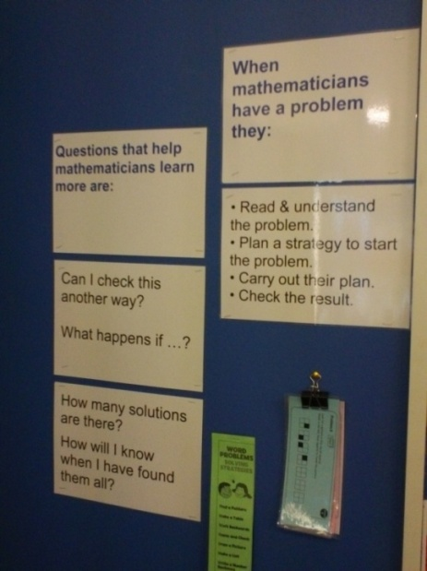

Examples of Maths Walls and Learning Journeys of students’ work



Two forms of intervention occurred at the school. The first was the Numeracy Intervention Program based on the Reading Recovery model of intervention in which students are targeted from all collective data as well as teachers’ observations. Students participate in a 12 to 13 week program involving one-on-one, 30 minute sessions, four times a week with a trained intervention teacher. The purpose is to scaffold the learner through any missed concepts and the Big Ideas/Threshold Concepts in numeracy. The second form of intervention was in small groups. The CMIT Coordinator either conducted small group intervention in withdrawal groups from class for approximately one term, or alternatively, the targeted small group work was in the classroom with the classroom teacher. The choice of intervention was based on the students’ needs and classroom dynamics.

The outcomes of this whole school approach to reform and intervention has been positive. Teachers have embraced the changes, recognising the need for whole school agreed practices and the analysis of data to target and track students, particularly those at risk. They also understand the need to differentiate the curriculum so that higher achieving students are provided with challenges and opportunities from which they also may grow and learn. The changes in the programming proforma and the inquiry/problem solving approach have allowed for both of these things to occur. Teachers are enthusiastic and have willingly adopted the suggested resources and approaches. After one programming session the Principal commented that the staff were ‘buzzing’ about the planning activities and enthused about mathematics again. While the school still has to fully embed these changes into everyday practice, the beginning of the whole staff approach to numeracy has gained momentum. Mathematics is no longer seen as a difficult subject in which to engage the students and teachers’ confidence to provide high calibre, differentiated curriculum and activities has improved.

Student engagement is higher and their metacognitive skills regarding their learning are improving. The leadership team has identified early numeracy development in the K-2 area as an area requiring greater support and further assistance and support is being provided for K-2 teachers. Peer mentoring and modelling will begin in this focus area in Terms 3 and 4 of 2012.

Students engaged in challenging and higher order thinking maths tasks in a cooperative learning environment.

Results of 2012 NAPLAN testing show some pleasing gains for the school in year 5 numeracy. Table 3.7 shows a significant increase in the school mean score, which is now similar to the state mean score. Table 3.8 shows a significant increase in the percentage of year 5 students at or above the national minimum standard.
Table 3.7: NAPLAN mean scale scores in year 5 numeracy 2011-2012 for Saint Francis of Assisi, Calwell School and nationally
 | 2011 | 2012
National  School | 488  477 | 488.4 ↑  492 ↑

Table 3.8: NAPLAN proportion of students at or above the national minimum standard in year 5 numeracy 2011-2012 for Saint Francis of Assisi, Calwell and nationally (%)
 | 2011 | 2012
National  School | 94  89 | 93.4 ↓  97 ↑

Table 3.9 shows significant improvement in the percentage of students in the all three upper bands (6,7,8) and a corresponding decrease in the three lower bands (3,4,5) in numeracy.
Table 3.9: Proportion of Saint Francis of Assisi, Calwell year 5 students in each achievement band in numeracy 2011-2012 (%)
Band | 2011 | 2012
8  7  6  5  4  3  2 | 10%  8.3%  31.7%  28.3%  11.7%  10% | 13.8% ↑  10.3% ↑  34.5% ↑  27.6 % ↓  13.9% ↓  0% ↓
Improved outcomes of students at Saint Francis of Assisi, Calwell are also reflected in the following excerpts from the SMART data School Measurement Assessment and Reporting toolkit:
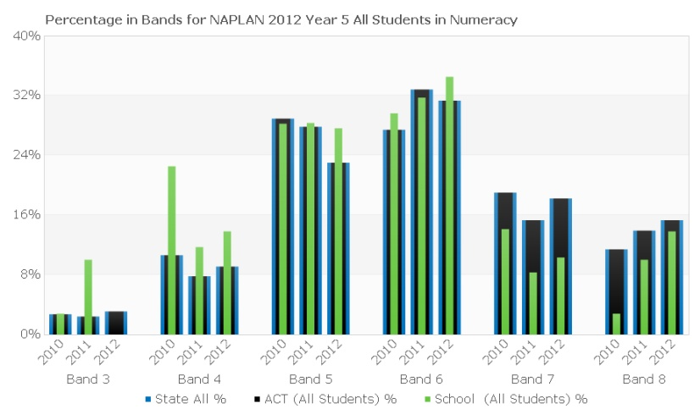

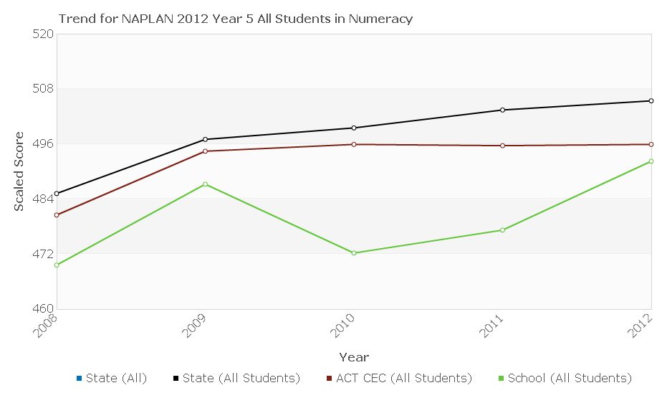

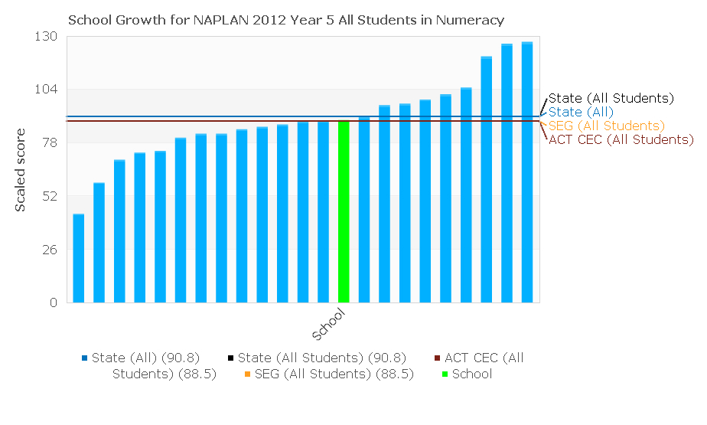

Literacy – Exemplary Schools

At Saint Michael’s Primary, Kaleen, Saint Thomas Aquinas, West Belconnen and Saint Matthew’s Primary, Page, Literacy Block timetabling decisions were mandated and whole school Agreed Practice in the teaching of reading using implementation of the First Steps Reading approach and the GRR model continued to be implemented and tracked. Professional development in teaching reading was ongoing, where the First Steps Reading pedagogical approach was supported through programming and planning workshops and a teacher mentor program. This approach commenced at Saint John the Apostle, Florey, in 2012.

Saint Clare’s of Assisi, Conder, Saint Francis of Assisi, Calwell and Saint John the Apostle, Florey all began training Reading Recovery teachers and implementing intensive Reading Recovery programs.

At Saint Michael’s Primary, Kaleen, Saint Thomas Aquinas, West Belconnen, Saint Matthew’s Primary, Page and Saint John the Apostle, Florey, professional learning in teaching reading, using the First Steps Reading approach and the GRR model, was run in parallel with the Reading Recovery teacher program. This provided staff with a sustained and in depth focus on the teaching of reading at a whole class, small group and individual level across the school.

The positive impact of this reform is evident in the increased levels of student achievement across the NP schools and for students below reading benchmarks in year one and increasing reading achievements by years two and three.

Students below reading benchmarks at the end of Kindergarten, (i.e. below level 8), were targeted for the intensive Reading Recovery program in order to raise their reading levels to Archdiocesan benchmarks of reading levels 15-17 by the end of year one, and reading level 24 by the end of year two. This was achieved through the Reading Recovery program and a whole school focus on timetabling, planning and pedagogical approaches in literacy blocks. In 2012, all Round 1 schools maintained their Reading Recovery programs which had begun in 2009. Significant progress was evident via tracking of reading levels of discontinued students at these schools. Although only partial quantitative data is currently available for Reward NP Phase 1 schools, the sample data and Reading Recovery teacher qualitative feedback indicate similar trends emerging in those schools that commenced NP activity in 2011.

NAPLAN analysis of School Measurement, Assessment and Reporting Toolkit (SMART) data for reading in 2012 indicate school improvement trends across Round 1 schools in moving students to higher performance bands and increasing school growth in reading performance over time.

Progress in Round 1 schools
The following information provides an overview of each of the Round 1 schools and their progress reflected by SMART Data analysis of 2012 NAPLAN data. Improving school literacy, specifically in reading, has been an area of focus for these schools since 2009.
Saint Mathew’s Primary, Page
This school, located in Belconnen, has a student enrolment of 336 students including 6 Aboriginal and Torres Strait Islander students. It is a two stream school with 19 classroom teachers and four school executives.
The percentage of year 3 students in Bands 4 and 5 exceeded ACT averages, while the percentage of year 5 students in Band 6 exceeded the ACT average. For year 5 students, there has been a significant increase in student representation in the top band from 2010 for both 2011 and 2012. There has also been decreased representation in the two lowest bands. For year 3 students, there has been an increasing representation in Bands 4 and 5 since 2010.
The school performance trend was slightly above the ACT Catholic sector average for year 3 students in 2012, and for year 5 students, the school performance trend was above both the ACT Catholic and ACT average.
Student growth was good, particularly in the lowest and middle bands. For 7% of students, there was double the predicted growth, with students moving from year 3 Bands 3-4 to year 5 Bands of 7-8.
Table 3.10 shows progress in reading recovery for students of Saint Matthew’s primary, Page.
Table 3.10: Progress in Reading Recovery at Saint Matthews’s Primary Page, by student
 | Discontinued reading recovery level | End year 1 | End year 2 | Current year 3
Student 1 | 17 | 20 | 29 | 30
Student 2 | 16 | 19 | 28 | 29
Student 3 | 17 | 19 | 27 | 30
Student 4 | 19 | 23 | 29 | 30
Student 5 | 17 | 18 | 26 | 25
 | Discontinued reading recovery level | End year 1 | Current year 2
Student 6 | 16 | 18 | 22
Student 7 | 16 | 20 | 24
Student 8 | 15 | 19 | 21
Student 9 | 18 | 19 | 23
Student 10 | 22 | 22 | 24
Student 11 | 22 | 22 | 20
Saint Thomas Aquinas Primary, West Belconnen
This school is located in the most western aspect of Belconnen and has a school enrolment of 226 students, including nine Aboriginal and Torres Strait islander students. The school has 13 classroom teachers and 3 school executives. There are two kindergartens, one year 1 class, one year 1/2 class, one year 2 class, and two year 3/4 and year 5/6 classes.
A school highlight was that 100% of year 5 students have improved by 64 scale scores in 2012 compared to the 2011 in the NAPLAN test aspect of reading. No year 3 students were at or below benchmark and 5% were at or below benchmark for year 5.There was a significant decrease in year 5 student representation in the two lowest bands coupled with increasing representation in the top 3 bands since 2010.
There has been an upward trend in year 5 student performance. In 2009, the school was 55.7 scale scores below the ACT average. In 2010, the school was 28.8 scale scores below the ACT average. In 2011, the school was 63.1 scale scores below the ACT average and by 2012 performed above ACT Catholic and only 1.6 scale scores below ACT average. These results indicate significant improvement over time in reading for year 5 students. The school has recognised the need to continue to focus on year 3 performance, particularly for boys.
Table 3.11 shows progress in reading recovery for students of Saint Thomas Aquinas, West Belconnen.
Table 3.11: Progress in Reading Recovery at Saint Thomas Aquinas West Belconnen, by student
 | Discontinued reading level | End year 1 | End year 2 | Current year 3
Student 1 | 16 | 22 | 25 | 25
Student 2 | 15 | 21 | 25 | 25
Student 3 | 18 | 22 | 25 | 26
Student 4 | 15 | 19 | 24 | 26
Student 5 | 22 | 22 | 27 | 28
Student 6 | 21 | 21 | 25 | 27
Student 7 | 19 | 19 | 25 | 25
Student 8 | 19 | 19 | 24 | 24
 | Discontinued reading level | End year 1 | Current year 2
Student 9 | 19 | 21 | 22
Student 10 | 18 | 21 | 23
Student 11 | 21 | 21 | 24
Student 12 | 25 | 24 | 25
Student 13 | 20 | 20 | 21
Student 14 | 20 | 20 | 22

Saint Michael’s Primary, Kaleen
This school is located in Northern Belconnen and has a school enrolment of 222 students, including 6 Aboriginal and Torres Strait Islander Students. There are 11 classroom teachers and three school executives. The school has two kindergarten classes, two year 1/2 classes, two year 3/4 classes and single stream year 3, 4, 5 and 6 classes.
There has been a significant increase in year 5 students’ representation in Band 7 over the last two years, while the percentage of students in the top two bands has shown growth since 2010.
The school trend in reading for year 5 performance exceeds the ACT average and school growth is consistent with the ACT average. There were no year 3 students at or below benchmark and 3% of year 5 students were at or below benchmark.
Table 3.12 shows progress in reading recovery for students of Saint Michael’s Primary, Kaleen.
Table 3.12: Progress in Reading Recovery at Saint Michael’s Primary, Kaleen, by student
 | June 2011 | June 2012
Student 1 | 7 | 25
Student 2 | 6 | 27
Student 3 | 3 | 20
Student 4 | 5 | 26
Student 5 | 3 | 23
Student 6 | 8 | 24
Student 7 | 13 | 25
Student 8 | 13 | 29
Student 9 | 5 | 26

Progress in Reward NP Phase 1 schools
Saint Clare’s of Assisi, Conder and Saint Francis of Assisi, Calwell are Reward NP Phase 1
2011 -2013 that have begun Reading Recovery this year. Saint Francis of Assisi, Calwell has a current enrolment of 485 students (2% Aboriginal and Torres Strait Islander students and 1% Language Background other than English). Saint Clare of Assisi Conder has a current enrolment of 686 students (2% Aboriginal and Torres Strait Islander students and no students with a Language Background other than English).
While limited data is available, the results in Table 3.13 indicate continuing levels of success in these schools, in line with the success of Round 1 schools in student reading achievement in the Reading Recovery program.

Table 3.13: Progress in Reading Recovery at Saint Clare’s of Assisi Conder and Saint Frances of Assisi, Calwell by student
Conder | Initial reading level – February 2012 | Reading level – August 2012
Student 1 | 0 | 16
Student 2 | 2 | 16
Student 3 | 1 | 12
Student 4 | 2 | 16
Calwell | Initial reading level | Reading level – August 2012
Student 1 | Below kindergarten benchmark | 17

Independent schools
Canberra Grammar School

Through the National Partnership the Primary School has focused on student improvement, particularly in literacy, by adopting a three -pronged approach:

- Professional learning
National Partnership funding allowed for all teachers to be trained in First Steps Writing and Reading. First Steps was used as the school’s primary literacy teaching resource and provides a common language for all staff when sharing ideas during collaborative planning. As First Steps has been of such success, the school is currently in the process of reviewing the possibilities to continue the growth in performance gains and student outcomes for 2013 and beyond.

2. Academic tracking
Canberra Grammar Primary School has established an Assessment and Reporting Schedule. As part of this schedule data is collected on all students from year 1 – year 6 in the areas of reading comprehension, spelling and mathematics. In addition, all students from year 3 to year 6 sit a vocabulary test. All kindergarten children participate in the PIPS testing.This data, along with other information including NAPLAN results and a variety of types of formative feedback, is analysed by the Enrichment Team and individual student performances are monitored and tracked.

3. Learning support
Based on the information collected, students were identified for additional support where necessary. This support may be provided through small withdrawal groups or ‘in class’ support.

In addition to regular groups, specific target groups have been established to target areas of relative weakness. In 2012, a new initiative, the Student Writing Assistance Team (SWAT) was introduced where all students from years 2 to year 5 have been involved in intensive writing blocks. Areas of focus for development were; oral language as a precursor to quality writing, an understanding of what a quality piece of writing looks like, building vocabulary and self analysis of errors and possible improvements, students have been encouraged to discuss and reflect on the writing process.

Spelling was also identified as an area of relative weakness and has been addressed by the establishment of a master spelling class. Identified students participated in intensive blocks lead by a spelling consultant.

Table 3.14 shows the school has maintained steady improvement across all domains. Improvements in NAPLAN performance observed in the cohort moving from year 3 to year 5 from 2009 to 2011 are evidenced in the table below.

Table 3.14: Average NAPLAN scores for reading, narrative writing, spelling, grammar & punctuation year 3 to year 5 cohort 2009 to 2011, Canberra Grammar School

 | Year 3  2009  mean | National mean | Score above national mean | Year 5  2011  mean | National mean | Score above national mean | Mean score gain | % change of score to national mean
Reading | 487 | 411 | 76 | 562 | 488 | 74 | -1 | -1.3
Writing | 443 | 414 | 29 | 534 | 483 | 51 | 22 | 75.8
Spelling | 433 | 405 | 28 | 525 | 484 | 41 | 13 | 46
Grammar | 474 | 420 | 54 | 588 | 499 | 89 | 35 | 64.8

Radford College

Radford College Junior School is completing its second year of a whole school approach to teaching spelling and grammar through an inquiry approach, using Barbara Brann’s Building Blocks to Literacy and Smart Words programs, locally named as Word Work.

Word Work is a sequential and developmental program aiming to give students the knowledge and strategies needed for competent spelling. The program is individualised and developmental in nature, allowing teachers to support all levels at students where they are currently at in their spelling and grammar development.

A Team Leader position was established in 2012 to allow further support the implementation of Word Work on the ground in classrooms. The Team Leader has worked within classrooms modelling inquiry approaches to teaching spelling and grammar with classroom teachers. This has seen an increased level of understanding of the program through ongoing reflection of best practice and use of differentiation strategies for students. The Team Leader also drives professional discussions regarding the practical implementation of the program at weekly planning meetings with teachers.

Increased engagement with the parent community has occurred through ongoing parent workshops and newsletter articles to enable a greater understanding and partnership with parents in their child’s spelling development. Recent Early Years Community Chats with parents from Pre-Kinder and Kindergarten were held to provide practical strategies for supporting the five domains of the Building Blocks program within the home.

An additional dimension of the success of implementation has been school growth nationally in its NAPLAN results from 2010 through to 2012 with the cohort that commenced the new Word Work approach to spelling and grammar. This cohort, now in year 5, has seen 40% of students improve over 100 base points in spelling and grammar NAPLAN results since year 3.

Another area of interest for Radford is that there is a significant gap in year 3 2012 NAPLAN results between the existing students that have been involved in the Word Work program from Year 1 and the intake students new to the cohort in year 3. With fifty percent of students new to the school in year 3 each year, this will continue to be an area of focus as students transition to from other local schools.

2012 year 3 NAPLAN results as a whole were well above the state, with Radford year 3 students achieving a mean of 499.3 in grammar compared to 439.9 in the ACT and 447.9 in spelling compared to 419.8 across ACT schools.

Teachers at Radford are also observing increased motivation and enjoyment in the students as they inquire into words and how they work, rather than the traditional methods of the past, using disconnected word lists and rote memorisation of lists of words.

Table 3.15: Year 3 and year 5 NAPLAN results, spelling, grammar and punctuation, Radford College

RADFORD  NAPLAN RESULTS | 2010  Year 3 |  | 2012  Year 5
RADFORD  NAPLAN RESULTS | Radford | ACT | Radford | ACT
Spelling | 454.7 | 410.3 | 542.3 | 499.7
Grammar and Punctuation | 475.0 | 435.0 | 596.8 | 512.9

Section 4 – Milestones Improving Teacher Quality NP

Part 1 - Milestones not reported/not achieved/partially achieved in the 2011 Annual Report

Milestone (state and territories may wish to identify whether the milestone relates to all sectors or a particular sector within their jurisdiction) | Detail of achievement against milestone (Quantitative and Qualitative) | If not achieved or partially achieved, reasons why (Qualitative) | Strategies put in place to achieve milestone and updated timeframe (Quantitative and Qualitative)

Workforce data collection tool contributing data to national data sets | Phase 1 remediation work has been successfully undertaken and phase 2 is being re-scoped. | Evolving revisions to school staffing HR and finance practices and models, and the embedding of these, in the context of the phased implementation of the Empowering ACT Schools initiative has necessitated a review of the ETD SiMS project. Actions in ETD are dependent upon development of a principal portal being set up in relation to ACT Empowering Schools. |  | SiMS reference group to be reconvened.  Re-scoping of SiMS Phase 2 by end 2012 and implementation in 2013.  ACT CEO sent data through to the national workforce data set project in September.
Part 2 - Milestones in Progress Report - (Achieved 1 January to 30 June 2012)
Milestone | Detail of achievement against milestone (Quantitative and Qualitative) | If not achieved or partially achieved, reasons why (Qualitative) |  | Strategies put in place to achieve milestone and updated timeframe (Quantitative and Qualitative)
Accomplished and Leading Teachers placed in schools, including School Centres of Teacher Education Excellence | The INSPIRE centre, a joint venture between the University of Canberra and Education and Training Directorate, was officially opened in 2012 and has been staffed with 6 associates selected on specific criteria developed in reference to the standards. The INSPIRE centre is staffed with 1 x 1.0FTE and 6 x 0.2FTE personnel. | TQI has conducted a pilot in 2012 to assess volunteer teachers for certification as accomplished or lead teacher status. The implementation of national certification of teachers will not officially commence until 2013.  As a result of the Education and Training Directorate Enterprise Agreement 2011- 2014 Executive Teacher (Professional Practice) positions have been created as a method for recruiting exemplary classroom teachers to lead best practice. |  | The ACT will commence certification of Highly Accomplished and Lead Teachers in 2013.  Placement of teachers who achieve certification can be suitably placed once this process has been completed.  Once approval of the Executive Teacher (Professional Practice) guidelines has been received selection processes and recruitment can commence in 2013.
Part 3 - Milestones that will progress through the 2012 calendar year (with no set milestone date)
Milestone | Detail of achievement against milestone  (Quantitative and Qualitative) |  | Strategies put in place to achieve milestone and updated timeframe (Quantitative and Qualitative)
Develop and implement professional learning programs aligned to the National Professional Framework and Standards (XS). | All Directorate based professional learning is aligned to the NPS through the use of a scoping template. |  | The use of this template is ongoing and evolving. The Professional Learning team is investigating methods to ensure the template is used effectively and that communication about connections between professional learning and the standards is clearly articulated.
Program cross sectoral Principal Forums aligned to Improving Teacher Quality and School Leadership agendas each semester. | A cross-sectoral Principal Forum was held on 14 June 2012 (Semester 1) hosted by TQI and focussed on recognising and promoting teacher quality. A second forum again hosted by TQI is scheduled for 22 November 2012 (Semester 2) focussed on the Continuing Professional Learning Framework and Teacher Portal. |  | These forums are ongoing. Schedules have been devised and working parties established to ensure the agendas are relevant and timely.
Participate in development of national longitudinal Teacher Workforce Study (XS). | The TQI business system has enabled cross sectoral data to be collected for the first time.  Representatives from TQI, ETD and CEO continue to contribute to the National Teacher Workforce Dataset via a sub-committee of which they are representatives. |  | Within the ACT CEO, ETD and TQI have or are in the process of submitting data (October) to the National Teacher Workforce Dataset.  ETD’s Human Resources branch is currently devising a data strategy and undertaking planning to support the continuation of this work.  It is anticipated that this work will be complete by the end of 2012.

Section 4 – Milestones Low SES School Communities NP

Part 1 - Milestones not reported/not achieved/partially achieved in 2011 Annual Report
Milestone (state and territories may wish to identify whether the milestone relates to all sectors or a particular sector within their jurisdiction) | Detail of achievement against milestone (Quantitative and Qualitative) | If not achieved or partially achieved, reasons why (Qualitative) |  | Strategies put in place to achieve milestone and updated timeframe (Quantitative and Qualitative)
Schools reached their school-based literacy and numeracy targets for 2010  (due 31 Mar 2011). | 2010 achievement  While not all targets were met, schools generally made improvement against measures.  Eight out of 24 school-based targets were fully achieved. | 2010  While not all targets were met, schools generally showed good growth from years 3 to 5 compared to the system average.  As Field Officers were not in their schools for very long before NAPLAN testing took place the efficacy of this strategy could not be measured against 2010 NAPLAN results with any reasonable validity.  In some of these schools issues of student engagement, disadvantage and initial deficit have to be addressed before quantifiable improvement in test results could be expected.
   | Year 3 |  | Year 5
  Charnwood Dunlop | Target | Actual | Target | Actual
  Reading | 403 | 384 | 476 | 456
  Writing | NA | 396 | 474 | 455
  Numeracy | 400 | 378 | 450 | 471
   | Year 3 |  | Year 5
  Kingsford Smith | Target | Actual | Target | Actual
  Reading | 397 | 395 | 490 | 491
  Writing | NA | 418 | 477 | 488
  Numeracy | 395 | 370 | 474 | 469
   | Year 3 |  | Year 5
  Florey | Target | Actual | Target | Actual
  Reading | 395 | 400 | 491 | 498
  Writing | NA | 403 | 496 | 486
  Numeracy | 393 | 395 | 469 | 499
   | Year 3 |  | Year 5
  Richardson | Target | Actual | Target | Actual
  Reading | 354 | 364 | 450 | 443
  Writing | NA | 349 | 459 | 441
  Numeracy | 358 | 334 | 458 | 445
   | System growth  (Mean scale scores) | School growth  (Mean scale scores)
  Reading | 88 | CDunlop 98  Richardson 102  Florey 104
  Writing | 71 | KSSmith 83  Richardson 92  CDunlop 94
  Numeracy | 85 | CDunlop 110  Richardson 112  Florey 120
Part 2 - Milestones in Progress Report - (Achieved 1 January to 30 June 2012)
Milestone | Detail of achievement against milestone (Quantitative and Qualitative) | If not achieved or partially achieved, reasons why (Qualitative) |  | Strategies put in place to achieve milestone and updated timeframe (Quantitative and Qualitative)
Acceptance of March 2011 Annual Report for the 2011 calendar year (due 31 march 2012)  Schools have reached their school-based literacy and numeracy targets for 2011  School plans have been reviewed and updated (due 31 March 2012). | Accepted  2011 Achievement  Achievement in 2011 NAPLAN against school targets.  School achievement against 2011 targets show significant improvement compared to 2010 results. Only 2 targets indicated in red were not met. The green shows achievement above the target range.  All school plans have been reviewed and updated. | 2011  Significant improvement is evident in the 2011 NAPLAN data. Only 2 of the 24 targets were not met. 22 school means were within the target range and 2 were significantly above.  This is an improvement on the 2010 results. |  | 2011  - All schools are working on improving their student performance.  - Embedding of system endorsed literacy and numeracy programs is continuing.  - Field officers are continuing in their schools and working with teachers to improve classroom practices.  Schools have developed 2012 plans for improvement.  New targets have been set for 2012.
  School Name | Year Level | Domain | Target | School Mean
  Charnwood Dunlop | 3 | Reading | 398 ± 30 | 382.2
  Charnwood Dunlop | 3 | Writing | 397 ± 20 | 382.3
  Charnwood Dunlop | 3 | Numeracy | 377 ± 24 | 369.9
  Charnwood Dunlop | 5 | Reading | 478 ± 24 | 501.3
  Charnwood Dunlop | 5 | Writing | 467 ± 18 | 489.3
  Charnwood Dunlop | 5 | Numeracy | 464 ± 20 | 482.5
  Richardson | 3 | Reading | 356 ± 34 | 334.6
  Richardson | 3 | Writing | 366 ± 28 | 316.2
  Richardson | 3 | Numeracy | 369 ± 26 | 318.7
  Richardson | 5 | Reading | 459 ± 26 | 473.0
  Richardson | 5 | Writing | 449 ± 22 | 434.9
  Richardson | 5 | Numeracy | 457 ± 20 | 461.7
  Florey | 3 | Reading | 410 ± 24 | 417.5
  Florey | 3 | Writing | 418 ± 20 | 417.9
  Florey | 3 | Numeracy | 391 ± 22 | 407.4
  Florey | 5 | Reading | 502 ± 20 | 489.7
  Florey | 5 | Writing | 493 ± 20 | 489.1
  Florey | 5 | Numeracy | 494 ± 20 | 490.0
  Kingsford Smith | 3 | Reading | 392 ± 20 | 418.7
  Kingsford Smith | 3 | Writing | 401 ± 17 | 406.7
  Kingsford Smith | 3 | Numeracy | 369 ± 20 | 378.2
  Kingsford Smith | 5 | Reading | 477 ± 18 | 467.3
  Kingsford Smith | 5 | Writing | 463 ± 20 | 474.2
  Kingsford Smith | 5 | Numeracy | 469 ± 16 | 464
Part 3 - Milestones that will progress through the 2012 calendar year (with no set milestone date)
Milestone | Detail of achievement against milestone  (Quantitative and Qualitative) |  | Strategies put in place to achieve milestone and updated timeframe (Quantitative and Qualitative)
NA

Section 4 – Milestones Literacy and Numeracy NP

Part 1 - Milestones not reported/not achieved/partially achieved in 2011 Annual Report
Milestone (state and territories may wish to identify whether the milestone relates to all sectors or a particular sector within their jurisdiction) | Detail of achievement against milestone (Quantitative and Qualitative) | If not achieved or partially achieved, reasons why (Qualitative) |  | Strategies put in place to achieve milestone and updated timeframe (Quantitative and Qualitative)
NA
Part 2 - Milestones in Progress Report - (Achieved 1 January to 30 June 2012)
Milestone | Detail of achievement against milestone (Quantitative and Qualitative) | If not achieved or partially achieved, reasons why (Qualitative) |  | Strategies put in place to achieve milestone and updated timeframe (Quantitative and Qualitative)
NA
Part 3 - Milestones that will progress through the 2012 calendar year (with no set milestone date)
Milestone | Detail of achievement against milestone  (Quantitative and Qualitative) |  | Strategies put in place to achieve milestone and updated timeframe (Quantitative and Qualitative)
NA

