

Smarter Schools National Partnerships

Improving Teacher Quality

Low Socio-Economic Status School Communities

Literacy and Numeracy

Australian Capital Territory

Annual Report for 2012

(due 30 April 2013)

Section 1 | Smarter Schools National Partnership – Impact
Section 2 | Improving Teacher Quality
Section 3 | Low Socio-economic Status School Communities
Section 4 | Literacy and Numeracy
Section 5 | Research and Evaluation
Section 6 | Co-investment Report
Section 7 | Milestone Report
Section 8 | Low SES School Communities - Performance Indicators for Identified Cohorts (separate Excel document)
Section 9 | Low SES School Communities - State Performance Measures

Section 1 – Smarter Schools National Partnerships – Impact (2-4 pages)

Improving Teacher Quality National Partnership
Teach for Australia
The ACT joined Teach for Australia in its second year of operation nationally. Teach for Australia is an independent, not for profit organisation working to confront educational disadvantage in Australia. The organisation attracts some of our country’s most outstanding individuals and empowers them to pursue teaching as part of their career journey. Three cohorts of teachers have begun in ACT schools with two of those cohorts still involved in the two year program. The Teacher Quality Institute maintains interest in the program and is involved in processing the teacher registration of Associates allowing them to teach in our schools.

Teach Next
The Teach Next initiative provides a new employment based pathway into teaching for highly skilled and experienced professionals who are seeking a career change. The initiative aims to attract professionals who hold a tertiary qualification in fields of teacher shortage such as mathematics, science and languages. The ACT expressed an interest in participating in the first cohort of the Teach Next program. The first cohort, following an initial intensive training program, commenced placement in schools in the second semester of 2012.

Teacher Quality Institute
The ACT has focussed on an integrated approach to the improvement of teacher quality through the use of the National Professional Standards. The ACT, through the Teacher Quality Institute, has led the national trialling of the National Professional Standards for Teachers through a number of projects undertaken with ACT schools, universities and AITSL. The implementation of the Standards is supported through regular workshops and forums for ACT teachers and the development of resources which are available on the Teacher Quality Institute’s Teacher Portal.
School Centres of Excellence
Down South
The Down South initiative is a partnership between St Mary MacKillop and the Australian Catholic University. The initiative is based on an immersion model and involves pre-service teachers in the Graduate Diploma of Education (Secondary) completing their studies while working within the school.
University of Canberra Clinical Practice program
The University of Canberra Clinical Practice program selects high performing classroom teachers from ACT Government schools to work with pre-service teachers during their pre-service teacher education program. The program better prepares teachers for entrance into the teaching profession. In 2012 the university advertised for further clinical teaching specialists to expand the program. These teachers enable greater opportunities for schools and the university to work in partnership around Teacher Education programs.
INSPIRE Centre
The INSPIRE Centre is a partnership between the ACT Education and Training Directorate (ETD) and the University of Canberra. The Centre facilitates a range of information and communication technology (ICT) related projects focusing on contemporary teaching practice and research into new and emerging technologies.
Low SES School Communities National Partnership
Incentives for attracting and retaining high quality principals and teachers
The ACT implemented a range of strategies and incentives to support high quality teachers and principals at both a systemic level and at the four schools participating in the Low SES School Communities National Partnership.
Strategies and incentives included:
- School Network Leaders continuing to prioritise principal collaboration
- a principal mentor program that provided support to new principals throughout their first 12 months
- a Principal Induction Program that was attended by 64 participants
- a revised School Leadership Strategy that was implemented in 2012 to align with the National Professional Standard for Principals
- a Principal Fellowship and Scholarships program
- seven information sessions delivered jointly by the Teacher Quality Institute (TQI), University of Canberra and the Australian Catholic University on the National Professional Standards for Teachers. The sessions were delivered to enhance teacher reflection, professional conversations and feedback to pre-service teachers. Over 500 teachers attended.
- implementation tools jointly developed by ACT schools, universities and the TQI to assist provisionally registered teachers to understand evidence requirements to enable them to move from proficient level standard to gain full registration
- the teacher certification pilot for Highly Accomplished and Lead Teachers implemented by the TQI in June 2012
- the teacher mentor five day cross sectoral program that was developed by the TQI
- the creation of Executive Teacher Professional Practice positions to provide an alternate career opportunity for teachers with a focus on exemplary teaching and capacity building in teaching practice
- the Teacher Professional Learning Fund provided schools with an additional $167.00 per teacher for professional learning in 2012
- $180,000 allocated to fund 43 Teacher Scholarships to support further training, education or research
- the Cross-sectoral Smarter Schools National Partnership Showcase held in
April 2012. The Showcase attracted over 230 educators from across the ACT to interact with NP school staff about their school programs, strategies for change and successes.
School community links – Canberra Institute of Technology Skills for Life Program for parents
The Skills for Life Program offered language, literacy and numeracy and information communication and technology (ICT) skills to parents and full time carers of children who attend one of the four Low SES Schools – Kingsford Smith School, Charnwood Dunlop, Florey and Richardson Primary Schools. The main goal of the program was to give participants the confidence to pursue further learning.
The program operated for 10 weeks during school hours and was free to participants. The delivery of this program was to a group, however individual aspects were tailored to suit each participant’s needs. Each participant was expected to complete tasks that had been negotiated with the teacher.

Fourteen parents drawn from Kingsford Smith School and Richardson Primary School attended the program and all provided positive feedback, with a number using this as a springboard to work or further study. Both programs ran during term 2.
The Canberra Institute of Technology (CIT) received a $10,000 Adult Community Education Grant that funded one program for 10 weeks for 2 ½ hours per week. The Low SES National Partnership matched this funding to enable the CIT to run a second program.
Literacy Numeracy National Partnership
Public Schools
Coaching as a strategy for improvement
In the ACT, Literacy and Numeracy Field Officers coach, model and work collaboratively with teachers to improve teaching practices. The field officers work at the classroom level and as part of the school leadership team to plan whole school literacy and numeracy approach based on evidence and data. Literacy and Numeracy National Partnership (LNNP) schools with field officers have shown greater improvement than non-LNNP schools as detailed in Table 1.1 below.

Table 1.1: Comparison of NAPLAN performance for students in ACT LNNP schools compared with students in non-LNNP schools - 2008 to 2012.
Domain | Year level | Partnership status | 2008 NAPLAN | 2012 NAPLAN | Difference 2008 to 2012
Reading | 3 | LNNP | 405.5 | 440.3 | 34.8
Reading | 3 | non-LNNP | 425.8 | 446.8 | 21
Reading | 5 | LNNP | 496.3 | 516.6 | 20.3
Reading | 5 | non-LNNP | 506.4 | 520.9 | 14.5
Numeracy | 3 | LNNP | 399.7 | 409.4 | 9.7
Numeracy | 3 | non-LNNP | 416.3 | 411.6 | -4.7
Numeracy | 5 | LNNP | 480.4 | 505.9 | 25.5
Numeracy | 5 | non-LNNP | 487.3 | 505.2 | 17.9

Catholic systemic schools
Gradual Release of Responsibility
A significant achievement in Catholic systemic schools is that all schools across the system are now using the research based pedagogical model of the Gradual Release of Responsibility Model (GRRM) in reading. This approach involves explicit teaching, targeted assessment to inform teaching and learning, scaffolding reading knowledge and skills through the teaching procedures of modelled, shared, guided and applied lessons, and differentiating teaching instruction. This model has been scaffolded explicitly in the National Partnership schools.

First Steps is a core resource used by all SSNP schools to support teachers in pedagogical method, informing programming, assessment, class teaching, home reading and student intervention approaches. (Refer to Annandale, K. et al, (2004) First Steps Reading Map of Development, 2nd Ed., Steps Professional Development. Melbourne: Rigby HeinemannAnnandale, K. et al, (2004) First Steps Reading Resource Book, 2nd Ed., Steps Professional Development. Melbourne: Rigby Heinemann and Annandale, K. et al, (2004) First Steps Linking Assessment, Teaching and Learning, Steps Professional Development. Melbourne: Rigby Heinemann).
The GRRM involves explicit teacher demonstrations of elements of the reading process, the information process, reading context, conventions, comprehension and word identification strategies. The teacher then creates reading scaffolds to support student learning in each area of focus.
Independent schools
Learning Support at Canberra Grammar School
In addition to regular support, groups of identified students have been established to target areas of weakness in short block intensive sessions. In 2012 a new initiative, the Student Writing Assistance Team (SWAT), was introduced involving all students from years two to five in intensive Writing blocks. Focusing on developing oral language as a precursor to quality writing, an understanding of what a quality piece of writing looks like, building vocabulary, self-analysis of errors and possible improvements, students have been encouraged to discuss and reflect on the writing process.

Following analysis of the school’s literacy results the Master Spelling Class strategy has been developed to address phonemic awareness and graphemes of written English. Identified students participated in intensive blocks led by a spelling consultant. The consultant used THRaSS (Teaching Handwriting Reading and Spelling Skills) a phonics teaching tool based on a phonographic and a multi-sensory approach. The groups focused on the structure of English, language acquisition and linguistic correctness. This resource and the associated professional learning is a regular inclusion in the Canberra Grammar Primary School Professional Learning plan.

Section 2 – Improving Teacher Quality
2012 Significant Achievements/ Highlights – 1 January to 31 December 2012
A significant achievement for 2012 under the National Partnership has been the development and delivery of a teacher mentor program. The ACT school sectors contracted the Education Institute of the University of Canberra (UC), in collaboration with the Australian Catholic University (ACU) and ACT Teacher Quality Institute (TQI), to develop and deliver a teacher mentor program which articulates into a Masters program at either of the two universities involved. During 2012 a total of 295 teachers from across all ACT schools participated in the program. The Education Institute has conducted a research evaluation on the initial stage of the program.
Participants of the teacher mentor program were invited to complete pre- and post-workshop evaluations by responding to a series of six questions to determine whether the workshop value-added to teachers’ understandings, abilities, knowledge and confidence. The responses demonstrated that post-workshop, value was added across all six areas, indicating highly successful workshops.
Another significant achievement in this reporting period has been the widespread engagement of ACT teachers from all sectors with the National Professional Standards for Teachers (the Standards). This work, led by the TQI, has focussed on an integrated approach to the use of the Standards to support teacher quality. It has been characterised by engagement with the profession across all ACT school sectors and close collaboration with ACT universities and the Australian Institute of Teaching and School Leadership (AITSL). Key achievements include:
- the development of an integrated process to align beginning teacher assessment for provisionally registered teachers in one process to satisfy both employer and regulatory purposes. This process applies to teachers from ACT Catholic, independent and public schools and incorporates the AITSL Evidence Guide for assessment against the proficient level standards.
- co-presentation by the TQI, UC and ACU of a series of 10 cross-sectoral workshops on the use of the Standards to support teacher reflection, professional conversations and feedback to over 900 teachers during 2012
- the national pilot of certification against the Highly Accomplished and Lead Standards managed by the TQI in conjunction with AITSL and the National Research Centre of Science ICT and Mathematics Education (SiMMER). This pilot involved teachers from 40 ACT schools and has significantly guided the development of processes and resources for the implementation of nationally consistent certification.
Other significant outcomes from the National Partnership continue to include:
- the alignment of leadership capability frameworks and leadership development programs with the National Professional Standard for Principals by both public and Catholic sectors
- the inclusion of additional classroom classifications in enterprise agreements, designed to keep the best classroom teachers working in classrooms, in enterprise agreements will improve teacher quality and student outcomes.
- Professional Practice positions have been agreed and positions created in twenty one schools. This involved thirty applicants and nine placements.

Support for Aboriginal and Torres Strait Islander Students – 1 January to 31 December 2012
An Aboriginal and Torres Strait Islander Student Scholarship Program has been established as part of the ACT Aboriginal and Torres Strait Islander Education Strategy 2010-2013. This scholarship program provides students with access to mentoring and opportunities to develop leadership skills in order to make an informed career decision regarding teaching. Scholarships of $5000 per year will be available for students to apply for during year 10. They are targeted at those who wish to pursue a career in teaching and who are enrolled in a tertiary package. During the reporting period, information about the scholarship program was communicated to schools, students and families as well as principals and contact teachers for Aboriginal and Torres Strait Islander students. Two scholarships were awarded to students in 2012 to commence in 2013.
In addition, scholarships of $10, 000 per semester are awarded to support Aboriginal and Torres Strait Islander students enrolled in pre-service teacher education programs at local universities. The scholarship program continues in 2013.

Support for Other Disadvantaged Student Cohorts (if applicable) – 1 January to 31 December 2012
As stated in the 2011 Annual report, reform initiatives under the Improving Teacher Quality National Partnership (TQNP) are about improving teacher quality as a whole and are not targeted at specific student cohorts. There are no milestone activities under the TQNP that reference or require targeted actions for specific disadvantaged student cohorts. The focus under the TQNP is teacher quality and activities that will develop and improve all teachers not just those teaching a particular student group.
Progress against TQNP Facilitation Reforms – 1 January to 31 December 2012
National Professional Standards for Teachers
The ACT has focussed on an integrated approach to the improvement of teacher quality through the use of the Standards. Through the TQI the ACT has led the national trialling of the Standards through a number of projects undertaken with ACT schools, universities and the Australian Institute for Teaching and School Leadership (AITSL). This work focused on the use of the Standards across the career stages of graduate level, proficient and highly accomplished and lead level. The cross-sectoral implementation of Standards has been supported through regular workshops and forums for ACT teachers and the development of a range of resources for teachers which are published on the TQI Teacher Portal.
National Certification of Accomplished and Lead Teachers
The cross-sectoral pilot certification assessment program was conducted during the second half of 2012 using the AITSL developed certification process. The pilot attracted 35 applicants, 20 for assessment at the highly accomplished level and 15 for assessment at the lead teacher level. AITSL contracted the ACT Centre for Science, ICT and Mathematics Education for Rural and Regional Australia to work with the TQI and report on the pilot program.
Nationally Consistent Registration of Teachers
The ACT processes for teacher registration align with the requirements for nationally consistent teacher registration. In the reporting period the ACT trialled the AITSL Evidence Guide for Full Registration as part of the inaugural process for teacher registration renewal in March 2012.
National Accreditation of Pre-service Teacher Education Courses
The ACT has continued to engage in national planning for the implementation of national accreditation of pre-service teacher education courses. In the reporting period the TQI has participated on the first inter-jurisdictional panels for this process for the accreditation of teacher education courses at the ACU.
Professional Development and Support for Principals
The Education and Training Directorate (the Directorate) conducted a new principal induction program in 2012. This program consisted of modules on financial management, school planning (school improvement and data analysis), human resources, and governance and legal management. Enrolment numbers across the five courses (two workshops for human resources) were sixty-four attendees. Feedback indicated 92 percent of attendees rated the content and presentation of the workshops as very good or excellent.
The Institute of Executive Coaching and Leadership was engaged to deliver a coaching course for principals and deputy principals. The program involved a three day course followed by individual coaching conversations. Forty-nine participants attended at least one day of the course with twenty-three completing the three day program. One hundred percent of respondents rated the program as very good or excellent.
A program of cross-sectoral principal forums has been established to facilitate professional discussion on educational initiatives at both a national and jurisdictional level. These cross-sectoral forums, hosted by the TQI, occur each semester and involve principals from all public, Catholic and independent schools in the ACT.
The ACT Catholic sector completed its delivery of 360° Feedback and Development Centre to its principals who are at a specific point of their tenure. Each principal who participated in the 360° Feedback and Development Centre process was provided with detailed capability-based, performance-oriented feedback and a report which informed the principal’s individualised professional learning and development plan. The comprehensive report was developed by the supervising psychologist.

A cohort of Catholic sector principals were trained in the language of coaching. All principals who had completed at least two years in the role of principal could:
- elect to formally coach another principal if fully trained as a coach
- be coached by a fully trained coach
- engage in high level conversations with another principal trained in the language of coaching
- lead high level conversations with a Principal if trained in the language of coaching.
Improved Performance Management and Continuous Improvement in Schools
Improved performance management and continuous improvement in schools in the ACT has links to enterprise agreements for public and Catholic school teachers and varies from school to school in the independent sector.
Work completed during the reporting period involved planning for alignment of performance management processes to the National Professional Standards for Teachers and implementation of initiatives aimed to drive continuous improvement in schools. For the Directorate this involved implementation of the Annual Professional Discussion from January 2011. Catholic sector principals and assistant principals engaged in a series of workshops and information sessions focusing on the development of high performance cultures within schools. This professional learning was underpinned by the AITSL frameworks and standards, and highlighted the importance of school leadership in driving continuous improvement. Catholic sector system support documents were developed for use with school staff.
New Pathways into Teaching
The ACT Government sector joined the Teach for Australia (TfA) program during cohort 2 placing five associates for the start of the 2011 school year. A further six associates were placed in cohorts 2 and 3 in 2012 and 2013 respectively, bringing the total ACT intake to 17 over the past three years.
In-school mentors, provided with a time allowance, have also been appointed to facilitate the ongoing learning of the TfA associates over their two year practical experience in schools. The mentors have all participated in training through the Melbourne Graduate School of Education.
Since completing their teacher education qualification, three of the five associates from the initial ACT cohort are now qualified teachers choosing to continue their teaching career in their original school placements.
Better Pathways into Teaching
During 2012 the ACT was engaged in the development of the Teach Next program including the pre-tender processes for the program delivery during 2012. In mid 2012, three career change associates were selected and matched with participating Government schools through a comprehensive selection process as part of Intake 1. The six week intensive at Deakin University prepared the associates for the start of their school professional experience in Semester 2. In-school mentors also received training through Deakin University held in Perth.

Intake 2 resulted in a further five school placement offers with two applicants declining prior to starting the intensive. Following a successful intensive period the associates began the 2013 school year in their school placements. One of the associates withdrew from the program three weeks after the commencement of his placement for personal reasons. This brings the combined total from both intakes to five associates.
Improved Quality and Availability of Teacher Workforce Data
The ACT contributed data to the National Teacher Workforce Dataset in October 2012. Comprehensive qualification data was provided on all ACT teachers by the TQI and employment related data on public and Catholic school teachers was provided by the Education and Training Directorate and Catholic Education Office.
The ACT also participated in the Longitudinal Teacher Education Workforce Survey with ongoing communication about the survey provided to 769 provisionally registered teachers.
Aboriginal and Torres Strait Islander Education Workforce Pathways
An Aboriginal and Torres Strait Islander Student Scholarship Program has been established as part of the ACT Aboriginal and Torres Strait Islander Education Strategy 2010-2013. This scholarship program provides students with access to mentoring and opportunities to develop leadership skills in order to make an informed career decision regarding teaching. Scholarships of $5,000 per year are available for students to apply for during Year 10. They are targeted to those who wish to pursue a career in teaching and who are enrolled in a tertiary package. During the reporting period, information about the scholarship program was communicated to schools, students and families as well as principals and contact teachers for Aboriginal and Torres Strait Islander students. Two scholarships were awarded to students in 2012 to commence in 2013.
Scholarships of $10,000 per semester are also awarded to support Aboriginal and Torres Strait Islander students enrolled in pre-service teacher education programs at local universities. The scholarship program continues in 2013.
The Directorate has worked in partnership with the ACT Aboriginal and Torres Strait Islander Education Consultative Group and the Education and Training Aboriginal and Torres Strait Islander Staff Network to develop the Directorate’s Employment Strategy. The Strategy will seek to address attraction, retention and career development opportunities for Aboriginal and Torres Strait Islander staff. In addition, the Directorate has had representation on the “More Aboriginal and Torres Strait Islander Teachers in Schools” project for the last two years.
In partnership with the UC, the Directorate continues to support the Charles Perkins Scholarships. Two scholarships at $2,000 each per annum are offered to Aboriginal and Torres Strait Islander students enrolled full-time in an undergraduate degree at the UC. Each scholarship is awarded for the current calendar year. The value of any one scholarship will not exceed $2,000. Recipients may reapply in following years of study.
Quality Placements
In the reporting period, the ACT completed a collaborative project between the UC, the ACU and TQI to develop common pre-service reflection and assessment tools for use with students from the two universities. This work, aligning standards based expectations and reporting frameworks from both universities, builds on previous ACT standards pilot projects.
The ACT commenced a new project with AITSL in late 2012 to develop an online professional module for supervising teachers of pre-service teachers. This joint TQI/UC project is part of the national Initial Teacher Education Professional Experience Project and provides online resources and learning to support supervising teachers provide on-balanced assessment of pre-service teachers.
School Centres of Excellence
The ‘Down South’ initiative, a partnership between St Mary MacKillop and the ACU continued during 2012. The initiative is based on an immersion model and involves pre-service teachers in the Graduate Diploma of Education (Secondary) completing their studies while working within the school. This program is completed by the UC Clinical Practice program. High performing classroom teachers from ACT Government schools are selected to work with pre-service teachers during their pre-service teacher education program to help prepare the teachers for entrance in to the teaching profession.
The INSPIRE Centre is a partnership between the Directorate and the UC. The Centre facilitates a range of information and communication technology (ICT) related projects focusing on contemporary teaching practice and research into new and emerging technologies. Since commencing startup operations during early 2012 (launched 30 May 2012) the Centre has facilitated events involving staff, students and external stakeholders that feature the latest innovative practices and emerging trends for learning with and through ICT. Examples include:
- Microsoft Partners in Learning National Schools Forum involving 80 educators from 24 schools across all 8 jurisdictions in a 2-day leading learning conference
- ACT Student Congress involving 120 students from approximately 60 schools across ACT discussing issues impacting ACT students and providing an opportunity for student voice
- the Australian Principal's Association where over 120 principals from across Australia attended INSPIRE to discuss education futures and the latest research findings. The Centre also hosts INSPIRE Associates Program consists of 5 leading ACT teachers who work 0.2 to provide practical advice and leadership in digital practice and learning.
Progress towards meeting TQNP Reward Reforms
Through enterprise bargaining negotiations, agreement on accelerated progression processes for the classroom teacher salary scale was achieved covering 86 government schools. Furthermore, an assessment process and criteria for accelerated incremental progression has been developed for implementation in 2013.

In addition, seven of the 17 independent schools have the capacity to reward classroom teachers in additional allowances while progressing through the salary scale through enterprise agreements.

Following final Australian Education Union agreement with the introduction of new classroom leadership positions in late October 2012, Executive Teacher Professional Practice positions were identified in 21 government sector schools. An initial selection process was conducted during November and December 2012 to determine eligibility of applicants for placement in these new positions. Successful applicants will commence in the roles in 2013 and the program will be expanded to 40 positions by the end of 2013.
Increased school-based decision making
An additional seven government schools were identified to join with the eight partner schools from 2011 and the eight Empowering Local School National Partnership schools (a total of 23 schools) to work in the Empowering ACT public schools model. Following agreement through the Teachers’ Enterprise Agreement in April 2012 on a number of new and revised staffing processes, these schools trialed new approaches to casual teacher management, teacher transfer processes and teacher recruitment processes.

During 2012, these 23 schools also worked with a dollar based resource allocation and accessed regular budget information to better align the resource allocation with the needs of students.
Continual Improvement Program For All Teachers
Through funding provided for teacher scholarships and principal fellowship in the government school sector, a total of 42 targeted scholarships were awarded in 2012. Twenty five scholarships were for studies in the Early Childhood area to enable the government school sector to meet its obligations under the national requirements. A further 15 scholarships were provided for teachers to undertake additional study in areas of need and two fellowships were granted to two principals to attend school leadership development programs to improve leadership capabilities.

In 2012, 542 new educators and teachers new to the government sector, were provided with time release to attend school based induction and orientation programs and the centrally provided New Educator Support Program (NESP). NESP is a structured program of professional learning, held over three separate days in each school term. The government sector also provided a system induction day for teachers new to the Directorate.

In 2012 there were 38 first year teachers and 30 second year teachers employed in the Catholic sector. An early career teacher induction program was provided to all of these teachers. The program included a range of workshops including duty of care, professional responsibilities and professional standards. This is also supported by the Early Career Teacher and Mentor training initiative which pairs experienced teacher mentors with a new educator. Mentor Training Days are provided to assist mentors in the use of the National Professional Standards.

Indigenous Teachers and Leaders Engagement With Community Members
By the end of 2012, 34 of the 130 government and non government schools had developed and were implementing a Reconciliation Action Plan (RAP) or partnership agreement with their communities. A further 11 schools with a high Aboriginal and Torres Strait Islander student enrolment will negotiate RAPs with their communities in 2013.

A formal network of the 31 focus government primary schools was formed in 2012. The Network met once a term to participate in professional learning programs. In addition, 12 schools engaged in an action inquiry program forming networks engaged in ongoing professional learning. Additional professional learning was provided to individual schools relative to their context.

Professional learning in the Catholic sector for 2012 included implementing and writing Personalised Learning Plans (PLPs) for Aboriginal and Torres Strait Islander students. Twenty four schools were involved. In addition, 18 schools were involved in professional learning which included Aboriginal Perspective in Science programs through the Primary Connections resource.
During 2012, 98 principals and deputy principals from across the government and Catholic school sectors participated in cultural competence/awareness programs. The Catholic sector’s Aboriginal Education Officer worked with 20 of the possible 27 Catholic schools. This work assisted principals, assistant principals and executive staff to develop a better understanding of Aboriginal culture and education.
Sustainability
The establishment of the TQI and the implementation of teacher registration is continuing to drive a number of reforms at a jurisdictional level. This reform will continue beyond the life of the partnership as the TQI is established under legislation and, as an independent statutory authority, it will continue to operate and generate funding through registration fees.
Finalisation of a number of nationally consistent processes for teacher registration and the accreditation of pre-service teacher education programs, the national Professional Standards for Teacher and the National Professional Standard for Principals will embed a number of reforms. Further national agreement on other reforms over the coming years will further ensure that reforms continue beyond the life of the National Partnership.
The development of associated National Partnerships such as the Empowering Local Schools National Partnership will provide added momentum for the implementation and longer term impact of the local decision making reward reform.

Showcase / Exemplary Activities – 1 January to 31 December 2012
Noteworthy activities highlighted in this report are:
- the development and delivery of the teacher mentor program in consultation with the Education Institute of the UC, the ACU and the TQI
- the nine Executive Teacher Professional Practice position appointments in late 2012
- work to embed National Standards Certification pilot.

Principal Professional Development
Description of Activity | Milestones 2012 | Progress against milestones to date
World leading professional development and support which will empower principals to better manage their schools to achieve improved student results and higher quality to lead performance improvement at the local level. | Map current School Leadership Frameworks against the Australian Professional Standard for Principals | Completed (ETD); launched as part of the 2012 ACT School Leadership Strategy and recruitment processes have now been aligned.  The Catholic sector has also mapped its School Leadership Strategy to the principal standard.
 | Develop and publish new School Leadership Frameworks aligned to the Australian Professional Standard for Principals | Completed (ETD); launched in April 2012.  The Catholic sector released its revised framework in late 2012.
 | Conduct School Leadership Conference for ACT principals and emerging principals | Completed in May 2012; feedback and evaluations have been incorporated into the 2013 planning for the ACT School Leadership Conference. This will feature international, interstate and local presenters and will focus on the theme of ‘engaging students, staff and the community’.
 | Program cross sectoral Principal forums aligned to the Improving Teacher Quality National Partnership and School Leadership agenda each semester | Two cross sectoral principal forum focussed on the Australian Professional Standards for Principals were held in 2012. This forum, now organised by a small team of principals from each sector, will continue to be arranged twice each year.
 | Provide induction and orientation programs for newly appointed principals | 6 modules were delivered to 64 attendees in 2012 with 92 percent of participants rating the content as very good or excellent. Feedback indicated the content was relevant, however the structure of the delivery was demanding. In 2013 this model will be reviewed to lessen the impact and time away from school for new principals.  The Catholic sector continues to offer a coaching based program to ensure that new principals are appropriately supported.
 | Provide professional learning aligned to the Australian Professional Standard for Principals | Each sector offer professional learning aligned to its School Leadership Framework which in turn are aligned to the principal standard. Opportunities for combined professional learning across the three sectors are being developed, lead through the Cross Sectoral Principals Forum and partnerships with the local universities.  Opportunities for principals were advertised throughout 2012. This included an Executive Coaching course where 100 percent of the 49 participants rated the programs as very good or excellent. A review of activity within the ACT School Leadership Strategy will identify further opportunity in this area.
 | Conduct preliminary evaluations of the professional development modules delivered in 2012, including participant data collection | A School Leadership Working Group has been established to review professional learning opportunities for principals and emerging principals. This will enable learning to be demand driven and targeted at key learning areas for staff at all levels of leadership.
 | Promote and coordinate access for principals to Targeted Scholarships in Leadership through universities | In 2012 two principals received financial support to participate in a Harvard Graduate School of Education course. Two others received financial support to undertake individual action research projects.  The principal scholarships process was reviewed and a further six scholarships will now be offered in 2013.
Facilitation Reform 5: New Professional Standards to underpin national reforms | Develop and implement professional learning aligned to the Australian Professional Standards for Teachers | A Workforce Capability Group for the Directorate has been established which will review the planning and strategic alignment for professional learning for all staff.  Accreditation of courses will be considered with the ACT Teacher Quality Institute.
Facilitation Reform 12: Improved Performance Management and Continuous Improvement in Schools | Develop system for cross sector communication and participation in professional learning to develop leadership capacity | A professional learning session by expert educator, Dylan Williams, was available to Government and independent school leaders.
Reward Reform 5: Continual improvement program for all teachers | Through an annual analysis of the Government school needs in relation to teachers’ skills and knowledge, and in partnership with the tertiary sector, a minimum of 35 targeted scholarships was awarded. This achievement contributes to reform by ensuring that teacher improvement opportunities incorporate a focus that responds to identified areas of student learning needs. | 40 scholarships were awarded in 2012 in areas such as Early Childhood Education, Educational Leadership, Special Education, Gifted Education and Teacher Librarianship.
 | Through the development and implementation of beginning teacher support structures for Government and Catholic school sector teachers, all eligible teachers participated in a structured program of professional learning that included school-based and off-site components. This achievement contributes to reform by laying the foundations whereby teachers accept and exercise responsibility for their continual professional improvement. | Date has previously been provided on this outcome; however the New Educator Support Program should only be considered as one part of this program. Consideration should also be given to the transition from graduate to proficient registration and the HR probation process.

Section 3 – Low Socio-Economic Status School Communities
2012 Significant Achievements/ Highlights – 1 January to 31 December 2012
Four ACT public schools met the Australian Government criteria for participation in the Low SES School Communities National Partnership. The achievements and highlights of Charnwood Dunlop Primary School, Florey Primary School, Kingsford Smith School (K-year 6) and Richardson Primary School are reported along with systemic achievements in the ACT Education and Training Directorate (the Directorate) which have led to improved student outcomes.
Incentives for attracting and retaining high quality principals and teachers
The Education and Training Directorate, the ACT Teacher Quality Institute and the ACT Principals’ Association (ACTPA) worked collaboratively to develop policies and procedures to attract and retain high quality teachers and school leaders . Some of these initiatives were developed and supported through the Improving Teacher Quality National Partnership.
Major initiatives and activities in 2012 that impacted on the Low Socio-economic Status (SES) School Communities National Partnership schools are as follows:
- A review of the principal classification structure was undertaken to examine the increasing complexity of the principal role with input from the ACT Principals Association.
- School Networks provided opportunities for principals and school leaders to work on a number of projects to improve student outcomes in literacy and numeracy, to increase student engagement, to increase attendance and on increasing collaboration between schools and across networks.
- Two new principals from the partnership schools participated in the principal mentor program. Each principal was teamed with an experienced mentor.
- The revised School Leadership Strategy was aligned with the National Professional Standard for Principals. This Strategy will be used to recruit a new principal at Charnwood Dunlop Primary in 2013.
- The Principal Fellowship and Scholarships program provided support to ACT public school principals to undertake further education, training and or research, or to attend and contribute to, conferences of international standing linked to further studies that will lead to an improvement in student learning outcomes across ACT public education. Four fellowships are offered annually and in 2012, two principals undertook action research projects and study tours, and two participated in a study course through the Harvard Graduate School of Education.
- Teacher National Standards information sessions were run to enhance reflective practices, professional conversations and feedback to pre-service teachers and their associates. Over 500 teachers attended seven sessions jointly delivered by the Teacher Quality Institute (TQI) and the universities.
- Teacher registration final component commenced in March 2012 with over 6,400 teachers completing the first annual renewal process. ACT schools, universities and the TQI jointly developed implementation tools to assist provisionally registered teachers to understand the evidence requirements using proficient level standards to gain full registration.
- Teacher certification pilot for Highly Accomplished and Lead Teachers commenced in
June 2012, led by the TQI. This pilot was in partnership with Australian Institute for Teaching and School Leadership (AITSL) and will inform the national roll-out of the certification process in 2013. Teachers from 40 schools across the three sectors were involved and focussed on the evidence requirements for certification and assessor training needs and guidelines. Eleven assessors were trained and 6 teachers were certified at the Highly Accomplished level and three at the Lead Teacher level.
- The Teacher mentor program developed by the TQI was launched with delivery of a five day cross sectoral program. Teachers who opted to continue with the program and complete days 2 and 3 received a TQI endorsed Certificate of Mentoring while the five full days provided credit towards a Masters of Education.
- Executive Teacher Professional Practice position was created to provide an alternative career opportunity for teachers with a focus on exemplary teaching and capacity building in teaching practice. Two teachers from National Partnership schools were successful in the first round of nine positions. Twenty one additional positions are available in March 2013, with a further 19 to be advertised later in the year.
- The Teacher Professional Learning Fund provided schools with an additional $167.00 per teacher for professional learning in 2012, and 43 Teacher Scholarships worth $180,000 were awarded to support further training, education or research.
- The Cross-sectoral Smarter Schools National Partnership Showcase attracted over 230 educators from across the ACT to interact with NP school staff and learn about school programs, change strategies and successes. Feedback from participants was very positive and referred to the valuable learning that took place and the participants’ high regard for the work of the National Partnership schools.
Adoption of best-practice performance management and staffing arrangements that articulate a clear role for principals
- Empowering ACT schools provides principals with information, tools and flexibility to manage their schools to innovate and further improve teaching and learning. Principals have increased control over their budgets, recruitment and use of resources both human and financial. All schools were able to implement new staff selection and recruitment processes at a local level.
School operational arrangements which encourage innovation and flexibility
Arrangements that enabled coaching and mentoring are as follows:
- Field Officers, whose primary role is to build teacher capacity through coaching, professional learning, mentoring and modelling continued in all four schools.
- Professional learning in coaching was provided for 31 principals and deputy principals and 54 school leader Cs (executive teachers/team leaders) to strengthen the coaching and mentoring culture.
- Resourcing was provided to schools for literacy and numeracy coordinators to work with teachers and students to improve literacy and numeracy outcomes.
- Tailored coaching suites were developed by the four participating schools through the use of staff capability/capacity audits to suit staff needs.
Initiatives that were used to develop school networks included:
- Collaboration and information sharing facilitated through field officers, and with other schools through the network structure.
The provision of flexible learning opportunities included:
- Extra release time to support action learning, lesson study, co-operative learning, coaching, and analysis of data was provided to teachers in two of the schools.
- Student access to programs before and/or after school such as a reading program for Kindergarten students at risk, homework clubs and an IT breakfast club. These programs were supported by staff and implemented in a range of ways across the four schools.
- All four schools engaging with outside agencies and groups to enhance student learning. Agencies and groups included but were not limited to Canberra Institute of Technology, Red Cross, The Smith Family, Tuggeranong Community Health Centre, Belconnen Child and Family Centre, Salvation Army, the Australian Institute of Sport, Australian National University, University of Canberra and the YWCA.
- Employment of additional Learning Support Assistants at Florey Primary School to provide flexible learning programs and additional support for students to enable them to successfully engage with classroom programs.
- After hours sporting opportunities supported by local sporting groups such as the Australian Institute of Sport and YWCA at Kingsford Smith School.
Providing innovative and tailored learning opportunities
Innovative learning opportunities in the four NP schools
- Engaging programs that support different learning styles and provide opportunities through non-academic activities were developed such as the Charnwood Dunlop Primary School band program and ukulele lessons.
- Charnwood Dunlop Primary School purchased a number of iPads to support individualised learning in the classroom.
- Florey Primary School implemented an IT club open to all students and all schools have interactive whiteboards to facilitate on-line learning and IT skill building in students.
- The Canberra Institute of Technology (CIT) program Skills for Life (see page 4) was offered to parents from the four schools and was hosted at Kingsford Smith School and Richardson Primary School.
Tailored learning opportunities
- Learning opportunities in response to student needs were developed in all schools. For example, Florey Primary School has a speech therapist who works with kindergarten classes and identified students and Charnwood Dunlop Primary School has implemented an alternative learning space named The Beach.
- Learning support teachers and/or assistants were employed to provide one-on-one and small group learning to support a variety of programs across the four schools.
Early Intervention responses
- Richardson Hub Community Plan was developed following an AEDI forum attended by school and Directorate staff, Community Services Directorate staff and community members, with the intention of linking school and local service providers in early community based intervention.
- Belconnen Child and Family Centre worked with the three schools in the Belconnen region on early childhood programs and provision of health and family support programs.
- Richardson Primary School and Kingsford Smith School identified a need for early intervention/playgroup/pre-preschool programs and will be working to develop these in 2013.
Preschool education programs
- 15 hour preschool programs operated in all four schools in 2012.
- The National Quality Framework is being implemented in all preschools.
Development of a school culture of inclusion, high expectations and engagement
- Enhanced home liaison strategies to connect with parents, particularly in relation to attendance were implemented in all schools.
- Regular parent information evenings were held at all schools to provide parents with information on teaching and learning programs, student support processes and to discuss student progress.
- Raising expectations for student performance was a priority for all four Low SES School Communities National Partnership schools with a focus on identified groups, particularly Aboriginal and Torres Strait Islander and EALD students.
Parent and student feedback was sought through school satisfaction surveys as part of the school improvement process to provide feedback about teaching and learning, parent and student involvement and school-home communication. The parent satisfaction survey at Florey Primary School showed an improvement in communication between teachers and parents from 69% in 2011 to 87% in 2012, and at Richardson Primary School 87% of parents and 97% of students indicated they were satisfied or highly satisfied with the education provided by the school.

Support for Aboriginal and Torres Strait Islander Students – 1 January to 31 December 2012
Support for Aboriginal and Torres Strait Islander Students remains an ongoing focus for ACT schools. The Australian Government funding to support local activities around key actions in the national Aboriginal and Torres Strait Islander Education Action Plan 2010-2014 supported 31 ‘focus schools.’ These were schools identified as having the highest number of Aboriginal and Torres Strait Islander students and where effort should be focused to make the greatest difference. The 31 focus schools accommodate approximately 75 percent of the Aboriginal and Torres Strait Islander students enrolled in ACT public primary schools.
The focus schools worked on the Engagement and Connections domain of the Aboriginal and Torres Strait Islander Education Action Plan 2010-2014 to improve relationships and partnerships with parents and caregivers of Aboriginal and Torres Strait Islander students.
In July 2012 these schools formed a professional learning network of principals and deputy principals with the purpose of sharing resources, strategies and learning around building stronger community partnerships and improving student outcomes.
In addition, clusters of schools across the system have chosen to focus on:
- attendance
- literacy and numeracy
- improving relationships and partnerships
- supporting Aboriginal and Torres Strait Islander students at key transition points in
their schooling.
This approach built on the work already being done in the ACT’s four school networks, such as the transition program that was piloted as a joint initiative of the North Canberra and Gungahlin networks. In this program, Aboriginal and Torres Strait Islander students were supported through:
- the provision of professional learning for teachers
- regular network meetings to share effective strategies and examine progress according to the agreed timeline
- ensuring all schools in the network used a consistent, effective approach to supporting students and families with transitions
- the appointment of an Aboriginal and Torres Strait Islander transitions contact officer or team at each school for 2012
- student engagement in induction programs in their new schools in semester 1 2012 to supplement the orientation programs of the previous year
- surveying of parents/caregivers and students in semester 1 2012 to ascertain the effectiveness of the orientation and transitions program so that adjustments to the pilot could be incorporated.
Aboriginal and Torres Strait Islander students who are identified as high achievers by their school and through data collected by the Directorate, could access the Aspirations Program that provided extension activities based on student interests. All Aboriginal and Torres Strait Islander students are expected to have a Personalised Learning Plan.
There was also increased professional learning for school leaders in 2012 including:
- Dare to Lead cross-sectoral conference held in Canberra in May 2012 attended by principals, deputy principals and aspiring leaders
- Directorate Leadership in Aboriginal and Torres Strait Islander Education conference attended by 51 school leaders in June 2012
- Stronger Smarter Leadership Institute training, five school leaders were supported to attend
- 2012 Aboriginal and Torres Strait Islander Action Inquiry Program focussing on implementing personalised learning strategies, improving literacy, successful transitions and improving attendance has 28 school leaders representing 14 schools being supported across 2012.
Strategies to improve Aboriginal and Torres Strait Islander student performance in literacy and numeracy included increased use of data to track student performance and growth and to identify students in need of targeted support. Support ranging from intervention to differentiated curriculum in the classroom was provided. Schools with Aboriginal and Torres Strait Islander students receive additional funding to provide targeted literacy and numeracy support. The amount of support varies according to the number of Aboriginal and Torres strait Islander students enrolled at the school.
All Aboriginal and Torres Strait Islander students are required to have a Personalised Learning Plan (PLP) negotiated with parents and caregivers that supports their individual learning goals, sets targets and is used to monitor performance against PLP goals.
The field officer in each of the schools supports classroom teachers to use data effectively, to build a school and individual student profiles and to develop appropriate classroom programs to meet the needs of Aboriginal and Torres Strait Islander students. In 2012 the Low SES School Communities National Partnership schools worked to increase the efficiency of their data gathering and use. They engaged with a range of assessment tools and the use of data walls in creating a visual representation of whole of school performance.
The most common data used in the early stages of developing a data wall was PM Reading Benchmarks, but other data sets were also used depending on school focus. In displaying data on a data wall, tags are used to represent individual students colour coded for year level and annotated with additional information, such as whether the students is Aboriginal or Torres Strait Islander or an EALD student. Data walls illustrate whole school trends as well as individual student placements across the school.
Statistically the numbers of Aboriginal and Torres Strait Islander student participating in NAPLAN in years 3 and 5 are problematic with the low numbers meaning variations from year to year are highly dependent on the performance of individual students and not ameliorated by a significant sample group. The performance of Aboriginal and Torres Strait Islander students across all ACT public schools in reading and numeracy will be presented in the Literacy and Numeracy Section.

Support for Other Disadvantaged Student Cohorts – 1 January to 31 December 2012
Throughout 2012 the Charnwood-Dunlop Schools hosts the Belconnen Primary Introductory English Centre (BPIEC). The BPIEX successfully offered a short term program designed to support newly arrived students with minimal English through intensive language teaching, prior to entry into mainstream schooling. The program was delivered in small classes by trained EALD teachers and bilingual assistants. Similar programs were offered in four other schools across the ACT. Three primary and one secondary Introductory English Centre (IEC) provided K-12 programs. An interpreter service is available to assist families if required. Upon completing the IEC program, a transition program is developed by IEC teachers to support students in their move to their local mainstream school, or in the case of the secondary IEC, to further study or work.
Many of the strategies implemented in mainstream schools to support Aboriginal and Torres Strait Islander students are also being used to support other disadvantaged cohorts, particularly EALD/LBOTE students. ACT public schools also attracted additional staffing resources to allow for the appointment of trained EALD teachers to support identified students in mainstream classrooms.
The use of evidence, development of school and individual student profiles, data walls and case management were also used by schools to identify and support EALD/LBOTE students in the four Low SES School Communities National Partnership schools. The performance of EALD/LBOTE students across all ACT public schools in reading and numeracy will be presented in the Literacy and Numeracy Section.

Florey Primary School which had the highest proportion of LBOTE students (32.5%) ran a regular Community Connections forum for the EALD parent community. The forum enabled parents to connect with other EALD parents and EALD teachers to discuss a range of topics that were relevant to their child’s learning and the school community in an informal setting. This was a way to promote inclusivity.

Sustainability
In the ACT the continuation of field officers in each of the schools has provided a sustained focus on school improvement aligned with the Low SES School Communities National Partnership reform areas.
The four field officers in this Low SES School Communities National Partnership participate in professional learning with field officers in the Literacy and Numeracy National Partnership schools. This provides a support network to share resources, and opportunities for professional conversations with peers engaged in similar work.
There is a need for sustained strategies aimed at improving outcomes for students and developing a school profile. This can be achieved through accurate data collection about LBOTE status and Aboriginal and Torres Strait Islander identification at time of enrolment, strengthening partnerships with parents, monitoring of performance at the individual, school and system level, and clear pathways are important strategies to ensure students get the support they need to ensure success.
In 2012 the ACT Aboriginal and Torres Strait Islander Student Community Partnership for Literacy Support project ran in five Tuggeranong High Schools. The findings and recommendations of this project will be used to inform future planning for Aboriginal and Torres Strait Islander literacy and numeracy programs. Although the project was high school based much of the information is relevant to upper primary, and will be important to the new Improving Literacy and Numeracy National Partnership which includes five high schools in 2013.
The examples that follow will showcase the work being done in Low SES School Communities National Partnership schools in the ACT that is being shared across schools via the field officers and the School Network structure.
Showcase – 1 January to 31 December 2012
Florey Primary School - Kindergarten Intervention Program
Florey Primary School is a P-6 school with an enrolment of 449 students. The school has an Index of Community Socio-Educational Advantage (ICSEA) of 1064 with 3% Aboriginal and Torres Strait Islander and 38% Language Background other than English (LBOTE) identified students. A new principal was appointed in late 2011.
Florey Primary School had a goal to increase the percentage of students in kindergarten who achieve average or above average value added in the Performance Indicators in Primary Schools (PIPS). The target was to increase reading results to 74 percent, (71% in 2011), and to 71 percent, up from (68 % in 2011) in mathematics.
The percentage of students who achieved average or above average value added in PIPS reading results increased from 71 percent (2011) to 89 percent in 2012. This was an increase of 18 percentage points and exceeded the school target by 15 percentage points. In mathematics the percentage of students who achieved average or above average value added in PIPS results increased from 68 percent (2011) to 91 percent in 2012. This was a 23 percentage point increase from 2011, and exceeded the school target by 20 percentage points. Tables 3.1 and 3.2 show the exceptional progress made by the school in reading and numeracy in kindergarten as measured by PIPS in 2012.
Table 3.1: Reading results from PIPS 2011 and 2012
Year | Less than expected growth | Expected growth | Better than expected growth
2011 | 29% | 48% | 23%
2012 | 11% | 39% | 50%
Source: Performance and Planning ACT ETD December 2012
Table 3.2: Mathematics results from PIPS 2011 and 2012
Year | Less than expected growth | Expected growth | Better than expected growth
2011 | 32% | 43% | 25%
2012 | 9% | 18% | 73%
One of the strategies that contributed to this increase was a reading intervention program for kindergarten students in semester 2 that included working with families to support student learning.
Children who were below benchmark in reading were identified using the school’s data. Parents were invited to join with the classroom teachers, the Deputy Principal and the Learning Assistance teacher in a program to improve student’s phonological awareness. The sessions were run every morning from 8:30 am until 9:00 am throughout term 3. During the sessions, parents were given strategies that they could use to assist student learning. The increase in growth was measured using the schools PM Benchmarks and the end of year PIPS results.

In 2012, Florey Primary School developed a coaching philosophy that articulated several models of coaching that were used across the school. The philosophy included: peer coaching, targeted coaching and team coaching. The Literacy and Numeracy Field Officer; Literacy coordinator; numeracy coordinator and English as an additional language or dialect (EAL/D) teachers were key coaches throughout 2012. Staff self-identified areas of strength and areas for improvement, set personal and team goals for improvement and received or provided coaching as required. The staff capacity matrix identified improvement in staff capacity across all areas of English and Mathematics.

Three network moderation sessions were held to develop a school wide consistency in moderation for writing. A criterion referenced assessment tool has been developed. The use of this tool has extended into the classrooms for moderation across all students in a given year level. Different genres of writing have been moderated each term.

Moderation of student work has been extended to reading. A small team of teachers completed running records for all students using benchmarking tools. This developed greater consistency of measurement of reading levels across the school; opportunities for coaching for staff; and more accurate targeting of students needing intervention. To ensure the ongoing consistency of assessing reading benchmarks, a Guide for Staff Implementation of Reading Assessments K-6 has been developed and will be used in 2013. Moderation has occurred through year group moderation tests as described earlier.
The effect of the strategies implemented at Florey Primary School over the last three years are clearly evident in Table 3.3 that compares the average scaled score growth of Florey Primary School with the ACT average scaled score growth. Florey outperforms the ACT average in both reading and numeracy.
Table 3.3: Average scaled score growth Florey Primary School and ACT in year 5 reading and numeracy
Domain | Florey | ACT
Year 5 reading | 88.3 | 79.4
Year 5 numeracy | 94.6 | 90.8
The school has also been a part of the Lead School project that has prepared exemplary units of work and assessment items for use on the Australian Curriculum Assessment and Reporting Authority (ACARA) and the Directorate websites. The units of work prepared were in the area of mathematics and two assessment items were prepared in science. These units and assessment items linked with the Quality Teaching model (QTm) and developed staff capacity and understanding around the use of QTm within the context of the Australian curriculum.
Kingsford Smith School - Collaborative Classrooms
Kingsford Smith School (KSS) is a P-10 school with an enrolment of 500 students. The partnership operates in the P-6 section. The school has an ICSEA of 1003, with 4.6% Aboriginal and Torres Strait Islander and 17.4% LBOTE students. It also has three Learning Support Centres and two Learning Support Units that support students with mild to moderate learning difficulties. Kingsford Smith, a relatively new school, opened in 2009 and had a new principal commence at the start of 2012.
The school had the opportunity to build a school culture based on high expectations of performance, and high quality learning outcomes for all students. The school leadership determined that the way to do this was to build the collective capacity of the teachers to facilitate learning. The KSS Professional Learning Model was developed in 2011 based on the basic belief that peer based learning in the context of the classroom would be the biggest motivator in building teachers’ capacity to improve student learning outcomes. Instructional Leadership and Instructional Rounds were gaining popularity in ACT schools and became the nucleus in establishing their collaborative classroom culture. This model (developed in 2012) has been embedded into professional practices at Kingsford Smith School.
Collaborative Classrooms is a process that builds and develops a teacher’s capacity by requiring teachers to work collaboratively on lesson design, observe each other’s lessons and provide feedback for improvement. Every teacher is an instructional leader and teachers learn from each other while transforming that knowledge into an understanding of change, effecting how learning occurs within their classroom.
Teams selected a Quality Teaching model (QTm) focus and developed a data and a feedback form around it. Over the following two weeks pairs or trios visited each others’ classrooms and collected data around the QTm focus. Teams provided feedback. Common areas of need were then incorporated in each team’s professional learning program. Below is an example of one of the Learning Team’s plans.
In addition to the Learning Teams there were also Professional Focus Teams comprising teachers of
P to year 10, with a similar area of focus. They were allocated two staff meetings a term to collaborate on their desired outcomes. Some of these groups also undertook classroom visits and observations. The Professional Focus Teams will continue their work in 2013.
This is all part of the principals’ agenda around teachers being more empowered around their own professional learning and recognising the different stages along the professional continuum.
A comparison of student performance at Kingsford Smith School (2009 -2012) using NAPLAN mean scores, shown in the graph below, indicates a significant improvement in the results for year 3 students in 2012. This commenced their education at Kingsford Smith and reflect the value added to student outcomes through the capacity building of staff.
Figure 3.1 Kingsford Smith average mean scores for year 3 and 5 reading and numeracy 2009 and 2012.
Richardson Primary School – K-2 literacy program and writing across the school
Richardson Primary School is a P-6 school with an enrolment of 231 students. The school has an ICSEA of 920, with 16% Aboriginal and Torres Strait Islander and 25% LBOTE identified students. There are also 13 students in special classes and two students receiving support from the Student Engagement Section, and a Koori preschool for 3-5 year olds. Richardson welcomed a new principal and deputy principal in 2012.
Richardson Primary School identified early years literacy as vital to later student success and has been working on improving literacy practices in classrooms. In 2012 Richardson Primary School’s NAPLAN mean score targets for year 3 literacy were 360+ 34 in reading and 370+28 in writing. Table 3.4 shows their actual mean score to have been significantly above the targets.
Table 3.4: Richardson Primary 2012 year 3 reading and writing mean targets and actual mean scores
Domain | Target | Actual school mean
Reading | 360 + 34 | 420.8
Writing | 370 + 28 | 402.6
In 2012 Richardson Primary also made significant progress in year 3 reading and writing compared to 2011 results. In reading they made an increase of 86.2 on their 2011 mean score, and in writing the increase was 86.4. They also made an increase of 61.3 in year 3 spelling as illustrated in the graph below. These results are indicative of a strong early childhood focus on literacy over the last three years.
Figure 3.2 Comparison of means scores for year 3 reading, spelling and writing at Richardson Primary school in 2011 and 2012

K-2 Literacy Program
Since 2011, the K-3 teachers at Richardson have worked collaboratively to implement Literacy Place for the Early Years, a comprehensive, strategy-based literacy resource with support for Reading, Writing, Oral Language, and Word Study. Every unit of work provided a model for teachers, showing how to structure the linking of authentic read aloud and shared reading texts for the modelling of reading and writing strategies, and the subsequent guiding students in guided reading and writing sessions as they started to apply their new learning. Using these authentic reading and writing experiences as a starting point, links were made to explicit English instruction in all areas, including spelling and grammar, phonological awareness, decoding, and fluency. This represented a significant shift from the previous approach to reading and writing instruction.
Materials such as unit and lesson plans, checklists, and continuums promoted data-driven differentiated instruction and fostered an understanding of how instructional strategies impact students’ learning. These materials supported teachers in shifting from less frequent summative assessment to regular and ongoing data collection to inform day-by-day, minute-by-minute instruction. These support materials also formed the basis of ongoing teacher collaboration and coaching conversations, and ultimately supported the development of whole school teaching practices across the early years.
For example, the Field Officer and Literacy and Numeracy Coordinator implemented a coaching cycle involving all K-3 teachers in the implementation of an approach to spelling outlined within the resource called Building Words. Teachers reported a significant impact on their own understanding of how to teach spelling, including how to guide students to transfer spelling strategies to reading and writing, and have noted a marked increase in student skills in this area. This practice is now being used across the school.
Using this resource as a scaffold has resulted in significant changes to English teaching in the early years. Teachers are more confident in ensuring they provide a data-driven, gradual release, balanced reading program in their classrooms. Further, they understand the necessary connections that needed to be made between all the components of their reading program and the necessary links to working with words (spelling, grammar, high frequency words) and to their writing program.
Writing across the school
In 2012 the school focused on capacity building in teaching and assessing writing. This has included targeted English projects, Action Learning Teams and refining the Richardson Primary school writing exemplars. Staff members engaged in coaching rounds for implementing a whole school approach to the teaching of spelling strategies and spelling patterns. Teachers looked at the importance of explicitly teaching high frequency words for reading and correct use in writing.
Staff at Richardson Primary School engaged with the work being done around writing in Ontario, Canada. They examined the Ontario Writing Exemplars with its writing samples and associated rubrics, and the Writing Tasks which were a series of lessons which resulted in the student Exemplars. Protocols were developed for teachers to examine their students’ writing samples against the Ontario rubric and help develop a Richardson rubric complete with samples of work from Richardson students. Writing samples collected after teaching this sequence were discussed at staff meetings using the protocol.

See also:
Ontario Writing Exemplars http://www.edu.gov.on.ca/eng/curriculum/elementary/writing18ex.pdf
Ontario Writing Exemplars Writing Tasks http://www.edu.gov.on.ca/eng/curriculum/elementary/task18.pdf
Table 3.5 shows a significant increase in student growth for all year 5 students who were students at Richardson since Kindergarten, in reading and spelling. These results are attributed to the quality instruction and intervention and the sustained focus.
Table 3.5: 2012 percentage of K-5 matched students achieving expected growth at Richardson Primary
Year level | Domain | Less than | Equal to or better | % Difference in growth from 2011
5 | Reading | 42.9 | 57.1 | 10.0
5 | Spelling | 33.3 | 66.7 | 7.9
5 | Writing | NA | NA | NA
Over the past three years there has been a positive shift in proficiency on school standards. Across all test scores there has been a significant decrease in students that are below national minimum standards and a far greater proportion of students who achieved at or above proficiency level in 2012. Year 5 results were not as significant; however there was a 9% growth in reading and 15% growth in spelling proficiency levels over a three year period.
CIT program for parents – hosted at Richardson Primary School and Kingsford Smith School
Many of the parents in the four Low SES School Communities schools indicated through surveys and anecdotally that they do not have post secondary qualifications. Some had not finished year 10. Parents also reported feeling unable to act as role models to their children and some struggled to assist their children with homework.
Parents, carers and community members were invited to attend the Skills for Everyday Life course run by the CIT at either Richardson or Kingsford Smith School (see page 4).
At Kingsford Smith School five of the six participants completed the program and two of the participants identified as coming from a home where English was the second language.
Of the five parents who completed the program:
- One is pursuing possible employment with the aid of Vision Australia
- One is pursuing studies with the Adult Migrant English Program
- One is pursuing training as a Home Tutor
- One is pursuing getting her qualifications acknowledgement with a view to employment.
Eight women enrolled at Richardson Primary School. All were parents of school aged children and ranged from 19 to 60 years old. One participant spoke English as a second language. In letters of appreciation they wrote of “kick starting their brains into gear after being at home for so long” and their desire to continue with their learning.

The goodwill engendered through the schools hosting of the program and the positive connection with CIT has improved participants’ perception of education and their engagement with lifelong learning. The collaboration with CIT will continue to expand in 2013.

Section 4 – Literacy and Numeracy
2012 Significant Achievements/ Highlights – 1 January to 31 December 2012
Cross Sectoral Highlights
Smarter School National Partnership Cross Sectoral Showcase
A Smarter Schools National Partnership Cross Sectoral Showcase was held on 2 April 2012 providing an opportunity to share the work and successes of the three Smarter Schools National Partnerships with the whole ACT education community. Eleven public, nine Catholic and two independent Literacy and Numeracy National Partnership schools presented displays at the showcase.
Over 230 educators from across the ACT attended the showcase to interact with the school stalls and talk with teachers about their programs, strategies for change and successes.
The showcase format was popular with teachers being able to access a large number of schools presenting a range of information. Participants were able to focus on schools with a similar context to theirs, discover new information, and speak to teachers about the practical aspects of implementing a range of programs. On a 1-4 point scale, 89% of participants rated the showcase as either a 3 or 4. One participant commented that it was “a chance to get together with common goals...to share ideas and hear very valuable work”.
Public Schools
The strategies being employed across the 12 public Literacy and Numeracy National Partnership (LNNP) schools to address the key reforms are:
- effective evidence-based teaching of literacy
- strong leadership and whole school engagement with literacy and numeracy
- monitoring student and school literacy performance to identify where support is needed.
Table 4.1.demonstrates that these strategies are having an impact. The comparison of performance for students in ACT public LNNP schools with students in non-LNNP schools clearly indicates greater improvement in LNNP schools. While average mean scores are slightly lower than non-LNNP schools their significantly higher rate of improvement between 2008 to 2012 clearly indicates strong performance of LNNP schools.

Domain | Year level | Partnership status | 2008 NAPLAN | 2012 NAPLAN | Difference 2008 to 2012
Reading | 3 | LNNP | 405.5 | 440.3 | 34.8
Reading | 3 | non-LNNP | 425.8 | 446.8 | 21
Reading | 5 | LNNP | 496.3 | 516.6 | 20.3
Reading | 5 | non-LNNP | 506.4 | 520.9 | 14.5
Numeracy | 3 | LNNP | 399.7 | 409.4 | 9.7
Numeracy | 3 | non-LNNP | 416.3 | 411.6 | -4.7
Numeracy | 5 | LNNP | 480.4 | 505.9 | 25.5
Numeracy | 5 | non-LNNP | 487.3 | 505.2 | 17.9
Table 4.1: Comparison of NAPLAN performance for students in ACT LNNP schools compared with students in non-LNNP schools - 2008 to 2012.

Monitoring student performance
In the ACT, schools continue to refine their monitoring and data collection processes. All schools have data collection and tracking mechanisms, and use them along with NAPLAN results to analyse student performance to inform teaching practices and allocation of resources.
After working with Professor Lyn Sharratt in 2011, from the Ontario Institute of Studies in Education at the University of Toronto, schools developed data walls using a range of data sources. A large number started with reading benchmark levels to provide a snapshot in time, while others used data sources such as Count Me In Too’s SENA and First Steps’ Maps of Development phases. While these data sources are more complex to work with, they provide a more detailed picture. Data walls have been used to stimulate professional discussions among staff around questions of student performance. The visual nature of data walls provoke questions about a student’s position relative to their peers and cohort performance as an aspect of the whole school performance and compared to system data.
Dr Sharratt’s returned in 2012 to present at the Directorate’s Leadership Conference. In her 2012 presentations, Dr Sharratt demonstrated how case management provides a structure for dealing with the questions of what to do for the students that are standing out on the data wall such as underperformers or high achievers, individuals or groups.
A number of the LNNP schools are also Lead Schools in trialling the Australian Curriculum. In the ACT this has involved the writing of units and moderation of work samples. The Lead Schools’ work through the LNNP has equipped them with the expertise to contribute in a significant way to this work, especially in relation to the cross curricula perspectives of literacy and numeracy.
Some LNNP schools have performed exceptionally well and continue to maximise outcomes for their students. Table 4.2 shows that of the 12 LNNP schools, six have average scaled score growth greater than the ACT average of 79.4 for year 5 reading, and three are above the ACT average of 90.8 in year 5 numeracy.

Table 4.2: Average scaled score growth 2013
School | Year 5 Reading | Year 5 Numeracy
ACT | 79.4 | 90.8
Bonython | 77.2 | 78.3
Caroline Chisholm | 80.3 | 89.0
Charles Conder | 99.7 | 87.8
Evatt | 99.9 | 89.0
Gilmore | 81.1 | 82.5
Giralang | 48.0 | 99.4
Gordon | 68.3 | 74.9
Latham | 97.7 | 75.5
Macgregor | 66.6 | 71.6
Mt Rogers | 83.7 | 91.3
Taylor | 75.5 | 91.5
Theodore | 76.9 | 86.1
Table 4.3 shows a comparison of the increase in average mean score between 2008 and 2012 for the LNNP schools against the ACT average. It demonstrates the strong performance of many of the LNNP schools.
In year 3 reading, seven of the 12 schools have an increase in average mean score greater than the ACT average.
Table 4.3: Comparison of increase in average mean score between 2008 and 2012
year 3 reading |  |  | year 3 numeracy
ACT | 27.3 |  | ACT |  | -1.20
Caroline Chisholm | 41.3 |  | Caroline Chisholm |  | 39.5
Charles Conder | 37.7 |  | Charles Conder |  | -0.40
Evatt | 67.6 |  | Evatt |  | 2.90
Gilmore | 77.6 |  | Gilmore |  | 31.9
Giralang | 56.1 |  | Latham |  | 35.3
Latham | 87.9
Macgregor | 34.2
year 5 reading |  |  | year 5 numeracy
ACT |  | 19.5 | ACT | 20.2
Caroline Chisholm |  | 39.1 | Caroline Chisholm | 51.1
Giralang |  | 28.4 | Giralang | 51.8
Latham |  | 57.8 | Gordon | 22.5
Evatt |  | 19.2 | Latham | 52.3
 |  |  | Taylor | 42.7
Catholic systemic schools
- 1. Numeracy Achievements and Highlights 2012
National Partnership (NP) funding and activity has occurred in six schools in 2012. The following schools (referred to as Round 1 schools) were involved from the beginning of the NP:

- Saint Francis of Assisi, Calwell
- Saint Anthony’s, Wanniassa
- Saint Thomas the Apostle, Kambah
- Good Shepherd, Amaroo

Two additional schools (referred to as Reward Phase 1 schools) became involved from 2011, having been allocated Reward funding from Phase 1:

- Saint Clare of Assisi, Conder
- Saint Thomas Aquinas, West Belconnen.
During 2012, an additional Curriculum Numeracy Officer was employed by the Catholic Education Office. This allowed for further collaboration and additional priorities to be managed at a system level. The supervision of these schools was devolved between the two Curriculum Numeracy Officers who could more closely monitor the reforms within the SSNP agreement at these schools.
The CEO Numeracy Team developed forms for the collection of SENA, PAT Maths and Nelson Diagnostic Assessment Kit data for all students in the National Partnership schools. These forms have allowed teachers at a year level and principals at a school level to map, analyse and inform the schools’ teaching and learning programs.
Curriculum Officers aligned School Annual Plans in Numeracy against the three SSNP reform elements so that schools could target specific areas of need in numeracy. Curriculum Officers then provided staff meetings and other professional learning which aligned with both.
The CEO Numeracy Team began a LIFE page for numeracy. LIFE’s technology builds on the latest cloud based thinking. The LIFE learning cloud is a globally hosted learning infrastructure. It connects our schools with a global learning community and gives them access to a host of content and functionality provided by our partners, suppliers, leading educationalists, other schools and learners. The Numeracy Team places resources, interactive white board flipcharts, copies of PowerPoints used in professional learning days, etc. to give schools regardless of their location access to the latest pedagogy and resources within the archdiocese.
The CEO numeracy team has used the introduction of the Australian Mathematics Curriculum as an impetus to evaluate the teaching of mathematics in ACT schools and to introduce a new and contemporary approach. A K-6 Mathematics Framework Version 1.0 was produced, providing the principles for effective mathematics education within the archdiocese and enabling the scoping and sequencing of all Australian Curriculum content descriptors into Understanding By Design inquiry-based units. These units provide teachers with connected units which reference the spiral mathematics curriculum while allowing teachers and schools to create learning plans and assessment tasks relevant to their schools and students. The Mathematics Framework is also available to schools on the LIFE numeracy pages.
All six schools participated in Primary Numeracy Network Days at which modules of work to introduce and familiarise all schools with the Australian Curriculum were created and unpacked modules covered the working paper, rationale, aims and proficiency strands of the new document. These modules have been made available on LIFE so they can be delivered by Numeracy Contact Teachers in schools could deliver these modules in staff meetings at individual schools.
Five of the six National Partnership schools have a Numeracy Intervention Program (NIP) , designed to target ‘at risk’ students who may be left behind. The CEO conducts NIP training for selected teachers so that they may provide one-to-one or small group intervention with these students four times a week for half hour intervention lessons. Pre and post test data is collected on all students participating in the NIP and progress is also mapped within the classroom following intervention.
The CEO employed the services of Professor Dianne Siemon, RMIT Bundoora, to deliver a session on the latest research with respect to threshold concepts and big ideas in mathematics. All SSNP schools attended this session and further professional learning was delivered by curriculum officers to ensure these measures are addressed in teachers’ thinking and programs.
Saint Francis of Assisi, Calwell and St Clare of Assisi, Conder
A Numeracy Coordinator (0.1 FTE), a Count Me In Too (CMIT) Coordinator (0.2 FTE) and a Numeracy Intervention Program (NIP) teacher (0.4FTE) were appointed within each of these schools with clearly articulated yet supplementary roles. Reports from all three coordinators were collected each term showing progress of agreed directions in numeracy. A numeracy team was also established in each school to oversee the changes within the school.
Two members of Calwell staff participated in six days of professional learning facilitated by the Black Douglas Corporation on Working Like a Mathematician. Staff at Conder participated in this course in 2011. These staff members have facilitated implementation of a problem solving/inquiry based approach to mathematics teaching at each school. All teachers are now programming with a problem solving experience at the commencement of every new concept.
All classrooms have maths walls that provide explanations of mathematical technical language, photographs of students’ work as well as problem solving skills and strategies for students when attempting word problems.
Professional learning sessions were conducted so that teachers could analyse and interpret mathematics data including SMART data and PAT Maths data to inform teaching and learning. June Maker’s Model of Differentiation (1982) was introduced so that the needs of all students can be catered for in teacher programs.
The innovative Count Me In Too numeracy project was extensively revised within the school environment. This project aims to broaden teachers’ knowledge of how children learn mathematics by focusing on the strategies students use to solve arithmetic tasks. The project aims to improve the educational outcomes in mathematics for all students through professional development of teachers. The research-based learning framework used in the project provides direction for teaching and learning. All teachers received this training and an Agreed Practice for the use of CMIT within the school was drafted.
A new programming template for the teaching of mathematics was introduced, trialled and subsequently adopted within each of these schools. This programming proforma reflects contemporary practices and is now being used by all teachers.
During the 2012 year, there was considerable work done to increase the pedagogy and content knowledge of all teachers. Analysis of NAPLAN data and growth patterns in Figure 4.1 shows that students in Year 3 at Calwell were consistently well below their territory peers and have been for a number of years. In 2013, teachers will be given targeted support by the 0.2 FTE Numeracy Coordinator in this school. The other graphs below show continued growth towards the territory mean for the Year 3 and 5 students in these who schools. Both schools show good growth with Year 5 students, at or above territory norms.

Figure 4.1: NAPLAN data and growth at Saint Francis of Assisi, Calwell and St Clare of Assisi, Conder
Calwell Growth Year 5 Students 2012 | Conder Growth Year 5 Students 2012
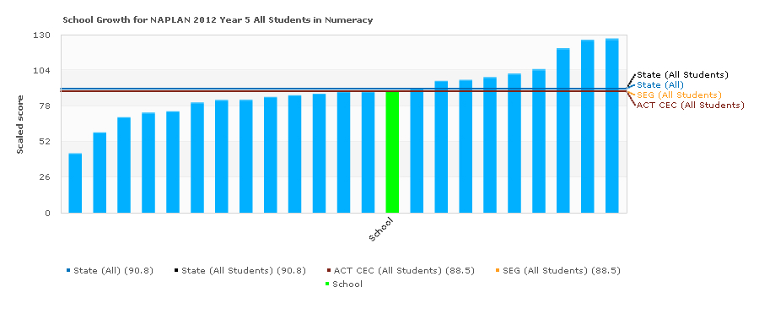 | 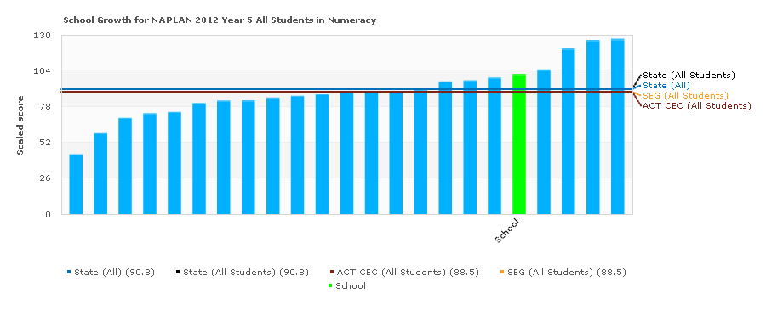

 | Year 3 | Year 5
Calwell | 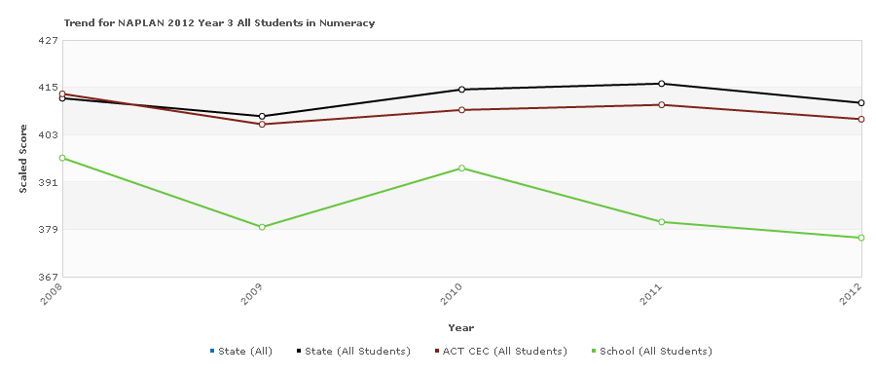 | 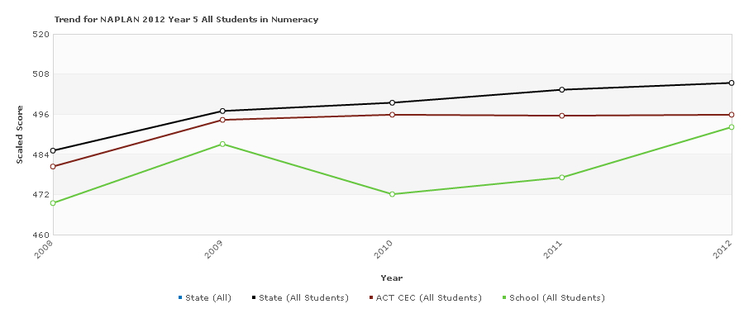
Conder | 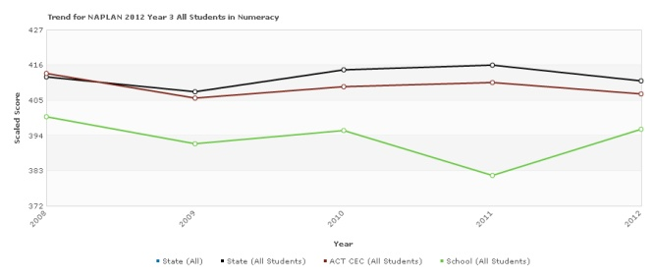 | 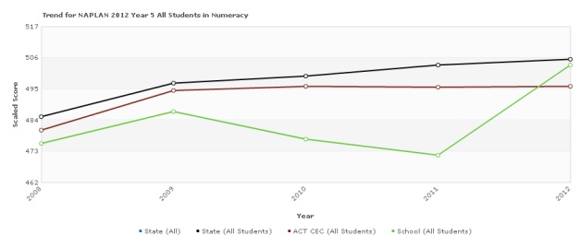
Saint Anthony’s Primary School, Wanniassa
A Numeracy Intervention Program (NIP) teacher (0.4FTE) was appointed within the school at the beginning of the SSNP project. The NIP teacher was responsible for small group intervention with ‘at risk’ students.
Maths Walls are in most classrooms. These Maths Walls provide explanations of mathematical technical language, photographs of students’ work as well as problem solving skills and strategies for students when attempting word problems.
The graphs below show that the students below in both Year 3 and Year 5 are above the territory mean. However the growth of Year 5 students is not as high as wished for. Professional Development and mentoring of Early Career Teachers was seen as a priority. The Mathematics Curriculum Officer from the CEO spent a number of sessions in this capacity.
Figure 4.2 Saint Anthony’s Primary School, Wanniassa

Wanniassa Growth Year 5 Students 2012
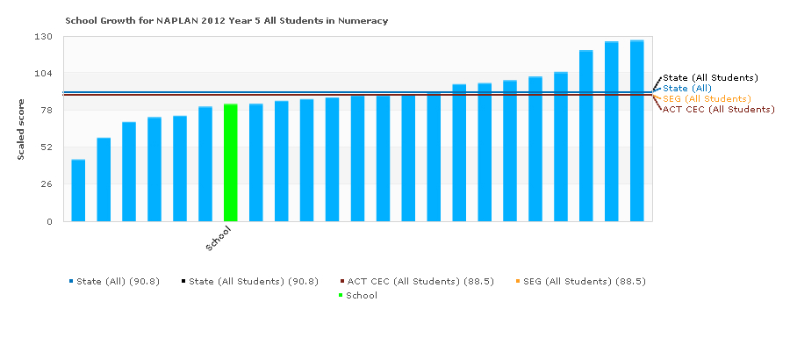
 | Year 3 | Year 5
Wanniassa | 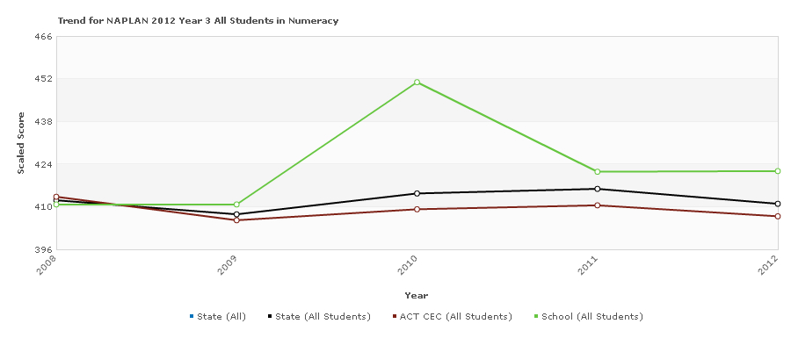 | 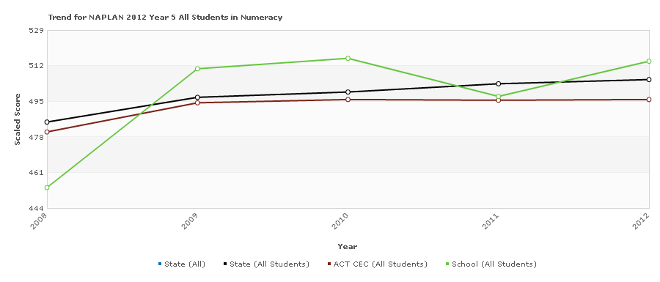
Saint Thomas Aquinas, West Belconnen
A numeracy coordinator (0.1 FTE) was appointed within the school with a clearly articulated role. This coordinator reports each term on progress of agreed directions in numeracy.
This coordinator, having previously participated in Working Like a Mathematician professional learning), has facilitated implementation of this problem solving/inquiry based approach to mathematics teaching at the school through modelling lessons and providing programming assistance. All teachers are now programming with a problem solving experience at the commencement of every new concept.
Maths Walls are in all classrooms. These Maths Walls provide explanations of mathematical technical language, photographs of students’ work as well as problem solving skills and strategies for students when attempting word problems.
Staff have also used June Maker’s Model of Differentiation (1982) to ensure the needs of all students can be catered for in teacher programs.
Count Me In Too was extensively revised within the school environment. All teachers received Count Me In Too training and an agreed practice for the use of this program within the school has been drafted.
An audit of all maths resources was conducted at the school and a budget for the replenishment of maths resources was developed. Mathematics resource tubs were provided to all year levels with sufficient manipulatives for hands on activities to support the learning and engagement of students.
West Belconnen received funding at the beginning of 2012. Figures x, y and z show good growth with year 5 students at or above territory mean. However, the NAPLAN results early in 2012 show that focus with early numeracy development in K-2 was warranted l. Subsequently, for the remaining part of 2012, CMIT was targeted as the program most in need at the school. Teachers are now implementing CMIT K-4 across the school.

Figure 4.3: Saint Thomas Aquinas Primary School, West Belconnen
West Belconnen Growth Year 5 Students 2012
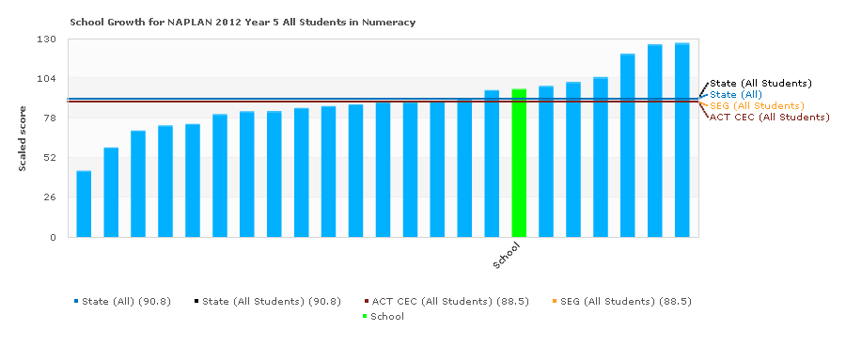

 | Year 3 | Year 5
West Belconnen | 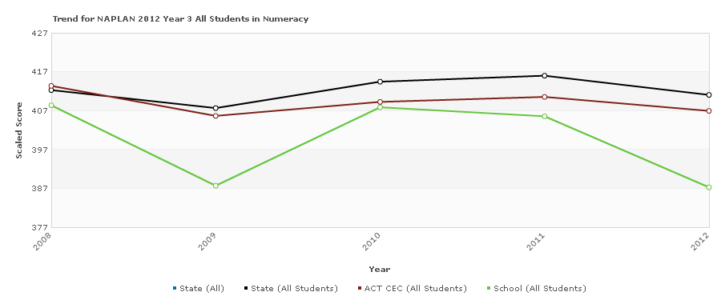 | 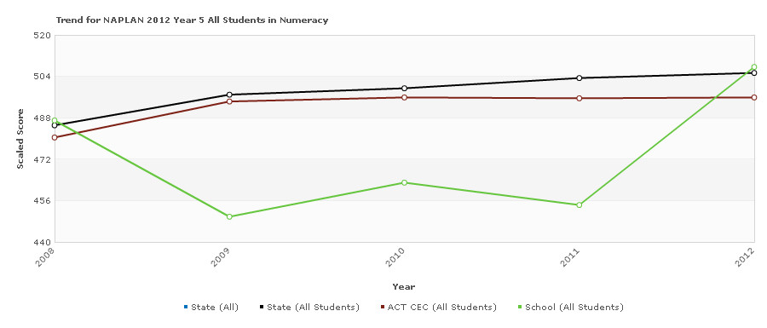
St Thomas the Apostle Primary School, Kambah
The Numeracy Intervention Program at this school was significantly modified so that an additional teacher would work with a group of year 3 and 4 students in multi age classes in those year groups.
The school continued to apply the Gradual Release from Responsibility model in the numeracy block. Key members of the staff participated in the Working Like a Mathematician course in 2011 and additional staff participated in this training in 2012. In 2012 the initial members of staff who were originally trained in Working Like a Mathematician attended a Working Like a Mathematician implementation day presented by the CEO numeracy team. The purpose of this day was to develop a whole school plan to be used in the school to incorporate problem solving and investigations in class programs. The school provided staff meetings where problem solving activities could be shared with staff.
The numeracy contact regularly attended primary numeracy contact days where current research and the implementation of the Australian Curriculum Mathematics K-10 were disseminated to school representatives. These included: the Working Paper, Rationale, Aims and Proficiency Strands of the new document.
The 2012 NAPLAN testing results indicated that the mean scores were higher than the previous cohort in 2011 in both year 3 and year 5.

Figure 4.4: Saint Thomas The Apostle Primary School, Kambah

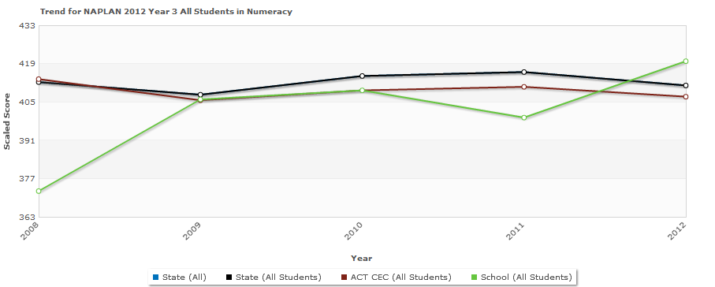
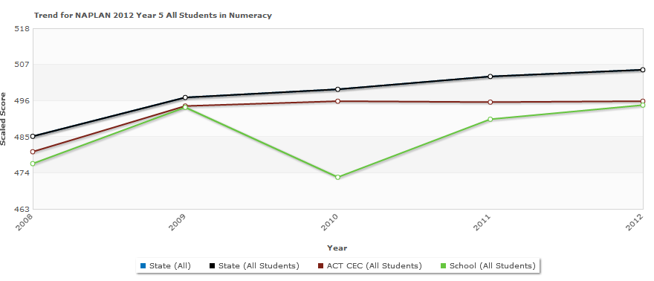
Year 3 were over represented in Band 6 and Band 4 but underrepresented in Band 5.

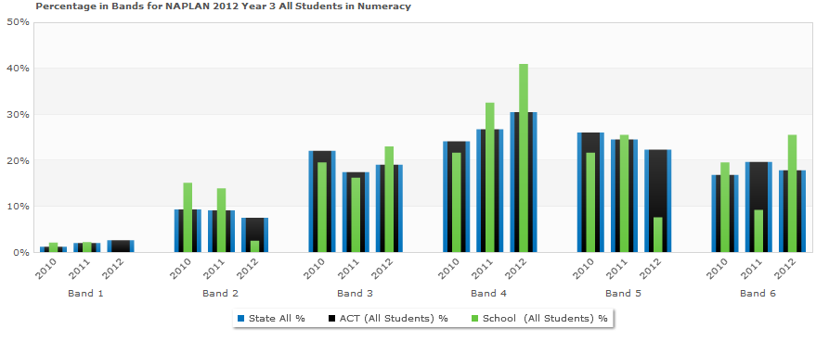
Year 5 was underrepresented in Bands 7 and 8 and the students were clustered in Bands 5 and 6. Neither Year 3 nor Year 5 had students in Band 1.
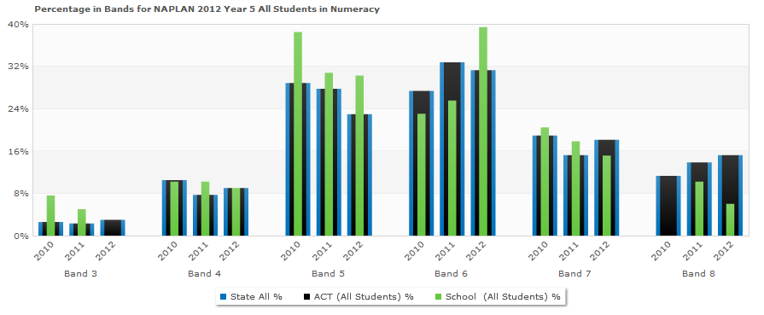
- Literacy Achievements and Highlights 2012
There are six schools within the ACT that have Smarter Schools National Partnership (SSNP) funding in literacy in 2012.
School | Funding | 2012
Saint Michael’s Primary Kaleen | Round 1  2009 -2011 | Reward 2012
Saint Thomas Aquinas West Belconnen | Round 1  2009 -2011 | Reward 2012
Saint Matthew’s Primary Page | Round 1  2009 -2011 | Reward 2012
Saint John the Apostle Florey | Reward NP Phase 1  2011 -2013 | Reward 2012
Saint Clare of Assisi Conder | Reward NP Phase 1  2011 -2013 | Reward 2012
Saint Francis of Assisi Calwell | Reward NP Phase 1  2011 -2013 | Reward 2012

Highlight One: Gradual Release of Responsibility
A significant achievement is that all schools across the system are now using the research based pedagogical model of the Gradual Release of Responsibility Model (GRRM) in reading. This approach involves explicit teaching, targeted assessment to inform teaching and learning, scaffolding reading knowledge and skills through the teaching procedures of modelled, shared, guided and applied lessons, and differentiating teaching instruction. This model has been scaffolded explicitly in the National Partnership schools.

First Steps is a core resource used by all SSNP schools to support teachers in pedagogical method, informing programming, assessment, class teaching, home reading and student intervention approaches. (Refer to Annandale, K. et al, (2004) First Steps Reading Map of Development, 2nd Ed., Steps Professional Development. Melbourne: Rigby HeinemannAnnandale, K. et al, (2004) First Steps Reading Resource Book, 2nd Ed., Steps Professional Development. Melbourne: Rigby Heinemann and Annandale, K. et al, (2004) First Steps Linking Assessment, Teaching and Learning, Steps Professional Development. Melbourne: Rigby Heinemann).
The GRRM involves explicit teacher demonstrations of elements of the reading process, the information process, reading context, conventions, comprehension and word identification strategies. The teacher then creates reading scaffolds to support student learning in each area of focus.

Teachers in all SSNP schools continue to investigate international research of elements of the reading process, the information process, reading context, conventions, comprehension and word identification strategies in order to guide selection of teaching content and provide scaffolds to support development of student knowledge and skills.
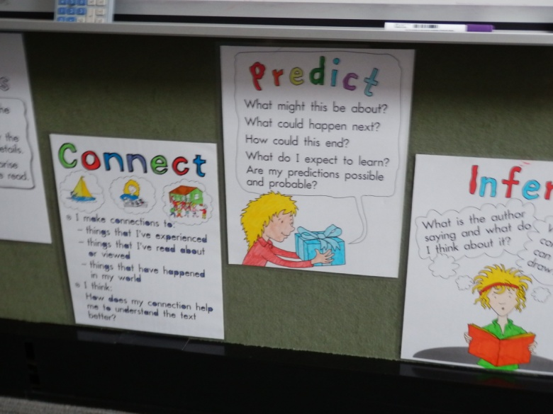
All SSNP schools use assessment to differentiate learning through the guided reading teaching procedure and group students accordingly.
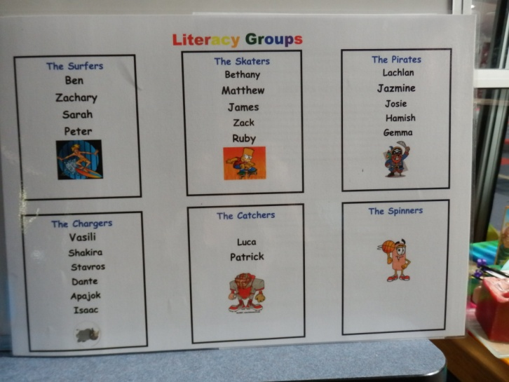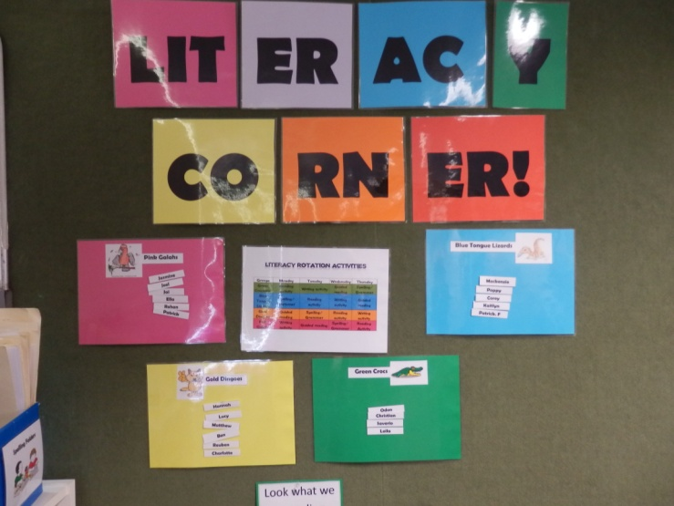
All SSNP schools continue to investigate guided reading approaches such as literature circles and reciprocal reading and book discussion groupings.
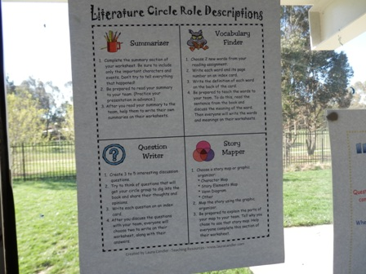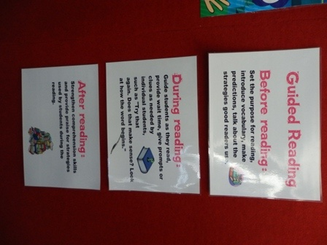

All SSNP schools continue to audit resources and in-service teaching and support staff in the use of text within the GRR through professional development opportunities including programming and planning workshops, modelled and guided lesson demonstrations, observations and mentoring in GRR in order to implement system agreed practice in use of text: i.e. selection of hard texts for Modelled Reading, instructional texts for Guided Reading and easy texts for home reading – levels to be differentiated based on student assessed need.

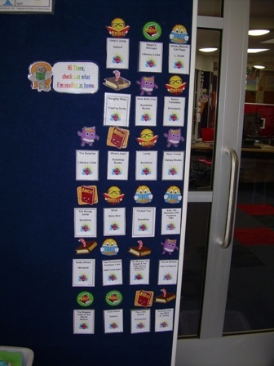

All SSNP schools continue to receive professional development and ongoing support in the implementation of the Australian Curriculum, which has provided improved knowledge of the reading process, the information process, reading context, conventions, and comprehension and word identification strategies. Specifically, teacher professional development continues to support teachers to use First Steps to implement the Australian Curriculum through SSNP partnerships with school executive, school literacy contact teachers and CEO Literacy Officers, network days, mentoring, annual First Steps courses, in-school course delivery, programming workshops, lesson demonstrations and observations, timetabling advice and audits, analysis of literacy blocks and support in formative and summative assessment.
Whole school agreed practice has mandated literacy blocks of 60 minutes reading and 60 minutes writing for kindergarten and year one at least four times a week and 45 minutes reading and 45 minutes writing for years two to six at least four times a week.

Literacy Quantitative and Impact Information Round 1 SSNP Schools 2012:
Saint Michael’s Primary School, Kaleen
Saint Michael’s Kaleen increased the proportion of students in Bands 7 and 8 from 2010 to 2012 (Table 2.1) and worked towards their literacy target that year five reading growth would be at least 80 scale scores (Table 2.1).

Figure 4.5: Saint Michael’s Kaleen
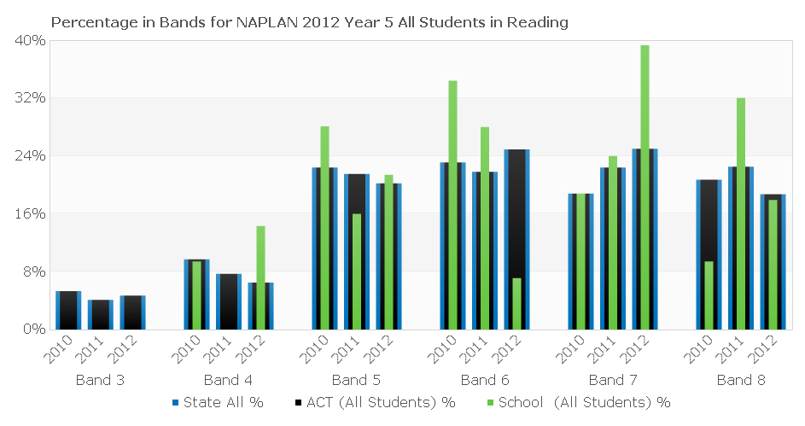

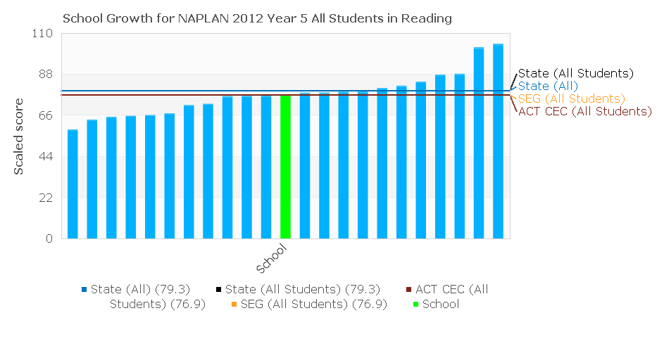
Saint Matthew’s Primary School, Page
Student achievement in year 5 in reading increased from 2010 to at or above state average. The number of year five students in the bottom two bands for reading decreased from 2010 to 2012. The number of year 3 students in Band 5 increased from 2010.

Figure 4.6: Saint Matthew’s Primary School, Page
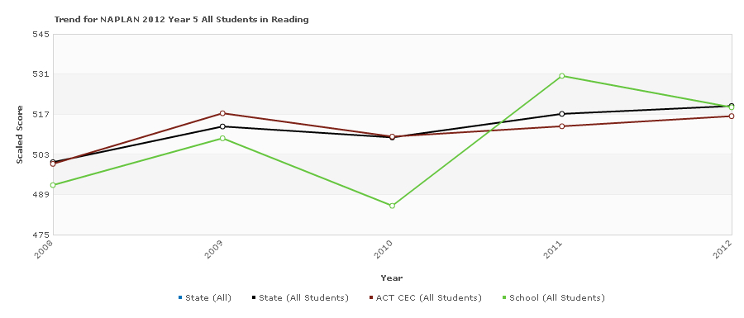

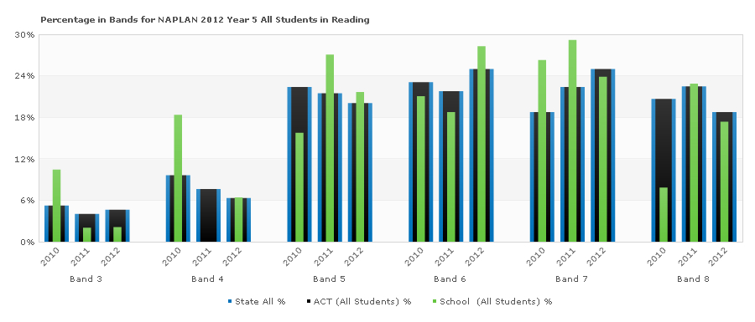

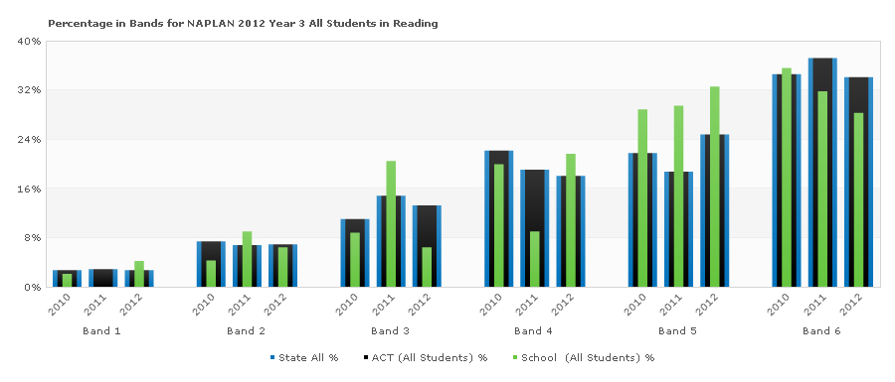

Saint Thomas Aquinas West Belconnen
Saint Thomas Aquinas reduced the number of year five students in the lower bands 3 and 4 from 2010 to 2012 and increased student representation in top two bands in 2012 compared to 2010
School achievement in year five was significantly below state average from 2008 but exceeded system average by 2012.

Figure 4.7: Saint Thomas Aquinas West Belconnen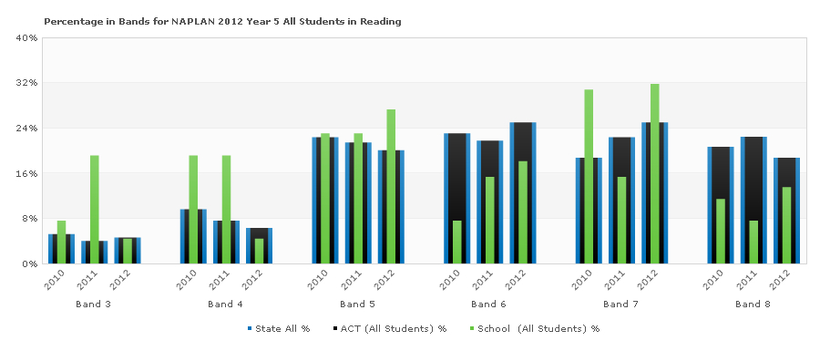

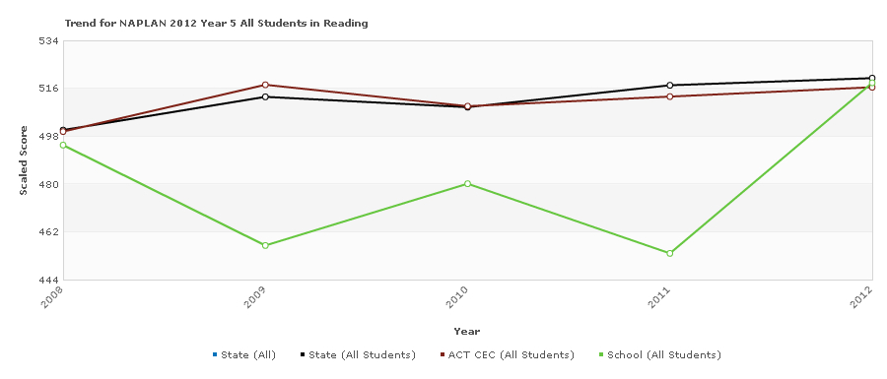

Reading Achievement for Year One Students Below Benchmark
All SSNP Literacy 2012 schools began or maintained Reading Recovery. Students below reading benchmarks at the end of Kindergarten (i.e. below Level 8) were targeted for the intensive Reading Recovery program in order to raise their reading levels to Archdiocesan benchmarks of reading levels 15-17 by end of year one and reading level 24 by end of year two through Reading Recovery and a whole school focus on timetabling, planning and pedagogical approaches in literacy blocks. Developed by New Zealand educator, Doctor Marie Clay, Reading Recoveryis a short- term intervention for children who have the lowest achievement in literacy learning in the first grade. Children meet individually with a specially trained teacher for 30 minutes each day for an average of 12-20 weeks. The goal is for children to develop effective reading and writing strategies in order to work within an average range of classroom performance.
Reading Recovery is an early intervention program. Proficient readers and writers develop early. There is strong evidence in the research literature that retention in grade level and long-term remediation efforts do not enable low-progress children to catch up with grade-level peers so that they can profit from classroom instruction. Reading Recovery has a strong track record of preventing literacy failure for many first graders through early intervention.
Results in tables 4.4 to 4.9 indicate that 86% of students reached reading level 24 or above by end of year two. Of students not requiring psychometric assessments, 96% reached reading level 24 or above by end of tear two.

For Round 1 schools that began Reading Recovery in 2009, tracking of reading levels for students that have participated in the Reading Recovery program provides evidence of significant progress. While partial quantitative data is currently available for schools that started the Reading Recovery program in 2011, the sample data indicate similar trends.
Table 4.4: Progress in Reading Recovery at Saint Michael’s Primary School, Kaleen, by student
 | Initial reading level | Discontinued reading level | End year 1 | End year 2
Student 1 | 7 | 17 | 23 | 25
Student 2 | 6 | 19 | 23 | 27
Student 3 | 3 | 16 | 16 | 20
Student 4 | 5 | 16 | 16 | 26
Student 5 | 3 | 17 | 17 | 23
Student 6 | 8 | Just begun program | 14 | 24
Student 7 | 13 | Just begun program | Just begun program | 25
Student 8 | 13 | Just begun program | Just begun program | 29
Student 9 | 5 | 16 | 18 | 24
Student 10 | 5 | 16 | 18 | 26
 | Initial reading level | Discontinued reading level | End year 1 | Year 3
Student 11 | 2 | 15 | 24 | 25
Student 12 | 1 | 15 | 18 | Transferred
Student 13 | 11 | 21 | 24 | 29
Student 14 | 1 | 9 | 9 | Referred
Student 15 | 1 | 14 | 26 | Referred

Table 4.5: Progress in Reading Recovery at Saint Matthew’s Primary School, Page
 | Discontinued reading level | End year 1 | End year 2 | Current year 3
Student 1 | 17 | 20 | 29 | 30
Student 2 | 16 | 19 | 28 | 29
Student 3 | 17 | 19 | 27 | 30
Student 4 | 19 | 23 | 29 | 30
Student 5 | 17 | 18 | 26 | 25
 | Discontinued reading level | End year 1 | Current ear 2
Student 6 | 16 | 18 | 22
Student 7 | 16 | 20 | 24
Student 8 | 15 | 19 | 21
Student 9 | 18 | 19 | 23
Student 10 | 22 | 22 | 24
Student 11 | 22 | 22 | 20

Table 4.6: Progress in Reading Recovery at Saint Thomas Aquinas Primary School, West Belconnen
 | Discontinued reading level | End year 1 | End year 2 | Current year 3
Student 1 | 16 | 22 | 25 | 25
Student 2 | 15 | 21 | 25 | 25
Student 3 | 18 | 22 | 25 | 26
Student 4 | 15 | 19 | 24 | 26
Student 5 | 22 | 22 | 27 | 28
Student 6 | 21 | 21 | 25 | 27
Student 7 | 19 | 19 | 25 | 25
Student 8 | 19 | 19 | 24 | 24
 | Discontinued reading level | Endyear 1 | Current year 2
Student 9 | 19 | 21 | 22
Student 10 | 18 | 21 | 23
Student 11 | 21 | 21 | 24
Student 12 | 25 | 24 | 25
Student 13 | 20 | 20 | 21
Student 14 | 20 | 20 | 22

Table 4.7: Reading Recovery Progress at Saint Clare of Assisi Primary School, Conder
 | Initial reading level | Reading level - July 2012
Student 1 | 0 | 16
Student 2 | 2 | 16
Student 3 | 1 | 12
Student 4 | 2 | 16

Table 4.8: Reading Recovery Progress at Saint Francis of Assisi Primary School, Calwell
 | Initial reading level | Reading level – August 2012
Student 1 | Below K benchmark | 17

Table 4.9: Reading Recovery Progress at St John’s Primary, Florey Reading Recovery
 | Initial reading level | Discontinued reading level  December 2012
Student 1 | 10 | 15
Student 2 | 4 | 15
Student 3 | 1 | 15
Student 4 | 1 | 9
Student 5 | 1 | 15
Student 6 | 2 | 15
Student 7 | 4 | 10*
Student 8 | 10 | 10*
*students carried over to 2013 – scores progress only

Independent schools
Canberra Grammar School outlines a range of highlights during this period.
Professional Learning
Teachers have been trained in First Steps Writing and Reading. First Steps is used as the Canberra Grammar Primary School main literacy teaching resource and provides a common language for all staff when sharing ideas during collaborative planning. As First Steps closed at the end of 2012 we are currently in the process of reviewing the possibilities for 2013 and beyond but still use the resource particularly the reading and writing ‘maps of development’.

Academic Tracking
Canberra Grammar Primary School has established an Assessment and Reporting Schedule. As part of the schedule, data is collected on all students from years one to six in the areas of reading comprehension, spelling and mathematics. In addition all students from years 4 to 6 sit a vocabulary test. All kindergarten children participate in the PIPS testing. This data, along with other information including NAPLAN and formative feedback, is analysed by the Enrichment Team and individual results are monitored and tracked.

Learning Support
In addition to regular support, groups of identified students have been established to target areas of weakness in short block intensive sessions. In 2012 a new initiative, the Student Writing Assistance Team (SWAT), was introduced involving all students from years two to five in intensive Writing blocks. Focusing on developing oral language as a precursor to quality writing, an understanding of what a quality piece of writing looks like, building vocabulary, self-analysis of errors and possible improvements, students have been encouraged to discuss and reflect on the writing process.

Following analysis of the school’s literacy results the Master Spelling Class strategy has been developed to address phonemic awareness and graphemes of written English. Identified students participated in intensive blocks led by a spelling consultant. The consultant used THRaSS (Teaching Handwriting Reading and Spelling Skills) a phonics teaching tool based on a phonographic and a multi-sensory approach. The groups focused on the structure of English, language acquisition and linguistic correctness. This resource and the associated professional learning is a regular inclusion in the Canberra Grammar Primary School Professional Learning plan.

Table 4.10: Improvement in number of predicted students not reaching benchmark at Canberra Grammar Primary School

Year | K | 1 | 2 | 3 | 4 | 5 | 6
Number of students below the benchmark  2011- 2012 |  | 1 | 0 | 2 | 3 | 1 | 2
Number of students below the benchmark  2010- 2011 benchmark data | 5 | 19 | 16 | 17 | 17 | 14 | 12

Based on the information collected, students are identified for additional support where necessary. This support is provided through small withdrawal groups or ‘in class’ support. The specific literacy learning is facilitated and supported by Reading Recovery and Literacy Support teachers. Class teachers benefit from the additional support of a Teaching Assistant during literacy sessions allowing small group instruction including guided reading.

Canberra Girls’ Grammar School also notes the following specific achievements as a result of engagement with this National Partnership:

Year 3 NAPLAN:
- Overall performance in literacy and numeracy remained high, at the top end of the ACT.
- Most children (82% to 95%) in all literacy areas scored in the two highest bands and there were fewer in the lower bands, indicating a generalised shift to the right from 2011. Means in reading, writing, spelling and grammar and punctuation were raised.
Year 5 NAPLAN:
- Overall performance in literacy and numeracy remained high, at the top end of the ACT.
- Most children in all literacy areas (70% to 95%) and Numeracy (60%) scored in the two highest bands and there were fewer in the lower bands, indicating a generalised shift to the right from 2011. Means in Reading, Writing, Spelling and Numeracy were raised.
- Average student growth in literacy ranged from 74 to 95 points, with those students accessing the learning support program showing the most growth.
While independent schools do not work as a ‘system’, it is appropriate to note that schools and teachers engaged in the National Partnership have also had the opportunity to share and engage in professional conversations with colleagues from other independent schools through the Association of Independent Schools ACT Teaching & Learning Network.

Support for Aboriginal and Torres Strait Islander students – 1 January to 31 December 2012
Reporting on the performance of Aboriginal and Torres Strait Islander students is performed on a whole of ACT basis due to the low number of Aboriginal and Torres Strait islander students in National Partnership schools in the ACT. Across the ACT, Aboriginal and Torres Strait Islander students performed well when compared to their peers in Australian metropolitan schools. This comparison is represented in table 4.11 below.
Table 4.11: Comparison of ACT and Australian Metropolitan Aboriginal and Torres Strait islander students in year 3 and 5 reading and numeracy
 | mean scale score | below NMS | at NMS | At or above NMS
Year 5 reading
Aust metro | 409 | 32.4 | 21 | 64.7
ACT | 459.7 | 13 | 18.5 | 80.4
Year 5 numeracy
Aust metro | 414 | 28 | 27.1 | 69.2
ACT | 447.2 | 11.9 | 25.7 | 81.5
Year 3 reading
Aust metro | 333.3 | 23 | 22.5 | 74.2
ACT | 372.6 | 9.9 | 20.9 | 85.7
Year 3 numeracy
Aust metro | 320.1 | 24.4 | 26.1 | 72.7
ACT | 350.6 | 11.5 | 21.8 | 84
A comparison of the ACT and Australian average gain for Aboriginal and Torres Strait Islander students, in Table 4.12, shows that performance in numeracy is comparable to the Australian average gain. In reading, the average gain for ACT Aboriginal and Torres Strait Islander students is 6.7 points above the Australian average gain.
Table 4.12: Comparison of average gain year 3 to year 5 of Aboriginal and Torres Strait Islander students in the ACT and the whole of Australia
Aboriginal & Torres Strait Islander Numeracy | Average gain ACT | Average gain Australia
2009-2011 | 103.2 | 100.6
2010-2012 | 85.5 | 88.7
ATSI Reading | ACT | Australia
2009-2010 | 99.4 | 82.4
2010-2012 | 84.9 | 78.2
In Table 4.13 growth in year 5 reading is 8.6 points higher for Aboriginal and Torres Strait Islander students and 10.5 points higher in numeracy when compared to ACT all students.
Table 4.13: Comparison of growth of ACT (all) Aboriginal and Torres Strait Islander students and ACT all students
Group | Growth year 5 reading | Growth year 5 numeracy
ACT all students | 79.4 | 90.8
ACT ATSI students | 88 | 100.3
Public Schools
In the ACT a range of strategies are implemented to support Aboriginal and Torres Strait Islander students in public schools.
All Aboriginal and Torres Strait Islander students have a Personalised Learning Plan (PLP). These plans are developed in collaboration with the student and parents and are designed to build on individual strengths and address any weaknesses. They provide an important basis for the provision of literacy and numeracy support.
In 2012 the ACT Aboriginal and Torres Strait Islander Student Community Partnership for Literacy Support project ran in five Tuggeranong High Schools.
The key literacy teaching strategies developed during the project continue to be shared with ACT schools through the school based literacy coordinator network. The project also developed key information and strategies for the development of a culturally responsive environment. Both of these strategies will be shared nationally through the Teach, Learn, Share website.
Catholic systemic schools
PLPs were written for Aboriginal and/or Torres Strait Islander students in the Literacy and Numeracy National Partnership schools. The PLPs covered student strengths and areas of need to enhance performance. The students not meeting minimum standards also received assistance through the Numeracy Intervention Program and Reading Recovery.

Working Like a Mathematician professional learning for classroom teachers not only enhanced teacher pedagogy but also provided Aboriginal and/or Torres Strait Islander students with real life and meaningful experiences/situations in mathematics.

A successful three day Cultural Immersion Program was designed and implemented for our National Partnership schools. The program was run by the Canberra Institute of Technology and the Aboriginal Contact and Early Career Teachers from each of the National Partnership schools were invited to attend. The program aimed to build teacher capacity allowing them to respond to the needs of Aboriginal and/or Torres Strait Islander students, parents and communities. At the end of the three days teachers commented on the practical advice they had received, and the useful resources. They also felt better equipped after the three days to meet the needs of Aboriginal and/or Torres Strait Islander students in their schools.

The Aboriginal Contact Teachers, through professional learning sessions, developed expertise in using SMART goals when writing PLPs, analysed appropriate and authentic resources to improve student outcomes and the explicit program development for Aboriginal and/or Torres Strait Islander students. One of the big successes in the literacy area during the reporting period was the introduction of the Yarning Strong literacy resource. The Yarning Strong literacy resource which was introduced at the beginning of 2012. The resource engaged our Aboriginal and/or Torres Strait Islander students and deepened teacher understanding of sensitive issues, correct use of terminology and comprehensive information related to Aboriginal and Torres Strait Islander people.
Independent schools
In 2012, one year 3 Aboriginal student was involved in literacy intervention and social skills development.

Support for Other Disadvantaged Student Cohorts (if applicable) – 1 January to 31 December 2012
Public schools
The ACT targets additional support to EAL/D students within the cohort identified as LBOTE.
The Education and Training Directorate (the Directorate) provides programs for each eligible student for up to seven years, through:
- full time intensive instruction at primary and secondary Introductory English Centres (IECs)
- early entry to preschool
- EAL/D support in mainstream schools, and
- tertiary accredited and registered ESL courses at senior secondary colleges.
Performance of LBOTE students in the ACT is strong when compared to LBOTE students across Australian metropolitan schools. This is the most appropriate group for comparison as their schooling most closely resembles the ACT LBOTE experience. In Table 4.14, ACT LBOTE students have higher mean scores, with fewer students below and more above the national minimum standard.
Table 4.14: Comparison of ACT and Australian Metropolitan LBOTE students in year 3 and 5 reading and numeracy
Year 5 reading | mean scale score | below NMS | at NMS | At or above NMS
Aust metro | 486.2 | 8.2 | 12.5 | 89
ACT | 510.1 | 3.9 | 8.4 | 91.9
Year 5 numeracy
Aust metro | 493.5 | 5.9 | 13.1 | 91.4
ACT | 507.6 | 2.6 | 10.3 | 93.1
Year 3 reading
Aust metro | 416.8 | 5 | 9.1 | 91.9
ACT | 440.5 | 2.6 | 6.7 | 94
Year 3 numeracy
Aust metro | 399.5 | 4.8 | 10.6 | 92.2
ACT | 409.4 | 1.9 | 9.1 | 95.1

Individual public schools develop programs to cater for their student profile. Enrolment data and annual moderation processes are used to assign a Language Performance Rating. Individuals and groups needing additional support are identified and allocated additional resources. Census processes ensure the equitable distribution of available resources to targeted students.
Table 4.15 demonstrates that LBOTE students perform well when compared to their peers in ACT schools. Growth in year 5 reading is only 1.5 points lower for LBOTE students; however in numeracy it is 3.0 points higher than ACT all students.
Table 4.15: Comparison of growth of ACT (all) LBOTE students and ACT all students
Group | Growth year 5 reading | Growth year 5 numeracy
ACT all students | 79.4 | 90.8
ACT LBOTE students | 77.9 | 93.8
Catholic systemic schools
The impact of a key strategy at the system and school level that continues to contribute to improved literacy outcomes for disadvantaged students in literacy (i.e. those below reading benchmarks) has been the system investment in professional development and training in Reading Recovery.

The Reading Recovery program continued to be implemented in St Thomas Aquinas West Belconnen, St Michael's Primary School Kaleen and St Matthew’s Page. The results of improvement in literacy were significant in these school and so three new schools implemented the Reading Recovery program in 2012. These were St John the Apostle Florey, St Clare of Assisi Conder and St Francis of Assisi Calwell.

The Numeracy Intervention Program also assisted the disadvantaged student cohort in several of the National Partnership schools. The schools that have benefitted from the numeracy intervention strategy include Good Shepherd Amaroo, St Thomas the Apostle Kambah, St Anthony’s Primary School Wanniassa, St Clare of Assisi Conder and St Francis of Assisi Calwell.
Independent Schools
Canberra Grammar Girls School Junior School has a small Learning Support department and procedures have been refined to ensure students are supported according to need as far as resources allow. The school is non-selective and there has been an increasing trend of students joining the school who have issues relating to ESL, a disability or learning difficulties. The school has adopted the following strategies:
- introduction of a data-driven triage system that is used to prioritise teacher referrals to the Learning Support team
- expansion of the team of teacher assistants who are trained in-house to take identified students through a remedial reading program
- expansion the Teacher Assistant Reading Program into Year 3
- expansion of the range of specialised numeracy support strategies
- along with standardised assessments, consideration of evidence from a larger range of diagnostic assessments and putting classroom strategies in place on the basis of evidence gathered from these assessments
- increasing the range of whole-cohort standardised assessments so that all year levels are serviced by some form of appropriate standardised assessment.
- conducting regular support group meetings which include teachers, learning support staff, relevant executive and the parents of students experiencing learning difficulties
- accessing the SCAN system where appropriate.

Sustainability
Public schools
Field officers in each of the participating schools have provided a sustained focus on school improvements aligned with the Low SES National Partnership reform areas. The new Improving Literacy and Numeracy National Partnership for 2013 will provide continuity of the ACT improvement agenda.
Ten of the schools will continue in the Improving Literacy and Numeracy National Partnership in 2013, and will retain a field officer responsible for coaching staff for improvements in literacy and numeracy.
In 2012 the 12 field officers in this National Partnership participated in professional learning with field officers in the Low SES National Partnership schools. This led to a support network and sharing of resources and opportunities for professional conversations.
There is a need for sustained strategies aimed at improving outcomes for students, including:
- developing a school profile based on accurate data collection at time of enrolment
- strengthening partnerships with parents
- monitoring performance data at the individual, school and system level resulting in clear pathways to ensure students get the support they need.
Catholic systemic schools
Numeracy
CEO Numeracy Officers have worked within schools to build teacher capacity across K-6. In addition, National Partnership Numeracy Officers have been appointed in schools with a minimum of 0.1 FTE to act as a coach or mentor for all teachers in their schools. The NP coordinators liaise with the CEO Numeracy Officers to facilitate staff meetings and mentoring programs for the teachers. This approach to building teacher capacity within schools will continue after the SSNP ceases.
The Primary Numeracy Network Days are also designed to facilitate contemporary practice is exposed to schools and coordinators are provided mentoring and supportive practices to maintain their positions. Networking days are core business for Curriculum Officers in the CEO and will continue after the SSNP program ceases.

The introduction of the cloud learning platform, LIFE, allows the freedom and flexibility to interact with all teachers and schools via technology. All professional learning packages as well as samples of other schools’ student work and teacher programs are available to all schools. This platform allows us to update and maintain consistent information and assistance to the schools. Parents also have access to their child’s work and this helps to build links between all of the communities within our CEO.
Literacy
In the SSNP Literacy Schools Saint Michael’s Kaleen, Saint Matthew’s Page, Saint Thomas Aquinas West Belconnen and Saint John the Apostle, mentoring programs have been established to embed the First Steps Approach in teaching reading. Building a professional learning community has been successful in up skilling early career teachers and new staff members each academic year to ensure the approach is maintained beyond the life of the SSNP partnership.
Catholic Education Officers – Literacy have worked with school executive in 100% of the SSNP literacy schools to formulate whole school policy regarding assessment, timetabling literacy blocks, implementation of the Gradual Release of Responsibility and inclusion of essential elements in programming reading instruction to ensure effective approaches in reading continue beyond the SSNP period.
Across the Archdiocese, 100% of schools have received professional development in First Steps reading and/or writing in order to plan for teaching staff transfer within the system, while professional development in First Steps reading and writing occurs annually to in service teaching staff new to the system.
Reading Recovery now occurs at eighteen primary and central schools within the Archdiocese of Canberra and Goulburn which is contributing to an increase in considerable staff expertise in reading across the system.
Independent schools
The National Partnership initiatives have been maintained through teacher mentoring and a collaborative approach to sharing ideas, successes and observations around improving writing achievement and professional learning.

Showcase – 1 January to 31 December 2012
Public schools
Latham Primary School - Visible Learning
Latham Primary School is a P-6 school with an enrolment of 259 students. The school has an ICSEA of 1009, 4% Aboriginal and Torres Strait Islander students, 13% LBOTE students, and 12 special needs students across two autism specific learning support units.
A number of ambitious targets for literacy and numeracy improvement were identified in the 2009-2011 School Plan. In 2012 they collated data across 2009-2011 to assess their performance against these targets. The school met or exceeded all targets.
The major strategy implemented at Latham Primary School was a focus on Visible Learning inspired by the work of John Hattie in which each teacher identified an area of focus for 2012. They worked with their class to make learning intentions and the steps for success clear to all.
One example was the writing goals template developed for use in the 4/5 unit with students on an integrated support program. It aligned Individual Learning Plans with their daily learning and clearly articulated their learning intention for writing.
Focussed and specific targets were set by the school to provide a measure of success and a guide for future goal setting.
Tables 4.16 through 4.118 demonstrate the targets set by the school and their achievement up to 2012 as well as the usefulness of very specific goals in monitoring student performance and school improvement.

Table 4.16: Year 3 reading targets and achievements at Latham Primary School 2009 to 2012
Target : Increase percentage of students in Bands 4, 5 and 6 in reading in Year 3 by 3% annually and decrease percentage of students in Bands 1, 2 and 3 in reading in Year 3 by 3% annually.
Percentage of year 3 students in bands 4, 5 & 6 |  |  | Mean Annual Increase/Decrease
2009 | 2010 | 2011 2012
54% | 70% | 80% 84% | + 10%

Percentage of year 3 students in bands 1, 2 & 3 |  |  | Mean Annual Increase/Decrease
2009 | 2010 | 2011 2012
46% | 30% | 20% 10% | -12%
Table 4.17: Year 3 writing targets and achievements at Latham Primary School 2009 to 2012
Target: Increase percentage of students in Bands 4, 5 and 6 in writing in Year 3 by 3% annually and decrease percentage of students in Bands 1, 2 and 3 in writing in Year 3 by 3% annually.
Percentage of year 3 students in bands 4, 5 & 6 |  |  | Mean Annual Increase/Decrease
2009 | 2010 | 2011 2012
50% | 80% | 93% 88% | +13%

Percentage of year 3 students in bands 1, 2 & 3 |  |  | Mean Annual Increase/Decrease
2009 | 2010 | 2011 2012
50% | 20% | 7% 4% |  | -16%
All year 3 literacy targets were met and maintained except for the percentage increase of the number of year 3 students in bands 4, 5 and 6 which at 84% is a high level and would be expected to plateau.
Table 4.18: Year 5 writing targets and achievements at Latham Primary School 2009 to 2012
Target: Reduce percentage of students at or below national minimum standards in writing in Year 5 to 20% or less by the end of 2011.

Percentage of students in year 5 that are at or below national minimum standards in writing
2009 | 2010 | 2011 2012
40% | 17% | 32% 13%
Although Latham didn’t meet their target of reducing the target of students in year 5 writing at or below the minimum standard to 20% or less in 2011, they achieved it in 2012 when they had only 13% of students in this category.
Latham Primary School has also achieved significant outcomes in numeracy. The pie chart in Figure 7 illustrates the proportion of year 5 students showing greater than or equal to expected growth. At 58.6% this is a significant achievement.
- Greater than or equal to expected growth
- Less than expected growth

Progress was also made in year 3 numeracy in 2012. In 2011 13.3% of year 3 students were in band 6 and in 2012 that had increased to 22.6%, an increase of 9.3% in one year.
Another effective intervention was the kindergarten teachers’ action learning project on reading. The two questions of practice for this action learning were:
- how can Latham Primary School improve reading outcomes for kindergarten students in the bottom 10% in order for them to achieve or exceed ACT Reading Benchmark?
- how can Latham Primary School build staff capacity to teach reading successfully for all kindergarten students?
Reading benchmark performance has shown improvement across K-2 when compared to results from 2010 and 2011. Table 4.19 shows the percentage of mainstream students meeting or exceeding ACT reading benchmarks for 2010 to 2012.
Table 4.19: Percentage of mainstream students meeting or exceeding ACT Reading Benchmarks
Latham Primary School |  | Reading Benchmark | 2010 | 2011 | 2012
Kinder | Mid Year | 1~3 | 90% | 74% | 97%
 | End of Year | 5~8 | 56% | 78% | 77%
Year 1 | Mid Year | 10~12 | 55% | 37% | 72%
 | End of Year | 14~16 | 63% | 61% | 89%
Year 2 | Mid Year | 16~18 | 81% | 68% | 95%
 | End of Year | 20~22 | 86% | 68% | 89%
Latham Primary School has made progress in both literacy and numeracy across the school through goal setting, building teacher capacity and collegial learning that led to improved teaching practices.
Gilmore Primary School - Whole School Practices
Gilmore Primary School is a P-6 school with an enrolment of 182 students. It has an ICSEA of 961 and has 9% Aboriginal and Torres Strait islander students and 29% LBOTE students.
In 2012 Gilmore Primary School had a joint focus on reading and numeracy. Reading activities were initiated that required parental involvement, acknowledging that learning does not just happen within school that parents are partners in learning also.
Reading
Packs of Fun- Reading For Enjoyment Initiative
The Packs of Fun – Reading For Enjoyment initiative was launched at Gilmore Primary School in June 2010 in order to influence and increase the amount of time students spent reading for enjoyment. Through discussions and surveys, it was discovered that most students only read home readers at home and didn’t have access to authentic, quality literature. They also prefered to watch television or play computer games for enjoyment, rather than read. The Packs of Fun were designed to encourage parents and children to enjoy reading together.

Enough back packs were purchased for each class. A collection of 10 books, appropriate for each age group, comprising both fiction and non-fiction texts were included in the pack. Books were also selected to appeal to Aboriginal and Torres Strait Islander and EALD students. Parents were provided with suggestions to support them when reading with their child. Each class was provided with a backpack of books (Packs of Fun) for students to borrow for four nights.

The expected outcomes for students were:
- to increase positive attitudes to reading and encourage life-long reading
- to increase the amount of time students spend reading for enjoyment, and
- to improve learning outcomes in reading.
The expected outcomes for parents were:
- to gain an understanding of the value of reading at home and the benefits of this to their child’s literacy development
- to promote the benefits of reading for enjoyment at home with their children, and
- to increase the amount of time spent reading for enjoyment at home.
In reflecting on the 2012 year 3 NAPLAN results, it appears that the Packs of Fun had a positive impact on reading results at Gilmore. The 2012 cohort of year 3 students have been involved in this initiative for three years.

Ongoing Assessment and Tracking of students in Reading
At Gilmore Primary School all teachers completed ongoing observations of students during guided reading sessions. They monitored and responded to students’ reading needs on a regular basis. Running Records were taken to validate the professional judgement of the teachers. The reading data and reading comments were analysed and students performing below benchmark were identified and their needs were discussed in assessment planning days. This data was also used to identify patterns or trends and determine whole class teaching.
Children at Gilmore Primary School read every day, more than once.
Whole School Guided Reading Practice
In 2012 Gilmore Primary School implemented Guided Reading in every classroom, with reading scheduled on a daily basis. All students read for at least 15 minutes before starting an activity based on the book.
Whole School Read Aloud and Quiet Reading Time
Each teacher was required to read aloud at the beginning of the day and model think-alouds. Teachers in K-2 teachers primarily used picture books or Big Books, while the 3-6 teachers read from novels. Quiet reading time was timetabled for all classes for after lunch.
First Steps Reading
All staff completed First Steps Reading at the beginning of 2010 to ensure consistency across the school. New staff were up skilled in First Steps by the field officer.
Numeracy
Focus on Pedagogy and Stepping Stones
Numeracy at Gilmore Primary School involved a team approach. The K-2 and 3-6 teams streamed students for numeracy lessons. Each teacher planned and implemented a numeracy program to meet the needs of their group.
The balanced numeracy approach was used. Numeracy lessons were designed using the planning template and Count Me In Too strategies were used in Years K-2, and Middle Years Mental Computation in Years 3-6.
In 2011, the Deputy Principals coached the Gilmore Primary School teachers in numeracy, using the Origo Stepping Stones Program. It complemented the Australian Curriculum and Middle Years Computation, encouraged the use of ICT and supported the use of concrete materials. It was fully implemented at Gilmore at the beginning of 2012. Staff reviewed the program and identified future directions for 2013.
Summary:
Strategies that have had a positive impact on NAPLAN results in reading and numeracy at Gilmore Primary School are:
- promoting and supporting literacy in the home
- keeping whole school reading data on one database that can be accessed by all teachers
- close monitoring and tracking of students
- in depth data analysis and using data to inform teaching
- setting targets
- a variety of opportunities for children to engage in reading every day
- whole school timetable and expectations
- team approach and problem solving, and
- trialling of new programs that support the Australian Curriculum Content Descriptors.

Gilmore Primary School’s target (National Partnerships Plan for 2011-2012) was to have 85% of K-6 students above the benchmark for their year level by the end of 2012. It can be seen that the target was almost achieved in 2012, with a figure of 82%.

Tables 4.20 and 4.21 track whole school progress towards the goal of having of 85% of students above benchmark by the end of 2012. Tracking such as this was an important component of Gilmore Primary’s school improvement plan.

Table 4.20: Semester 1 record of progress towards reading benchmark goal of 85%
2012 | Benchmark | Number of students at or above benchmark | % at or above benchmark in June 2012
Kindergarten | 5 | 3/ 27* | 11%
Year 1 | 12 | 9/32 | 28%
Year 2 | 20 | 9/19 | 47%
Year 3 | 24 | 17/29 | 59%
Year 4 | 26 | 19/26 | 73%
Year 5 | 28 | 14/20 | 70%
Year 6 | 30 | 16/31 | 52%
Total |  | 87/184 students | 47%
*3/27 means 3 of the total of 27 students

Table 4.21 :Semester 2 record of progress towards reading benchmark goal of 85%
2012 | Benchmark | Number of students at or above benchmark | % at or above benchmark in December 2012
Kindergarten | 5 | 21/27 | 78%
Year 1 | 12 | 23/27 | 85%
Year 2 | 20 | 15/20 | 75%
Year 3 | 24 | 28/33 | 85%
Year 4 | 26 | 18/22 | 82%
Year 5 | 28 | 13/16 | 81%
Year 6 | 30 | 26/30 | 87%
Total |  | 144/175 students | 82%

Gilmore Primary School has been very successful in meeting and/or exceeding their set goals as illustrated above. The improved student performance demonstrates the value of the selected strategies for improving literacy and numeracy outcomes.
Catholic systemic schools
Numeracy Showcase School – Good Shepherd Primary School, Amaroo
Context setting
Good Shepherd Primary School is one of three Catholic primary schools in the Gunghalin area of Canberra.
The school caters for students from kindergarten to year 6 and it currently has an enrolment of 630 students, comprising 51% female students and 49% male students. The students at the school represent a wide range of backgrounds and nationalities with Indigenous students representing 1% of the student population and 3% of the student population having a language background other than English (LBOTE).
The school employs 44 staff, comprising 37 teachers and 7 non-teaching staff, the latter being employed in a variety of capacities including as Learning Support Assistants and administrative staff.
The school is in its fourth year as an SSNP school. Its initial involvement was from 2009 to 2011 and the school thereafter received reward funding based on its NAPLAN results.
Good Shepherd Primary school is targeting the following numeracy and SSNP goals:
- continuing the Numeracy Intervention Program
- embedding effective pedagogical practices in numeracy within the school
- developing effective assessment practices within the school to inform teaching and learning and reporting to parents
- increasing the proportion of students in the top two achievement bands in the NAPLAN testing for years 3 and 5.
Numeracy reform activities and strategies
2012 was a successful year for the Numeracy Intervention Program (NIP) at the school. A funding allocation of 0.1 was provided by the CEO to support NIP in the school. The school executive elected to implement a modified NIP model to support the students in years 3 and 5 who required additional help to develop their confidence and skills in numeracy. Consequently, the program was presented in semester units with eight year 3 students and four year 5 students being taught in small groups of four students during semester 1. During semester 2, eight year 3 students and six year 5 students were taught in small groups. All students were selected for the program based on classroom assessment such as SENA2 and PAT Maths and teacher observations. Once selected for the program each student was administered with the Nelson Assessment Kit appropriate for their year level. From this, areas of strength and weakness were ascertained and areas in which the students required further development were identified for teaching. The teaching component was based on brain based learning strategies and processes to support students’ conceptual understanding of the key ideas in numeracy. After approximately 17 weeks the students were administered with a post-test from the Nelson Assessment Kit. The NIP teacher also provided a written report for the school records and Catholic Education Office which highlighted both quantitative and qualitative data on each student’s progress. The qualitative aspect of the report addressed issues such as behaviour changes, attitude and use of mathematical languagewhilst the quantitative data showed which answers were now correctly answered. Throughout the time students were in NIP, the NIP teacher liaised regularly class teachers about students’ progress and other matters as they arose.During the year the NIP teacher underwent further training to further develop the pedagogical approaches that could be used in the program.
To embed effective pedagogical practices across the school a number of approaches were taken. The school leadership team nominated one of the coordinators to have the specific carriage of numeracy within the school. As a member of the school executive, the coordinator’s FTE was used to work on a range of strategies and offer support to the staff in numeracy. This was an effective way to increase the focus on numeracy within the school and to increase the sustainability of the SSNP programs in the long term. Regular contact was maintained with the Catholic Education Numeracy Officer to develop ideas for implementation and discuss progress.
Two staff members attended the Working like a Mathematician professional learning in 2011 which was facilitated by Douglas Williams. In 2012 the same staff members also attended Working Like a Mathematician implementation professional learning provided by the Catholic Education Office Numeracy Team. They developed a whole school plan to implement problem solving based activities across the school. Their planning focussed on the wider use of problem solving in all classrooms as well as the implementation of strategy and skill toolboxes. The Numeracy Coordinator provided staff meetings on problem solving and toolboxes as well as modelling in classrooms. To increase the collaborative nature of the implementation, year level teams were encouraged to discuss problems that had worked in their classrooms as well as the effectiveness of different strategies.
Two staff members attended the Scaffolding Numeracy in the Middle School professional learning presented by Professor Dianne Siemon fromRMIT Bundoorain 2012. The focus of the professional learning was the Threshold Concepts and the Big Ideas in Mathematics. The Threshold concepts from kindergarten to year 6 were presented at a staff meeting by the Numeracy Coordinator. Staff members were encouraged to include the ideas from the Threshold Concepts in their programming pertinent to their year level.
As part of the whole school approach to numeracy development across the school, teachers were encouraged to developed maths walls in their classrooms. The purpose of the maths wall is so that processes, strategies and concepts explored in the classroom are displayed for student references. Most teachers have developed these in their classrooms.
The numeracy coordinator attended the Numeracy Contact Days provided by the Catholic Education Numeracy Team at which current research in mathematics and approaches to implementing the Australian Curriculum Mathematics were disseminated. The modules of work which had been created to introduce and familiarise all schools with the Australian Curriculum were unpacked at staff meetings. These included the working paper, rationale, aims and proficiency strands of the new document.
Over the course of the school’s involvement in SSNP it has embraced the Gradual Release of Responsibility model (GGR) incorporating David Sousa’s research with brain based learning in mathematics. In 2012 the school revisited the programming template that was in use, to trial possible changes and effectiveness. Teachers were given a term to trial changes and then staff members collaboratively agreed to retain the original template. Further, the numeracy coordinator modelled the GRR model to beginning teachers and then observed them in a reciprocal arrangement. Feedback was supplied. Mentoring arrangements were also organised within the school for teachers to work together in planning a lesson and then observing each other against agreed criteria. The mentoring program has been seen as a positive way to develop teacher capacity within the school.
Student assessment was another avenue which the school felt was vital to attend to so as to maximise student outcomes. Assessment was seen as informing teaching and learning as well as for writing reports when reporting student progress to parents. The school provided extensive training in Count me in Too, SENA 1 and SENA 2 testing as well as in PAT Maths. The training not only focussed on placing students on the Mathematics Framework but also drew attention to the use of the most efficient activities from Developing Effective Numeracy Strategies books (DENS Stage 1 and Stage 2) to move students to the next level. Teachers of years 5 and 6 used the PAT Maths testing to ascertain areas of strength and weakness to inform classroom teaching to meet the needs of the students. These forms of diagnostic assessment were counterbalanced by the use of formative assessment in daily lessons and summative assessment at the end of a unit of work. The school was beginning to use the Backward by Design formatting to develop units of work and open ended assessment tasks.
Numeracy progress and outcomes
The Numeracy Intervention Program involved 16 year 3 students and ten year 5 students in 2012. All the students in the program experienced improvement between their pre-test and post test scores based on the Nelson Assessment Kit.
Year 3, semester 1 results (Table 4.22) shows the percentage improvement for the eight students in the program. The average percentage growth was 92% with the greatest growth being 154% and the least growth being 55%.

Table 4.22: Numeracy Intervention Results at Good Shepherd Primary School, Amaroo Numeracy Intervention

Year 3, semester 2 results (Table 4.23) shows the percentage improvement for the eight students in the program. The average percentage growth was 40% with the greatest growth being 68% and the least growth being 10%.

Table 4.23: Numeracy Intervention Results at Good Shepherd Primary School, Amaroo

Year 5, semester 1 results (Table 4.24) shows the percentage improvement for the 4 students in the program. The average percentage growth was 115% with the greatest growth being 186% and the least growth being 63%.
Table 4.24 Numeracy Intervention Results at Good Shepherd Primary School, Amaroo

Year 5, Semester 2 results (Table 4.25) shows the percentage improvement for the 6 students in the program. The average percentage growth was 88% with the greatest growth being 138% and the least growth being 65%.
Table 4.25 Numeracy Intervention Results at Good Shepherd Primary School, Amaroo

Qualitative data from the NIP written reports at the completion of the program refers to comments such as the student is; now more organised in class, has greater confidence in their mathematical ability, more willing to take chances, willing to have a go, understanding concepts, greater accuracy in calculations, enjoys answering questions, greater understanding of strategies, more positive in class, participates positively in mathematics lessons, more focussed.
NAPLAN results from 2012 indicate the school is performing above the national mean scale scores in both years 3 and 5. Table 4.26 demonstrates the comparison between the school mean scale score and the national means scale score.

Table 4.26: Comparison between school and national mean scale scores
Year 3 | Numeracy | Year 5 | Numeracy
National | 395 | National | 488
School | 409 | School | 491
Table 4.27 indicates the percentage of students who were at or above the national minimum standard from Good Shepherd Primary school. 98% of Year3 students and 96% of year 5 students were at or above the national minimum standard.
Table 4.27 : Percentage of students at or above the National Minimum Standard
Year 3 | Numeracy | Year 5 | Numeracy
National | 94% | National | 93%
School | 98% | School | 96%
The above tables show the school’s strong achievement in the 2012 NAPLAN testing.

Literacy Showcase School- Saint John the Apostle Florey
Context Setting
Saint John the Apostle School is a Catholic Primary School located in Florey, ACT. The school was opened in 1979 and was one of the first schools in Canberra not to be staffed by a religious order.

The school caters for students in kindergarten - year six, and has a current enrolment of 379 students.

Students attending this school come from a variety of backgrounds and nationalities consisting of 54% male and 46% female students, 26% indigenous students and 17.5% Language Background other than English (LBOTE).

The school employs thirty-six staff comprising twenty-four teachers and twelve non-teaching staff, the latter being employed in a variety of capacities including as Learning Support Assistants, Office Manager, Finance Officer, Janitor and Tuckshop Coordinators.

Saint John the Apostle Primary School is targeting the following literacy and SSNP goals:
- improving teacher use of student assessment data to inform teaching and learning
- increasing student achievement in upper bands in NAPLAN data for years three and five
- implementing a research-based, whole school approach in teaching reading
- investigating models of reading intervention
- implementing an effective reading intervention program
- addressing disengagement of girls in years five and six in reading
Literacy Reform Activities and Strategies at Saint John the Apostle Florey
Key Reform One: Effective and evidence based teaching of literacy
Saint John the Apostle implemented the research based pedagogical approach of First Steps in the teaching of reading and formulated a whole school approach in literacy blocks and programming. In 2012, teaching staff continued to receive professional learning in First Steps. Staff continued to be mentored using an in-school mentoring program combined with mentoring partnerships with the Catholic Education Office, continued to provide each other with professional support in teaching and programming through class visits and feedback using Two Stars and A Wish, and participated in team programming workshops inyear levels and in partnership with Literacy Officers in the Catholic Education Office and demonstration lessons in staff meetings and classrooms.

Key Reform Two: Strong Leadership and whole school engagement with literacy
School executive mandated timetabling requirements for sustained, uninterrupted literacy blocks for years K-6 and formulated and monitored school agreed practice in programming, planning, assessment and teaching and learning. School executive continued to promote the Reading Recovery program for year one students. Professional learning in First Steps was ongoing for kindergarten to year six teaching staff and learning support staff through course participation, staff meetings, workshops and a mentoring program,supported by school executive through staffing, timetabling and funding. Tracking assessment data in literacy from kindergarten to year six continued to be a focus where pre and post-test information from 2009 to 2012 was analysed in NAPLAN and PAT R Reading, kindergarten assessment and year one observation survey data 2010 and 2011 and Reading Recovery levels for students entering the program and discontinued students from 2010 to 2012.

Key Reform Three: Monitoring student and school literacy performance to identify where support is needed.
Saint John the Apostle Florey began the Reading Recovery program and targeted year one students. The increased teacher expertise in assessment, pedagogical approach and differentiation was shared amongst the teaching staff, particularly in the early literacy years of kindergarten to year two. In order to implement the First Steps pedagogical approach throughout the primary school, programming, literacy blocks, professional dialogue and professional mentoring were provided by the school Literacy Contact teacher, the Reading Recovery teacher, the Catholic Education Literacy Team Officers and members of the school executive. Tracking of student assessment data using PAT Reading, running records, kindergarten assessment and year one observation surveys was monitored by the school executive, ensuring that tracking of all student achievement for years K-6 was maintained. Decisions were made based on tracking assessment data, on early literacy requirements for the junior years, and on identified students of high needs. Students making slow progress were referred for further literacy support.

Literacy Progress/Outcomes at Saint John the Apostle Florey
In the Archdiocese of Canberra and Goulburn, reading growth in the SSNP schools is measured annually through the Progressive Achievement Tests in Reading (PAT R) which are produced by the Australian Council for Educational Research (ACER). These tests are designed to assist teachers in their assessment of students’ reading comprehension skills. These standardised tests assess:
- retrieving directly stated information
- reflecting on texts
- interpreting explicit information
- interpreting by making inferences.
At Saint John the Apostle, Florey, Table 4.28 indicates reading growth for year four students from March 2012 to February 2013. Analysis of results of the current year four student cohort who have been enrolled during the period of testing from March 2012 to February 2013 indicates that 80.4% of students demonstrate improvement in raw reading scores, with 52% making an improvement of one or more stanines and 20% making an improvement of two or more stanines.

Table 4.29 indicates reading growth for year five students from March 2012 to February 2013. An analysis of results of the current year five student cohort who have been enrolled during the period of testing from March 2012 to February 2013 indicate that 79% of students demonstrate improvement in raw reading scores, with 45% making an improvement of one or more stanines and 14% making an improvement of two or more stanines.

Table 4.30 indicates reading growth for year six students from March 2012 to February 2013. Analysis of results of the current year six student cohort who have been enrolled during the period of testing from March 2012 to February 2013 indicates that 80% of students demonstrate improvement in raw reading scores, with 60% making an improvement of one or more stanines and 30% making an improvement of two or more stanines.

Table 4.31 compares the average stanines for the year three cohort from March 2012 to February 2013. In year three, 2012, the average reading stanine for the cohort was 3.8. There has been an improvement for the current year three students, with the average reading stanine of 4.1.

Table 4.32 indicates levels of reading achievement for year one students reading below system reading benchmarks. 83% of discontinued year one students reached system benchmarks at the end of the reading recovery program.
Table 4.28: St John’s Primary, Florey PAT R Comprehension Reading Stanines Year 1 tracking data 2012-2013
Student | Feb 2012 stanine | Feb 2013 stanine | Student | Feb 2012 stanine | Feb 2013 stanine
1 | 2 | 4 | 31 | 6 | left school
2 | 3 | 3 | 32 | 3 | 2
3 | 8 | 6 | 33 | 4 | 4
4 | 2 | 6 | 34 | 5 | 6
5 | 6 | 5 | 35 | 6 | 6
6 | 3 | 4 | 36 | 3 | 3
7 | 5 | 4 | 37 | 6 | 8
8 | 4 | 7 | 38 | 2 | left school
9 | 6 | left school | 39 | 2 | 3
10 | 4 | 5 | 40 | 2 | 4
11 | 1 | 5 | 41 | 2 | 3
12 | 3 | 5 | 42 | not enrolled | 3
13 | 6 | 7 | 43 | 6 | 5
14 | 4 | 5 | 44 | not enrolled | 3
15 | 5 | 6 | 45 | 9 | 5
16 | 2 | 2 | 46 | 3 | 3
17 | 2 | 2 | 47 | 2 | 4
18 | 6 | 5 | 48 | 3 | 4
19 | 2 | 3 | 49 | 5 | 5
20 | 5 | 6 | 50 | 4 | 5
21 | 1 | 3 | 51 | 4 | 2
22 | 3 | 4 | 52 | not enrolled | 3
23 | 5 | 6 | 53
24 | 2 | 3 | 54
25 | 3 | 3 | 55
26 | 3 | 3 | 56
27 | not enrolled | 2 | 57
28 | 6 | 3 | 58
29 | 4 | 4 | 59
30 | 6 | 5 | 60

Table 4.29: St John’s Primary, Florey PAT R Comprehension Reading Stanines Year 5 tracking data 2012-2013
Student | Feb 2012 stanine | Feb 2013 stanine | Student | Feb 2012 stanine | Feb 2013 stanine
1 | 9 | 7 | 31 | 1 | 2
2 | 1 | 2 | 32 | 6 | 6
3 | 3 | left school | 33 | 6 | 9
4 | 2 | 3 | 34 | 5 | 6
5 | 5 | 5 | 35 | 7 | 6
6 | 3 | left school | 36 | 4 | 4
7 | 6 | 5 | 37 | 5 | 5
8 | 6 | 5 | 38 | 2 | 4
9 | 2 | 2 | 39 | 3 | 3
10 | 4 | 5 | 40 | 5 | 6
11 | 5 | 6 | 41 | 4 | 4
12 | 7 | 7 | 42 | 4 | 5
13 | 6 | 4 | 43 | 1 | 4
14 | 4 | 5 | 44 | 2 | 3
15 | 7 | 6 | 45 | 1 | 5
16 | 4 | 3 | 46 | 1 | left school
17 | 4 | 7 | 47 | 4 | 4
18 | 5 | 7 | 48 | 2 | 4
19 | 5 | 5 | 49 | 4 | 3
20 | 3 | 4 | 50 | 6 | 6
21 | 6 | 6 | 51 | 6 | 5
22 | 7 | 3 | 52 | not enrolled | 5
23 | 5 | 4 | 53 | 6 | 5
24 | 7 | 6 | 54 | 7 | 7
25 | 7 | 6 | 55 | 6 | 5
26 | 2 | 3 | 56 | 3 | 6
27 | 6 | 5 | 57 | 2 | 4
28 | 3 | 3 | 58 | 4 | 5
29 | 5 | 5 | 59 | 2 | 4
30 | 5 | 5 | 60 | 6 | 7
Table 4.30: St John’s Primary, Florey PAT R Comprehension Reading Stanines Year 6 tracking data 2012-2013
Student | Feb 2012 stanine | Feb 2013 stanine | Student | Feb 2012 stanine | Feb 2013 stanine
1 | 4 | 6 | 31 | not enrolled | 4
2 | 3 | 5 | 32 | not enrolled | 4
3 | 4 | 5 | 33 | 5 | 9
4 | 5 | 8 | 34 | 5 | 6
5 | 4 | left school | 35 | 4 | 4
6 | 8 | left school | 36 | 4 | 5
7 | 6 | 5 | 37 | 3 | 2
8 | 4 | 4 | 38 | 3 | 3
9 | 5 | 6 | 39 | 6 | left school
10 | 7 | 8 | 40 | 4 | 5
11 | 7 | 7 | 41 | 3 | 6
12 | 5 | 3 | 42 | 3 | 4
13 | 4 | 5 | 43 | 5 | 5
14 | 5 | 5 | 44 | 3 | 5
15 | 4 | 6 | 45 | 6 | 6
16 | 5 | 4 | 46 | 4 | 6
17 | 7 | left school | 47 | 6 | 5
18 | 6 | left school | 48 | 5 | 4
19 | 6 | 6 | 49 | 6 | 5
20 | 3 | left school | 50 | 2 | 5
21 | 6 | 5 | 51 | 4 | 6
22 | 5 | 4 | 52 | 7 | 8
23 | 4 | 5 | 53 | 3 | 4
24 | 3 | 5 | 54 | 7 | 7
25 | 4 | 5 | 55 | 3 | 5
26 | 6 | 8 | 56 | 4 | 5
27 | 5 | 5 | 57 | 6 | 8
28 | 6 | 8 | 58 | 4 | 3
29 | not enrolled | 1 | 59 | 3 | 6
30 | not enrolled | 2 | 60 | 3 | left school
 |  |  | 61 | 7 | 6

Table 4.31: St John’s Primary, Florey PAT R Comprehension Reading Stanines Comparison Year 3 2012 with Year 3 2013
2012  Student | Feb 2012 Stanine | 2012  Student | Feb 2012 Stanine | 2013  Student | Feb 2013 Stanine | 2013  Student | Feb 2013 Stanine
1 | 2 | 31 | 6 | 1 | 5 | 31 | 3
2 | 3 | 32 | 3 | 2 | 5 | 32 | 3
3 | 8 | 33 | 4 | 3 | 5 | 33 | 3
4 | 2 | 34 | 5 | 4 | 4 | 34 | 4
5 | 6 | 35 | 6 | 5 | 5 | 35 | 3
6 | 3 | 36 | 3 | 6 | 3 | 36 | 3
7 | 5 | 37 | 6 | 7 | 7 | 37 | 6
8 | 4 | 38 | 2 | 8 | 4 | 38 | 3
9 | 6 | 39 | 2 | 9 | 6 | 39 | 6
10 | 4 | 40 | 2 | 10 | 6 | 40 | 5
11 | 1 | 41 | 2 | 11 | 4 | 41 | 4
12 | 3 | 42 | not enrolled | 12 | 3 | 42 | 1
13 | 6 | 43 | 6 | 13 | 3 | 43 | 3
14 | 4 | 44 | not enrolled | 14 | 6 | 44 | 1
15 | 5 | 45 | 9 | 15 | 6 | 45 | 3
16 | 2 | 46 | 3 | 16 | 7 | 46 | 4
17 | 2 | 47 | 2 | 17 | 2 | 47 | 3
18 | 6 | 48 | 3 | 18 | 4 | 48 | 4
19 | 2 | 49 | 5 | 19 | 6 | 49 | 0
20 | 5 | 50 | 4 | 20 | 2 | 50 | 3
21 | 1 | 51 | 4 | 21 | 5 | 51 | 5
22 | 3 | 52 | not enrolled | 22 | 4 | 52 | 3
23 | 5 | 53 |  | 23 | 8 | 53 | 6
24 | 2 | 54 |  | 24 | 6 | 54 | 1
25 | 3 | 55 |  | 25 | 2 | 55 | 2
26 | 3 | 56 |  | 26 | 4 | 56 | 5
27 | not enrolled | 57 |  | 27 | 7 | 57 | 3
28 | 6 | 58 |  | 28 | 8 | 58
29 | 4 | 59 |  | 29 | 3 | 59
30 | 6 | 60 |  | 30 | 2 | 60

Table 4.32: St John’s Primary, Florey Reading Recovery Student Results
Student | Concepts About Print |  | Word Reading |  | BURT |  | Writing Vocabulary |  | Hearing and Recording Sounds In Words |  | Letter Identification |  | Running Records
 | Before | After | Before | After | Before | After | Before | After | Before | After | Before | After | Before | After
1 | 16 | 21 | 13 | 13 | 19 | 26 | 29 | 43 | 36 | 35 | 52 | 47 | 10 | 15
2 | 15 | 21 | 9 | 13 | 18 | 23 | 31 | 47 | 32 | 37 | 53 | 53 | 4 | 15
3 | 15 | 19 | 4 | 14 | 6 | 25 | 10 | 41 | 13 | 36 | 40 | 52 | 1 | 15
4 | 14 | 13 | 4 | 14 | 4 | 24 | 9 | 26 | 7 | 34 | 42 | 53 | 1 | 9
5 | 17 | 19 | 1 | 7 | 4 | 21 | 5 | 26 | 14 | 36 | 38 | 54 | 1 | 15
6 | 16 | 18 | 5 | 13 | 8 | 25 | 24 | 31 | 11 | 35 | 45 | 51 | 2 | 15
7 | 11 | 18 | 6 | 13 | 11 | 18 | 22 | 34 | 24 | 35 | 48 | 53 | 4 | 10*
8 | 15 | 19 | 11 | 13 | 13 | 30 | 25 | 39 | 36 | 37 | 53 | 52 | 10 | 10*
*students carried over to 2013 – scores progress only
Independent schools
The collaborative writing program (SWAT initiative) at Canberra Grammar School allowed two outside specialist teachers to work with classroom teachers to introduce a new writing genre to several classrooms. Through wide ranging literature experiences, students were introduced to the language of persuasion through quality ‘persuasive literature’, familiarising the students with the language of that genre. Students were given the opportunity to express their own opinions, be passionate about them and provide reasons for their opinions as a precursor to writing. Having an extra teacher allowed the passionate language to be recorded for use by students in their writing. Small groups with specific needs received assistance because of the intensive nature of the teaching environment. The teachers provided modelled and guided writing practices to enable students to have guided practice in each of the elements required for persuasive writing. During writing times, there were three teachers present to scaffold students as they wrote and to provide on the spot feedback about their writing. In this way, students had the opportunity to improve with each writing experience.

Section 5 – Research and Evaluation
Public Schools
Research
Coaching as a strategy for improvement has been submitted and accepted by the Teach, Learn, Share National Literacy and Numeracy Evidence Base. The strategy is awaiting publication.
Literacy and Numeracy Field Officers coach, model and work shoulder-to-shoulder with teachers to improve teaching practices at the classroom level, and work as part of the school leadership team to plan a whole school literacy and numeracy approach based on evidence and data.
Data was collected at a system level across the 12 Literacy and Numeracy National Partnership schools using NAPLAN data. It was also collected at school level through local measures including reading levels, SENA testing, and school developed assessment.
Comparison groups included:
- 12 primary schools with field officers
- 54 primary schools without field officers
- 2010 and 2011 NAPLAN school based targets for LNNP schools with field officers.
An audit of system endorsed literacy and numeracy programs was conducted in schools at the end of 2009, prior to the appointment of the Literacy and Numeracy Field Officers. Information was collected in 2012 based the same criteria.
Information gathered in 2012, demonstrated a general trend towards increased compliance with the use of system endorsed literacy and numeracy programs and implementation of literacy planning processes.
The results revealed some discrepancies which may be attributed to the fact that the initial audit in 2009 was carried out by three Directorate Literacy and Numeracy staff and the later audit was performed by school based field officers who may have rated their schools more critically and with more variation across schools.
Teacher surveys/feedback demonstrated teacher practice has shifted significantly over the three years of this initiative. A shared responsibility for literacy and numeracy was evident in the 12 participating schools. Other common practices included:
- a more consistent approach to teaching practices
- the use of system endorsed literacy and numeracy programs and
- professional discussion informed by data tracking and evidence based decision making.
Of particular note is the focus by all schools on improved collection and tracking of student data and its use in allocating resources and targeted provision of support. Schools and field officers have provided evidence of change through surveys, (some of which have been repeated over time), feedback, forums and good news stories.
This research was linked to outcomes for the Literacy and Numeracy National Partnership.

In 2010 all targets were met. The measures were the:
- percentage of students at or above National Minimum Standard (NMS)- the targets set for year 3 and year 5 reading and numeracy were met or exceeded.
- mean target was met or exceeded by all schools
- percentage of Indigenous students at or above the National Minimum Standard was exceeded.
Eleven of the 12 targets were met in 2011. The measures were:
- the percentage of students at or above NMS - three of the four targets were met, one was partially met
- all mean targets were met and
- the percentage of Aboriginal and Torres Strait Islander students at or above the NMS was exceeded.
Table 5.1, comparing results for LNNP schools with field officers and non-LNNP schools without field officers, highlights better performance of students in field officer schools.

Table 5.1: Comparison of NAPLAN performance for students in ACT LNNP schools compared with students in non-LNNP schools - 2008 to 2012.
Domain | Year level | Partnership status | 2008 NAPLAN | 2012 NAPLAN | Difference 2008 to 2012
Reading | 3 | LNNP | 405.5 | 440.3 | 34.8
Reading | 3 | non-LNNP | 425.8 | 446.8 | 21
Reading | 5 | LNNP | 496.3 | 516.6 | 20.3
Reading | 5 | non-LNNP | 506.4 | 520.9 | 14.5
Numeracy | 3 | LNNP | 399.7 | 409.4 | 9.7
Numeracy | 3 | non-LNNP | 416.3 | 411.6 | -4.7
Numeracy | 5 | LNNP | 480.4 | 505.9 | 25.5
Numeracy | 5 | non-LNNP | 487.3 | 505.2 | 17.9
Coaching as a strategy for improvement is also employed in the Low SES National Partnership schools and has become an accepted school improvement strategy across the Directorate.
Evaluation
As this initiative is still ongoing, final comparisons have not been made and will form part of an independent evaluation of the LNNP. An evaluation of quantitative and qualitative strategies implemented in schools that have shown improvement will also be made.
Each year NAPLAN data is used to compare performance of the schools with their individual targets, to determine the value added since the previous year, and to analyse performance.
Improving Teacher Quality
Research
The Education Institute (University of Canberra) was commissioned to investigate the learning needs of ACT teachers in regard to mentoring in the context of the National Professional Standards for Teachers. The following is a direct extract from the Executive Summary of this research report:

The project involved:
- a review of the relevant literature on both mentoring and the National professional Standards, including policy documents and international research
- a collaborative partnership with the ACT Teacher Quality Institute
- extensive consultation with teachers, policy personnel and other stakeholders from both government and non-government education systems in the ACT
- synthesis of data from research and consultations to inform the delivery of a pilot introductory mentoring program for teachers and school leaders on mentoring in the context of the National professional Standards
- analysis of data from teachers and school leaders about their capacity to provide mentoring in the context of the National professional Standards as well as their needs for further professional learning.
In summary, the research found:
- teachers’ and school leaders’ understandings, abilities, knowledge and confidence in mentoring can be significantly improved through professional learning that introduces key mentoring concepts and provides some practical tools
- teachers’ and school leaders’ familiarity with the National Standards for teachers can be significantly improved through focused professional learning on mentoring in the context of the National Standards
- there is a strong demand for high quality professional learning on mentoring at the introductory level as well as for further training in mentoring among teachers and school leaders in the ACT.

(Dr Janet Smith, Associate Professor at the Education Institute University of Canberra, Mentoring in the context of the National Professional Standards for Teachers)
The role of structure mentoring in supporting beginning teachers and improving classroom practice is a key focus of the ACT Improving Teacher Quality reform agenda. The program developed and offered, in collaboration with the two local universities providing pre-service teacher education program, meets the objectives of the National Partnership.
Research commissioned for 2013
The proposed research is to investigate the process of moving from a graduate teacher to a fully registered teacher in the ACT.
The recently established ACT Teacher Quality Institute is implementing a cross-sectoral approach to teacher registration for the first time in the ACT’s history. The Australian Professional Standards for Teachers are a key informant in this work.
The research will be conducted over 2013 and will involve a review of relevant literature, interviews with those involved in the registration process and an examination of site documents related to the gathering of evidence of growth from Graduate to Proficient, as described in the Australian Professional Standards for Teachers. Evidence will be collected from personnel in the government, Catholic and independent school sectors.
The research will provide evidence for policy makers at the system level in both the government and non-government sectors. The findings will also be useful to graduate teachers and school leaders, as well as university faculties involved in teacher preparation.

Moving from ‘Graduate’ to ‘Proficient’ – an exploration of the process and impact of the Australian Professional Standards for Teachers for newly qualified teachers.

(Dr Misty Adoniou and Mary Gallagher, Education Institute University of Canberra, Moving from ‘Graduate’ to ‘Proficient’ – an exploration of the process and impact of the Australian Professional Standards for Teachers for newly qualified teachers)

Section 6 – Co-investment Report
Improving Teacher Quality National Partnership
 | 2008-09  $’000 | 2009-10  $’000 | 2010-11  $’000 | 2011-12  $’000
State/Territory co-investment amount in Bilateral Agreement/ Implementation Plan | 122.5 | 275 | 272.5 | 217
Actual State/Territory  co-investment | 122.2 | 275 | 272.5 | 303.9
The ACT has met the co-investment obligation for the Improving Teacher Quality National Partnership for each of the financial years 2008-09, 2009-10, 2010-11 and 2011-12: YES

Low SES School Communities National Partnership
 | 2008-09 $’000 | 2009-10 $’000 | 2010-11 $’000 | 2011-12 $’000
State/Territory co-investment amount in Bilateral Agreement/ Implementation Plan | 20 | 300 | 410 | 750
Actual State/Territory  co-investment | 20 | 680 | 725 | 765
The ACT has met the co-investment obligation for the Low SES School Communities National Partnership for each of the financial years 2008-09, 2009-10, 2010-11 and 2011-12: YES

Section 7 – Milestone Reporting Improving Teacher Quality NP

Part 1 - Milestones not reported/not achieved/partially achieved in Progress Report for 2012
Milestone  (States/ territories may wish to identify whether the milestone relates to all sectors or a particular sector within their jurisdiction). | Detail of achievement against milestone. Quantitative and Qualitative | If not achieved or partially achieved, reasons why.  Qualitative | Strategies put in place to achieve milestone (including updated timeframe). Quantitative and Qualitative
Accomplished and Leading Teachers placed in schools, including School Centres of Teacher Education Excellence | Ten teachers assessed as eligible for placement in Executive Teacher Professional Practice positions in 2013. This is a local initial with a degree of equivalence to the Highly Accomplished and Lead teacher. | Certification of teachers against the Australian Professional Standards will not commence until the second half of 2013, consequently a local designation of Executive Teacher Professional Practice is being used. | Certification will commence during 2013. Decisions will be made on how teachers achieving certification will be utilised in schools and Centres of Teacher Education Excellence.
Part 2 - Milestones in Annual Report - Achieved 1 January to 31 December 2012
Milestone | Detail of achievement against milestone. Quantitative and Qualitative | If not achieved or partially achieved, reasons why.  Qualitative | Strategies put in place to achieve milestone (including updated timeframe). Quantitative and Qualitative
Participate in development of national longitudinal Teacher Workforce Study (XS). | Completed. ACT schools participated in Teacher Workforce study.
Registration and certification of ACT teachers through Teacher Quality Institute | Completed. All ACT teachers are now registered through the Teacher Quality Institute.
Increased enrolment of Indigenous students in tertiary study of education | Two scholarship programs have been established to support Indigenous students either wishing to enrol in teacher education or currently enrolled in teacher education. | Partially achieved. Two scholarships have been awarded to support Indigenous students, who are interested in enrolling in teacher education, complete Yr 11 and 12. | The availability of scholarships for Indigenous students already engaged in pre-service teacher education has been advertised. Scholarships will be awarded in 2013, if required.
Teachers from second cohort complete New Pathways program | Completed. Five Teach for Australia associates from cohort 2 graduated at the end of 2012.

Section 7 – Milestone Reporting Low SES School Communities NP

Part 1 - Milestones not reported/not achieved/partially achieved in Progress Report for 2012
Milestone (state and territories may wish to identify whether the milestone relates to all sectors or a particular sector within their jurisdiction). | Detail of achievement against milestone. Quantitative and Qualitative | If not achieved or partially achieved, reasons why.  Qualitative | Strategies put in place to achieve milestone (including updated timeframe) Quantitative and Qualitative
Schools have reached their school-based literacy and numeracy targets for 2011. | Partially achieved  Achievement in 2011 NAPLAN against school targets. | Schools have now achieved or exceeded all 2011 NAPLAN targets.
  School Name | Year Level | Domain | Target | School Mean
  Charnwood Dunlop | 3 | Reading | 398 ± 30 | 382.2
  Charnwood Dunlop | 3 | Writing | 397 ± 20 | 382.3
  Charnwood Dunlop | 3 | Numeracy | 377 ± 24 | 369.9
  Charnwood Dunlop | 5 | Reading | 478 ± 24 | 501.3
  Charnwood Dunlop | 5 | Writing | 467 ± 18 | 489.3
  Charnwood Dunlop | 5 | Numeracy | 464 ± 20 | 482.5
  Richardson | 3 | Reading | 356 ± 34 | 334.6
  Richardson | 3 | Writing | 366 ± 28 | 316.2
  Richardson | 3 | Numeracy | 369 ± 26 | 318.7
  Richardson | 5 | Reading | 459 ± 26 | 473.0
  Richardson | 5 | Writing | 449 ± 22 | 434.9
  Richardson | 5 | Numeracy | 457 ± 20 | 461.7
  Florey | 3 | Reading | 410 ± 24 | 417.5
  Florey | 3 | Writing | 418 ± 20 | 417.9
  Florey | 3 | Numeracy | 391 ± 22 | 407.4
  Florey | 5 | Reading | 502 ± 20 | 489.7
  Florey | 5 | Writing | 493 ± 20 | 489.1
  Florey | 5 | Numeracy | 494 ± 20 | 490.0
  Kingsford Smith | 3 | Reading | 392 ± 20 | 418.7
  Kingsford Smith | 3 | Writing | 401 ± 17 | 406.7
  Kingsford Smith | 3 | Numeracy | 369 ± 20 | 378.2
  Kingsford Smith | 5 | Reading | 477 ± 18 | 467.3
  Kingsford Smith | 5 | Writing | 463 ± 20 | 474.2
  Kingsford Smith | 5 | Numeracy | 469 ± 16 | 464
Part 2 - Milestones in Annual Report - Achieved 1 January to 31 December 2012
Milestone | Detail of achievement against milestone. Quantitative and Qualitative | If not achieved or partially achieved, reasons why.  Qualitative | Strategies put in place to achieve milestone (including updated timeframe) Quantitative and Qualitative
Acceptance of April 2013 Annual Report for the 2012 calendar year. | Annual Report for the 2012 calendar year accepted
Schools have reached their school-based literacy and numeracy targets for 2012. |  | Of the 24 targets eight were not achieved. Six of these were in year 5 domains and five of the eight not achieved were in writing.  The strategies implemented through the NP focused on reading improvement in the first instance. Results are indicative of this focus.  Five of the eight targets not met were in the domain of writing and this is an area that has not had as high a focus in schools as reading. | Research into successful writing strategies in the Low SES environment is planned. These strategies will then be promoted to the four participating schools with the aim of improved the achievement rate in 2013 reporting.  Schools should achieve the missed targets in the 2013 NAPLAN test.
  School Name | Year Level | Domain | Target | School Mean
  Charnwood Dunlop | 3 | Reading | 402 ± 30 | 400.7
  Charnwood Dunlop | 3 | Writing | 401 ± 20 | 364.6
  Charnwood Dunlop | 3 | Numeracy | 381 ± 24 | 394.0
  Charnwood Dunlop | 5 | Reading | 482 ± 24 | 454.5
  Charnwood Dunlop | 5 | Writing | 471 ± 18 | 439.1
  Charnwood Dunlop | 5 | Numeracy | 468 ± 20 | 451.1
  Richardson | 3 | Reading | 360 ± 34 | 420.8
  Richardson | 3 | Writing | 370 ± 28 | 402.6
  Richardson | 3 | Numeracy | 373 ± 26 | 376.1
  Richardson | 5 | Reading | 463 ± 26 | 446.7
  Richardson | 5 | Writing | 453 ± 22 | 426.8
  Richardson | 5 | Numeracy | 461 ± 20 | 412.8
  Florey | 3 | Reading | 414 ± 24 | 408.8
  Florey | 3 | Writing | 422 ± 20 | 403.1
  Florey | 3 | Numeracy | 395 ± 22 | 374.1
  Florey | 5 | Reading | 506 ± 20 | 477.9
  Florey | 5 | Writing | 497 ± 20 | 452.1
  Florey | 5 | Numeracy | 498 ± 20 | 486.3
  Kingsford Smith | 3 | Reading | 396 ± 28 | 413.9
  Kingsford Smith | 3 | Writing | 405 ± 24 | 366.0
  Kingsford Smith | 3 | Numeracy | 373 ± 28 | 373.2
  Kingsford Smith | 5 | Reading | 481 ± 26 | 461.9
  Kingsford Smith | 5 | Writing | 467 ± 28 | 461.2
  Kingsford Smith | 5 | Numeracy | 473 ± 22 | 457.3

Section 8 – Performance Indicators for Identified Cohorts Low SES School Communities NP

Clause 20 of the Low SES School Communities NP Agreement provides for reporting on outcomes for identified cohorts, where possible and appropriate. Identified cohorts include Indigenous students, students with a disability, students with other additional learning needs, students from a non-English speaking background, refugees and homeless students.

A separate Excel spread sheet is provided for the provision of data.

Section 9– State Performance Measures Low SES School Communities NP

Reform 1 – Incentives to attract high-performing principals and teachers
Actions and strategies
- Attracting high performing principals
- Support for principals
- Attracting high-performing teachers

Outcome
- Incentives for attracting high performing principals
- A Review of the principal classification structure was undertaken to examine the increasing complexity of the principal role with input from the ACT Principals Association.
- Support for principals
- School Networks continue to strengthen opportunities for principals to work collaboratively and with other schools. School Networks provided opportunities for principals and school leaders to work on a number of projects to improve student outcomes in literacy and numeracy, to increase student engagement, to increase attendance and on increasing collaboration between schools and across networks.
- Principal mentors and induction program offered to support new principals in their first 12 months .The Principal Induction Program comprised 10 modules and was designed to be progressively delivered to new principals and their mentors from February to November. These programs supported new principals in two of the four Low SES schools.
- A revised School Leadership Strategy in 2012 to align with the National Professional Standard for Principals. This Strategy will be used to recruit a new principal at Charnwood Dunlop Primary in 2013 after the current principal’s retirement.
- Principal Fellowships and Scholarships program provides access for principals to undertake further education, training, research, and to attend and contribute to conferences of international standing that will contribute to improvement in student learning outcomes in the ACT public education system. Four fellowships are offered annually and in 2012 allowed two principals to undertake action research projects and study tours, and two to participate in a study course through the Harvard Graduate School of Education.

- Attracting high-performing teachers
- Information sessions on the Teacher National Standards were run to enhance teacher reflection, professional conversations and feedback to pre-service teachers and their associates. Over 500 teachers attended seven sessions jointly delivered by the Teacher Quality Institute (TQI) and the universities.
- Final component for teacher registration commenced in March with over 6,400 teachers completing the first annual renewal process. ACT schools, universities and the TQI jointly developed implementation tools to assist provisionally registered teachers to understand the evidence requirements using proficient level standards to gain full registration.
- Teacher certification pilot for Highly Accomplished and Lead Teachers commenced in June, led by the TQI. This pilot was in partnership with AITSL and will inform the national roll-out of the certification process in 2013. Teachers from 40 schools across the three sectors were involved and focussed on the evidence requirements for certification and assessor training needs and guidelines. Eleven assessors were trained and 6 teachers were certified at the Highly Accomplished level and 3 at the Lead Teacher level.
- Teacher mentor program developed by TQI was launched with delivery of a five day cross sectoral program. Teachers who opted to continue with the program and complete days 2 and 3 received a TQI endorsed Certificate of Mentoring and the five full days provided credit towards a Masters of Education.
- Executive Teacher Professional Practice created to provide an alternate career opportunity for teachers with a focus on exemplary teaching and capacity building in teaching practice. Two National Partnership school teachers were successful in the first round of nine positions–one from each Partnership. Twenty one additional positions were available in March 2013, with a further 19 to be advertised later in the year.
- Teacher Professional Learning Fund provided schools with an additional $167.00 per teacher for professional learning in 2012, and 43 Teacher Scholarships worth $180,000 were awarded to support further training, education or research
- The Cross-sectoral Smarter Schools National Partnership Showcase held in April attracted over 230 educators from across the ACT to interact with NP school staff and talk with teachers about their school programs, changes and successes. Feedback from participants was very positive and referred to the valuable learning that took place and the participants’ high regard for the work of the National Partnership schools.

Reform 2 – Adoption of best practice performance management and staffing arrangements that articulate a clear role for principals
Actions and strategies
- Flexible staffing arrangements

Outcome
- Flexible staffing arrangements
- Empowering ACT schools gave principals the information, tools and flexibility to manage their schools to innovate and further improve teaching and learning. Principals have increased control over their budgets, recruitment and use of resources both human and financial.
Reform 3 – School operational arrangements which encourage innovation and flexibility
Actions and strategies
- Learning and Teaching
- Student Environment
- School Communities
- Staffing

Outcome
- Learning and Teaching
- Field Officers, whose primary role is to build teacher capacity through coaching, professional learning, mentoring and modelling continued in all four schools
- professional learning in coaching was provided for 31 principals and deputy principals and 54 school leader Cs (executive teachers/team leaders) to strengthen the coaching and mentoring culture
- tailored coaching suites were developed by the four participating schools through the use of staff capability/ capacity audits and matrices to suit staff needs
- collaboration and information sharing between schools was facilitated through their field officers, and with other schools through the network structure
- additional release time to support action learning, lesson study, co-operative learning, coaching, and analysis of data was provided to teachers in two of the schools.
- Students environment
- Students were given access to programs before and or after school such as a reading program for kindergarten students at risk, homework clubs and an IT Breakfast Club.
- after hours sporting opportunities supported by local sporting groups, Australian Institute of Sport and YWCA were provided at Kingsford Smith School.
- School communities
- Home liaison strategies including telephone calls, written correspondence, and text messages to connect with parents, particularly in relation to attendance were implemented in all schools.
- Regular parent information evenings at all schools to explain teaching and learning programs, student support processes, report on and discuss student progress.
- Raising expectations for student performance was a priority for all four Low SES NP schools with a focus on identified groups, particularly Aboriginal and Torres Strait Islander and EAL/D students.
- A component of the School Improvement Process feedback was sought from parents and students (year 5 -10) on their level of satisfaction with the teaching and learning provided at the school, parent and student involvement and school-home communication. The data will be used to inform 2013 school planning. The parent satisfaction survey at Florey Primary showed an improvement in communication between teachers and parents from 69% in 2011 to 87% in 2012, and at Richardson Primary 87% of parents and 97% of students indicated they were satisfied or highly satisfied with the education provided by the school.
- Staffing
- Resourcing was provided to schools for literacy and numeracy coordinators to work with teachers and students to improve literacy and numeracy outcomes continued in all schools.
- Learning support teachers and assistants were appointed in two schools to work with identified students most at risk. For example at Florey Primary a flexible learning program provided extra support for students to enable them to successfully engage with classroom programs.

Reform 4 – Providing innovative and tailored learning opportunities
Actions and strategies
- Literacy and Numeracy Field Officers
- School Literacy and Numeracy Coordinators
- Indigenous Literacy and Numeracy Officers
- Individual Learning Plans
- Personal Learning Plans
- Early Intervention
- Preschool education programs

Outcome
- Literacy and Numeracy Field officers
- Field officers continue in all four schools – they provide coaching for improving teaching practices in literacy and numeracy, lead data collection and evidence based decision making and work with school leaders to improve literacy and numeracy outcomes for all students
- School literacy and numeracy coordinators
- Every school receives staffing resources to provide for literacy and numeracy coordinators based on school enrolment numbers. Additional resources are provided to schools identified as needing additional support
- Indigenous Literacy and Numeracy officers
- Staffing resources previously allocated to Indigenous Literacy and Numeracy Officers are now provided directly to schools based on enrolment figures.
- Individual Learning Plans
- Students with an identified learning disability have an Individual Learning Plan (ILP) that is developed annually in collaboration with parents, and sets goals for student achievement. Students on ILPs have their learning assessed and reported against the agreed goals of their ILP.
- Personal Learning Plans
- All Aboriginal and Torres Strait Islander students are required to have a Personalised Learning Plan (PLP) that supports their individual learning goals, sets targets and is used to monitor performance against PLP goals. Early Intervention
- Belconnen Child and Family Centre worked with the three schools in the Belconnen region on early childhood programs and provision of health and family support programs
- Richardson Primary and Kingsford Smith School have identified a need for early intervention/playgroup/pre-preschool programs and will be working to develop these in 2013.
- Preschool education programs
- 15 hour preschool programs ran in all four schools in 2012
- National Quality Standards were being implemented in all preschools.

Reform 5 – Strengthened school accountability
Actions and strategies
- School Improvement Framework

Outcome
- School Improvement Framework
- All schools are working with the School Improvement Framework and are supported in this by the Office for Schools and School Network Leaders.
Reform 6 – External partnerships with parents, other schools, businesses and communities, and the provision of access to extended services
Actions and strategies
- School community partnerships
- Outside agencies and community organisations

Outcome
- School community partnerships
- Richardson Hub Community Plan was developed following an AEDI forum attended by school and Directorate staff, Community Services Directorate staff and community members, with the intention of linking school and local service providers in early community based intervention.

- Outside agencies and community organisations
- Outside agencies and groups were active in all four schools in 2012, these included but were not limited to CIT, Red Cross, The Smith Family, Tuggeranong Community Health Centre, Belconnen Child and Family Centre, Salvation Army, the Australian Institute of Sport, Australian National University, University of Canberra and the YWCA.

