

Reporting CRICOS Provider Default Obligation Outcomes in PRISMS
How to report obligation outcomes in PRISMS following a provider default
When a provider default occurs, Commonwealth Register of Institutions and Courses for Overseas Students (CRICOS) education providers must meet their tuition protection obligations under the Education Services for Overseas Students Act 2000 (ESOS Act). This includes reporting whether and how it discharged its obligations to each affected student in the Provider Registration and Internation Student Management System (PRISMS) within 21 days of the default, in accordance with section 46F of the ESOS Act. This document guides CRICOS providers through reporting their provider default obligation outcomes in PRISMS.
For further information about the TPS and provider default obligations, visit the TPS International Providers webpage, or contact the TPS by emailing support@tps.gov.au or calling 1300 131 798.
Steps to Compete
Step 1: Log in to PRISMS 2
Step 2: Record provider default 2
Step 3: Record the default outcome 4
Step 3a: ‘Placed student in a course’ outcome 4
Step 3b: ‘Refunded tuition fees’ outcome 5
Step 3c: ‘Placed student and refunded tuition fees’ outcome 5
Step 3d: ‘I did not meet my obligations’ outcome 6
Step 3e: ‘There was no obligation to be met’ outcome 6

Step 1: Log in to PRISMS
- Log in to PRISMS via the PRISMS Logon page.
- Navigate to ‘Students/CoEs’.
- Insert the relevant CoE Code, then click Search.
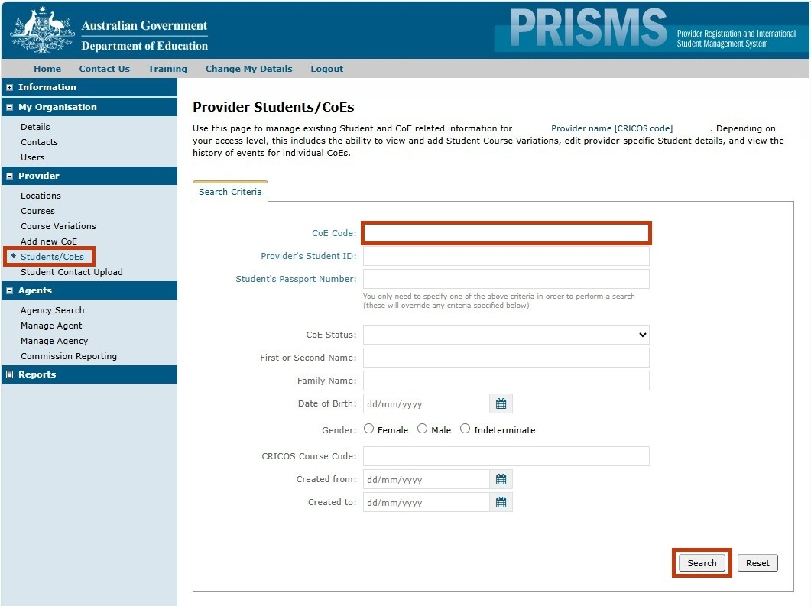

Step 2: Record provider default
- Navigate to the ‘Course Variation/Defaults’ tab, then click Record Provider/Student Default.
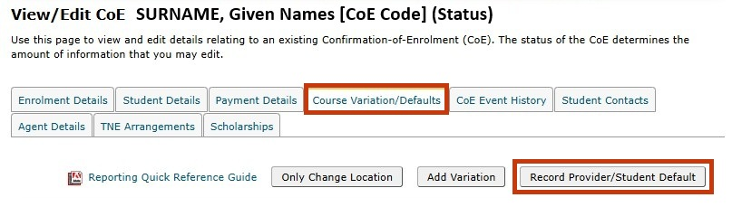
- Review the student’s details to ensure the correct CoE Code has been entered.
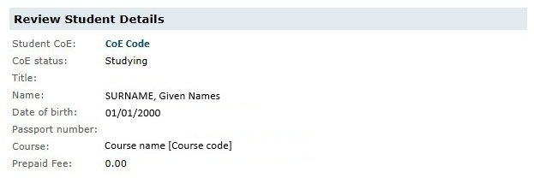
- For a provider default, record the default type as ‘Provider’, then indicate the date the default occurred. If the default occurred before the student commenced their course, select ‘Provider FAILS TO START course’ as the default reason. If the student commenced their course before the default date, select ‘Provider CEASES TO PROVIDE course’.
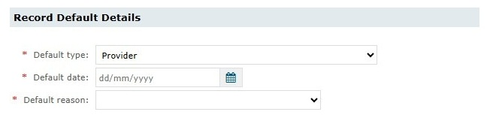
- Confirm or update the student’s contact details.
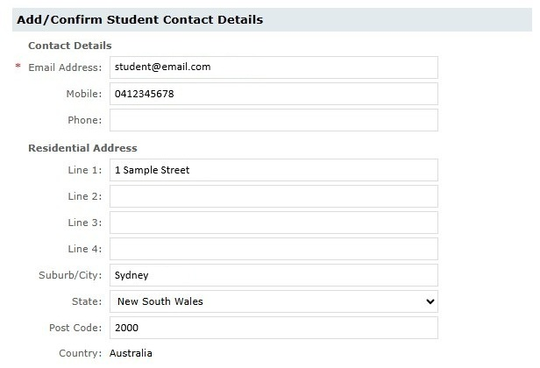

Step 3: Record the default outcome
- To record the default outcome, select ‘Yes’.
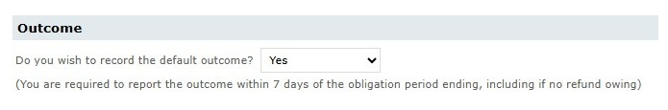
- Select the applicable outcome under ‘Record Outcome’. Please refer to the following list to ensure the correct outcome is selected.
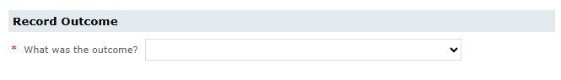
  - Placed student in a course: The defaulted provider arranged for the student to be offered a place in an alternative course, and the student accepted that offer in writing.
  - Refunded tuition fees: The defaulted provider issued a refund of unspent tuition fees to the student.
  - Placed student AND refunded tuition fees: The defaulted provider met both of the above obligations.
  - I did not meet my obligations: The defaulted provider did not arrange for the student to be offered a place in an alternative course which the student accepted in writing and did not provide the student with a refund of unspent tuition fees. This outcome should be selected where the provider has attempted to contact the student but has not received a response, or where the provider is awaiting information from the student.
  - There was no obligation to be met: This outcome must only be selected in exceptional circumstances. Defaulted providers are legally required under section 46D of the ESOS Act to either place the student in an alternative course which the student accepts in writing or refund the student’s unspent tuition fees. Detailed comments must be provided explaining why no obligation applied if this outcome is selected.
- Complete the steps for the applicable outcome, then click Save & Confirm.

Step 3a: ‘Placed student in a course’ outcome
- Indicate the date that the placement arrangements were made. This date may be the date the new CoE was created, the date the written agreement was signed, or the date the student accepted an offer in the new course in writing.
- Provide the student’s new CoE code. If you do not know the student’s new CoE code, provide details in the ‘Comments’ section explaining why you do not know it.
- If applicable, check the box indicating that you have written evidence of the student’s acceptance of an offer in the new course.
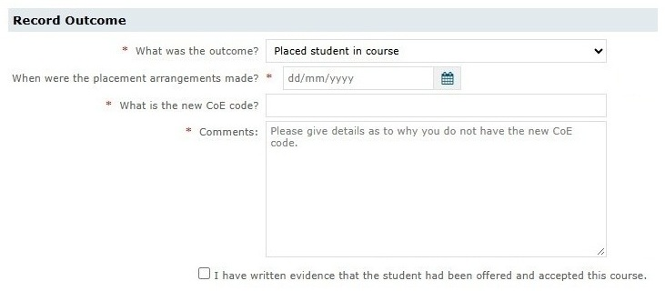

Step 3b: ‘Refunded tuition fees’ outcome
- Indicate the date the student’s refund was issued.
- Indicate the amount refunded (AUD).
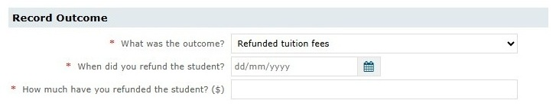

Step 3c: ‘Placed student and refunded tuition fees’ outcome
- Provide the information outlined in Step 3a and Step 3b.
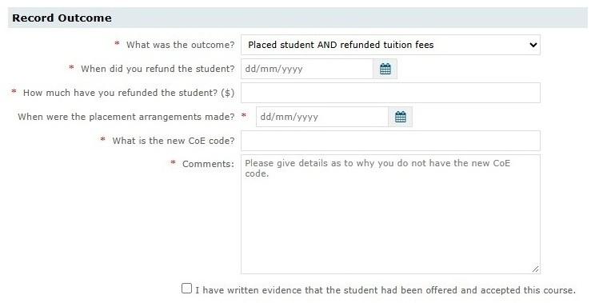

Step 3d: ‘I did not meet my obligations’ outcome
- Indicate the reason why obligations to the student were not met. Reasons may include ‘Student is unreachable’, ‘Awaiting student information’, or ‘Others’.
- Provide details in the ‘Comments’ section as to why obligations to the student were not met.
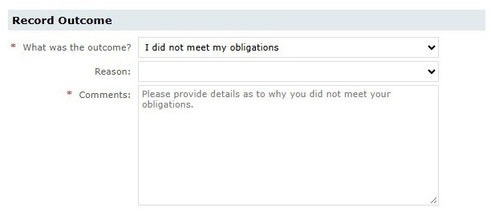

Step 3e: ‘There was no obligation to be met’ outcome
- Provide details explaining why no obligations were required to be met in the ‘Comments’ section.
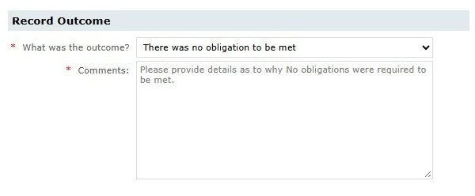

www.legislation.gov.au/C2004A00757/latest/text
www.education.gov.au/tps/international-providers-tps
prisms.education.gov.au/Logon/Logon.aspx

