


National Code Web Portal User Guide
  - Version 1.0


With the exception of the Commonwealth Coat of Arms, the Department’s logo, any material protected by a trademark and where otherwise noted all material presented in this document is provided under a Creative Commons Attribution 4.0 International licence.
The details of the relevant licence conditions are available on the Creative Commons website (accessible using the links provided) as is the full legal code for the CC BY 4.0 International.
The document must be attributed as the Higher Education Gender-based Violence Regulator’s Guidance for the Gender-based Violence Portal.

Contents
National Code Web Portal User Guide 1
Acknowledgment of Country 4
Victim-survivor Acknowledgements 4
About this user guide 5
Purpose 5
Scope 5
Document Version History 6
Key Systems Overview 7
National Code Web Portal 7
myID 7
Relationship Authorisation Manager 7
Accessing the National Code Web Portal 8
Step One: Set up myID 8
Step Two: RAM Authorisation 8
Step Three: Acceptance RAM Registration 9
Step Four: Access the National Code Web Portal 9
Using the National Code Web Portal 12
Step 1: Your tasks 13
Step 2: Upload document 13
Step 3: Successful submission 14
Common Issues and Troubleshooting 14
Before Contacting Support 14
Common Access and Login Issues 15
Common Portal Access Issues 16
Common Submission Issues 17
Support 17
References 18
Acronyms 18
Relevant links 18

Acknowledgment of Country
We acknowledge the Traditional Owners and Custodians of Country throughout Australia and their continuing connection to land, waters and community. We pay our respects to them, their cultures and Elders past and present.

Victim-survivor Acknowledgements
We acknowledge the strength, courage and resilience of those who have experienced gender-based violence. Their lived experience and tireless advocacy have been instrumental in shaping the National Higher Education Code to Prevent and Respond to Gender-based Violence.
Everyone deserves to live a life free from gender-based violence and the opportunity to reach their full potential in higher education. To those whose voices have inspired this change and continue to guide this work—thank you for shaping a future where safety, equality and respect are the foundation of higher education.

About this user guide

Purpose
The National Code Web Portal has been developed to support higher education providers to submit data, plans, reports and information to the Higher Education Gender-based Violence Regulator (GBV Regulator) to demonstrate compliance with the National Higher Education Code to Prevent and Respond to Gender-based Violence (National Code).
This will include regular mandated reporting, such as Whole of Organisation Gender-based Violence Prevention and Response Plans and annual reporting data, as well as other information requested by the GBV Regulator to monitor compliance.
This guidance provides practical instructions for representatives of higher education providers to register, access and use the National Code Web Portal.
This guidance applies to:
- All Table A and Table B providers under the Higher Education Support Act 2003 (Cth); and
- All other higher education providers registered under the Tertiary Education Quality and Standards Agency Act 2011 (Cth).

Who should register for access to the National Code Web Portal?
Multiple users within a higher education provider can register to access the portal. The GBV Regulator recommends ensuring up to 3 people within the organisation have access to ensure the provider is well placed to respond to requests from the GBV Regulator in a timely manner.
Key higher education staff involved in implementing the requirements of the National Code and delivering prevention and response initiatives should register to access the portal. This may include:
- staff within the provider’s centralised prevention and response team (often referred to as Safety and Wellbeing Team or similar)
- staff within the provider’s human resources area who are responsible for managing staff safety and wellbeing
- staff responsible for ensuring legal compliance with regulatory schemes
- staff responsible for data collation and reporting

Scope
This guidance is limited to National Code Web Portal access and functionality. It does not address the collection, preparation or reporting of data and information required under the National Code.
Separate guidance to support compliance with the National Code’s requirements, including annual data collection and reporting, is available on the GBV Regulator’s website.

Document Version History
Version | Publication date | Changes since last version
1 | 1 October 2026 | N/A – Initial version

Key Systems Overview
There are three systems that users will engage with to access the National Code Web Portal.

National Code Web Portal
The National Code Web Portal is a secure online portal managed by the GBV Regulator. It allows higher education providers to upload and submit required information and data to demonstrate compliance with the National Code.

myID
myID is an Australian Government Digital ID application that allows individuals to securely verify their identity online. In line with broader government direction, agencies across sectors such as health, education, regulatory services and revenue rely on myID as the mechanism for ensuring services and systems are only accessible by those with genuine need to have access.
Most people already have a myID account to access other government services, such as Medicare or the Australian Tax Office via MyGov.
To access the National Code Web Portal, you must have a valid myID account with a minimum standard identity strength (however a strong identity strength is recommended as it provides access to all participating government online services).

Does using myID provide the GBV Regulator with access to my personal information?
myID is only used to verify the identity of users for the purposes of accessing the National Code Web Portal. It does not link your other government services to the GBV Regulator. The GBV Regulator will not be able to see any information regarding your interactions with other government services or agencies.

Relationship Authorisation Manager
Relationship Authorisation Manager (RAM) is an application managed by the Australian Taxation Office (ATO) that connects an individual to a business or organisation, allowing them to act on behalf of the business or organisation when accessing government services online.
To access the National Code Web Portal on behalf of your organisation, your myID needs to be linked to your higher education provider in RAM.
The GBV Regulator anticipates that all providers will already be linked to RAM, noting this is a requirement to access key government services, including taxation services. If your organisation has not yet been linked in RAM: the Principal Authority must complete this process before users can be authorised. Step-by-step instructions for registering with RAM are available on the RAM website.

Accessing the National Code Web Portal

Step One: Set up myID
If you already have a myID account with a standard strength: proceed to Step Two.
If you need to set up a myID account or increase the strength of your myID account: please follow the step-by-step instructions available on the myID website.
Note: myID is managed by the Australian Tax Office (ATO) on behalf of the Australian Government. If you require assistance with registering for myID or increasing your myID strength, please refer to the available supports on the myID website.

Step Two: RAM Authorisation
- To link your myID to RAM, you must first identify your organisation’s Principal Authority or Authorisation Administrator.
- Principal Authority (PA) – this is the responsible person for the organisation such as a public officer or director. The Principal Authority can create authorisations for others to act on behalf of the business, including Authorisation Administrator who can also create and manage authorisations.
- Authorisation Administrator (AA) – this is the person who is given authorisation by a Principal Authority or another Authorisation Administrator to manage authorisations on their behalf.

How to identify a Principal Authority or Authorisation Administrator
  - Internal Channels (Recommended)
Contact your organisation’s IT help desk/support team as they may be able to progress your request or direct you to the appropriate area of the institution. If this is not possible, or your IT help desk/support team are unable to assist, we recommend contacting:
- Finance/Accounting Team: RAM access may be managed by a team responsible for the organisation’s central financial/accounting functions who lodge Business Activity Statements (BAS) on behalf of the organisation.
- Human Resources: Staff who are familiar with delegations, compliance and reporting obligations may be able to assist in finding the relevant team/person responsible for RAM.
- Office of the Principal Executive Officer: The Principal Executive Officer will typically be listed as the Principal Authority for an organisation or will know who is.
  - Check Existing Access
If you are already registered in RAM (for example, you have already been given access to another government system on behalf of your organisation), you can use the 'History' function to see which Principal Authority or Authorisation Administrator granted your access. More information is available on the RAM website.
  - Contact RAM Support
If you cannot identify the linked Principal Authority, call the RAM support line for assistance.
Please note: the GBV Regulator is not able to advise who your Principal Authority or Authorisation Administrator is. The Australian Taxation Office (ATO) does not disclose this information for privacy reasons.
- Once you have identified the Principal Authority or an Authorisation Administrator for your organisation, request access to the National Code Web Portal in RAM. Depending on your organisation’s arrangements, you may be required to submit an access request form or business case to facilitate access.
- If your PA or AA needs assistance granting staff access through Relationship Authorisation Manager (RAM): refer them to the adding authorisations in RAM guidance.
- Important: your RAM access must be registered using your full name as per your myID registration, and your work email address. Failure to do so may impact your ability to successfully register with the National Code Web Portal.

Step Three: Acceptance RAM Registration
Once you have been granted access in RAM, you will receive an email containing an authorisation code. To accept the authorisation, sign in to RAM using myID and follow the prompts to enter the authorisation code provided in the email. Step-by-step instructions are available on the RAM website.

Step Four: Access the National Code Web Portal
Before accessing the portal, you will receive a unique registration link from the GBV Regulator and must complete the registration process with this link.
Once registered, navigate to the National Code Web Portal via nationalgbvcodeportal.education.gov.au. You will automatically be directed to myID to commence the log-in process. Follow the below steps:

Step 1: Sign in
On the sign-in page, select the Digital ID for Individuals to continue.
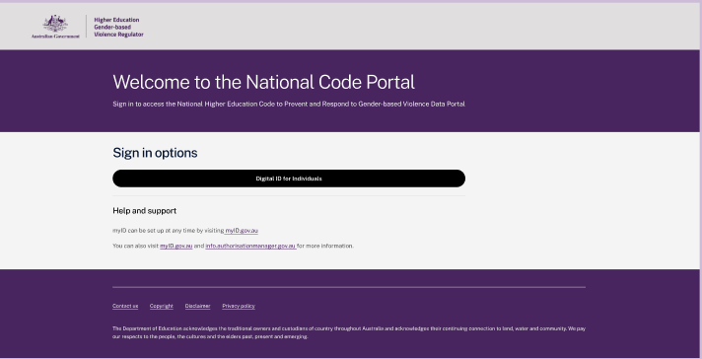

Step 2: Select myID
Select your Identity Provider by clicking ‘Select myID’
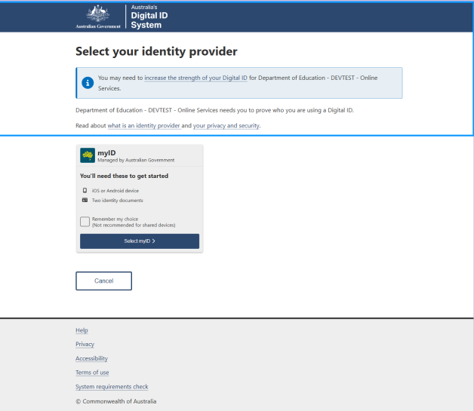

Step 3: Enter email address
Enter the email address associated with your Digital ID (myID), which is usually your personal email address.
Please note: Your personal email address is only used to authenticate you as a user, facilitating access to the National Code Web Portal. The GBV Regulator / the Department of Education will not have access to this email address and will not use it for any communication.
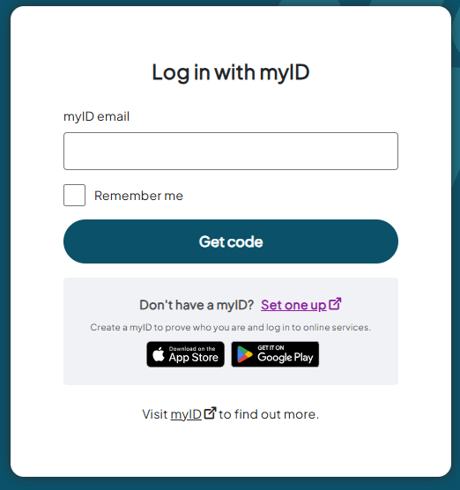

Step 4: Sign in using myID
Open the myID app on your mobile device. Review the code displayed in the app and confirm that it matches the code shown on the screen. If you are prompted, enter the code displayed on the screen into the myID app. Then return to the browser to continue accessing the National Code Portal.
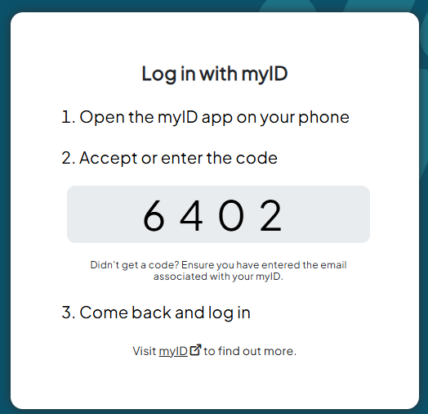

Step 5: Select organisation
Your organisation/employer should be listed on this page. Select your organisation/employer and click the ‘continue’ button.
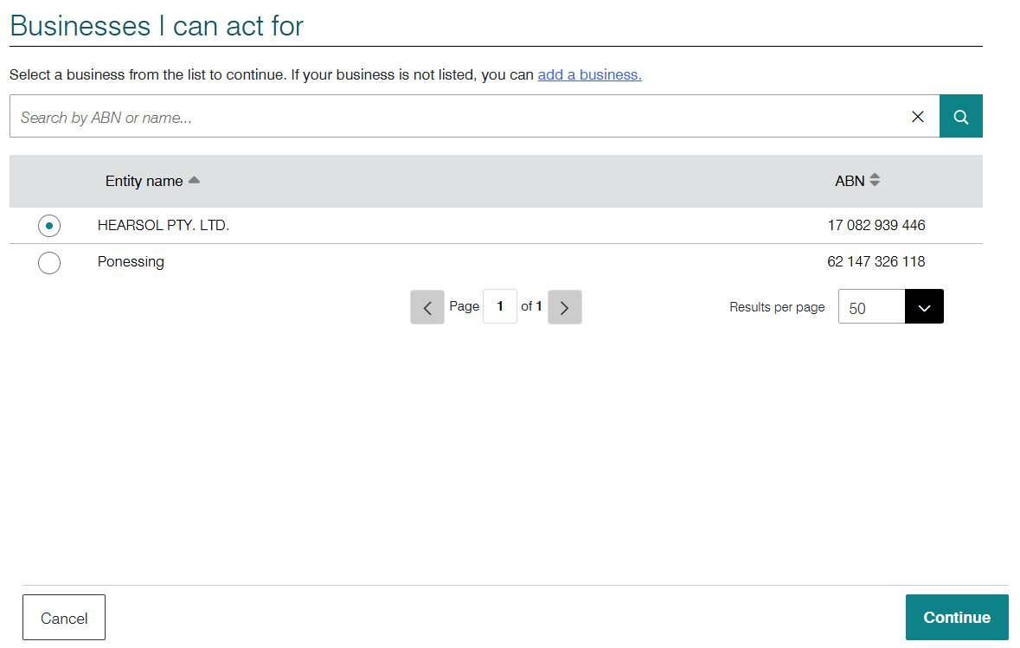
Note: if you have been connected to multiple businesses/organisations in RAM (for example, if you own your own business or have multiple employers), they will all appear on this page. It is important that you only select the higher education provider you will be representing for the purposes of the National Code Web Portal.

Step 6: Provide consent
Review the details that will be shared with RAM. If the details are correct, select Consent to continue.
If you do not want to be asked to provide consent each time you access RAM using your myID, select Yes, remember my consent. This is optional.
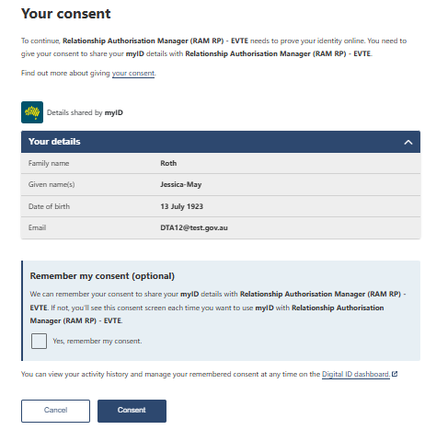
You have now successfully registered for the National Code Web Portal. For information on using the web portal, see section 4 below.

Using the National Code Web Portal
The below steps set out how to navigate and use the National Code Web Portal once you have access (section 3).

Step 1: Your tasks
Once signed in, you will be taken to the ‘Your Tasks’ page. This page displays the reporting tasks available for your organisation.
Select the relevant task. For example, to upload an annual report, locate ‘Annual Report YEAR’ in the list of tasks.
Select the ‘Proceed to upload’ button to begin the submission process.
Note: all staff who are registered with the National Code Web Portal on behalf of an organisation will have access to the required tasks for that organisation.
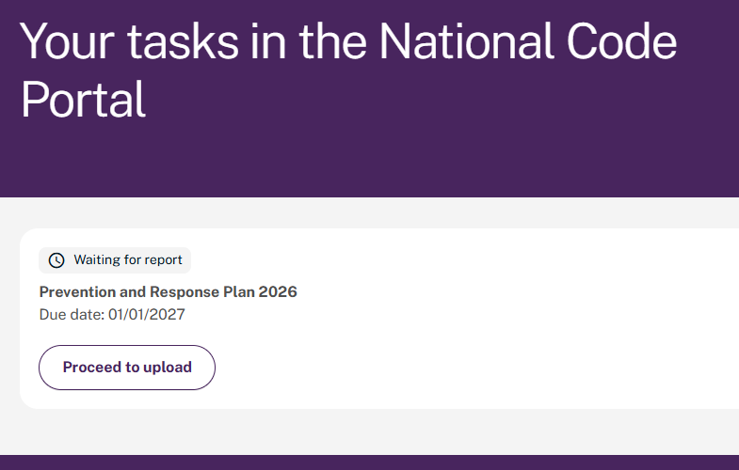

Step 2: Upload document
Select ‘Choose file’ or drag and drop the file into the upload area.
The accepted file types include .doc, .docx and .pdf and must not exceed 20 MB in size for each file.
Click the ‘Submit’ button to complete the upload.
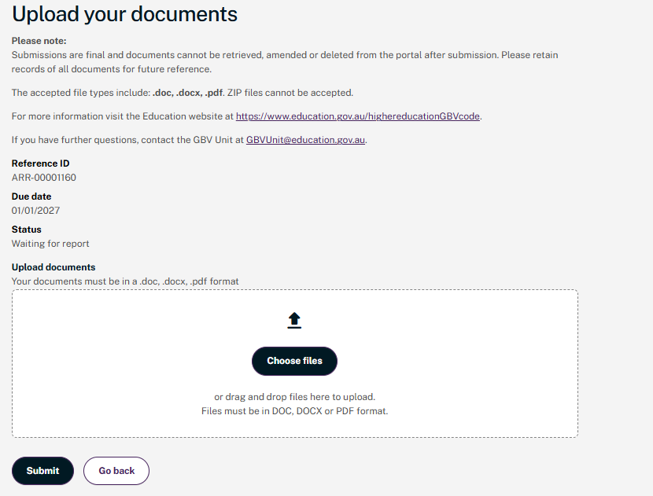

Step 3: Successful submission
After you successfully submit the document, a confirmation message will appear in a green box at the top of the page.
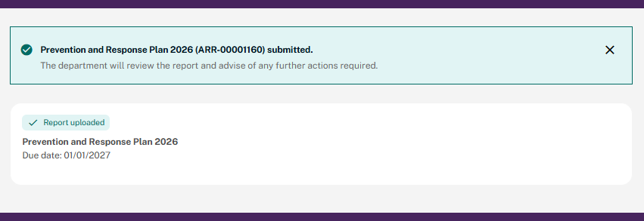
Note: The request will no longer be visible once the document has been successfully uploaded.

Common Issues and Troubleshooting

Before Contacting Support
Before requesting assistance, please:
- Confirm that you are using the correct portal link listed in Section 5.1.
- Check that the relevant myID account is active. See the myID website for further troubleshooting.
- Verify that you have been granted the appropriate Relationship Authorisation Manager (RAM) permissions listed in Section 4.5.7.
- Attempt to log out and sign in again.
- Clear browser cache and refresh the page.
- Review the below common issues and troubleshooting steps.

Common Access and Login Issues
Issue | Possible Causes | Potential Resolution | Next Steps
Unable to log into the National Code Web Portal. | - myID has not been set up correctly.  - myID is not linked to the provider through RAM.  - The user has not accepted their RAM authorisation.  - The wrong myID account is being used.  - The myID application is undergoing maintenance. | - Confirm your myID account is active.  - Verify that your authorisation has been granted and accepted in RAM.  - Ensure you are signing in using the same email address associated with your myID account.  - Sign out and attempt to log in again. | Contact your organisation’s RAM administrator.  Check the myID website for notifications of scheduled (or unscheduled) maintenance.
Organisation does not appear after signing in. | - RAM authorisation has not been granted.  - Authorisation has not been accepted.  - The authorisation has expired.  - You have been granted access to a different ABN. | - Log in to RAM and review your authorisations.  - Confirm you have access to the correct organisation. | Contact your organisation's Principal Authority or Authorisation Administrator to verify the authorisation.
Multi-factor authentication is not working. | - The myID app notifications are disabled.  - The mobile device is offline.  - An incorrect authentication code is being entered. | - Ensure your device has internet access.  - Confirm notifications are enabled for the myID app.  - Restart the myID application.  - Try signing in again. | For myID-specific issues, refer to the official myID guidance listed in Section 4.2.

Common Portal Access Issues
Issue | Possible causes | Potential Resolution
The portal page will not load. | - Browser compatibility issues.  - Temporary network interruption.  - Browser cache or cookies causing conflicts. | - Refresh the page.  - Close and reopen your browser.  - Clear browser cache and cookies.  - Try another supported browser.  - Attempt access from a different network.
An unexpected error message appears. | - Temporary system issue.  - Incomplete data entered into a required field.  - Session timeout. | - Take a screenshot of the error message.  - Record the date and time of the error.  - Log out and sign in again.  - Retry the action at a later day/time.
The portal appears blank or some fields are missing. | - Browser settings preventing content from loading.  - Unsupported browser version.  - Temporary display issue. | - Refresh the page.  - Clear browser cache.  - Open the portal in a different browser.  - Ensure your browser is up to date.
I have been added to RAM but cannot access the Portal | - Registration has not been completed using the invitation email provided by the GBV Regulator  - You signed in with a different myID from the one that was authorised in RAM  - Your RAM authorisation has not yet been processed or assigned to the correct ABN and/or email address. | - Check whether you have completed the registration process using the registration link in the invitation email provided by the GBV Regulator. Registration is only required once unless the authorised user changes.  If you cannot locate the invitation email, contact the GBV Regulator for assistance.  - Ensure you sign in with the same myID that has been authorised in RAM.  - Confirm with your organisation's RAM Administrator that you have been assigned the correct authorisation against the correct ABN and/or email address.

Common Submission Issues
Issue | Possible Causes | Potential Resolution
Unable to upload a document. | - Unsupported file format.  - File exceeds the maximum size limit.  - File name contains unsupported characters.  - Temporary connection issue. | - Confirm the file type is permitted.  - Reduce the file size if necessary.  - Rename the file using standard characters only.  - Try uploading the file again.
My submission will not validate. | - Mandatory fields have not been completed.  - Required supporting documents are missing.  - Information has been entered in an incorrect format. | - Review all mandatory fields.  - Check for any validation messages displayed on screen.  - Upload all required documents.  - Correct any formatting issues and resubmit.
I selected the wrong document or uploaded the incorrect version. | -- | - If the submission has not yet been finalised, remove the document and upload the correct version.  - If the submission has already been submitted, contact the GBV Regulator as soon as possible and provide details of the correction required.
Unsure whether submission was successful. | -- | Indicators of a successful submission:  - A confirmation message displays on the screen.  - The submission status changes to "Submitted".  - The submission appears in your submission history.  - A confirmation email is received (if applicable).

Support
If you are still unable to resolve an issue using this guide, please contact the GBV Regulator at GBVRegulator@education.gov.au and provide:
- Your organisation name
- Your name and contact details
- A description of the issue
- The date and time the issue occurred
- Screenshots of any error messages (if possible)
- The action you were attempting to complete when the issue occurred
This information will assist the support team to investigate and resolve the issue more efficiently.

References

Acronyms
Acronym | Description
ABN | Australian Business Number
ABR | Australian Business Register
ATO | Australian Taxation Office
GBV | Gender-based Violence
RAM | Relationship Authorisation Manager

Relevant links
Material | Link
Digital ID – myID | myID website
Australian Government – Relationship Authorisation Manager | Relationship Authorisation Manager contact and support
Guidance on Collecting Annual Reporting Data | Guidance on Collecting Annual Reporting Data

