


Adding authorisations in Relationship Authorisation Manager (RAM)
  - Guidance


With the exception of the Commonwealth Coat of Arms, the Department’s logo, any material protected by a trade mark and where otherwise noted all material presented in this document is provided under a Creative Commons Attribution 4.0 International licence.
The details of the relevant licence conditions are available on the Creative Commons website (accessible using the links provided) as is the full legal code for the CC BY 4.0 International.
The document must be attributed as the Higher Education Gender-based Violence Regulator’s Guidance for the Gender-based Violence Portal.

Contents
Adding authorisations in Relationship Authorisation Manager (RAM) 1
Purpose and scope 4
Before starting 4
Detailed instructions 4
Support 10

Purpose and scope
This guidance has been developed to support Principal Authorities and/or Authorisation Administrators to grant relevant staff access to the National Code Web Portal in Relationship Authorisation Manager (RAM). More detailed guidance can be found at RAM Support.
The National Code Web Portal enables higher education providers to submit data and information to the Higher Education Gender-based Violence Regulator (GBV Regulator) to demonstrate compliance with the National Higher Education Code to Prevent and Respond to Gender-based Violence (National Code).
For more information, see the National Code Web Portal User Guide.

Before starting
Access to RAM and the National Code Web Portal requires both the Principal Authority/Authorisation Administrator, as well as the staff member seeking access, to have a valid myID account.
If any relevant person does not have a myID, information on creating a myID is available on the myID website.

Detailed instructions

Step 1: Sign in to RAM
Navigate to RAM.
Select Continue with Digital ID and sign in using myID.
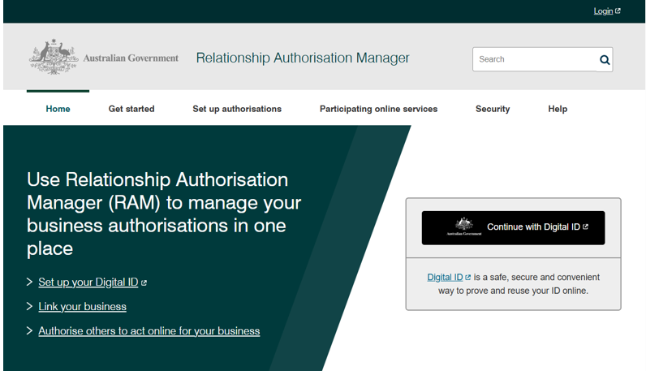

Step 2: View or manage authorisations
Once signed in, go to View or manage authorisations from the home page
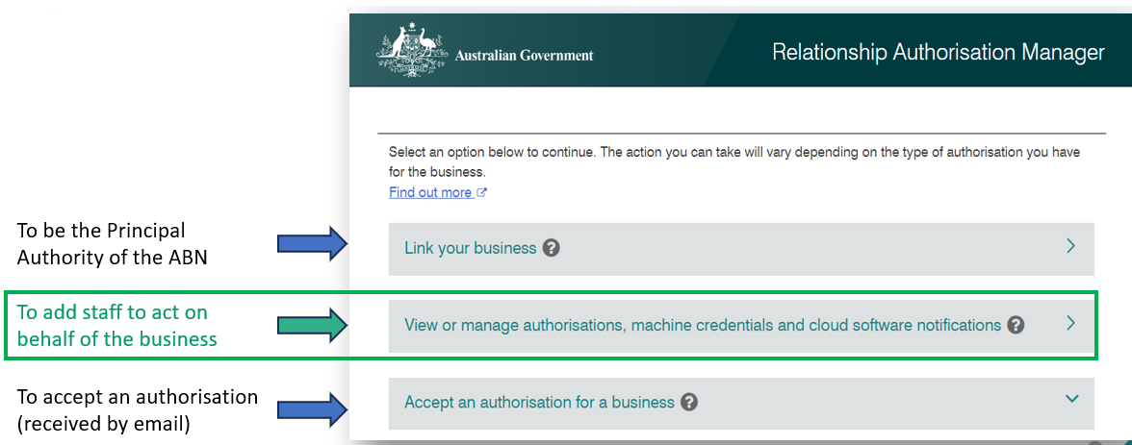

Step 3: Select your organisation
Select the relevant entity (the higher education provider) from the list of available entities
Note: a Principal Authority or Authorisation Administrator may be linked to multiple entities in RAM, for example if they have multiple employers or own their own business.
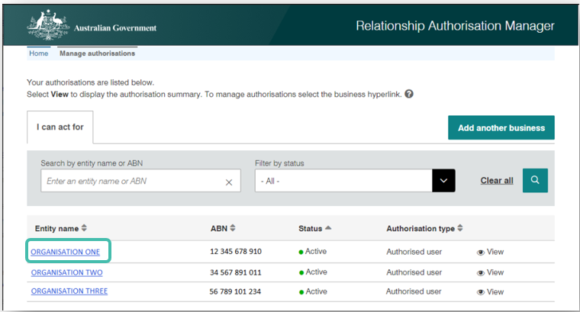

Step 4: Add a new user
All authorised users for this business will be displayed on the page. Click ‘Add new user’ as shown in the diagram below.
Note: We do not recommend using the bulk user upload function available in RAM.
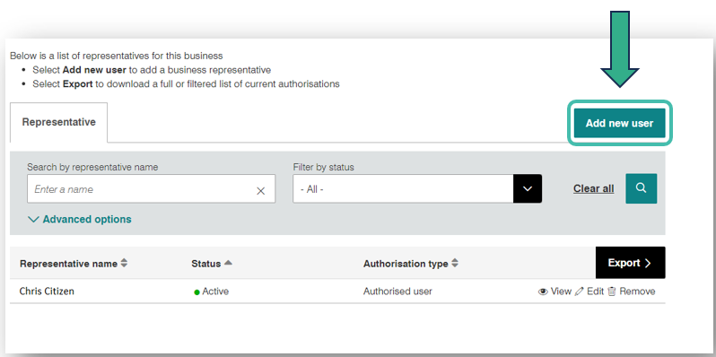

Step 5: Select user type
Select ‘Standard User’ in the dropdown box shown below and hit the ‘Continue’ button.
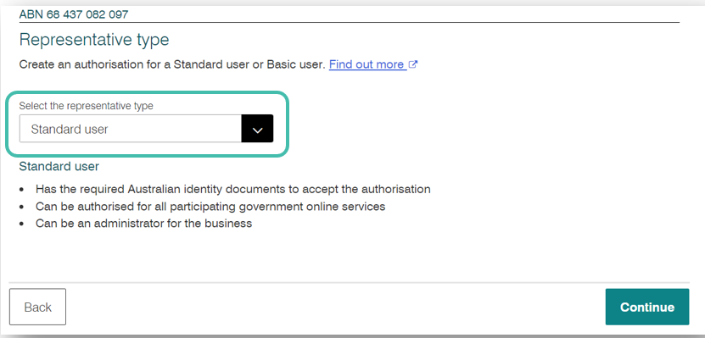

Step 6: Enter representative details
On the Representative details page, enter the full name and email address of the employee you wish to grant access to.
IMPORTANT:
Enter the user's full name exactly as it appears in their myID. If the name entered does not match their Digital ID, the user will not be able to accept the authorisation.
The email address must be the same as the user’s email address provided to the GBV Regulator. This is usually the employee’s nominated work email address. This will likely be different to the personal email address they use to login to myID.
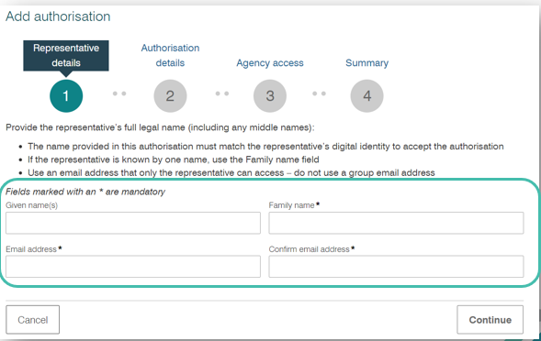

Step 7: Configure authorisation settings
On the Authorisation details page:
- Select ‘yes’ or ‘no’ to whether you want the employee to be an Authorisation Administrator. Answering yes will allow the employee to manage access to the organisation in RAM for other users.
- Select ‘no’ to whether you want the employee to be a Machine credential administrator.
- Enter the start and end date for the authorisation. The start date should reflect the day the user is given authorisation, and the end date (if applicable) should reflect when the user is authorised until. Alternatively, you can select ‘No end date’.
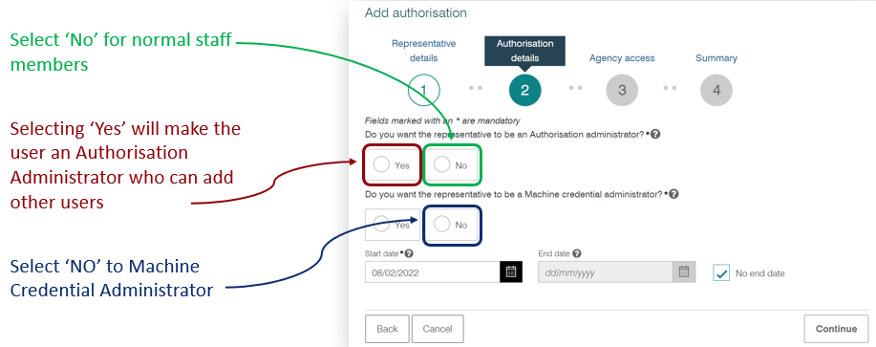

Step 8: Grant access to the National Code Web Portal
On the Agency Access Page, scroll down to Department of Education and select + View services.
Choose The National Higher Education Code to Prevent and Respond to Gender-based Violence Data Portal and select Continue.
Note: Please only grant access to additional services or agencies if they are required for the user's role.
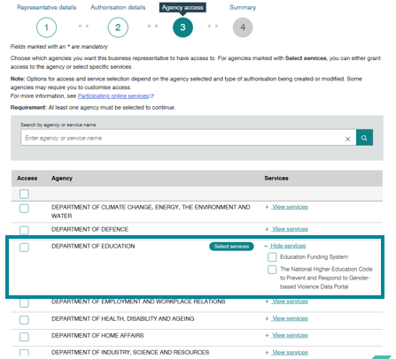

Step 9: Review and submit the authorisation
Review the authorisation details and declaration, click to accept the declaration, and then select Submit.
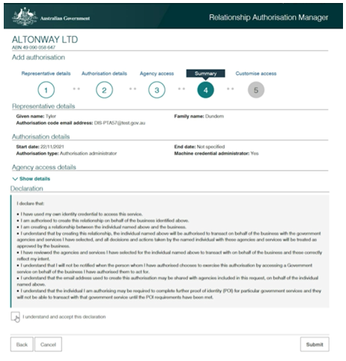

Step 10: User accepts the authorisation
An authorisation request will be sent to the user's nominated email address. The email will include an authorisation code.
To accept the authorisation, the user must sign in to RAM using their Digital ID (myID) and enter the authorisation code when prompted. For more information, the user should refer to the National Code Web Portal User Guide.
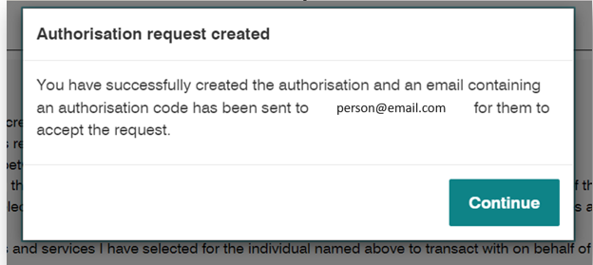

Support
If you require any assistance in granting access to new user via RAM, please refer to the RAM website.
If you require any assistance in relation to the National Code Web Portal, please contact GBVRegulator@education.gov.au.

