


Agent Commissions Data Collection
  - Finance Officer Factsheet

Purpose
This factsheet provides practical guidance for finance officers supporting CRICOS registered providers to complete the 2026 Agent Commissions Data Collection.
The guidance is general in nature and does not constitute accounting or legal advice. Providers should consider their own circumstances and seek professional advice where appropriate.

How to use this factsheet
This factsheet provides guidance on the financial and accounting considerations relevant to preparing the collection. It should be read together with:
- the Secretary’s written request, which specifies the information required, reporting period and due date
- the Principal Executive Officer Factsheet, which outlines governance and assurance considerations
- the PRISMS Guidance, which explains how to complete the template and submit the response.

Background: What is this and why is Finance involved?
The Education Services for Overseas Students Act 2000 (ESOS Act) sets out the legal framework governing delivery of education to international students in Australia on a student visa. Under section 21B of the ESOS Act, the Secretary of the Department of Education (the department) may require CRICOS registered providers to give information about commissions paid or provided to education agents in connection with the recruitment of accepted students. Providers are required to submit the requested information within the timeframe specified in the Secretary's request and should ensure that information provided is complete, accurate and supported by appropriate records.
For each agent business, providers are asked to report:
- number of accepted students: students accepted or enrolled who require a student visa and for whom a related commission was paid or incurred in the reporting period
- direct commissions paid or incurred: monetary amounts attributable to the number of accepted students
- indirect commissions paid or incurred: monetary amounts that are not attributable to the number of accepted students
- non-monetary benefits: a short text description of non-cash benefits provided to an education agent or associate.
The Secretary’s written request for education agent commission information will specify the date providers must submit the information.
The ESOS Act and related collection terms may not align precisely with concepts used in Australian Accounting Standards Board (AASB) standards. For the purposes of this collection, providers should apply the statutory definitions and guidance provided by the department.
The involvement of finance officers is important because relevant data may be held in accounts payable, general ledger and contract management systems, as well as in student management systems.
Important: This collection is undertaken under section 21B of the ESOS Act. Providers should take reasonable steps to ensure information supplied to the department is complete and accurate. The ESOS Act includes provisions relating to non-compliance with a request for information and the provision of false or misleading information.

At a glance: Key accounting positions
Topic | Position | Rationale
Reporting basis | Accrual preferred; cash permitted where required or more appropriate | Promotes consistency with provider financial records and supports reconciliation to the general ledger.
GST treatment | All amounts GST exclusive | Ensures monetary values are reported on a consistent GST-exclusive basis across agents and provider systems.
Currency conversion | Rate at date of payment or obligation; use 30 June 2026 rate if unavailable | Consistent with a transaction-date approach, with a practical fallback where source rates are not available.
Direct vs Indirect classification | Apply the attribution test (see diagram below) | Applies the ESOS collection definitions. AASB 15 concepts are included as an interpretive aid only.
Non-monetary benefits | Financial (fair or actual) value not required – description only | Reduces inconsistency of approach across providers.
Reporting period | 1 January – 30 June 2026 | Fixed by the Secretary's request.

Classifying payments as direct or indirect
For the purposes of classifying direct and indirect commissions, please use the following definitions:
- Direct commission: "A cash or cash-like payment that relates directly to the acceptance of a student".
- Indirect commission: "A cash or cash-like payment that does not relate directly to the acceptance of a student".
For classification purposes, the key question is whether the payment can be attributed to the acceptance of an identifiable student or students. A payment may be connected with recruitment activity generally but still be indirect if it is not attributable to specific student acceptances.
AASB 15 concepts may assist finance officers to analyse the substance of a payment. However, the AASB comparison is an interpretive aid only and does not replace the ESOS Act or the collection definitions.
ESOS Term | Possible AASB 15 comparison | Characteristic
Direct | Incremental cost of obtaining a specific contract | Would not have been incurred if that specific student acceptance or contract had not occurred
Indirect | General selling expense or portfolio-level cost | Incurred in connection with recruitment activity generally, but not attributable to a specific student acceptance

The attribution test
Can the education agent commission payment be attributed to the acceptance of an identifiable student or students? In practice, this asks whether a specific student acceptance triggered the payment obligation.
Answer | Classification
Yes - the payment can be attributed to the acceptance of an identifiable student or students. | Direct
No - the payment is triggered by aggregate metrics, collective thresholds or activity not attributable to identifiable student acceptances. | Indirect

Supplementary: Mixed payments
Where a single agent agreement or invoice includes both a component attributable to specific students and a component that is not, split the payment into its direct and indirect components:
- Per-student component: classify as Direct.
- Fixed or retainer component: classify as Indirect.
Example: An agreement provides for a $500 monthly retainer plus $1,500 for each enrolled student.
- The $500 monthly retainer is Indirect, as it is payable regardless of whether a specific student is accepted.
- The $1,500 per-student amount is Direct, as each payment is attributable to an identifiable student acceptance.
Apply the split at invoice line level where possible. If that is not available, derive a reasonable allocation from the agent agreement and apply it consistently to payments for the reporting period.

Supplementary: Reversals, clawbacks and credit notes
Where an agreement with an agent allows for reversals or clawbacks, these negative amounts should be included in the overall calculation of direct and indirect commissions. In the situation where total direct or indirect payments to an agent business are overall negative for the period (i.e. reversals and clawbacks exceed outgoing payments), record a negative amount in the template. This situation was considered when designing the collection.
Where a reversal or clawback relates to students previously included in the accepted student count, providers may make a corresponding adjustment to the accepted student count. If those adjustments exceed new accepted students associated with direct commissions during the reporting period, a negative accepted student count may be reported.
Credit notes should be accounted for under standard accrual practices. Reported commissions cannot be corrected after the collection timeframe is closed, so if a credit note is accounted for in one reporting period, it should not be reported again in any future reporting period. It is recommended that credit notes be identified in any reconciliation notes to reduce the risk of double counting in future collections.

Supplementary: Cash vs accrual accounting
Accrual accounting is the preferred standard, in alignment with Australian Accounting Standards. However, in situations where accrual accounting may provide a misleading impression of commissions paid, have poor alignment with accepted student counts, or are not aligned with the provider’s current accounting arrangements, cash-based accounting can be used. Keep a note of any use of cash accounting for future records and to ensure consistency across future reporting periods.

Classification decision diagram
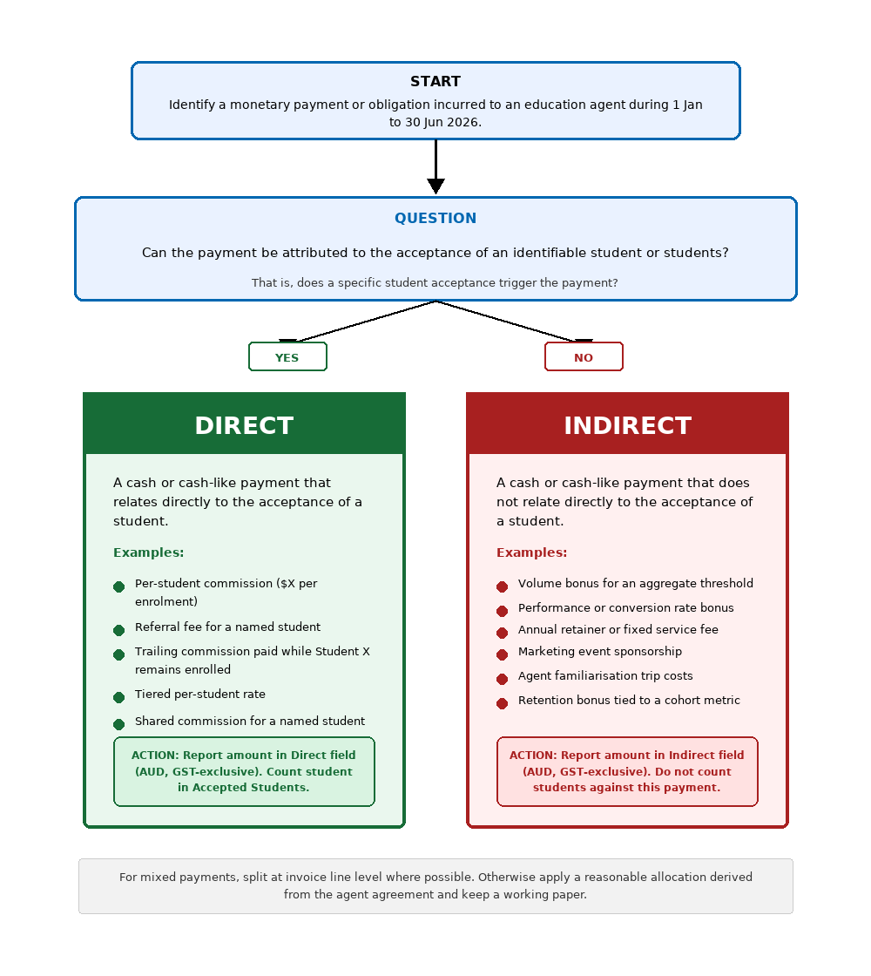

Supplementary: Tuition fee payments made through agent
Where an agreement with an agent requires or otherwise allows all student payments to be made to the agent, which are then passed through to the provider after some trigger (e.g. visa grant) with the one or more fees kept by the agent, these retained fees should be identified as a direct payment to the agent. For example:
- A written agreement requires the payment of $1000 enrolment/administration fee, $5000 pre-paid tuition fees and $500 materials fees
- Student pays all three fees to the agent
- Upon visa issue, agent transfers the pre-paid tuition and materials fees to the provider and is permitted by the provider to retain the $1000 enrolment/administration fee.
The $1000 enrolment/administration fee is a direct commission and should be reported.

Common classifications — quick reference
Examples only. This list is not definitive or exhaustive.
Payment type | Attributable to a specific student? | Classification
Per-student commission ($X per enrolment) | Yes - paid because Student A enrolled | Direct
Tiered/escalating per-student rate | Yes - each payment remains attributable to a named student, even if the rate varies. | Direct
Referral fee for a named student | Yes - explicitly tied to one person | Direct
Trailing commission (annual payment while Student X remains enrolled) | Yes - each instalment tied to a named student's continued enrolment | Direct
Commission top-up at census for a named student who hasn't withdrawn | Yes - paid because Student A remained enrolled | Direct
Shared commission (two agents, one student) | Yes - each agent's portion is still attributable to that student | Direct (each agent’s share)
Scholarships or fee discounts offered at agent's request | Yes – attributable to a specific student as reduced revenue | Direct
Retained fees for amounts paid through the agent | Yes – attributable to a specific student | Direct
Volume bonus ($Y lump sum when Z students reached) | No - aggregate trigger; not attributable to an identifiable student acceptance. | Indirect
Performance bonus (conversion rate target) | No - rewards process efficiency across a cohort. | Indirect
Retention bonus ($Y if attrition stays below Z%) | No - portfolio-level metric. | Indirect
Annual retainer or fixed service fee | No - payable regardless of whether a specific student is accepted. | Indirect
Marketing event sponsorship | No - payable regardless of whether a specific student is accepted. | Indirect
Platform/portal access fee | No - payable regardless of whether a specific student is accepted. | Indirect

Supplementary: Why volume bonuses are generally indirect
A volume bonus may appear to be Direct because it is linked to enrolment outcomes. However, the ESOS collection definition asks whether the payment relates directly to the acceptance of a student.
A volume bonus is generally triggered by an aggregate threshold, such as a specified number of enrolments. If the payment cannot be attributed to the acceptance of an identifiable student or students, it should be treated as a portfolio-level incentive and classified as Indirect.
This is broadly consistent with the AASB 15 concept that an incremental cost of obtaining a contract is a cost that would not have been incurred if that contract had not been obtained. This comparison is an interpretive aid only.

Non-monetary benefits
The agent commissions data collection does not require providers to report the monetary value of non-monetary benefits provided to an agent business. Instead, providers are only required to provide a description of the non-monetary benefits that were provided during the reporting period.
This differs from some accounting and financial reporting requirements, where a monetary value may be assigned to non-cash benefits. The department has decided not to define a specified monetary value after consultation with the sector.
A non-monetary benefit may be provided directly (for example, where a provider purchases and supplies an airline ticket) or indirectly through reimbursement of a specific expense incurred by the agent. The method of provision does not affect the classification of the benefit as a non-monetary benefit for the purposes of this collection.

Non-monetary classifications – quick reference
Examples only. This list is not definitive or exhaustive.
Benefit | Non-monetary under ESOS?
Flights and accommodation for agent familiarisation trips | Yes
Meals, venue hire, entertainment at provider-hosted events | Yes
Merchandise or gifts provided to agents | Yes
Free or discounted access to provider facilities (e.g., office space, technology) | Yes
Free or discounted courses for agent staff | Yes
Marketing materials provided to agents for use with students | Yes
Commissions paid in the form of credit notes against future invoices | No — cash-like, not non-monetary

Practical guidance to non-monetary benefits data field
Provide a concise description of the nature of the non-monetary benefits provided to each agent business. The description should give sufficient context to understand the type of benefit provided but should not include a monetary value.
Examples include:
- Funded return flights and 3 nights accommodation for 2 staff to attend annual agent familiarisation event in Sydney (May 2026). Provided branded merchandise packs for student recruitment events.
- Provided complimentary access to agent portal, quarterly marketing collateral packs, and hosted 1 agent staff member at campus open day including meals and transport.
Note: If no non-monetary benefits were provided to an agent business during the reporting period, enter "Nil".

Reconciling the ESOS agent commissions data collection to provider financial records
The ESOS agent commissions data collection serves a different purpose from provider financial statements. A one-to-one reconciliation may not be possible, but providers should be able to explain and evidence material differences. A reconciliation working paper should address:
Reconciliation area | Working paper consideration
General ledger/AP extraction | Record the GL accounts, cost centres, supplier groups and AP fields used to identify agent commission amounts.
Timing and completeness | Identify accrued but uninvoiced amounts, invoices received after period end, reversals and credit notes affecting the reporting period.
Direct/indirect allocation | Document the basis for classifying each payment type, including treatment of mixed invoices, retainers, volume bonuses and shared commissions.
Foreign currency | Record the exchange rate source and date used for each foreign currency amount, including any 30 June 2026 fallback rate.
GST-exclusive reporting | Retain evidence that GST has been excluded from reported monetary amounts.
Accepted students count | Reconcile the count to commission records and retain evidence that each counted student has a related Direct commission reported in the period.
Non-monetary benefits | Record the GL accounts and cost centres excluded from indirect benefit calculation due to the non-monetary nature of the benefit provided.
Recommendation: Prepare a brief reconciliation note for your files explaining the basis of preparation. This supports internal audit review, external audit of financial statements, where agent commissions are material and any future Department or regulator validation queries.

Accepted student count in practice
The ESOS Act definition (section 5) defines an accepted student as a person who is accepted for enrolment, or enrolled, in a course provided by the registered provider and who is, or will be, required to hold a student visa. For the purposes of this collection, count an accepted student only where a direct education agent commission is reported for the reporting period. If no related commission is reported in the period, do not include the student in the accepted student count.

Quick Reference: Reporting Checklist
- Use an accrual basis where commission obligations were incurred during the reporting period. Where accrual information is unavailable or may not appropriately reflect the provider’s arrangements, a cash basis may be used and the basis should be documented. Extract all agent commission payments or obligations for 1 January to 30 June 2026.
- Ensure reported monetary amounts are provided on a GST-exclusive basis.
- Convert foreign currency amounts to AUD using the exchange rate at the date of payment or obligation. If that rate is unavailable, use the 30 June 2026 rate and keep appropriate records of the source used.
- Classify each payment as Direct or Indirect using the attribution test.
- For capitalised commissions, where relevant, report the amortisation amount expensed during the reporting period.
- Count Accepted Students only where a direct commission amount is reported in the period.
- Describe non-monetary benefits in 255 characters or fewer per agent business or record "nil".
- Download and populate the collection template available in PRISMS. Details for completing the template can be found in the Education Agent Commission – PRISMS Guidance.
- Consider preparing and retaining a reconciliation note for provider records.
- Submit the completed response by the due date specified in the Secretary’s written request and displayed in PRISMS.

This factsheet is intended as a practical guide for finance teams supporting the agent commissions data collection. It does not constitute accounting or legal advice. Providers should ensure their reporting approach is reviewed by appropriately qualified finance and legal professionals.

Other support documentation
Providers may wish to refer to the:
- Principal Executive Officer Factsheet
- PRISMS Guidance
- Education agent and commissions fact sheet
Document version: 1.0 Final
First published: 21 Sept 2026
Last updated: N/A (draft versions)

