

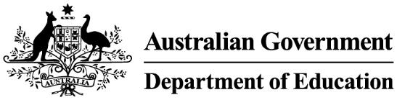

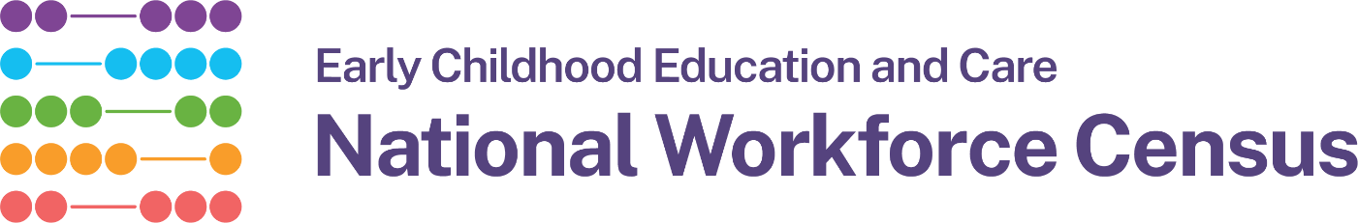

Privacy notice for families

The Australian Government Department of Education is conducting the Early Childhood Education and Care (ECEC) 2026 National Workforce Census (NWC) from 14 September to 11 December 2026.

The NWC collects information about ECEC services, workers and children. It helps governments understand the ECEC workforce and plan for future workforce needs.

The NWC does not collect children’s names.

If you do not want your child included in the census, you can choose to opt-out.

To opt-out, please let your service know by 21 September 2026.

To read the full privacy notice, ask your service director for a copy, or visit:

https://www.education.gov.au/early-childhood/resources/2026-early-childhood-education-and-care-national-workforce-census-privacy-notice

