
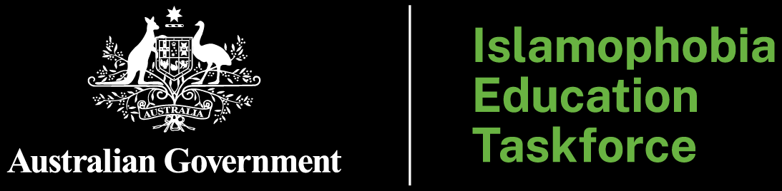

Terms of Reference
Addressing Islamophobia in the education sector is a priority for the Australian Government. There is no place in Australia for Islamophobia, religious hatred or discrimination of any kind. Everyone should be able to participate in education, and in the Australian community, without prejudice or discrimination.
The Australian Government is committed to helping Australia’s education system prevent, tackle, and properly respond to Islamophobia. The Islamophobia Education Taskforce (the Taskforce) is established to provide time-limited, focused national leadership to progress agreed education measures and advise on any further measures required.

1. Purpose
The purpose of the Taskforce is to help the Australian education system prevent, tackle, and properly respond to Islamophobia, and to contribute to existing efforts to strengthen social cohesion through education. In undertaking its work, the Taskforce will oversee rapid implementation of education-related measures identified in the Australian Government’s response to the Special Envoy to Combat Islamophobia’s report, and identify further measures to combat Islamophobia in education settings.

2. Scope
The scope of work covers all Australian education systems including early childhood education and care, schooling and tertiary education including vocational education and training and higher education.
The Taskforce will drive and monitor implementation of education measures announced as part of the Australian Government’s response to the Special Envoy’s Plan to Combat Islamophobia. This includes:
- a focused review of the Australian Curriculum, including primary and secondary content, to identify opportunities to strengthen racial and religious tolerance, ensuring that students can develop the knowledge and capabilities required to support a cohesive, inclusive and respectful society. The focused review will examine all forms of hatred, including islamophobia. It will be undertaken by ACARA, who will provide advice to Education Ministers.
- providing early childhood educators, teachers, school leaders and families with access to free high-quality resources and guidance to combat racial and religious discrimination, including Islamophobia, to be added to the new Social Cohesion Education Hub.
- development and delivery of a Social Cohesion Framework for Schools that delivers practical, evidence-based guidance to support inclusive, safe and respectful learning environments and to prevent and respond to Islamophobia, faith-based discrimination, racism and other forms of discrimination.
- development of a national, consistent framework for anti-racism in universities, aligned with the National Anti-Racism Framework. This may include the development of specific guidelines to combat Islamophobia that address incidents of Islamophobia explicitly, outlining prevention strategies, response protocols, educational initiatives and support services for affected individuals, including staff.
- support the ongoing work of TEQSA to implement strengthened powers and penalties to ensure it is able to step in and act when it is justified in the public interest, and stronger Commonwealth higher education regulation that ensure institutions demonstrate a commitment to addressing racism, and ensure TEQSA can monitor compliance.
- explore and share best practices and new ideas for tackling, responding to, and preventing Islamophobia including in education settings and leveraging educations to strengthen social cohesion in Australia.
The Taskforce will also identify and advise on any further measures required to tackle, respond to, and prevent Islamophobia.

3. Membership
Representation on the Taskforce will include:
- Ms Jasmina Joldić PSM (Interim Chair)
- Australia’s Special Envoy to Combat Islamophobia
- Australian Government Department of Education
- State and territory departments of education
- Independent Schools Australia
- Islamic Schools Association of Australia
- National Catholic Education Commission
- Australian Children’s Education and Care Quality Authority
- Australian Curriculum, Assessment and Reporting Authority
- Australian Institute for Teaching and School Leadership
- Education Services Australia
- The Tertiary Education Quality and Standards Agency
- Universities Australia
- The Australian Tertiary Education Commission
- Department of Employment and Workplace Relations
- Other relevant community representatives, subject matter experts and stakeholder groups, as determined by the Chair, to ensure the Taskforce’s work is grounded in lived experience and evidence.
The Taskforce will be supported by a secretariat in the Australian Government Department of Education.

4. Consultation
The Taskforce will, as appropriate, consult with the Australian Muslim community and representative organisations; young people, students and their parents and carers; early education providers; educators, teachers and school leaders; the National Principal Reference Group; student, education and industrial unions; and universities and tertiary education providers.

5. Timing and reporting
The Taskforce will present early findings and directions to the Education Ministers Meeting within 6 months, noting any emerging priorities, implementation risks and proposed next steps.
The Taskforce may provide a final report at 12 months, setting out progress against agreed measures, any further recommended actions, and any issues requiring ministerial consideration.

