


Task card
  - How to edit child enrolments in the Provider Entry Point

Overview 1
Logging in 2
Editing an enrolment 2

Overview
This task card outlines how to edit child enrolments using the Provider Entry Point (PEP).
This task card is for providers that use the Provider Entry Point (PEP). If you use third-party software, contact your software provider for help.
Find more task cards for the PEP on our website.
If you need further assistance, contact the Child Care Subsidy Provider Helpdesk on 1300 667 276 9am to 5pm AEST or via email anytime.
Note: Only certain special characters can be used in the PEP:
- full stop (.)
- comma (,)
- hyphen (-)
- slashes (/, \)
- apostrophe (‘).
All other special characters will cause an error in the system.

Logging in

Step 1
Log in to the Provider Entry Point (PEP).

Step 2
Once logged in, select the service where the enrolment applies.

Editing an enrolment

Step 1
From the service landing page, select More details under Enrolments.
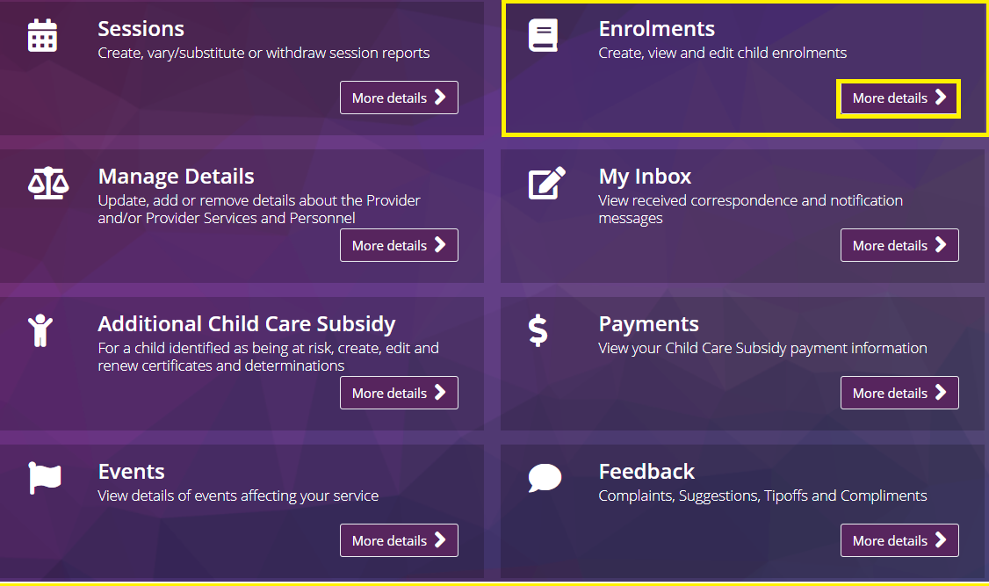

Step 2
All current enrolments associated with the service will be displayed. Select the enrolment you wish to update.
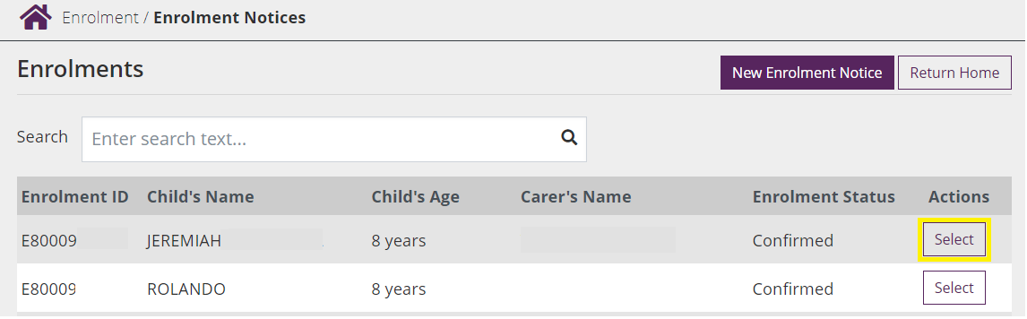

Step 3
Select Update from the Actions drop down menu.
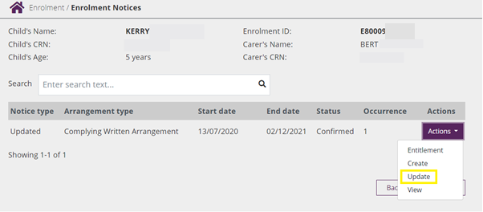

Step 4
The following fields of the enrolment are editable:
- Child under state/territory care (yes/no)
- Enrolment start and end dates
- CRNs for the child and claimant, where these were not previously provided
- Party to arrangement/organisation name (if applicable)
- Educator details, where the primary educator for Family Day Care and In Home Care enrolments has changed.
Enter the date that the care details changed under Date of Event.
Select Next.
Note: If an enrolment is being updated following a claimant dispute, the date of event should be the date the dispute was submitted. Services will receive a notification containing the dispute details and should contact the claimant to discuss and clarify the issue before updating the enrolment.
Important: The system will indicate if the enrolment information is being submitted late. If so, a reason must be recorded in the reason field.
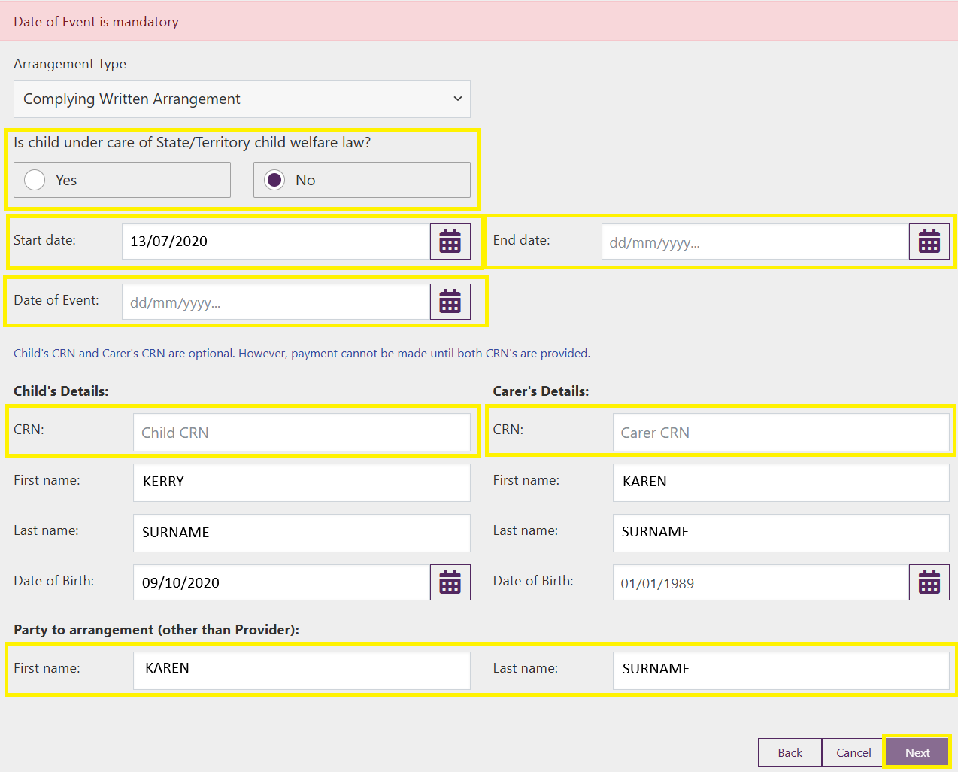

Step 5
Review and update the following information as needed by selecting Edit:
- Session type (type of care)
- Details of routine sessions (start time, end time, fee amount and fee unit)
- Details of casual fees (description, fee amount, fee unit (session or hourly) and session length)
Select Submit. An enrolment notice receipt will be generated.
Select Return Home to return to the Provider Home Page or Continue to return to the enrolment summary page.

