


Task card
  - How to create child enrolments in the Provider Entry Point

Overview 1
Logging in 2
Creating an enrolment 2

Overview
This task card outlines how to create child enrolments using the Provider Entry Point (PEP). If you use third-party software, contact your software provider for help.
Find more task cards for the PEP on our website.
If you need further assistance, contact the Child Care Subsidy Provider Helpdesk on 1300 667 276 9am to 5pm AEST or via email anytime.
Note: Only certain special characters can be used in the PEP:
- full stop (.)
- comma (,)
- hyphen (-)
- slashes (/, \)
- apostrophe (‘).
All other special characters will cause an error in the system.

Logging in

Step 1
Log in to the Provider Entry Point (PEP).

Step 2
Once logged in, select the service where the enrolment applies.

Creating an enrolment

Before you begin
To commence an enrolment, you will need to know the following details.

The type of care arrangement
There are four types of arrangements:
- Complying Written Arrangement (CWA)
- Relevant Arrangement (RA)
- Provider Eligible Arrangement (PEA)
- Arrangement with Organisation (OA)
Refer to the Child Care Provider Handbook for a description of each arrangement type.

Customer details
If you’re creating a CWA, you’ll need the following information for both the Child Care Subsidy (CCS) claimant and the child:
- Customer Reference Number (CRN) – Child and claimant CRNs can be added later; however, CCS and ACCS cannot be paid until both CRNs have been provided.
- First and last name
- Date of birth.
- Care status (if the child is under care of the state/territory)
If you are creating an RA or OA, you will need the below information:
- Child CRN
- First and last name
- Date of birth.
- Party to the arrangement (Organisation or liable individual)
- Care status (if the child is under care of the state/territory)
If you are creating a PEA, you will require the below information:
- Child CRN
- First and last name
- Date of birth
- Care status (if the child is under care of the state/territory)
CCS/ACCS is not payable where children are under the care of a person (other than a foster parent) under a state/territory child welfare law.

Start date of enrolment
- the date the provider and individual/organisation entered into an arrangement for care, or
- the start date of the certificate for a PEA enrolment.

End date of enrolment (if applicable)
- If known, the date the enrolment will cease

Reason for late submission (if applicable)
Enrolments must be submitted within 7 days after the end of the week in which the care arrangement was made. If you have exceeded this timeframe, you must provide a reason.

Session and usual fee details
Session and fee details should accurately reflect the agreed care arrangement.
- Routine, casual or combined care
- Weekly or fortnightly cycle
- Session start and end times
- Usual fee amount

Step 1
From the service home page, select More details under Enrolments.
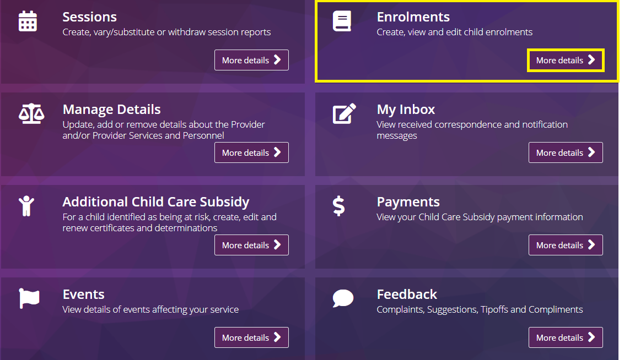

Step 2
Select New Enrolment Notice.
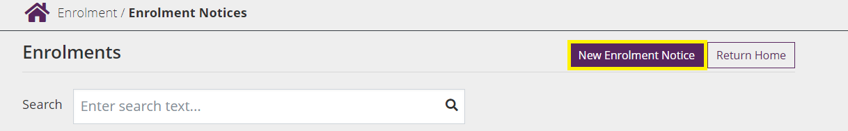

Step 3
Select an Arrangement Type from the drop-down menu.
Select Yes or No as applicable if the child is under care of state/territory child welfare law.
Input the arrangement start date (which cannot be a date in the future) and end date (if applicable).
Note: The system will indicate if the enrolment information is being submitted late. If submitted late, a reason will need to be recorded in the free text fields.
Provide the CRN (if known), first name, last name and date of birth of the child for whom care is being provided.
For Family Day Care or In Home Care services, select the educator who is the primary educator for the child from the list of registered educators.
Note: the educator must be registered in PRODA and added as an educator of the service for this step to occur.
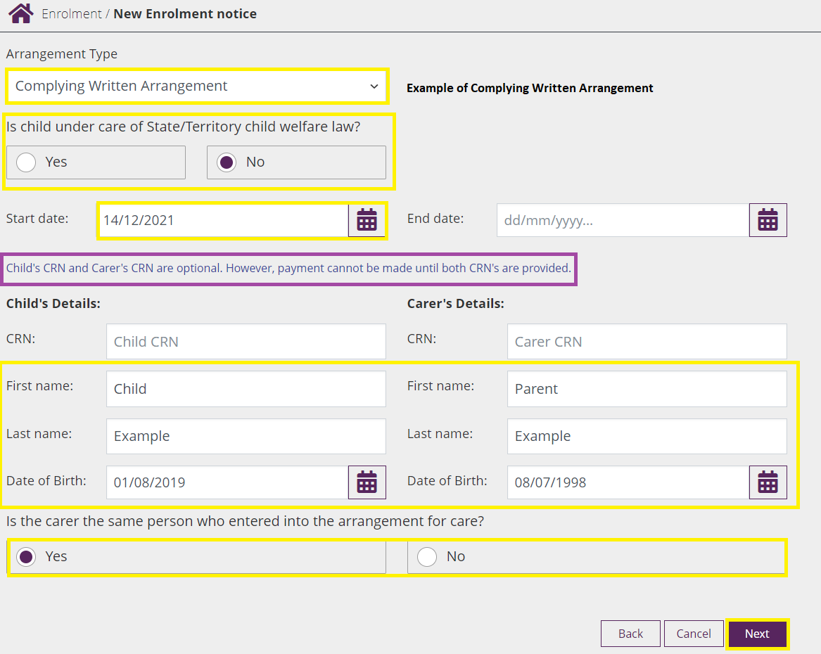

Step 4
Where the following arrangement types are selected additional information is required.
Complying Written Arrangement
- Provide the CRN (if known), first name, last name and date of birth of the claimant
- Select Yes or No as applicable if the CCS claimant is also the person who entered into the arrangement for care with the provider.
  - If Yes, the claimant’s name will autofill the Party to the arrangement field.
  - If No, you will need to enter the name of the person who entered into the arrangement with the provider.
Note: To be eligible for CCS, the claimant or their partner must be liable for the child care fees under the CWA.

Relevant Arrangement
- Provide first name and last name of the guardian who entered into the care arrangement with the provider.
Arrangement with an Organisation
- Provide name of the organisation who is liable for the fees for the child.
Provider Eligible Arrangement
- Reason for using a PEA enrolment
Select Next.

Step 5
Enter session and usual fee details.
This is not the weekly session reporting, but the type of care expected under the enrolment and details of any routine sessions (‘booked days’) for the child. This must be updated if the arrangement changes on an ongoing basis.
Note: For CWA enrolments, this information will be provided to the claimant for confirmation, so it is important that the information provided correctly reflects the agreed care arrangement.
Select the Session type.
- Routine sessions (casual permitted)
- Routine sessions only (no arrangement for casual care)
- Casual sessions only
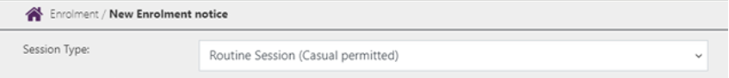

Step 6
Record weekly or fortnightly cycle.
This allows you to indicate if a child’s sessions of care are the same week to week or occur on a fortnightly basis (i.e. the routine sessions are different in the first week of each CCS fortnight to the second week).
If the child is booked to attend the same sessions of care each week, select Weekly.
If the child is booked to attend different sessions on alternating weeks, select Fortnightly and complete the additional fields:
- Is there at least one routine session in each week of the fortnight?
- Select Yes if the child is booked to attend at least one routine session of care in both weeks of the fortnight.
- Select No if the child is booked to attend routine sessions of care in only one week of each fortnight.
- In which week is/was the child’s first routine session?
  - This date is required to ensure routine sessions entered for a fortnightly cycle align with CCS fortnights.
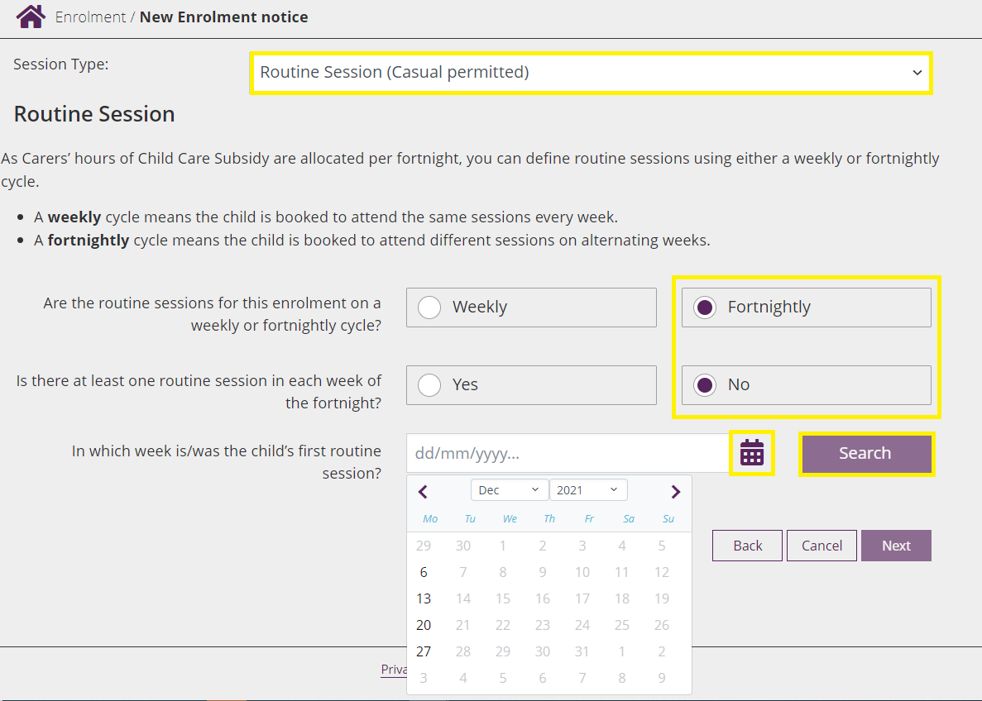

Step 7
Record session and usual fee details
- For Routine sessions (casual permitted): the start time, end time, usual fee and fee unit (per session/hour) fields are mandatory for each routine session of care. It is optional to provide details for casual sessions of care to be provided.
- For Routine sessions only (no arrangement for casual care): the start time, end time, usual fee amount and fee unit (per session/hour) fields are mandatory for each routine session of care.
- For Casual sessions only: a minimum of one casual fee description, usual fee amount and fee unit (per session/hour) is mandatory. Session length is mandatory if fee unit is per session.
- If Fortnightly cycle is selected, two weeks of routine sessions will display.
- Additional sessions may be added for a day by clicking the actions button and then selecting add. These can be deleted by selecting remove.
Select Next.
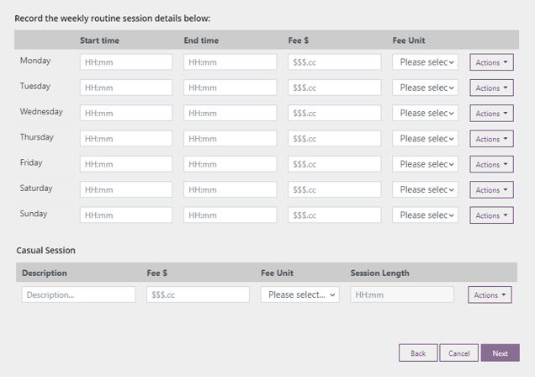

Step 8
Review the enrolment details.
To make changes to any of the details, select Edit.
To finalise the enrolment, select Submit.
Once submitted, an Enrolment Notice Receipt will be generated.
Select Return Home to return to the provider home page or select Continue to return to the enrolment summary page.

Next steps
Family confirmation of enrolment (CWA enrolments only)
- The enrolment details will be sent to the claimant for review. The status of the enrolment will be Pending Confirmation.
- The claimant must confirm the details of the enrolment are correct before their CCS/ACCS entitlement can be paid to you on their behalf. This process is managed by Services Australia and does not require any action from the service or provider.
- Session reports can be submitted before an enrolment has been confirmed. However, CCS and ACCS cannot be paid until the enrolment has been confirmed and the family has established CCS eligibility.
- If the claimant disputes a detail about the enrolment, or indicates their child is not enrolled at the service at all (‘rejects’ the enrolment), you will receive a notification through the PEP advising of this. The status of the enrolment will also reflect the action the claimant took i.e. disputed or rejected.
  - If an enrolment is disputed, it will need to be updated with the correct information, and the claimant will need to reconfirm this information before CCS/ACCS can be paid to you on the claimant’s behalf.
  - If an enrolment is rejected, you will not be able to update the enrolment. A new enrolment will need to be created if you have a care arrangement with the claimant.
- The enrolment status will change from Pending Confirmation to Confirmed once the claimant confirms the enrolment.

