


Task card
  - How to view child enrolments in the Provider Entry Point

Overview 1
Logging in 3
Viewing an enrolment 3

Overview
This task card outlines how to view child enrolments using the Provider Entry Point (PEP).
This task card is for providers that use the Provider Entry Point (PEP). If you use third-party software, contact your software provider for help.
Find more task cards for the PEP on our website.
If you need further assistance, contact the Child Care Subsidy Provider Helpdesk on 1300 667 276 9am to 5pm AEST or via email anytime.
Note: Only certain special characters can be used in the PEP:
- full stop (.)
- comma (,)
- hyphen (-)
- slashes (/, \)
- apostrophe (‘).
All other special characters will cause an error in the system.

Logging in

Step 1
Log in to the Provider Entry Point (PEP).

Step 2
Once logged in, select the service where the enrolment applies.

Viewing an enrolment

Before you begin
The Enrolment Status field can help you identify:
- if the parent (claimant) is eligible for CCS
- if the parent has confirmed the enrolment (required for CCS to be paid)
- when you can submit session reports for an enrolment
- when CCS can be calculated and paid for those sessions
- shows the steps to view enrolment status, and
- explains what each enrolment status means and what you or your parents may need to do next.
The following table outlines the statuses for enrolments.
Enrolment status | Definition | Next steps | Claimant entitlement displayed? | Can session reports be submitted? | Can CCS be paid?
Received | New enrolment submitted without child and/or claimant CRN and/or date of birth. | Claimant needs to provide CRN and/or DOB to provider. Provider updates enrolment with CRN and/or DOB. | No | Yes | No
Pending eligibility | Claimant has not lodged a CCS claim for this child | Claimant should lodge a claim as soon as possible. Enrolment confirmation will be part of claim process. | No | Yes | No
Pending eligibility | Claimant is not linked to this child in Centrelink records. | Claimant should contact Centrelink to confirm child is linked | No | Yes | No
Pending confirmation | Enrolment has successfully been sent to claimant for confirmation (claimant may or may not have commenced CCS claim for this child) | Claimant notified. Needs to review the enrolment and/or submit CCS claim | No | Yes | No
Confirmed | Claimant has reviewed and confirmed the enrolment and CCS claim for this child has been completed | Provider notified. Claimant entitlement information available. Session reports submitted before confirmation will begin processing. CCS can be paid. | Yes | Yes | Yes
Confirmed | Claimant has reviewed and confirmed the enrolment but CCS claim has not yet completed | Provider notified. No claimant entitlement available. Claimant should ensure CCS claim has been submitted | No | Yes | No
Disputed | Claimant has reviewed the enrolment and indicated one or more details are not correct | Provider notified. Review enrolment. Discuss with parent and submit update notice. | No | Yes | No
Rejected | Claimant has reviewed the enrolment and indicated the child is not enrolled at the service | Provider notified. Review enrolment. Discuss with claimant and submit new enrolment notice if child is enrolled | No | No | No
Ceased | The enrolment has reached its end date. | Ceased enrolments cannot be reactivated. Submit a new enrolment notice if child is enrolled again. | No | No | No

Step 1
From the service landing page, select More details under Enrolments.
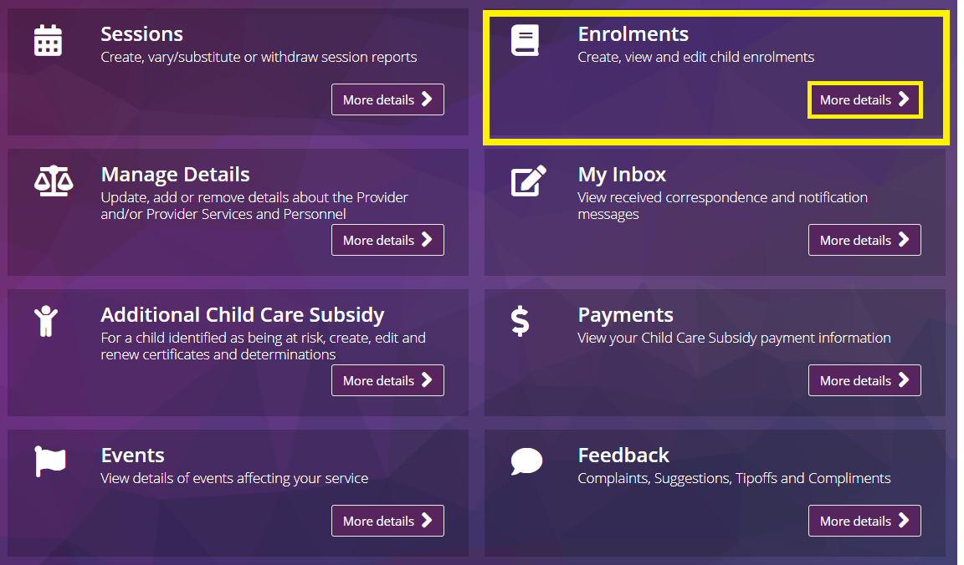

Step 2
The Enrolment summary page will open, displaying the most recent status for each enrolment.
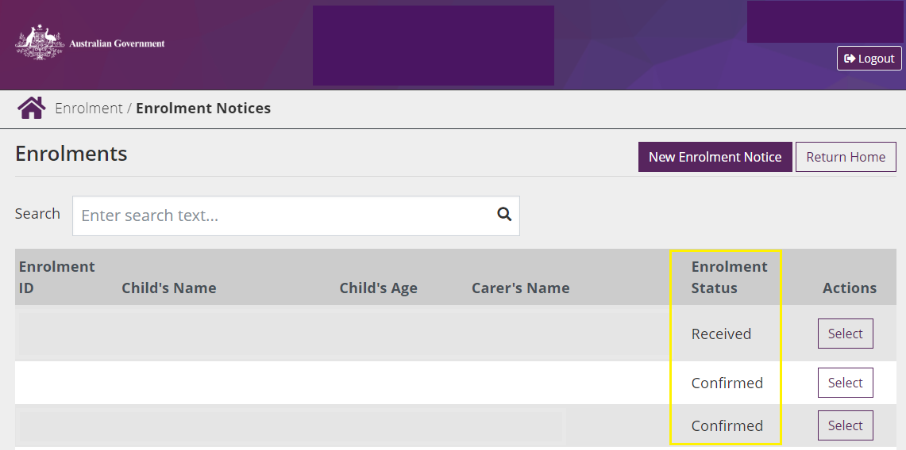

Step 3
The enrolment detail page also has the enrolment status displayed
This page appears if you select an individual enrolment from the list of enrolment notices in the summary page.
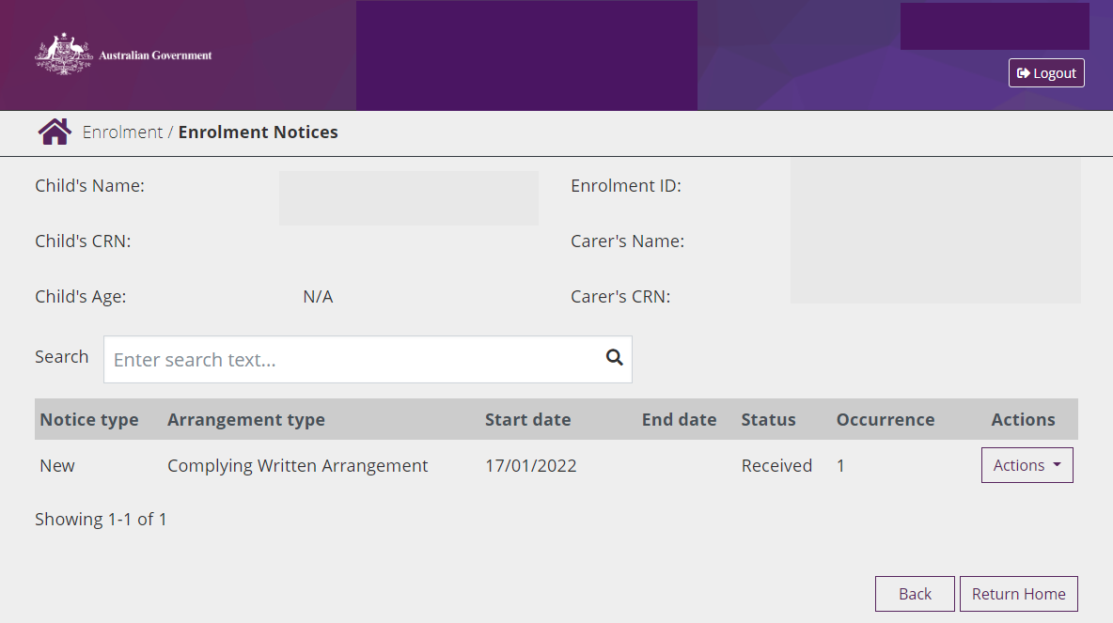

Next steps
You may need to help families confirm their enrolment. Below is a quick guide of how parents and carers can confirm their enrolments in their Centrelink online account.

How to confirm your enrolment
Child Care Subsidy can only be paid to your child care provider if you have confirmed your child’s enrolment details. To do this you need to log in to your Centrelink online account through myGov.
- From the menu go to Child Care Subsidy and then Enrolments.
- If the Enrolment Status is unconfirmed click Review
- Select Yes or No to whether the enrolment details are correct then click Next
- If all the details are correct, read the declaration. If you understand and agree with the declaration, select I accept this declaration. Then select Submit.
- Note of the Claim ID for your records, then select Return Home
To check your enrolment details have3 been updated, click the menu and go to Child Care Subsidy and then Enrolments.

