


Learning & Teaching Repository
A step-by-step guide to locating individual documents on TROVE

Step 1  Access the National Library of Australia (NLA) website home page and click on ‘Trove’ on the top left of the screen to be redirected to Trove’s webpage.  If this is not found, the screen may be minimised. If so, click on the three striped icon on the top right instead to find ‘Trove’. |   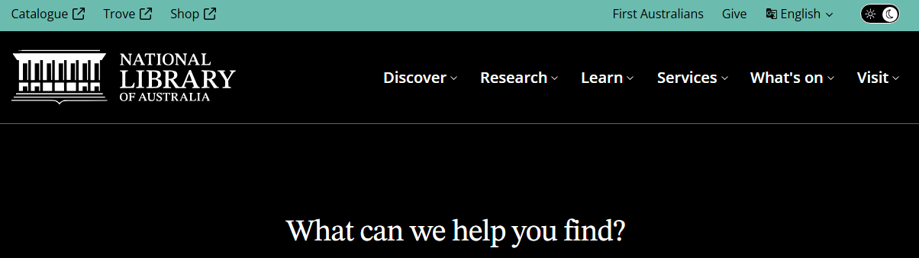
Step 2  Once on the Trove webpage, click on the ‘Search Trove’ bar and begin typing the item name of the article from the LTR Catalogue.  Filter the search using the category drop-down beside the green box with the magnifying glass.  The ‘Research & Reports’ category will likely be of most use.  Once a category is selected, click enter or click on the green box with the magnifying glass to search.  If the document type is unknown, select ‘All categories’. | 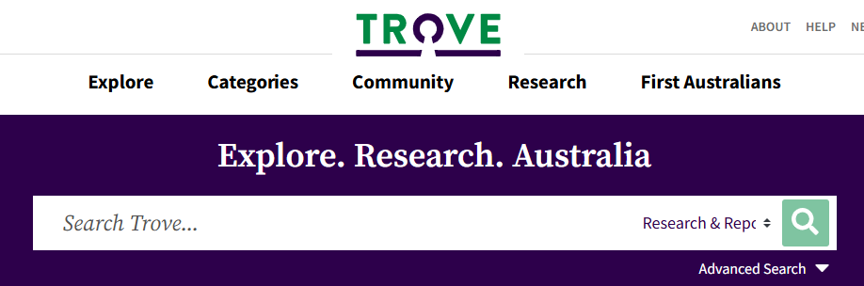
Step 3  After being redirected to the search page, results will arise, categorised by the publication medium.  Navigate through the list by scrolling down. The correct result will most likely be found under ‘Research & Reports’.  The result can be cross-checked by identifying the year of publication from the LTR Catalogue against the date on the result. | 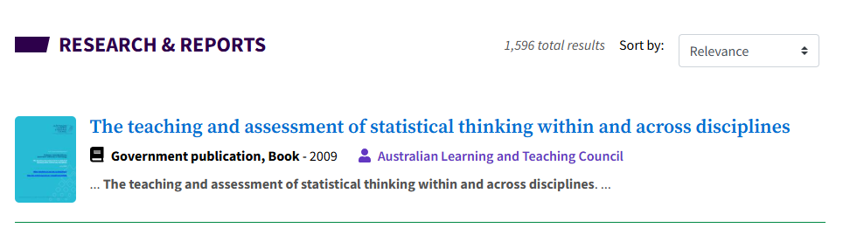  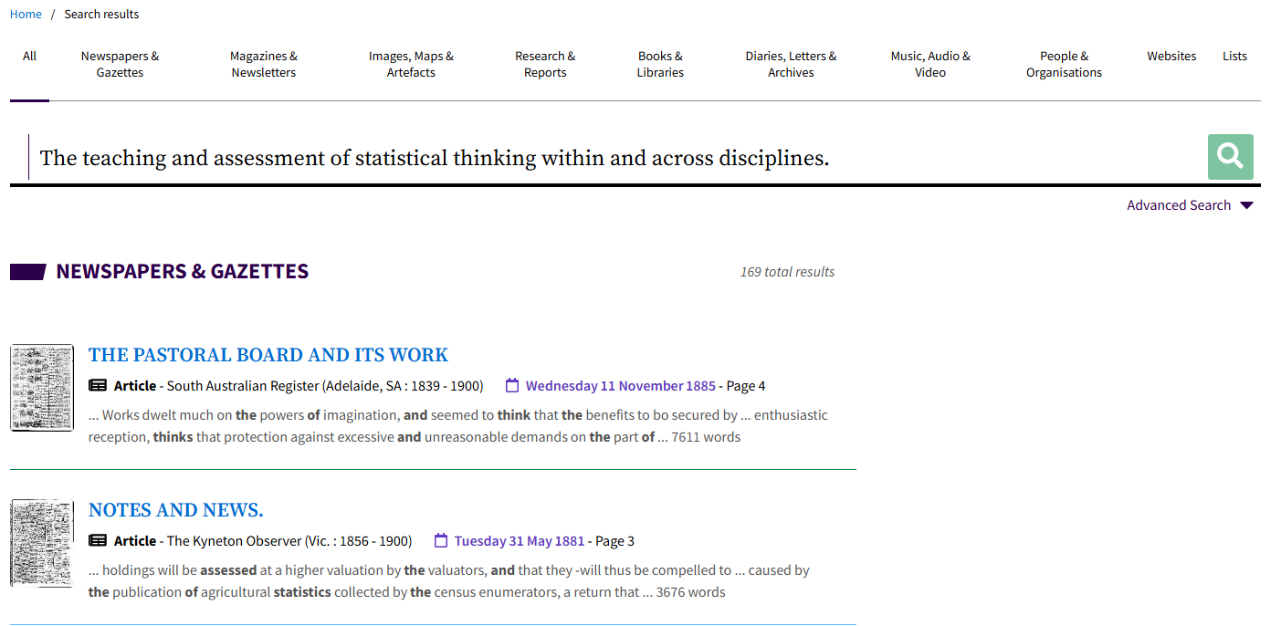
Step 4  Once the correct result is located, click on the blue title.  Click on the purple rectangular icons below the publication image to explore reading options.  To gain free reading access, click the ‘Read’ box, then click ‘National edeposit’ to be redirected to the text itself. | 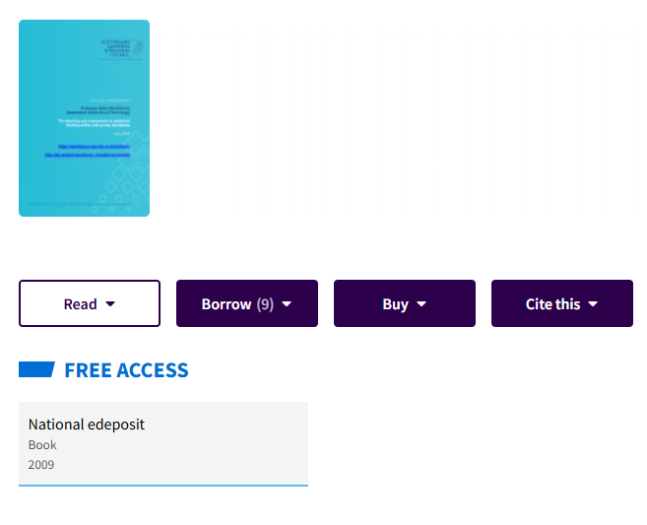
Tip  If the item cannot be found, click ‘Advanced Search’ underneath the green box with the magnifying glass, then click ‘Research & Reports’. This enables detailed searching, including by Title, Creator, ISBN, Year and more. | 