

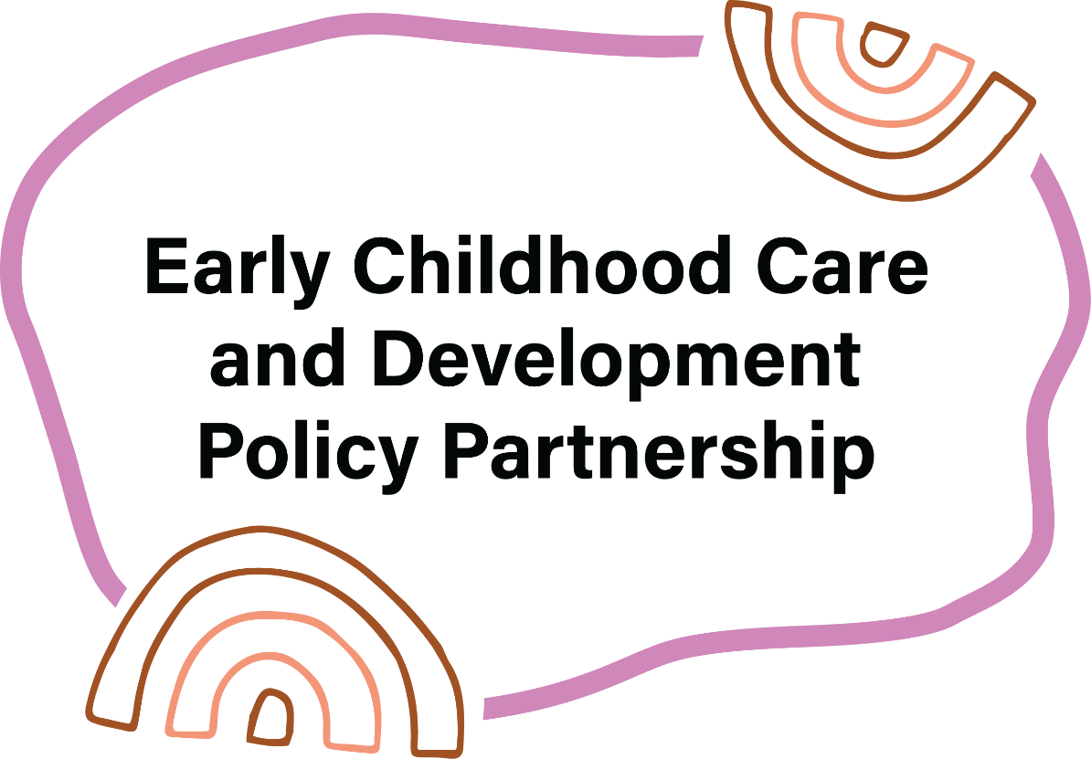

Annual Report

1 Jan 2025 – 31 Dec 2025

Acknowledgement
The Early Childhood Care and Development Policy Partnership acknowledges the Traditional Custodians of Country across the continent and islands and their continuing connections to land, waters and communities. We pay our respects to Aboriginal and Torres Strait Islander cultures and Elders past and present and emerging. We acknowledge and respect their continued connection to Country, care for community and practice of culture for generations uncounted.
We also acknowledge the Aboriginal and Torres Strait Islander leaders, parents, families and kinship carers who are the custodians of caring practices that have kept children safe and thriving for more than 65,000 years.

Artwork

Guiding Stars


Artist attribution

Guiding Stars description
This vibrant artwork, titled "Guiding Stars," symbolises the unity and shared decision-making embodied by the Early Childhood Care and Development Policy Partnership.
The central motif of interconnected patterns and shapes represents the coming together of Aboriginal and Torres Strait Islander leaders, families, and government representatives, all working harmoniously to ensure the well-being and cultural richness of the youngest children. The bright, swirling elements signify the Guiding Stars, an ancestral reminder of the wisdom and strength that guide the community in making decisions for a brighter future. Surrounding footprints depict the journey of collaboration and continuous support from the community, creating a nurturing environment where every child can thrive and remain connected to their heritage. This piece is a celebration of the ECCDPP's commitment to fostering early childhood development and closing the gap for Aboriginal and Torres Strait Islander children.

Artist bio
Tovani Cox is a proud Bunuba, Gija and Karajarri woman from the Kimberley region of Western Australia. Born in Broome, Tovani is passionate about art and design and often her inspiration is from her long-standing commitment to self-determination and rights of First Nations people and communities. She was predominantly raised in Noongar country in Perth, and since early 2017 has been living in Melbourne on Wurundjeri country, and travels home to the Kimberley as often as she can to connect with kin and Country. Tovani has qualifications in Digital Graphic Design from RMIT University and wants to pursue further skills and training using art as therapy and healing.

Artist attribution
Tovani Cox is a proud Bunuba, Gija and Karajarri woman from the Kimberley region of Western Australia.

Design attribution
Early Childhood Care and Development Policy Partnership logo and creative elements designed by Coolamon Creative.

Note on timeframes
The content in this report reflects the status of actions at the end of 2025. The report has not been updated to reflect changes that occurred in 2026, as these will be reflected in the 2026 annual report.

Contents
Acknowledgement 1
Artwork 1
Guiding Stars 1
Artist attribution 1
Design attribution 2
Note on timeframes 2
Contents 3
A Message from the Co-Chairs 5
Executive Summary 7
Part 1 – About the Early Childhood Care and Development Policy Partnership – Overview, Ways of Working and Challenges 10
Background 10
Co-Chairs & Membership 11
Partnership Operations 12
Making Recommendations to Joint Council 12
Scope of Partnership 13
Ways of Working 13
Probity Framework 15
Engagement with Closing the Gap Reviews 16
Strengthening SNAICC’s Capacity as an ACCO 17
Relationships 19
Challenges 19
Part 2 – Year Three: Our focus in 2025 23
Key Developments and Achievements 23
Recommendations for Joint Council on Closing the Gap 23
National Commissioner for Aboriginal and Torres Strait Islander Children and Young People 25
Priorities 2A and 2B, implementation advice 26
Evaluation 26
Increased access to Early Childhood Education and Care 26
ECCDPP Meetings 29
Year 3 Workplan 30
Part 3 – Progressing Reform: The ECCDPP Priorities 32
Third Year Priorities: Strengthening Collaboration and Implementation 32
Part 4 – Looking Forward 43
Appendix A – List of Members 45
Appendix B – Acronym and abbreviation list 49
Appendix C – Making Recommendations to Joint Council 50
Appendix D – Closing the Gap Outcomes 53

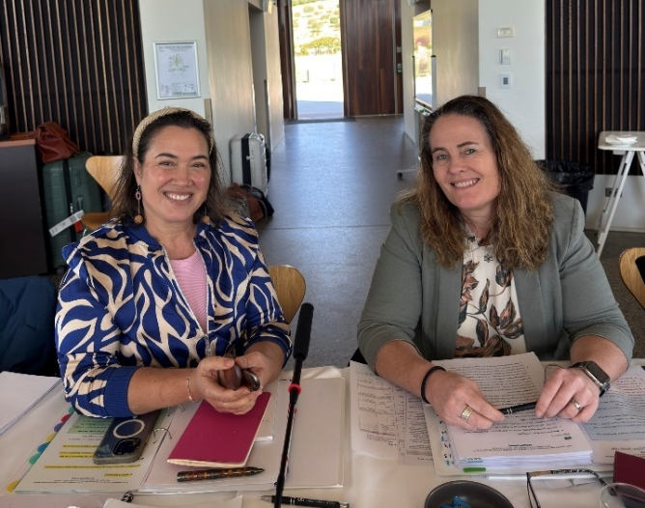
A Message from the Co-Chairs
We’re proud to share the 2025 Annual Report for the Early Childhood Care and Development Policy Partnership (ECCDPP, the Partnership). This year was a milestone: we completed our first three-year term and the Partnership was extended with a further three years of funding, reflecting the trust and momentum we’ve built together.
Figure 1: Catherine Liddle and Kylie Crane, Co-Chairs of the ECCDPP

Our work continues to be guided by the simple but powerful goal of ensuring Aboriginal and Torres Strait Islander children and families can thrive. Over the past year, we strengthened partnerships, delivered key projects, progressed research and contributed to reforms that matter, like changes to the Child Care Subsidy Activity Test and the appointment of Australia’s first National Commissioner for Aboriginal and Torres Strait Islander Children and Young People.

This year, we strengthened collaboration between shared decision-making forums by joining forces with the Safe and Supported Implementation Coordination Committee. This collaboration reflects our dedication to breaking down silos and working collectively to progress shared commitments. Together, we are working on shared decision-making under Closing the Gap Priority Reform One and reducing the number of Aboriginal and Torres Strait Islander children in out-of-home care under Target 12. This is also a key focus for the Joint Council on Closing the Gap.

We also acknowledge our co-secretariat team, with staff from SNAICC – National Voice for our Children and the Australian Government Department of Education, who help to drive forward the priorities of the Partnership. In 2025, the team’s hard work and dedication to working in partnership—in the spirit of the National Agreement on Closing the Gap—were recognised by the Institute of Public Administration Australia as a finalist for the 2025 Spirit of Service Awards in the ‘collaboration’ category.

These achievements are only possible because of the commitment of our members and the communities we serve. We know there’s more to do, especially to reduce the number of children in out-of-home care, and we remain focused on driving change through genuine shared decision-making.
Thank you to everyone who has walked this journey with us in 2025. Together, we’re building strong foundations for the next three years and beyond.
Kind regards,
Catherine Liddle and Kylie Crane
Co-Chairs of the ECCDPP

Executive Summary
The Early Childhood Care and Development Policy Partnership (the Partnership/ECCDPP) was established in August 2022 under the National Agreement on Closing the Gap (National Agreement) to drive transformative action to improve outcomes for Aboriginal and Torres Strait Islander children.
The Partnership completed its initial three-year term in 2025 and commenced its second three-year term after receiving funding in late 2024, which extended operations through to mid-2028. The funding extension reflects the progress achieved to date and the importance of continuing efforts to ensure Aboriginal and Torres Strait Islander children and families are supported to thrive.
The Partnership held four in-person meetings across Australia in its third full calendar year of operation. During this time, the Partnership advanced work across 16 priorities, with a strong focus on Closing the Gap Target 12, which relates to reducing the overrepresentation of Aboriginal and Torres Strait Islander children in out-of-home care. The Partnership strengthened collaboration with other shared decision-making forums, including other Policy Partnerships, Safe and Supported governance and the Early Childhood Policy Group, to align priorities, reduce siloes and accelerate reform.
This year, the Partnership continued to focus on progressing funding reform for Aboriginal Community Controlled Organisations (ACCOs) delivering integrated early years services and child and family services. This is in recognition that sustainable funding is essential for ACCOs to deliver the supports children need and play their role as vehicles for self-determination. The Partnership worked with governments to deliver implementation advice on new funding models for ACCO integrated early years services. The Partnership also commissioned SNAICC to develop funding model options for ACCOs delivering child and family services, with research due to be completed in early 2026.
In November, the Partnership presented its second set of recommendations to the Joint Council on Closing the Gap (Joint Council), reinforcing its role in shaping national policy. Joint Council noted key projects the ECCDPP has underway and agreed that the Partnership should continue to collaborate with Safe and Supported governance to drive progress towards Closing the Gap Target 12.
The Partnership progressed work on major projects, including the Evidence Guidance Framework, which is expected to be finalised in 2026. SNAICC also developed the Shared Decision-Making Guidance as part of their role as ECCDPP Co-Chair. This guidance provides a valuable tool to support shared decision-making in the early childhood sector and beyond.
The influence of the Partnership’s priorities was reflected in significant announcements. We welcomed the appointment of Adjunct Professor Sue-Anne Hunter as Australia’s first National Commissioner for Aboriginal and Torres Strait Islander Children and Young People - a landmark step in elevating the voices of children and families. In December 2024, the Australian Government committed to a major reform: from the 5 January 2026, all Child Care Subsidy (CCS) eligible families will be entitled to at least 72 hours of subsidised early childhood education and care (ECEC) per fortnight, per eligible child, regardless of their activity levels. Families caring for an Aboriginal and Torres Strait Islander child will be eligible for 100 hours of subsidised ECEC per fortnight, lifting the current baseline entitlement from 36 hours. This reform strongly aligns with ECCDPP’s priorities and research, and reflects the collective advocacy of the sector and SNAICC.
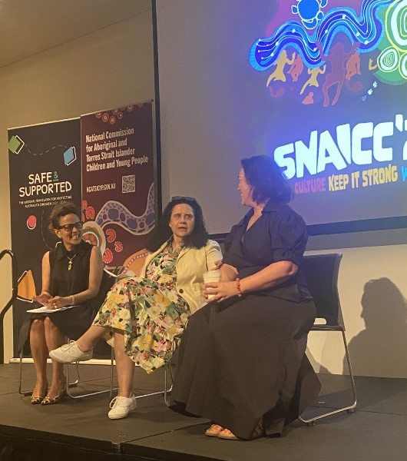
To support accountability and continuous improvement, the ECCDPP commissioned yamagigu Consulting to conduct an independent evaluation of the ECCDPP, due to be finalised in early 2026. The Partnership also engaged with the findings and recommendations from the Independent Aboriginal and Torres Strait Islander Review of Closing the Gap along with the Australian National Audit Office audit of Closing the Gap in early childhood development and schooling, which provide valuable insights to guide future work.
The Partnership has focused on communicating its work within governments and the ACCO sector, and more broadly to the public and Aboriginal and Torres Strait Islander communities. This has included regular updates on Partnership meetings through Department of Education and SNAICC communication channels. ECCDPP members provided an overview of the ECCDPP’s work to representatives from ACCOs at the SNAICC Conference in October 2025 and Catherine has regularly spoken in the media about how the Partnership’s work helps progress Closing the Gap.
Figure 2: Picture of ECCDPP members Catherine Liddle, Aunty Muriel Bamblett and Donnella Mills presenting on the ECCDPP at the SNAICC Conference
Throughout 2025, the Partnership reflected on how members work together, acknowledging progress while recognising the ongoing challenge of addressing power imbalances and accelerating reform within government systems. This progress was made possible through the consistent contributions of members to workshops, meetings, and out-of-session work, which strengthened relationships and built shared understanding of this important work.
In 2025, ECCDPP meetings were held across Australia, and we acknowledge and thank the Traditional Owners who welcomed us onto their lands: the Noongar, Gadigal, Wurundjeri, and Ngunnawal Peoples.
Looking ahead, the Partnership will continue to build on these foundations, driving reforms that place Aboriginal and Torres Strait Islander children and their wellbeing at the centre of all we do.

Part 1 – About the Early Childhood Care and Development Policy Partnership – Overview, Ways of Working and Challenges

Background
The ECCDPP was established in August 2022 and is one of six Policy Partnerships established under the National Agreement. The Partnership enables a joined-up approach to Aboriginal and Torres Strait Islander early childhood care and development policy, with a focus on:
- ensuring Aboriginal and Torres Strait Islander children (0-5 years) are born healthy and remain strong, nurtured by strong families and thrive in their early years; and
- ensuring Aboriginal and Torres Strait Islander children’s safety and care in family and addressing the impacts of child protection and out-of-home care systems on children’s health, wellbeing and development.
The Partnership gives effect to the core commitment of Priority Reform 1: Formal agreements and shared decision-making, by establishing a mechanism for shared decision-making and policy development between governments and Aboriginal and Torres Strait Islander community representatives. The establishment of the Partnership recognises that previous ways of developing and implementing policy targeting Aboriginal and Torres Strait Islander children have not worked and a new approach is required.
The shared decision-making model underpinning policy partnerships acknowledges that Aboriginal and Torres Strait Islander communities are experts in their own lives and respects the cultural authority of Aboriginal and Torres Strait Islander leaders to develop and decide policy in equal partnership with government. The Aboriginal and Torres Strait Islander members of the Partnership represent Aboriginal and Torres Strait Islander communities across the country, providing an essential connection between the Partnership and the Aboriginal and Torres Strait Islander communities, families and children it serves.
The National Agreement sets out the principles of partnership and shared decision-making. These principles are reflected in the Partnership’s membership and working arrangements and are detailed in the Agreement to Implement, which sets out its objectives, deliverables and overarching governance arrangements.

Co-Chairs & Membership
The Partnership is co-chaired by:
- SNAICC – National Voice for our Children (SNAICC)
- the Australian Government Department of Education (Department of Education)
SNAICC is the national peak body for Aboriginal and Torres Strait Islander children and a national member of the Coalition of Aboriginal and Torres Strait Islander Peak Organisations (Coalition of Peaks).
To enact the partnership model set out in the National Agreement, membership of the Partnership consists of:
- Aboriginal and Torres Strait Islander Members (representatives from the Coalition of Peaks and independent members)
- all Australian governments (Commonwealth, state and territory)
The Partnership has 14 Aboriginal and Torres Strait Islander members and partners. These members are a mix of elected representatives from the Coalition of Peaks and independent representatives with specialist knowledge of the early childhood care and development sector. The Aboriginal and Torres Strait Islander members of the Partnership are deeply connected to their communities and carry the aspirations and voices of Aboriginal and Torres Strait Islander children and families into Partnership meetings.
The Partnership has 19 government members and partners, from across the Commonwealth and each state and territory, with representation from portfolios including early childhood education and child and family services. The ‘member and partner’ model ensures appropriate portfolio representation in the Partnership. For example, the Department of Education Co-Chairs the Partnership with SNAICC, and the Australian Government Department of Social Services (the Department of Social Services) and the National Indigenous Australians Agency act as Partners. To maintain equal representation in decision-making between governments and Aboriginal and Torres Strait Islander members are represented by one vote per jurisdiction.
A full list of members and partners for 2025 is at Appendix A.

Partnership Operations
The Partnership is supported by a co-secretariat with functions shared by SNAICC and the Department of Education, which further embeds the shared decision-making model.
To support establishment of the Partnership, the Australian Government committed $10.2 million over 3 years from 2022-25 in the October 2022-23 Budget. This included funding for SNAICC to co-chair the Partnership, take part in the co-secretariat for the Partnership, facilitate engagement of Aboriginal and Torres Strait Islander members, and conduct research.
In the Mid-Year Economic Fiscal Outlook Budget 2024-25, the Australian Government provided a further $11.4 million to extend the Partnership over 3 years, from 2025-26 to 2027-28. This extension enables the Department of Education and SNAICC to continue their roles as Co-chair and co-secretariat of the Partnership and maintains the research fund that enables the Partnership to commission research. As part of the extension, $5.0 million will be provided to SNAICC to continue their Co-Chair, co-secretariat and research functions, and the remainder will be overseen by the Department of Education on behalf of the Partnership.
In pursuing its objectives in 2025, the Partnership has continued to draw on its research funding, which supports the ECCDPP to advance its identified policy reform priorities and to support informed and evidence-based advice and recommendations.
The Partnership started work on three new research projects in 2025 to progress ECCDPP Priorities 1B, 1C and 4B. Further details are provided in Part 3.

Making Recommendations to Joint Council
The primary function of the Partnership is to make recommendations to Joint Council which reflect member consensus on actions to improve early childhood care and development outcomes for Aboriginal and Torres Strait Islander children. These recommendations are non-binding and may have either a national, jurisdictional or local focus. As detailed in Part 2, the Partnership successfully delivered its second set of recommendations to Joint Council in November 2025.
A full update on Joint Council Recommendations for 2025 is at Appendix C.

Scope of Partnership
The Partnership’s remit encompasses several sectors focusing on Aboriginal and Torres Strait Islander children and their families across early childhood education and care, maternal and child health, child safety, and children and families (out-of-home care and family violence). While these are the key focus areas of the Partnership, there are many social determinants that impact a child’s early care and development journey, and these determinants align with the intersecting areas of justice, disability and housing. The Partnership seeks opportunities to work collaboratively across these areas, where appropriate and in line with its annual workplans.
Wherever possible, the Partnership is leveraging existing governance structures, such as the Education Ministers Meeting and Joint Council, to socialise and progress its priorities. The Partnership also has strong linkages with the following:
- National Aboriginal and Torres Strait Islander Early Childhood Strategy
- Early Childhood Care and Development (ECCD) Sector Strengthening Plan
- Safe and Supported: The National Framework for Protecting Australia’s Children 2021-2031 (Safe and Supported).
The Partnership’s scope focuses on actions that will deliver progress towards the Closing the Gap Outcomes 2, 3, 4, 12 and 13. The ambition for the Partnership and the focus of its activities is to drive improvements across these Outcomes through a joined-up approach to policy recommendations and actions at the community level, including partnering with the other Policy Partnerships to progress priorities.
Further details on these Outcomes, related Targets, and their status (as at July 2025) are provided at Appendix D.

Ways of Working
In 2025, the Partnership continued to refine its ways of working, both internally and in engagement beyond the ECCDPP. Co-Chairs and the co-secretariat have continued to ensure strong engagement and support processes for members to promote collaboration, build consensus and ensure transparency in the lead up to meetings to enable the Partnership to have robust discussions.
Key successful practices continue to be:
- Strong operational backbone: Preparing papers to prepare members for meetings and build clarity and alignment on key positions, developing annual workplans and reports; maintaining action registers; and managing logistics and communications to ensure continuity, accountability, and institutional memory.
- Timely information sharing: Distributing meeting papers at least a week ahead of meetings.
- Structured pre-briefs and debriefs: Separate sessions for government and Aboriginal and Torres Strait Islander members to build internal clarity and alignment before ECCDPP meetings, enabling more focused and confident joint discussions, and to provide space for joint reflection after meetings.
- Dedicated Aboriginal and Torres Strait Islander caucusing: Annual all-day meetings to deliberate and set shared priorities.
- Co-Chair collaboration: Regular discussions before and after Partnership meetings to agree on pathways through key issues.
- Momentum between meetings: Advancing Partnership work out-of-session.
- Inclusive participation: Ensuring all members can engage comfortably, equally, and effectively.
- Relational care: Co-Chairs and co-secretariat routinely check in, follow up after difficult conversations, and create safe spaces for contribution.
- Continuous improvement: Acting on member feedback after each meeting.
- Collaboration with other Policy Partnerships: Informal and formal links maintained between meetings.
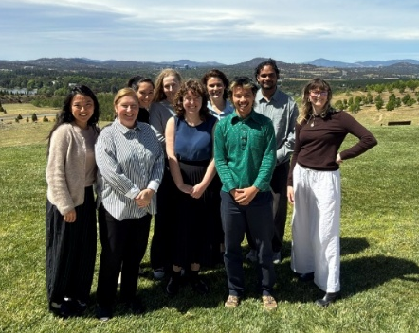
- Culturally grounded logistics: Observing cultural protocols, visiting diverse jurisdictions, and embedding local culture and community in every meeting.
The co-secretariat teams at SNAICC and the Department of Education work together closely to ensure every piece of work is developed and delivered collaboratively. ECCDPP materials are drafted, reviewed and finalised together, as are decisions related to planning meetings.
Figure 3: Members of the SNAICC and Department of Education co-secretariat team
Throughout 2025 the co-secretariat has been updating ways of working in response to member feedback and emerging findings from the ECCDPP evaluation. These efforts will continue in 2026 when the evaluation report is finalised. The sections below provide more detail on improvements to our ways of working.

Spirit of Service Award 2025 Nominees
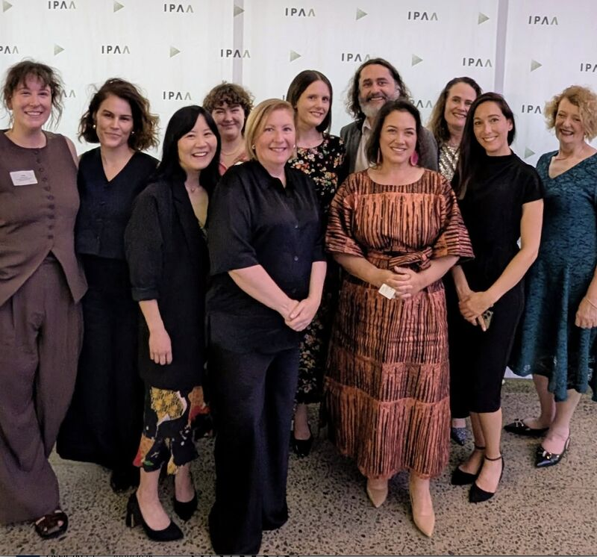
The SNAICC and the Department of Education ECCDPP co-secretariat were nominated for the Institute of Public Administration Australia Spirit of Service Award in 2025, which celebrates public sector initiatives driving change for the Australian community, in recognition of our collaborative work on the ECCDPP.
This is the first time that a non-government agency has been nominated for the award. This reflects how the public service is changing to recognise that new ways of working in partnership are required under the National Agreement.
“Although we didn't get the win, we congratulate the winners while also proudly celebrating the nomination as a milestone for the partnership in our journey towards a better future for our children.” – SNAICC – National Voice for our Children

Probity Framework
The Department of Education commissioned the development of an ECCDPP Probity Framework to ensure strong probity practices within the shared decision-making context of the ECCDPP, including when collaborating with ACCOs during commissioning processes. O’Connor Marsden & Associates Pty Limited were engaged by the Department of Education to provide these independent probity services.
The Probity Framework clarifies roles and responsibilities of Co-Chairs, co-secretariat, Members, and other representative bodies who participate in the Partnership, in relation to potential probity risks and to uphold a high probity standard.
In practice, the Probity Framework will support the Department of Education and SNAICC with the identification and management of probity matters that may arise as part of Partnership decision-making and the commissioning of projects and activities from the ECCDPP Research Fund. This includes providing clear guidance to ensure Aboriginal and Torres Strait Islander representatives can be involved in shared decision-making about projects while managing any potential conflicts of interest.
The Probity Framework was finalised and published on the Department of Education and SNAICC websites on 11 December 2025. Learn more about the Probity Framework and its findings.

Engagement with Closing the Gap Reviews
In 2025, the ECCDPP strengthened its role within the broader National Agreement accountability landscape by actively engaging with two major reviews:
- The Productivity Commission’s Review of the National Agreement on Closing the Gap (2024)
This review highlighted that shared decision-making remains uneven, with many arrangements still government-driven rather than genuinely co-designed. It called for embedding formal partnership structures with Aboriginal and Torres Strait Islander organisations throughout policy design and implementation, supported by clear accountability mechanisms. These findings reinforced the importance of ECCDPP’s work to advance Priority Reform 1 and strengthen partnership governance.
- The Independent Aboriginal and Torres Strait Islander-led Review of the National Agreement on Closing the Gap (2025), conducted by the Jumbunna Institute for Indigenous Education and Research on behalf of the Coalition of Peaks.
The Independent Aboriginal and Torres Strait Islander-led Review (the Independent Review), released on 20 June 2025, was the first independent review of the National Agreement. Building on the Productivity Commission’s findings, it concluded that, while the National Agreement architecture is sound, progress is constrained by government inaction, power imbalances, and a lack of accountability and transparency. The Independent Review delivered 12 findings and nine recommendations.
Throughout the year, the Partnership actively incorporated these reviews into its work. Updates were embedded in meeting agendas by the co-secretariat, with members frequently referencing the findings and recommendations. Jumbunna provided an out-of-session presentation to deepen members’ understanding of the Independent Review. Government members provided updates on how they are embedding the findings of the Reviews in Closing the Gap Implementation Plans across their jurisdictions. These conversations focused on overcoming implementation barriers, directly addressing concerns raised in the Independent Review about uneven progress and the need for tangible outcomes.
The Partnership is prioritising funding reform, in line with Recommendation Three of the Independent Review, by progressing implementation advice on sustainable funding for ACCOs delivering integrated early years services, and commissioning research to develop a dedicated funding model for Aboriginal and Torres Strait Islander child and family support ACCOs (for further detail on this work see updates on priorities 1B, 2A and 2B in Part 3).
The Partnership also committed to exploring new ways of communicating outcomes and priorities to communities, addressing Recommendation Six of the Independent Review on improving communication.
SNAICC is leading development of a Data Lake, an initiative designed to build ACCO-led data capability and improve accessibility. While in its early stages, this project directly supports Priority Reform Four and Recommendation Seven of the Independent Review, which emphasise Indigenous Data Sovereignty and governance. The co-secretariat has also initiated conversations with the Data Policy Partnership to identify shared priorities and areas of alignment.
Finally, both reviews are informing the Partnership’s evaluation recommendations and strategic planning for the next three years. Their findings and recommendations were incorporated into workshop sessions with members and the evaluation team to ensure the Partnership’s future work remains focused on tangible outcomes, accountability, and strengthening shared decision-making.

Strengthening SNAICC’s Capacity as an ACCO
Part of SNAICC’s initial funding as ECCDPP Co-Chair was dedicated to building the capacity of SNAICC and the broader Aboriginal and Torres Strait Islander early childhood care and development sector, in line with Priority Reform Two of the National Agreement. Projects that came out of this included strengthening SNAICC’s data capacity, setting up a Youth Voice mechanism, and developing shared decision-making guidance.

Data Lake
In the 2024-25 financial year, SNAICC received funding to support its role as Co-Chair and co-Secretariat of the ECCDPP to strengthen its role as a peak body and ECCDPP Co-Chair through data capability. Building SNAICC's capacity to lead in data practice is strongly aligned to Priority Reform Four as well as the ECCDPP’s work to make evidence informed recommendations through shared decision-making.
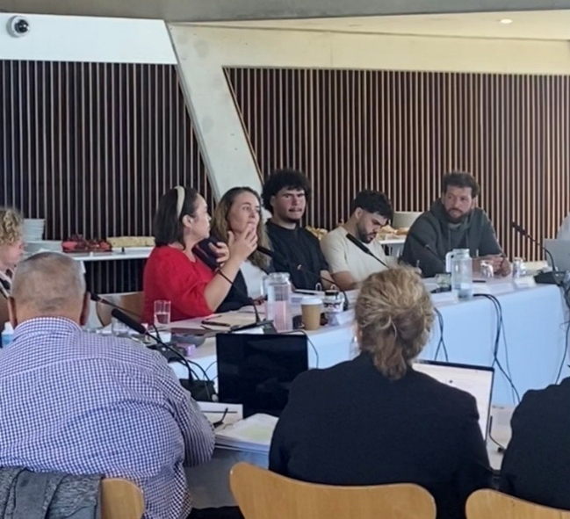
SNAICC’s newly established Data Lake seeks to bring Aboriginal and Torres Strait Islander knowledge and data under community control and pursue Indigenous Data Sovereignty in child and family data. The Data Lake will also provide more accessible and usable data to government partners of the ECCDPP and the work of the Partnership. As the Data Lake grows, SNAICC will have improved infrastructure to securely store and accurately analyse data for its own use as well as for the use of the ECCDPP and the community-controlled sector. The Data Lake creates opportunities for SNAICC to enter into data sharing agreements with governments and access more detailed data relevant to Aboriginal and Torres Strait Islander children and families.

Youth Voice
SNAICC established the Youth Voice in 2025 as a formal engagement mechanism to strengthen its policy and advocacy leadership. The Youth Voice enables Aboriginal and Torres Strait Islander young people to have a direct role in shaping SNAICC’s work and strategic priorities, recognising that children and young people are experts in their own lives and have the right to be heard on issues that affect them.
Figure 3. Youth Voice representatives & ECCDPP Members at Meeting 12
The Youth Voice will not only embed youth perspectives into SNAICC’s governance and advocacy but also provide a strategic avenue for the ECCDPP to engage with young people. At ECCDPP Meeting 12, members met with representatives from the Youth Voice to commence dialogue on practical approaches to engagement, alongside other existing youth advocacy mechanisms. This engagement informed shared understanding of the Youth Voice’s role and scope, and the conversation will continue in 2026.

Creating Structural Change Through Shared Decision-Making
The Shared Decision-Making Guidance has been developed by Coolamon Advisors, in partnership with SNAICC. The Shared Decision-Making Guidance is informed by input from governments, Aboriginal and Torres Strait Islander people, and national forums, including the ECCDPP. It aims to provide succinct, easy to follow, adaptable advice for ACCOs and governments, and recognises the importance of shared decision-making as identified in Closing the Gap.
It is suitable for organisations and partnerships of all maturity levels interested in pathways toward sustainable, effective and equal shared decision-making. For ACCOs, it provides information to participate in shared decision-making with governments from a strong, knowledgeable position, grounded in self-determination. For governments, it offers reflections on what it means to share decision-making with Aboriginal and Torres Strait Islander communities. For all parties, it provides the tools and rubric necessary to create a shared understanding of shared decision-making and put this into practice. The Partnership was involved in the development of the Shared Decision-Making Guidance, providing insights and expertise which has shaped the final document. The document was endorsed by the Coalition of Peaks in late 2025 and launched via a public webinar in December.

Relationships
At its core, the ECCDPP is sustained by relationships. In 2025, the Partnership continued to mature as a forum for shared decision-making, grounded in trust, reciprocity, and mutual accountability. The strength of its work lies not only in programs or outputs, but in the integrity of relationships between Aboriginal and Torres Strait Islander members and governments—a principle described in the Independent Review of Closing the Gap as coming into “right relationship.”
This approach recognises that the health of any system reflects the health of its relationships. When trust and transparency are strong, the Partnership can adapt and respond to challenges; when they weaken, progress stalls. In 2025, members invested in building feedback loops, strengthening two-way learning, and embedding cultural authority in decision-making. These practices have reinforced the legitimacy of the Partnership and its ability to influence outcomes for children and families.
Moving forward, the ECCDPP will continue to prioritise relational integrity as the foundation for shared responsibility and genuine partnership under the National Agreement.

Challenges
This section outlines challenges to genuine shared decision-making experienced by the ECCDPP, with the intention of supporting shared work to address the issues identified. Many of these challenges are not confined to the ECCDPP and are reflected more broadly across work on Closing the Gap.
Key areas identified include government processes presenting barriers to timely implementation, working across government silos and addressing power imbalances.
Notwithstanding the successes of the ECCDPP outlined in this report, systemic barriers remain that inhibit shared decision-making. These barriers have slowed progress on some ECCDPP actions, particularly those that require governments to operate across silos in their respective jurisdictions, make decisions about funding and progress implementation.
For example, bringing implementation advice to the Education Ministers Meeting regarding the ECCDPP’s research on funding model options for ACCO integrated early years services was a significant milestone for the ECCDPP in 2025, detailed further below.
However, it took almost two years between the ECCDPP research being finalised, and the subsequent implementation advice being formally considered by Education Ministers. This was due to the time taken to go through the relevant governance processes and time taken by governments to develop the advice via relevant fora. This includes by the Joint Council on Closing the Gap. Further time will also be required for Ministers to consider the implementation of reforms relating to the ECCDPP research. The First Nations Cacus has raised that this timeframe does not reflect the urgency of the reforms recommended in the research and is indicative of broader issues around slow government processes, which have also been highlighted in reviews of Closing the Gap.
While progress has been made to embed the principles of shared decision-making, further work is needed to strengthen the way governments translate these principles, and the decisions they produce, into effective action. These barriers have been well documented across other shared decision-making forums, and in national reports such as the 2024 Productivity Commission Review of Closing the Gap (PC Review) and the 2025 Independent Review.
The Partnership has had some significant successes in 2025 but Closing the Gap Outcomes 4 and 12 are still worsening. Strong foundations and ways of working within the ECCDPP have limited impact if the Partnership’s priorities and purpose are not being implemented on the ground and across jurisdictions. As the Independent Review noted, while the architecture of the National Agreement is largely sound, a lack of government implementation of the Priority Reforms continues to inhibit systemic reform and prevent timely implementation of recommendations made through shared decision-making.
The ECCDPP recognises that Aboriginal and Torres Strait Islander members and their communities want to see change occur at a pace which recognises the urgency to close the gap for Aboriginal and Torres Strait Islander children. The pace of change within governments remains insufficient to meet the National Agreement targets and continues to be slowed by a lack of interdepartmental coordination and transparency.
The Independent Review also found that government members are not directly accountable to community in the same way as the Coalition of Peaks and Independent representatives—who directly represent particular community groups—are. This often creates a distinct difference in how problems and solutions are framed by either government or Peak/Independent members.
The ECCDPP’s first Annual Report highlighted this imbalance between Coalition of Peaks and Independent members and government representatives, which continues to exist. As governments hold the authorising environment, it is their timeframes that reform works to. Aboriginal and Torres Strait Islander members are engaged in only one part of this broader structure, and they have limited to no opportunity to expedite timelines, challenge ways of working, and drive change outside of the ECCDPP. SNAICC’s Shared Decision-Making Guidance, which was commissioned by the ECCDPP and published in late 2025, recognises these ongoing barriers to effective shared decision-making. The Shared Decision-Making Guidance identifies common challenges to both ACCOs and governments when entering shared decision-making arrangements and poses solutions as to how these barriers may be overcome.
For more urgent action to Close the Gap, coordinated and ambitious reform is needed not only across the Closing the Gap governance fora but all government portfolios.
The ECCDPP will continue to embed this focus, so it is not only a space for discussion but for ambitious action driving reforms and delivering outcomes for Aboriginal and Torres Strait Islander children. For example, the Partnership is coordinating across governments and has a strategic focus on priorities which drive progress against Target 12 of Closing the Gap, in alignment with Joint Council’s focus on Target 12. The Partnership has also focused on joining up work across portfolios and collaborating with different policy partnerships. Collaboration is essential for progressing reform under Closing the Gap and the ECCDPP has developed priorities that support joined-up approaches across justice, disability, Safe and Supported, and data initiatives to deliver more integrated and holistic policy recommendations and responses.
An ongoing challenge in progressing the Partnership priorities is that decisions about funding reform do not sit within the scope of the ECCDPP, rather with each government. Government budgetary decision-making processes, including any related to ECCDPP priorities that require budgetary commitments, sit within complex bureaucratic systems not directly involved with Closing the Gap or the Partnership. These systems balance a range of fiscal decisions and priorities within its jurisdiction. All governments have committed to transforming government organisations under Priority Reform Three of the National Agreement, and it is the responsibility of government members of the ECCDPP to be driving this change within their own areas of responsibility, as it is for all public servants. However, as noted in both the Productivity Commission Review and the Independent Review, many of these challenges require transformation of systems and processes beyond the authority of ECCDPP members.
Addressing the challenges noted above will continue to be a focus for the Partnership, including via the second three-year strategic plan to be developed in 2026 and the response to the ECCDPP evaluation. However, addressing these issues also requires action beyond the scope of the ECCDPP, in line with governments’ broader commitments to reform under the National Agreement.

Part 2 – Year Three: Our focus in 2025
The Partnership has continued to build on its strong foundations in 2025. This year, the ECCDPP focused on deepening collaboration with other Policy Partnerships and Safe and Supported, and driving reform for Aboriginal and Torres Strait Islander children and families through joined-up policy recommendations and implementation advice for ministerial consideration.

Key Developments and Achievements
In its third year of work, the ECCDPP continued to progress its priorities which resulted in successful outcomes and achievements that are included below:

Recommendations for Joint Council on Closing the Gap

Second set of recommendations
On 21 November 2025, the Partnership progressed its second set of recommendations to Joint Council on Closing the Gap (see Appendix C). The policy recommendations had a strong evidence base that built on the Partnership’s research and policy work. The four recommendations were all accepted. The endorsement of these recommendations by Joint Council demonstrates the Partnership’s maturity as a shared decision-making forum that can effectively work across governments. A communique was published outlining the Joint Council discussion regarding the ECCDPP and the four recommendations and is available on the Department of Education and SNAICC websites.

Joint Council and Outcome 12
Joint Council currently has a focus on National Agreement Outcome 12, which relates to reducing the over-representation of Aboriginal and Torres Strait Islander children in out-of-home care. This outcome is within the ECCDPP’s remit and its related target is currently not on track to be met.
In acknowledgement of the shared priorities between ECCDPP and actions under the Safe and Supported: Aboriginal and Torres Strait Islander Action Plan 2023–2026, Joint Council asked the ECCDPP and Safe and Supported Senior Oversight Committee to work together and invited the Co-Chairs of both forums to provide an update at the November 2025 Joint Council meeting.
The update aligned with the actions outlined in the ECCDPP fourth recommendation to Joint Council, which called for coordinated action to advance Outcome 12 through increased and better coordinated investment in ACCO-led child and family services, strengthened early support and prevention, progress towards delegating statutory child protection authority to ACCOs, and growth of a culturally safe Aboriginal and Torres Strait Islander child and family services workforce (see Appendix C for full list of recommendations).
ECCDPP Recommendation Four was agreed by Joint Council and the ECCDPP will continue to work closely with the Safe and Supported Senior Oversight Committee and its sub-committee, the Implementation Coordination Committee, to accelerate progress against Outcome 12 and provide regular updates to Joint Council.
Case Study: Shared-Decision Making in Practice
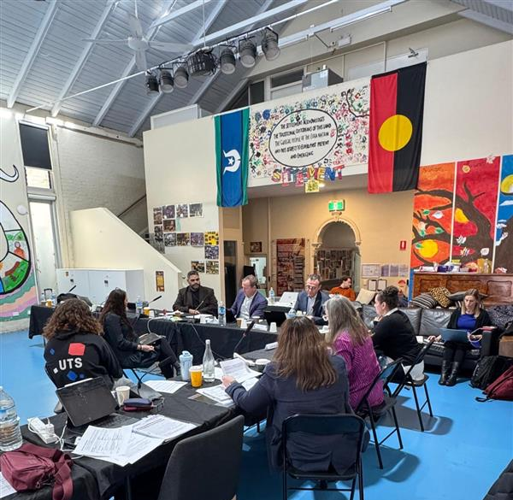
Traditionally, government agencies have operated in silos, with limited coordination across related policy areas. In line with the National Agreement, the ECCDPP is committed to changing this approach by fostering collaboration between shared decision-making forums.
A strong example of this was the joint workshop held on 4 July 2025, where ECCDPP members met with the Safe and Supported Implementation Coordination Committee. The Implementation Coordination Committee is a shared decision-making mechanism responsible for implementing actions under Safe and Supported: The National Framework for Protecting Australia’s Children 2021–2031 and its associated action plans.
This workshop created an opportunity to join up work across the two forums, aligning efforts on overlapping priorities and exploring high-impact strategies to transfer resources to Aboriginal and Torres Strait Islander community-controlled child and family services. Members also discussed priority actions to reduce the over-representation of Aboriginal and Torres Strait Islander children in out-of-home care.
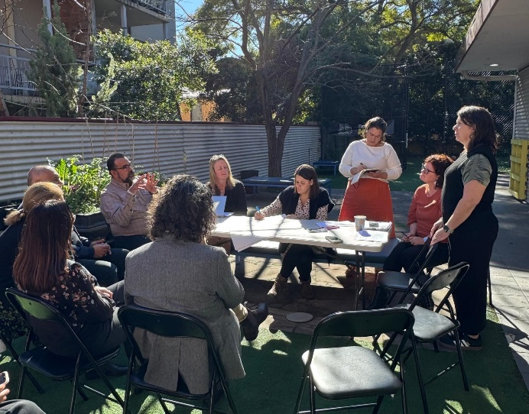
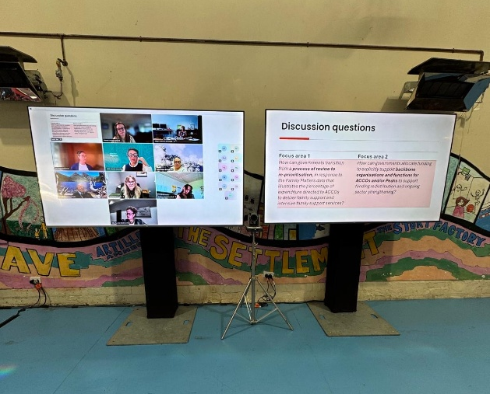
The session featured a presentation from Dr Dawn Casey (Deputy CEO, National Aboriginal Community Controlled Health Organisation) and Melinda Turner (Department of Health, Disability and Ageing), who shared insights from the First Nations Health Funding Transition Program—a successful example of shifting resources from mainstream to Aboriginal Community Controlled Health Organisations.
This collaboration demonstrates what is possible when shared decision-making forums work together to break down silos. The Partnership and the Implementation Coordination Committee agreed to continue coordinating efforts, progress actions, and present joint recommendations to Joint Council in November 2025, reinforcing a commitment to strong partnerships and systemic change.
Photos from Meeting 10 Workshop on Gadigal Country

National Commissioner for Aboriginal and Torres Strait Islander Children and Young People
The ECCDPP (alongside Safe and Supported) played an important role in the establishment of the National Commissioner for Aboriginal and Torres Strait Islander Children and Young People (National Commissioner) by providing a forum for Aboriginal and Torres Strait Islander leaders to work with governments to build a shared understanding about the importance of an independent commissioner role and shape priorities around its establishment.
Commissioner Sue-Anne Hunter commenced as the National Commissioner in September 2025. Commissioner Hunter is a Wurundjeri and Ngu rai Illum Wurrung woman with extensive experience leading ACCOs. The Partnership welcomed Commissioner Hunter to ECCDPP Meeting 11 in September where she met with members and discussed her role and the establishment of the National Commission to promote and protect the rights of Aboriginal and Torres Strait Islander children and young people.
Prior to Commissioner Hunter’s appointment, the National Commission commenced operations on 13 January 2025, with Ms Lil Gordon, a Ngemba woman, operating as the Acting Commissioner until the formal appointment process was finalised.
The Partnership will continue to engage with the National Commissioner in 2026.

Priorities 2A and 2B, implementation advice
The ECCDPP, co-developed implementation advice with the Early Childhood Policy Group (ECPG) for consideration by Education Ministers Meeting in December 2025. This action followed ECCDPP Recommendation Three to Joint Council in June 2024:
Jurisdictions to develop implementation advice (Priorities 2A and 2B) in response to the findings of 2 ECCDPP commissioned research reports: Funding Model Options for Aboriginal Community-Controlled Organisations Integrated Early Years Services Report, and Evidence on Optimal Hours of ECEC for Aboriginal and Torres Strait Islander Children Literature Review.
The implementation advice has been driven by ECPG, via a dedicated Steering Committee made up of representatives from the Australian, Victoria and New South Wales education departments and SNAICC. The Steering Committee reported directly to the ECCDPP and ECPG throughout the development phase, with the advice to Education Ministers informed by feedback from all members.

Evaluation
An evaluation of the ECCDPP was commissioned by the Department of Education on behalf of the ECCDPP as part of its scheduled three-year review. Led by yamagigu Consulting, the purpose of the evaluation was to assess how effectively the ECCDPP is operating as a shared decision-making mechanism, to identify enabling conditions for success, and to support continuous learning as the partnership matures.
The evaluation focused on both visible outputs such as governance structures, decisions, and coordination mechanisms; as well as the relational elements that sustain them, including trust, legitimacy, and reciprocity. The evaluation report is due to be finalised in early 2026 and will be available publicly.

Increased access to Early Childhood Education and Care
In 2025, the Partnership has seen the impact its ongoing work is having on influencing policy reforms related to its priorities.
As part of its first set of priorities, the ECCDPP commissioned two research reports, a Literature Review of Evidence on Optimal Hours of ECEC for Aboriginal and Torres Strait Islander Children and Funding Model Options for ACCOs delivering Integrated Early Years Services. These reports informed the Productivity Commission’s Inquiry into ECEC, with the final report recommending removing the CCS Activity Test to ensure families can access at least 30 hours of quality ECEC per week.
In alignment with the Productivity Commission Inquiry’s recommendations, the Australian Government replaced the CCS Activity Test from January 2026. All eligible families will be entitled to at least 72 hours of subsidised ECEC per fortnight, per eligible child, regardless of activity levels. Families caring for an Aboriginal and Torres Strait Islander child will be eligible for 100 hours of subsidised ECEC per fortnight, for each Aboriginal and Torres Strait Islander child, lifting the baseline entitlement from 36 to 100 subsidised hours. These reforms will make a huge difference for Aboriginal and Torres Strait Islander children and families, by enabling children to access more quality early learning and supporting families to balance child care with other responsibilities.
The Partnership is proud of the contribution its work has made to this significant reform and looks forward to seeing the impact on children in 2026.
Case Study: Shared-Decision Making in Practice
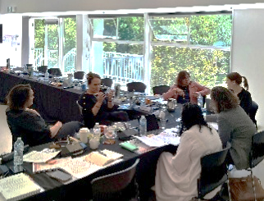
Historically, governments have often developed implementation approaches to new policies without involving Aboriginal and Torres Strait Islander people from the outset. Consultation would occur late in the process, as an afterthought, or not at all. The ECCDPP is committed to doing things differently.
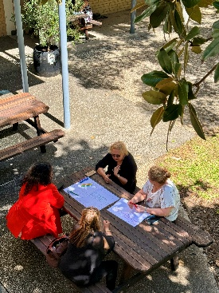
An example of shared decision-making in practice was the recent workshop where members of the ECPG joined an ECCDPP meeting to co-design the scope of implementation advice for Education Ministers in response to the two ECEC-focused research reports commissioned by the ECCDPP.
This collaboration marked a new way of working - bringing together ECCDPP’s Aboriginal and Torres Strait Islander leadership with government representatives to scope advice from the beginning, rather than being consulted later.
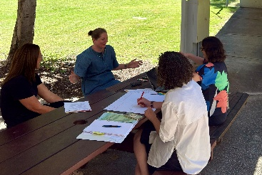
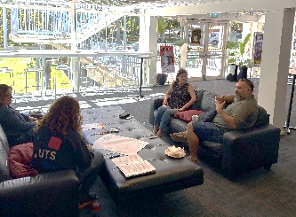
The Partnership welcomed this approach as best practice for governments engaging in forums like the ECCDPP, demonstrating a willingness to work differently and uphold commitments under Priority Reform One of the National Agreement. ECPG members will continue to progress the development of implementation advice and engage ECCDPP members throughout the process, reinforcing the principle that decisions affecting Aboriginal and Torres Strait Islander children must be made in genuine partnership.

Photos from Meeting 9 workshop in Boorloo

ECCDPP Meetings
In 2025, the Partnership convened four in-person meetings, which were instrumental in deepening connections and supporting the Partnership’s capacity for frank, challenging conversations that drive progress.
Each meeting begins with a joint presentation by government representatives and Aboriginal and Torres Strait Islander leaders from the host jurisdiction to demonstrate how the Partnership’s work is being implemented locally.
The Partnership also invited external stakeholders to present on work directly relevant to Partnership priorities. These presentations included from the Council of Aboriginal Services Western Australia, the East Kimberley Place-Based Partnership, Tamworth Aboriginal Community Controlled Organisations, The Kids Research Institute, Ngaweeyan Maar-oo, SNAICC Youth Voice Advisory Group and the Australian Government Department of Health, Disability and Ageing on Thriving Kids.
We welcomed Justice Policy Partnership representatives to discuss joint priorities for reducing the number of children in youth justice, and the Partnership began to hold workshops during meetings to encourage deeper conversation, collaboration and problem solving.
The yamagigu evaluation team attended multiple meetings throughout 2025 to observe and inform the evaluation report.
A summary of the outcomes for each of these 4 meetings, along with other key documents, is available on the Department of Education’s and SNAICC’s websites.
Meeting 9 Highlight: Presentation from East Kimberly Place-Based Partnership
During Meeting 9, members heard from Binarri-binyja yarrawoo Aboriginal Corporation and the WA Department of the Premier and Cabinet on the East Kimberley Place-Based Partnership, established under the National Agreement. The East Kimberly Place-Based Partnership prioritises community voices in setting local priorities—such as early childhood development—and works with governments to align funding to those priorities. This local place-based partnership demonstrates shared decision-making in practice and offers insights on coordinating services locally and transforming funding approaches to enable Aboriginal organisations to lead service design and delivery. Showcasing this work helps ECCDPP members learn from and amplify best practice across different contexts, while supporting the Partnership’s commitment to collaboration and the National Agreement Priority Reforms.

Meeting 10 Highlight: Presentation from Tamworth Coalition of Aboriginal Community Controlled Organisations & Tamworth Regional Council
During Meeting 10, members welcomed Tamworth Coalition of Aboriginal Community Controlled Organisations to present on the Mara Ngali Partnership Agreement with Tamworth Regional Council - a first-of-its-kind local Closing the Gap agreement between Council and a local ACCO. “Mara Ngali” reflects a vision of unity - two hands working together under a shared roadmap addressing multiple National Agreement targets through five pillars: formal partnerships, strengthening community-controlled services, culturally safe Council practices, transparent data sharing, and boosting Aboriginal employment and economic development. This presentation highlighted local-level action, capacity for Aboriginal organisations to lead, and government willingness to reconfigure processes based on community‑led priorities.

Year 3 Workplan
To support the objectives of the Partnership and guide the actions and activities of the third year of the ECCDPP, the Partnership agreed to a Year 3 Workplan that contained 11 strategic and procedural actions (see the ECCDPP’s Year 2 Workplan Summary).
A table outlining each of the actions, their completion status, and progress to date, is below.
Action | Progress to date
Action One:  Meet quarterly to progress policy and research priorities that have been considered and agreed to by the Partnership. | Status: Ongoing  Progress: The Partnership held four Meetings in 2025. Each meeting agenda includes items focused on the ECCDPP Priorities and reporting on progress against them.
Action Two:  Make recommendations to Joint Council for all Governments to take tangible action to improve early childhood and wellbeing outcomes for Aboriginal and Torres Strait Islander children and families. | Status: Completed  Progress: The Partnership delivered its second set of recommendations to Joint Council in November 2025.
Action Three:  Implement actions to deliver progress against Closing the Gap Target 12 including through collaboration with Safe and Supported. | Status: Ongoing  Progress: The Partnership met with the Safe and Supported Implementation Coordination Committee for a workshop at Meeting 10 and provided a joint update to Joint Council in November. The Partnership will continue to collaborate with Safe and Supported to drive progress on Target 12 in 2026.
Action Four:  Deliver ACCO funding model research project in the child and family safety sector commissioned by ECCDPP (Priority 1B). | Status: In progress, slight delays  Progress: SNAICC was commissioned to undertake the research in June 2025. SNAICC delivered interim findings in December 2025 and will finalise the research in 2026.
Action Five:  Deliver Evidence Guidance Framework project (Priority 5A). | Status: In progress, slight delays  Progress: Project has moved into the engagement phase following ethics approval. Timelines have shifted slightly due to earlier delays, with the final report now expected mid-2026.
Action Six:  Deliver an independent evaluation of the first term of the ECCDPP. | Status: On track for early 2026  Progress: The evaluation team presented at meetings throughout the year to seek member feedback. The final report is expected to be finalised in early 2026.
Action Seven:  Commission research into enhancing support for children with disability in the child protection system, through better service integration (Priority 4B). | Status: In progress, slight delays  Progress: Research commissioning is underway, and the procurement process are being finalised in collaboration across key Australian Government agencies.
Action Eight:  Develop an Annual Report to Joint Council on Closing the Gap for 2025. | Status: On track  Progress: Members agreed to the outline and process for developing the 2025 Annual Report at Meeting Nine. The co-secretariat progressed a draft and final report for ECCDPP endorsement, and the final report is expected to be considered by Joint Council in May 2026.
Table 1. ECCDPP Year 3 Workplan Summary

Part 3 – Progressing Reform: The ECCDPP Priorities

Third Year Priorities: Strengthening Collaboration and Implementation
In line with the Year 2 and Year 3 workplans, the Partnership continued to progress the agreed 16 ECCDPP priorities across early childhood care and development policy areas, as part of its third year of operation. The priorities aim to drive concrete action to advance the safety, development and wellbeing of children and to meet National Agreement Targets 2, 3, 4, 12 and 13 and the cross-cutting area of disability.
These 16 priorities are a significant expansion of the Partnership’s work in Year 1, when the ECCDPP worked to six agreed priorities. The ECCDPP Priorities were identified and brought forward to the Partnership by the Aboriginal and Torres Strait Islander members, reflecting their expertise and sector knowledge, and leveraging shared policy objectives between Australian, state and territory governments. They were then workshopped and agreed by all members as priorities to guide the Partnership’s work.
The 16 priorities reflect the ECCDPP’s remit under the National Agreement, its leadership of the ECCD Sector Strengthening Plan, and its collaboration with other areas like Safe and Supported. They have been organised according to theme and responsibility, with each priority falling under one of:
- Government and community led priorities, led by government members in their own jurisdictions in partnership with Peaks and ACCOs. Priorities 1A, 2A, 2B, and 3A are government and community led priorities.
- A Partnership priority, led by Co-Chairs and the co-secretariat. Priorities 1B, 1C, 4D, and 5A are Partnership priorities.
- A collaboration priority, where leadership is shared with another forum – such as Safe and Supported or another Policy Partnership - and facilitated by the co-secretariat. Priorities 1D, 3B, 4A, 4B, 4C, 5B, 6A and 6B are collaboration priorities.
Figure 1. List of ECCDPP priorities and status as of mid-January 2025
Theme 1: Child and family services funding and workforce reform
Priority 1A: Increase the proportion of child and family services funding to ACCOs with consideration to the proportion of Aboriginal and Torres Strait Islander children involved in child protection systems, across Commonwealth and jurisdictions in line with the recommendations of the Stronger ACCOs, Stronger Families Report and Family Matters Report. (Government and community led priority)
Status: Underway.
Each jurisdiction is progressing this priority. All jurisdictions have agreed to increase the proportion of funding to ACCO child and family services, as an essential part of reducing the over-representation of Aboriginal and Torres Strait Islander children in child protection systems.
In 2025, the ECCDPP engaged in a workshop to identify strategic opportunities and map potential actions to progress Priority 1A. In November 2025, the ECCDPP and Safe and Supported delivered recommendations to Joint Council to promote progress towards National Agreement Target 12 (see Appendix C), including actions to increase proportionate funding to ACCOs delivering child and family services. Joint Council agreed that ECCDPP and Safe and Supported should drive action to catalyse implementation of the existing priority government commitments to advance progress against Target 12, including by increasing proportionate funding to ACCOs. Joint Council will receive regular updates from the Australian, state and territory governments on these efforts.
Priority 1B: Develop models for adequate and co-ordinated funding of ACCOs that deliver child and family services, in consideration of the real cost of service delivery, including core functions, capital infrastructure, wage parity and other workforce costs. (Partnership priority)
Status: Underway.
The ECCDPP has commissioned a research project to develop funding model options for ACCOs delivering child and family services, in line with Priority 1B. SNAICC is delivering the research, with Deloitte Access Economics sub-contracted to lead financial modelling for the funding options. The Terms of Reference for the project were endorsed by members in March 2025, and the SNAICC project team completed a project plan and literature review in November 2025, with draft interim findings completed in December 2025. SNAICC has undertaken stakeholder engagement with governments and ACCOs to inform the funding model options and final report.
Priority 1C: Monitor and engage with reform agendas that are central to responding to the needs and priorities of the ACCO early years and child and family services workforce, including particularly: (a) The National Skills Agreement (b) The Australian Government’s response to the Australian Universities Accord Final Report. (Partnership priority)
Status: Underway.
The Partnership has agreed to a joint workforce project to support Priority 1C and the Safe and Supported Aboriginal and Torres Strait Islander First Action Plan Action 4.a. In September 2025, the Partnership agreed that this priority will be taken forward via a child and family services workforce scoping study in collaboration with Safe and Supported. The Australian Government Department of Social Services and the Department of Education are finalising funding arrangements, and the Department of Social Services will lead the procurement process in early 2026.
Once the First Nations Vocational Education and Training and Skills Policy Partnership is established in early 2026, the ECCDPP will explore collaboration opportunities relating to Priority 1C.
Priority 1D: Collaborate with Safe and Supported and other Policy Partnerships on delivering Aboriginal and Torres Strait Islander community-led, place-based commissioning models in each jurisdiction to address child and family needs. (Collaboration priority)
Status: This priority is on hold while decisions on funding requirements to support new place-based commissioning models are being considered by Safe and Supported governance.
Safe and Supported workshops have raised place-based commissioning as a pathway to take forward ECCDPP Priority 1A. Therefore, this priority will also be considered in the context of Priority 1A discussions.

Theme 2: Early years funding reform
Priority 2A: Coordinate and guide the development, in partnership with peaks, ACCO sector and communities, of jurisdictional and cross-jurisdictional implementation advice in relation to a dedicated, needs-based, sustainable funding model for ACCOs delivering early years services, including integrated early years services, in response to the findings of the ECCDPP Year 1 Priority research project. (Government and community led priority)
Status: Underway.
The ECCDPP previously commissioned two research projects to progress ECCDPP Priority 2A and 2B. In 2024, Joint Council noted these reports and requested governments develop implementation advice on the findings of the research in response.
In early 2025, Education Ministers agreed for ECPG to oversee the development of implementation advice in response to the findings of these reports and provide updates to the Education Ministers Meeting and ECCDPP as appropriate. The Australian and Victorian Departments of Education led the process to develop implementation advice, including by establishing a Steering Committee that involved New South Wales Department of Education and SNAICC to help provide close guidance on the progress of the project.
The Steering Committee has directly engaged with the ECCDPP and ECPG, including through a joint ECCDPP-ECPG workshop in March to develop the implementation advice. In late 2025, ECPG delivered the implementation advice to the Education Ministers Meeting for out of session consideration of the advice and associated recommendations to progress this work.
In line with Priority 1B, funding models to adequately and sustainably support ACCOs in early childhood sectors will remain a priority for the ECCDPP in 2026.
Priority 2B: Coordinate and guide the development of jurisdictional implementation advice in relation to increasing the hours of free ECEC available for Aboriginal and Torres Strait Islander children, in response to the findings of the ECCDPP Year 1 Priority research project. (Government and community led priority)
Status: Underway.
See Priority 2A above, noting the research findings informed the final report from the Productivity Commission’s Inquiry into ECEC, and complementary reforms have progressed which will contribute to improved affordability and accessibility of ECEC for Aboriginal and Torres Straits Islander children. For the Australian Government, these include the 3 Day Guarantee, the Building Early Education Fund, and the Service Delivery Prices Project.

Theme 3: Strong Aboriginal and Torres Strait Islander leadership and accountability for governments
Priority 3A: Support and resource communities and ACCO sector to establish and operate peak bodies for Aboriginal and Torres Strait Islander early childhood education, care and development, and child safety sectors across each jurisdiction, noting the design of the peak would vary depending on community needs and priorities in each jurisdiction. (Government and community led priority)
Status: Underway.
Each jurisdiction is progressing the priority individually. In 2025, the Australian Government entered into 4-year grant agreements with SNAICC, as the peak body for Aboriginal and Torres Strait Islander children, and National Aboriginal and Torres Strait Islander Education Corporation, as the peak body for Aboriginal and Torres Strait Islander education—giving effect to its commitment to support ongoing operations of these Aboriginal and Torres Strait Islander education peaks.
State and territory governments where early childhood care and development sector peaks are not yet established or are under development are responsible for progressing this priority together with Aboriginal and Torres Strait Islander communities and organisations, noting this should be a community-led process.
Priority 3B: Support and provide advice on the establishment and process for the appointment of a legislated, independent, and empowered National Commissioner for Aboriginal and Torres Strait Islander Children and Young People, in line with the principles of shared decision-making, and in collaboration with Safe and Supported governance. (Collaboration priority)
Status: Underway.
This priority builds on the ECCDPP’s Year 1 Priority to establish a National Commissioner role, which is now operational, with the National Commissioner established through a process of shared decision-making. In September 2025, Sue-Anne Hunter commenced as the first ongoing National Commissioner.
The National Commissioner met with the ECCDPP in September 2025 and is working closely with the Australian Government and key stakeholders to progress policy priorities and to develop their proposed work program, informed by the ECCDPP priorities for which the Australian Government has carriage. The Department of Social Services is leading the development of the legislation in consultation with the National Commission and other key stakeholders.

Theme 4: Breaking down government silos to deliver integrated support for families
Priority 4A: The ECCDPP, building on the existing workstreams of the Housing Policy Partnership where possible, will identify initiatives relevant to supporting the provision and prioritisation of stable and appropriate housing for Aboriginal and Torres Strait Islander families where children are at risk of or are in contact with child protection. This is as part of broader work by the ECCDPP to break down silos to address the social and economic determinants of child protection involvement and provide holistic support for families. (Collaboration priority)
Status: This priority is currently on hold, pending the capacity of the Housing Policy Partnership and ECCDPP to commence a new project.
In 2025, the ECCDPP and Housing Policy Partnership co-secretariats held initial discussions to scope opportunities to collaborate to progress Priority 4A. This work will be pursued further in the coming year, including exploring further opportunities for tripartite collaboration between the ECCDPP, Housing Policy Partnership and Justice Policy Partnership to progress this priority and expand the focus to Aboriginal and Torres Strait Islander children at risk of, or in contact with, the children protection and justice systems.

Priority 4B: Oversee and support joined-up responses to reviews and inquiries relevant to Aboriginal and Torres Strait Islander children and families with disability in partnership with community, relevant peaks and the sector, in line with the Partnership’s cross-cutting remit and with reference to the Disability Sector Strengthening Plan. This work should have a focus on capable and culturally driven services to Aboriginal and Torres Strait Islander children with developmental delay and disability, and their families, including integrated health and allied health assessments and evidence-based supports. (Collaboration priority)
Status: Underway.
In 2025, the ECCDPP developed a research project to progress Priority 4B. The research project will explore how to improve culturally safe data collection and disability assessment for Aboriginal and Torres Strait Islander children and parents with disability and developmental delay in contact with the child protection system.
The Scoping Paper and Terms of Reference for the project was developed by the Department of Education co-secretariat, in consultation with the Department of Social Services and other Australian Government representatives, and with input from SNAICC and First Peoples Disability Network. The Terms of Reference were agreed by ECCDPP members in July 2025. The Department of Education is finalising the procurement approach on behalf of the ECCDPP and will begin targeted procurement in early 2026.
This priority has also been identified as an opportunity to collaborate with the Justice Policy Partnership. The ECCDPP and Justice Policy Partnership co-secretariats continue to explore opportunities to consider how the work could support the Justice Policy Partnership’s focus on supporting Aboriginal and Torres Strait Islander children at risk of, or in contact with, justice systems. This is in line with National Agreement Target 11, to reduce the rate of youth incarceration.
Priority 4C: Identify, promote, and research options to expand existing successful Aboriginal and Torres Strait Islander community-led therapeutic models of care to support the perinatal health and wellbeing of Aboriginal and Torres Strait Islander babies and parents and prevent infant removals by child protection authorities. (Collaboration priority)
Status: Underway.
SNAICC is leading research that will support Priority 4C, focusing on pre-birth notifications to child protection and infant removals.
Guided by the expertise of ECCDPP members and the SNAICC Council, SNAICC has procured a project to identify barriers to accessing consistent and national data on pre-birth notifications and infant removals. The research is being undertaken by Australian Centre for Child Protection at the University of South Australia, the University of Melbourne and SNAICC. Work commenced in July 2025 and the project is expected to be complete by July 2026 (pending timely ethics approvals to allow the work to progress). The ECCDPP will continue to be updated as the work progresses so the research can inform the direction of Priority 4C.
Priority 4D: Work with the proposed governance mechanism for the Our Ways – Strong Ways – Our Voices: National Aboriginal and Torres Strait Islander Plan to End Family, Domestic and Sexual Violence (Our Ways – Strong Ways – Our Voices) and the Aboriginal and Torres Strait Islander Leadership Group of Safe and Supported to progress priorities and actions of Our Ways - Strong Ways - Our Voices that align with the remit of the Partnership. This work will leverage Aboriginal and Torres Strait Islander-led evidence of ‘best practice’ to support Aboriginal and Torres Strait Islander children experiencing family, domestic and sexual violence to engage in early learning and work alongside families to prevent contact with the child protection system and entry into out-of-home care. (Collaboration priority)
Status: Paused while Our Ways
– Strong Ways – Our Voices governance is being established.
The ECCDPP agreed this Priority in March 2025, and the Our Ways – Strong Ways – Our Voices Steering Committee endorsed the final draft of the plan in October 2025, with the Department of Social Services working with state and territory governments to secure their endorsement.
While Our Ways – Strong Ways – Our Voices governance is being established, the ECCDPP has categorised this work as a ‘Priority for Monitoring’. The co-secretariat will monitor Our Ways – Strong Ways – Our Voices and inform the ECCDPP when there are future opportunities to engage in this work. Agreement on the governance approach and establishment of the new national peak body for Aboriginal and Torres Strait Islander Family Safety is expected in early 2026.

Theme 5: Commission research and evidence development on Aboriginal and Torres Strait Islander-led models of family support to prevent entry into out-of-home care
Priority 5A: Commission research that is grounded in Aboriginal and Torres Strait Islander knowledge, practice wisdoms and theoretical frameworks to develop an Aboriginal and Torres Strait Islander-led Evidence Guidance Framework to build a shared understanding between Aboriginal and Torres Strait Islander-led services, communities and governments on what is understood as ‘evidence’ in the context of Aboriginal and Torres Strait Islander-led child and family support services. Once the Evidence Guidance Framework is complete, ensure that it is used to promote a better understanding of the value of community-led approaches to child and family support, to support government decision-making, and implement the Framework across jurisdictions. (Partnership priority)
Status: Underway – project anticipated to be completed and endorsed in 2026.
In 2024, the ECCDPP commissioned a consortium of Aboriginal and Torres Strait Islander researchers to develop an Evidence Guidance Framework. The consortium includes experts from the Queensland Aboriginal and Torres Strait Islander Child Protection Peak, the Jumbunna Institute for Indigenous Education and Research and Professor Aunty Cath Chamberlain from the University of Melbourne. The Evidence Guidance Framework is intended to create a shared understanding between Aboriginal and Torres Strait Islander-led services, communities and governments on what is understood as ‘evidence’ and identify the key elements of a new approach to applying evidence in child and family services in a way that embeds Aboriginal and Torres Strait Islander ways of knowing, being and doing.
In 2025, the project has undergone ethics approvals and consultations to develop the Evidence Guidance Framework. The evidence scan has been completed and has been shared with ECCDPP members as part of their engagement on the development of the framework. Due to staff changes and delays with ethics approvals, the project has been delayed slightly, and the final report is expected in mid-2026.
Priority 5B: Collaborate with Safe and Supported on any shared opportunities to progress research priorities, working with the National Aboriginal and Torres Strait Islander Centre for Excellence in Child and Family Support once it is established. (Collaboration priority)
Status: On hold, pending the establishment of the National Aboriginal and Torres Strait Islander Centre for Excellence in Child and Family Support.
The Department of Social Services is continuing to progress a selection process for the establishment of the National Aboriginal and Torres Strait Islander Centre for Excellence in Child and Family Support. The ECCDPP co-secretariat will contact the Centre for Excellence once established and inform the ECCDPP of opportunities to collaborate on work, including by considering a workplan for Priority 5B to ensure coordination with ECCDPP’s research fund.

Theme 6: Connection and collaboration
Priority 6A: Work with the Justice Policy Partnership and Safe and Supported governance to identify opportunities to increase the capacity of specialist ACCO legal services to provide support for Aboriginal and Torres Strait Islander children and families, including Aboriginal and Torres Strait Islander children in contact with both the justice and child protection systems. This will include consideration of any findings from the SNAICC and National Aboriginal and Torres Strait Islander Legal Services ACCO Legal Supports Scoping Study and the National Aboriginal and Torres Strait Islander Family Safety Plan. (Collaboration priority)
Status: Paused until Safe and Supported and Justice Policy Partnership proposed response to the Legal Supports Scoping Study.
The ECCDPP has been working with the Department of Social Services and Justice Policy Partnership to progress the findings of the ‘Barriers Experienced by Aboriginal and Torres Strait Islander Children and Families Accessing Legal Supports Scoping Study’ report.
The Legal Supports Scoping Study finalised by SNAICC and National Aboriginal and Torres Strait Islander Legal Services was accepted as a deliverable meeting Action 6.a. of the Safe and Supported Aboriginal and Torres Strait Islander First Action Plan 2023-2026 by the Safe and Supported Implementation Coordination Committee in late 2025. The Legal Supports Scoping Study will be made public in early 2026. In 2026, the ECCDPP co-secretariat will work with the Justice Policy Partnership and Safe and Supported secretariats to explore opportunities to collaborate to consider the findings of the study, in line with Safe and Supported Actions 6.b and 6.c.
Priority 6B: Work with the Languages Policy Partnership to develop a shared Priority to identify opportunities to promote traditional and local languages in early years education for Aboriginal and Torres Strait Islander children (0-5 years), including Aboriginal and Torres Strait Islander non-verbal languages. (Collaboration priority)
Status: Underway.
While the ECCDPP is focusing on other projects, SNAICC and First Languages Australia are undertaking some research to help inform the ECCDPP’s future work on this priority. The research will explore the benefits of languages education in the early years.
Although the research is led by SNAICC and First Languages Australia, the ECCDPP and Languages Policy Partnership will be provided with visibility and opportunities to provide input, to ensure the work is informed by a wide range of perspectives and to lay the groundwork for future ECCDPP and Languages Policy Partnership work in this area.
In 2025, SNAICC and First Languages Australia have identified research priorities and developed a draft project plan for the research. Initial consultations to inform the direction of the project have taken place, including via a yarning circle with Aboriginal and Torres Strait Islander languages experts in 2025. The insights from this consultation have informed the scope of the project and a supplier for the research is expected to be selected in early 2026.
SNAICC and First Languages Australia will meet regularly throughout this project to establish appropriate cultural governance for the project and will report on the project to both ECCDPP and Languages Policy Partnership on its progress and outcomes.

Part 4 – Looking Forward
As the Partnership enters its fourth year, it will maintain a strong focus on delivery and implementation, continuing to refine ways of working and embed shared decision-making at every level. In early 2026, the independent evaluation of the ECCDPP will be completed, providing valuable insights into the Partnership’s impact and opportunities for improvement. These findings, together with the Closing the Gap Reviews and the Australian National Audit Office Audit of Closing the Gap, will inform strategic planning and guide the next three years of work.
Throughout 2026, the Partnership will monitor progress against its priorities and work collaboratively to identify and remove barriers to implementation. Several research and capacity-building projects will be undertaken to strengthen the evidence base for the ECCDPP and its stakeholders. This will include completing the existing research and commissioning new research projects.
A key priority for the year ahead will be considering the next steps of priorities relating to funding reform that will provide sustainable, long-term investment in Aboriginal and Torres Strait Islander child and family services. This will include completing the research currently underway on funding models for ACCOs delivering child and family services and considering an approach to implementation of the existing research on funding models for ACCOs delivering integrated early years services in accordance with the implementation advice provided to Education Ministers in December 2025. These reforms aim to address systemic barriers and strengthen the capacity of ACCOs to deliver culturally safe, integrated services.
In 2026 the Evidence Guidance Framework will also be completed. Grounded in cultural knowledge, practice wisdom and community perspectives, this framework will help governments, communities and Aboriginal and Torres Strait Islander-led services share a common understanding of what counts as ‘evidence’ in child and family support. Once established, it will highlight the value of community-led approaches, guide government decision-making and support implementation across jurisdictions.
In line with the Disability Sector Strengthening Plan, the Partnership will also commission research to improve disability supports for Aboriginal and Torres Strait Islander children and families in contact with child protection systems. This work will focus on improving access to health and allied health assessments and supports for children with developmental delay and disability, ensuring services are culturally safe, evidence-based and better integrated.
The Partnership’s work will also progress collaborative work with Safe and Supported on a scoping study into the needs of the child and family services workforce. In their role as Co-Chair, SNAICC is also working with First Languages Australia to conduct research into the benefits of languages education in the early years, which can inform the ECCDPP’s work.
These projects will contribute to the growing body of Aboriginal and Torres Strait Islander-led research and analysis that can be used by the sector to inform decision-making and policy advice. Through its communications and engagement work, the ECCDPP will also build awareness and capability across the sector to ensure these resources are widely understood and applied.
Collaboration will remain central to the ECCDPP’s work and will become even more critical as new Policy Partnerships are established and existing ones mature.
The Partnership will continue its close collaboration with Safe and Supported and work with new bodies such as the National Commissioner to align efforts and maximise impact for Aboriginal and Torres Strait Islander children and families. Leveraging its experience and leadership, the ECCDPP will pursue integrated, holistic responses and drive outcomes across the National Agreement. As of July 2025, only four of the 17 socio-economic targets are on track to be met. The Partnership will prioritise collaborative approaches to support lagging targets while leading initiatives to progress Targets 4, 12 and 13.
The growth of the Partnership to date has shown that time and trust are essential to building the relationships that shared decision-making depends on. In 2026, Co-Chairs and the co-secretariat will continue to centre processes that enable the Partnership to thrive. With a finalised Probity Framework, the ECCDPP will refine its ways of working internally and with external stakeholders, embedding best practice and accelerating reform. Streamlined processes will support frank and fearless discussions and effective decision-making, while transformation of the broader architecture will remain a key focus.
At the heart of this work, the ECCDPP will continue to grow and evolve, ensuring Aboriginal and Torres Strait Islander children are supported by dedicated National Agreement leadership. The Partnership is proud of its achievements over the past three years and looks forward to driving reform and delivering better outcomes for children now and into the future.

Appendix A – List of Members
Note: This table represents Partnership members and partners between January to December 2025.
Members' attendance at each meeting in 2025 is included in the relevant Meeting Outcomes published on Department of Education’s and SNAICC’s websites.
Representing | Name | Tenure
Aboriginal and Torres Strait Islander Representatives
SNAICC – National Voice for our Children (SNAICC) | Co-Chair and member: Catherine Liddle  Chief Executive Officer, SNAICC | August 2022 – current
 | Partner: Muriel Bamblett  Chair of SNAICC | August 2022 - current
National Aboriginal Community Controlled Health Organisation (NACCHO) | Donnella Mills  Chair, NACCHO | August 2022 - current
First Peoples Disability Network (FPDN) | Tennille Lamb  National Systemic Advocacy and Policy Manager, FPDN | July 2024 – November 2025
Tasmanian Aboriginal Centre (TAC) | Lisa Coulson  North-West Regional Manager and Children and Families Spokesperson, TAC | August 2022 - current
Victorian Aboriginal Education Association Incorporated (VAEAI) | Neville Atkinson  Programs and Policy Manager, VAEAI | August 2022 - current
The South Australian Aboriginal Community Controlled Organisation Network (SAACCON) | Kylie Degenhardt (representing Sharron Williams)  Senior Manager, Cultural Clinician, Aboriginal Family Support Services | March 2025 – December 2025
Independent member | Joanne Della Bona  Chief Executive Officer of Coolabaroo | August 2022 – current
Independent member | Associate Professor Paul Gray  University of Technology Sydney, Jumbanna Institute of Indigenous Education and Research | August 2022 – current
 | Partner: John Leha  Chief Executive Officer, AbSec - NSW Child, Family and Community Peak Aboriginal Corporation | July 2024 – current
Independent member | Darcy Cavanagh  Chief Executive Officer of REFOCUS | August 20022 - current
Independent member | Partner: Phillip Brooks  Chief Executive Officer of Queensland Aboriginal and Torres Strait Islander Child Protection Peak (QATSCIPP) | September 2025 - current
Independent member | Garth Morgan  Chief Executive Officer, CHANGEWISE (previously CEO of QATSICCP) | March 2023 - current
Independent member | Elizabeth Cox  General Manager, Early Years, Wunan Foundation | March 2025 - current
Government Representatives
Australian Government | Co-Chair and member: Kylie Crane  Deputy Secretary, Department of Education | March 2023 – current
 | Partner: Letitia Hope  Deputy Secretary, Department of Social Services | March 2023 – current
 | Partner: Julie-Ann Guivarra  Deputy Chief Operating Officer, National Indigenous Australians Agency  Partner: Deborah Fulton  A/g Deputy Chief Operating Officer, National Indigenous Australians Agency | October 2023 – November 2025  November 2025 – current
Australian Capital Territory Government | Member: Dr Nicole Moore  Executive Group Manager, ACT Education Directorate | August 2022 – current
 | Partner: Chris Simpson  Executive Branch Manager, ACT Health and Community Services Directorate | June 2023 – current
New South Wales Government | Member: Mark Barraket  Deputy Secretary, NSW Department of Education | September 2023 – current
 | Partner: Stuart Malcher  Executive Director, NSW Department of Communities and Justice | February 2024 – current
Northern Territory Government | Member: Gabrielle Brown  Executive Director, Department of Territory, Families Housing and Communities  Member: Karen Broadfoot  Deputy Chief Executive Officer, Department of Territory, Families Housing and Communities | August 2022 – March 2025  March 2025 – current
 | Partner: Aderyn Chatterton  Executive Director, NT Department of Education | November 2024 – current
Queensland Government | Member: Tania Porter  Deputy Director-General, Department of Education | August 2022 – current
 | Partner: Fiona Ward  Deputy Director-General, Department of Children, Youth Justice and Multicultural Affairs  Partner: Ron Weatherall  Executive Director, QLD Department of Families, Seniors, Disability Services and Child Safety | July 2024 – July 2025  July 2025 – current
South Australian Government | Member: Kim Little  Chief Executive Officer, Office for Early Childhood Development | March 2024 – current
 | Partner: Jackie Bray  Chief Executive, Department for Child Protection | June 2023 – current
Tasmanian Government | Member: Peter Whitcombe  Deputy Secretary, Department for Education, Children and Young People | December 2024 – current
Tasmanian Government | Partner: Jodee Wilson  Deputy Secretary, Department for Education, Children and Young People | August 2022 – current
Victorian Government | Member: Mathew Lundgren  Executive Director, Department of Education | August 2022 – current
 | Partner: Simone Corin  Executive Director, Department of Families, Fairness and Housing | August 2022 – current
Western Australian Government | Member: Caron Irwin  Assistant Director-General, Department of Communities  Member: Melanie Samuels  Deputy Director General,  Department of Communities | August 2022 – March 2025  March 2025 – current
 | Partner: Lisa Criddle  Executive Director, Department of Education  Partner: Raechelle Lee  Executive Director, Department of Education | June 2023 – March 2025  March 2025 – current

Appendix B – Acronym and abbreviation list
Acronym | Full name of acronym
ACCO/s | Aboriginal community-controlled organisation/s
Coalition of Peaks | Coalition of Aboriginal and Torres Strait Islander Peak Organisations
Department of Education | Australian Government Department of Education
ECCDPP | Early Childhood Care and Development Policy Partnership (see also “The Partnership”)
ECEC | Early Childhood Education and Care
ECPG | Early Childhood Policy Group
Independent Review | The Independent Aboriginal and Torres Strait Islander-led Review of the National Agreement on Closing the Gap
Joint Council | Joint Council on Closing the Gap
National Agreement | National Agreement on Closing the Gap
National Commissioner | National Commissioner for Aboriginal and Torres Strait Islander Children and Young People
Our Ways – Strong Ways – Our Voices | Our Ways – Strong Ways – Our Voices: National Aboriginal and Torres Strait Islander Plan to End Family, Domestic and Sexual Violence
Safe and Supported | Safe and Supported: The National Framework for Protecting Australia’s Children 2021-2031
SNAICC | SNAICC – National Voice for our Children
The Partnership | Early Childhood Care and Development Policy Partnership (see also “ECCDPP”)

Appendix C – Making Recommendations to Joint Council
Recommendation | Action from Joint Council | Progress by end of 2025
1. Note the finalisation of the ECCDPP Probity Framework, which supports the new ways of  working required under the National Agreement on Closing the Gap (National Agreement) and ensures strong probity practices in the shared decision-making context of the ECCDPP, including when collaborating with ACCOs and Aboriginal and Torres Strait Islander leaders  during commissioning processes. | Noted | The ECCDPP Probity Framework and summary were published in December 2025.
2. Note that the ECCDPP has worked alongside the Early Childhood Policy Group to progress  implementation advice to the Education Ministers Meeting before the end of 2025 on ECCDPP Research into ACCO Funding Models for Integrated Early Years Services and Optimal Hours of Early Childhood Education and Care for Aboriginal and Torres Strait Islander children, in  response to the July 2024 Joint Council recommendation; and will provide an update on the progress and consideration of this advice and next steps in 2026. | Noted | The implementation advice, with the draft cover paper progressed to Education Ministers in December 2025.
3. Note that the ECCDPP will provide Joint Council with further updates on its work in 2026, including:  - The final report of the ECCDPP’s first evaluation  - The second ECCDPP three-year strategic plan  - The development of guidance on shared decision-making in an early childhood care  and development context  - The development of an Evidence Guidance Framework to inform the use of Aboriginal  and Torres Strait Islander-led evidence in the context of child and family services  - Research project to develop funding models for ACCOs delivering child and family  services, with a focus on early and tailored supports  - Research on the benefits of Aboriginal and Torres Strait Islander languages education  in the early years, and supports for new parents and children and families with  disability to avoid child protection intervention  - Work to progress ECCDPP priorities relating to the intersections between the housing  and child protection systems, the workforce needs of the ECCD sector and the  establishment and resourcing of peak bodies for Aboriginal and Torres Strait Islander  children. | Noted | This recommendation was agreed at the Joint Council meeting on 21 November 2025. An update will be provided to Joint Council in 2026.
4. Agree Safe and Supported and ECCDPP should drive action to catalyse implementation of the following existing priority government commitments to advance progress against target 12. Agree that Joint Council will provide oversight and require regular updates from the Commonwealth, states and territories on these efforts.  - Increase adequate and coordinated funding to ACCO child and family services, including the completion of jurisdictional implementation plans for the forthcoming National Child and Family Investment Strategy.  - Increase investment in early support and prevention services to support and strengthen children and families and address the underlying drivers of child neglect and abuse, including increasing the proportion of early support and prevention services delivered by ACCOs.  - Delegate statutory authority to ACCOs for child protection, prevention and reunification functions, in line with self-determination and Aboriginal and Torres Strait Islander community priorities and aspirations for exercising authority. Develop jurisdictional plans including timelines for each jurisdiction’s legislative reform to support the delegation of legislative authority with regard to statutory child protection powers.  - Grow the Aboriginal and Torres Strait Islander child and family services workforce by providing appropriate recognition of lived experience, cultural competency and expertise, including implementing vocational training and tertiary education pathways that embed cultural safety and competency, and providing support for ACCOs to attract and retain staff to match their current and future workforce needs. | Agreed | This recommendation was agreed at the Joint Council meeting on 21 November 2025.
5. Notes the communique that will be published by the Department of Education and SNAICC as  ECCDPP Co-Chairs pending Joint Council noting/ agreement of recommendations 1-4. | Noted | The communique has been published on the Department of Education and SNAICC websites.

Appendix D – Closing the Gap Outcomes
 | National Agreement on Closing the Gap Outcome and related Target | National Indicators  (July 2024 data compiled by the Productivity Commission)
Outcome 2 | Aboriginal and Torres Strait Islander children are born healthy and strong.  Target:  - By 2031, increase the proportion of Aboriginal and Torres Strait Islander babies with a healthy birthweight to 91%. | Not on track to be met  Nationally in 2022, 89.2% of Aboriginal and Torres Strait Islander babies born were of a healthy birthweight.  This is an increase from 88.8% in 2017 (the baseline year). However, taking into account the natural variation in the data, there has not been significant change in the proportion over the six years since the baseline.
Outcome 3 | Aboriginal and Torres Strait Islander children are engaged in high quality, culturally appropriate early childhood education in their early years.  Target:  - By 2025, increase the proportion of Aboriginal and Torres Strait Islander children enrolled in Year Before Fulltime Schooling early childhood education to 95 per cent. | On track to be met  Nationally in 2024, 94.2% of Aboriginal and Torres Strait Islander children in the Year Before Full‑time Schooling age cohort were enrolled in a preschool program.  This is an increase from 61.3% in 2016 (the baseline year).
Outcome 4 | Aboriginal and Torres Strait Islander children thrive in their early years.  Target:  - By 2031, increase the proportion of Aboriginal and Torres Strait Islander children assessed as developmentally on track in all five domains of the Australian Early Development Census to 55 per cent. | Worsening  Nationally in 2024, 33.9% of Aboriginal and Torres Strait Islander children commencing school were assessed as being developmentally on track in all five Australian Early Development Census domains.  This is a decrease from 35.2% in 2018 (the baseline year).
Outcome 12 | Aboriginal and Torres Strait Islander children are not over-represented in the child protection system.  Target:  - By 2031, reduce the rate of over-representation of Aboriginal and Torres Strait Islander children in out-of-home care by 45 per cent. | Worsening  Nationally in 2024, the rate of Aboriginal and Torres Strait Islander children aged 0–17 years in out‑of‑home care was 50.3 per 1,000 children in the Aboriginal and Torres Strait Islander population.  The 2024 rate is the same as the rate in 2023, and it is an increase from 47.3 per 1,000 children in 2019 (the baseline year).
Outcome 13 | Aboriginal and Torres Strait Islander families and households are safe.  Target:  - By 2031, the rate of all forms of family violence and abuse against Aboriginal and Torres Strait Islander women and children is reduced at least by 50 per cent, as progress towards zero. | No data available since the baseline year  Nationally in 2018-19, 8.4% of Aboriginal and Torres Strait Islander females aged 15 years and over experienced domestic physical or face-to-face threatened physical harm.




Note, families will still be eligible to receive 100 hours of subsidised ECEC per fortnight if they meet participation requirements or have a valid exemption.
This includes Aboriginal and Torres Strait Islander children and young people aged between 0-17 years.
Note, Closing the Gap Outcomes 2, 3 and 4 relate to Aboriginal and Torres Strait Islander children aged 0-5 years and Outcomes 12 and 13 to Aboriginal and Torres Strait Islander children and young people aged 0-17 years.
Families will still be eligible to receive 100 hours of subsidised ECEC per fortnight per child if they meet participation requirements or have a valid exemption.
Agreeing to the priorities means that members agree that these policy areas will be the focus of the ECCDPP’s work. Priorities agreed by the Partnership do not represent formal government commitments until they have progressed through National Agreement governance and/or are reflected in the policy commitments of individual governments.
On 5 February 2026, the National Commission for Aboriginal and Torres Strait Islander Children and Young People Bill 2026 was introduced into the Australian Parliament.

