


Task card – How to Update Hours of Operation in the Provider Entry Point (PEP)
  - How to update hours of operation for the Service in the Provider Entry Point
Task card – How to Update Hours of Operation in the Provider Entry Point (PEP) 1
Overview 1
Logging in 3
Hours of Operation 3
Step 1 3
Step 2 4
Step 3 4
Step 4 5
Step 5 5

Overview
This task card outlines how to update the Hours of Operation for Services in the PEP.
This task card is for providers that use the Provider Entry Point (PEP). If you use third-party software, contact your software provider for help.
Find more task cards for the PEP on our website.
For hours of operation displayed on the StartingBlocks.gov.au website you will need to also update this in the National Quality Agenda IT System (NQAITS)
If you need further assistance, contact the Child Care Subsidy Provider Helpdesk on 1300 667 276 9am to 5pm AEST or via email anytime.
Note: Only certain special characters can be used in the PEP:
- full stop (.)
- comma (,)
- hyphen (-)
- slashes (/, \)
- apostrophe (‘).
All other special characters will cause an error in the system.

Logging in
Step 1
Log in to the Provider Entry Point (PEP).
Step 2
On the homepage select “More details” in the “Manage Details” field in the PEP.
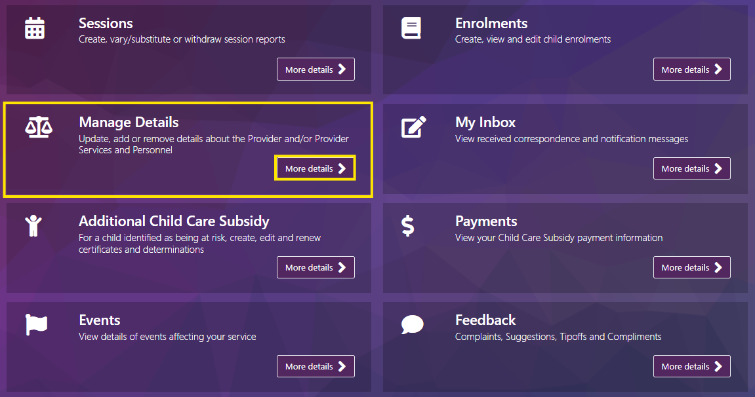

Hours of Operation

Step 1
Under the Business Details heading select Hours of Operation
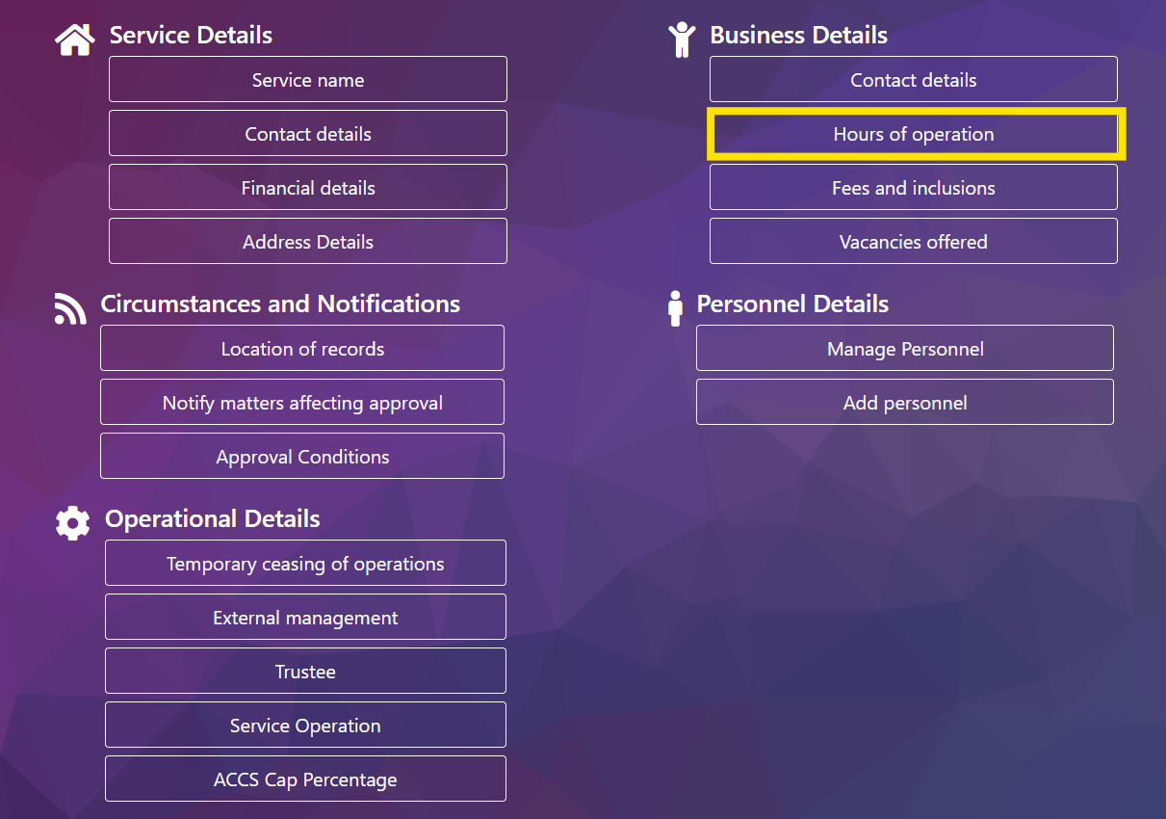

Step 2
Enter Date of event, this is the date your new hours are valid from.
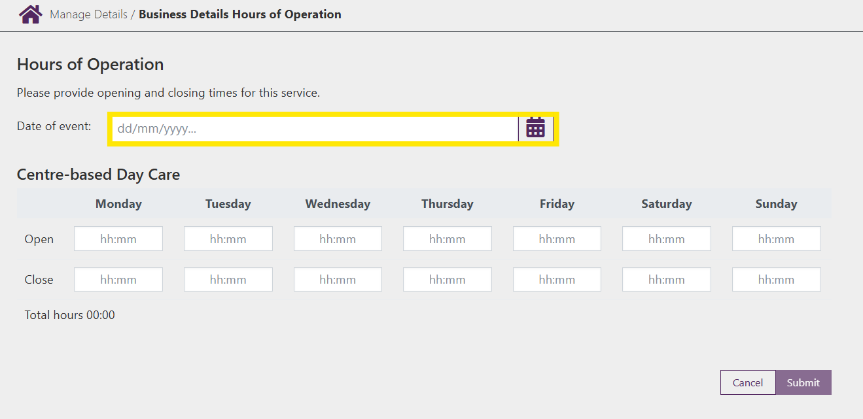

Step 3
Complete the opening hours for each relevant day:
- Open: Enter the opening time. The format is required to be in HH:MM
- Close: Enter the closing time. The format is required to be in HH:MM. It must be a time later than the opening time.
Note: You are required to enter both Open and Close times.
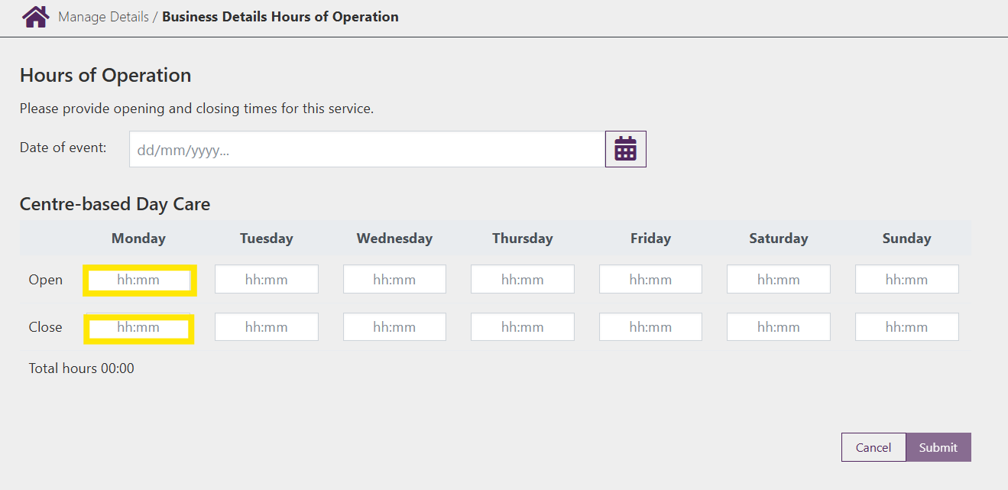

Step 4
Review the information and select Submit to submit the change.
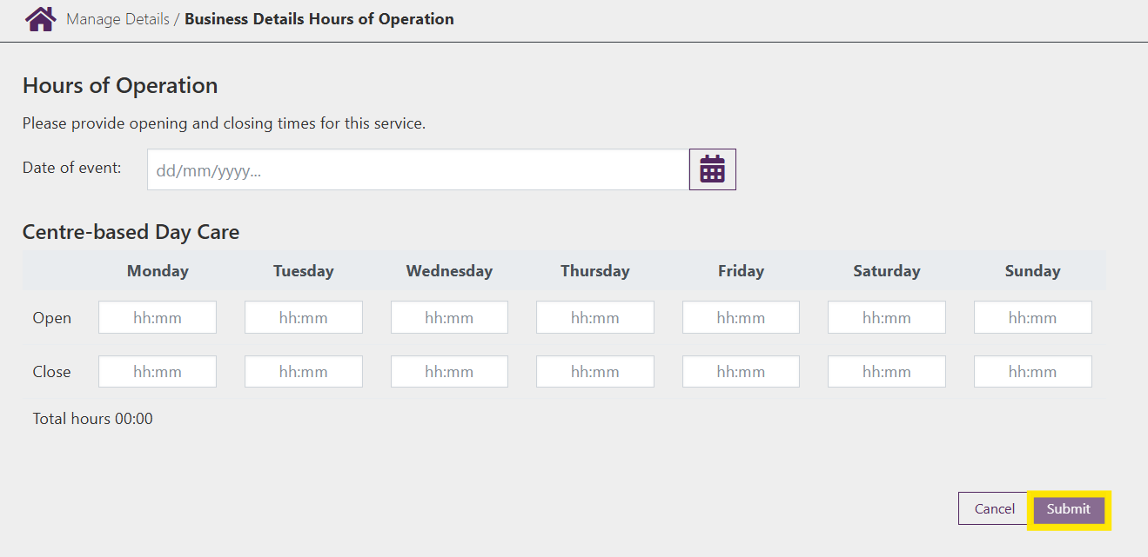

Step 5
You will receive a receipt confirming the submission of the new opening times. Select either Return Home to return to the Service home page or Continue to return to the Manage Details page.

