


Get Started User Guide for Relationship Authorisation Manager
Provider Registration and International Student Management System (PRISMS)

Document Purpose
Education providers and software vendors who request to access PRISMS API Services must hold a valid and current Relationship Authorisation Manager (RAM) Certificate to meet Australian Government’s expectation on secure machine-to-machine exchanges. As an essential step of the application process to gain access to PRISMS API Services, providers and vendors are required to provide their public certificate which is contained in their RAM Certificate to the Australian Department of Education.
This document provides a guide for Principal Authorities and Authorised Administrators to create a RAM Certificate and extract the public certificate from it using Open SSL.
This guide should be used along with the RAM website for more detailed and updated information.

Key Terms and Acronyms
Term/Acronym | Description
API | An Application Programming Interface is a set of rules and protocols that allows two different software programs to communicate with each other.
ATO | The Australian Taxation Office owns the RAM service that enables individuals to link their Digital ID (myID) to an Australian Business Number (ABN) to act on behalf of a business online.
Authorised Administrator | An authorisation administrator is a person appointed by Principal Authority to manage business access and machine credentials in RAM, allowing them to create, edit, and revoke authorisations for staff on behalf of the business.
Keystore | The computer file path specified to create and store RAM machine credential aka RAM Certificate.
OpenSSL | OpenSSL is a software library for applications that provide secure communications over computer networks against eavesdropping and identify the party at the other end. OpenSSL contains an open-source implementation of the Secure Sockets Layer (SSL) and Transport Layer Security (TLS) protocols. It is widely used by Internet servers, including majority of the HTTPS websites.
Principal Authority | A principal authority is a person responsible for the business, such as a trustee or director. A principal authority can create a machine credential or authorise someone else to do so. Click here for more information.
PRISMS | The Provider Registration and International Students Management System is a secure Australian government database used by education providers to issue Confirmations of Enrolment (CoE) and report international student data to the Department of Education and Department of Home Affairs. It ensures compliance with the Education Services for Overseas Students (ESOS) Act.
Private Key | A private key in asymmetric key pair in RAM Certificate is the secure, secret cryptographic key. This key enables secure machine-to-machine transactions, authenticating the business during electronic interactions with government agencies.
Public Certificate | RAM Certificate contains a public certificate and a private key. The public certificate contains a public key in asymmetric key pair which is an electronic document component of a Business Machine Certificate that binds a specific machine or software application to an organization, enabling secure machine-to-machine interactions with government agencies.
RAM | Relationship Authorisation Manager
RAM Certificate | A RAM Certificate is an electronic document signed by the ATO as the Certification Authority for the Machine Authentication Service via the RAM system. The certificate identifies a subscriber by way of a distinguished name, binds the subscriber to a key pair by specifying the public key of that key pair, and contains the information required by the certificate profile.

Access RAM
To access RAM, a Digital ID recognised by the Australian Government such as myID is required. The standard of the identity strength has different requirements for different access purposes. For how to set up a Digital ID to access RAM, visit the RAM website. This website will detail:
- what identity strength is required
- how to access RAM with your Digital ID

Create Machine Credential/RAM Certificate
A machine credential is also a business machine certificate which permits machine-to-machine interactions. Creating a machine credential via RAM is required to transact with government services including PRISMS API services owned by the Department of Education through your business software. The RAM website has clear step-by-step instructions to create and store a machine credential aka RAM Certificate. The website also has other relevant information you might need:
- When to and who can create a machine credential
- Who is a principal authority
- How to create an authorisation

Extract Public Certificate
A RAM Certificate is an X.509 certificate. X.509 is a standard format for public key certificates. Each X.509 certificate includes a public key, identifying information, and a digital signature.
There are various methods to extract the public-key certificate from an X.059 certificate, OpenSSL is the most common way. The following steps outline how to extract the public certificate from your RAM Certificate using OpenSSL.

Step 1
To begin with, download and install OpenSSL via its official website.

Step 2
Locate your RAM Certificate file in your keystore path, which is in the “.xml” format and named keystore.xml by default but the name can be changed when you create the machine credential. Use a text editor such as Notepad or Word to open the file.

Step 3
Copy <publicCertificate> base 64 encoded content into a new text editor.

Step 4
In your new text editor, add a line
-----BEGIN CERTIFICATE-----
to the top, then add a line
-----END CERTIFICATE-----
to the end.

Step 5
Save your new text editor file in the “.p7b” format with a meaningful name to your organisation.

Step 6
Open your computer Command window, navigate to the folder where the p7b file is stored by using the Change Directory command CD, e.g., type:
cd C:\Users\Username\Downloads
then hit Enter to run it.

Step 7
Type the command:
openssl pkcs7 -print_certs -in xxx.p7b -out xxx.cer
then hit Enter to run it. This command exports the p7b file to a new file in the “.cer” format.

Step 8
Open the “.cer” file using a text editor, the first certificate in the list you see is your public certificate of your RAM Certificate. Copy the entire text block between the first “-----BEGIN CERTIFICATE-----” and “-----END CERTIFICATE-----”.
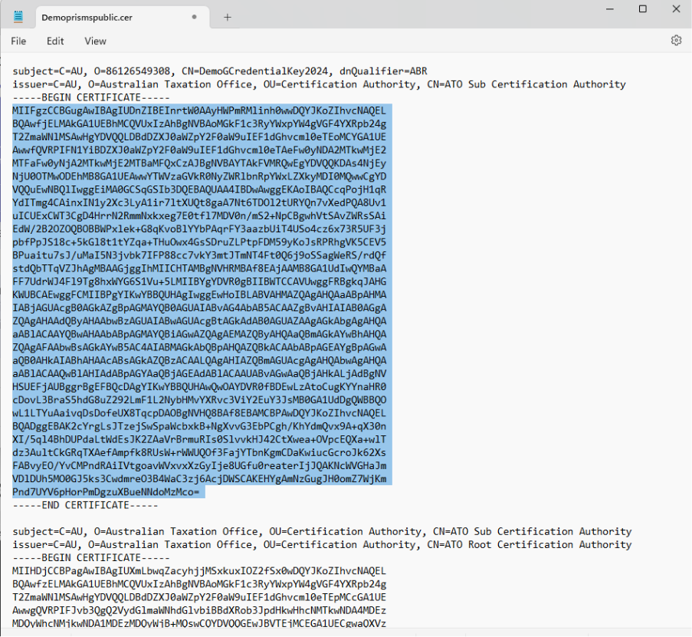

Step 9
Remove all hidden line spacing characters in the copied text block before sending it to PRISMSAPI@education.gov.au.
To remove the hidden line spacing characters, you can use Ms Word or other text editor tools. If using Word, click “¶” to show all toggle symbols and remove them.

