


2026 Mission-Based Compact Between the Commonwealth of Australia and Adelaide University

Purpose
This compact is an agreement between the Commonwealth and the University. Entering into a Compact is one of the quality and accountability requirements, which a higher education provider must meet under the Higher Education Support Act 2003 (HESA) as a condition of receiving a grant. Specifically, subsection 19-110(1) of HESA requires that Table A and Table B providers must, in respect of each year for which a grant is paid to the provider under HESA, enter into a Mission -Based Compact with the Commonwealth for a period that includes that year.
All strategies should provide qualitative and/or quantitative measures of assessment.

Mission and Strategic Planning
2026 MISSION, STRATEGIC PLANNING AND KEY OUTCOMES
Established in 2026, Adelaide University (AU) delivers an integrated, future focused model of higher education that combines scale, comprehensive disciplinary breadth and contemporary institutional design. Guided by its founding legislation, Vision, and Strategic Ambition & Direction 2024–34, AU is committed to expanding access and participation, strengthening partnership with First Nations peoples, delivering a contemporary curriculum, and translating research and innovation into measurable economic, social and cultural impact. This ambition is underpinned by a statewide physical and national online footprint, strong regional and international engagement, and the Adelaide Attainment Model that positions students and their experience at the centre of the university.

To monitor corporate performance the University Council is developing contemporary governance arrangements that reflect the recommendations of the Expert Council on University Governance report.

Workforce and skills needs
Adelaide University integrates education, research and engagement to meet workforce needs, community priorities and Australia’s long-term national interest. Through its Industry and Government Engagement Framework, AU aligns innovative program design with national and state priorities, including stackable program architecture and sector-responsive offerings such as Australia’s first degree apprenticeship delivered in partnership with industry.

Upholding academic freedom and freedom of speech
Academic Freedom and Freedom of Speech arrangements continue under the relevant foundation university Enterprise Agreements and the associated procedures and guidelines; limits and freedoms relating to speech and other forms of expression remain unchanged. The AU Enterprise Agreement, currently being negotiated, will also include these provisions and a new AU Policy and Procedure will be developed in consultation with staff and their representatives.

Ensuring student and staff safety
Adelaide University is implementing a Safer Community initiative with associated updates to operational structures, policies and procedures. As part of this initiative, AU's Integrity Unit will be expanded and renamed as the Safer Community Unit to improve visibility and expand the scope of its work. The Unit will foster a safe, respectful and inclusive culture by focusing on responding appropriately to incidents of harmful behaviours, including all forms of racism and gender-based violence, as well as evidence-based prevention activities. This will be underpinned by a coordinated governance and capability framework, including the delivery of education on antisemitism to all leaders in the University and all front-line staff initially and wider University community subsequently. These efforts will be overseen by a steering committee accountable to the Vice Chancellor and regular reports on both incidents and progress of the initiative will be reported to Council.

Adelaide University provides extensive student support services including access and inclusion services, counselling, sexual assault and harassment reporting and assistance, career services, community clinics, student wellbeing and tailored support for cohorts such as international students, regional students, veterans and Aboriginal students. These services are complemented by an internal Student Ombud, an independent and impartial role to further assist students once internal processes have been exhausted.

Adelaide University is building an encompassing approach to staff support and wellbeing, rooted in a unified approach to physical and psychosocial safety, inclusive culture, workforce capability development and stewardship of people and resources, supported by comprehensive services and resources outlined on the University’s staff Support and Wellbeing page.

Countering Foreign interference
Adelaide University has established policy, continues to monitor the evolving geopolitical landscape and is undertaking the following activities to reduce risk:
- Updating foreign interference frameworks
- Ensuring a Foreign Engagement Compliance Review is conducted on all high-risk activities
- Undertaking a Declaration of Foreign Interests process for all staff during 2026.

Cyber and data security
Adelaide University applies a risk-based, globally aligned approach to cyber and data security that supports innovation and trusted engagement. This is underpinned by established cyber security, information technology and management policies, regular cyber risk reporting, and a defined 2026 program focussing on AI-enabled security operations, Zero Trust identity controls, third-party risk management, and strengthened detection, response and resilience, aligned with the ACSC Essential Eight and NIST frameworks.

Strategies for Improving Equality of Opportunity in Higher Education
Adelaide University serves approximately 65,000 students, including over 20,000 equity students (36%) – approximately 21% from low SES backgrounds, 16% from regional and remote areas, 1.6% Aboriginal or Torres Strait Islander, 18% living with disability, and 18% first-in-family. The South Australian Government has provided a $120m Student Support endowment, the proceeds of which will be directed to improve participation and success for these cohorts, with implementation guidelines in development.

Adelaide University’s approach to widening participation includes engagement with schools, communities and industry, supported by broader community and partner engagement activities. Early outreach, pathway development, and targeted student support services enable access and support success for learners from under-represented backgrounds. Dedicated senior leadership, including a Deputy Vice-Chancellor, Student Experience & Success and Deans of Students in each College, provide coordinated oversight of student experience, wellbeing, retention and success.

AU Online (AUO) plays a critical role in expanding national access to higher education. It serves a notably diverse cohort with more than 60% of its 5,500+ students identifying with one or more equity categories. A substantial proportion of its students study from outside South Australia, providing access for learners who may otherwise face barriers to participation including mature-age students, women, and in-career professionals. AUO offers flexible, high-quality learning pathways that enable study alongside work, caring responsibilities and other commitments, supporting lifelong learning and workforce preparation across Australia.

AU aims to be a university of choice for Aboriginal and Torres Strait Islander Peoples. It is the first university in Australia to include provision for an Aboriginal name in its founding Act. Tirkangkaku—meaning Place of Learning—is a gift from the Kaurna People honouring AU’s connection to Country its commitment to reconciliation. A commitment embedded in governance through the Indigenous portfolio led by the Deputy Vice Chancellor, Indigenous, and appointment of 6 Aboriginal and Torres Strait Islander leaders, making up 1.7% of AU’s senior appointments. AU has also created a First Nations Ambassador role to strengthen communication with communities, champion participation in education, and ensure First Nations voices shape university decision making.

Drawing on more than 15 years of proven practice, Adelaide University offers three preparatory programs—UniStart (100% online), Foundation Studies, and the Aboriginal and Torres Strait Islander Pathway—designed to support diverse learners into undergraduate study. Programs are delivered flexibly across online, blended, face-to-face, metropolitan and regional settings and emphasise academic literacy, numeracy, discipline specific preparation and culturally responsive design. Curricula are nationally benchmarked and aligned with the endorsed learning outcomes of the National Association of Enabling Educators of Australia.

Adelaide University’s Statewide footprint includes a strong regional presence with Whyalla and Mount Gambier campuses providing foundational academic and professional services and acting as regional anchors. Both campuses deliver Pathway programs (also delivered at Port Lincoln and Ceduna, and in partnership with Technical Colleges in Port Augusta and Mount Gambier) and Foundation Studies (also delivered in Adelaide and expanding to the Playford Hub in late 2026). Adelaide University also partners with regional study hubs in Kadina, Port Pirie, Port Augusta, Roxby Downs and Port Lincoln, enabling participation without relocation.

To strengthen research pathways, Adelaide University has introduced Aboriginal and Torres Strait Islander Master of Research Cohort Scholarships, with modular coursework Graduate Certificates providing flexible access through to PhD. The scholarships offer a tax-free stipend of $53,608 per annum, with the first cohort commencing in August 2026.

Adelaide University’s HECG Equity Plan builds on 18 existing initiatives and three new major programs, targeting Adelaide’s northern suburbs, school partnerships, financial support, SATAC fee waivers, and minor capital works to improve access, inclusion and regional student experience.

Strategies for Improving Teaching and Learning
The establishment of Adelaide University has enabled the design of a contemporary, accessible and future focused curriculum, informed by academic expertise from both foundation institutions and supported by new programs with consistent curriculum architecture, digital learning platforms, and curriculum management systems. Central to this approach is the Adelaide Attainment Model, which provides students with multiple entry and transition points, modular course design, common core courses, and embedded, industry partnered credit-bearing Work-Integrated Learning (WIL) courses in all coursework programs.

Teaching and Learning Performance Strategies
Teaching quality is supported through a structured curriculum quality assurance framework, with regular monitoring, review and enhancement at College and University levels, informed by student feedback and stakeholder input. Adelaide University’s internal Feedback on Learning Experiences (FLEx) survey provides insights into teaching quality, course design and student experience, supporting evidence based curriculum and teaching improvement. Staff are supported in the use of teaching technology, and to enhance the quality, of teaching through dedicated resources, and the Education Quality Framework supports continuous improvement of curriculum. A comprehensive suite of referral guides has been developed to assist staff to support student success, covering wellbeing, academic skills, inclusion, specific resources for international students, and resources for staff training and managing at-risk students.

An Academic Integrity transformation program is underway to strengthen assessment design and ensure integrity. Enhanced data capture and analytics will support systematic monitoring of misconduct trends and inform continuous improvement in program and course level assessment practices.

Performance measures and targets
Adelaide University’s Strategic Ambition & Direction 2024–34 was developed to articulate the ambition and purpose of the new University as a globally connected institution that combines academic excellence with deep local impact, social responsibility and economic contribution. Adelaide University commenced operation on 1 January 2026, and Council and Executive are reviewing and refreshing its strategic plan. Specifically, the development of a Curriculum Performance Framework will provide systematic oversight of curriculum performance, review and renewal of content, and informed by external performance measures to drive continuous improvement.

Admissions Transparency
Adelaide University’s Admissions Policy ensures that selection processes are equitable, transparent, inclusive and aligned with legislative and policy requirements. Our Entry Pathways website provides entry pathways for prospective students from all backgrounds including specific programs for Foundation Studies, Aboriginal and Torres Strait Islanders and UniStart. Adelaide University has well-developed policy and procedures to proactively identify and support students at risk of poor performance. Academic review of applications ensures that prospective candidates benefit from holistic advice that combines technical and discipline-specific information.

Labour market outcomes
Adelaide University’s newly designed curriculum and initial suite of online programs have been developed to align closely with contemporary workforce needs, incorporating embedded WIL, employability skills and industry informed assessment across all relevant programs. Program design and review are informed by College-level external advisory boards, which bring industry, professional and community-based expertise to advise on curriculum relevance, emerging skills needs and graduate destinations. Recent accreditation of coursework programs ensures qualifications meet professional, regulatory and industry standards, strengthening program quality and graduate skills. Together, contemporary curriculum design, external industry insight, and comprehensive accreditation provide a strong foundation for positive graduate employment outcomes, career mobility and long-term workforce relevance.

International Student Support
Adelaide University provides integrated, end-to-end support for international students across the student lifecycle, including prearrival information, orientation, visa and compliance advice, academic skills, wellbeing services and employability support. International students’ experience and educational progress are improved through monitoring student feedback, progression and completion data.

Strategies for Improving Research, Research Training, and Innovation
Adelaide University’s approach to research, research training and innovation is guided by the Adelaide University Research Strategy and its five Signature Research Theme (SRT) research strategies: Creative & Cultural; Defence & National Security; Food, Agriculture & Wine; Personal & Societal Health; and Sustainable Green Transition. These are complemented by the Aboriginal and Torres Strait Islander Research Strategy connecting and enabling opportunities and outcomes in all research areas for Aboriginal and Torres Strait Islander researchers and communities.

The strategy provides a framework for prioritising investment, capability development and partnerships, ensuring that research activity is aligned with national and State priorities and delivers economic, social and environmental benefit. It identifies Adelaide University’s research focus areas and priorities and establishes success metrics for measuring progress and impact.

The Adelaide University Research Strategy emphasises research translation that is codesigned and delivered with industry, government and community partners to support the practical application of research and deliver measurable impact. This approach is intended to strengthen industry capability, productivity, innovation, commercial outcomes and workforce development, through aligning strategic partnerships, and investments with relevant partner objectives, therefore, delivering wider public benefit.

As South Australia’s premier university, we aim to leverage the state’s unique strengths, through our integrated industry-connected campuses, world-class research and talent, major long-term alliances, and proven translation models to attract investment and deliver high-impact solutions to local and global challenges. Targeted strategic initiatives include development of a Northern Corridor Gateway project which will integrate research, education, industry and clinical partnerships to improve health outcomes, workforce capability, and innovation in this region. Similarly, Adelaide University’s Research-engaged Action Laboratories for Innovation (ReAL Innovation) brings together multidisciplinary expertise to support co-design and deliver projects that address defined real-world challenges. ReAL Innovation supports the development, testing and implementation of solutions through applied research, industry-embedded learning activities, workforce-focussed programs. Through testing, implementation and adoption of solutions, ReAL Innovation strengthens pathways from research to practice and supports innovation update, skills development and measurable economic, social and environmental outcomes.

The operationalisation of these strategies will be aided by new analysis which provides a robust, evidence-based framework for guiding investment and collaboration to drive innovation, productivity and sustainable growth across the state. This analysis centres on the five SRTs as focal points for academic-industry partnerships, each reflecting critical sectors for South Australia’s prosperity.

The South Australian Government has provided Adelaide University with an endowment, the earnings from which will be focussed on priority areas aligned with the University Research Strategy, with implementation guidelines in development.

Research Training
Adelaide University is focused on building a strong, diverse and sustainable research workforce. A new Master of Research (MRes) is being delivered for the first time, providing a structured pathway for candidates without an Honours degree and opening a pathway to a PhD that includes stackable course-work graduate certificates to cater for diverse experience and pathways. MRes Equity Scholarships will be offered to support participation from under‑represented cohorts and to address barriers to entry.

PhD candidates will be recruited through three pathways:
- a merit‑based round, based on academic attainment to date;
- a project‑based pathway, aligned to prioritised research programs, including projects co‑designed with industry; and
- cohort‑based recruitment targeting strategic sectors, such as Defence and National Security, to build communities of graduate researchers aligned to workforce and capability needs.
Adelaide University aims to award 400 higher degree research scholarships in 2026.

Greater alignment will be progressively achieved between the Signature Research Themes, South Australia’s economic priorities and graduate researcher recruitment, to contribute to skills development, innovation capacity and the long‑term economic resilience of the State and Nation.

Research Security
Adelaide University intends to maintain a high level of Defence Industry Security Program (DISP) accreditation and strengthen its research security framework in response to the evolving geopolitical landscape. This includes enhancing cyber and physical security controls, supporting secure international collaboration, and embedding research security as a core component of research culture.

Innovation
Innovation is integral to Adelaide University’s role as a for‑purpose, industry‑engaged institution. A new equity holding structure will bring together the University’s two commercialisation entities, enabling a more coordinated and strategic approach to intellectual property management, venture creation and industry engagement.

Where appropriate, research translation and investment will align with the Australian Government’s Future Made in Australia agenda, particularly in areas supporting net zero transformation, economic security and advanced manufacturing.

Strategies for Engaging with Industry
The Adelaide University Research Strategy, emphasises research translation that is co-designed and delivered with partners to support practical application and impact. It is intended to improve capability, productivity, innovation, commercial outcomes and/or workforce development for industry partners. To achieve this, Adelaide University co-designs initiatives with government agencies, industry partners and peak bodies informed by our Industry and Government Engagement Framework supports the development of agreed outcomes that deliver coordinated engagement, align activity to strategic priorities, and support partnerships, investment and skills development.

Adelaide University’s Enterprise and Innovation Hub offers both physical and virtual access to university expertise and supports collaboration from early engagement through to project delivery and application to practical contexts. By coordinating these partnerships, the University supports research translation, sovereign capability, workforce development and innovation contributing to economic, social and environmental outcomes, and strengthening its role as a trusted partner locally, nationally and internationally.

Engagement is further strengthened through a coordinated network of external advisory boards at institutional, College and discipline levels, which provide strategic insight into emerging challenges and help ensure research, education and innovation remain aligned with industry and policy needs. College-level boards ensure industry expertise informs curriculum, program design and research direction while A whole-of-university External Advisory Board will provide cross-sector insight and external perspective.

Within this framework, the Australian Defence Technologies Academy (ADTA) adopts a coordinated, partnership-driven approach to engaging with industry and government, focusing on aligning research and innovation, education, and workforce development with defence sector needs. ADTA is an Innovation-led learning and research academy that prioritises, industry partnering to identify and build future talent pipelines and uplift existing workforce capabilities to address defence sector employment needs.
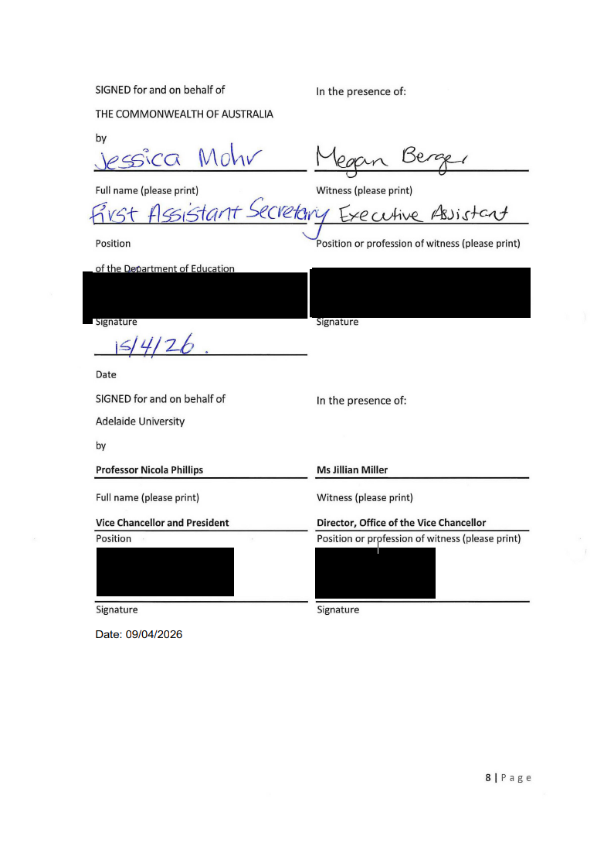

Attachment 1 – Student Ombud
Attachment 2 – Staff Support and Wellbeing
Attachment 3 – Adelaide Attainment Model
Attachment 4 – Feedback on Learning Experience
Attachment 5 – Education Quality Framework
Attachment 6 – Academic Integrity

