


Compliance and Enforcement Policy
  - December 2025



With the exception of the Commonwealth Coat of Arms, the Department’s logo, any material protected by a trade mark and where otherwise noted all material presented in this document is provided under a Creative Commons Attribution 4.0 International (https://creativecommons.org/licenses/by/4.0/) licence.
The details of the relevant licence conditions are available on the Creative Commons website (accessible using the links provided) as is the full legal code for the CC BY 4.0 International (https://creativecommons.org/licenses/by/4.0/legalcode)
The document must be attributed as the Compliance and Enforcement Policy of the Higher Education Gender-based Violence Regulator.



Contents
1 Introduction 5
1.1 Purpose 5
1.2 Scope 5
1.3 Legislative framework 5
1.4 Strategic context and supporting documents 8
1.5 Statutory and regulatory principles 8
1.6 A risk-based approach: application of regulatory focus 9
1.7 Early regulatory focus: Recognising regulatory and compliance maturity 10
2 How information informs the regulatory approach 11
2.1 Data, evidence and intelligence 11
2.2 Information requests 12
2.3 Use of monitoring and investigation powers 12
3 Approach to compliance and enforcement 12
3.1 Other considerations 13
4 Voluntary compliance 14
4.1 Purpose of voluntary compliance 14
4.2 Activities to support voluntary compliance 14
5 Directed compliance 15
5.1 Purpose of directed compliance 15
5.2 Activities to support compliance activities 15
5.3 Outcomes of directed compliance activities 15
6 Enforcement 16
6.1 Purpose of enforcement activities 16
6.2 Enforcement tools and activities 16
6.3 Outcomes of enforcement activities 16
7 Compliance and enforcement tools 17
8 Transparency and accountability 19
8.1 Co-regulators 19
8.2 Statutory and public reporting 19
8.3 Privacy 19
8.4 Evaluation 20
9 Appendix: tables for assessing risk and non-compliance 21

Introduction

Purpose
The Higher Education Gender-based Violence Regulator (GBV Regulator) is Australia’s regulator of higher education to prevent and respond to gender-based violence.
The GBV Regulator is successful if:
- Higher education providers prevent, reduce and eliminate gender-based violence.
- Victim survivors are believed and supported through higher education providers' responses to gender-based violence that are consistently trauma-informed and person-centred.
- The higher education sector plays a leading role in eliminating gender-based violence in a generation.
The purpose of this Compliance and Enforcement Policy is to set out how the GBV Regulator exercises its compliance and enforcement powers. It provides clarity for higher education providers, staff that carry out duties on behalf of their provider, students, and other key stakeholders about the GBV Regulator’s approach to promoting compliance, responding to non-compliance and how enforcement measures will be applied where necessary.

Scope
This policy is for:
- Higher education providers registered with the Tertiary Education Quality and Standards Agency (TEQSA) including all Table A and Table B providers under the Higher Education Support Act 2003 (Cth) (HESA), and other providers registered under the TEQSA Act 2011 (Cth) (TEQSA Act). This includes Australian universities, institutes of higher education, and university colleges.
- Staff of higher education providers who are responsible for implementing their provider’s requirements under the National Code.
- Students and staff engaged with or by a higher education provider, including those enrolled or employed by the provider.
- GBV Regulator Authorised Officers who monitor compliance and enforce requirements under the Act and the National Code.

Legislative framework
The GBV Regulator operates within a legislative and regulatory framework designed to prevent and respond to gender-based violence within the Australian higher education sector. This framework sets out the GBV Regulator’s powers and responsibilities, as well as the requirements of higher education providers.
The Universities Accord (National Higher Education Code to Prevent and Respond to Gender-based Violence) Act 2025 (Cth) (the Act) is the GBV Regulator’s primary legislation. The Act provides the Secretary of the Department of Education with a range of powers to monitor and respond to non-compliance.
The National Higher Education Code to Prevent and Respond to Gender-based Violence 2025 (National Code) is a legislative instrument that establishes mandatory requirements for higher education providers to prevent and respond to gender-based violence across their organisation.
The Act ties compliance with the National Code as a condition of funding to the Higher Education Support Act 2003 (Cth) (HESA). This means that a higher education provider’s non-compliance with the National Code may also have consequences for that provider’s approval under HESA. For example, the Minister for Education could take action to suspend or revoke a provider’s approval under Division 22 of HESA if a provider does not meet the requirements of the National Code. Failure to comply with the requirements of the National Code may also result in TEQSA taking regulatory action in relation to compliance with the Threshold Standards made under the TEQSA Act.

Powers of the GBV Regulator under the Act and the Regulatory Powers Act
The compliance and enforcement powers of the GBV Regulator come from two pieces of legislation: the Act and the Regulatory Powers (Standard Provisions) Act 2014 (Regulatory Powers Act). The Regulatory Powers Act provides a standardised framework for regulatory powers across all Commonwealth regulators, and the Act details additional regulatory powers that are unique to the GBV Regulator. Together, these Acts provide the GBV Regulator with a full suite of powers to promote, monitor and, where necessary, enforce compliance with the National Code. These powers are:
- Education and Guidance: Providing advice, resources, and best practice examples to build sector capability and foster voluntary compliance (Section 26 of the Act).
- Information Gathering: Setting information requirements by rules and issuing notices to require providers or connected persons to give information and documents within defined timeframes (Sections 22 and 27 of the Act).
- Information Sharing: Sharing information with co-regulators or oversight bodies (Section 42 of the Act).
- Monitoring and Investigation: Exercising monitoring powers (Section 35 of the Act and Part 2 of the Regulatory Powers Act) and investigation powers (Section 36 of the Act and Part 3 of the Regulatory Powers Act), including entry, inspection, and evidence collection.
- Compliance Powers: Issuing formal notices requiring providers to take corrective action within specified timeframes (Section 32 of the Act).
- Enforcement Powers: Applying civil penalties (Section 37 of the Act and Part 4 of the Regulatory Powers Act), issuing infringement notices (Section 38 of the Act and Part 5 of the Regulatory Powers Act), accepting enforceable undertakings (Section 39 of the Act and Part 6 of the Regulatory Powers Act), and seeking injunctions through the courts (Section 40 of the Act and Part 7 of the Regulatory Powers Act).
- Transparency and Reporting: Publishing compliance outcomes and sector-wide data to promote accountability (Sections 43 and 44 of the Act) and reporting annually to Parliament on compliance activities (Section 47 of the Act).

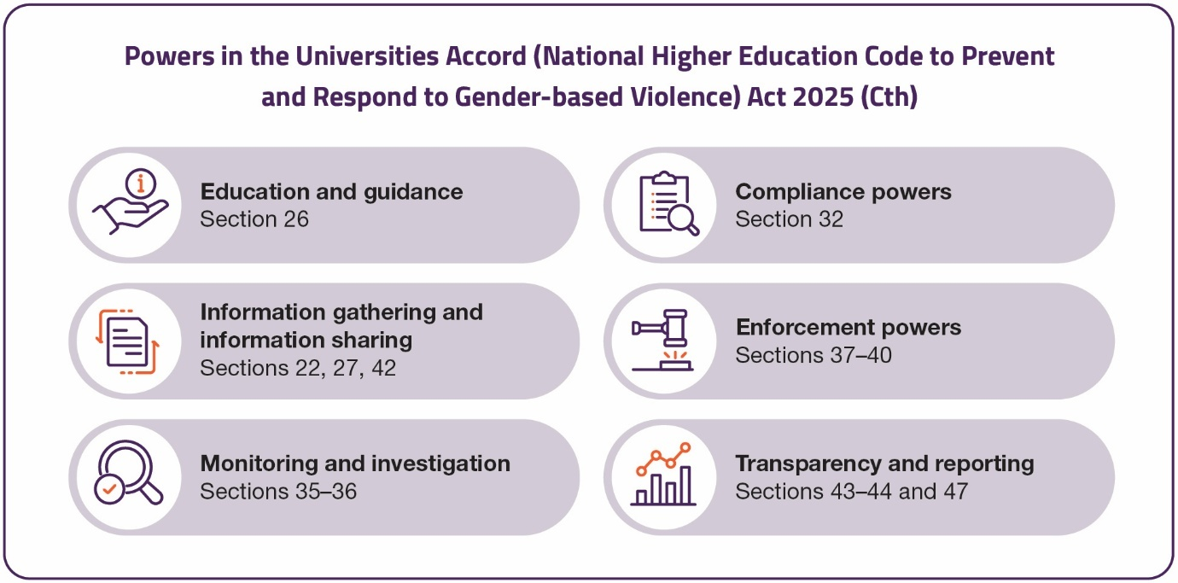
Powers of the GBV Regulator under the Act

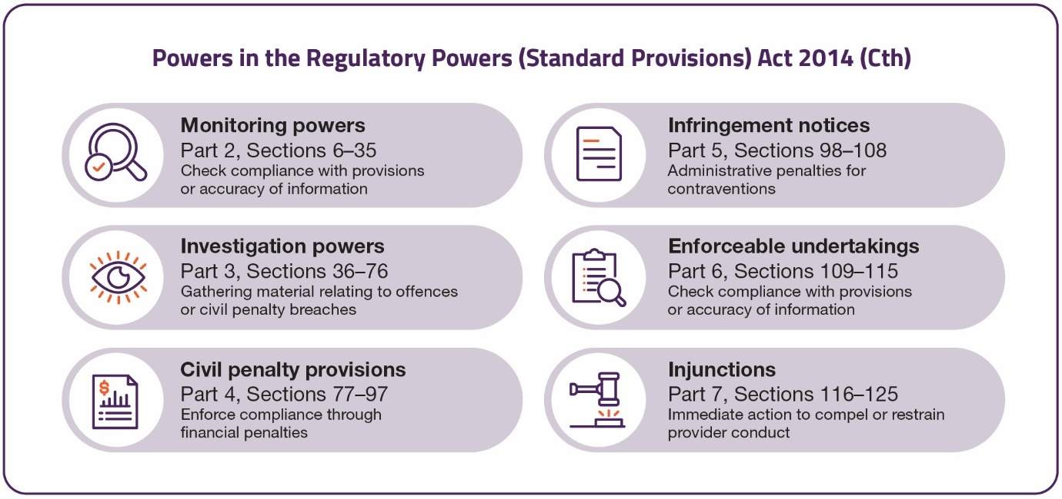
Powers of the GBV Regulator under the Regulatory Powers Act

Provider requirements under the Act
Higher education providers are subject to a range of statutory requirements under the Act
that form the foundations of regulatory requirements. Providers must meet these
requirements to be compliant. Failure to do so may result in compliance or enforcement
action:

- Comply with the National Code: Providers must implement and adhere to all requirements set out in the National Code (Section 20).
- Recordkeeping: Providers must retain records relevant to compliance with the Act and the National Code for a minimum of 7 years (Section 21).
- Provide required information: Providers must supply information to the Secretary as required (Sections 22 and 27).
- Notification of changes or non-compliance: providers must notify the Secretary within 14 days of becoming aware of any inaccurate information previously provided or any contravention of the Act or Code (Section 23).
- Avoid false or misleading information: providers must not give false or misleading information to the regulator. This applies to all forms of communication, including reports, submissions and responses to notices (Section 24).

Strategic context and supporting documents
The GBV Regulator’s Regulatory Statement (Statement) is the overarching framework that establishes the GBV Regulator’s posture, expectation and approach to regulating. This Compliance and Enforcement Policy aligns with this Statement and is subject to this broader framework to ensure that compliance and enforcement is consistent with a commitment to risk-based approach to regulation.
The GBV Regulator has released comprehensive regulatory and educative guidance for higher education providers and their staff about how to comply with the National Code. These can be found here:
- Regulatory Guidance for the National Higher Education Code to Prevent and Respond to Gender-based Violence
- Minister for Education’s Statement of Expectations 2025
- Department of Education’s Statement of Intention 2025
- Guidance to Develop a Whole-of-Organisation Gender-based Violence Prevention and Response Plan Outcomes Framework
- Optional Plan Template: Whole-of-Organisation Prevention and Response Plan and Outcomes Framework

Statutory and regulatory principles

Statutory principles
The GBV Regulator is required to comply with two statutory principles under Sections 9 –12 of the Act:
- Regulatory necessity: The exercise of powers must not burden a provider any more than is reasonably necessary. In practice, this means avoiding duplication of information requests, only seeking clarification when required, and requesting information only where there is a clear need (for example, to determine compliance with the Act or the National Code).
- Proportionate regulation: Powers must be exercised in proportion to any non-compliance or risk of future non-compliance. This includes considering the seriousness of the issue, the actual or potential risk of harm to students and staff, the likelihood of recurrence, and the provider’s capability and commitment to address the issue.
These statutory principles apply whenever powers are exercised under the Act. Authorised officers appointed under Section 33 of the Act must comply with these principles when taking regulatory action.
Both statutory principles are embedded in the following six regulatory principles.

Regulatory principles
The GBV Regulator exercises its powers and makes decisions based on its regulatory principles. These principles shape how risk is assessed, cases are prioritised, and the most appropriate compliance or enforcement response is determined. They also support transparency and accountability, ensuring that actions are consistent, evidence-based and aligned with statutory requirements.
Principle | Commitments
Proportionate and  risk-based | Regulatory powers are exercised in proportion to the seriousness of non-compliance or the risk of future non-compliance. Action is directed toward areas of greatest harm and highest impact, considering the severity and likelihood of harm, as well as the provider’s compliance history.
Evidence and Outcomes Driven | Intelligence, data, information and external expertise are used to inform the allocation of regulatory effort and regulatory decisions with the goal of achieving measurable improvements in student and staff safety.
Transparent and Accountable | Expectations of higher education providers are clearly communicated, along with reasons for regulatory decisions and decision-making principles.
Continuous Improvement | Regulatory posture supports capability-building and sector-wide maturity, encouraging providers to embed best practice and improve over time.
Collaborative | The GBV Regulator works with partner regulators to drive compliance with the National Code.
Coherence and Alignment | Regulatory activities align with broader government policy, legislative frameworks, and other regulatory schemes to ensure consistency and reduce duplication.

A risk-based approach: application of regulatory focus
In alignment with the regulatory principle of proportionate and risk-based regulation, the GBV Regulator directs its compliance activities based on a thorough risk assessment. This assessment evaluates how a provider’s actions to prevent and respond to gender-based violence may impact the safety and wellbeing of students and staff within higher education. This risk-based targeting and prioritisation approach informs regulatory actions, including whether the GBV Regulator:
- Educates and engages providers on their requirements.
- Provides guidance materials to assist with compliance.
- Assesses, monitors and investigates non-compliance (e.g. inspections, audits, reviews).
- Exercises compliance powers.
- Undertakes enforcement action (e.g. referrals or sanctions).
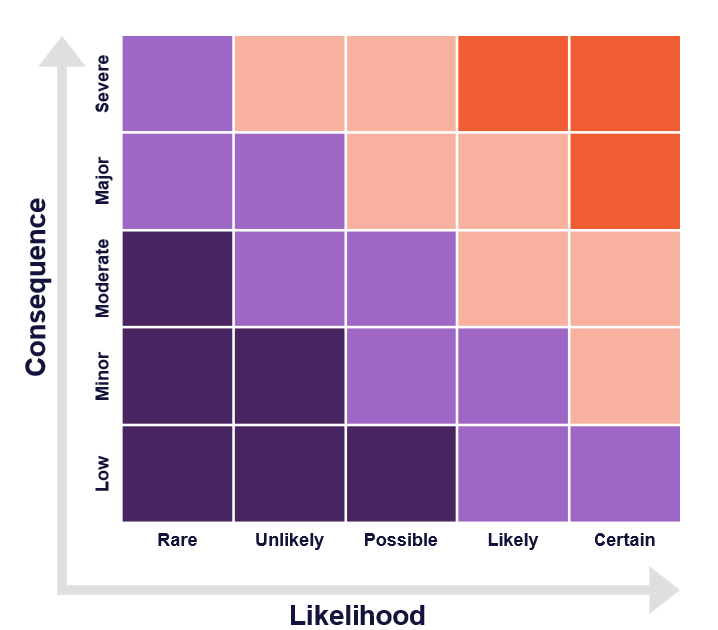
The risk assessment is based on the:
- Consequence of non-compliance: the severity of the potential or actual harm to students or staff.
- Likelihood of non-compliance: how likely it is that the provider will not comply with their requirements.
The image on the right represents how the GBV Regulator considers the likelihood and consequence of non-compliance to determine a higher education provider’s risk profile and the consequential prioritisation of resources. Further guidance on how risk and non-compliance is assessed provided in Appendix 1.
This approach shapes how the GBV Regulator carries out its compliance and enforcement activities.

Early regulatory focus: Recognising regulatory and compliance maturity
As set out in the regulatory principles of collaborative and continuous improvement, the GBV Regulator acknowledges the diversity of the higher education sector and that both the GBV Regulator and the sector are in the early stages of implementing the National Code, which is a newly regulated environment where capability is still maturing.
To reflect this unique context, the GBV Regulator has an early regulatory focus on:
- Education and engagement to build higher education providers’ understanding and implementation of their requirements.
- Supporting voluntary compliance through guidance, templates, and capability-building.
- Identifying systemic gaps and promoting continuous improvement.
- Taking proportionate and necessary regulatory action where required.
In line with this, the GBV Regulator expects higher education providers to take proactive steps to review and strengthen their organisational systems and practices to drive structural change. Higher education providers should focus on whether their processes and resources practically support victim-survivors, uphold their dignity, and minimise the risk of re-traumatisation.
While the GBV Regulator operates within this early regulatory focus, proportionate and necessary compliance and enforcement action can be taken by the GBV Regulator depending on its assessment of risk.
The GBV Regulator’s expectations of the sector will increase in line with sector maturity and as the National Code’s implementation is progressed.

How information informs the regulatory approach
As set out in the regulatory principles of proportionate and risk-based, evidence and outcomes-driven, and transparent and accountable, the GBV Regulator uses data and intelligence, information requests and its monitoring and investigation powers to identify systemic or provider-specific risks, inform its regulatory activities and determine whether to take compliance and enforcement action.

Data, evidence and intelligence
The GBV Regulator uses both proactive and reactive measures.
The National Code requires higher education providers to provide information and data to the GBV Regulator on a scheduled basis to assist it to assess whether providers are meeting their requirements under the National Code.
These proactive monitoring activities are designed to verify compliance, identify risks early and support continuous improvement across the sector forming part of the routine assurance program.
Proactive monitoring activities include:
- Whole-of-Organisation Prevention and Response Plans and Outcomes Framework (Standard 1.8) (required to be submitted by providers on the initial reporting date, and every four years thereafter).
- Whole-of-Organisation Prevention and Response Plan (Standard 1.10) (required to be submitted every two years, commencing after the initial reporting date).
- Provider Annual Reporting (Standard 6) (provided annually on 30 June, commencing 30 June 2027 for Table A and B higher education providers and 30 June 2028 for all other providers).
The GBV Regulator also undertakes reactive compliance and enforcement action where data or other intelligence outside its general monitoring requirements indicates there is reason to believe a higher education provider may not be meeting its requirements under the National Code.
Reactive compliance is used to verify suspected non-compliance, assess risk and determine whether further action is required. It enables the GBV Regulator to respond proportionately to emerging risks and ensure accountability where harm may have occurred or is likely to occur.
Triggers for reactive compliance include:
- Complaints or disclosures from students or staff.
- Referrals from co-regulators or oversight bodies.
- Media reports or public concern.
- Data and unexplained trends.
- Provider self-reporting of non-compliance.

Information requests
The GBV Regulator has powers to require higher education providers to supply documents and information to support monitoring, compliance and enforcement activities.
Information requests may be made in relation to reactive compliance and triggers listed above in Section 2.1: Data, evidence and intelligence.

Use of monitoring and investigation powers
The GBV Regulator also exercises monitoring and investigation powers under the Act to verify compliance and respond to emerging risks.
These powers include:
- Entry to premises (with consent or warrant) by Authorised Officers.
- Inspection of documents, systems and practices.
- Structured discussions with provider staff.
- Collection of evidence relevant to compliance.

Approach to compliance and enforcement
The GBV Regulator’s regulatory approach is set out in the Regulatory Statement, which includes the six regulatory principles outlined in Section 1.5.2. The GBV Regulator’s compliance and enforcement function is one part of this broader regulatory approach.
As set out in Section 1.6, the GBV Regulator uses a risk assessment to detect whether actions being undertaken by a higher education provider will create harm to higher education students and staff. Where non-compliance occurs, the regulatory response or remedy will depend on assessment of:
- Harm or risk of harm from non-compliance: considering the likelihood, consequences, and severity of non-compliance (i.e. the harm or likely harm); and
- Provider culpability or commitment: considering the degree of fault in the non-compliance or the higher education provider’s behaviour and commitment to compliance, and what steps they could or should have taken to avoid non-compliance (i.e. their responsibility in relation to the non-compliance).
Consistent with the regulatory principle of transparency and accountability, the Compliance and Enforcement Pyramid (page 12) demonstrates how harm, the consequences of non-compliance, and higher education provider culpability, are considered in determining compliance and enforcement activities.
In all cases, enforcement decisions are made based on the circumstances of the case. This means the GBV Regulator’s initial enforcement approach may start at lower or higher levels in the compliance pyramid, reflecting the harm or likely harm from the non-compliance, or a higher education provider’s culpability in relation to the non-compliance.
It should also be noted that, while the Compliance and Enforcement Pyramid considers when the GBV Regulator recommends or seeks action relating to a higher education provider’s registration, it does not include all powers available to other partner regulators.
Compliance and Enforcement Pyramid
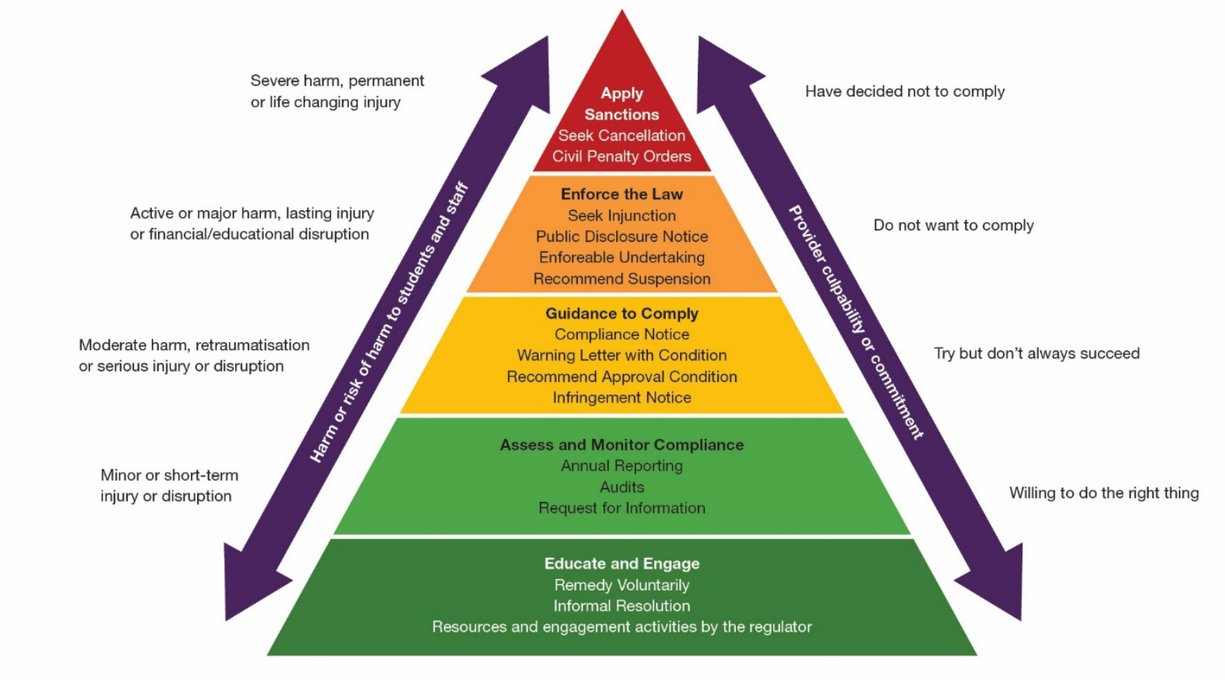

Other considerations
As set out in the regulatory principles of proportionate and risk-based and coherence and alignment, the GBV Regulator considers a range of factors when assessing risk and determining the appropriate compliance and enforcement response, including:
- Nature and seriousness of the suspected non-compliance
- Severity of the potential or actual harm to students or staff
- Level of public concern or scrutiny
- Evidence of deliberate disregard for requirements or repeated non-compliant behaviour
- Potential for regulatory action to drive systemic and cultural change
- Consistency with person-centred and trauma-informed practice
- Actions taken by the provider to remedy or address the issue
- Willingness to cooperate with the GBV Regulator to achieve voluntary compliance
- Provider context, including:
  - Compliance history
  - Systems and practices to identify and manage risk
  - Capability and resources dedicated to risk management
  - Attitude and commitment to compliance and the Code
Where a provider chooses to self-report potential non-compliance, this may positively influence the GBV Regulator’s decision regarding the most appropriate an appropriate regulatory response.

Voluntary compliance
As set out in the regulatory principles of collaborative and continuous improvement, the GBV Regulator seeks to promote voluntary compliance, which is the preferred compliance behaviour. This recognises that most providers are committed to meeting their requirements under the National Code, and that proactive support by the GBV Regulator fosters a culture of accountability and continuous improvement.
Voluntary compliance is largely supported through education and engagement activities. A dedicated education and engagement team within the GBV Regulator determines appropriate activities with the higher education sector, gender-based violence experts, staff, students, partner regulators and the wider public. This raises awareness of the National Code and cultivates a culture of compliance amongst providers.

Purpose of voluntary compliance
Voluntary compliance supports the GBV Regulator’s objective to prevent and respond to gender-based violence in a way that is proactive, proportionate, and sustainable.
When providers voluntarily meet their requirements under the National Code it:
- Reduces the need for enforcement action and its associated burden on providers.
- Enables identification and resolution of risks before the harm occurs.
- Builds trust and transparency between providers and the GBV Regulator.
- Promotes sector-wide learning and continuous improvement.
- Strengthens provider capability to meet requirements consistently.
- Increases the likelihood of the activities being effective at preventing and reducing gender-based violence.
The GBV Regulator allocates significant effort to these activities to minimise harm, build capability, and support providers to meet their requirements under the National Code without the need for enforcement action.

Activities to support voluntary compliance
Consistent with the regulatory principle of collaborative, the GBV Regulator undertakes a range of educative and engagement activities designed to promote understanding and encourage early resolution of issues. These activities focus on preventing harm before it occurs and supporting voluntary compliance.
Key activities include:
- Guidance: Practical guidance aligned with regulatory priorities and systemic risks. Resources are developed in response to gaps in knowledge or practice and are made accessible online.
- Templates: Standardised templates for key reporting and notification requirements to support consistency and reduce administrative burden.
- Advice: Responsive advice to clarify misunderstandings. Where repeated issues arise, FAQs are updated to ensure sector-wide access to consistent information.
- Engagement: Strategic engagement with peak bodies, individual providers, and advisory panels to share insights, and promote emerging and leading practices.
- Capability building: Support for providers to strengthen governance, systems, and culture. This includes embedding trauma-informed and person-centred approaches.
- Stakeholder analysis: Identification of key groups and organisations that influence successful implementation of the Code, ensuring tailored engagement strategies.
- Letters of assurance: provider commitments to remediate issues that are monitored by the GBV Regulator.

Directed compliance
Consistent with the regulatory principle of transparency and accountability, directed compliance refers to the GBV Regulator’s regulatory actions to address non-compliance or suspected non-compliance that has been identified through monitoring, intelligence, or provider engagement.
These actions are designed to guide providers toward meeting their requirements under the National Code without immediately escalating to formal enforcement.

Purpose of directed compliance
The purpose of compliance activities is to:
- Prompt corrective action in response to identified or suspected non-compliance.
- Support providers to understand and resolve issues in a timely and proportionate manner.
- Minimise harm and disruption while maintaining accountability.
- Encourage continuous improvement and prevent recurrence of breaches.

Activities to support compliance activities
Key compliance activities and tools include:
- Compliance notices: formal notices requiring corrective action, which may result in a civil penalty if the provider fails to comply.
- Warning letters: informal written notices identifying concerns and expected actions.

Outcomes of directed compliance activities
Directed compliance actions are intended to support providers in resolving issues early and proportionately. The outcomes of these activities include:
- Corrective action: providers take steps to address identified/suspected non-compliance.
- Timely resolution: issues are resolved without escalation to formal enforcement and minimises disruption to students and staff.
- Escalation to enforcement: where directed compliance does not result in satisfactory outcomes or where there is serious risk, it is escalated to formal enforcement action.
Directed compliance is also consistent with the regulatory principle of continuous improvement as it contributes to sector-wide improvement by promoting consistent standards, encouraging early intervention, and reinforcing a culture of accountability. These activities are not designed only to address individual instances; they help build a regulatory environment where providers are supported to meet their requirements and uplift their performance and where risks are addressed before harm occurs.

Enforcement
The GBV Regulator exists to drive sector-wide change to reduce gender-based violence. This is reflected in its regulatory principle of continuous improvement. Enforcement is one way to achieve this purpose. Enforcement actions seek to generate sector-wide impact by prompting improvements in practice, increasing awareness of requirements, and creating a culture of compliance.
Consistent with the regulatory principles of proportionate and risk-based, and transparent and accountable, enforcement is used where there is serious or systemic non-compliance from a provider, or where there is a significant risk of harm to students, staff or to the broader community. Enforcement actions are taken to hold higher education providers accountable to their requirements under the National Code and the Act.

Purpose of enforcement activities
The purpose of enforcement actions is to:
- Protect students and staff from harm.
- Ensure accountability for serious or repeated breaches of the National Code or the Act.
- Deter future non-compliance and promote sector-wide compliance.
- Maintain public confidence in the higher education sector and the GBV Regulator’s regulatory framework.

Enforcement tools and activities
Key enforcement activities and tools include:
- Infringement notices: administrative penalties for contraventions.
- Civil penalties: court-imposed fines for breaches of the National Code or Act.
- Enforceable undertakings: legally binding commitments to take corrective action.
- Injunctions: court orders to compel or restrain provider conduct.
- Litigation: legal proceedings to enforce requirements or penalties.
- Referrals: escalation to other regulators.

Outcomes of enforcement activities
Outcomes of enforcement action vary depending on the nature and the severity of the non-compliance and may include:
- Corrective action: provider is required to take specific steps to remedy non-compliance.
- Legal consequences: enforcement may result in court-imposed actions or enforceable undertakings that have legal requirements.
- Referral: matters may be referred to other relevant regulatory bodies that may result in additional sanctions, including suspension, deregistration or cancellation of funding.
- Reputational consequences: enforcement may affect the perceptions students, staff and the public have of them, particularly where breaches are serious and/or repeated.
These outcomes contribute to a strong and accountable regulatory environment that prioritises safety, equity, and justice and are consistent with the regulatory principle of continuous improvement.

Compliance and enforcement tools
The GBV Regulator uses a range of regulatory tools where necessary to secure compliance. These tools are grouped into several areas:
Tool | Role
Guidance to Comply | Provide clear guidance and good practice examples to promote voluntary compliance. This includes information on regulatory obligations, minimum standards, risk management, and reporting requirements.
Information gathering and compliance monitoring | Proactive and responsive measures to monitor performance, detect non-compliance, identify risks, compel the giving of information and identify guidance to ensure compliance. Examples include requiring a higher education provider to report on how it has complied with the National Code under a Notice to Report on Compliance, requiring provision of requested information under a Notice to Produce, or the conduct of an audit, survey or inspection.  Audits may include desktop reviews, rapid reviews triggered by complaints or referrals, or in-depth audits including on-site reviews. There may also be thematic sector-wide audits on specific issues or joint audits with a co-regulators such as TEQSA, or with other agencies like the National Student Ombudsman (NSO).
Notifiable Conduct | Requires notification to the GBV Regulator where provided information is no longer accurate. Examples include changes to student accommodation details, and where a higher education provider identifies non-compliance.
Remediation | Where non-compliance is identified, the GBV regulator encourages voluntary compliance or use of regulatory tools to secure compliance.  Examples of remedial action include:  - Providing verbal or written guidance to support remedial action by a higher education provider in the form of a warning letter. Guidance will notify providers of suspected non-compliance and outline concerns. There is an opportunity to respond and take corrective action.  - Remedying by agreement or by accepting a written voluntary undertaking.  - Issuing a Compliance Notice with require remedial conditions to remedy a non-compliance, or a Prohibition Notice to stop a higher education provider from taking an action for a defined period.  - Issuing a Notice to Implement a National Student Ombudsman Recommendation relating to gender-based violence and report on implementation.
Public reporting | Sections 43 and 44 of the Act allow the GBV Regulator to publish information about a higher education provider’s non-compliance, the exercise of monitoring and investigation powers, enforcement actions taken and any sector-wide compliance trends.  Public reporting is used to promote accountability and act as deterrence. It ensures that students, staff and the public are informed about providers who fail to meet obligations and support sector-wide learning.
Referral | Referral of a matter to another agency, regulator or law enforcement agency to review, consider enforcement action, vary registration or support an existing investigation or regulatory action.  The GBV Regulator may refer matters to the Minister for Education, TEQSA, the NSO, or other agencies including State and Territory government agencies.  Non-compliance with the National Code can trigger action under:  - HESA: Serious or sustained breaches may lead to suspension or cancellation of Commonwealth funding approval under Division 22.  - TEQSA Act: Non-compliance may indicate governance failures, allowing TEQSA to impose conditions or cancel registration.  While the GBV Regulator prioritises voluntary compliance, systemic or persistent breaches will be escalated to these bodies to ensure accountability and student safety.
Sanctions | Where serious non-compliance is identified, the GBV Regulator will consider the risk and harm from the non-compliance, and the higher education provider's culpability and attitude to compliance, when deciding what action to take.  Examples of sanctions include:  - Infringements.  - Publicly naming non-compliant higher education providers.  - Seeking a civil penalty order.  - Accepting a court enforceable undertaking.  - Seeking an injunction to prevent non-compliance or further non-compliance with the National Code.  - Seeking HESA cancellation.

Transparency and accountability
Consistent with the regulatory principle of transparent and accountable, the GBV Regulator exercises its compliance and enforcement functions in a manner that is open and subject to scrutiny.
Avenues to review regulatory decisions are made clear to higher education providers when the GBV Regulator uses its regulatory tools. Where there are concerns that the GBV Regulator is acting outside of the scope of its statutory powers, concerned parties are advised of the process to lodge a complaint, request an internal review, seek a merits review through the Administrative Review Tribunal (ART) or judicial review through the Courts.

Co-regulators
Consistent with the regulatory principle of coherence and alignment, the GBV Regulator operates within a shared regulatory environment alongside agencies that have complementary responsibilities for safety, standards and equality in higher education.
Collaboration is essential to avoid duplication and reduce burden on providers, and to ensure a consistent national approach to preventing and responding to gender-based violence.
The GBV Regulator works with key partners such as TEQSA and the NSO to share information and reduce regulatory burden.

Statutory and public reporting
In accordance with Section 47 of the Act, the GBV Regulator reports to Parliament annually on compliance, monitoring, investigation and enforcement activities, including the number and type of activities conducted, use of statutory powers and key outcomes.
Aggregated sector insights from compliance activities are summarised each year in the Annual Report to Parliament, consistent with privacy, confidentiality and trauma-informed principles to promote sector learning and transparency. These reports present trends and good practice examples without identifying individual providers.

Privacy
The GBV Regulator collects, uses and manages information in accordance with the Act, the Privacy Act 1988 (Cth), the Australian Privacy Principles (APPs), the Department of Education’s Privacy Policy and Information Management Policy (https://www.education.gov.au/using-site/privacy).
All protected information obtained through compliance monitoring, audit, or engagement activities is handled lawfully, securely, and proportionately, as required under Section 42 of the Act. Under Section 42 of the Act, officers, contractors and any person engaged under the Act may use protected information, in accordance with the delegations, for the purposes of promoting compliance with this Act or legislative instruments made under the Act or in performing functions, or exercising powers, under the Act or legislative instruments made under this Act.
The GBV Regulator also shares information with co-regulators or oversight bodies under Section 42 of the Act in accordance with the Privacy Act and confidentiality obligations. All such exchanges are governed by Memorandums of Understanding that specify information-handling, confidentiality, and data-protection requirements.
GBV Regulator staff and Authorised Officers are bound by the APS Code of Conduct and the APS Values, and must act with honesty, integrity, care and diligence, treat all people with respect and courtesy, and maintain appropriate confidentiality about information obtained through their work. These obligations underpin every aspect of compliance and audit activity.
Any disclosures to the public about compliance performance or using information obtained through compliance activities are made in accordance with Sections 43 and 44 of the Act, and consistent with regulatory principles.

Information handling
Personal information is collected only where it is reasonably necessary for performing our statutory compliance and monitoring functions. Information is used solely for the purpose for which it was collected, unless a lawful exception applies. All information must be stored within systems listed on the department’s approved Information Management Systems Register. Access to protected information is restricted to GBV Regulator employees and authorised officers with a legitimate business need and stored within approved departmental systems.

Evaluation
Consistent with the regulatory principle of continuous improvement, the GBV Regulator is committed to continuous improvement of its compliance and enforcement approach.
Evaluation ensures that regulatory settings, guidance, and practices remain effective, proportionate, and responsive to emerging risks and sector needs.
The GBV Regulator is committed to:
- Evaluate how compliance and enforcement activities contribute to preventing and responding to gender-based violence across the higher education sector.
- Use data, intelligence, and stakeholder feedback to identify challenges, emerging risks, and opportunities for improvement.
- Incorporate lessons from compliance activities into regulatory priorities and guidance.
- Engage with providers and co-regulators to share insights, promote best practice, and build capability.
- Publish aggregated compliance data and regulatory outcomes in annual reports and other public documents, consistent with privacy and trauma-informed principles.
Evaluation findings also inform updates to compliance guidance, regulatory priorities, and enforcement strategies. This policy is reviewed annually, or sooner if required, to ensure alignment with legislative changes, sector maturity, and best practice in regulatory design.

Appendix: Tables for assessing risk and non-compliance

Table 1: Assessing the likelihood of non-compliance
Certain | Repeated failure to meet acceptable standards, to understand requirements, and to have systems of management or address concerns
Certain | Refusal to comply, to dedicate suitable resources or qualified staff, and to cooperate with the GBV Regulator or provide information
Certain | Significant substantiated or outstanding investigations, complaints, incidents or NSO recommendations
Likely | Pattern of repeated non-compliance, biased or misleading self-assessment, poor compliance history or failure to comply with a remedial notice
Likely | Higher than average volume of complaints or notifications from partner regulators, legal action, or a disproportionate ratio of disclosures to students and staff
Likely | Questionable capacity to meet requirements, high staff turnover or casualisation, poor risk-management processes in place, or presence of governance related registration conditions
Possible | Numerous previous incidents of non-compliance, of complaints, or relevant legal proceedings, or media/public reports or registration conditions
Possible | Failure to update governance bodies, to dedicate suitable resources or absent resources, late or incomplete planning, reporting, document provision, or notification to regulator and partner regulators
Possible | Outdated methods, responses or practices, poor risk identification or management, or issues with training or support to staff and students on gender-based violence
Unlikely | Demonstrated willingness to comply, strong internal governance and reporting, and a healthy culture with a strong focus on wellbeing, with dedicated resources and roles to meet standards
Unlikely | Previous isolated or one-off non-compliance or complaints, timely reporting and regulatory co-operation
Unlikely | Awareness of risk and needs reflected in systems of work, practices, relationships with student organisations and other peak representative bodies
Rare | No previous occurrence of non-compliance, complaints, NSO recommendations, or related registration conditions, and leadership known to be addressing gender-based violence in line with standards
Rare | Co-operative and open compliance attitude, high levels of student and staff satisfaction, known as a good performer with a strong governance culture and continuous improvement approach
Rare | Good systems of management, governance, reporting, risk identification and management, including dedicated roles or governance responsibility and public transparency

Table 2: considering the consequences of non-compliance
Severe | Severe, permanent or life-changing physical or psychological injury
Major | Substantial or long-lasting physical or psychological injury
Major | Significant financial harm or life-impacting educational disruption
Moderate | Serious physical or psychological injury with moderate-term recovery
Moderate | Medium term financial harm or educational or work disruption
Moderate | Re-traumatisation, diminishment of rights or harm caused by higher education provider denial or conduct impacting recovery or healing
Minor | Short term injury with short-term recovery
Minor | Short term disrespect, loss of agency, disruption from education or work or loss of trust in institution
Low | Minor relational, social, physical or psychological injury
Low | Temporary loss of agency or disconnection from education or work

Table 3: considering a provider’s culpability
Serious | Deliberate, wilful or misleading conduct, omission, or actively hindering regulatory action or undermining the National Code and its intention
Serious | Repeated non-compliance across many areas, or non-compliance involved significant falling short of acceptable standards
Serious | Risk was obvious and preventable with ongoing non-compliance, or non-compliance of long duration
Major | Conduct was reckless, with no thought to risk despite obvious consequences, or involved avoidance of compliance obligations or a pattern of disregard to compliance
Major | Non-compliance was foreseeable and easily preventable, no action was taken or insufficient remedial effort made, no or limited effort to understand or resolve compliance issue
Major | Previous non-compliance in one or many areas, or regulatory action or concerns of employees, students or student accommodation or placement staff not acted on
Moderate | Risk was foreseeable and whilst difficult to prevent or intervene, was preventable, and there was inaction knowing harm could occur
Moderate | Awareness or knowledge of non-compliance but lax attitude or past isolated non-compliance, reports or complaints from students or staff
Moderate | Lack of insight into non-compliance or its consequences
Minor | Didn’t anticipate or intend harm, demonstrates insight and informed understanding of risk and the potential impacts of provider behaviour
Minor | Non-compliance of short duration, difficult to predict and prevent and incident occurred despite reasonable prevention and risk-management practices
Minor | Actions taken to address compliance and engage with regulatory processes
Low | No history of non-compliance or NSO recommendations
Low | Proactive remedial action taken to prevent recurrence or future harm, non-compliance of short duration, commitment to continuous improvement
Low | High level of responsiveness to the regulator, genuine insight and demonstrable engagement to improve practices

