


Regulatory Statement
  - December 2025



With the exception of the Commonwealth Coat of Arms, the Department’s logo, any material protected by a trade mark and where otherwise noted all material presented in this document is provided under a Creative Commons Attribution 4.0 International (https://creativecommons.org/licenses/by/4.0/) licence.
The details of the relevant licence conditions are available on the Creative Commons website (accessible using the links provided) as is the full legal code for the CC BY 4.0 International (https://creativecommons.org/licenses/by/4.0/legalcode)
The document must be attributed as the Regulatory Statement of the Higher Education Gender-Based Violence Regulator.

Secretary’s Foreword
I am pleased to present this Regulatory Statement for the Higher Education Gender-based Violence Regulator.
The establishment of the Gender-based Violence Regulator reflects the Australian Government’s determination to address gender-based violence harms in higher education through evidence-based regulation and sector-wide cultural change.
This Regulatory Statement sets out how the Regulator will exercise its authority to uphold the National Higher Education Code to Prevent and Respond to Gender-based Violence. It outlines the principles, priorities, and approach that are anchored in transparency, accountability, and collaboration. The goal is clear – to ensure higher education providers take proactive, trauma-informed, and person-centred steps to prevent gender-based violence and respond effectively when it occurs.
The National Code sits within the Australian Government’s broader commitments to eliminate gender-based violence, including the National Plan to End Violence Against Women and Children 2022–2032 and the Action Plan Addressing Gender-based Violence in Higher Education, ensuring a coordinated, whole-of-system approach to prevention and response of gender-based violence.
The Regulator will work in partnership with higher education providers, students, staff, and stakeholders to drive systemic reform. Through education, engagement, and enforcement, we will hold higher education providers accountable and support continuous improvement across the sector. Together, we can create environments where every student and staff member feels safe, respected, and empowered to thrive.
I commend this Regulatory Statement to all stakeholders and look forward to working with the higher education sector to eliminate gender-based violence in higher education.


Tony Cook PSM
Secretary
Department of Education



About the Higher Education Gender-based Violence Regulator
The Higher Education Gender-based Violence Regulator (GBV Regulator) regulates gender-based violence in Australia’s higher education sector. It holds higher education providers accountable through compliance with the National Higher Education Code to Prevent and Respond to Gender-based Violence (National Code), which aims to prevent gender-based violence and requires higher education providers to respond effectively to protect and support students and staff.
The GBV Regulator is a Branch located within the Department of Education. It operates as a specialist regulatory function that exercises delegated powers from the Secretary of the Department of Education to administer, oversee and enforce compliance with the National Code.
It was established in 2025 and took effect operating as a regulator from 1 January 2026 which is the date the National Code first took effect.

Purpose of this Regulatory Statement
This Regulatory Statement guides the GBV Regulator in fulfilling its legal obligations.
The Statement sets out who the GBV Regulator regulates, the rationale behind regulation, the methods employed, and how the GBV Regulator uses its regulatory powers and authority to drive cultural change, minimise harm, and shape the strategic direction of its regulatory efforts. It informs the GBV Regulator’s regulatory operations, including compliance and enforcement strategies and actions. It supports transparency and sector-wide engagement by clearly communicating the GBV Regulator’s expectations and approach.

Scope of regulation
The consequences of gender-based violence are devastating and can have lifelong impacts on victim-survivors.
The GBV Regulator regulates higher education providers’ compliance with the National Code which mandates that higher education providers take evidence-based steps, that are trauma-informed and person-centred, to prevent and respond to gender-based violence across their whole organisation, wherever the gender-based violence occurs.
Gender-based Violence is defined under the National Code as any form of physical or non-physical violence, harassment, abuse, or threats based on gender that result in, or are likely to result in, harm, coercion, control, fear, or deprivation of liberty.
Anyone can be a victim-survivor of gender-based violence, although it is predominantly perpetrated by men against women and girls, as well as LGBTQIA+ individuals. Gender-based violence disproportionately impacts specific groups, including First Nations women, culturally and linguistically diverse (CALD) women, people with disabilities, and individuals of diverse sexual orientations and gender identities.
The National Code’s intended harm minimisation focus aims to comprehensively capture all forms and occurrences of gender-based violence. As such, the GBV Regulator’s focus is on the prevention and response actions of higher education providers to drive the systemic and cultural change required.

Regulated entities
The GBV Regulator covers higher education providers registered with the Tertiary Education Quality and Standards Agency (TEQSA), including all Table A and Table B providers under the Higher Education Support Act 2003 (Cth), and other providers registered under the TEQSA Act 2011 (Cth). This includes Australian universities, institutes of higher education and university colleges.

Regulatory role and outcomes
The GBV Regulator is committed to holding higher education providers accountable for creating safe environments for all students and staff, and for ensuring that, where gender-based violence does occur, effective systems are in place so that students and staff feel safe and supported.
The desired regulatory outcomes define the purpose of the GBV Regulator’s work and provide measures of its success.
The GBV Regulator is successful if:
- Higher education providers prevent, reduce and eliminate gender-based violence.
- Victim-survivors are believed and supported through higher education providers' responses to gender-based violence that are consistently trauma-informed and person-centred.
- The higher education sector plays a leading role in eliminating gender-based violence in a generation.

Driving change through regulation
The GBV Regulator is dedicated to fostering long-term and sustainable systemic and cultural change within the higher education sector and is committed to ensuring higher education providers create safe and supportive environments for working, living, and learning.
To achieve this, it prioritises:
- Education and engagement: actively working with stakeholders to enhance understanding and collaboration.
- Accountability: upholding the standards of the National Code through high-quality compliance and enforcement measures.
- Continuous improvement: encouraging ongoing development and innovation within organisations.

Regulatory principles
In undertaking its regulatory role, the GBV Regulator applies its reach and authority in accordance with a set of six regulatory principles.
These six principles guide all regulatory activities and ensure the GBV Regulator acts in a manner that is both predictable and effective.
Principle | Commitments
Proportionate and risk-based | Regulatory powers are exercised in proportion to the seriousness of non-compliance or the risk of future non-compliance. Action is directed toward areas of greatest harm and highest impact, considering the severity and likelihood of harm, as well as the provider’s compliance history.
Evidence and Outcomes Driven | Intelligence, data, information and external expertise are used to inform the allocation of regulatory effort and regulatory decisions with the goal of achieving measurable improvements in student and staff safety.
Transparent and Accountable | Expectations of higher education providers are clearly communicated, along with reasons for regulatory decisions and decision-making principles.
Continuous Improvement | Regulatory posture supports capability-building and sector-wide maturity, encouraging providers to embed best practice and improve over time.
Collaborative | The GBV Regulator works with partner regulators to drive compliance with the National Code.
Coherence and Alignment | Regulatory activities align with broader government policy, legislative frameworks, and other regulatory schemes to ensure consistency and reduce duplication.
The six regulatory principles reflect the GBV Regulator’s application of a risk-informed and proportionate approach to its regulatory activities, to ensure actions are effective, transparent and fair.
In exercising its powers, the GBV Regulator also applies the statutory principles of regulatory necessity and proportionate regulation to ensure that it does not burden a higher education provider more than is reasonably necessary and so that its powers are exercised in proportion to any non-compliance or risk of future non-compliance.
Oversight applies to all higher education providers. Every higher education provider is subject to ongoing monitoring and engagement. The intensity of regulatory activities is in line with the level of risk (potential or actual) ensuring that efforts are focused where they can best prevent harm and support compliance.

Regulatory approach to minimise harm
The GBV Regulator adopts a harms and intelligence-led approach to regulating higher education providers seeking to:
- Educate higher education providers on their obligations, and to promote good practices to prevent and respond to gender-based violence.
- Target and prioritise resources towards the greatest harms and where it will have the biggest impact.
- Harness information and intelligence to assess and monitor compliance with the National Code.
- Require remedy by higher education providers where non-compliance is found and, where appropriate, apply sanctions to shift higher education provider behaviour.
- Continually review our guidance, regulatory settings and higher education providers' performance, to identify emerging risks and improve the safety of students and staff.
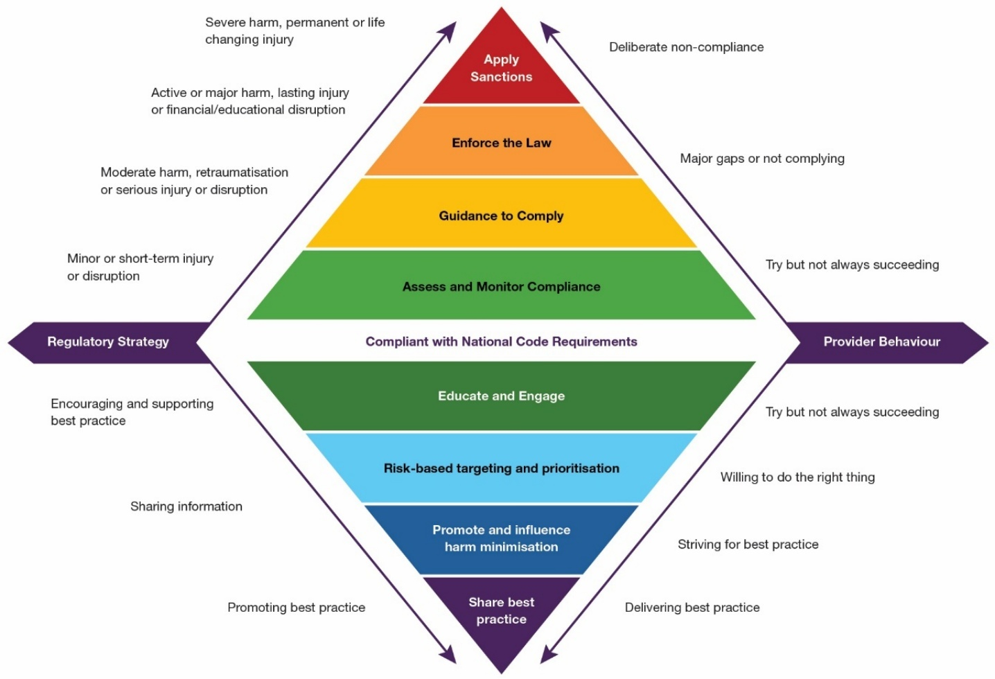

In terms of its harms of focus, the GBV Regulator uses its regulatory function authority and influence to prioritise:
- Psychological and emotional harm
- Physical and sexual harm
- Financial, education and career harm
- Institution- and system-induced harm and traumatisation caused by higher education provider conduct.
“It is the job of the GBV Regulator to hold higher education providers to account through compliance with the National Higher Education Code to Prevent and Respond to Gender-based Violence.
The Regulatory Approach articulates how the Regulator uses its regulatory authority and influence to shift the behaviour of higher education providers to prevent and minimise harm to students and staff.”

Partner regulators and stakeholders
The GBV Regulator operates within a shared regulatory environment alongside agencies that have complementary responsibilities for safety, standards and equality in higher education, and that play a role in minimising harm from gender-based violence.

This includes the:
- Tertiary Education Quality and Standards Agency (TEQSA): the independent national quality assurance and regulatory agency for higher education providers.
- Australian Skills Quality Authority (ASQA): regulates vocational education and training providers, including dual-sector providers that provide both higher education and VET.
- Australian Human Rights Commission (AHRC): enforces the Sex Discrimination Act 1984, including positive duty obligations that require organisations to take measures to eliminate sexual harassment and discrimination.
- eSafety Commissioner: regulates online safety under the Online Safety Act 2021, including technology facilitated abuse.
- State and Territory Work Health and Safety regulators: enforce workplace safety laws, including psychosocial hazards.
The GBV Regulator recognises other stakeholders who seek to minimise harm and prevent and respond to gender-based violence in the higher education sector, and more broadly, including the National Student Ombudsman, higher education peak bodies, student and staff organisations, victim-survivor advocates, and gender-based violence specialists.

Regulatory behaviour
The GBV Regulator acknowledges the balance between enforcing compliance to prevent harm with the importance of building long-term capability across higher education providers. It ensures its actions protect students and staff, uphold and improve sector quality, and remain proportionate, fair and responsive to risk.
The GBV Regulator operates with transparency, clearly articulates its decisions, and remains open to scrutiny and review. It is committed to continuous improvement and accountability, holding itself to the same standards it expects of others.
Higher education providers will have clear avenues to review regulatory decisions. In cases of concern, the GBV Regulator encourages parties to submit any complaints in writing for appropriate consideration.
The GBV Regulator’s Authorised Officers play a pivotal role in upholding regulatory standards and are expected to exemplify best practices in their conduct. Their actions are guided by the GBV Regulator’s regulatory principles, ensuring integrity and accountability in their duties.
The GBV Regulator maintains a distinct separation between its regulatory responsibilities and broader policy functions, referring matters outside its remit to relevant areas within the department. While the department oversees the overall regulatory approach, the GBV Regulator is responsible for developing and enhancing regulatory capabilities.

