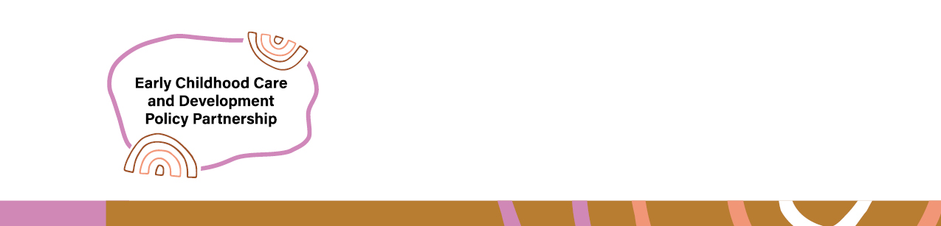

Early Childhood Care and Development Policy Partnership takes second set of recommendations to Joint Council

On 21 November 2025, the Joint Council on Closing the Gap (Joint Council) considered the second set of recommendations from the Early Childhood Care and Development Policy Partnership (ECCDPP). The ECCDPP brings together Aboriginal and Torres Strait Islander representatives and Commonwealth, state and territory governments to drive community-led early childhood outcomes for Aboriginal and Torres Strait Islander children and families.
Bringing recommendations to Joint Council is an important process that provides senior Aboriginal and Torres Strait Islander leaders and Ministers for Indigenous Australians with visibility of the ECCDPP’s work to improve outcomes for Aboriginal and Torres Strait Islander children. It also supports Joint Council to make decisions about the direction of relevant policy work, as the most senior decision-making body under the National Agreement on Closing the Gap (National Agreement).
The ECCDPP took its first round of recommendations to Joint Council in July 2024. The ECCDPP 2024 annual report provides an update on work to progress these recommendations.
Joint Council noted that the ECCDPP was working with relevant government bodies to provide Education Ministers with implementation advice on two research reports commissioned by the ECCDPP. These reports include a report on Funding Models Options for ACCOs delivering integrated early years services, and an Evidence Scan on Optimal Hours of Early Childhood Education and Care for Aboriginal and Torres Strait Islander children.
Joint Council considered a joint update from co-chairs of the ECCDPP and Safe and Supported Shared Decision-Making Committee on work to progress Target 12 under the National Agreement: Aboriginal and Torres Strait Islander children are not overrepresented in child protection systems. This Target is not on track to be met and overrepresentation in the child protection system is worsening. The update considered actions being taken under Safe and Supported: The National Framework for Protecting Australia’s Children 2021-2031 and the Safe and Supported: Aboriginal and Torres Strait Islander First Action Plan 2023-2026, as well as the priorities of the ECCDPP.
Joint Council agreed that Safe and Supported and ECCDPP should drive action to catalyse implementation of the existing priority government commitments to advance progress against Target 12 and receive regular updates from the Commonwealth, states and territories on these efforts:
- Increase adequate and coordinated funding to ACCO child and family services, including through the National Child and Family Investment Strategy
- Increase investment in early support and prevention services to strengthen families, including increasing the proportion of these services delivered by ACCOs
- Delegate statutory authority to ACCOs for child protection, prevention and reunification functions, in line with self-determination
- Grow the Aboriginal and Torres Strait Islander child and family workforce, including through education and training pathways and providing support for ACCOs to attract and retain the staff they need.
The ECCDPP provided Joint Council with an update on work to develop a Probity Framework to ensure strong probity practices within the shared decision-making context of the ECCDPP, including when collaborating with ACCOs during commissioning processes. This work is important because it involves changing the ways governments work so Aboriginal and Torres Strait Islander organisations are more involved in decision-making, while also upholding ethical decision-making practices.
The ECCDPP also updated Joint Council on work it will progress into 2026, including:
- Finalising an evaluation of the ECCDPP
- Preparing a second ECCDPP three-year strategic plan
- Developing guidance on shared decision-making in an early childhood care and development context
- Developing an Evidence Guidance Framework to inform the use of Aboriginal and Torres Strait Islander-led evidence in the context of child and family services
- Developing a funding model for ACCOs delivering child and family services, with a focus on early and tailored supports
- Researching the benefits of Aboriginal and Torres Strait Islander languages education in the early years, and supports for new parents and children and families with disability to avoid child protection intervention
- Continuing work to progress ECCDPP priorities relating to the intersections between the housing and child protection systems, the workforce needs of the ECCD sector and the establishment and resourcing of peak bodies for Aboriginal and Torres Strait Islander children.
The ECCDPP will provide further updates on this work as part of its regular annual reports.

