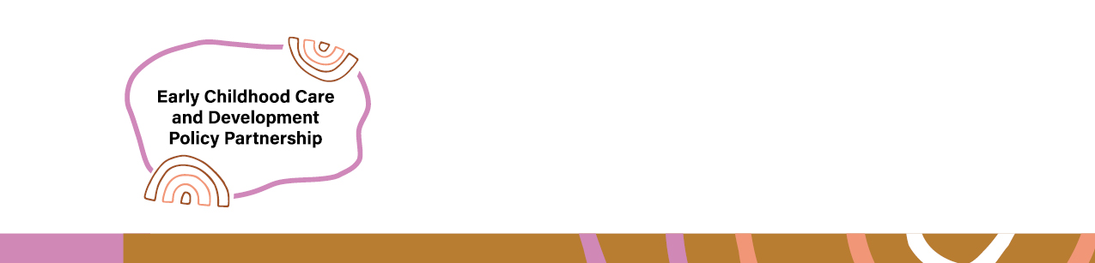

Probity Framework Summary
  - Early Childhood and Care Development Policy Partnership

Context
The National Agreement on Closing the Gap (National Agreement) commits all Australian governments to work in partnership with Aboriginal and Torres Strait Islander peoples on matters which affect their lives and requires new ways of working and commissioning to support genuine shared decision-making.
The Productivity Commission’s 2024 Review of Progress on the National Agreement noted that shared-decision making is rarely achieved in practice, and highlighted the need for agencies to work genuinely and collaboratively with Aboriginal Community Controlled Organisations (ACCOs) in all phases of commissioning and procuring services and programs.
The Australian Government Department of Education commissioned development of an ECCDPP Probity Framework (Framework) to ensure strong probity practices within shared decision-making context of the ECCDPP, including when collaborating with ACCOs during commissioning processes. The department engaged O’Connor Marsden & Associates Pty Limited to provide these independent probity services.

Purpose
The Framework clarifies roles and responsibilities of Co-chairs, Co-secretariat, Members, and other representative bodies who participate in the Partnership, in relation to potential probity risks and to uphold a high probity standard.
It is designed to identify, assess, mitigate and support the management of probity risks associated with ECCDPP activities, having regard to key probity principles of:
- Accountability
- Transparency
- Impartiality
- Management of conflicts of interest
- Maintenance of confidentiality
- Achieving value for money.
The Framework equips the ECCDPP with practical strategies to identify and manage perceived, potential and/or actual probity risks. It supports the ECCDPP to have strong, ethical, transparent and accountable processes, in the context of consensus decision-making and commissioning research. This includes guidance to inform decision-making about the use of the ECCDPP research fund, which is administered by the Department of Education at the direction of the ECCDPP.

Key findings
As part of developing the Framework, independent experts established that shared decision-making between Aboriginal and Torres Strait Islander representatives and governments does not carry any inherent probity risks. Ethical decision-making is strengthened when Aboriginal and Torres Strait Islander ways of knowing, being and doing underpin ECCDPP policy development and governance processes.
The Framework identified tangible methods of managing real or perceived probity risks which may arise across the ECCDPP work, including:
- Establishing and maintaining clear governance arrangements;
- Ensuring all decisions made by Co-chairs and members align with the Partnership’s Goal;
- Commitment to transparency of shared decision-making and accountability; and
- Detailed and transparent record keeping by the Co-secretariat.
The Framework establishes clear guidance to achieve value for money, both as measured against the goals of the Partnership and against Commonwealth Procurement Rules. It recognises that the Partnership’s expertise can be used to inform what value for money looks like in different circumstances.
The Framework asks for ECCDPP Research Fund officials to consider how the procurement process can help to achieve the Partnership Goal. This includes satisfying considerations such as:
- Aboriginal and Torres Strait Islander community-led governance embedded in project design and delivery
- Aboriginal and Torres Strait Islander knowledges, practice and theoretical frameworks weighted equally
- Cultural protocols for research and engagement with Aboriginal and Torres Strait Islander communities are respected and observed
- Indigenous Data Sovereignty Principles apply to the collection, analysis, storage and sharing of project research and data.

Probity Framework in Practice
In practice, the Framework will support the department and SNAICC with the identification and management of probity matters that may arise as part of Partnership decision-making and the commissioning of projects and activities from the ECCDPP Research Fund.
As noted above, the Framework clarifies the roles and responsibilities of various ECCDPP participants in relation to potential probity risks. It provides proposed mitigation strategies, and supports a clearer understanding of how decisions of the Partnership align with the Partnership’s Goal.
The Framework provides the Partnership with clear, expert advice to manage real or perceived probity risks as they arise. This empowers the Partnership to address risks promptly and effectively, using the Framework as a source of guidance to do so.
The Framework will drive improved outcomes for children, families and communities by ensuring Aboriginal and Torres Strait Islander expertise and lived experiences remain at the centre of the Partnership’s discussion and decision-making.

Next steps
The Probity Framework is intended to be an iterative document, evolving as the Partnership matures. The Probity Framework will be reviewed regularly and updated as required, in parallel with the annual review of the ECCDPP Agreement to Implement and the Operating Protocols.

