Dashboard instructions

General instructions
To navigate between pages in the dashboard, click the button located in the bottom of each page.
Specific selection instructions
Home page  When opening the dashboard for first time, you will reach the home page. Select the relevant button to go to the desired page. The dashboard contains data from 2011 to 2024*.  *Bond University, University of Divinity and Torrens University for 2020 to 2024 only. Avondale University for the 2023 and 2024 only. | 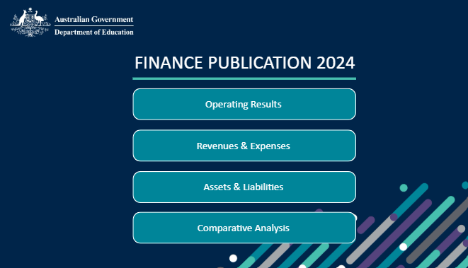
University selection  You can explore the data for the whole sector or by selecting individual institutions in the ‘University’ menu at the top of each page. All institutions are selected by default.  - To view the data for just one university, click on that university.  - To view data for multiple universities, click on each relevant university.  - To clear your selection, deselect the relevant boxes or click on | 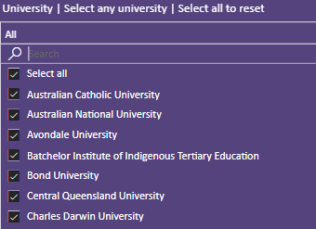
Year selection  You can explore the data for different reporting periods by selecting from the ‘Year’ menu at the top of each page.  - To view the data for a particular year, click on that year.  - Click the > for previous years. | 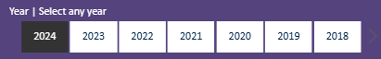
Comparative Analysis  This page allows you to compare financial metrics and ratios and visualise them on a clustered bar chart.  - Select the relevant institution and reporting period from the ‘University’ and ‘Year’ menus as outlined above.  - Select a financial metric or a ratio to view from the menu at the top of the page.  - Only one line item and one ratio can be viewed at a time. | 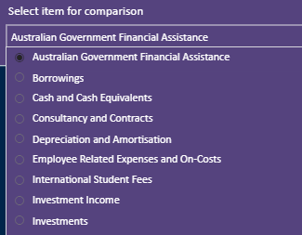

Glossary of Terms Used in the Dashboard
Net Operating Margin
Net operating result divided by total revenue
Australian Government Funding as a Proportion of Revenue
Total Australian Government funding divided by total revenue
International Student Fees as a Proportion of Revenue
International student fees divided by total revenue

