

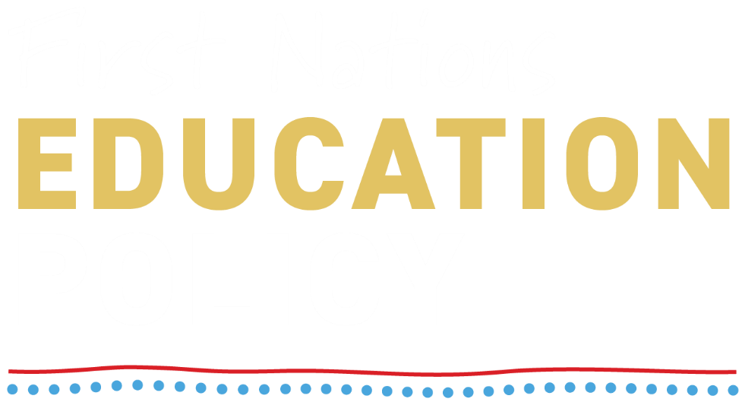

Discussion Paper

Acknowledgement of Country
The Department of Education acknowledge the Traditional Custodians of the lands across Australia where this work has been developed and where it will be read, discussed, and shared. We pay our deepest respects to Elders past and present and extend that respect to all First Nations peoples.
We acknowledge that First Nations peoples have been teaching, learning, and sharing knowledge on these lands for tens of thousands of years. This legacy of education – grounded in culture, Country, and community – continues to thrive today.
As we reflect on the future of First Nations education, we do so with humility and a commitment to listening. We acknowledge the enduring sovereignty of Aboriginal and Torres Strait Islander peoples and the strength of their voices, which must be at the centre of any meaningful change.
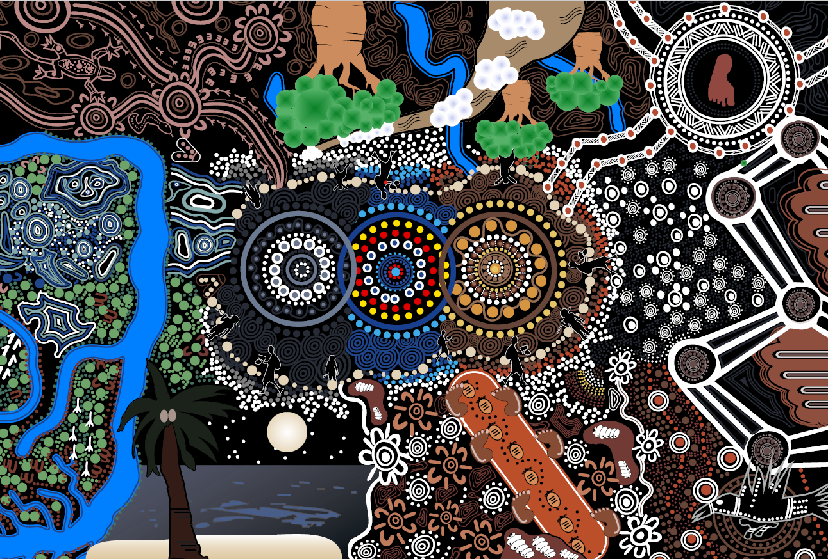
This artwork was produced during a First Nations Education Policy workshop with the First Nations Education Youth Advisory Group. It was facilitated by artist Mr Trevor Eastwood of Dalmarri, a descendant of the Ngamba people from the Barwon River region, which is part of Kamiloroi Country.
This vibrant contemporary artwork depicts a thriving student integrating culture and education in two worlds, across Australia's culturally rich and diverse landscapes.
Central to the piece are three interwoven rings, symbolising the interconnected journey of culture, education, and the challenges faced by many. The student embodies resilience, bridging traditional and western education systems. The surrounding design celebrates the richness of First Nations cultures, showcasing the importance of storytelling and community.
The artwork emphasises the importance to support students, highlighting that through unity and understanding, all can flourish and thrive. It also serves as an inspiring reminder of the power of knowledge and cultural connection in overcoming challenges.

Contents
Discussion Paper 1
Acknowledgement of Country 2
Contents 3
Introduction 4
The purpose and scope of the First Nations Education Policy 4
Policy development grounded in partnership and respect 4
The purpose of this discussion paper - a chance to have your say 5
What have we heard so far 5
What we want to know from you 6
Background 9
Language and Definitions 9
Cultural capability, responsiveness, and safety 9
Cultural capability 10
Cultural capital 10
Cultural responsiveness 10
Cultural safety 10
Learners 10
Education settings 10
How to Submit 11
Contact for more information 11

Introduction

The purpose and scope of the First Nations Education Policy
The Australian Government is committed to accelerating improvements in education outcomes of First Nations learners.
The purpose of this discussion paper is to gather your input on the proposed First Nations Education Policy (the Policy). The Policy will drive tangible changes that affirms First Nations identities, knowledges, and aspirations, and enables learners to thrive throughout the education lifecycle. The Policy will focus on:
Early childhood education
School education
Post-school pathways, including into tertiary education.
First Nations peoples and communities have long called for an education system that is culturally safe and responsive, respecting their sovereignty, culture, and aspirations. Current approaches have not delivered equity for First Nations peoples. Governments must do more to ensure that education settings are places where First Nations learners are represented, respected, and supported to thrive.
Subject to the outcomes of consultation activities, the Policy will:
define the national aspirations for First Nations education by defining shared priorities and establishing how change will be enacted and evaluated
translate national commitments - such as the Mparntwe Education Declaration, Better and Fairer Schools Agreements 2025–2034 (BFSA), the National Aboriginal and Torres Strait Islander Early Childhood Strategy, the Universities Accord, and the National Agreement on Closing the Gap - into tangible action
be adaptable to different contexts, recognising the roles of states, territories, and local communities.

Policy development grounded in partnership and respect
The Policy is being developed in partnership with First Nations peak organisations (First Nations Partners) — the National Aboriginal and Torres Strait Islander Education Corporation (NATSIEC), SNAICC – National Voice of our Children (SNAICC), the National Aboriginal and Torres Strait Islander Principals Association (NATSIPA), the National Indigenous Youth Education Coalition (NIYEC), and the National Aboriginal & Torres Strait Islander Higher Education Consortium (NATSIHEC) — and state and territory governments, the non-government education sector, education providers, unions and professional associations in 2025 and 2026, with finalisation in 2026.
A core principle in developing the Policy is recognising First Nations self-determination and the autonomy of their peoples and communities. The Australian Department of Education
(the department) and First Nations Partners aim to ensure the voices and perspectives of First Nations communities are heard, understood, and built into the Policy. Acknowledging the significance of First Nations informed actions to enhancing educational experiences and outcomes, particular emphasis will be placed on the contributions and perspectives of First Nations stakeholders.

The purpose of this discussion paper - a chance to have your say
For the Policy to be effective, it should be shaped by First Nations peoples, including learners, families, communities, organisations, educators and school and education leaders whose lives and futures are most directly impacted. By developing the policy in partnership, the voices of First Nations peoples will be placed at the centre of the Policy.
As the stewards of Australia’s education system and those responsible for the day-to-day delivery of education, input from stakeholders representing education systems, education providers, and the education workforce – from early childhood through to tertiary education – will be critical to design and successfully implement the Policy.
To support the development of the First Nations Education Policy a range of engagement activities will be held between November 2025 and April 2026. This discussion paper and its associated public submission process form part of the department-led consultation. Input collected through this process will be analysed by the department. Where ‘we’ is used in this document, it refers to the department.
First Nations Partners will also undertake culturally informed processes and further information will be available separately on this.
The purpose of this discussion paper is to help gather your input by providing information on the proposed Policy and the key issues it is planning to address. The Background and Further Information section provides further information on why and how the Policy will be developed. The Languages and Definitions section outlines the meaning and intent of some key terms used in this document.
This discussion paper also includes question prompts which you may like to use as a guide as you write your submission to the department. The questions are designed to help the department better understand where and how the Policy can have the most impact. You do not need to answer all questions to make a submission, and you can include further thoughts and suggestions beyond the questions listed.
We want to hear from you – learners, families, all educators and leaders across the early childhood, schooling and tertiary sectors, community members, allied health professionals and organisations who want to help make a positive impact on First Nations education in Australia.

What have we heard so far
The department has consolidated input and views from various First Nations stakeholders, including but not limited to the department’s Indigenous Education Consultative Meeting (IECM), NATSIEC, SNAICC, NIYEC, NATSIPA, and NATSIHEC as well as state and territory departments of education and education program providers. The department also looked at past and current First Nations education policies around the country and is conducting a rapid literature scan. This has helped the department to start to identify what is working well and uncover new opportunities to better support First Nations learners to thrive through education.
From what we have heard so far, four initial focus areas are emerging:
- Embedding culturally responsive curriculum and teaching practices
- Improving access to education services, linkages with external services, and transitions
- Creating culturally safe learning and working environments
- Transforming education organisations to improve accountability and to be responsive to the needs and aspirations of First Nations peoples.
These initial focus areas will likely change with your input and the input from other engagement activities First Nations Partners and the department are leading.
Stakeholders have also acknowledged the importance of increasing the number of First Nations educators in the workforce. Alongside work on a new First Nations Education Policy, a First Nations Teacher Strategy is being developed under the National Teacher Workforce Action Plan, which will seek to improve the attraction and retention of the First Nations educator workforce. These are in addition to the Commonwealth’s commitment through the BFSA.

What we want to know from you
To support submissions, this paper includes a set of guiding questions. You don't need to answer every question; use them as prompts to guide your submission. You are welcome to share what you consider most important.
General questions (related to the four initial focus areas) for First Nations communities – these are a set of opening questions to hear from you about the direction of the Policy. You may also choose to answer the additional questions listed against each of the four focus areas.
Prompting questions (related to the four initial focus areas) for First Nations communities – we want to better understand the perspectives and lived experiences of First Nations peoples. That’s why these questions are specifically targeted towards First Nations individuals.
Prompting questions (related to the four initial focus areas) for other stakeholders with an interest in First Nations education outcomes – we want to hear from those with a genuine interest in positively impacting the educational experience and outcomes of First Nations learners. These questions are targeted towards First Nations and non-First Nations individuals and organisations.

General questions you may like to answer
- What changes within education settings (e.g. schools, early learning centres, universities, and other formal and informal learning environments) would have the greatest positive impact on the experiences and outcomes of First Nations learners?
- Do you think the initial four focus areas identified by the department reflect the most important things that the Policy should address?
- What should be done to ensure the Policy creates long-lasting change?
- Anything else you want to share?

Prompting questions for First Nations peoples and communities
Focus area one  Embedding culturally responsive curriculum and teaching practices. | - How can education better reflect and integrate First Nations knowledges, languages, and histories?  - What support or changes would help educators teach in ways that are more culturally responsive to First Nations learners?  - How can the Policy help create an education system which attracts and keeps more First Nations educators?  - How can the Policy help support education settings that respect and value the cultural capital of First Nations educators?
Focus area two  Improving access to education services, linkages with external services, and transitions. | - In what ways have you been supported to access education, and what supports would have made that access stronger?  - How can First Nations learners be better supported to transition from school to further education (VET or university), employment or other chosen post schooling pathways?  - How do connections between education and other services - such as health, housing, and employment supports - affect the education experience of First Nations learners?
Focus area three  Creating culturally safe learning and working environments. | - If you have witnessed or experienced racism in a learning environment, what helped, or could have helped, address the situation and made you feel supported?  - How can education leaders and staff in education settings create environments where First Nations peoples (encompassing learners, staff, community members, and any First Nations peoples with involvement in, or connections to, educational settings) feel safe and experience a strong sense of belonging?  - What practices or actions have you experienced, or would you like to see, that help create culturally safe learning environments?  - What influences how safe and included First Nations peoples feel in education settings?
Focus area four  Transforming education organisations to improve accountability and to be responsive to the needs and aspirations of First Nations peoples. | - How should success be measured for this Policy?  - How can education systems and organisations be accountable to First Nations peoples and responsive to their cultures, voices, needs and aspirations?

Prompting questions for other stakeholders with an interest in First Nations education outcomes
Focus area one  Embedding culturally responsive curriculum and teaching practices. | - How can we ensure curriculum implementation and teaching practices better reflect First Nations learners’ cultures, voices, needs and goals?  - What programs or other initiatives have you seen that effectively support First Nations learners and what elements of these were most impactful? What additional supports are needed?  - What additional supports are needed for teachers, teaching assistants, and principals?
Focus area two  Improving access to education services, linkages with  external services, and transitions. | - How are First Nations learners, families, and communities involved in the development, implementation and review of programs and initiatives which support access to education and other supporting services?  - How can we support First Nations students to access education and support them to transition into early learning, primary, secondary, and post-school pathways?  - How do connections between education and other services - such as health, housing, and employment supports - affect the education experience of First Nations learners?
Focus area three  Creating culturally safe  learning and working environments. | - What approaches or practices have proven effective in strengthening cultural safety across education settings?  - What supports or resources would help you contribute to a culturally safe environment?
Focus area four  Transforming education organisations to improve accountability and respond  to the needs of First Nations peoples. | - How can education better reflect and integrate First Nations cultures, needs and aspirations:  - from a whole of school perspective?  - from an education system perspective?  - How should success be measured for this Policy?  - How can education systems and organisations be accountable to First Nations peoples and responsive to their cultures, voices, needs and aspirations?

Background
The 1989 Aboriginal and Torres Strait Islander Education Policy (AEP) was the first national framework agreed between the Commonwealth, states, and territories for First Nations education. It set 21 long-term goals focused on access, participation, and achievement. After 36 years, many of the AEP’s goals remain unrealised.
In 2024, the Australian Government committed to develop a new First Nations Education Policy in partnership with First Nations education stakeholders and state and territory governments through both the 2024–25 Budget and the BFSA.
There are a number of broader, related national commitments to the Policy. For example, the 2020 National Agreement on Closing the Gap, a landmark partnership between all Australian governments and the Coalition of Peaks. This Agreement is built around four Priority Reforms that are seen as prerequisites for governments adopting a fundamentally new way of developing and implementing policies and programs that affect the lives of First Nations peoples. The First Nations Education Policy needs to embed and drive these Priority Reforms. While there has been progress on the education Targets in the National Agreement on Closing the Gap, the latest Productivity Commission data shows there is much more to do.

Language and Definitions
We acknowledge First Nations peoples comprise diverse nations, cultures, values, and languages. In this paper, we use the term First Nations peoples to refer to the First Peoples of Australia. We use the language of First Nations peoples for consistency and clarity for the reader, not to preference or elevate it above any other term used or preferred by First Nations peoples.

Cultural capability, responsiveness, and safety
Cultural capability, cultural responsiveness, and cultural safety, are interrelated concepts that contribute to learning environments where First Nations peoples are:
respected, heard and safe to be themselves
free from racism, deficit assumptions, and stereotypes
supported and empowered
enabled to thrive to achieve their aspirations.
These collective concepts should not be interpreted through the lens of interpersonal interactions, rather it requires consideration of the systemic and institutional factors that impact interpersonal experiences. Put simply — cultural capability is what you develop, cultural responsiveness is what you practice, and cultural safety is what you aim to create.

Cultural capability
Cultural capability is a continuous journey of lifelong learning, making culturally informed approaches in day-to-day work to ensure policy, programs and services are appropriate and reflect the needs of First Nations peoples.

Cultural capital
Cultural capital refers to the unique cultural knowledge, relationships, and ways of knowing that First Nations educators contribute to education settings. First Nations educators bring cultural knowledge and relationships that are central to creating respectful and inclusive learning environments.

Cultural responsiveness
Cultural responsiveness is the practice of engaging, reflecting, and acting so that education honours and responds to the cultures, knowledges, and aspirations of First Nations peoples. It requires ongoing reflexivity and relationships and must be embedded in everyday teaching and
decision-making to create culturally safe learning environments.

Cultural safety
Cultural safety refers to the experience of First Nations peoples and whether it conflicts with, or negatively impacts, their cultural identity. There can be many factors that contribute to cultural safety, but at its core, a culturally safe environment exists when First Nations peoples determine that their cultures, identities, and sovereignty are respected, and they are free from racism and the dominance of whiteness. It is defined by those experiencing it, not by those providing it.

Learners
In the context of this document and the First Nations Education Policy, ‘learners’ refers to all First Nations peoples who are participating in education, wherever they happen to be on their journey across the education lifecycle from early childhood through to post-school pathways. This could include (but is not limited to) students actively engaged in education or those that are looking to re-engage in schooling or tertiary education).

Education settings
In the context of this document, education settings refers to anywhere that formal learning takes place within the education system, across the entire lifecycle of education from early childhood to post school years education.

How to Submit
Please go to the First Nations Education Policy website to submit: https://www.education.gov.au/first-nations-education-policy

Contact for more information
For more information on the First Nations Education Policy, contact the First Nations Education Policy and Partnerships team at the Australian Government Department of Education at:
Email: FirstNationsEducationPolicy@education.gov.au

The concept of cultural safety originates from Irihapeti Ramsden’s work in Aotearoa (1980s) and has since been extended and applied in the Australian context, notably through the scholarship of Aileen Moreton-Robinson.

