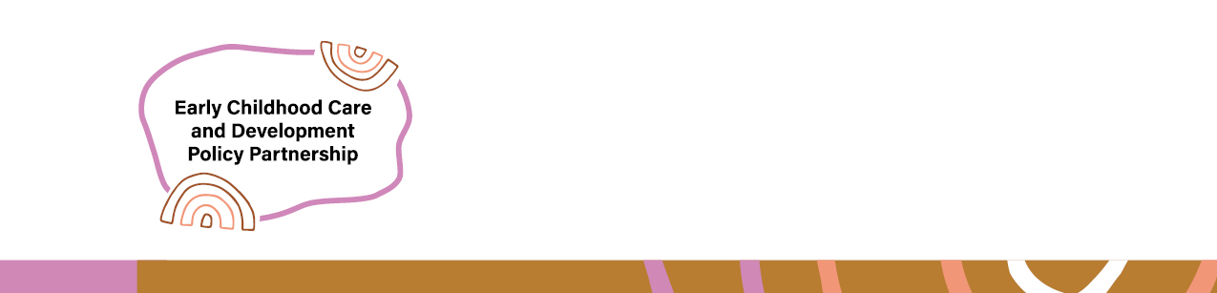

Early Childhood Care and Development Policy Partnership
  - Year 3 Actions 2025

To achieve its objectives, the Early Childhood Care and Development Policy Partnership (Partnership) will undertake the following actions:
Action | Description
Action 1 | Meet quarterly to progress policy and research priorities that have been considered and agreed to by the Partnership.
Action 2 | Make recommendations to Joint Council for all Governments to take tangible action to improve outcomes for Aboriginal and Torres Strait Islander children and families.
Action 3 | Develop implementation advice for Education Ministers consideration based on the research commissioned by the ECCDP: the ACCO Integrated Early Years Services Report and Evidence review on optimal hours of early childhood education and care for Aboriginal and Torres Strait Islander children (Priorities 2A and 2B).
Action 4 | Implement actions to deliver progress against Closing the Gap Target 12 including through collaboration with Safe and Supported.
Action 5 | Deliver ACCO funding model research project in the child and family safety sector commissioned by ECCDPP (Priority 1B).
Action 6 | Deliver Evidence Guidance Framework project (Priority 5A).
Action 7 | Deliver an independent evaluation of the first term of the ECCDPP.
Action 8 | Commission research into enhancing support for children with disability in the child protection system, through better service integration (Priority 4B).
Action 9 | Develop an Annual Report to Joint Council on Closing the Gap for 2025.
Action 10 | Develop a second 3-year strategic plan for the Partnership from 2025-28.
Action 11 | Develop a fourth-year workplan for the Partnership for 2026.

