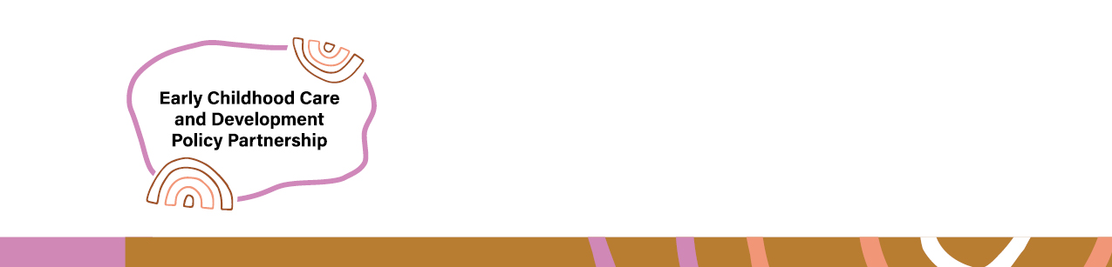

Early Childhood Care and Development Policy Partnership
  - Meeting 11 Outcomes 18-19 September 2025
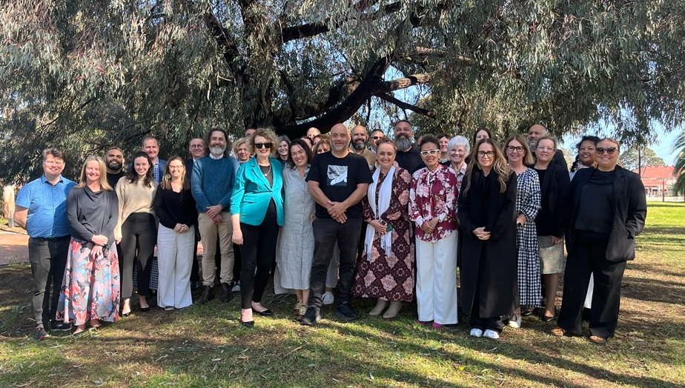
Members of the Early Childhood and Development Policy Partnership on the lands of the Wurundjeri people in Naarm/Melbourne with Uncle Bill Nicholson and meeting guests
The Early Childhood Care and Development Policy Partnership (ECCDPP, Partnership) held its eleventh meeting in Naarm/Melbourne on 18–19 September 2025 on the lands of the Wurundjeri people.
Uncle Bill Nicholson welcomed members to Wurundjeri Country and performed a smoking ceremony. He reflected on the impact colonialism had on the peoples of the Kulin Nation, as well as his ancestors who had fought for sovereignty and those that did not survive the colonisation of the lands now known as Melbourne. Uncle Bill noted the importance of educating people on the history of Wurundjeri Country, and how working together to raise children has always been a part of Aboriginal culture.
The meeting was held at the Aborigines Advancement League, an important Aboriginal Community Controlled Organisation (ACCO) that was established in 1957. The League has been fighting for the rights of Aboriginal and Torres Strait Islander people for almost seventy years and members reflected on the value of being hosted by such an important site.
The meeting was co-chaired by Catherine Liddle, CEO, SNAICC – National Voice for our Children (SNAICC) and Anne Twyman, First Assistant Secretary, Child Safety and Quality Taskforce, Australian Government Department of Education (the department) as proxy for Kylie Crane, Deputy Secretary, Early Childhood and Youth Group. It was attended by Aboriginal and Torres Strait Islander independent and peak body representatives and representatives from all Australian governments. A full list of attendees is located from page 5.
Catherine welcomed Sue-Anne Hunter, the new National Commissioner for Aboriginal and Torres Strait Islander Children and Young People. Members reflected on the importance of the Commissioner role in advocating for the rights of Aboriginal and Torres Strait Islander children. Catherine noted that the ECCDPP was instrumental in having the Commissioner established, building on decades of community advocacy.
The Commissioner reflected on how her role will help advance justice for Aboriginal and Torres Strait Islander children. The Commission will focus on building strong foundations and a robust strategy to ensure the voices of Aboriginal and Torres Strait Islander children are heard. Members reflected on the need for the Commissioner to be fully funded and empowered through legislation to perform her role.

Presentation on Early Childhood Care and Development policy landscape in Victoria
Representatives from the Victorian Government, Victorian Aboriginal Education Association Incorporated, Victorian Aboriginal Child and Community Agency and Ngaweeyan Maar-oo presented on the Victorian policy context. Representatives reflected on how Treaty and Truth Telling are core elements of work in Victorian to advance Aboriginal self-determination. The historic Statewide Treaty Bill 2025 was recently introduced to Parliament and the Yoorook Justice Commission has played an important role encouraging government to reflect on its role addressing the ongoing impacts of colonialism.
There are significant reforms underway in Victoria to involve Aboriginal people in decision-making, provide ACCOs with greater control over decisions about Aboriginal children, and support increased access to culturally capable early childhood education and care (ECEC) for Aboriginal children.
Victoria has established the Closing the Gap Partnership Forum as the overarching shared decision-making forum between governments and Aboriginal people, as well as sector-specific forums. These forums make sure the voices of Aboriginal people are heard in decision-making.
Six ACCOs are now authorised to case manage Aboriginal children in contact with child protection systems, in recognition that Aboriginal people are best placed to make decisions about what is best for their children. More ACCOs are now preparing to take on this case management function. Aboriginal organisations are also working closely with governments to transform education for Aboriginal children, through the Marrung Education Plan. Government representatives reflected that ACCOs are leaders in providing strength-based, holistic supports for children and families and governments need to listen to their expertise when designing policies and programs.

Progressing the Partnership’s Priorities
The Partnership’s priorities are the agreed policy reform areas on which the Partnership will focus its work. The priorities aim to drive concrete action to advance the safety, development and wellbeing of children and to meet Closing the Gap targets 2, 3, 4, 12 and 13 and the cross-cutting area of disability. A full list of priorities can be found on the SNAICC website.

Priority 2A and 2B
Development of implementation advice in relation to a dedicated, needs-based on sustainable funding models for Aboriginal Community Controlled Organisations delivering early years services
Increasing the hours of free early childhood education and care for Aboriginal and Torres Strait Islander Children
Members discussed the status of implementation advice on ECCDPP Priorities 2A and 2B, which relate to access to ECEC for Aboriginal and Torres Strait Islander children and sustainable funding models for ACCOs delivering integrated early years services. The ECCDPP previously commissioned two research reports to progress these priorities (2A and 2B). The research found that current funding approaches were not fit for purpose for ACCOs delivering integrated early years services and limited their capacity to deliver holistic, child-centred services needed to support Aboriginal and Torres Strait Islander children and families to thrive.
In July 2024, the Joint Council on Closing the Gap noted these reports and requested governments develop implementation advice on the findings of the research in response. Members discussed the draft implementation advice, which will progress to Education Ministers later this year.
The First Nations Caucus noted that the draft advice was insufficient to allow governments to agree to a way forward for implementing the findings of the research reports. They expressed their strong disappointment that after extensive community consultations and more than 18 months to consider the research, governments had still not made a decision about implementing the model. They noted that delay in government commitment was undermining work to Close the Gap in early childhood outcomes and indicated a need to explore broader reporting and engagement mechanisms. The First Nations Caucus proposed exploring pathways for the ECCDPP to report to or engage directly with ministerial forums when required, including the Education Ministers Meetings and Community Services Ministers Meetings, to help ensure that actions to improve outcomes for Aboriginal and Torres Strait Islander children were progressing at the necessary speed.
Australian Government members noted this feedback and agreed to explore new reporting pathways for further consideration. Government members also acknowledged that the research findings informed the final report from the Productivity Commission’s inquiry into ECEC, and that complementary reforms were being progressed which will contribute to improved affordability and accessibility of ECEC for First Nations children. These include the Service Delivery Price Project, 3-Day-Guarantee and Building Early Education Fund. The next step is for the Steering Committee to refine the implementation advice and work with the Early Childhood Policy Group to finalise the advice for Education Ministers. The Policy Partnership will continue to discuss this priority at future meetings.

Priority 1C
Monitoring and engaging with reform agendas to respond to the needs and priorities of the ACCO early years and child and family services workforce
Members discussed and agreed an approach for collaborating with Safe and Supported governance on a scoping study of the needs of the Aboriginal and Torres Strait Islander child and family sector workforce. The purpose of this research would be to help understand what is needed to build a strong, community-controlled workforce that can deliver the supports Aboriginal and Torres Strait Islander families need to keep children safe and cared for.
Members discussed the importance of pay parity and flexible approaches to build a sustainable workforce. ACCOs have passionate, skilled and dedicated staff, but it can be challenging to build a workforce when they do not have the funding to pay the same as government services. Members noted that ACCOs play an important role advancing Aboriginal self-determination and strengthening Aboriginal and Torres Strait Islander communities, as well as delivering services, and they need a workforce that supports all their functions.

Priority 6A
Accelerating progress on youth justice: collaboration with the Justice Policy Partnership
Members met with Justice Policy Partnership (JPP) representatives Melissa Clarke, National Aboriginal and Torres Strait Islander Legal Services (NATSILS) General Manager, and Tamsyn Harvey, Deputy Secretary, Justice and Communities Group, Commonwealth Attorney-General's Department and JPP Co-chair, to discuss opportunities to address the ongoing harmful overrepresentation of Aboriginal and Torres Strait Islander young people in youth justice systems. This discussion follows the third Policy Partnership Co-chairs forum held in August 2025, where it was agreed that all Policy Partnerships would invite JPP co-chairs to explore areas for collaboration. The ECCDPP has an important role to play in this space, because evidence shows that providing early and targeted supports to children and families is an effective way of preventing involvement with justice systems.
ECCDPP members noted evidence-based actions highlighted by the JPP representatives that help reduce contact with justice systems, such as schools avoiding suspensions and supporting children to stay engaged in education and not calling the police to deal with incidents in residential care that would normally be managed by a parent. They also discussed how connection to Culture and Country helps children and young people to thrive.
The First Nations Caucus highlighted the urgent need to raise the age of criminal responsibility and support children with disability in youth justice settings, who are often not appropriately diagnosed. First Nations Cacus members also noted that governments continue to consult with First Peoples without taking the tangible actions required to keep young people out of jail. They emphasised the need for the Commonwealth’s national leadership on youth justice. Government members noted that all levels of government have specific levers and a responsibility to address youth justice issues.
The co-secretariat will work with the JPP co-secretariat to identify further collaboration opportunities.

Priority 5A
Evidence Guidance Framework
Members received an update on the progress of the Evidence Guidance Framework, including the finalisation of the evidence scan, ethics approvals and next steps for engagement. This project aims to understand how Aboriginal and Torres Strait Islander people, organisations and communities understand and use evidence in the context of child and family services. The intention is that this will also help governments better utilise Aboriginal and Torres Strait Islander-driven evidence when making policies regarding child and family services. The project team will consult with Aboriginal and Torres Strait Islander communities to inform the development of the Framework (pending ethics approval).

Other ECCDPP work

National Agreement on Closing the Gap Target 3 Refresh
Closing the Gap Outcome 3 is: Aboriginal and Torres Strait Islander children are engaged in high quality, culturally appropriate early childhood education in their early years. The current target for this outcome, which relates to enrolment in ECEC is on track to be met. This is an important success of work under Closing the Gap. Governments and Aboriginal and Torres Strait Islander peoples have agreed to work together to develop a new target for this outcome to set the ambition for future progress.
Members noted the work done to date to develop a new target and provided feedback on the options for a new target. Members agreed that there is a need for targets and measures to capture more than just enrolment in ECEC. To understand whether ECEC is supporting Aboriginal and Torres Strait Islander children to thrive, we must also understand how often children are attending and whether the education and care is meeting their needs and that of their families. This includes having accessible, culturally safe care that adapts to the needs of children and communities. Members agreed to next steps for recommending a refreshed target to Education Ministers and the Joint Council on Closing the Gap.

Supporting Shared Decision-Making between government and community
The Partnership is committed to supporting shared decision-making arrangements between governments and community, recognising the Aboriginal and Torres Strait Islander people must be at the table for the discussions and decisions that impact their lives. Members received an update from Katrina Fanning AO PSM, Coolamon Advisors, on the Shared Decision-Making Guidance project which is being led by SNAICC. Members provided feedback on the draft shared decision-making guidance. The project will provide practical guidance for governments and ACCOs to self-evaluate their performance in shared decision-making in relation to early childhood care and development policy and identify areas for improvement. The final guidance will be published for governments and ACCOs to use.

Update on the evaluation of the ECCDPP
Members received a further update from yamagigu Consulting Pty Ltd on the Evaluation underway of the ECCDPP. Members provided feedback as part of sense checking the preliminary findings of the evaluation. The Evaluation Final Report will be delivered by the end of 2025 and will be published once finalised.

ECCDPP Annual Report 2025
Members provided feedback to inform the development of the ECCDPP 2025 Annual Report, which will be published in early 2026.

Next meeting
The Partnership will meet again on 12–13 November 2025 to continue progressing the Partnership’s priorities.

Attendees/Apologies
Name | Representing
Coalition of Peaks representatives
Catherine Liddle | SNAICC – National Voice for our Children (SNAICC)
Donnella Mills | National Aboriginal Community Controlled Health Organisation (NACCHO)
Neville Atkinson (Apology for Day 2) | Victorian Aboriginal Education Association Incorporated
Lisa Coulson | Tasmanian Aboriginal Centre
Tennille Lamb (Apology for Day 2) | First Peoples Disability Network
Kylie Degenhardt (proxy for Sharron Williams, apology) | South Australian Aboriginal Community Controlled Organisation (SAACCON)
Independent Aboriginal and Torres Strait Islander representatives
Darcy Cavanagh | Independent representative
Paul Gray (online) | Independent representative
Garth Morgan (Apology Day 2) | Independent representative
Joanne Della Bona (Apology) | Independent representative
Elizabeth Cox (Online) | Independent Representative
Government representatives
Anne Twyman (proxy for Kylie Crane) | Commonwealth Government, Department of Education
Mark Barraket | New South Wales Government
Mathew Lundgren | Victorian Government
Lyn Luxford (proxy for Tania Porter) | Queensland Government
Melanie Samuels | Western Australia Government
Kim Little | South Australia Government
Peter Whitcombe | Tasmania Government
Liam McNicholas (proxy for Nicole Moore) | Australian Capital Territory Government
Rachel McMillian (proxy for Karen Broadfoot) | Northern Territory Government
Partners
Shantai Croisdale (proxy for Muriel Bamblett) | SNAICC – National Voice for our Children (SNAICC)
John Leha | CEO of AbSec – NSW Child, Family and Community Peak Aboriginal Corporation
Phillip Brooks | CEO of Queensland Aboriginal and Torres Strait Islander Child Protection Peak (QATSICPP)
Letitia Hope | Commonwealth Government, Department of Social Services
Deborah Fulton (proxy for Julie-Ann Guivarra) | Commonwealth Government, National Indigenous Australians Agency
Stuart Malcher | New South Wales Government
Simone Corin | Victorian Government
Ron Weatherall | Queensland Government
Raechelle Lee | Western Australia Government
Shirley Smith (proxy for Jackie Bray) | South Australian Government
Jodee Wilson | Tasmanian Government
Chris Simpson | Australian Capital Territory Government
Audrey Billias (proxy for Aderyn Chatterton) | Northern Territory Government

