

Guidance to Develop a Whole-of-Organisation Gender-Based Violence Prevention and Response Plan and Outcomes Framework


For queries in relation to this document, please contact NationalGBV.Code@education.gov.au
Contents
1. Intent of a Whole of Organisation Approach in the National Higher Education Code to Prevent and Respond to Gender-based Violence 1
2. Purpose of this guidance 3
3. Overview of key steps 3
4. Provider requirements 5
5. Details of submission 6
5.1 What needs to be submitted and by when? 6
5.2 How should it be submitted? 6
5.3 How will it be assessed and by who? 6
6. Details of Key Steps 7
6.1 PREPARE 7
A. Engagement 8
B. Data analysis and evidence review 9
C. Identifying systemic risks, enablers and barriers 9
D. Implementation of requirements 10
6.2 PLAN 10
6.2.1 Whole of Organisation Plan (the Plan) 11
6.2.2 Outcomes Framework 11
6.2.3 Gender Equality Action Plan 12
6.3 REFLECT 13
6.3.1 Reflect on engagement 13
6.3.2 Ensure implementation readiness 13
6.4 ENDORSE AND ENABLE 14
6.4.1 Role of the Higher Education Principal Executive Officer 14
6.5 ACTIVATE AND EMBED 15
6.6 REFRESH 15
7. Questions and support 16

1. Intent of a Whole of Organisation Approach in the National Higher Education Code to Prevent and Respond to Gender-based Violence
Higher education providers (providers) know they have a critical role to play in addressing gender-based violence by recognising their unique capacity to drive social change, and their responsibility to create safe environments for study, work, accommodation and social life.
Achieving lasting cultural and structural change requires coordinated leadership, clear accountability, and active engagement at every level of the organisation. When senior leaders visibly champion change and model commitment, it signals that preventing and responding to gender-based violence is a shared responsibility, not confined to any single department, faculty or team.
Many providers are already taking proactive steps to prevent and respond to gender-based violence in their higher education communities.
Under the National Higher Education Code to Prevent and Respond to Gender-based Violence (National Code) a provider, led by its Higher Education Principal Executive Officer is required to develop, implement, and publish a Whole-of-Organisation Prevention and Response Plan (Plan) and Outcomes Framework.
This is designed to support the transformative and cultural change needed to prevent and respond to gender-based violence and ensure leadership drives the change from the top. It also ensures that strategies and actions are stewarded by a provider’s senior leadership and are prioritised, embedded in everyday practice, supported by robust systems and policies, and underpinned by strengthened accountability and a commitment to continuous improvement.

2. Purpose of this guidance
This guidance has been prepared by the Gender-based Violence Reform Branch (Branch) in the Department of Education (Department). It provides information to assist a provider’s Higher Education Principal Executive Officer in leading the development of their Plan and Outcomes Framework in alignment with the requirements of the National Code.
Providers may choose to develop a Plan and Outcomes Framework in their own format or use the optional templates referenced in this guide, provided they meet the requirements set out in the National Code.

3. Overview of key steps
This guidance, along with the associated Plan template and Worksheets, has been designed to assist a provider’s Higher Education Principal Executive Officer in developing, implementing and reviewing a Plan and Outcomes Framework that complies with the National Code and drives lasting change.
Importantly, the development of the Plan and Outcomes Framework is not a ‘tick and flick’ compliance exercise; nor is it a ‘one-off’ reporting obligation.
The Plan and the Outcomes Framework are significant, evolving and foundational products that guide providers, or in many cases continue to guide providers, in activating and embedding how they prevent and respond to gender-based violence.
This guidance outlines six key steps providers are encouraged to work through, demonstrating how they are preparing to meet the requirements of the National Code and embedding practices to prevent and respond to gender-based violence throughout their organisation.
The steps also acknowledge that providers are at different stages of preparedness in meeting the requirements of the National Code. Some organisations are already well-advanced in their undertakings; others may have more progress to make.
The steps also recognise that implementing the type of changes required from providers by the National Code will take time to develop and embed.

Figure 1: Overview of key steps for developing a Whole-of-Organisation Gender-Based Violence Prevention and Response Plan and Outcomes Framework
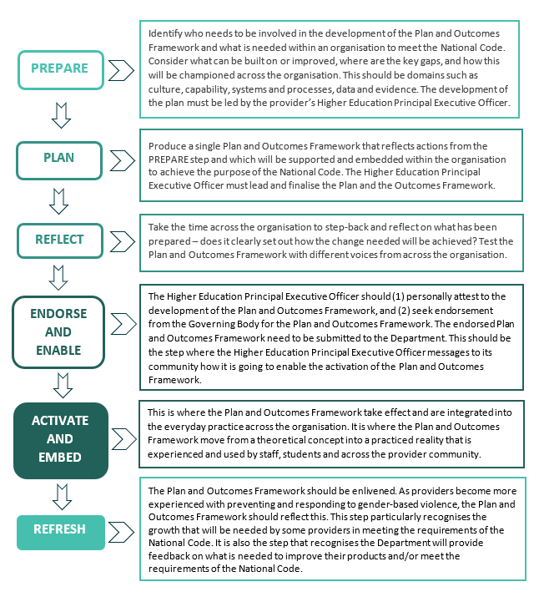

4. Provider requirements
The National Code requires that a provider, led by its Higher Education Principal Executive Officer, prepare, implement and publish on their website (1) the Plan (Standard 1.4(a) – (m) and 1.6) and (2) an Outcomes Framework (Standard 1.7).
National Code - Standard 1
1.4 A Provider must, led by its Higher Education Principal Executive Officer, prepare, implement and publish on its website a Whole-of-Organisation Prevention and Response Plan that:
- records the Provider's Whole-of-Organisation approach to preventing and responding to Gender-based Violence, including in any Student Accommodation which the Provider directly owns, operates and/or manages, that prioritises the safety and support of its Students and Staff;
- responds to Gender-based Violence wherever it is experienced by the Provider's Students and Staff;
- addresses the factors that drive and contribute to Gender-based Violence, as well as any factors relevant to the Provider’s context.
- records how the Provider will implement the requirements in the Code, including in any Student Accommodation which the Provider directly owns, operates and/or manages;
- includes a Whole-of-Organisation assessment, which includes any Student Accommodation which the Provider directly owns, operates and/or manages, that identifies systemic risks, enablers and barriers to preventing Gender-based Violence;
- includes actions that will be taken in response to findings of the assessment;
- includes a gender equality action plan, which the Secretary may require to be prepared in a prescribed manner and form;
- reflects the needs, experience and agency of all members of the Provider’s community, particularly those members who are disproportionally affected by Gender-based Violence, including women, First Nations people, culturally and linguistically diverse communities, people with disability and people of diverse sexual orientation and gender identity;
- is developed in respect to its design and implemented through engagement and collaboration with Students and Staff, including those who have experienced Gender‑based Violence;
- is informed by the Provider’s analysis of available data or other relevant publicly available data, as reported to the Secretary under Standard 6;
- includes a systemic review and analysis of the Provider’s responses to Disclosures and Formal Reports to identify barriers, gaps and opportunities for improvement;
- is informed by available and relevant domestic and international evidence about the nature and extent of Gender-based Violence; and
- is endorsed by the Provider's Governing Body.

1.6 A Provider that directly owns, operates and/or manages Student Accommodation must ensure that its Prevention and Response Plan comprehensively addresses how it will comply with its obligations under the Code in the Student Accommodation.
1.7 A Provider must develop and implement an outcomes framework to track and measure the effectiveness of actions under their Prevention and Response Plan.
The National Code defines Whole-of-Organisation as:
an approach applied across all areas of a Provider’s operations, including any student accommodation which it directly owns, operates and/or manages, or the operations of a student accommodation provider or affiliated student accommodation provider as the context requires it, and at all levels that is evidence-informed, uses multiple strategies and is subject to ongoing monitoring and evaluation, including in respect to:
- leadership, culture and environment;
- structures, norms and practices;
- systems and infrastructure;
- service delivery, such as curriculum, teaching and learning;
- policies and procedures;
- management and governance;
- community engagement;
- business;
- research; and
- partnerships.
Providers should be aware that under Standard 1.13, the Secretary may also require a provider to report on how it has complied with its obligations under Standard 1 in a manner and form to be prescribed by the Secretary.

5. Details of submission

5.1 What needs to be submitted and by when?
As required by Standard 1.8, providers must submit their Plan and Outcomes Framework, which has been developed and attested to by their Higher Education Principal Executive Officer and endorsed by their Governing Body to the Department by 1 January 2026.
The Plan and Outcomes Framework can be submitted using the Optional Plan Template that accompanies this guidance or in another format. Relevant supplementary documents may also be provided.
If submitted in another format, providers must ensure it aligns with the requirements of the National Code and also submit the Endorsement Template.

5.2 How should it be submitted?
The Department will communicate separately with each provider about the administrative process to formally submit their proposed Plan and Outcomes Framework to the Department by
1 January 2026.

5.3 How will it be assessed?
The submission of a proposed Plan and Outcomes Framework is the first step in the assessment process.
The Department will then work with providers to assess and finalise their Plan and the Outcomes Framework to ensure they meet the requirements of the National Code (primarily set out in Standard 1.4).
Standard 1.12 of the National Code requires that any provider that receives feedback from the Department must engage with the Department about that feedback, revise its Plan and provide an updated version in the timeframe specified by the Department.
The finalisation of the Plan and Outcomes Framework is likely to take some time, which reflects the significance of the undertaking; implementation of the National Code will require change, including cultural change, and this is likely to be experienced differently by each organisation.

6. Details of Key Steps

6.1 PREPARE

PREPARE
Investing time and expertise in the development of the Plan and Outcomes Framework, as well as ensuring meaningful engagement with staff and students, will strengthen the resulting products.
Standard 1 of the National Code requires that providers, led by their Higher Education Principal Executive Officer, must prepare, implement and publish on their website a Whole-of-Organisation Prevention and Response Plan. Standard 1.4 (d)-(l)) requires providers to demonstrate the work undertaken to inform the development of the Plan and to identify actions to prevent and respond to gender-based violence. Further, Standard 1.6 requires any provider that directly owns, operates and/or manages student accommodation to ensure that its Plan comprehensively addresses how it will comply with its obligations under the National Code in its student accommodation.
Higher Education Principal Executive Officers are encouraged to view the National Code’s requirements for their Plan (i.e. Standard 1.4 (d)-(l)) as their starting point. They should use the opportunity in the PREPARE stage to:
- Identify who needs to be involved in its development.
- Identify what is needed within their organisation to meet the National Code.
- Consider what can be built on or improved.
- Highlight where there are key gaps.
- Formulate how this will be championed and stewarded across the organisation.
- Commit to how it will be embedded and be used to drive culture, capability, systems and processes, data and evidence.
To support the preparation of the Plan and the Outcomes Framework, the Department recommends that providers group the requirements together as follows:
THEMES | REQUIREMENTS FROM NATIONAL CODE
Engagement | 1.4(h) reflects the needs, experience and agency of all members of the Provider’s community, particularly those members who are disproportionally affected by Gender-based Violence, including women, First Nations people, culturally and linguistically diverse communities, people with disability and people of diverse sexual orientation and gender identity  1.4(i) is developed in respect to its design and implemented through engagement and collaboration with Students and Staff, including those who have experienced Gender‑based Violence
Data analysis and evidence review | 1.4(j) is informed by the Provider’s analysis of available data or other relevant publicly available data, as reported to the Secretary under  Standard 6  1.4(k) includes a systemic review and analysis of the Provider’s responses to Disclosures and Formal Reports to identify barriers, gaps and opportunities for improvement  1.4(l) is informed by available and relevant domestic and international evidence about the nature and extent of Gender-based Violence
Systemic risks, enablers and barriers assessment | 1.4(e) includes a Whole-of-Organisation assessment, which includes any Student Accommodation which the Provider directly owns, operates and/or manages, that identifies systemic risks, enablers and barriers to preventing Gender-based Violence  1.4(f) includes actions that will be taken in response to findings of the assessment
Implementation of requirements | 1.4(d) records how the Provider will implement the requirements in the Code, including in any Student Accommodation which the Provider directly owns, operates and/or manages

The Department has developed Optional Worksheets that may assist providers in documenting the processes used to meet these requirements, identify priority actions and support the development of the Plan and the Outcomes Framework. While these worksheets can assist providers in meeting the requirements, their use alone does not guarantee compliance.
Providers not wishing to use the worksheets will need to document the processes they have undertaken to inform development of the Plan and Outcomes Framework. This documentation may need to be provided to the Department at its request.
The Optional preparation worksheets can be found here: https://www.education.gov.au/highereducationgbvcode/resources/optional-preparation-worksheets-wholeorganisation-genderbased-violence-prevention-and-response-plan-and-outcomes-framework
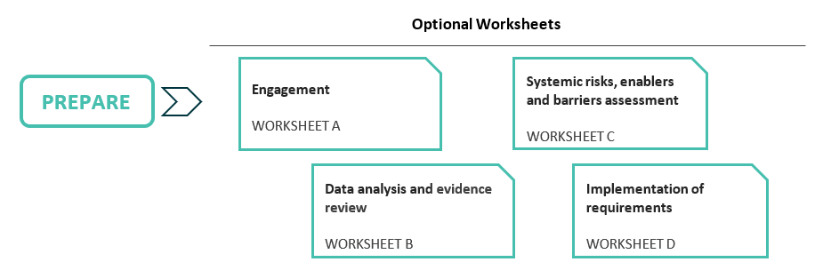

There is likely to be some overlap among the actions that emerge in the PREPARE step including with the provider’s existing plans to prevent and respond to gender-based violence and promote gender equality. Providers can include, cross-reference and record existing actions and the plans within their Plan.

A. Engagement
Standard 1.4 of the National Code requires a provider’s Higher Education Principal Executive Officer, in leading the preparation of the Plan, to reflect the needs, experience and agency of all members of a provider’s community, especially those members of the community who are disproportionately affected by gender-based violence (1.4(h)) and collaboratively designed with students and staff including those who have experienced gender-based violence (1.4(i)).
Providers should document:
- Processes undertaken to address the relevant National Code requirements
Providers can consider a range of evidence-informed processes to gather diverse and insightful data.
- Evidence that demonstrates the processes undertaken
This evidence may need to be made available to the Department if requested.
- Findings from processes undertaken
Summarise findings to support prioritisation and the identification of actions.
- Actions to be implement prompted by findings
Note actions prompted by findings and informed by available data and evidence.
Providers may be required under Standard 1.5 of the National Code to report to the Department on how engagement with and views of students and staff have informed the development of their Plan.
Worksheet A: Actions - Engagement is an optional template that can assist providers in demonstrating how they meet the requirements of the National Code relating to engagement.

B. Data analysis and evidence review
Standard 1.4 of the National Code also requires a provider’s Higher Education Principal Executive Officer, in leading the preparation of the Plan, to demonstrate how their Plan reflects a review of available data on gender-based violence experienced by staff and students, analysis of the provider’s responses to disclosures and formal Reports (1.4 (j)(k)) and is informed by available and relevant domestic and international evidence (1.4(l)).
Providers should document:
- Processes undertaken to address the relevant National Code requirements
Providers can consider a range of evidence-informed processes to gather diverse and insightful data.
- Evidence that demonstrates the processes undertaken
This evidence may need to be made available to the Department if requested.
- Findings from processes undertaken
Summarise findings to support prioritisation and the identification of actions.
- Actions to be implement prompted by findings
Note actions prompted by findings and informed by available data and evidence.
Worksheet B: Actions – Data and Evidence is an optional template that can assist providers in demonstrating how they achieve the requirements of the National Code relating to data and evidence.

C. Identifying systemic risks, enablers and barriers
Standard 1.4 of the National Code requires a provider’s Higher Education Principal Executive Officer, in leading the preparation of the Plan, to demonstrate how actions in their Plan are informed by a Whole-of-Organisation assessment identifying systemic risks, enablers and barriers centred on preventing and responding to gender-based violence. Student accommodation must be considered within this assessment and resulting actions (1.4(e)-(f)).
Providers need to clearly demonstrate they understand their community of staff and students, the complexity of gender-based violence, and that risks, enablers and barriers have been identified. Plans should clearly include actions that seek to manage or mitigate risk, maximise opportunities to enable and drive change, and overcome barriers.
Providers should ensure their assessment covers all ten domains (a-j) outlined in the National Code’s definition of Whole-of-Organisation (see page 5 and 6 of this guidance). For each of the ten domains, providers need to identify systemic risks, enablers, and barriers. Systemic risks, enablers and barriers refer to patterns in an organisation's systems and processes.
Providers should document:
- Data capture methods used in your whole-of-organisation assessment to identify risks, enablers and barriers in each operational area.
Data capture methods should be varied, trauma-informed, and support understanding of the experiences of people and groups who are often disproportionately impacted by gender-based violence. Evidence of these data capture processes may need to be made available to the Department if requested.
- Systemic risks, enablers and barriers identified for each operational area.
- Actions to be implemented to address risks, enablers and barriers, relevant to the findings in each operational area.
Worksheet C: Risks, enablers and barriers is an optional template that can assist providers in demonstrating how they achieve the requirements of the National Code relating to risks, enablers and barriers.
Providers are likely to already have existing strategies, plans and actions relating to the prevention and response of gender-based violence and promotion of gender equality in place. Providers are encouraged to reference these and record actions from them, either in the worksheet or in a format of their choosing.

D. Implementation of requirements
Standard 1 – 1.4 (d) of the National Code requires a provider’s Higher Education Principal Executive Officer, in leading the preparation of the Plan, to record how they will implement its requirements, including in any student accommodation which the provider directly owns, operates and/or manages.
Providers should:
- Consider each requirement of the National Code.
- Document work already undertaken or requirements already met and reference evidence selected to demonstrate actions have been undertaken.
- List actions to address each requirement.
Worksheet D: National Code requirements is an optional template that can assist providers in demonstrating how they achieve the requirement to implement the requirements of the National Code.

6.2 PLAN

PLAN
Standard 1.4 of the National Code requires providers to prepare, implement and publish on their website (1) the Plan, including a Gender Equality Action Plan, and (2) an Outcomes Framework.
Providers will need to produce:
- A single consolidated and meaningful Plan, led by their Higher Education Principal Executive Officer, including or attaching a Gender Equality Action Plan and reflecting actions from the PREPARE step, should be supported and embedded across the organisation and aligned with the purpose of the National Code.
- An Outcomes Framework which is clearly linked to the Plan and tracks and measures the effectiveness of the actions under the Plan.

6.2.1 Whole of Organisation Plan (the Plan)
Standard 1.4 of the National Code requires that providers, led by their Higher Education Principal Executive Officer, must prepare, implement and publish on their website a Whole-of-Organisation Prevention and Response Plan.
Leaders have a pivotal role in driving change to end gender-based violence by shaping and transforming institutional culture at every level. They define, communicate, and model core values of respect, safety, and inclusion, embedding these principles into governance, policy, and daily practice. They also proactively identify and address systemic issues such as gender inequality and harmful stereotypes, foster a culture of innovation and inclusivity, and ensure coordinated prevention and response efforts across the institution.
The Plan must:
- Record a Whole-of-Organisation approach to preventing and responding to gender-based violence (Standard 1.4(a)).
- Respond to Gender-based Violence wherever it is experienced by the Provider's Students and Staff (Standard 1.4(b)).
- Address the factors that drive and contribute to gender-based violence and any relevant factors for a particular provider (Standard 1.4(c)).
- Record how a provider will implement the requirements in the National Code (Standard 1.4(d)).
- Include:
  - An assessment that identifies systemic risks, enablers and barriers to preventing gender-based violence (Standard 1.4(e)) and actions to respond to these (Standard 1.4(f)).
  - A gender equality action plan (Standard 1.4(g)).
  - A systemic review and analysis of responses to disclosures and formal reports to identify barriers, gaps and opportunities for improvement (Standard 1.4(k)).
- Reflect:
  - The needs, experience and agency of all members of their community, particularly those disproportionately impacted by gender-based violence (Standard 1.4(h)).
  - Findings from engagement and collaboration with students and staff, especially those who have experienced gender-based violence (Standard 1.4(i)).
  - Domestic and international evidence about the nature and extent of gender-based violence (Standard 1.4(l)).

6.2.2 Outcomes Framework
Standard 1.7 of the National Code requires providers to develop an Outcomes Framework to track and measure the effectiveness of actions under their Plan. They are required to report to their governing body every six months against this Outcomes Framework, and this report is also to include updated gender-based violence incident data and identification of any emerging trends.

Providers may have their own templates that align to organisational reporting and evaluation processes and these can be used, noting providers are responsible for ensuring their Outcomes Framework aligns to the Plan.
Plan and Outcomes Framework template is an optional template that can assist providers to develop a single consolidated Plan that meets the requirements of the National Code and to track and measure the effectiveness of their actions in the Plan. While this template is optional, providers must ensure any Plan submitted in another format meets the requirements of the National Code.
Standard 1.10 of the National Code also requires that providers must also submit to the Department a report on the Plan and its Outcomes Framework every two years. Further details will be provided by the Department on what this reporting should look like.

The Optional Plan and Outcomes Framework Template can be found here:
https://www.education.gov.au/highereducationgbvcode/resources/optional-plan-template-wholeorganisation-genderbased-violence-prevention-and-response-plan-and-outcomes-framework

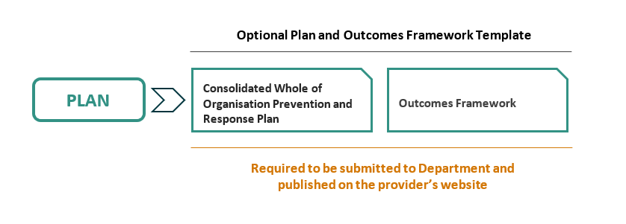

6.2.3 Gender Equality Action Plan
Standard 1.4(g) of the National Code requires a provider’s Plan to include a Gender Equality Action Plan that outlines targeted actions that promote gender equality.
Many providers already have existing Gender Equality Action Plans that are focussed on staff, such as those developed for the Commission for the Gender Equality in the Public Sector, Science in Australia Gender Equity (SAGE) and/or other gender equality/equity initiative.
For providers who do not have an existing Gender Equality Action Plan, there is existing guidance available to support its development including the:
- Action Planning Tool developed by the Workplace Gender Equality Agency.
- Gender Equality Action Plan Guide and Templates developed by the Victorian Government Commission for Gender Equality in the Public Sector.
To meet the requirements of the National Code, providers can use their existing Gender Equality Action Plans and: (1) expand them to include actions for students and the broader provider community; or (2) incorporate actions to promote gender equality for students and the broader community into their consolidated Plan.
For those providers who wish to use their existing Gender Equality Action Plan, this can be submitted as an annex to a provider’s Whole-of-Organisation Prevention and Response Plan.
If a provider is submitting an existing Gender Equality Action Plan, it must note its alignment to the Plan by noting:
- Name and tenure E.g. Gender Equity Plan 2023-2027.
- Authorising or commissioning agency E.g. SAGE
- Revision commitments within the four-year period of the Plan: e.g. The next scheduled revision is reportable to the Gender Equity Committee on 30 June 2026.

6.3 REFLECT

REFLECT

6.3.1 Reflect on engagement
Before the Plan and Outcomes Framework are finalised by the provider’s Higher Education Principal Executive Officer and endorsed by the provider’s Governing Body, providers should take time to reflect across their organisation on what has been prepared and whether the Plan clearly outlines how the required change will be achieved and how it meets the requirements of the National Code.
This step should also be used by the Higher Education Principal Executive Officer to test the Plan and Outcomes Framework and ensure that they genuinely capture the diverse perspectives and needs of all staff and students.
Engagement and consultation are not only a requirement of the National Code, they are also key to:
- Identifying gaps and addressing potential barriers.
- Building a Plan that reflects the need of the provider’s community.
- Fostering a sense of shared ownership and building legitimacy within the provider’s organisation.
These factors, especially the role of the Higher Education Principal Executive Officer, are crucial for successful implementation and lasting cultural change.

6.3.2 Ensure implementation readiness
Providers, led by their Higher Education Principal Executive Officer, should also reflect on their implementation readiness to ensure their Plan is practical and achievable within their current context. By taking deliberate action to ensure implementation readiness, providers can be confident that their Plan will be effectively implemented and deliver its intended outcomes.
Assessing implementation readiness involves confirming that necessary resources, systems, and stakeholder support are in place, and that any potential barriers to implementation have been identified and addressed.
This may require providers to:
- Assess resource availability and allocation: Confirm that the necessary staff, budget, and infrastructure are in place to support the plan’s implementation and identify any gaps that need to be addressed.
- Establish clear systems and processes: Ensure that supporting systems, policies, and procedures are ready and aligned to facilitate the plan’s rollout and ongoing monitoring.
- Engage stakeholders and secure commitment: Verify that key stakeholders—including leadership, staff, and students—are informed, supportive, and prepared to contribute to the plan’s successful implementation.

6.4 ENDORSE AND ENABLE

ENDORSE

EEe
As outlined in Section 1: Intent of a Whole of Organisation Approach in the National Higher Education Code to Prevent and Respond to Gender-based Violence, lasting cultural and structural change requires coordinated leadership, clear accountability, and active engagement across every level of the organisation.
To this end, the National Code sets out the following requirements:
- Standard 1.4 of the National Code requires that providers, led by their Higher Education Principal Executive Officer, must prepare, implement and publish on their website a Whole-of-Organisation Prevention and Response Plan.
- Standard 1.4(m) requires that the Plan and Outcomes Framework be endorsed by the provider’s Governing Body.
Requiring both leadership of the development of the Plan and Outcomes Framework from the Higher Education Principal Executive Officer and endorsement by the Governing Body reinforces the transformative and cultural change needed to meet the requirements of the National Code. It also sends a strong and powerful signal of the provider’s commitment to preventing and responding to gender-based violence across its broader higher education community.

6.4.1 Role of the Higher Education Principal Executive Officer
Accountability for compliance with the National Code sits at the highest level of the provider’s organisation and regular reporting to the provider’s governing body on incident data and efforts to prevent and respond to gender-based violence is required.
Effective leaders also play a critical role in change management, navigating resistance and fostering collective commitment to transformation. By prioritising ethical leadership, accountability, and collaboration with students, staff, and external experts, they set the moral compass for the university and champion a culture that embraces social responsibility and sustains long-term change. Ultimately, leadership is both a catalyst for, and a reflection of, cultural transformation, and is essential in creating safer, more equitable university environments where gender-based violence is actively prevented and addressed.

The Plan and Outcomes Framework have a mandatory Endorsement Template where the leadership of the Higher Education Principal Executive Officer and the endorsement of the Governing Body can be recorded.
The Endorsement Template can be found here:
https://www.education.gov.au/highereducationgbvcode/resources/endorsement-template-wholeorganisation-genderbased-violence-prevention-and-response-plan-and-outcomes-framework
Providers choosing not to use the Plan and Outcomes Framework template are still required to complete and submit the separate endorsement template, to ensure the leadership of the Higher Education Principal Executive Officer in the development and endorsement of the Plan. The Plan’s endorsement by the Governing Body should be clearly documented.
This step should also be used to communicate to the broader higher education community that the Plan and its Outcomes Framework are in place, are a priority to be implemented across all levels of the organisation and are actively being put into action.

6.5 ACTIVATE AND EMBED

activated
Standards 1.4 and 1.7 of the National Code require providers, led by its Higher Education Principal Executive Officer, to implement their Plan and monitor its progress through an Outcomes Framework.
To effectively embed and activate the Plan, this is the step where providers will need to move beyond endorsement and activate the plan (avoiding a ‘set and forget’ mindset) so it becomes an integral and embedded part of everyday practice across the organisation.
This is likely to involve the provider demonstrating:
- Clear communication of the plan’s purpose and requirements to all stakeholders.
- Active monitoring and mitigation of gender-based violence risks in the provider community.
- Integrating its actions and principles into existing capabilities, systems, policies, and procedures; and
- Providing ongoing training and support to staff and students.
Under Standard 6.9 of the National Code, the Secretary may also require a provider to provide data on student and staff awareness of the providers:
- plan;
- policies and procedures for making disclosures and formal reports; and
- availability and accessibility of the provider’s support services, including academic adjustments, in relation to gender-based violence.

6.6 REFRESH

REFRESH
Standards 1 and 6 of the National Code require that a provider must commit to continuous improvement and strengthening of their efforts to prevent and respond to gender-based violence through their Plan and Outcomes Framework.
As the Higher Education Principal Executive Officer leads the development and implementation of the Plan, they should necessarily have a role in tracking progress, reflecting on progress and endorsing any changes made to the Plan.
Ongoing monitoring, review and refreshment of the Plan and Outcomes Framework are essential to ensure that intended outcomes are being achieved and that the provider remains responsive to emerging needs, trends and challenges. By systematically tracking progress, collecting feedback, and analysing data, organisations can identify what is working well, where improvements are needed, and whether new risks or opportunities have arisen.
Specifically, providers will need to:
- Report to their Governing Body at least every six months (from their initial reporting date) against the Plan and Outcomes Framework, which must include deidentified data on incidents of gender-based violence experienced by students and staff since the last report, including identification of any trends in the data (Standard 1.9).
- The Higher Education Principal Executive Officer must submit a report to the Secretary of the Department on the Plan and Outcomes Framework every two years after their initial reporting date (Standard 1.10).
- Review and amend their Plan having regard to their duty of care to students and staff (Standard 1.11).
- Engage with the Department about any feedback they receive, revise their Plan and provide an updated version in the timeframe specified by the Department (Standard 1.12).
- Ensure that all data collected in accordance with Standard 6 is used to inform and strengthen their whole-of-organisation approach, including the Plan and Outcomes Framework (Standard 6.5).
These processes support continuous improvement, enable evidence-informed decision-making, and help to maintain momentum for change. Importantly, continuous review ensures that the Plan and Outcomes Framework are adapted as circumstances evolve, strengthening their effectiveness and ensuring they continue to be effective in preventing and responding to gender-based violence.

7. Questions and support

SUPPORTEe
The introduction of the National Code’s requirements is a significant endeavour that will require change, including cultural change, and that this will take time to be embedded within your organisations. This change is likely to be experienced differently by each organisation.
The Department is committed to working with the higher education sector to implement the National Code and to build higher education environments that are safe and supportive for all students and staff its success.
The Gender-based Violence Reform Branch is available to meet with organisations to discuss the National Code and its requirements. It can be contacted at NationalGBV.Code@education.gov.au

