****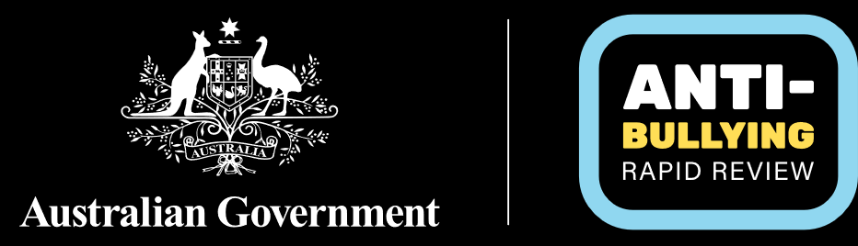

**Summary Recommendations from the Anti-Bullying Rapid Review**

The Review includes eight recommendations that aim to ensure that every Australian school is a safe, inclusive and respectful learning environment where bullying and other harmful behaviours are not accepted.

### Education Ministers commit to actions and reforms that set a national standard for every Australian school to be a safe, inclusive and respectful learning environment where:

### bullying behaviours, including harmful antecedent behaviours (referred to as bullying and other harmful behaviours), as described in this report, are not accepted, and

### the school workforce – including principals, school leaders, teachers, education support staff, specialist support staff and health professionals – is supported to take appropriate action.

### Education Ministers consider the suggested principles-based National Standard included in the report for implementation across all school systems.

### 

1. The Australian Government lead transformative national actions, including:
2. A targeted public awareness campaign, to be developed with experts in primary prevention and behaviour change, the education sector, the school workforce, and other stakeholders, to:
3. build community understanding of bullying and other harmful behaviours and their impacts, including cyberbullying and image-based abuse
4. equip the community to contribute to cultural change
5. support any national implementation of this Review’s recommendations, including the National Standard.

### Consideration through the next Australian Curriculum review cycle of opportunities to enhance education on social, emotional, empathy, respect and relationship issues to equip students with the knowledge, skills and behaviours to understand and prevent harmful behaviours from occurring.

1. Education Ministers, school systems, and school leaders support every school across Australia to implement clear, transparent, trauma-informed and responsive anti-bullying policies and procedures that:

### Include a requirement that schools make reasonable effort to initiate safety and support planning and communication in response to observed or reported bullying or other harmful behaviours, within two school days of becoming aware of the behaviour, recognising further time may be required to fully address the issue.

### Are developed for their local school context in partnership with students, parents and carers and the school workforce.

1. Education Ministers commit to actions to empower and equip school communities to work together to prevent and address bullying and other harmful behaviours and build safe and positive environments, including:

### Trauma-informed training and resources for school leaders, teachers, teaching support staff, allied health and specialist staff on preventing and responding to bullying and other harmful behaviours.

### Targeted resources on addressing cyberbullying, deepfakes and online harms, developed in consultation with the eSafety Commissioner.

### Resources to help and support students, upstanders (those supporting others at risk of being harmed) and families, including families of students who have experienced or engaged in bullying and other harmful behaviours.

### Ensuring the risk factors and needs of local school populations are fully considered, including the unique and intersecting needs of diverse student groups and school staff including First Nations people, those who identify as LGBTIQA+, people with disability, and other groups experiencing additional risk factors such as women and girls.

1. Education Ministers, school systems and school boards support local school action by providing:

### Support for schools to analyse student-level data to enable the identification of bullying-related risks within their school communities to help inform targeted school-level prevention, early intervention and response and support activities, and to support continual improvement of approaches.

### Clear guidance on evidence-based, whole-of-school trauma-informed responses that help schools intervene early and appropriately to prevent the development and/or escalation of harmful behaviours.

### Structured initiatives that provide all students with appropriate support, experiences, teaching and resources to positively and confidently engage in learning.

### Targeted and evidence-based approaches that help support and change behaviours of students engaging in bullying and other harmful behaviours, including supporting the schools to work with parents/carers to cultivate their child’s prosocial behaviours.

1. Education Ministers commit to continual improvement in addressing bullying and other harmful behaviours, including:

### Reviewing implementation of these recommendations in 2027 and routinely thereafter to ensure Australia’s action remains suitably targeted to achieve change and is being implemented and adhered to in schools and the school workforce remains informed and supported to take appropriate action.

### Identifying opportunities to build the national evidence base through research and data collection on risk factors, trends and impacts of actions to adapt to emerging issues.

1. Education Ministers note that preventing and addressing bullying and other harmful behaviours goes beyond the education setting and engage with other relevant portfolio Ministers to support a whole-of-society approach including to address broader risk factors and support safe, inclusive and respectful learning environments, including through linkages with the health, community and communication sectors.