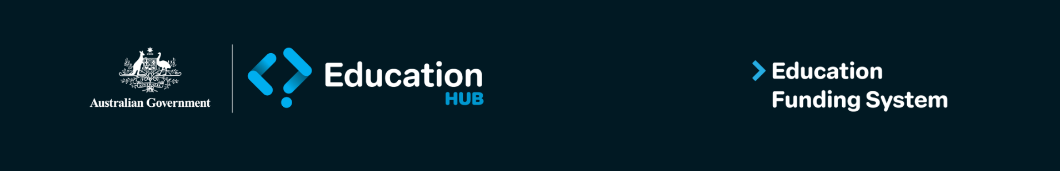

Education Funding System and Digital ID

What is the Digital ID Act?
The Digital ID Act 2024 governs how individuals and organisations use Digital ID to securely access government and business services online.
It came into effect on 1 December 2024 and is part of a national initiative to improve online security and reduce the need to repeatedly share personal documents.
The Act supports the Australian Government Digital ID System (AGDIS), which includes tools like myID (the government’s Digital ID app) and RAM (Relationship Authorisation Manage.

Is Digital ID voluntary?
Section 72 of the Digital ID Act 2024 states that the use of a Digital ID is voluntary within the Australian Government Digital ID System (AGDIS). However, there are important exceptions, where the use of a Digital ID to access a service does not need to be voluntary.
Subsection 74(3)(a) of Digital ID Act 2024 sets out an exception to the voluntary requirement where a relevant entity is providing a service, or access to a service, to an individual who is acting on behalf of another entity in a professional or business capacity.
In this instance, as access to the EFS is being provided to you on the basis that you are acting on behalf of an Approved Authority, Block Grant Authority, non-Government Representative Body or higher education provider, in a professional or business capacity, the department considers that it is not required to offer an alternative access method.

Why is this important?
The Department of Education is strengthening our cyber security arrangements, including access to the Education Funding System. The use of Digital ID (in this case myID and the Relationship Authorisation Manager (RAM)), will ensure the EFS is accessed only by verified users who are appropriately linked and authorised to act on behalf of a registered organisation.

Where can I get support?
To help with this transition, the Department of Education will provide step-by-step guides, webinars, FAQs, and helpdesk support for EFS-specific queries.
myID and the RAM are administered by the Australian Taxation Office (ATO). This means that, in addition to the support provided by the Department of Education for EFS-specific queries, the ATO can also assist users with any issues related to setting up or using myID and RAM.

Resources

Education Funding System
Website: www.education.gov.au/efs
Email: EFSengagement@education.gov.au
Phone: 1800 677 027

Digital ID
Website: www.digitalidsystem.gov.au

myID
Website: www.myid.gov.au

Relationship Authorisation Manager
Website: www.info.authorisationmanager.gov.au

