

# Health Practitioner HELP Debt Reduction & Indexation Measure Applicant Portal User Guide

Contents

Overview 3

1. Prepare to apply 4

2. Access the Portal 7

3. Register in the Poral and build your applicant profile 8

Register in the Portal 8

Build your applicant profile 9

Add your residential information 10

Add your employment information 11

4. Start an application 16

5. Next steps 19

## Overview

This guide is structured into five sections:

1. **Prepare to apply**

What you need to access the Applicant Portal (the Portal) and the evidence you need to support your application.

1. **Access the portal**

How to find the Portal and the steps to log in with your myID account.

1. **Register in the Portal and build your applicant profile**

How to register in the Portal and add the personal and employment data and evidence that is needed to assess your applications.

1. **Submit your application**

How to select the relevant evidence from your profile and submit your application.

1. **Next steps**

What happens after you apply.

## 1. Prepare to apply

### Set up myID

You must have a myID account to access the Applicant Portal. Get a myID account at [https://www.myid.gov.au](https://www.myid.gov.au/)

### Prepare your supporting documentation

You need the following evidence for an application.

|  |  |
| --- | --- |
| Document / Evidence | Explanation |
| **Ahpra number** | Look yourself up on the [*Register of Practitioners*](https://www.ahpra.gov.au/Registration/Registers-of-Practitioners.aspx) to find your AHPRA number. |
| **CHESSN or USI** | Your Commonwealth Higher Education Student Support Number (CHESSN) was your unique reference number for applying for Commonwealth assistance such as HELP loans.  Find your CHESSN on your Commonwealth Assistance Notice (CAN).Your CAN would have been provided to you by your higher education provider each semester.  The Unique Student Identifier (USI) was introduced on 1 January 2021 and replaced the CHESSN as the primary higher education student support reference number. You may not have a USI. It is useful but not compulsory to share it with us. Learn to [find your USI.](https://www.usi.gov.au/students/find-your-usi) |
| **Statement of Service from your employer** | A statement of service or letter from employer is required as evidence of your work in rural, remote of very remote areas of Australia. The statement of service or letter from your employer must be on official letterhead and confirm things like the duration, location and duties of your employment.  Specifically, the statement of service or letter from employer should include:   * your full name and position title * description of your role & activities performed * date of your commencement * duration of your employment * the location of your duties - where you are working in multiple locations, a list of locations must be provided. * number of hours worked each week – where you are working in multiple locations, a breakdown of hours worked at each location. * periods of unpaid leave. |
| **Proof of residency information** | To be eligible you must provide documents which confirm that you have also resided in a rural, remote or very remote area of Australia while employed there.  The documentation needs to provide evidence of location and also demonstrate continued residence over time. For example, you may provide an electricity bill from when you first started to reside in the location and then provide quarterly bills demonstrating your continued residence.  **If you are staying in private accommodation / accommodation sourced by you, examples of suitable evident include:**   * Internet provider invoice  - Utility bills should be provided that cover the entire period at a particular address. * Gas provider invoice - Utility bills should be provided that cover the entire period at a particular address. * Electricity provider invoice - Utility bills should be provided that cover the entire period at a particular address. * Lease agreement – the agreement should clearly display the length / dates of the rental agreement. * Rental ledger  - the ledger should clearly display the duration of the stay in the rented accommodation. * Home contents insurance certificate of currency / insurance invoice (must include contents insurance).   **If you are staying in employer provided accommodation examples of suitable evident include:**   * Letter from employer on employer letterhead confirming location and duration of stay at accommodation.   **Use of a Statutory Declaration**  If you are unable to provide the necessary documents detailed above, a [Commonwealth statutory declaration](https://my.gov.au/en/about/help/digital-id/commonwealth-statutory-declarations) will be accepted.  In the statutory declaration you must detail the residential address, how long you lived there and provide a brief explanation as to why you are unable to provide alternative documents.  Suggested wording for the statutory declaration is detailed below:  *For the purposes of my application for the Health Practitioner HELP initiative, I would like to declare that I resided at ADDRESS between START DATE and END DATE. I was unable to provide other documentary evidence such as a utility bill, lease agreement, tenancy agreement, or rental ledger because STATE BRIEF EXPLANATION.* |
| **Academic Transcript** | You must provide a copy of your degree and official academic transcript. The official academic transcript should be following the conclusion of your degree and detail all units studied.  This document must confirm the date course requirements were completed or date conferred.  If you are nurse practitioner you should provide an endorsement from NMBA. |
| **Australian Taxation Office (ATO) HELP Debt Statement** | To determine your outstanding HELP debt balance, you need to provide an ATO HELP debt statement.  The ATO HELP debt statement can be downloaded from ATO online services in your [MyGov account](https://my.gov.au/).  The ATO HELP debt statement must show your name and TFN.  Help to download your ATO HELP debt statement is available on the [ATO](https://www.ato.gov.au/individuals-and-families/study-and-training-support-loans/view-your-loan-account-online) website. |

Once you have collated all this information you are ready to proceed to lodge your application.

## 2. Access the Portal

A. Go to [myHELP reduction](https://myhelpreduction.gov.au/) and click ‘Continue with Digital Identity’ under the Medical and Nurse Practitioners section.

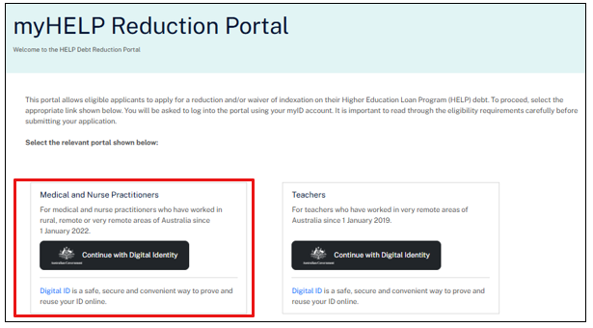

## 3. Register in the Portal and build your applicant profile

### Registration page for the Australian Government Department of Education's myHELP Reduction Portal. On this page, enter your Tax File Number. Then read the Privacy Notice and select the checkbox to accept it. Then read the Terms and Conditions and select the checkbox to accept it. Hit the Continue Button to move to the next screen.Register in the Portal

A. Check pre-populated information

* Check the accuracy of given name, family name, date of birth and email address from your myID account.
* Update inaccuracies at [Managing your myID | myID](https://www.myid.gov.au/help/managing-your-myid).

B. Enter your tax file number (TFN).

C. Confirm you have read the relevant documents:

* Read the Privacy Notice and select the checkbox to accept it.
* Read the Terms and Conditions and select the checkbox to accept it.

System check

The Applicant Portal checks your family name, date of birth and Tax File Number with the Department’s HELP Debt records.

If the family name does not match, but there is a record for your Tax File Number and date of birth, the system will ask for the name used at the time you studied your course.

The system also checks if you have a valid CHESSN, eligible qualification and HELP debt associated with your course.

If the system does not allow you to progress email [HealthPractitionerHELP@education.gov.au](mailto:HealthPractitionerHELP@education.gov.au).

D. Click ‘Get started’ to set up your profile.

### Build your applicant profile

Your profile contains information we need to process your application.

The Home Page includes two tabs: Overview and Profile. Use these two tabs to enter information that is required later when you apply for an indexation waiver or HELP debt reduction.

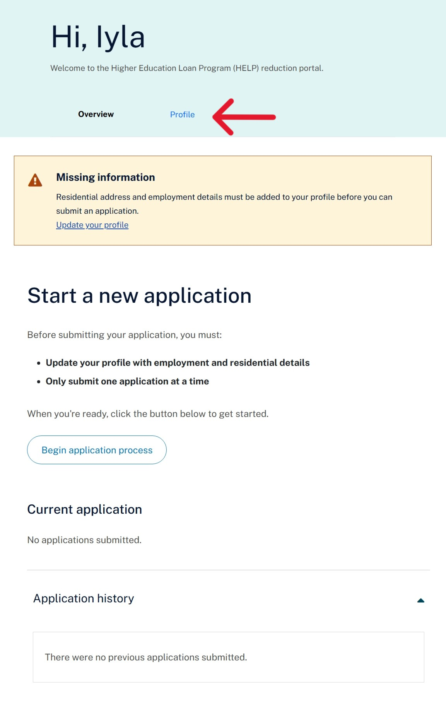

|  |  |
| --- | --- |
| Overview Manage your application(s). | Profile Update your personal details and provide relevant residential and employment periods. |

A. Click on the Profile tab.

B. Edit personal details if required.

C. From the personal details you add and edit residential information.

|  |
| --- |
| The Profile tab for the Home Page for the Australian Government Department of Education's myHELP Reduction Portal. |
| The update personal details screen. |

#### Add your residential information

D. Select ‘Add a new residential address’.

E. Start typing your address. As you type, a drop down list will be displayed. Select the correct address from the list.

If your residential address is not displayed, click ‘Provide address manually’.

F. Use the calendar / date picker to enter the start and end dates of your residential location.

When adding your current address, make the ‘end date’ the date you submit your application.

G. Upload evidence that shows the start and end dates of this location.

* The file must be a PNG, JPEG/JPG or PDF document only.
* The file size must be less than 10MB.
* Submit each document as a separate PDF file. Avoid scanning multiple documents into a single PDF file.

#### Add your employment information

H. Navigate back to the Profile tab.

I. Click ‘add a new employer’.

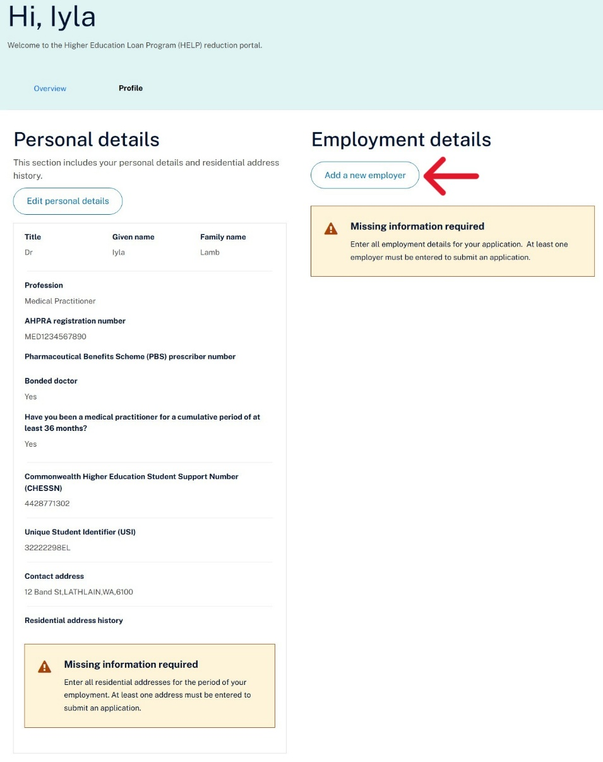

J. Enter the name of the organisation you work / worked for. Click ‘save’ to create the employer record.

If you are / were self-employed, you will need your Australian Business Number (ABN).

|  |
| --- |
| Enter the name of your employer. |
| K. Add employment period details – click ‘Edit’ next to the name of the employer. |
| Click edit to add an employment location. |
| L. Click ‘ add new employment location’. |
| Click add an employment location. |
| M. Enter work history within the employer record you created in the previous step. |

Repeat the following process to record multiple employment periods.

|  |  |
| --- | --- |
| **Address.** Start typing the address and pick the location from the drop-down list.  **Health service location**. This is the name of the general practice setting.  **Medicare provider number**. 7 digits followed by a letter.  **Employment type**. Select Part or Full time.  **Employer Phone**: Used if needed to clarify details for your application.  **Start date / End date**: Click the calendar symbol to select the date or enter the date as dd/mm/yyyy.  **Contracted hours per week.**  **Employment evidence**: A statement of service or a letter from your employer on official letterhead, providing evidence of your employment that supports the full period applied for in your application.  Click save and you will return to the employer record.  Click Save again and you will return to the Profile tab on the Home page. | The screen where applicants enter employment details. |

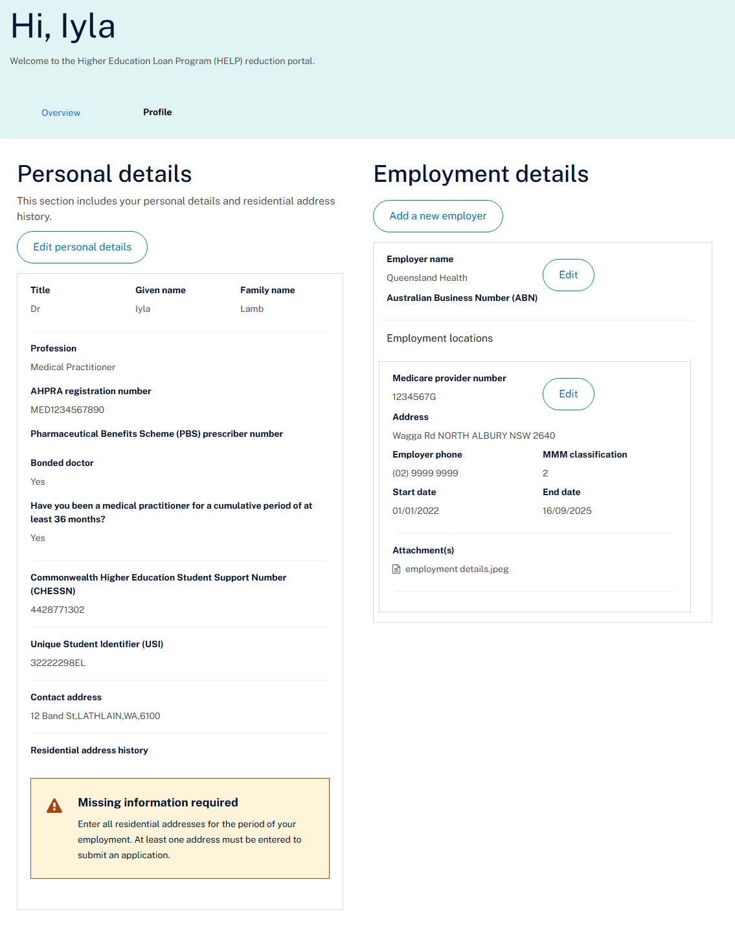

An application is not considered complete until we have all the right information.

Click Begin application process on the Home Page Overview tab.

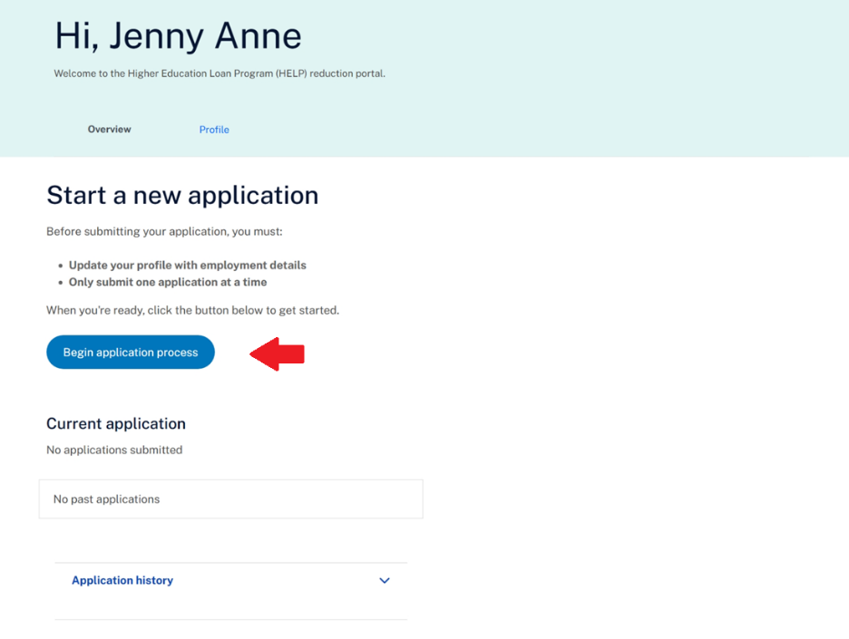

## 4. Start an application

Once your profile is complete, follow these steps to submit your application.

A. You start an application through the ***Overview*** tab. Click into Overview.

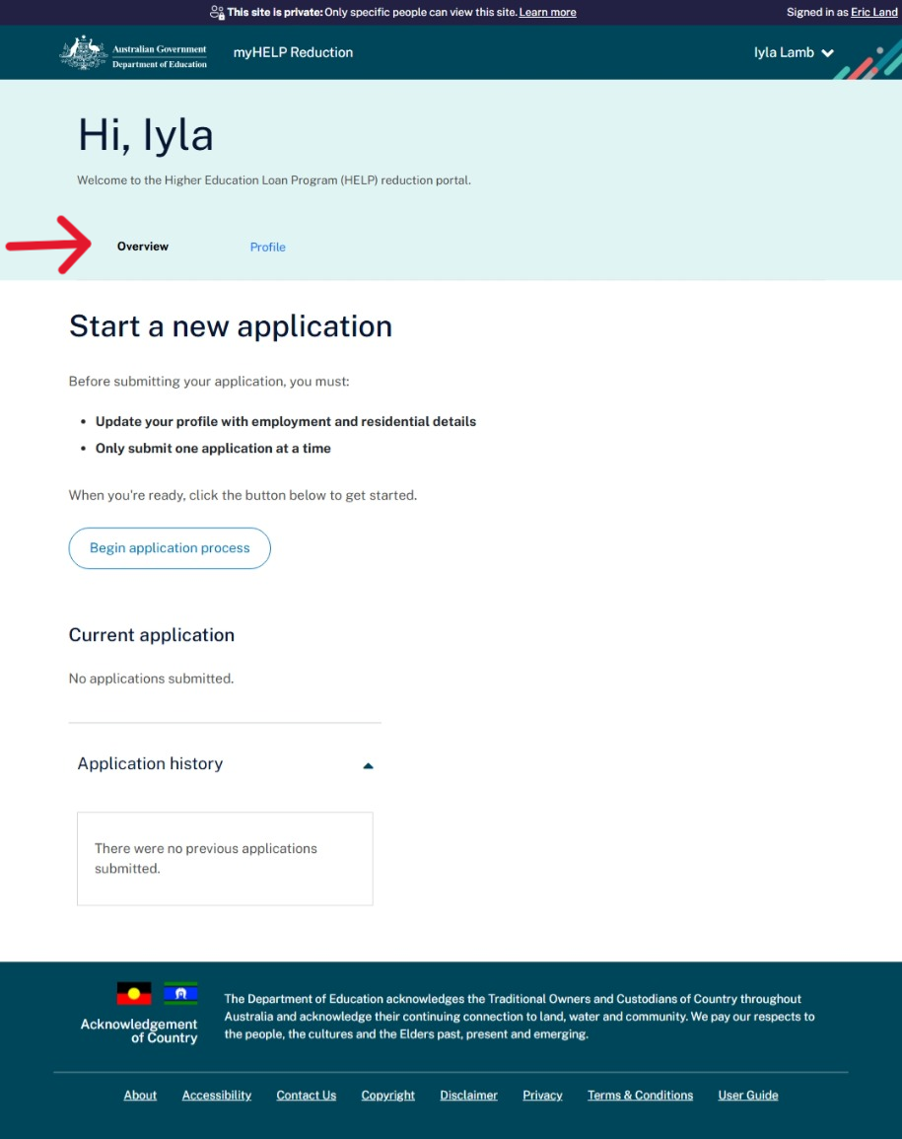

B. Click ‘***Begin application process’***.

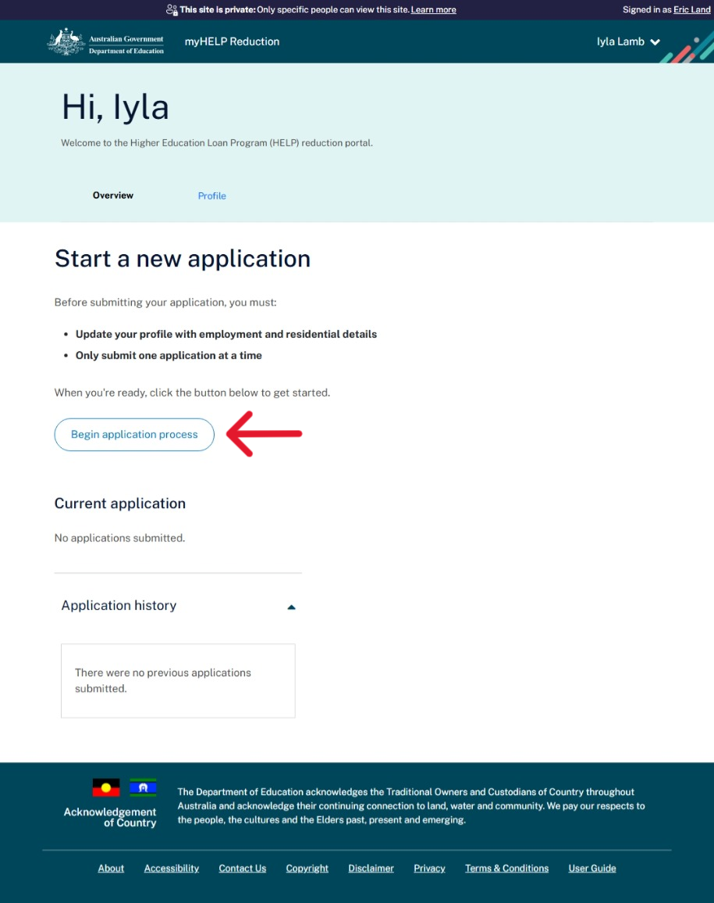

C. Read the information on the page and then click ‘**continue**’.

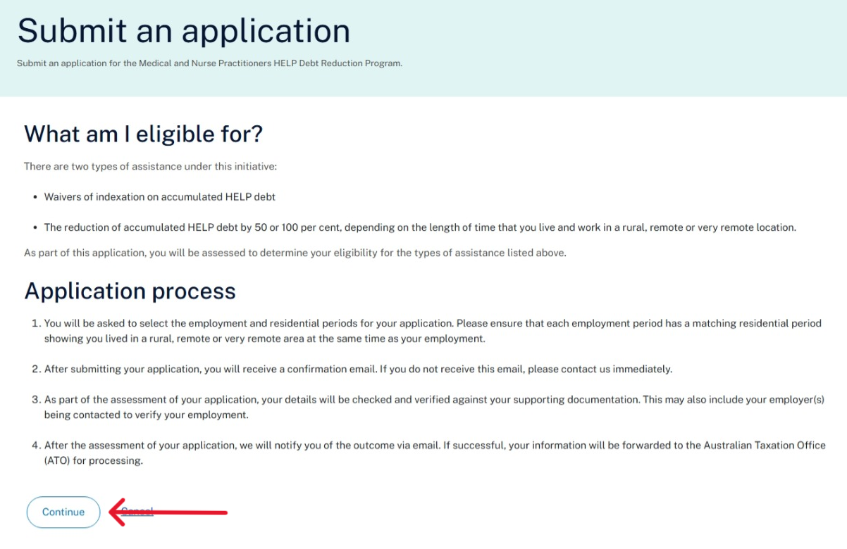

**Select Employment Location/s**

D. Select eligible employment locations from your profile to include in your application. Click ‘**Save and continue’.**  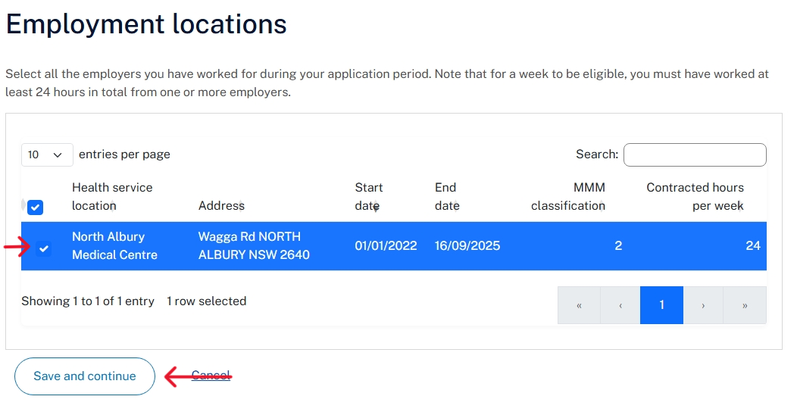

**Select Residential Location/s**

E. Select eligible residential locations from your profile to include in your application. Click ‘**Save and continue**’.

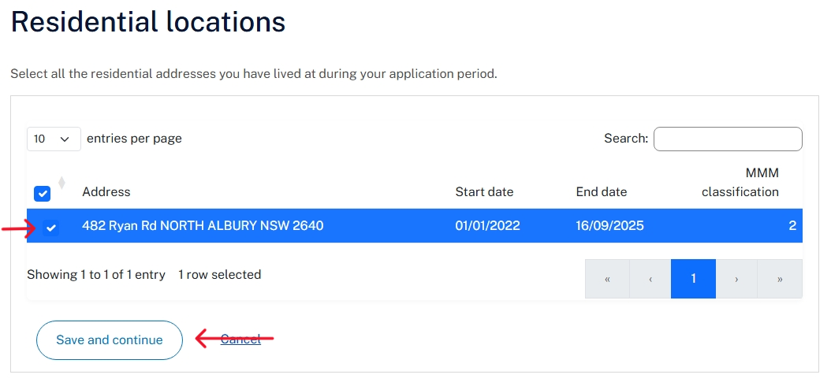

F. Confirm the selected employment and residential locations, and your understanding of the declaration. If you are happy, hit **‘submit’**.

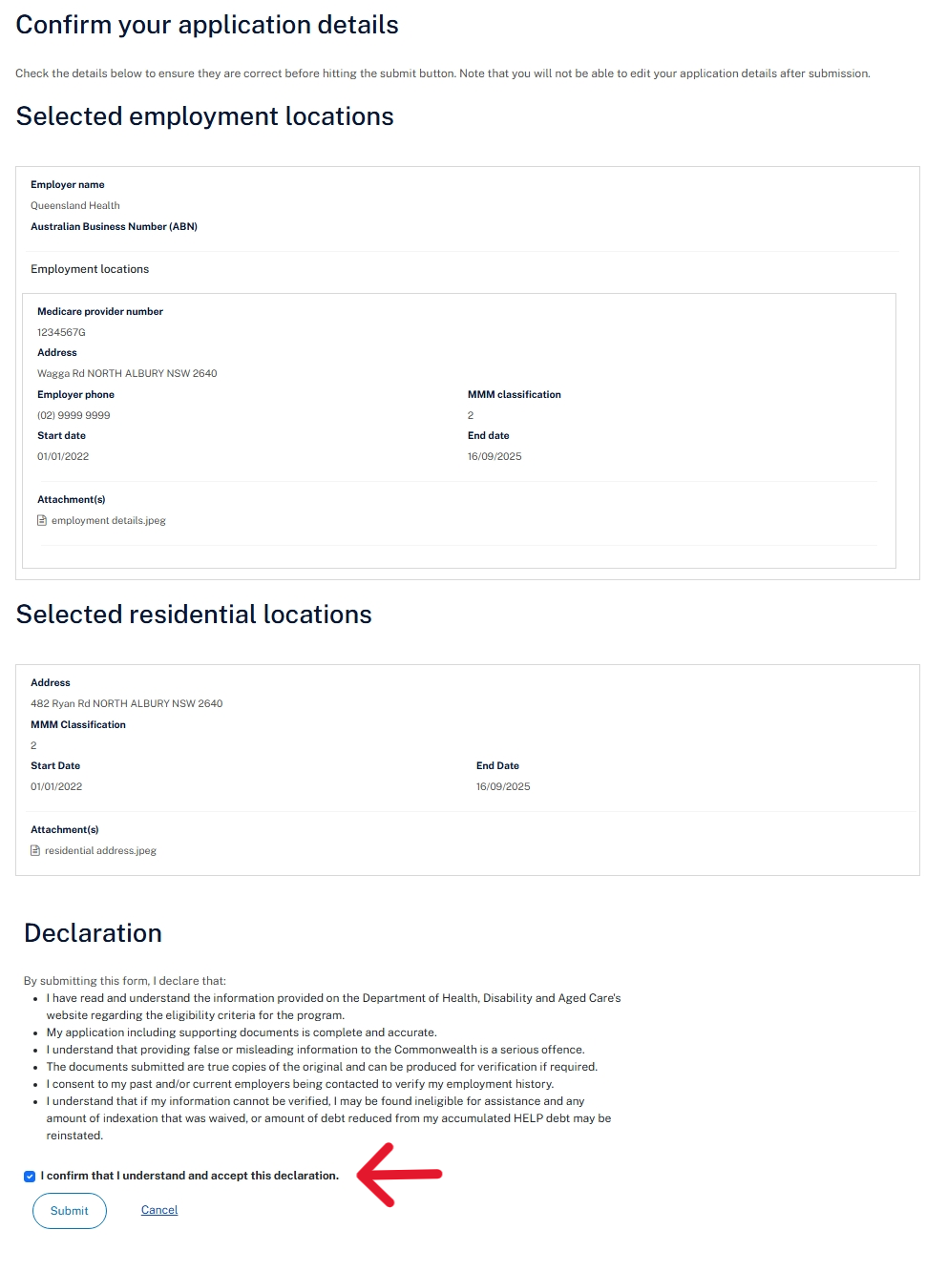

## 5. Next steps

You will see the submitted application in ‘current applications’ on the **Overview** tab. You will also receive an email confirming the submission.

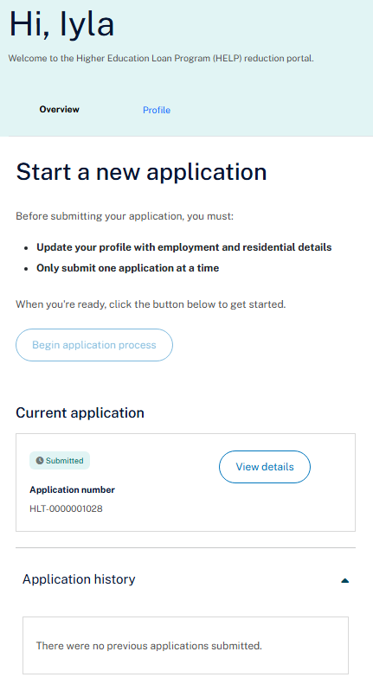

**Status**

The status of your application will change when it is being assessed. The statuses include:

* **Saved as draft** - you have started the application process but not submitted it.
* **Submitted** - you have submitted the application.
* **Review in progress** - the application is being processed.
* **Request for further information** – we have asked you to provide additional information regarding your application. This will be via the email you provided.
* **Approved** - your application is approved.
* **Rejected** - your application is not approved.

### 

### How to log out

A. Go to the top right-hand corner of the screen where your name is displayed.

B. Click on the down arrow and the ‘logout’ option will be displayed.

*---End of Application Process---*