


HELP Debt Reduction Program for Rural Health Practitioners
  - Applicant Portal User Guide

Contents
1. Introduction 3
1.1 Background 3
1.2 Notes 3
2. Application Process 3
2.1 Overview 3
2.2 Compulsory evidence 3
2.3 myID account 6
2.4 Access to the portal 6
2.5 Registration 8
2.6 Set up your personal details 9
2.7 Add your residential address details 10
2.8 Add your employment details 12
2.9 Begin application process 17
2.10 Submit your application 18
2.11 After submission 22
2.12 Sign out 22

1. Introduction

1.1 Background
This guide explains how to use the Applicant Portal to submit an application for the HELP Debt Reduction Program for Rural Health Practitioners.

Further information about the program is available at: HELP Debt Reduction Program for Rural Health Practitioners.

1.2 Notes
All personal information listed on the screens in this document are fictitious.

2. Application Process

2.1 Overview
There are five main steps to submit your application.

Step 1. | Prepare and save all compulsory supporting evidence (identified in section 2.2) as you will be required to upload these documents into the Applicant Portal.
Step 2. | Log in to the Applicant Portal with your myID account and complete the registration page.
Step 3. | Set up your personal profile and attach your Academic transcript, Australian Taxation Office (ATO) HELP Debt Statement and residential address evidence.
Step 4. | Register your employment details by selecting the relevant employment  locations and attach your Statement of Service (SoS).
Step 5. | Review and submit your application.

2.2 Compulsory evidence
To avoid delays in processing your application, the following documents must be uploaded with your application:

- Statement of Service (SoS):
You must provide a SoS from each employer showing your employment history for the period you are claiming.

If you can’t get a SoS, you may provide a letter from your employer. The letter must be on official letterhead, signed and dated, and cover the period you are claiming.

The SoS or letter must include:
- your full name
- description of your role and duties performed
- the location i.e. the address of where you worked (where you are working in multiple locations, a list of addresses must be provided)
- exact number of hours worked each week (where you are working in multiple locations, a breakdown of hours worked at each location is required)
- exact start and end dates of employment
- periods of unpaid leave more than 10 business days.
You can only apply for work you have completed.

The end date of the period which you are claiming will be the employment end date listed on your SoS/letter or the SoS/letter issue date if still currently employed.

TIPS for your employment evidence
- Please don’t submit an employment contract as it doesn’t include details of your past service history.

- Proof of Residency
You must provide evidence that you resided in the rural, remote or very remote location and that you resided continuously for the period of your employment.

This documentation will be used to verify you were residing at the address for the dates you have provided.

You must provide residency evidence that shows you resided at the address when you started and finished employment, and for each year in between.

Residential Document | Document Requirements
Utility bill - from an electricity, gas or internet provider.  Note: water rates and council rates are not accepted. | Your utility bill must include:  • your full name  • residential address (not a PO Box)  • date of issue (aligned with your stated employment period).
Lease agreement | Your lease agreement must include:  • your full name  • residential address  • duration of the lease (aligned with your stated employment period)  • your signature and the signature of your landlord  • date of agreement
Rental ledger | Your rental ledger must include:  • your full name  • residential address  • dates of rent payments (aligned with your tenancy/employment period)  • signature of landlord or property manager
Home and Contents insurance document | Your certificate of insurance must include:  • your full name  • the property residential address  • dates of coverage  • confirm coverage of contents
Accommodation provided by your employer | If your accommodation was provided by your employer, you may provide a letter from your employer as proof of residency.  This letter must be dated and signed by your employer, and include:  • your full name  • the property residential address  • dates of residency

Using a Commonwealth statutory declaration
If you are unable to collate all the required residency documents, you may be able to bridge a gap in your residential evidence through the use of a Commonwealth statutory declaration available through myGov.

You will still need to provide independent corroborating residential evidence as we are unable to accept a Commonwealth statutory declaration alone for proof of residency.

The Commonwealth statutory declaration available through myGov is the only acceptable form of statutory declaration and must include:
- a statement that you are making this declaration for the purposes of your application for the HELP Debt Reduction Program for Rural Health Practitioners
- the eligible residential address
- the period you resided at this address (exact start and end date)
- a detailed explanation as to why you are unable to provide the required documentation
- what documents you have been able to supply and how they relate to your residency.

TIPS on your residential evidence:
- Make sure you provide residential evidence to cover your entire employment period. If your residential information does not match your employment periods, some service may not be eligible.

- Australian Taxation Office (ATO) HELP Debt Statement

You must provide a current ATO HELP Debt Statement in PDF form. A PDF can be downloaded from ATO Online Services in your myGov account.

- Log in to myGov.
- Click on Services.
- Select the Australian Taxation Office.
- In ATO Online Services, scroll down to loan accounts.
- Select your HELP loan account.
- Click the down arrow next to the word “Filter” below the Download button and additional filter options will appear. In the ‘From date’ field type in 01/06/2021 and in the ‘To date’ field type in today's date. Then click the ‘Filter’ button in the bottom right corner.
- Click the print friendly version button at the top of the screen and save as a PDF.

The statement must show your full name, Tax File Number and full HELP loan transaction history.

Note: In ATO Online Services, an automatic filter is applied to your HELP Debt Statement for the last 24 months. You must make sure you adjust the filter and generate a statement for your entire HELP debt history.

- TIPS on your ATO HELP Debt Statement
- Make sure your statement shows your full HELP debt history by adjusting the filters as needed.
- Export your statement as a PDF from ATO Online Services. Excel or Word files are not accepted.

- Academic transcript/statement of results
You must provide an academic transcript/statement of results from your university confirming completion of your medical/nurse practitioner qualification.

The transcript must show:
- your full name
- all course units, including any credited prior study, recognition of prior learning, or advanced standing
- conferral or course completion date.

TIPS on your Academic transcript
- Make sure it covers your complete study history.
- Make sure it's an ‘Official’ transcript.

Contact your higher education provider if you need assistance.

2.3 myID account
You must have a myID account to access the Applicant Portal. The Australian Government uses ‘myID’ (previously known as ‘myGovID’) as a secure way for people to prove their identity when accessing online government services. To set up a myID account, visit myID.

2.4 Access to the portal
Go to the myHELP Reduction Portal.

On this page you will see two options – one for ‘Medical and Nurse Practitioners’ and one for ‘Teachers’.

Select ‘Continue with Digital Identity’ in the ‘Medical and Nurse Practitioners’ section (Figure 1) and then select ‘myID’ (Figure 2).
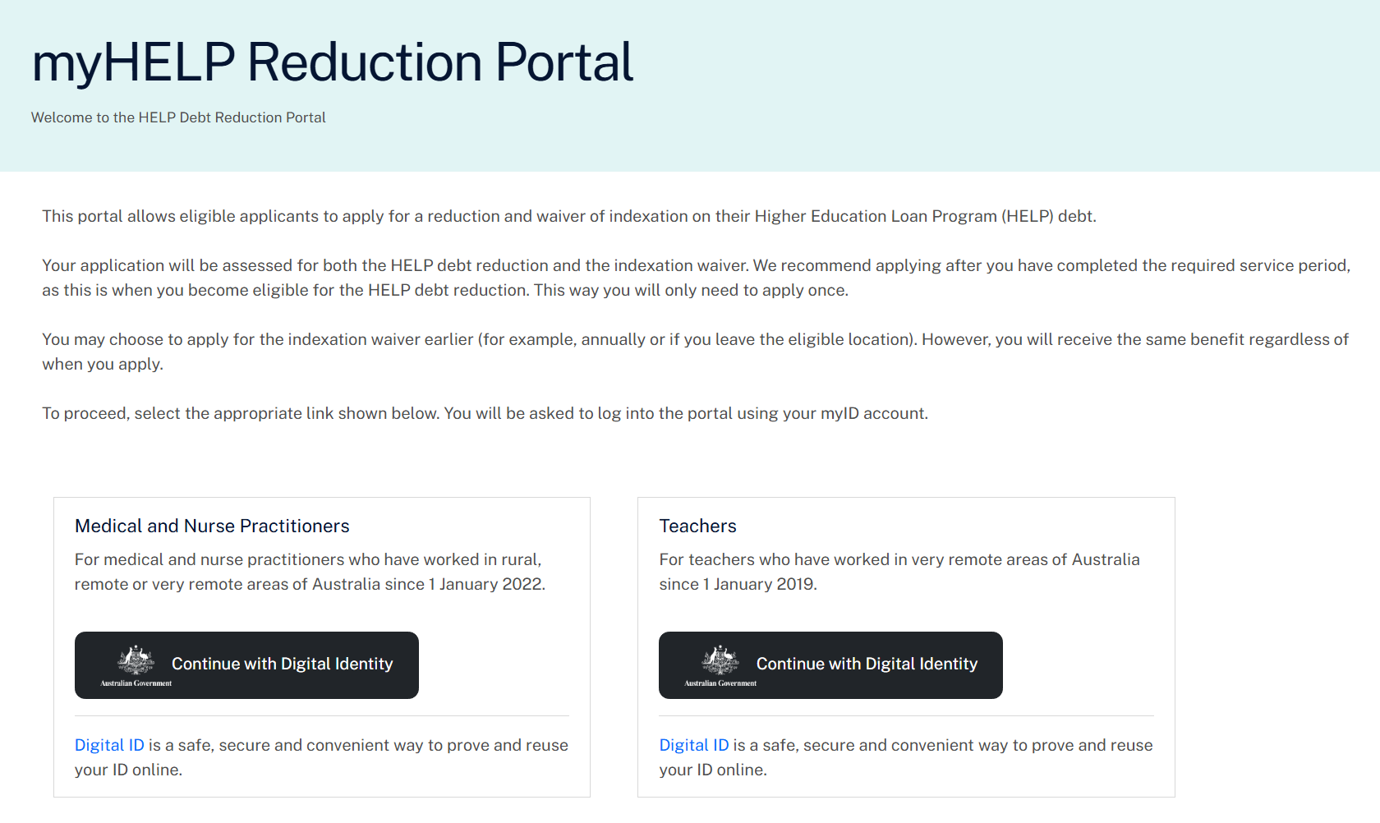
Figure 1. Landing page for the myHELP Reduction Portal

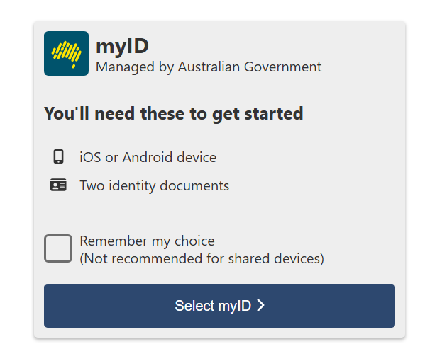
Figure 2. myID

2.5 Registration
Most of the fields on the registration page will be pre-populated with information sourced from your myID account (Figure 3). This includes your given name, family name, date of birth and email address.

Before selecting ‘Continue’, enter your 9-digit Tax File Number, read the Privacy Notice and Terms and Conditions, and select the checkboxes to accept them.

The portal will use your family name, date of birth and Tax File Number to match your records with the tertiary study records held by the department.

If your details don’t match
- If your family name doesn’t match, but your Tax File Number and date of birth match a record, the portal may ask for the name you used when you studied your qualification.
- If the portal doesn’t allow you to progress, email the department for further assistance.

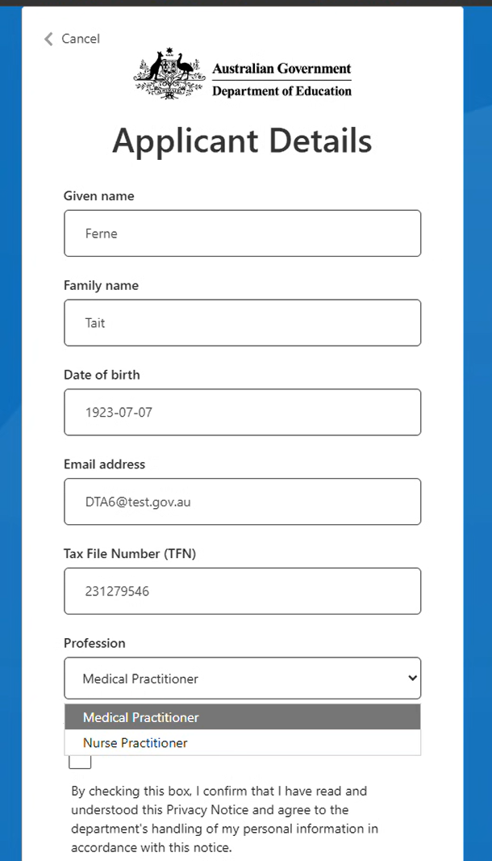
Figure 3. Registration page for the myHELP Reduction Portal
After successfully registering, the ‘Welcome’ page will list the steps required to submit your application. Select ‘Get started’ to set up your profile (Figure 4).
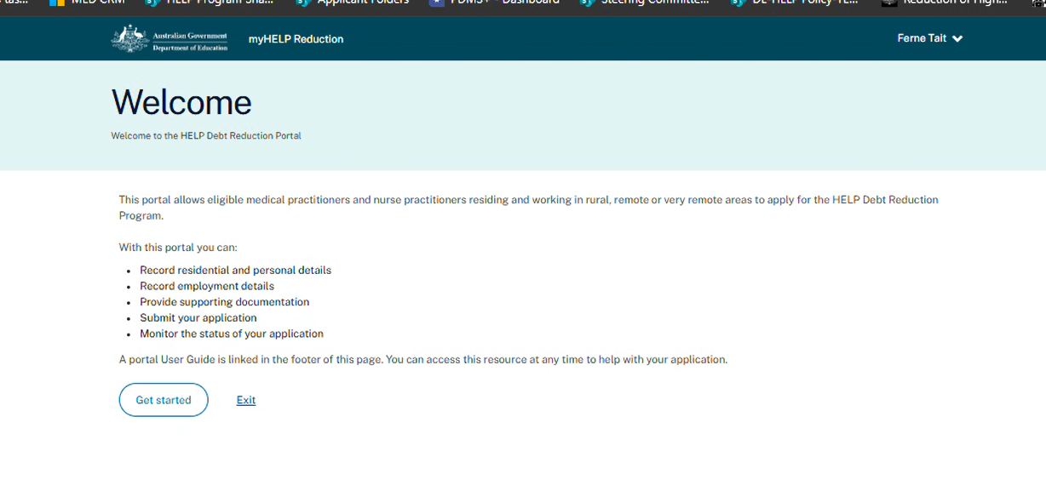
Figure 4. Welcome page for the myHELP Reduction Portal

2.6 Set up your personal details
Several fields will auto populate into the ‘Set up your Profile’ page (Figure 5). You will need to enter the following:
- Title
- Ahpra registration number
- PBS prescriber number
- Whether you are or were in the Bonded Medical Program
- For doctors, whether you have completed the required 36-month post-registration service
- Phone number
- Contact address - Start typing your address and select it from the suggested list. If your address is not available, enter it manually.

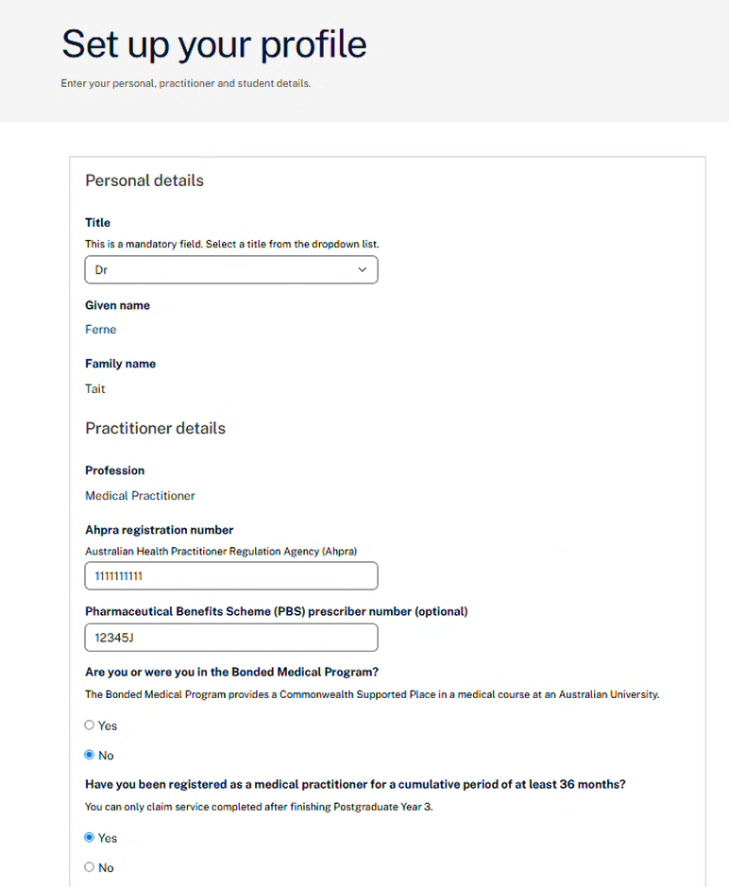
Figure 5. Set up your profile page (Personal details)

Upload your compulsory supporting evidence. Two documents must be uploaded on your personal details page - your Academic transcript and ATO HELP Debt Statement. Note: Further compulsory supporting evidence needs to be attached to your residency and employment information.

Select ‘Save and continue’ to progress to the next stage (Figure 6).

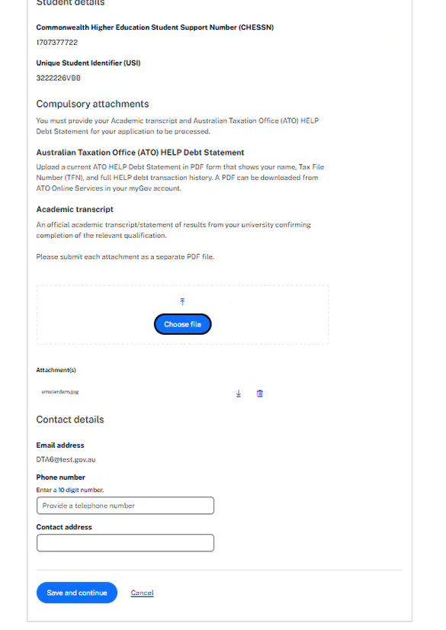
Figure 6. Upload evidence on your profile page

2.7 Add your residential address details
You will be directed to the dashboard where you have the option to switch between the ‘Overview’ or ‘Profile’ tabs.

A pop-up message will display on the dashboard after you enter your personal details prompting you to add your residential and employment details.

Select the ‘Profile’ tab to find the residential details screen (Figure 7).

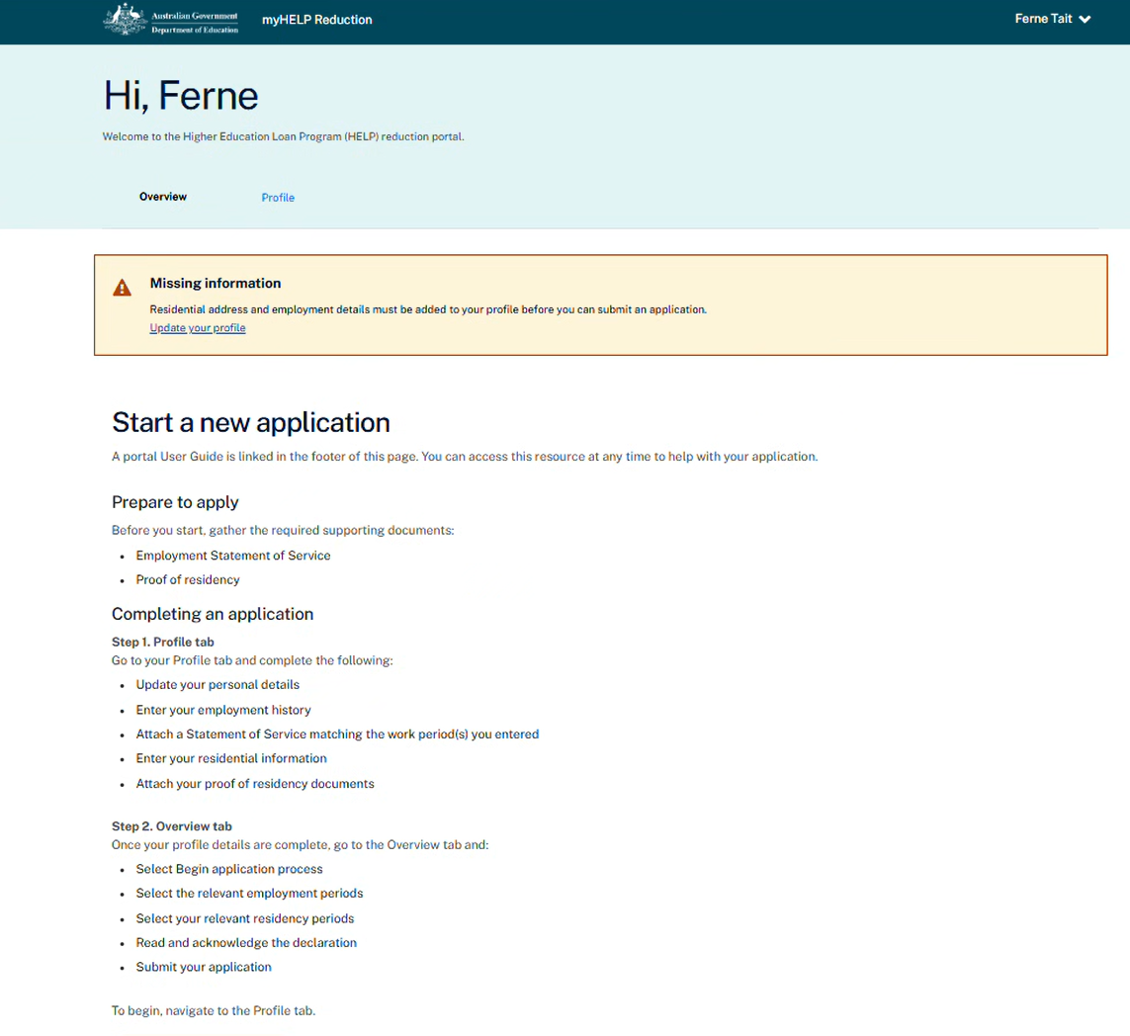
Figure 7. Dashboard select Profile to direct you to Residential details

Select the ‘Edit personal details’ button to go to the ‘Residential addresses’ section.

Select ‘Add a new residential address’ (Figure 8).

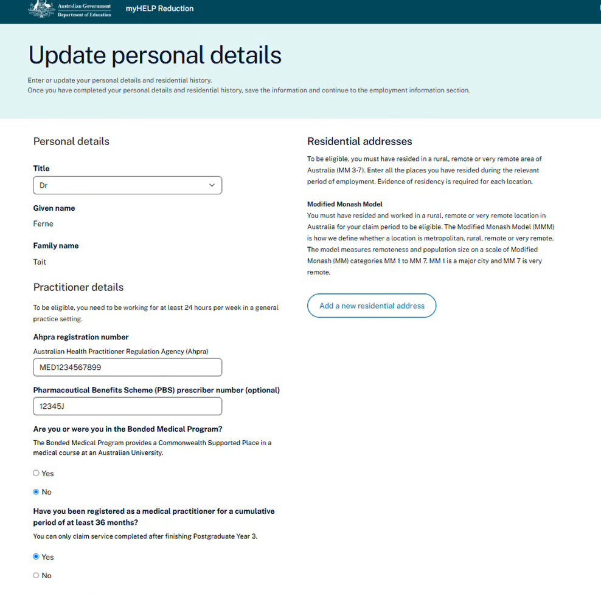
Figure 8. Residential addresses selection

Enter all the places you have resided during your relevant period of employment. Evidence of residency is required for each location (Figure 9).

Ensure you attach the acceptable forms of documentation for proof of residency – see section 2.2 for further information. Select ‘Save’.

To add multiple addresses, repeat this process by selecting ‘Add a new residential address’.

Once you have added all relevant residential addresses, select ‘Save’ at the bottom of the ‘Update personal details’ screen.

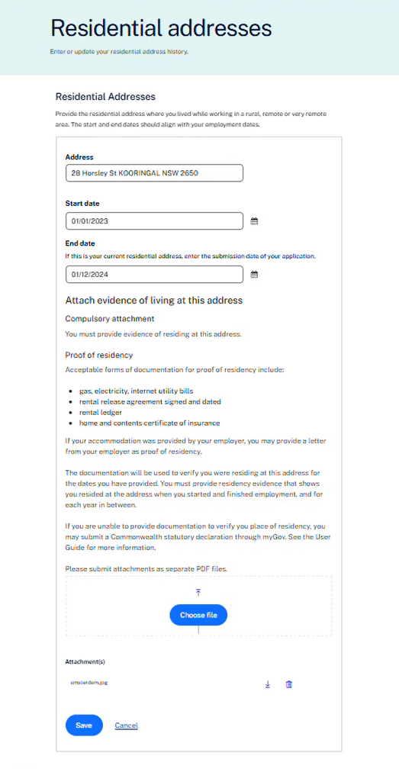
Figure 9. Add residential details and attach evidence

2.8 Add your employment details
You will be directed to the dashboard where you have the option to switch between the ‘Overview’ or ‘Profile’ tabs. The dashboard will be displayed after you have entered and saved your residential addresses.

Select the ‘Profile’ tab to go to the ‘Employment details’ screen. Select ‘Add a new employer’ button (Figure 10).
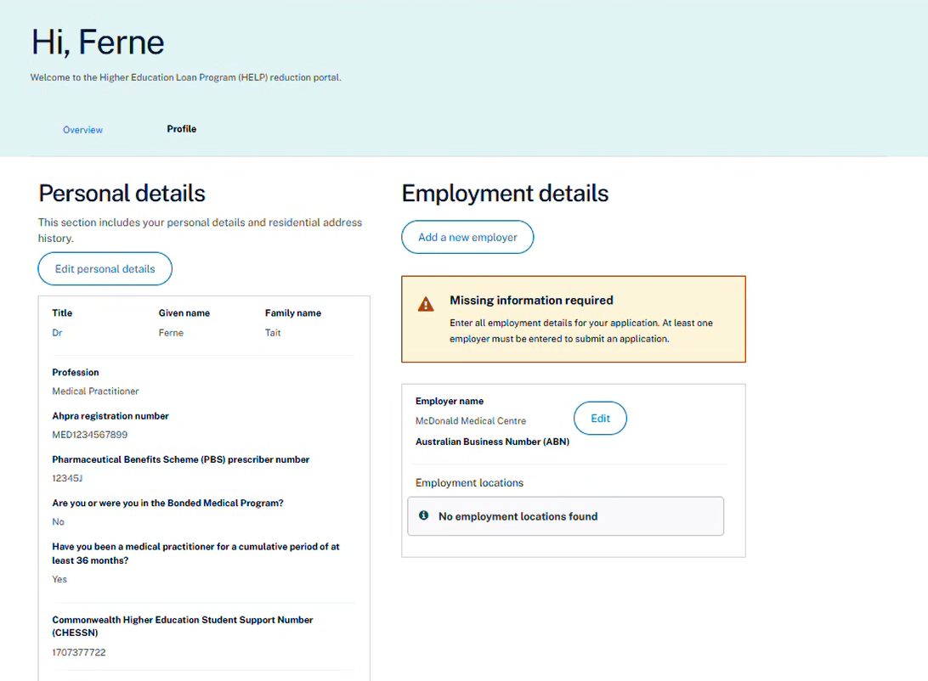
Figure 10. Navigate to the employment details screen

On the ‘Employment details’ screen, complete the ‘Add a new employer’ section then select ‘Save’ (Figure 11).

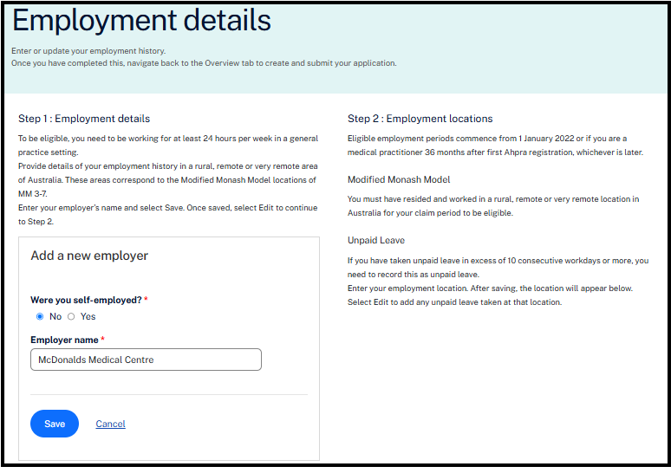
Figure 11. Add a new employer

This will direct you back to the ‘Employment details’ dashboard. Select the ‘Edit’ button (Figure 12).

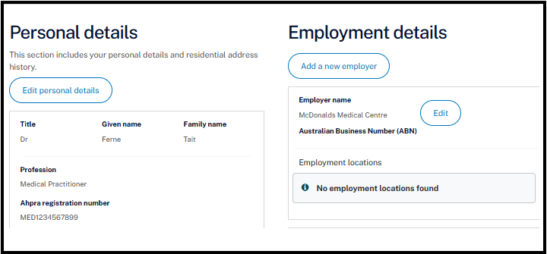
Figure 12. Employment details – Edit

Select the ‘Add an employment location’ button (Figure 13).
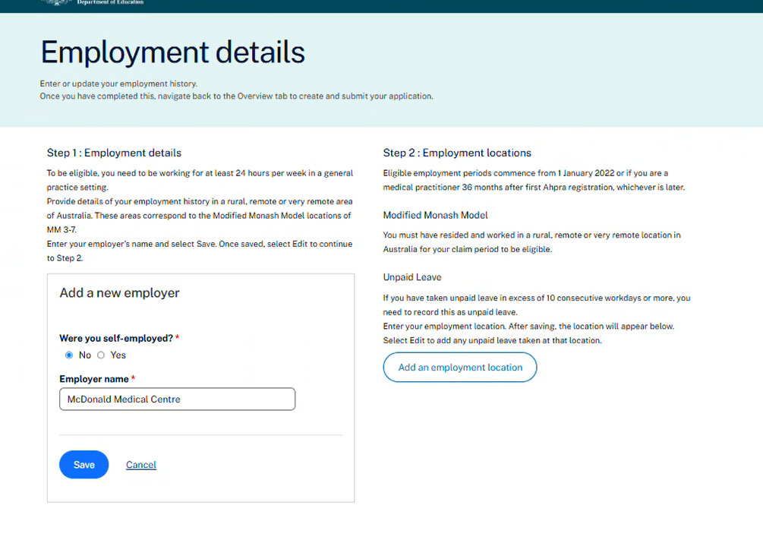
Figure 13. Add an employment location

The ‘Employment details’ page allows you to enter your work history. Each entry must reflect a single period of eligible employment. The portal will save all employment periods you enter which enables you to select and/or edit for future applications. You can update your personal details at any time by selecting the ‘Profile’ tab.

TIPS for entering details correctly:
- Address: Start to type in the street address, if the correct address is not displayed then enter manually.
- Health service location: Enter town or suburb of your work location.
- Medicare provider number: Must be 8 digits.
- Employment type: Select from drop down
- Employer phone: Enter as10-digit number i.e. (03) 9999 9999 would be entered as 0399999999.
- Start date / End date: Select the calendar symbol to find the correct date or enter the date in the format dd/mm/yyyy, for example 4 January 2020 would be entered as 04/01/2020.
- Contracted hours per week: e.g. 25
- Attach evidence of your employment: Attach a Statement of Service or a letter from your employer on official letterhead providing evidence of your employment that supports this period.

Select the ‘Save’ button, to return to the ‘Employment details’ screen.
To enter additional employment periods, follow the same process.
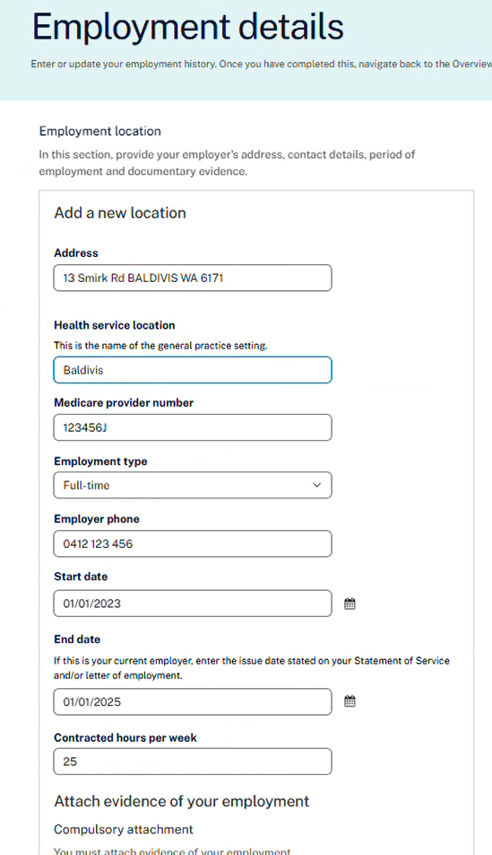
Figure 14. Add employment details

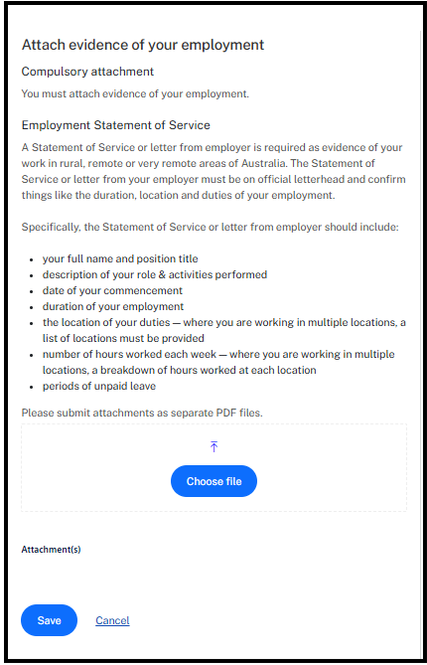
Figure 15. Add employment evidence
Add your employment evidence. Select ‘Choose file’ and then ‘Save’. This will take you back to the dashboard.

Add unpaid leave
If you have taken unpaid leave of 10 consecutive workdays or more, you need to record this as unpaid leave.

To enter unpaid leave, select the ‘Edit’ button for the relevant employer (Figure 16).
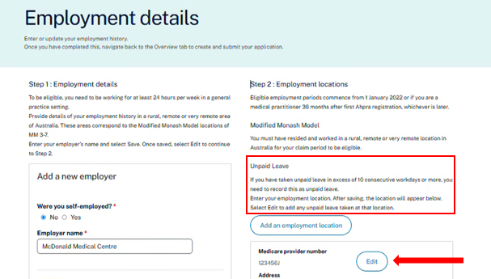
Figure 16. Navigate to add unpaid leave

On the next screen select ‘Add unpaid leave’ (Figure 17).

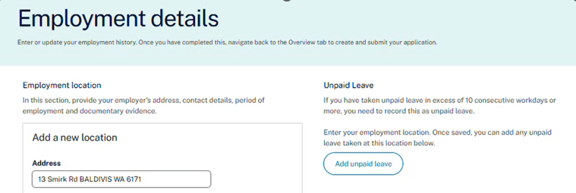
Figure 17.Option to add unpaid leave

Enter the unpaid leave start and end dates and the select ‘Save’ (Figure 18).

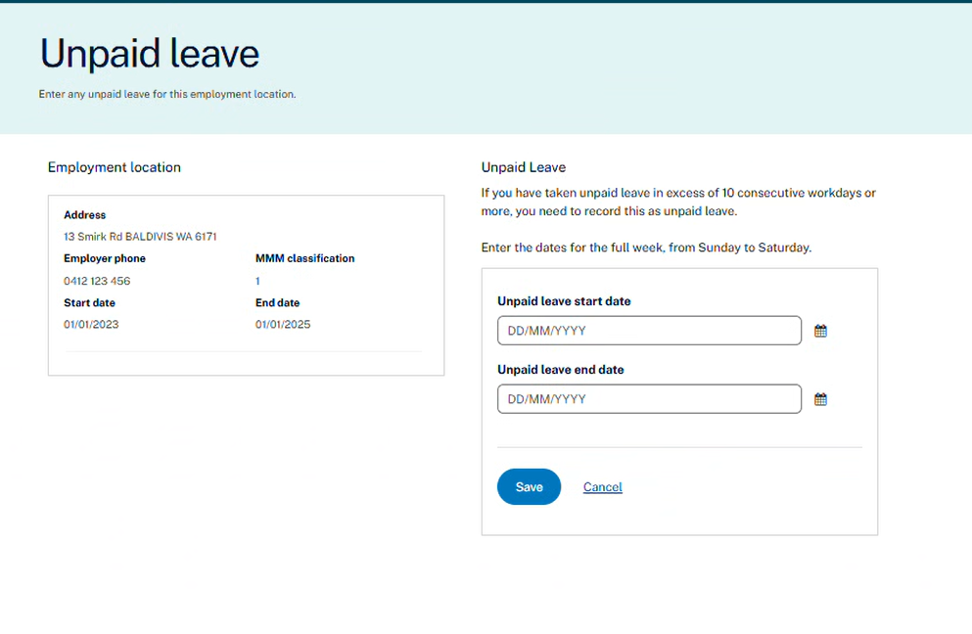
Figure 18. Add unpaid leave details

This will take you back to the ’Employment details’ screen and show the unpaid leave you have just entered (Figure 19).
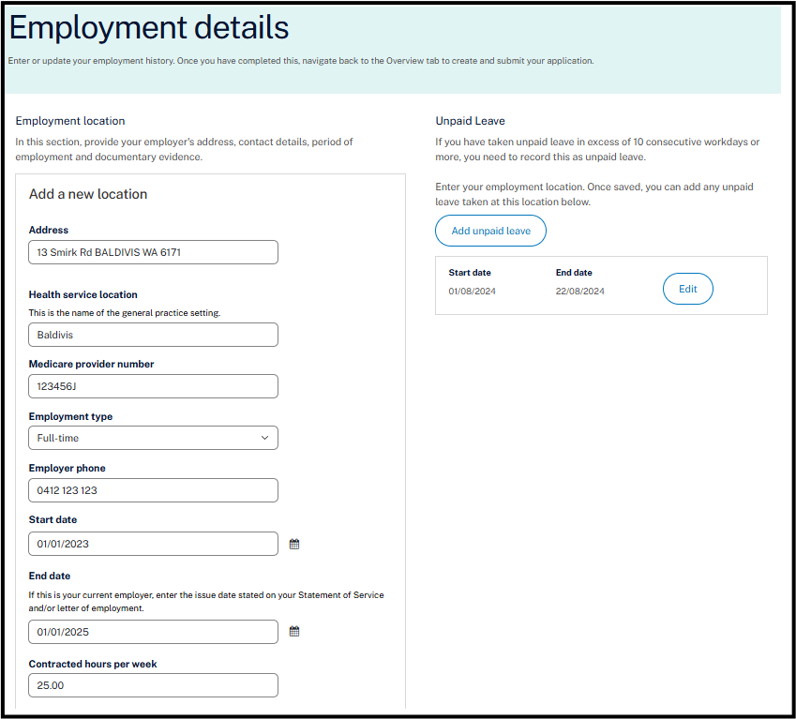
Figure 19. Employment details
Select ‘Save’ at the bottom of this page. This will take you back to the ‘Employment details overview. Select ‘Save’ (Figure 20).

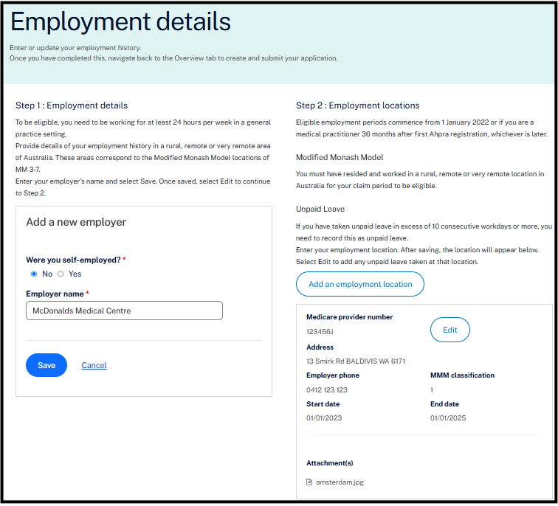
Figure 20. Employment details overview

You have now added your residential and employment details and your supporting documentation.

2.9 Begin application process
Go to the ‘Overview’ tab (Figure 21).

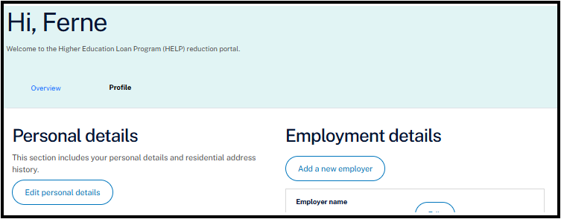
Figure 21. Overview tab

The page lists the steps required to submit your application and any previous applications under ‘Application history’.

Select the ‘Begin application process’ button to create your new application (Figure 22).

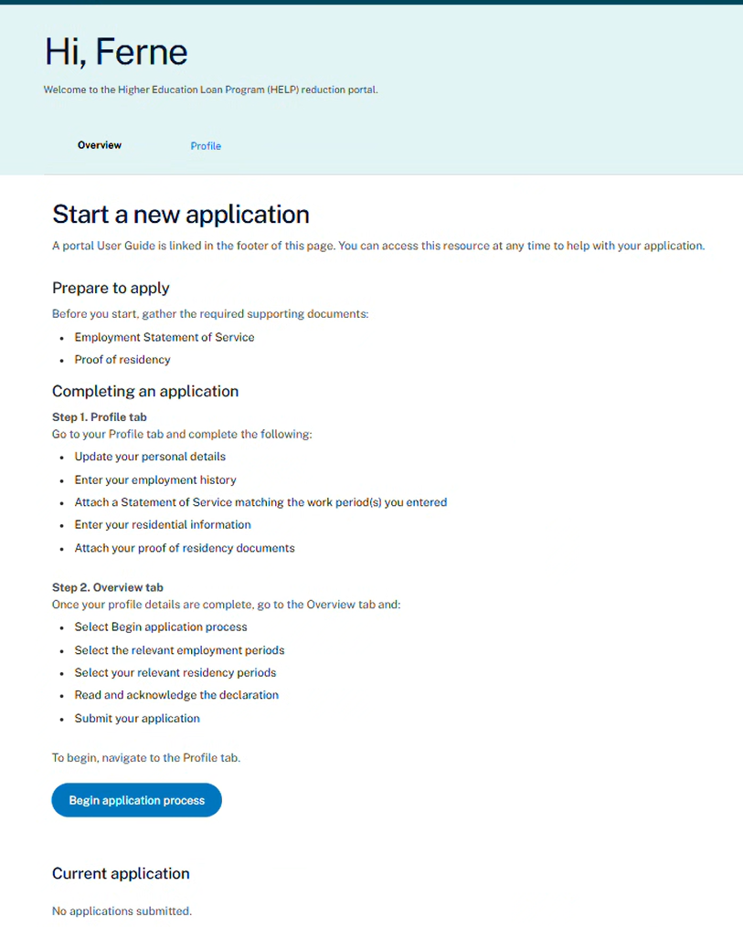
Figure 22. Progress a new application

2.10 Submit your application
This is the final step to submit your application and supporting evidence to the Department of Education.

Read the ‘Application process’ dot points then select ‘Continue’ (Figure 20).

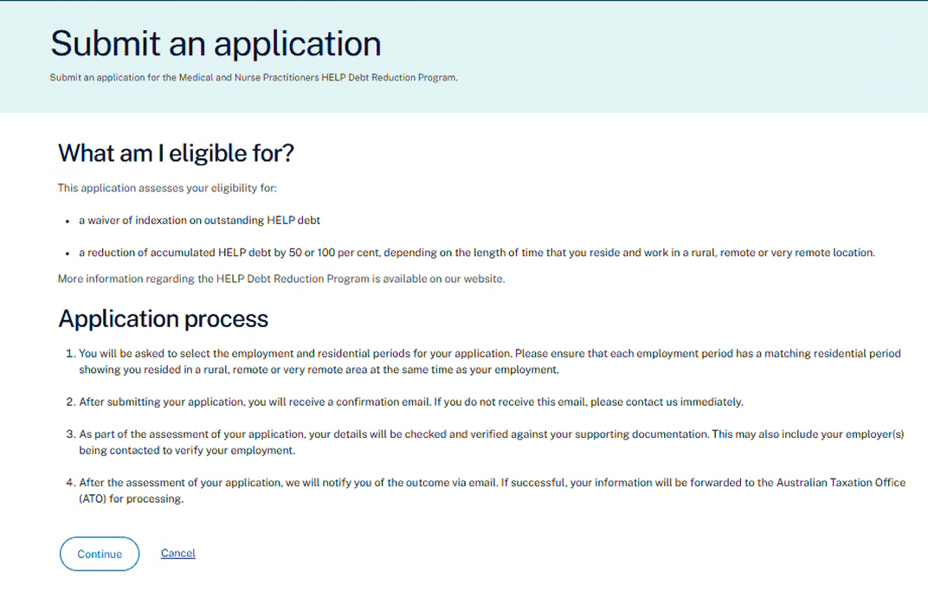
Figure 20. Submit an application screen

The ‘Employment locations’ page will display all the employment locations you have entered (Figure 21).

To include an employment location/s in your application, select the relevant checkbox for each employment period.

Select ‘Save and continue’ to progress your application.

If you select ‘Cancel’, you will return to the dashboard and your application will be saved as a draft.

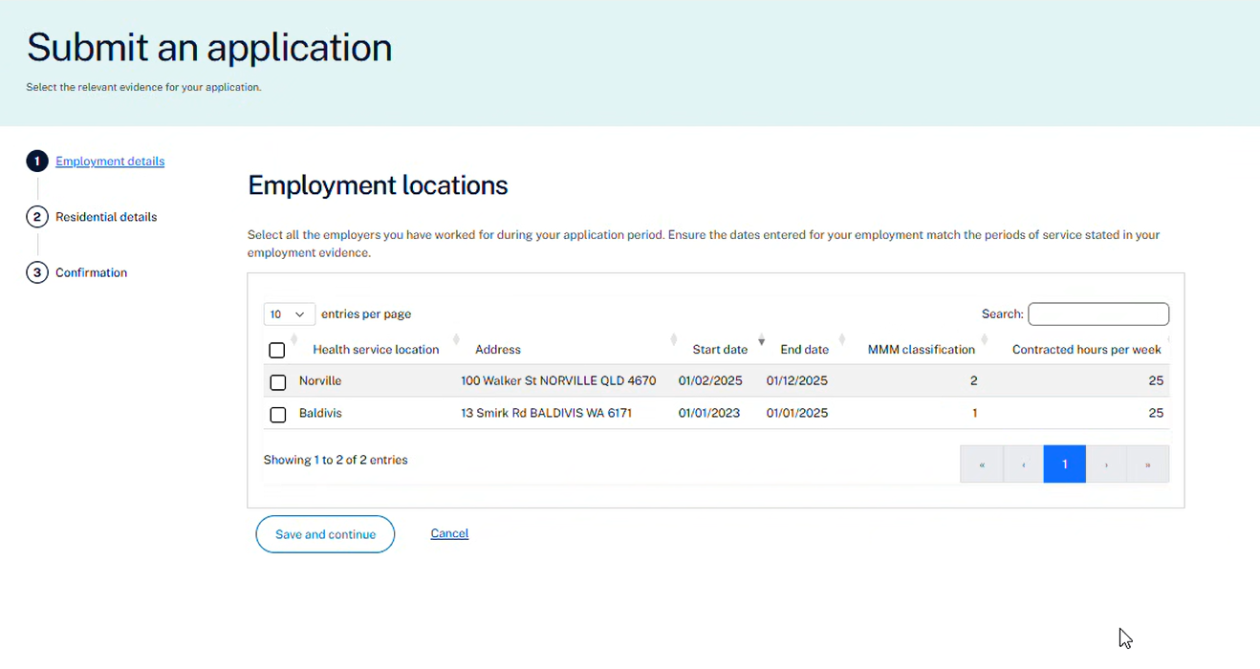
Figure 21. Select the relevant employment locations

Follow the same process on the ‘Residential locations’ page by selecting the relevant checkbox (Figure 22). Select ‘Save and continue’.

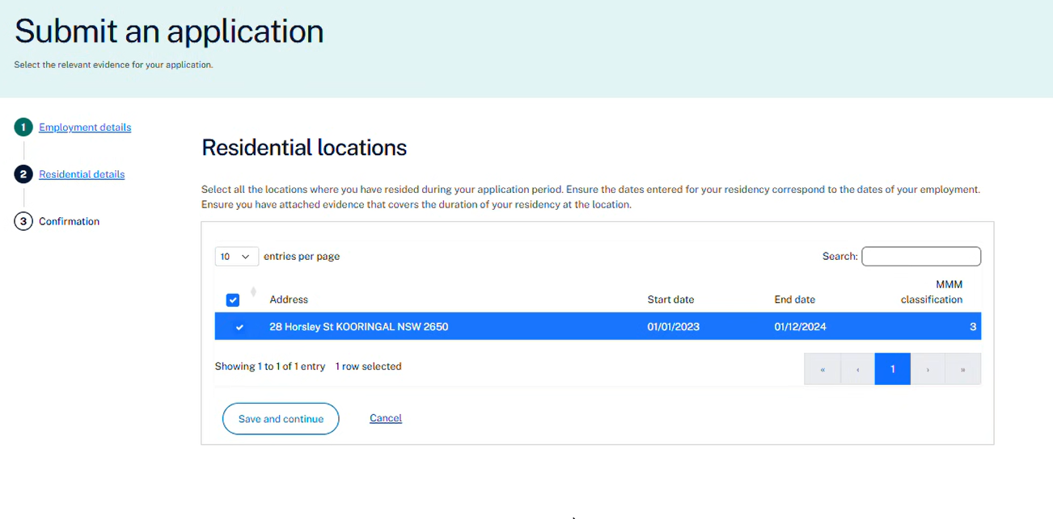
Figure 22. Select the relevant residential locations

The next screen will provide an overview of the selected employment and residential locations included in your application (Figure 23).

Ensure all relevant employment and residential locations are shown on this screen. If not, you will need to select ‘Cancel’ and enter them in the ‘Profile’ tab.

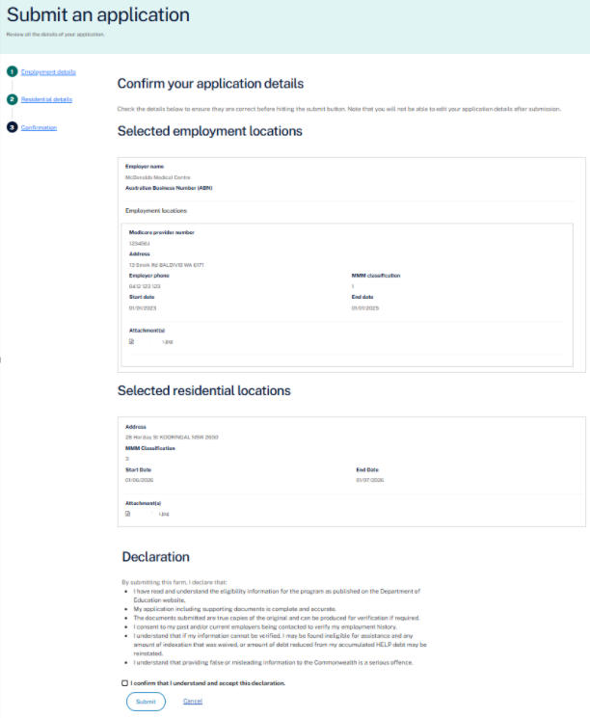
Figure 23. Confirm your application details

On the ‘Confirm your application details’ screen, it is important that you read all the details carefully as mistakes will delay the processing of your application.

Note: You will not be able to edit your application details after submission.

Note: The declaration specifies that you give consent for your past and/or current employers to be contacted to verify your employment history.

To submit your application, select the checkbox to confirm your understanding and acceptance of the declaration and then select ‘Submit’.

If you have found an error or want to delay submitting your application, select ‘Cancel’ to return to the dashboard.

Once you have selected ‘Submit Claim’, you will see a notification that your application has been successfully submitted in the ‘Current application’ section (Figure 25). An application number is provided, the status is ‘Submitted’ and the submission date is recorded.

You will also receive an email receipt confirming your application has been received.

Any previous applications can be viewed by selecting the ‘Application history’ drop down arrow.

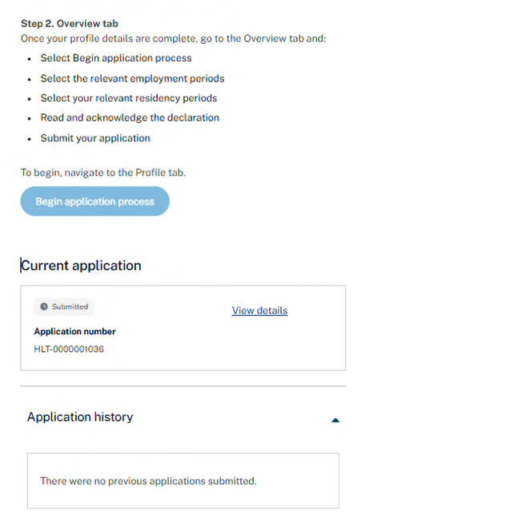
Figure 25. Successfully submitted screen

You can view your application and details submitted by selecting ‘View details’ (Figure 26).

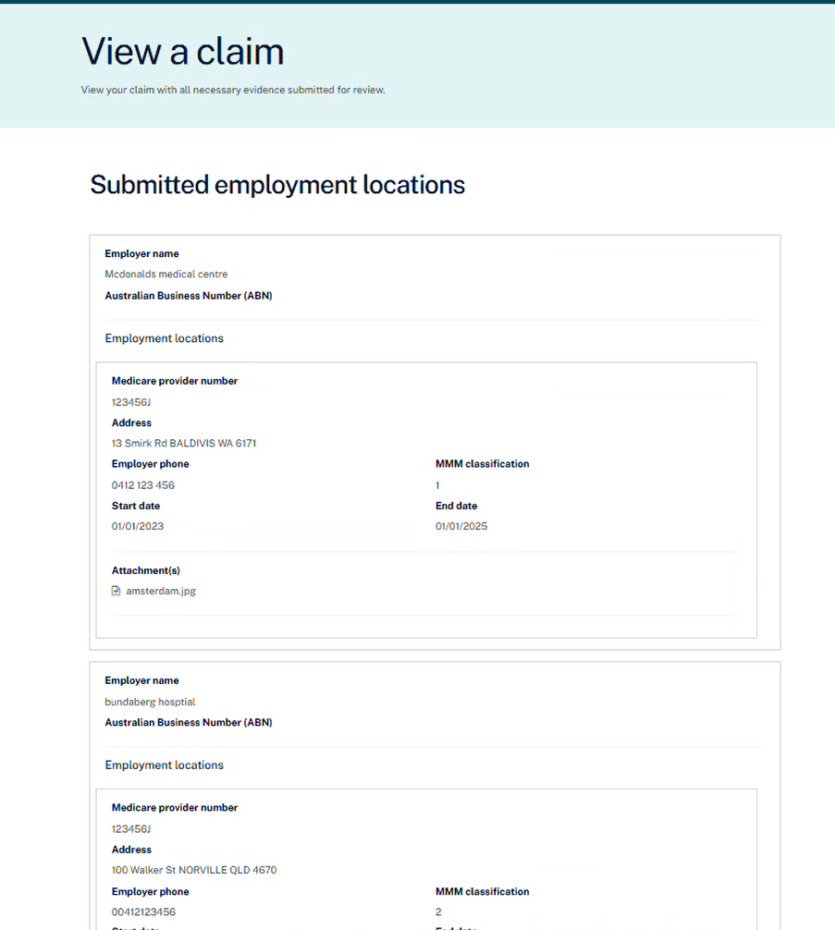
Figure 26. View a submitted claim

2.11 After submission
Once you have successfully submitted your application, you will receive confirmation on the ‘Overview’ tab on the dashboard. You will also receive an email receipt confirming your application has been received.

Depending on the stage of your application, the status may be displayed as any of the following:
Saved as Draft | You have started the application process but have not submitted the application. You can continue to edit all information.
Submitted | You have submitted your application to the Department of Education for assessment.
Review in Progress | Your application is being assessed.
Request for Further Information | Your application is incomplete and we require further information to support your application.
Approved | Your application has been approved.
Rejected | Your application was not successful.

After submitting your application, it can no longer be changed in the Applicant Portal.

If you need to change any information in your application after it has been submitted, contact the Department of Education.

If you already have an application saved as a draft, you must continue or update this draft application rather than start a new application.

If you have previously submitted an application and its currently ‘under review’, you must wait until it is processed before starting a new one. It must have a status of Approved or Rejected for a new application to be submitted.

2.12 Sign out
To sign out of the portal, select the down arrow in the top right corner and select ‘

