An Evidence-Informed Framework for
Recognition of Prior Learning in Initial Teacher Education
Final Report 29 February 2024



Table of Contents
Glossary of Terms and Acronyms iii
Executive Summary iv
Overview of the process iv
An Evidence-Informed Framework for RPL in ITE iv
Possible implementation Strategies v
Acknowledgements of contributors v
Introduction 6
Approach Implemented to Deliver the Outcomes of the Project 7
Background Literature 7
Phase 1: Document Analysis 9
Phase 2: Survey to Stakeholders 9
Phase 3: Social Labs 9
Phase 4: Data Collation 10
An Evidence-Informed Framework for RPL in ITE 11
Overview of Evidence based RPL Principles – Policy, Evidence, Process, & Governance 11
Policy Focused Principles 12
Evidence Focused Principles 14
Process Focused Principles 16
Governance Focused Principles 18
Possible Implementation Strategies 22
Possible alignment within existing ITE Program Standards 22
Incentivising RPL in ITE 22
Conclusion 23
Appendix A: Phase 1 Document Analysis 24
Methodology 24
Findings 25
RQ1: How is RPL defined? 25
RQ2: How is RPL assessed? 25
Appendix B: Phase 2 Survey to Stakeholders 30
Methodology 30
Findings 30
Conclusion 35
Appendix C: Phase 3 Social Labs 37
Methods 37
Participants 37
Data Collection 37
Data Analysis 38
Discussion mapped to deliverables 38
Appendix D: Phase 4 Co Design Workshop 43
Appendix E: Terms of Reference 44
Appendix F: Documents included in the Document Analysis archive 45
Appendix G: The Social Lab’s Slide Deck 47
Appendix H: The Final Social Lab Template 50
Appendix I: Examples of evidence of Formal, Informal, and Non-formal Learning that may be used for RPL in ITE 54
References 57

Glossary of Terms and Acronyms
In line with the Tertiary Education Quality and Standards Agency (TEQSA) 2021 Guidance Note, Recognition of Prior Learning (RPL) is defined as:
“…an assessment of an individual’s prior learning to determine whether credit will be granted. RPL includes formal, informal, and non-formal learning”
The Australian Qualification Framework (AQF) Glossary of Terminology (2013) further clarifies these categories as follows:
- Formal learning – “learning that takes place through a structured program of learning that leads to full or partial achievement of an officially accredited course” (p. 95).
- Informal learning – “learning gained through work, social, family, hobby or leisure activities and experiences. It is not organised or structured in terms of objectives, time or learning support (p. 96).
- Non-formal learning – “learning that takes place through a structured program of learning but does not lead to an officially accredited qualification” (p. 98).
This document adheres to the aforementioned definitions and incorporates the following acronyms for clarity and ease of reference.
Acronyms | Description
ACDE | Australian Council of Deans of Education
AITSL | Australian Institute for Teaching and School Leadership
APST | Australian Professional Standards for Teachers
AQF | Australian Qualifications Framework
ITE | Initial Teacher Education
LANTITE | Literacy and Numeracy Test for Initial Teacher Education
NESA | New South Wales Education Standards Authority
PEx | Professional Experience
RPL | Recognition of Prior Learning
TEQSA | Tertiary Education Quality and Standards Agency

Executive Summary
In response to a national teacher shortage, on 15 December 2022, Education Ministers agreed on a
National Teacher Workforce Action Plan. This report contributes to the Plan's goals by establishing an
Evidence-Informed Framework for Recognition of Prior Learning (RPL) in Initial Teacher Education (ITE). Central to this framework is the implementation of Action 9 under Priority Area 2, which is important for enhancing the supply and retention of teachers. This action underscores the strategic recognition of skills, knowledge, and experiences across diverse cohorts, notably First Nations peoples, mid-career changers, paraprofessionals, and classroom support staff. By valuing prior study and experiences, the framework aims to create more accessible and efficient pathways into ITE, potentially shortening program duration and reducing associated costs. This may not only enhance entry rates but also potentially improve completion rates through diminished financial burden and time commitment.
The intended audience for this Evidence-Informed Framework includes key educational stakeholders such as the Australian Institute for Teaching and School Leadership (AITSL), State and Territory regulatory bodies, universities, and other ITE providers.

Overview of the process
Adopting a comprehensive, multi-phase methodology, this project integrates current research, document analysis, stakeholder surveys, and social labs. This diverse approach captures a wide array of perspectives and explores the nuances of RPL for course credit in ITE. The project's findings underscore the necessity for clear RPL definitions, streamlined processes, and consistent application across ITE programs.

An Evidence-Informed Framework for RPL in ITE
In line with the directives of the Action Plan, this framework presents 13 principles focusing on RPL for course credit in ITE. These principles are designed to align with the standards set by the Tertiary Education Quality and Standards Agency (TEQSA), the Australian Qualifications Framework (AQF), and State and Territory regulatory requirements. This alignment reflects a commitment to maintaining robust teacher qualification requirements.
The principles emphasise that RPL in ITE:
- Must align with TEQSA, AQF, State and Territory regulatory requirements and university policies.
- Should be reflected in regulatory and university policies, including clauses pertaining to ITEspecific RPL practices where necessary.
- Should be expressed clearly and explicitly, using nationally consistent RPL nomenclature.
- Must allow for the alignment of prior learning with a known outcome.
- Must be feasible in terms of volume of material required for the application and the assessment of RPL, with streamlined processes for the applicant and university staff.
- Must utilise valid and reliable sources of evidence to enable consistent decisions.
- Should ensure relevant prior experience is at least equivalent in discipline content, depth and breadth to the unit(s) being awarded credit.
- Should ensure assessment of RPL is undertaken by university staff with well-developed knowledge of RPL policies and practices, and ITE degrees.
- Must be timely.
- Must adhere to fair and equitable governance principles.
- Must ensure that appropriate records are maintained.
- Must incorporate national benchmarking, standard setting, and moderation processes.
- Must incorporate short-term and long-term evaluation processes.

Possible Implementation Strategies
The implementation strategies for the RPL framework in ITE are designed for a phased rollout, ensuring alignment with existing university policies and standards set by TEQSA and the AQF.
A key aspect of this implementation involves AITSL recognising RPL as a Program Standard within the accreditation process for ITE, prompting universities and regulatory bodies to align their policies accordingly. This foundational step is crucial for embedding RPL processes within ITE program delivery and ensuring a consistent, transparent approach across ITE providers.
The strategies emphasise the importance of RPL in addressing specialist skill needs, such as in mathematics and Technological and Applied Studies (TAS), and the potential for alignment with existing initiatives like the NSW Teacher Supply Strategy. The oversight by a national body like AITSL, in collaboration with State and Territory regulatory bodies, promotes consistent, high-quality RPL practices across ITE providers, enhancing the credibility of RPL.
A critical consideration in the successful implementation of RPL is the workload associated with effective assessments and the potential financial implications for ITE providers. Governments and educational bodies are encouraged to explore incentives for RPL within ITE to address these challenges, thereby supporting a sustainable, effective framework that recognises the diverse competencies of individuals entering the teaching profession.

Acknowledgements of contributors
The consortium extends its gratitude to the dedicated stakeholders from across Australia who actively contributed to the research that informed the development of this framework.

Introduction
This report responds directly to Action 9 in Priority Area 2 (Strengthening Initial Teacher Education) of the National Teacher Workforce Action Plan (Department of Education, 2022). The report specifically focuses on developing an evidence-informed framework for the Recognition of Prior Learning (RPL) in Initial Teacher Education (ITE) programs, with an emphasis on course credit rather than entry into ITE programs. This distinction is critical as it aligns with the Plan's objective to effectively utilise prior study, work experience, and skills that are transferable to the teaching profession.
In the context of Action 9, this report aims to ensure that ITE candidates, particularly those from diverse groups including First Nations peoples, mid-career professionals, and para-professionals, receive appropriate acknowledgment for their unique skills, expertise, and previous learning through the allocation of credit towards their qualifications. This initiative is vital for upholding stringent teacher qualification standards, while catering to the multifaceted needs of a diverse teaching workforce.
In aligning with Action 9 of the National Teacher Workforce Action Plan, this framework for RPL in ITE also aligns with the principles outlined in the Australian Universities Accord (Australian Department of Education, 2024). The Accord's strategic vision for enhancing access, participation, and integration within tertiary education underscores the importance of innovative pathways and recognises the value of diverse learning experiences—principles that are foundational to this RPL framework. By facilitating a more inclusive and accessible approach to ITE, particularly for underserved groups such as First Nations peoples, mid-career professionals, and para-professionals, the framework echoes the Accord's commitment to equity and quality in higher education.
In the development of this framework, the research team embraced a multi-phase methodology that encompassed an integration of contemporary research, detailed analysis of pertinent documents, surveys engaging a broad range of stakeholders, and the utilisation of social labs. This approach was strategically designed to encompass a wide spectrum of viewpoints and to investigate the subtle complexities of RPL for course credit within ITE programs. The aim was to construct a framework that was not only informed by a robust evidence base but also reflective of the diverse experiences and needs within the educational community. By doing so, the resulting framework is both comprehensive and aligned to the realities of implementing RPL in ITE settings.
The framework introduces 13 principles that concentrate specifically on RPL for course credit within ITE programs. Each principle has been designed not only to resonate with but also to enhance the existing standards established by the Tertiary Education Quality and Standards Agency (TEQSA), the
Australian Qualifications Framework (AQF), and any the regulatory requirements set forth by various State and Territory authorities. This strategic alignment not only demonstrates a dedication to maintaining quality but it also aims to foster a culture of continuous improvement and innovation within ITE programs. The principles advocate for a comprehensive and adaptable approach to recognising and valuing the diverse experiences and skills that candidates introduce into their teaching careers, thus facilitating a more expedited journey through ITE pathways. By valuing prior academic achievements, professional experiences, and relevant skills for teaching, the framework supports the overarching goals of the National Teacher Workforce Action Plan by bolstering the supply and retention of quality teachers in the workforce.
Significantly, this framework is designed to be applicable across a broad spectrum of ITE programs, including Undergraduate and Postgraduate programs in primary, secondary, and K-12 education. This approach enables the principles to cater to the diverse spectrum of teaching environments and educational levels, providing a unified framework for RPL across various ITE programs.
The relationship between this framework and existing general RPL policies at universities is one that is complementary yet enhances existing practices. It is designed to integrate with and augment existing RPL practices, enabling a synergistic, and national approach to RPL in ITE. It lays the foundation for the development and refinement of institution-specific RPL policies, particularly for those institutions that might not have established ITE-specific RPL processes or practices.
Furthermore, the framework's principles have the potential to inform future refinements of the
Australian Institute for Teaching and School Leadership’s (AITSL’s) Accreditation of Initial Teacher Education Programs in Australia Standards and Procedures, advocating for a standardised and cohesive approach to RPL across the ITE spectrum.

Approach Implemented to Deliver the Outcomes of the Project.
The approach employed by this consortium to deliver the outcomes of this project commenced with a review of background literature. This strong theoretical and contextual foundation grounds the subsequent phases of the project. This review of research set the stage for the project by identifying key themes, gaps, and emerging trends in RPL practices and policies relevant to ITE, thereby informing the direction and focus.
This review was followed by a four-phase blend of qualitative inquiry, quantitative analysis, and innovative social labs. This multi-method approach was of paramount importance for several reasons. It strategically synthesised multiple research methodologies, resulting in a comprehensive and robust foundation upon which an evidence-informed framework for RPL in ITE programs could be constructed. The combination of qualitative inquiry, quantitative analysis, and social labs created a methodological triangulation that enhanced the depth, validity, and applicability of the resultant framework. Additionally, it provided a platform for key stakeholders within ITE to have a voice.

Background Literature
Led by Rachael Adlington from the University of New England
In essence, Recognition of Prior Learning (RPL) is a means by which already-acquired learning outcomes are validated and formerly recognised as part of entry into or credit for higher level learning experiences or qualifications (Mikulec, et al., 2022). Typically, RPL processes recognise learning that has taken place in a variety of contexts and timeframes (Mikulec, et al., 2022).
Definitions extend to “all learning that takes place consciously and unconsciously, informally, formally and non-formally, and above all continuously” (Dovekot, et al., 2020, p. 1), and terms used to describe recognition include Validation of Prior Learning (Dovekot et al., 2020), Accreditation of Prior
Experiential Learning, Prior Learning Assessment and Recognition, and Recognition, Validation and
Accreditation of non-formal and informal learning (European Centre for the Development of Vocational Training [Cedefop]; European Training Foundation; United Nations Educational, Scientific and Cultural Organization [UNESCO]; UNESCO Institute for Lifelong Learning, 2019). The term, Recognition of Prior Learning (RPL), however, is widely used and recognised, so will be adopted in this report.
Aligning with notions of lifelong learning and outcomes-based learning qualification (Mikulec et al.,
2022), the prima facie aim of RPL is to make visible and document the competencies of individuals and thus provide a means for translating learning experiences and expertise into currency for the attainment of improved employment outcomes (Werquin, 2021). As such, effective RPL is viewed a lever of equity and social justice (Atesok, et al., 2019; Barter, 2020; Maurer, 2021; Taylor, Lalovic & Thompson, 2019) and a means by which countries may address labour force shortage and skills issues more generally (Werquin, 2021). One critical viewpoint, however, is that RPL is one of a range of mechanisms by which education policy is moving “towards market strategies and neoliberal values, which are reflected in a culture of performativity, accountability [and] measurement …” (Mikulec et al., 2022). Further, having been created in developed nations, such as the United Kingdom, RPL models and the national qualifications frameworks on which they rely may not meet the ideals of RPL in lower- and middle-income countries (Maurer, 2021; Mikulec et al., 2022). Nevertheless, RPL is well established as a valued construct in many countries, including Australia, alongside national qualifications frameworks (NQFs), such as the Australian Qualification Framework (Australian Qualifications Framework Council, 2013), which broadly articulate learning outcomes for each level and type of qualification.
National qualifications frameworks typically include both vocational and tertiary qualifications, although RPL tends to be better defined and established for vocational training (Baumeler et al., 2023). However, RPL may be applied to all forms of educational pursuit, including articulation of vocational training in culinary arts (Williams, 2019) and nursing (Stuart & Gorman, 2015). In the education sector, RPL has been applied for commercial pilots aspiring to captaincy in multi-crew flagship aviation (Fenton & Goggin, 2020), early childhood educators wishing to upgrade their vocational qualifications (Jackson, 2020), for vocational trainers who themselves may be wishing to gain formal qualifications in vocational education (Walsh, et al., 2020), and to ITE (Duvekot & Doorlag, 2020; Baumeler et al., 2023).

Policies and national systems
The range of global adopters of RPL is visible in the fourth edition of the Global Inventory of Regional and National Qualifications Frameworks (Cedefop et al., 2019) which, in meeting UNESCO’s aims of sustainable development pertaining to education and economic development, captures and compares the qualifications systems and RPL strategies in use throughout the world, including countries across Europe and the Mediterranean, Asia, the Pacific, the Caribbean, North and South America, Africa and Commonwealth countries. RPL is a significant policy driver, and many countries have qualifications frameworks and RPL schemes in place or in development (Cedefop et al., 2019). Some models are longstanding, such as France’s validation des acquis de l’expérience (VAE, validation of experiential learning outcomes), established in 2002 following a 1992 occupational learning outcomes-based model (Werquin, 2021). Other models are relatively new, such as Serbia’s 2018 and Ghana’s 2019 National Quality Frameworks (Mikulec et al., 2022). In Australia, the Australian Qualification Framework (Australian Qualifications Framework Council, 2013) articulates both the qualification framework and broad guidelines for RPL.

Issues
Perhaps unsurprisingly, despite the proliferation of both NQFs and RPL mechanisms, issues in turning RPL policy into practice have emerged. The chief concern echoed across literature is inconsistency of assessment (e.g., Barter, 2020; Baumeler et al., 2023; Shelembe, 2021). Other issues include the financial overheads of assessment for both the applicant and institution, quality of assessment, lack of guidance and support for applicants and assessors, poorly defined or unavailable pathways between learning providers, sectors and countries and between qualification and employment (whereby the qualification including validation of prior learning [VPL] is recognised by employers), the legality of VPL processes (Duvekot et al., 2019) and lack of applicant readiness for undertaking recognition processes (Werquin, 2021). Similar issues persist even within vocational education where recognition and validation of prior learning is well established and commonly undertaken (Maurer, 2021). Further, some issues are particularly difficult or costly to overcome for applicants for whom their mother tongue is not the language of the country in which they are applying for RPL, or for whom their evidence requires translation (Atesok et al., 2019). To overcome these issues and promote the articulation of RPL policy into practice, the Berlin Declaration on Validation of Prior Learning (Duvekot et al., 2019) establishes six principles for effective VPL systems,: 1) organisational arrangements; 2) financing; 3) procedures and instruments; 4) support structures; 5) post-validation pathways (to learning); and 6) legal foundations.

Phase 1: Document Analysis
Led by Reece Mills and Terri Bourke from the Queensland University of Technology
The purpose of the document analysis phase was to provide contextual relevance. By analysing related policies, the resulting framework would align with the existing landscape of professional requirements.
For more detailed information on this phase, including comprehensive results, please see Appendix A.

Phase 2: Survey to Stakeholders
Led by Zara Ersozlu, Susan Ledger, and Elena Prieto from the University of Newcastle.
The purpose of Phase 2 was to develop an understanding of any practices that may exist regarding RPL in ITE across Australia. This phase involved the development of a comprehensive survey as an integral part of the project.
Qualitative insights from Phase 2 informed the design of the survey, enabling the incorporation of nuanced elements that emerged during the qualitative data analysis.
The online survey was distributed via email to all Deans/Heads of School of all ITE providers across Australia. The process of analysing the collected survey data entailed applying statistical techniques to quantify trends and correlations, complemented by qualitative content analysis.
For more detailed information on this phase, including comprehensive results, please see Appendix B.

Phase 3: Social Labs
Led by Kim Wilson, Janet Dutton, and Rebecca Andrews, from Macquarie University.
Social labs were chosen in this phase of the project to enable the widening of stakeholder perspectives and provide an opportunity to address complex social problems related to RPL.
Various stakeholders, including staff members from ITE providers participated in these labs. Three Social Labs facilitated robust stakeholder discussions about evidence for RPL. The process allowed for guided discussions to explore resolutions and generate insights.
Data from the Social Labs were coded thematically using template analysis, a useful approach for identifying themes in large datasets.
For more detailed information on this phase, including comprehensive results, please see Appendix C.

Phase 4: Data Collation
Led by Wayne Cotton, from The University of Sydney.
Following the completion of the Social Labs, a co-design workshop was held in Sydney, where team members collaboratively drafted the initial RPL framework, focusing on establishing principles for a valid and equitable RPL process for ITE candidates. This phase marked the culmination of the data collection and analysis process, leading to an iterative cycle of framework refinement by the research team.
For more detailed information on this phase, including comprehensive results, please see Appendix D.

An Evidence-Informed Framework for RPL in ITE
The development of the evidence-informed framework for RPL in ITE through this project has been underpinned by a set of fundamental values that assist in its robustness and relevance to the evolving landscape of ITE in Australia. This framework adopted a holistic approach by acknowledging various forms of learning, including formal, informal, and non-formal. This recognition serves to inclusively assess the diverse experiences and knowledge that ITE applicants bring to the table, fostering a more inclusive and equitable teacher education system.
The foundational values that guide this RPL framework emphasise the importance of validity, reliability, and practicality in the RPL process. Ensuring these aspects of the RPL process is crucial for maintaining the integrity and fairness of the process. Furthermore, the framework is designed to be practical and effective, catering to the needs and expectations of both ITE candidates and the universities offering these programs. This focus on feasibility enables the framework to be academically sound, and operationally viable, while aligning with real-world requirements.
The framework’s principles adopt a future-oriented perspective, recognising the dynamic nature of education and the evolving needs of the teaching profession. They are designed to be adaptable and forward-thinking, ensuring that teacher education remains relevant and responsive to changing educational paradigms and societal demands.
With a forward-looking approach, the framework is designed to be adaptable and anticipatory, ready to address the dynamic nature of education and the evolving needs of the teaching profession. It is intended to be applicable across a wide range of ITE programs, including undergraduate and postgraduate degrees in primary, secondary, and K-12 education, acknowledging the diversity of pathways within teacher education and ensuring broad applicability.
Moreover, this framework’s principles are firmly rooted in a national perspective, aligning with the requirements set forth by the Tertiary Education Quality and Standards Agency and the Australian Qualifications Framework (AQF). This alignment with national standards supports consistency and quality in teacher education across the country, enhancing the credibility of ITE programs and the qualifications of teachers.

Overview of Evidence based RPL Principles – Policy, Evidence, Process, & Governance
The framework and its associated principles developed through this project are firmly grounded in the evidence accumulated during the project's duration. The development process prioritised a rigorous approach to evidence collection, drawing upon various sources to inform and substantiate the principles. The integration of empirical data and scholarly insights ensured that the resulting principles are not only robust, but also reflective of the evolving landscape of ITE in Australia.
The table provided below succinctly maps out how the framework and its principles align with the various evidence sources that played a role in their formulation. These sources include a review of relevant literature, an analysis of key documents, insights gleaned from social labs and surveys, and an examination of pertinent policies within the education sector. Each of these sources contributes unique perspectives and insights, enriching the evidence base upon which the framework and principles are founded.

Table 1 The evidential base for each principle.
Principle |  |  | Evidence Source
 | Literature | Phase 1  Document Analysis | Phase 2 Social Labs | Phase 3 Survey | Existing Policies
1 | x | x | x |  | x
2 | x | x | x | x | x
3 | x | x | x | x | x
4 | x | x | x | x | x
5 | x | x | x | x
6 | x | x | x | x | x
7 | x | x | x | x | x
8 | x | x | x | x
9 |  | x |  |  | x
10 | x | x | x | x | x
11 |  | x |  | x | x
12 | x | x | x | x | x
13 | x | x
The principles are organised into four distinct themes: policy, evidence, process, and governance. Within each of these themes, the principles address the guiding questions stated in the initial Expression of Interest.

Policy Focused Principles
In the realm of ITE, policy plays a pivotal role in shaping the framework and boundaries within which RPL operates. The Policy Focused Principles are designed to ensure that RPL practices are not only aligned with national and institutional regulatory requirements but also reflect the evolving landscape of teacher education. These principles serve as a blueprint, guiding ITE providers to integrate RPL within their existing structures in a manner that upholds the standards of TEQSA, AQF, and State and Territory regulatory bodies. They emphasise the need for policies to be transparent, inclusive, and reflective of the diverse pathways into the teaching profession, ensuring that RPL is an accessible and equitable process for all teacher education students.
Recognition of Prior Learning in Initial Teacher Education:
- Must align with TEQSA, AQF, State and Territory regulatory requirements and university policies.
Recognising Prior Learning (RPL) in Initial Teacher Education (ITE) in Australia is a critical process that must adhere to national policies established by the Tertiary Education Quality and
Standards Agency (TESQA) (2021) and the Australian Qualifications Framework (AQF) (2011). These policies serve as a quality assurance mechanism that ensures the consistency and standardisation of ITE programs across the country. By adhering to TESQA and AQF standards, ITE providers can maintain a high level of educational quality, thereby guaranteeing that aspiring teachers receive a consistent and robust foundation in pedagogy and teaching practices.
The integration of TESQA and AQF guidelines in RPL processes safeguards the reputation and credibility of the teaching profession in Australia. When RPL practices are aligned with these national standards, it demonstrates a commitment to maintaining the highest educational standards in teacher preparation. Furthermore, the use of TESQA and AQF policies in RPL ensures that ITE programs remain dynamic and relevant. While policies may periodically evolve to reflect changes in educational theory, best practices, and technological advancements, by adhering to these, ITE providers can adapt to evolving educational landscapes, ensuring that teachers are equipped with the most current knowledge and skills necessary to excel in the classroom. In essence, following national policies from TESQA and AQF in RPL within ITE is not only a matter of compliance but a strategic imperative to uphold the integrity, quality, and relevance of ITE programs in Australia.
- Should be reflected in regulatory and university policies, including clauses pertaining to ITEspecific RPL practices where necessary.
The process of RPL can be viewed as policy work as universities make sense of and construct responses to national TEQSA and AQF policies. The interpretation and translation (Ball et al., 2012) of RPL policies primarily occurs at a university level and does not meet the unique needs of ITE in the present moment of critical teacher shortages. It is recommended that Faculties and Schools of Education do their own policy enactment work to develop ITE-specific policies and procedures. Bourke and Mills (2022) offer steps for policy enactment in ITE that can be followed. Specifically, the interpretive work includes: 1) Formulate: shared interpretations of policy intent for all actors through initial sense-making; 2) Consult: with stakeholders in the policy agenda; and 3) Translate: from a researcher disposition where translators are afforded autonomy (Bourke & Mills, 2022, p. 48). This policy enactment work may include seeking exemptions to university policy where relevant, especially in terms of awarding RPL for non-formal and informal learning.
The Phase 1 Document Analysis revealed a paucity of ITE-specific policies and procedures and limited ITE-specific exemptions to university policy. Many universities’ policies outwardly deprioritise non-formal and informal prior learning by capping the number of credit points allowed to be awarded to students (e.g., maximum 24 credit points). This can work against highly skilled and experienced groups seeking to become a teacher such as career changers and paraprofessionals. The Phase 2 survey provides further rationale for ITE-specific RPL policies and procedures, with responses indicating a low understanding of generic RPL nomenclature and processes and a low confidence enacting RPL policy in terms of assessing student applications.
To promote the adoption of RPL policies and guidelines by ITE providers, it is recommended that AITSL, along with State and Territory regulatory authorities, incorporate specific stipulations regarding RPL in ITE within forthcoming editions of their Standards and Procedures. This document sets out the criteria necessary for an ITE program to achieve national accreditation.
- Should be expressed clearly and explicitly, using nationally consistent RPL nomenclature, and they should be publicly and readily accessible by the intended audiences.
In the quest for transparent and accessible RPL practices, it is imperative that policies and frameworks are articulated with clarity and precision. The use of nationally consistent RPL terminology provides a standardised language that resonates in different contexts and promotes a common understanding. Furthermore, to maximise their effectiveness, these policies should be easily accessible to targeted audiences, promote transparency and empower stakeholders with readily available information.
Phase 2 results showed that the information provided shows that when it comes to the clarity of RPL terminology in ITE policies and frameworks, a significant proportion of respondents perceive the terminology as moderately clear (47%) and somewhat clear (28%). This indicates a mixed but generally positive assessment of the clarity of language and terms used in ITE policies and frameworks related to RPL. This finding correlates with the respondents' lack of confidence in defining RPL processes, as indicated in the response to Question 11. The implication is that the perceived lack of clarity in RPL terminology in ITE policies and frameworks may contribute to respondents' uncertainty in providing clear definitions of RPL processes. Essentially, the data implies a potential link between the clarity of terminology used in ITE policies and respondents' confidence levels in articulating RPL processes, highlighting the importance of clear and clear language in policy documents for effective understanding and implementation.
An example of this can be drawn from the disparities in credit point systems across different universities. For instance, at one university, a standard session's workload might consist of four Units of Study (or Subjects or Courses), equating to 40 credit points, whereas at another, the same number of Units might only account for 24 credit points. This inconsistency in terminology and valuation may lead to confusion among students and complicate the RPL process, making it challenging to equate experiences and the amount of RPL given.
To mitigate such discrepancies and enhance the transparency and coherence of RPL practices, it is advisable to adopt a unified measure, such as Equivalent Full-Time Study Load (EFTSL). Incorporating EFTSL into the RPL nomenclature and providing guidance on its application may streamline the understanding and implementation of RPL, ensuring that all stakeholders, particularly students, are fully informed of the process. This approach not only aligns with the call for clear and accessible RPL policies but also addresses the concerns highlighted in the Phase 2 findings above, where a considerable portion of respondents indicated only a moderate to somewhat clear comprehension of RPL terminology within ITE policies and frameworks.

Evidence Focused Principles
The evidence required by teacher education students to be credited for formal, informal, and nonformal learning is diverse as are the experiences of those seeking credit through RPL. Given wide ranging backgrounds, it is essential that teacher education students are fully cognisant of what is required for each course and understand clearly how they need to meet the learning outcomes, the associated AITSL’s Australian Professional Standards for Teachers (APST), and their relation to the mapping of the graduate program standards, and the assessable tasks that have been required of students enrolled within programs. Teacher education students applying for RPL should be supported institutionally and with specific educational prowess to ensure that enrolled students can achieve the maximum credit without impairing the integrity of the program. The relevant appendices aim to provide additional clarification of both the type of evidence that might be employed as well as the ways those pieces of evidence can be utilised in RPL applications.
Recognition of Prior Learning in Initial Teacher Education:
4. Must allow for the alignment of prior learning with a known outcome.
The evidence required for RPL in ITE programs must satisfy the needs of the learning outcomes for the individual units or courses that are to be credited. Additionally, and specifically, in ITE the evidence provided must satisfactorily demonstrate the connections between prior learning and the APST aligned to that unit or course outcomes. This may require evidence that confirms that the teacher education student has been taught, has practiced and has been assessed at a graduate level for any of the APSTs ascribed to that unit or course.
The relationship of individual courses to the program must also be considered. There may be a course which is the only time a particular APST is mapped from a program level. Alternatively, some APST may be mapped against several units/courses. These mapped relationships are critical in directing the type and amount of evidence required and how the evidence meets each unit/course learning outcomes as well as the associated APST.
In evaluating the connection to the APSTs aligned with a unit or course, evidence from formal educational achievements, such as elements of tertiary qualifications in a related field, may be considered. The assessment of informal learning evidence, like conference attendance records or professional reflection documents, demands a more rigorous comparison and standard setting (see principle 12). The same rigorous approach applies to non-formal learning evidence, such as online courses or educational workshops.
Establishing a clear link between the evidence, the course learning outcomes, and the APST is critical in the evaluation of credit. This ensures the maintenance of program integrity and meets the requirements for professional accreditation.
- Must be feasible in terms of volume of material required for application and the assessment of RPL, with streamlined processes for the applicant and university staff.
ITE providers should aim to limit the volume of evidence that teacher education students are required to provide. Where possible it would be mutually beneficial that pieces of evidence could be used for multiple purposes. Existing formal documentation, such as course outlines and descriptions that provide robust connections between prior learning and courses where a teacher education student is seeking credit, are essential in streamlining processes for all stakeholders.
The institutional requirements for RPL should be publicly available and provide sufficient generic information to enable students to feel equipped to know what is being requested and how to provide the requisite evidence. Wherever possible Higher Education Institutions should provide exemplars and clarifying statements for procedures and evidence that supports the timely completion of RPL processes.
To manage the volume of submissions, institutions may choose to develop a dedicated template for RPL applications. This template could guide students to present evidence directly related to the learning outcomes of the specific unit or course. Additionally, institutions could conduct workshops or informational sessions to assist ITE applicants and students in preparing their RPL applications. These sessions would offer advice on assembling an RPL portfolio, selecting appropriate evidence, and matching prior learning to the unit or course outcomes. The institution may also supply examples of successful RPL submissions and case studies, explaining the rationale behind the acceptance of certain pieces of evidence.
- Must utilise valid and reliable sources of evidence to enable consistent decisions.
RPL requires that all evidence provided must meet the equivalency of the comparable AQF level of learning and must demonstrate the equivalent rigour irrespective of the type of RPL being sought.
If an ITE student is seeking RPL from formal learning they have undertaken, the expectation would be that they provide current academic transcripts that shows the completion of the course in question. Additionally, the teacher education student should provide course descriptions that outline the learning outcomes, activities, and assessable tasks. This will allow institutions to efficiently assess the comparability of the courses to the credit being sought. In the case where courses have Professional Experience, it would be expected that a teacher education student also provides the number of placement days completed on that practicum and any evidence that supports the successful completion, such as a professional experience report.
The evidence necessary when seeking RPL for informal learning may be more diverse than the nature of the credit being sought. The evidence may be determined by the nature of the informal learning and how the ITE student can meet the learning outcomes for the courses they are seeking credit. A teacher’s aide may have experiences that may be considered for some unit or courses and the evidence might include testimonies of length of service and allied observations that have occurred during that service. Expertise in language and culture, including expertise from Indigenous applicants, bi- and multi-lingual applicants may be evidenced by examples of language assessment and supporting statements from community members that can attest to the skill level.
Evidence from non-formal learning would require submission of the completion of the program and additional narratives around how this study is applicable to the course for which the ITE student is seeking credit. Sample portfolios or case studies that demonstrate successful RPL applications from non-formal learning, along with explanations of why certain evidence was deemed sufficient, will help direct future submissions.
Additional examples of types of evidence and their applicability to RPL for each of these categories are available at Appendix F.
7. Must ensure relevant prior experience is at least equivalent in discipline content, depth and breadth to the unit(s) being awarded credit
To uphold the integrity of ITE programs, Principle 7 emphasises the necessity for RPL to equate closely with the discipline content, depth, and breadth of the units for which credit is sought. This principle ensures that the foundational knowledge and competencies acquired through prior experiences are commensurate with the academic standards and learning outcomes of the unit or course. Ensuring such equivalence is critical for maintaining the quality and rigor of teacher education, thereby preparing graduates who are well-equipped to meet the diverse needs of learners in their future classrooms.
In operationalising this principle, ITE providers must employ a systematic approach to evaluate prior learning against the specific requirements of each unit or course. This approach may also be informed by documents like AITSL’s (2015) Schedule 1 for Program Standard 4.2 (p.16), and the New South Wales Education Standards Authority’s (NESA) Subject Content Knowledge requirements (2018), which provide a clear outline of what students are required to possess for each subject and learning area.

Process Focused Principles
The Process Focused Principles underscore the importance of an efficient, transparent, and studentcentric approach to RPL in ITE. These principles are crafted to streamline the RPL process, ensuring that it is not only responsive to student needs but also feasible and effective for administrative purposes. They focus on simplifying procedures, reducing bureaucratic hurdles, and enhancing the clarity of RPL processes. By standardising these processes, the principles aim to reduce variability in RPL assessments and ensure a consistent experience for all applicants. They advocate for a system where RPL is not an afterthought but an integrated, well-thought-out component of the student journey, facilitating smooth transitions and recognition of diverse learning experiences.
Recognition of Prior Learning in Initial Teacher Education:
- Should ensure assessment of RPL is undertaken by university staff with well-developed knowledge of RPL policies and practices, and ITE degrees.
The assessment of RPL within individual institutions is a process that must be carried out by university staff who hold well-developed knowledge of their institution’s RPL policies and practices, and of the constitution of their ITE degree offerings. ITE Institutions should proactively provide targeted trainings, workshops, and collaborative forums to increase understanding and trust among RPL assessors. By addressing this gap, ITE institutions can develop a more informed and effective RPL assessors to contribute to the overall integrity of RPL processes.
Evidence from the Phase 1 policy analysis showed that across all universities, assessment and granting of RPL is done by an approved academic staff member at the faculty or school level (such as Course Convenor or Program Coordinator) with appropriate expertise who can act in accordance with relevant policy documents. But other people are often included in the RPL granting process. Unit Coordinators are asked to make recommendations on RPL assessment which are kept in respective universities’ credit transfer systems and reviewed every five years. In this way, professional staff can then make decisions on RPL assessment in accordance with the register. Given that the most reported sources of data cited as evidence for RPL are official records or transcripts, unit outlines and award certificates, assessors require a well-developed knowledge base to accurately assess applications. Although, if the prevalence of non-formal and informal RPL increases, the review timeframes and process may need evaluating.
Phase 2 analysis revealed that ongoing institutional professional development is essential to be provided to personnel undertaking assessments. Responses from Phase 2 survey showed that 63% of respondents had not received training or professional development relating to RPL processes, yet 87.5% of them indicated that they assessed RPL applications, with 38% having assessed RPL in the previous month. Despite being familiar with their respective institution’s RPL process, participants were not very confident in providing a clear definition of the process. Despite being operationally familiar with their organisation's RPL process, participants struggled to provide a clear definition, suggesting a lack of confidence. This inconsistency highlights an important need for continuous professional development in RPL assessment.
- Must be timely.
This principle aligns with the standards set for higher education providers by the TEQSA and addresses key considerations and identified issues related to student satisfaction and academic planning.
TEQSA emphasises the need for higher education providers to inform students about RPL policies, arrangements, and potential eligibility for credit for RPL, prior to enrolment. This early communication is crucial as it enables students to make informed decisions about their course choices and understand how their previous learning experiences may influence their course progression. Timeliness in RPL processes ensures that students are not left in uncertainty regarding their course progression, credit transfers, and overall academic workload.
For overseas students, TEQSA mandates that providers must make students aware of any course credit applicable prior to accepting their enrolment in a course. This requirement is particularly important for international students who may be navigating the complexities of studying in a new educational system. Early notification about RPL outcomes allows these students to plan their studies effectively, including planning for travel, accommodation, and financial commitments.
TEQSA has identified issues regarding a lack of timeliness in notifying students about whether credit will be granted and the reasoning if it is not. Delays in these notifications can lead to a poor student experience, as it affects students' ability to plan their academic pathways and may result in extended study durations or unnecessary financial burdens. Timely decisions and clear communication about RPL outcomes and rationales are essential for maintaining trust and satisfaction among students.
In summary, adhering to the guideline of timely RPL processes in ITE is key for enhancing the student experience, aligning with TEQSA’s standards, and ensuring that students are fully informed and prepared for their educational journey. It reflects a responsive and respectful approach to student needs and fosters a positive academic environment conducive to learning and progression.

Governance Focused Principles
The Governance Focused Principles are centred on establishing robust oversight and quality assurance mechanisms for RPL in ITE. These principles emphasise the need for transparent governance structures that ensure RPL decisions are made fairly, equitably, and in line with established standards. They call for comprehensive record-keeping, regular reviews, and benchmarking to uphold the credibility of RPL assessments. Moreover, these principles advocate for ongoing evaluation processes to continually refine and improve RPL practices. By setting clear governance standards, these principles aim to instil confidence in the RPL process, assuring students and stakeholders alike of the integrity and validity of the credits awarded through RPL.
Recognition of Prior Learning in Initial Teacher Education:
10. Must adhere to fair and equitable governance principles.
The governance environment surrounding RPL in ITE encompasses the policies, guidelines, processes, and structures dedicated to the assessment and validation of prior learning experiences within ITE institutions. This environment is pivotal in ensuring the RPL processes are characterised by consistency, fairness, and transparency, thereby fostering an equitable environment where individuals' competencies are duly acknowledged and credited.
From the findings of the Phase 2 analysis, it is evident that there is a pressing need to enhance clarity and fairness within RPL assessments in ITE. Approximately 32.5% of surveyed individuals rated their institutions' RPL practices as merely satisfactory in terms of fairness, with 27.5% remaining neutral. This indicates a considerable segment of ITE programs might lack a robust framework or a pronounced emphasis on fairness within their RPL assessment processes. Moreover, 29% of participants disclosed their unawareness regarding their institution's strategies to mitigate potential biases during prior learning assessments. When queried about the mechanisms to ensure fair assessments based on prior knowledge or experiences, only 41% of the respondents acknowledged the existence of explicit assessment criteria. This underscores the imperative need to prioritise fairness and standardise RPL practices across ITE programs.
Addressing the challenges identified, such as the ambiguity and perceived unfairness in RPL practices, necessitates a concerted effort by ITE providers to ensure clear guidelines, resources, and a supportive infrastructure exists. This approach will not only make the RPL assessment process more equitable and transparent, but it may also streamline the process.
The insights from Phase 3 analysis reinforce the necessity for a more structured and equitable governance model for RPL in ITE. The establishment of uniform rules and national protocols is critical to ensure consistency across universities and states. Decision-making in RPL should be a collective endeavour rather than being dependent on individual discretion, underscoring the complexity of these assessments and advocating for a standardised and collaborative methodology. The prevalent frustration among participants due to the inconsistencies observed between various institutions and teacher registration bodies underscores the urgency of aligning with consistent standards. This concept is further addressed in principle 12.
To enhance the governance of RPL processes within ITE, it is advised that ITE providers undertake several key initiatives. Firstly, it is imperative to create and circulate detailed, comprehensive guidelines regarding the RPL processes in ITE. This step ensures a unified understanding among all involved parties of the expected criteria, procedures, and outcomes.
Moreover, the adoption of uniform assessment tools and criteria for evaluating prior learning is essential. This approach guarantees that assessments are carried out in a consistent, objective, and unbiased manner. Additionally, it is crucial to provide regular training for assessors on the principles of fair and equitable assessment practices. Such training should highlight the significance of maintaining consistency and transparency in the assessment of prior learning.
Finally, the establishment of strong review and appeal mechanisms for RPL decisions is necessary. These mechanisms allow individuals to seek clarification in instances of disagreement, thereby increasing the process's transparency and perceived fairness. Collectively, these measures will significantly improve the RPL governance framework, making it more equitable and transparent.
By taking these steps, ITE providers can significantly improve the governance environment for RPL processes, making them more equitable, transparent, and aligned with the overarching goal of recognising and crediting individuals' existing competencies in a fair manner.
- Must ensure that appropriate records are maintained.
Keeping appropriate records is essential for maintaining accountability, ensuring fairness, and continuously improving the quality and effectiveness of RPL assessments. These records serve as concrete evidence of the RPL process by documenting the steps taken throughout the assessment process, the criteria applied, and the decisions reached. It should also include any reasons for not granting credit. This evidence not only promotes transparency but also ensures accountability by allowing educational institutions and assessors to justify their decisions and actions. Robust record keeping is also an integral part of quality assurance efforts and allows ITE institutions to review and improve their RPL procedures in line with relevant standards. From a legal and regulatory perspective, recordkeeping is also important to ensure compliance and help organisations demonstrate their adherence to established policies, guidelines, and processes.
Phase 2 analysis showed that 37% of respondents indicated that their institution keeps these records indefinitely, and another 33% indicating that their institution keeps these records for a period of up to five years. Notably, 76% of respondents indicated that their institution has set up systems to securely store these records in a database. Collectively, these data underscore a notable commitment to record-keeping practices with an emphasis on longevity, as reflected in the high percentage of institutions that have chosen to maintain RPL records permanently or for a defined period of up to five years. Moreover, the prevalence of established mechanisms and database systems indicates a coordinated effort to ensure the security and integrity of these records in the surveyed institutions.
- Must incorporate national benchmarking, standard setting, and moderation processes.
Incorporating national benchmarking, standard setting, and moderation processes within Recognition of Prior Learning (RPL) in Initial Teacher Education (ITE) is fundamental in elevating the quality, equity, and consistency of RPL assessments across various educational institutions. The establishment of national benchmarks and standards provides a uniform framework, guiding
RPL decisions and ensuring they adhere to agreed-upon quality thresholds. The findings from
Phase 2 of our study underscore the significance of transparent and well-defined standards, with 41% of respondents advocating for a standardised approach to RPL across different programs and institutions. This is in stark contrast to the minimal utilisation of moderation processes, highlighted by only 6% of respondents, which involves collaborative reviews to ensure consistent judgements across programs and institutions. Achieving such consistency is crucial, as it guarantees that, given the same evidence against national benchmarks and standards, the outcomes of RPL assessments would be uniform. This area represents a significant opportunity for enhancement in the RPL decision-making process.
Moreover, the necessity of a collective effort in decision-making, as emphasised by results from Phase 3, is paramount for ensuring that judgements are impartial, valid, and reliable. A framework that integrates national benchmarks, standards, and moderation processes is indispensable for a more cohesive and rigorous approach towards recognising prior learning in ITE. This not only bolsters the credibility of the RPL process but also reinforces the confidence of students and educators in the fairness and validity of the decisions made.
Adding to this, the implementation of benchmarking, standard setting, and moderation processes is critically important in shaping both the real and perceived impact on the quality of ITE. These critical processes are key in maintaining high educational standards, thereby directly influencing the quality of teaching, and learning outcomes. They provide a mechanism for continuous quality improvement, ensuring that the recognition of prior learning is not only consistent but also meets the high standards expected of the teaching profession. Furthermore, the perceived quality and credibility of ITE programs are enhanced when stakeholders are aware that robust, transparent, and equitable processes underpin RPL assessments. This perception is vital in attracting and retaining high-calibre students into the teaching profession, thereby contributing to the development of a well-qualified teaching workforce equipped to meet the diverse needs of learners.
13. Must incorporate short-term and long-term evaluation processes.
The incorporation of both short-term and long-term evaluation processes to monitor the effectiveness and fairness of procedures used to accredit prior learning within ITE is vital for the continuous improvement and effectiveness of the procedures. This approach is aligned with the objectives set out in the National Teacher Workforce Action Plan, aiming to enhance teacher supply and retention through effective educational strategies.
Short-term evaluation processes are important for early feedback and adjustments. They allow for the timely review of RPL practices using data from their initial implementation to evaluate their impact and the extent to which the results are consistent with expectation. This early, and necessary monitoring of outcomes enables the identification of any operational challenges, inconsistencies, or unintended consequences that might arise in the implementation of RPL that could lead to a diminution of confidence in the procedures.
Long-term evaluation should provide evidence of the sustained impact of the procedures, and any unintended consequences that the procedures might be having on ITE. This type of evaluation can provide a comprehensive analysis of how RPL policies influence the overall quality of teacher education programs, the diversity and preparedness of the teaching workforce, and the alignment with national educational goals over an extended period. Longterm evaluation processes help in understanding the evolving needs and outcomes of RPL, ensuring that it continually meets the standards and expectations of the teaching profession.
Evaluation processes more broadly are required to monitor the uptake and impact of RPL in ITE. By regularly reviewing and updating RPL practices, ITE institutions can work towards making sure that the procedures remain relevant, effective, and in alignment with the ever-changing educational landscape. This is particularly pertinent given the National Teacher Workforce
Action Plan's emphasis on attracting and retaining a diverse and skilled teaching workforce. Effective RPL evaluation ensures that the process is not just a theoretical exercise but a practical tool contributing to the development of a robust and capable teaching workforce.

Possible Implementation Strategies
The phased implementation of the RPL framework within ITE programs necessitates an approach to ensure seamless alignment with existing university policies, which are in turn compliant with the existing standards set by the Tertiary Education Quality and Standards Agency and the Australian Qualifications Framework. This alignment is pivotal for maintaining the integrity and quality of ITE programs and ensuring that they meet national educational standards.

Possible alignment within existing ITE Program Standards
A critical step in this phased implementation could involve the Australian Institute for Teaching and School Leadership recognising RPL as an integral Program Standard within the accreditation process for teacher education programs. This recognition will serve as a catalyst for universities and teacher regulatory bodies to review and align their policies, guidelines, and practices with new specific ITE standards. Such alignment is not merely procedural but foundational, in ensuring that RPL processes are embedded within ITE program delivery and evaluation.
The recommendation for RPL to be addressed as a program standard is significant. It mandates ITE providers to explicitly articulate how RPL will be incorporated into their programs, following the university's policies and adhering to the established guidelines and procedures. This requirement fosters a consistent and transparent approach to recognising prior learning, ensuring that all stakeholders, including students, educators, and regulatory bodies, have a clear understanding of how RPL contributes to the educational pathways within ITE.
Moreover, this approach enables AITSL and State and Territory regulatory authorities to highlight the importance of RPL in addressing areas of specialist skill needs, such as mathematics and Technological and Applied Studies (TAS). It also allows for the alignment and highlighting of RPL processes within existing initiatives like the NSW Teacher Supply Strategy and Queensland's Turn to Teaching and Trade to Teach initiatives, as regulatory bodies and ITE providers can create more aligned pathways into and through ITE. This alignment not only enhances the quality and diversity of the teaching workforce but also enables ITE programs to be responsive to the evolving needs of the education sector.
Another significant advantage of recognising RPL in ITE as an AITSL program standard is the oversight by a national body, which adds a layer of governance and quality assurance to the RPL processes. With AITSL's oversight, in collaboration with State and Territory regulatory bodies, and backed by appropriate funding, Principles 12 and 13 of the framework could be effectively administered. This national oversight ensures that RPL practices across ITE providers are not only consistent but also adhere to the highest standards of quality and equity. It facilitates a unified approach to benchmarking, standard setting, and moderation processes, thereby enhancing the credibility and recognition of RPL across different jurisdictions. Such a coordinated approach, underpinned by national leadership and support, is crucial for the successful implementation and sustainability of the RPL framework, ensuring it effectively contributes to the development of a robust and responsive teacher education system.

Incentivising RPL in ITE
In contemplating the successful implementation of RPL in ITE, a critical consideration is the workload associated with conducting effective RPL assessments. Given the nature of evaluating prior learning, especially when considering formal, informal, and non-formal learning avenues, the process can be resource-intensive. Recognising the potential financial implications, particularly since RPL can be applied for prior to enrolment and may not directly generate income, and the fact that successful RPL may reduce the number of units or courses a student is required to complete, thereby potentially reducing income for ITE providers, it is essential that governments and educational bodies consider mechanisms to incentivise RPL within ITE.
Such incentives could take various forms, including funding allocations specifically earmarked for the administration of RPL processes, grants to support the professional development of staff involved in
RPL assessments, or financial compensations to balance the potential reduction in course fees due to RPL credits. These incentives would not only alleviate the financial and administrative burdens associated with RPL but also encourage ITE providers to fully embrace and integrate RPL into their program structures, aligning with university policies and broader educational standards set by TEQSA and AQF.
By addressing the workload and financial aspects of RPL through targeted incentives, governments and educational authorities can further solidify the framework's sustainability and effectiveness, ensuring that RPL continues to serve as a pivotal pathway for recognising the diverse competencies of individuals entering the teaching profession.

Conclusion
In concluding, the possible implementation strategies outlined above underscores the necessity of a carefully phased approach to the integration of RPL within ITE, ensuring it is aligned with existing university policies and that it complies with the standards set by TEQSA and AQF. The pivotal role of AITSL in potentially recognising RPL as a Program Standard within the accreditation process signifies a transformative step towards embedding RPL in the very foundation of ITE program delivery and evaluation. This strategic move, coupled with the national oversight by AITSL and State and Territory regulatory bodies, promises to standardise and elevate the quality, fairness, and consistency of RPL assessments across educational institutions. Furthermore, addressing the workload and financial implications associated with effective RPL assessments is critical. Governments and educational bodies are encouraged to explore incentives for RPL within ITE, acknowledging its potential impact on income streams for ITE providers due to pre-enrolment applications and the possible reduction in units and course for students. By fostering a supportive ecosystem that incentivises RPL, ensures rigorous governance, and aligns with national educational standards, the framework sets a solid foundation for enhancing the recognition of prior learning, thereby enriching the teaching profession with diverse and competent educators whilst maintaining robust teacher qualifications.

Appendix A: Phase 1 Document Analysis
Led by Reece Mills and Terri Bourke from the Queensland University of Technology

Methodology
Two research questions guided this phase of the study:
- How is RPL defined?
- How is RPL assessed?
  - Who is responsible for the assessment of RPL?
  - What evidence is required for the assessment of RPL?
  - What are the parameters for awarding RPL (e.g., maximum limits)?
Documents from 12 universities across all states and territories of Australia were included in this analysis, as well as documents from Australian Institute for School Leadership (AITSL) and Tertiary Education Quality and Standards Agency (TEQSA). The universities comprise the eight universities in the research consortium, plus one university from states and territories not represented (see Table 2). The documents have a date range from 2014-2023, with most documents approved/reviewed in 2023. The length of the documents ranged from 2 to 104 pages, which meant varied levels of detail were accessible across the documents.
Appendix 2 outlines the documents included in the archive. They mostly comprise policies and procedures, however, when we could not garner enough information to answer the research questions, we also searched relevant websites. We included the approval/review date and access (public/private) because we were interested in the recency of the documents and whether they are publicly available or for internal university use.
Table 2 Universities whose policies are included in the analysis.
University | Location
Charles Darwin University | Northen Territory
Curtin University | Western Australia
Macquarie University | New South Wales
Monash University | Victoria
Queensland University of Technology | Queensland
University of Adelaide | South Australia
University of Canberra | Australian Capital Territory
University of Newcastle | New South Wales
University of New England | New South Wales
University of Southern Queensland | Queensland
University of Sydney | New South Wales
University of Tasmania | Tasmania
To determine how RPL is defined, we copied definitions from the glossary of each document into an
Excel spreadsheet. We then looked for commonalities and contradictions between definitions. We followed a similar process to determine how RPL is assessed, this time copying information about who is responsible and what evidence is required for the assessment of RPL. When examining the parameters for awarding RPL, we considered factors such as general rules and exemptions, recency, and maximum credit limits.

Findings

RQ1: How is RPL defined?
RPL is defined by TEQSA as the evaluation of “an individual’s previous learning experiences to determine their eligibility for credit” (p. 1). The definition in the AQF glossary is “recognition of prior learning is an assessment process that involves assessment of an individual’s relevant prior learning (including formal, informal and non-formal learning) to determine the credit outcomes of an individual application for credit” (p. 99). All universities define RPL in line with these definitions. The terms formal, informal, and non-formal are defined in the Australian Qualifications Framework glossary as follows:
- “Formal learning is the learning that takes place through a structured program of learning that leads to the full or partial achievement of an officially accredited qualification” (p. 95). For example: a university program, a vocational education and training (VET) course, an accredited course offered by a Registered Training Organisation, or overseas equivalents.
- “Informal learning is learning gained through work, social, family, hobby or leisure activities and experiences. Unlike formal or non-formal learning, informal learning is not organised or externally structured in terms of objectives, time, or learnings support” (p. 96). Some universities gave examples that may include charity or community work, volunteering, internships, professional learning, and self-tuition.
- “Non-formal learning refers to learning that takes place through a structured program of learning but does not lead to an officially accredited qualification” (p. 98). However, there does seem to be slippage between informal and non-formal learning such as professional development.
Three universities did not use this nomenclature. First, the University of Sydney referred to: a) level and subject area of qualifications completed prior to admission; or b) equivalent professional experience. Second, the University of Canberra used the terms credentialled and non-credentialled learning, which are synonymous with formal and informal learning. Finally, the University of Newcastle, although not defining formal, informal, and non-formal, did recognise RPL as specified and non-specified credit, where specified credit is “credit granted towards specific courses of a program of study” and unspecified credit is “credit granted towards directed or elective courses of a program of study.” These terms are elaborated later.

RQ2: How is RPL assessed?
Three sub-questions are elaborated to guide the answer to this research question: Who is responsible for the assessment of RPL? What evidence needs to be provided for the assessment of RPL? and What are the parameters for awarding RPL?
Who is responsible for the assessment of RPL?
Across all the universities, granting of RPL is done by an approved academic staff member at the faculty or school level, designated by either the Pro Vice-Chancellor, Executive Dean, Head of School, or similar. Universities describe this staff member as a person with appropriate expertise who can act in accordance with relevant policy documents. The most common example given is a Course Coordinator (otherwise known as a Course Convenor or Program Coordinator). Other people involved in the RPL process are Unit Coordinators, who may be asked to make recommendations.
Universities usually run a precedent system or credit transfer register, where previous assessments of RPL are kept and reviewed (e.g., every five years). Professional staff can make decisions on RPL in line with the register. Universities regularly review RPL information (generally every five years), so that information is kept current and relevant. Some universities stipulate a timeframe for the decision made (e.g., between 10-20 working days).
What evidence needs to be provided for the assessment of RPL?
According to the AQF Council (2012), evidence for RPL should demonstrate prior achievement of the learning outcomes and assessment requirements of the qualification components for which credit is sought. Evidence must be “authentic,” “valid,” and “current” (AQF Council, 2012, p. 2). The AQF Council (2012) suggests a range of evidences that might include: “mapping of learning outcomes from prior formal or non-formal learning to the relevant qualification components; questioning (oral or written); observation of performance in work based and/or simulated environments; challenge examinations/assessments; consideration of third party reports and/or other documentation such as articles, reports, project material, papers, testimonials or other products prepared by the RPL applicant that relate to the learning outcomes of the relevant qualification component; consideration of a portfolio and review of contents; and participation in structured assessment activities that individuals normally would be required to undertake if they were enrolled in the qualification components” (AQF Council, 2012, p. 2). The AQF Council (2012) further states evidence should be the same standard as other assessments for the qualification and should recognise learning regardless of how, when, and where it was acquired, provided the learning is relevant.
Universities’ policies name a multitude of evidence that can be assessed for RPL, often in combination with each other or an additional interview or examination. The most common documentary evidence cited in the policies are academic transcripts, unit outlines, certificates, curriculum vitae, and letters of reference/testimonials from employers (see Table 3). Interviews and tests or practical demonstrations are also widely mentioned. Less common examples identified in the policies are work artefacts (e.g., authored publications, creative works), presentations, and videos or photos. The type of evidence required is generally based on whether the applicant’s prior learning is formal or informal and non-formal. For example: official academic transcripts and unit outlines are commonly cited as appropriate evidence of formal learning, whereas a curriculum vitae, letters of reference, and position description/s are commonly cited for informal and non-formal learning. Many policies mentioned that the RPL applicant is responsible for providing ‘sufficient’ evidence that matches the relevant learning outcomes and that applicants may be charged a fee for the assessment. Nomenclature around whether applicants “may” or “must” submit certain evidence is highly varied between universities.

Table 3 The most cited examples of evidence for RPL
RPL Evidence | Frequency
Official academic record, transcript, or equivalent (and explanation of what the results mean) | 9
Unit outlines/syllabus, indicating content covered in the unit, assessment requirements, reading list, contact hours and qualifications of course facilitator | 9
Certificates or results from non-award qualifications, professional development, and short courses / Award certificates as related to the applicant’s learning, skill, or  competencies | 8
Curriculum vitae, including an outline of relevant work history | 7
Letter of reference/testimonial from employers (on business letterhead) verifying knowledge, skills, duration of service, and experience | 7
Two other commonalities between the universities’ policies arose. First, most policies stipulated that supporting documentation must be in English or accompanied by a certified English translation. Second, students applying for RPL within an institution do not need to provide documentation if it is available from the university’s management systems. There are two mentions of RPL being assessed on a case-by-case basis (Monash University, University of Canberra) and one mention of moderation procedures for the assessment of RPL (Queensland University of Technology). Two universities mentioned a prescribed format (Queensland University of Technology and University of Newcastle).
What are the parameters for awarding RPL?
When examining the parameters for awarding RPL, we considered guiding principles, general rules and exemptions, maximum credit limits, and recency and timings. These themes are now elaborated.

Guiding principles
The policies set out principles underpinning RPL and advanced standing processes, which are generally centred around credit decisions being evidence-based, equitable, and transparent. Across the policies it is commonly acknowledged that credit is only granted if the integrity of the program and qualification is maintained, and if the applicant will not be disadvantaged through the process. Five of the universities’ policies (Curtin University, Macquarie University, University of Adelaide, University of New England, University of Southern Queensland) explicitly acknowledge that RPL cannot be granted in cases where it will affect the attainment of professional accreditation or registration.
Following the AQF, three credit types are specified across the policies:
- Block credit: credit granted towards whole stages or components of a program of learning leading to a qualification.
- Specific credit: credit granted towards particular or specific components of a qualification or program of learning.
- Unspecified credit: credit granted towards elective components of a qualification or program of learning.
Exemptions are mentioned by three universities’ policies (Monash University, the University of New England, and University of Southern Queensland), which means a student is not required to complete a particular unit.
Many universities prioritise the awarding of credit for formal learning. Relevant prior informal and/or non-formal learning is prioritised last. One university’s policy (University of Canberra) specifies that informal and non-formal learning is ineligible for block credits and caps the amount of credit granted to 24 credit points in a three- or four-year undergraduate course and 12 credit points in a postgraduate course. The University of New England also only allows 24cp granted on the basis of “work, life, or professional experience” (p. 7). Another university’s policy (University of Newcastle) states “credit will not be granted for professional experience or employment, except where professional experience is explicitly included in an admission pathway” (p. 4). Here we can see a deprioritisation of informal and non-formal learning in RPL processes.

General rules and exemptions
There are several broad rules common across all universities’ policies, all of which relate to RPL for formal learning. These are:
- Credit may not be granted based on study within the same course.
- Credit awarded must be the same volume or less than the previously studied unit.
- Credit can only be granted for a fully completed and passed unit, and cannot be granted more than once (i.e., no double-dipping).
- Where a qualification is required as the basis of admission (e.g., graduate-entry Degrees), that same qualification will not usually be permitted as the basis of a credit application.
- Grades awarded by another institution are not transferable and will not be included on the student’s academic transcript nor included in GPA calculations.
- Grades achieved in courses completed at the university for which credit is granted will be recorded on the student’s academic transcript and are also included in the calculation of a student’s GPA.
- Credit granted for formal learning must be completed at the same AQF level or higher. This means that completed undergraduate studies cannot be used as a basis of credit towards postgraduate study. One university (Curtin University) elaborated that in cases where study is jointly taught to both undergraduate and postgraduate students, credit may not be granted as it is expected that postgraduate students will have different assessment and learning outcomes.
The universities’ policies also outline exceptions where RPL will not be granted, or where RPL is capped at a certain volume of credit. Most universities’ policies contained information about AQF levels in relation to RPL. There was agreement across most universities that completed study below
AQF level 4 (Certificate IV) will not be used as a basis for awarding credit. However, Charles Darwin University’s policy states studies at or below AQF level 4 may for part of an application for informal/non-formal RPL. Research units are most frequently mentioned in the policies but are spoken about differently. While some universities (Charles Darwin University, Monash University, University of Adelaide, and University of Southern Queensland) stipulate credit will not be granted for research/project/dissertation components of a program, others (University of Canberra) state credit may be granted provided it is not an admission requirement. Final year or capstone units are the other exception mentioned by one university. Curtin University’s policy declares credit for final year or highest-level units will only be granted for a maximum of 50 credit points. Very short courses (i.e., 12 credit points) and micro-credentials are mentioned by some universities as being ineligible in terms of RPL for formal learning.
There is general information across most universities’ policies that students can appeal credit decisions in accordance with the relevant policy and that credit decisions are subject to ongoing monitoring and review. The University of Southern Queensland specifically mentions a Quality Assurance Review Cycle, which is a process wherein Recorded Credit precedents, including Articulation and Credit Transfer Arrangements, will be reviewed by the relevant faculty-level committee every three (3) years or when there are substantial changes to program or Course objectives, whichever is earlier.

Maximum credit limits
Maximum credit limits are common to the universities’ policies. This means that are expected to complete a minimum amount of study at the university. However, these expectations are expressed in various ways. Often there are matrices that outline the minimum and maximum credit limits for the universities’ degrees. The matrices are generally organised according to AQF levels or length of degrees and specify volumes of learning using credit points, number of units, time, and/or percentages. Some universities also specify minimum and maximum thresholds for credit depending on whether the RPL is formal or informal or nonformal. In many cases there is a separate policy document detailing this information. Although there appeared to be some consistency in credit limits across the universities’ policies, this was hard to determine because of the diversity in how this information is expressed. Internal credit transfers to another degree, a newly accredited course, or exit degree are exempt from the maximum limits.

Recency and timing
In terms of recency of evidence for RPL, seven universities’ policies (Curtin University, Charles Darwin
University, University of Adelaide, University of Newcastle, University of New England, University of Southern Queensland, University of Sydney) specified restrictions around the currency of learning demonstrated in RPL applications, which ranged from five to 10 years. It was noted in some universities’ policies that a shorter timeframe of less than ten years may be applied to meet professional accreditation requirements or where there have been significant changes in the relevant field of study since the prior study occurred. Work integrated courses were mentioned as an example of courses with shorter time limits. Time was also mentioned in terms of when applicants are allowed to apply for RPL and how long they can expect the assessment process to take. Charles Darwin University’s policy encourages students to apply as early as possible – preferably one week before each term commences. Conversely, the University of Adelaide’s policy stipulates a later cut off time of 10 days before enrolments close. The time allocated to assess RPL applications and provide students with an outcome is cited as ranging from 10-20 working days.

Appendix B: Phase 2 Survey to Stakeholders
Led by Zara Ersozlu, Susan Ledger, and Elena Prieto from the University of Newcastle.

Methodology
The purpose of Phase 2 of the project is to obtain a deeper understanding of the existing procedures regarding the RPL in ITE, and to identify opportunities for improvement and optimisation. The use of a survey in this Phase of the project was deemed appropriate due to its efficiency, reach, and versatility.
Through an analysis of current procedures, this survey aims to provide insight into the efficiency of RPL processes, potential obstacles that institutions may encounter, and ways to improve the procedure. This represents the result of a comprehensive investigation and gathering of information from a wide variety of institutions providing ITE programs throughout Australia. The information acquired from this survey will not only help to clarify RPL in the context of teacher education, but it will also offer insightful suggestions for improving and fortifying these procedures going forward.

Findings
In the following section, a structured analysis of the quantitative responses (N=42) is given which also gives a concise summary of the trends, patterns, and conclusions that may be drawn from the survey. The distribution of responses across different states: NSW: 56%, WA (Western Australia) 20%, QLD: 15%, VIC: 5%, TAS: 2%, SA: 2%.

0.00
%
17.50
%
15.00
%
%
32.50
%
35.00
0
%
%
5
10
%
15
%
20
%
25
%
30
%
35
%
40
%
Less than a
year
1-3
years
4-6
years
years
7-10
More than
10
years

Figure 1 Demographics of Respondents
Most of participants (56%) were from NSW ITE programs followed by WA (20%) and QLD (15%). 35% of all participants were working more than 10 years at their ITE institute followed by 32.5% who were working between 7-10 years.
The survey questions seek to determine participants' awareness of Recognition of Prior Learning (RPL) as it relates to Australian ITE programs. The results for question 3 showed that 62.5% of respondents have not received training or professional development relating to RPL processes, however 87.5% of them indicated that they assessed RPL applications (Q4). With 44.8% in ITE, the program convenors are responsible from assessing RPL (Q5). These questions relate to Q20 which asks what kind of training opportunities are provided to faculty and staff involved in the prior recognition process. Respondents stated with 40% that it is not applicable, with 20% mentoring, coaching or diversity and equity training. They also relate to Q21 in terms of when was the last RPL assessment that they undertook. Respondents stated that they assessed and RPL within the last month (37.5%) or within the last three months (17.5%) or more than a year ago (20%).
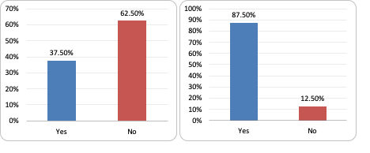
Figure 2 Responses to Q3 (respondents who have received RPL training) and Q4 (respondents who assess RPL)
While 90% of them stated that their institution has a policy or framework to assess RPL (Q6), when it comes to describing the elements of this policy or framework, they heavily agreed on how the policy specifies the types of RPL (14.5%), followed by clear guidelines of legibility criteria (13.9%), clear details of documentation requirements (13.4%) and clear information on student’s appeal process (11.7%) (Q8).
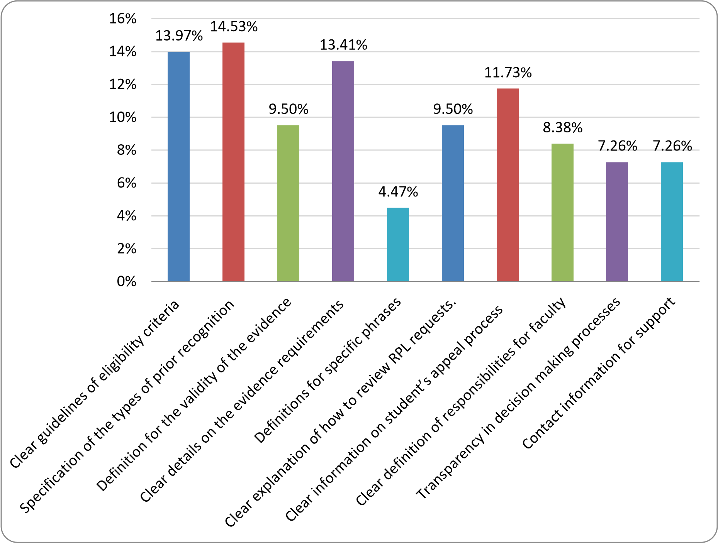
Figure 3 Responses to Q8 (Perceptions of RPL processes)
In response to how familiar they are with the RPL process (Q10), 37.5% of them were moderately familiar, 30% of them were very familiar with the RPL processes at their respective universities and institutes (figure 4).

0.00
%
20.00
%
37.50
%
30.00
%
12.50
%
0
%
10
%
%
20
%
30
40
%
Not familiar at all
Somewhat familiar
Moderately
familiar
Very familiar
Extremely familiar
Figure 4 Responses to Q10
(how familiar faculty staff are with the RPL process)
Although they stated that they were moderately or very familiar with RPL processes (Q11), they were not very confident (15% slightly confident, 42.5% moderately confident and only 20% was very confident) in providing a clear definition of the RPL process (figure 5). This may indicate that even though they are involved in the RPL process, and were familiar with the RPL processes, they were challenged to provide a clear definition of RPL processes.

%
5.00
15.00
%
42.50
%
%
20.00
17.50
%
%
0
%
20
40
%
60
%
Not confident at all
Slightly confident
Moderately
confident
Very confident
Extremely
confident
Figure 5 Responses to Q11
(Level of confidence in providing a clear definition of the RPL process)
Another interesting finding related to Q12 (formal learning) and Q13 (informal learning) (Figure 6).
While they stated that they understood formal learning recognition in RPL (35% [moderately] and
30% [very well] followed by 20% [extremely well]), when it comes to informal learning recognition 50% reported a moderately understanding, with 17.5% not understanding informal learning recognition at all. This may raise a question of how informal learning recognition in ITE institution’s policy and framework is defined, if there is any, to help the staff understand how to assess this kind of recognition.
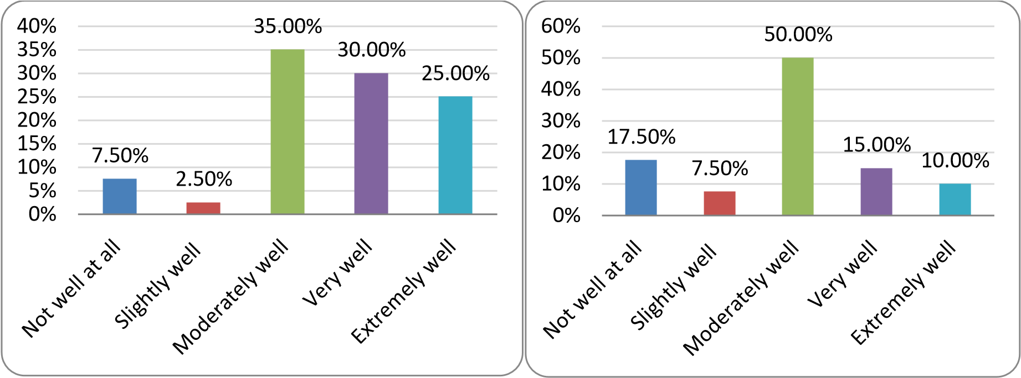
Figure 6 Responses to Q12 (on the left-reported understanding of formal learning) and Q13 (on the right-reported understanding of informal learning)
Reponses to Q14 regarding the clarity of RPL terminology used in ITE policies and frameworks reveals that they are moderately clear (47%) and somewhat clear (27.5%) (Figure 7). This finding also relates to Q11 where respondents stated that are not confident in defining RPL processes, as this may be due to the lack of clear terminology around RPL in ITE policies or frameworks.

5.00
%
%
27.50
47.50
%
20.00
%
0.00
%
%
0
%
10
%
20
%
30
%
40
%
50
Not clear at all
Somewhat clear
Moderately clear
Very clear
Exceptionally clear
Figure 7 Responses to Q14(perceptions of the clarity of RPL terminology used in ITE policies)
In terms of metrics or parameters that are used to calculate the amount of credit granted through RPL, 35% of respondents stated that they have a credit transfer policy for this, while 30% of them stated they were assessed individually (Figure 8). This may indicate that there is no consistency across ITE programs in terms of clear metrics to assess RPL.

%
7.50
35.00
%
%
2.50
%
30.00
%
25.00
%
0
5
%
%
10
%
15
%
20
%
25
%
30
35
%
40
%
Yes, we have set
standards based on
the type and
relevance of prior
learning.
Yes, we have a
credit transfer
policy with defined
credit limits for RPL.
Yes, a committee
decides on RLP
credits after
considering the
evidence.
No, each case is
assessed
individually.
Do not know/Not
sure.
Figure 8 Responses to Q15
(parameters that are used to calculate the amount of credit granted through RPL)
In terms of emphasising fairness of RPL assessments in ITE, respondents stated that their institution is somewhat fair (32.5%), or they remained neutral (27.5%). This shows that most of ITE programs do not provide a clear definition or place an emphasis on fairness when assessing RPL (Figure 9). Most of them also do not know how their institution addresses potential biases that may arise during the evaluation of prior recognition with 29% (Q17).

%
25.00
32.50
%
%
27.50
%
10.00
2.50
%
%
2.50
0
%
%
5
%
10
%
15
20
%
%
25
30
%
35
%
A strong
emphasis on
transparency
and fairness.
Somewhat
emphasis on
transparency
and fairness.
Neutral
emphasis on
transparency
and fairness.
Somewhat lacks
emphasis on
transparency
and fairness.
Strongly lacks
emphasis on
transparency
and fairness.
Not applicable.
Figure 9 Responses to Q16
(respondent’s perceptions of emphasising fairness of RPL assessments in ITE)
In response to Q18 which relates to how to ensure that students are fairly evaluated based on the content of their prior knowledge or experiences, 41% of respondents stated that they use clear evaluation criteria.
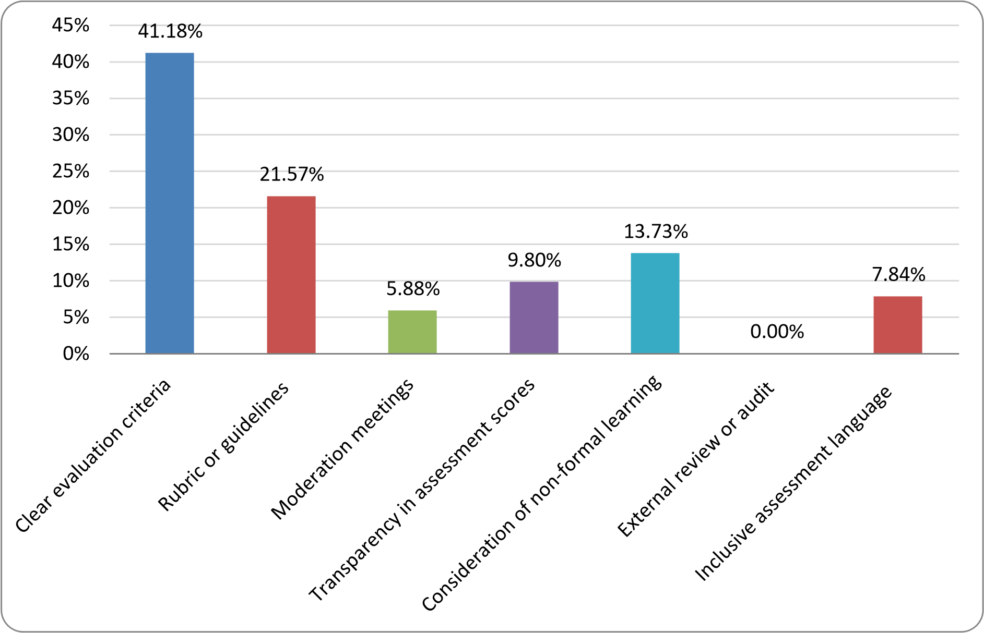
Figure 10 Responses to Q18 (processes used to fairly evaluate RPL)
In terms of keeping the records of RPL assessments and outcomes, majority of respondents stated that their institution keeps the records indefinitely (37%) or up to 5 year (33%). 75.6% of them also stated their institution has an established system to keep records safe on a database.
On collecting feedback from students about their experience with the RPL process, 84.6% of the respondents stated that they do not know if their institution collects student feedback on RPL experiences. 81.5% of respondents also do not know if their institution uses such data for institutional improvement.
Finally, respondents were asked if they can rate their satisfaction level of their current prior recognition processes/procedures of their institution. 42% of them stated that they were neutral, 31.5% were satisfied, while 23.6% stated that they were not satisfied (see Figure 11).

0.00
%
%
23.68
42.11
%
31.58
%
2.63
%
0
%
10
%
%
20
%
30
%
40
50
%
Very Unsatisfied
Unsatisfied
Neutral
Satisfied
Very Satisfied
Figure 11 Responses to Q29
(Staff satisfaction levels of their current RPL process at their institutions)

Conclusion
The aim of this study was to investigate how participants in Australian ITE programs perceived and responded to RPL. According to the data, a sizable percentage of respondents did not obtain professional development or training on RPL procedures. Nonetheless, most of them stated that they evaluated RPL applications. The principal evaluators of RPL in ITE were found to be program convenors/directors.
A substantial number of respondents said that the training opportunities offered to academics and staff participants in the prior recognition process were not applicable (N/A). The most commonly reported forms of training for those who did receive it were diversity and equity, coaching, and mentoring.
The majority of respondents said that their organisation has a structure or policy in place for evaluating RPL. They underlined how crucial it is to include details on the student's appeal process, eligibility conditions, paperwork requirements, and RPL types in these rules or frameworks. Even though a significant percentage of respondents stated they were familiar with the RPL processes, a substantial percentage indicated uncertainty about being able to define it clearly. This implies that despite participation in RPL processes, there may be a knowledge gap.
Remarkably, when it came to formal learning recognition, respondents understood it better than informal learning recognition. This calls into question the definition and handling of informal learning recognition in the frameworks and policies of ITE programs. Another contributing factor in the respondents' lack of confidence in defining the RPL process may be their moderate clarity of the terminology used in ITE policies and frameworks. The metrics or elements used to determine the credit amount awarded through RPL varied, suggesting that ITE programs were not all the same.
There was variation in the importance placed on fairness in RPL ratings; most respondents indicated neutrality or a moderate emphasis on it. This raises the possibility that RPL definitions and policies related to fairness in RPL evaluations need to be clarified.
A significant portion of respondents indicated that their institution uses established mechanisms to ensure the security of records, and the majority stated that records of RPL evaluations are kept either permanently or for a maximum of five years. However, it was discovered that there were instances where student feedback was often not collected regarding their RPL experiences, with the majority of respondents stating that they had no idea if their institution gathered this kind of feedback or utilised it for institutional development and improvement.
Lastly, a significant number of respondents reported neutrality, while others stated varying degrees of pleasure with their previous recognition processes. Furthermore, more than 50% of the participants mentioned that they were facing difficulties or problems with their existing RPL processes.
These findings highlight areas where improvements and clarifications in RPL policies, training, and assessment practices within ITE may be beneficial. They also indicate moderate to high degree of familiarity with this key component of teacher preparation. This suggests a promising base on which organisations might develop RPL procedures that are more reliable.

Appendix C: Phase 3 Social Labs
Led by Kim Wilson, Janet Dutton, and Rebecca Andrews, from Macquarie University.
When addressing the need to create an evidence-informed framework to assist ITE providers in providing RPL for students, the University of Sydney Consortium placed a strong emphasis on engaging with the stakeholders. Consequently, social labs were the medium selected for the Phase 3 consultation because social labs seek to bring together a diverse range of stakeholders to develop new approaches to solving complex social problems. Social labs are part of an emerging field of practice (Mackenzie, 2015), as a way of dealing with ‘wicked’ (Lake et al. 2016) or complex social problems. Social labs have been chosen in this phase of the project to enable the widening of stakeholder perspectives and to provide an opportunity to open possibilities, sharpen ideas, shape attitudes, build trust and alignment, and identify opportunities for intervention (adapted from Mackenzie, 2015). The process of awarding RPL requires deep knowledge of ITE course requirements together with a sophisticated understanding of how learning and/ or work experiences map to ITE course outcomes. Furthermore, the broader implications of awarding RPL for ITE student preparedness to teach requires both knowledge and experience in classroom practice. The complexity of awarding RPL when combined with the imperative to address critical teacher supply issues through the acceleration of candidates through ITE programs is indeed a complex social problem in need of well-considered and multifarious approaches.

Methods

Participants
The following stakeholders were invited to participant in the Consortium social labs:
• One staff member from each ITE provider in Australia
A total of 19 stakeholders participated in the three social labs, with each social lab having between five and seven participants. All participants were based in a higher education institution with 18 participants holding academic teaching and/or research positions and one participant a professional staff member working in admissions and enrolments.

Data Collection
Three, 2-hour social labs were held in the week commencing 02/10/2023. Morning and afternoon labs were offered to accommodate the different time zones across Australian states and territories. All three social labs were facilitated by the same researcher and used the same presentation materials (see Appendix C for the Social labs slide deck).
The Social labs allowed for guided rather than directed discussion. The discussion was framed by four questions:
- What are the current enablers for entry into and progression through an ITE program?
  - What enabling factors are most significant to accessing and progressing through an ITE program?
- What are the current constrainers for entry into and progression through an ITE program?
  - What constraining factors are most significant to accessing & progressing through an ITE program?
- What do accessible pathways into and progressing through an ITE program look like?
- How can ITE providers and regulatory and accrediting bodies support accessible pathways into teaching?
Participant discussion of responses to questions 1 and 2 took between 40 mins to 1 hour. At this midpoint of the social lab, the facilitator came back into the group to summarise key discussion points, highlight identified issues, and recap suggested solutions. Participants spent the remainder of the social lab discussing responses to questions 3 and 4. When the discussion had exhausted itself, or the 2 hours had been reached, the facilitator came back into the group, thanked everyone for their contributions and closed the lab.

Data Analysis
Data was coded thematically using Template Analysis. Template analysis is a useful approach for the identification of themes when: i) the data set is large; ii) there are multiple coders; and iii) when researchers are looking for the occurrence of themes using a priori codes (King & Brooks, 2017). Data were coded in a three-phase process with Phase 1 including familiarisation with the data set, recording the occurrence of a priori thematic codes, providing descriptive labels for segments of residual data items, and drafting a template. Two researchers then independently coded 10% of the data set. The inter-rater reliability check for Phase 1 coding was 93.2% in agreement on 74 coding decisions.
In Phase 2, the draft template was applied to the full data set by one researcher using NVivo. In Phase 3, data labels and corresponding items were reviewed by the second researcher. In discussion, the researchers fine-tuned data labels as necessary, finalised the template and identified themes. The final template can be viewed in Appendix D.

Discussion mapped to deliverables.
Discussion in the social labs addressed concerns regarding the nature of evidence for RPL together with the processes for recording and moderating outcomes across ITE providers. The social labs
generated newly emerging insights and resolutions for using RPL to support those considering
transitioning into teaching. Below (see
Table 4) we map ACDE project deliverables to the solutions provided in the data. Furthermore, we note potential constrainers to practical solutions as identified in social lab discussion.

Table 4 Analysis of Social lab data, mapped to ACDE RPL Guideline deliverables.

ACDE Solutions from Potential constrainers
Deliverable the data from the data

Forms of evidence for RPL | - Portfolio (16 refs) mapped against AITSL Standards (21 refs)  - Identified UG degrees and Trade certificates, universally accepted as RPL e.g., Nursing degree articulates to Science with Biology specialization (refs are embedded in ‘Difficulty in determining RPL’ subcode).  - Statement of Service from employers (1 ref)  Participant comment: ‘instead of me trawling through every Bachelor of Nursing applicant to see if I can finagle four courses that I can count towards biology, or whatever, just having a blanket, “If you have a Bachelor of Nursing, you are eligible to teach biology. If you have a Bachelor of Engineering, there is an assumption – even if you have not done four courses called Advanced Engineering Mathematics – because the entire practice is based upon mathematics, if you have got a Bachelor of Engineering, you are qualified to teach mathematics.” (pp. 124-125). |  | 1.  2.  3.  4. | Inconsistent approach across state & universities (34 refs). Requirements of State  Accrediting bodies that restrict flexibility in degree program and  unit offerings (31 refs) Large [credit] Units make it difficult to apply RPL for the entire unit. (see 9 refs to ‘Microcredentials’)  Student disadvantaged if given credit for a full unit for which their RPL claim does not address all Unit outcomes/ content. (refs are embedded in ‘Difficulty in determining RPL’ & ‘Microcredentials’ subcodes).
Presentation of evidence for RPL (documentation) | - Portfolio (16 refs) mapped against AITSL Standards (21 refs)  - Degree or certificate testamur (5  refs)  - Test Results e.g., for native language speakers (3 refs) Participant comment: ‘We’re not here to lower the quality, we’re simply looking for equivalent levels of quality with the appropriate evidence.’ (p.  65). |  | 1.  2.  3. | Inconsistent approach across state & universities (34 refs). Requirements of State  Accrediting bodies that restrict  flexibility (31 refs)  Burden of evidence – the huge amounts of evidence required to make an RPL claim was noted  (embedded throughout  Constrainer codes)
Assessment of evidence - processes for RPL | - National guidelines for awarding RPL (22 refs)  - National ITE Outcomes for ITE providers to map courses to (4 refs)  - National Capstone Assessment which could be used to credit |  | 1. 2.  3. | University autonomy (1 ref)  State Accreditation requirements  (31 refs) and,  Inconsistent regulation requirements (8 refs)
Assessment of evidence - processes for RPL |  |  | Participant comment: Accrediting bodies (state bodies/ AITSL) create the requirements/ demands (p115,
RPL for degree entry or 117) that are quite “strict” (p45) (“we progression (7 refs) can’t actually get to the point of
4. Agreed principles and giving the credit where we might like thresholds (3 refs) to” p117).
 | Participant comment: ‘National  1. bodies providing resources, guidelines |  |  | LANTITE hindering access to or completion of ITE degree (18 refs)
 | … seamless and supported. So that we are not independent, different schools having to try and grapple round and do all this.’ (p.115).
Administration & management of RPL (Who  can conduct the assessments) | 1. Program directors/ Course (& sometimes Unit) Convenors i.e., academics are the current assessors of evidence | 1. |  | Inflexible ITE degrees or university structures that make conducting assessments difficult (13 refs).
 |  | 2. |  | Time constraints force rigidity in decisions, no time or  administration support to look at alternatives just check and reject
Record of outcomes of RPL process | Not mentioned in social labs |  |  | (summary).
Moderation/benchmarking of RPL decisions | - National guidelines for awarding RPL (22 refs)  - National ITE Outcomes for ITE providers to map courses to (4 refs)  - National Capstone Assessment | 1. |  | Inconsistent approach across state & universities (34 refs).
Moderation/benchmarking of RPL decisions |  | Participant comment: “And then we are trying to make these decisions to try and make it equitable, but it’s actually a struggle at the moment.
Moderation/benchmarking of RPL decisions | which could be used to credit RPL And all the institutions are doing for degree entry or progression different things. And so are all the  (7 refs) sectors. And so are all the teacher  4. Agreed principles and thresholds registration authorities and boards.”  (3 refs) (p. 52).  Summary of participant comments: National structures and guidance needed for consistency (p115) - including aligning AITSL standards with evidence (p 154). Therefore, national bodies provide resourcing, guidelines – supported process for universities (“not up to one person to decide [the RPL of a particular student]” p115 “We’d all be operating off the same songbook” “we want to enable the right people to become teachers, not gatekeep –we are enablers not gatekeepers.” (p. 117).

Amongst social lab participants there was widespread support for a portfolio to be the form of evidence and mode of presentation in applications for RPL. Participants noted the appropriateness of mapping portfolio items to the AITSL’s Australian Professional Standards for Teachers. There was also strong support for the development of national guidelines for the awarding of RPL, together with some suggestion of national ITE outcomes for ITE providers to map their course content. Participants also saw value in developing national guidelines and national ITE outcomes to assist with the process of moderating and benchmarking RPL decisions.
Some participants suggested a National Capstone Assessment which could be used to credit RPL for degree entry or progression; however, other participants expressed reservations noting the need for ITE provider autonomy and the complexity of different state and territory accreditation requirements as a potential constrainer.
There was minimal discussion of the administration and management of RPL decisions. Participants were more concerned with questions of RPL evidence together with the difficulties, limitations and regulatory constraints that make the award of RPL difficult.
At the conclusion of each Social Lab, participants reported their appreciation for the opportunity to discuss these important issues and potential solutions associated with awarding RPL for ITE.

Appendix D: Phase 4 Co Design Workshop
Led by Wayne Cotton, from The University of Sydney.
The fourth phase of the project was pivotal in developing the evidence-informed Framework for RPL in ITE and involved a one-day hybrid workshop in Sydney. This format allowed for both in-person and virtual participation, broadening the scope of input and collaboration. The workshop represented the convergence of insights and data accrued from the project's initial stages, paving the way for the development of an evidence-informed framework.
The day began with a discussion on the best practices in RPL, drawing from recent literature. This session provided a robust foundation, reviewing global models and frameworks of RPL, highlighting their efficacies and areas needing enhancement. The objective was to equip consortium members with a solid base of RPL best practices that would inform the subsequent stages of guideline development.
Subsequently, the results from the first three phases of the project were presented. This segment provided a holistic overview that encapsulated crucial insights, evolving trends, and a detailed analysis of challenges and opportunities revealed through the document analysis, stakeholder surveys, and social labs. The emphasis was on fostering a unified comprehension of the project's findings among all consortium members, thereby establishing a shared platform for the subsequent development of the framework.
The workshop then transitioned into an interactive phase, emphasising focused discussions on framework development. During this session, consortium members actively engaged in brainstorming and debates, facilitated through a series of breakout groups and roundtable discussions. This collaborative approach was instrumental in aligning theoretical understanding and empirical data into actionable and practical principles.
The workshop also involved writing time for drafting the initial principles. Consortium members in smaller, focused groups, started translating the day's discussions into written form, drafting various sections of the framework. This session was pivotal in transforming collective thoughts and discussions into an initial draft of the RPL Framework.
The day concluded with a critical discussion on standard setting and the evaluation processes for the Framework. This session aimed to establish a method for assessing the effectiveness of the framework and ensuring their adaptability and relevance across different educational contexts within ITE.
Following the workshop, a smaller writing group from the consortium continued the refinement of the draft framework. Their focus was on ensuring the framework and its principles were not only comprehensive and robust, but also practical and user-friendly.
The finalisation of the framework entailed an exhaustive review by the consortium. This process helped ensure that the framework and its principles were not only reflective of the consortium's collective expertise but also aligned with the latest research and best practices in the field. This comprehensive approach to the fourth phase not only solidified the findings from the initial stages but also set a dynamic, evolving blueprint for the future of RPL in ITE.

Appendix E: Terms of Reference
As part of the National Teacher Workforce Action Plan, ACDE have been asked to develop best practice guidelines to support Initial Teacher Education (ITE) Providers offering recognition (RPL) for ITE students who have prior learning, work experience which aligns with the course outcomes in ITE programs. RPL is a process that assesses an individual’s knowledge, skills and capabilities that may have been acquired through non-formal and informal learning to determine the extent to which an individual meets the requirements specified in subject(s)/unit(s)in an ITE program.
The Australian Council of Deans of Education is calling for expressions of interest for Best Practice
Guidelines for the recognition of prior learning (study, work experience and skills) in Initial Teacher Education programs. This is an opportunity for an ITE provider (individually or in collaboration with others) to produce a set of guidelines which can then be distributed across all ITE providers to support the use of quality RPL processes for ITE programs.
The Project
Action 9 in Priority Area 2 (Strengthening Initial Teacher Education) the National Teacher Workforce Action Plan notes the opportunity to ‘recognise previous study, work experience and skills that may be transferable to teaching’. The Action Plan views the use of quality RPL assessment processes as having the potential to contribute to accelerating the progress of candidates in ITE programs. While
Higher Education Providers will have policies, procedures and guidelines governing the ways in which RPL is managed in their programs, this project offers the opportunity for the development of a specific set of guidelines for use by ITE providers.
Outcomes/Deliverables
The project will provide a succinct, practical set of guidelines (in soft and hard copy formats) that will to valid, reliable, and fair outcomes from RPL processes offered to ITE candidates. The guidelines need to address (but are not limited to) matters such as:
- The forms of evidence that need to be provided for an RPL process in a program/course of study.
- The ways in which the evidence needs to be presented (documentation)
- How the assessment process is conducted (pre-assessment/advice; assessment and postassessment).
- Who can conduct the assessments.
- How are the outcomes of the RPL process recorded.
- How RPL decisions are moderated/benchmarked.

Appendix F: Documents included in the Document Analysis archive.
Institution | Title | Approval/review date, length, and access
AITSL | Accreditation Guidelines | 2020  135-page document  Public access
AQF Council | Qualifications Pathway Policy | 2013  5-page document  Public access
AQF Council | Recognition of Prior Learning: An Explanation | 2012  2-page document  Public access
Charles Darwin University | Academic Credit Policy | 2022  8-page document  Public access
Curtin University | Credit for Recognized Learning Policy | 2020  3-page document  Public access
Curtin University | Credit for Recognized Learning Procedure | 2021  8-page document  Public access
Macquarie University | Recognition of Prior Learning Policy | 2020  7-page document  Public access
Macquarie University | Assessing Recognition of Prior Learning Applications Procedure | 2023  6-page document  Public access
Macquarie University | Schedule of Minimum Requirements at Macquarie University | 2023  7-page document  Public access
Monash University | Credit Procedure | 2021  9-page document  Public access
Queensland University of Technology | Manual of Policies and Procedures: Recognition of Prior Learning | 2022  Website  Public access
Queensland University of Technology | Manual of Policies and Procedures: Advanced Standing | 2021  Website  Public access
Queensland University of Technology | Recognition of Prior Learning Protocols | 2019  11-page document  QUT-only access
TEQSA | Guidance note: Credit and recognition of prior learning | 2023  5-page document  Public access
The University of Adelaide | Academic Credit Arrangements Policy | 2023  8-page document  Public access
University of Canberra | Credit Procedures | 2019  14-page document  Public access
University of Canberra | Credit for Non-Award Studies Policy | 2014  6-pages  Public access
University of Newcastle | Academic Credit Policy | 2023  8-page document  Public access
University of Newcastle | Program Based Credit Limits and Currency | 2023  5-page document  Public access
University of New England | Admission, Credit and Enrolment Policy | 2023  14-page document  Public access
University of New England | Guidelines for Advanced Standing for Professional Experience for Education Students | No date  Website  Public access
University of Southern Queensland | Credit and Exemption Procedure | 2023  16-page document  Public access
University of Southern Queensland | Recognition of prior learning | 2023  Website  Public access
University of Sydney | Coursework Policy | 2021  104-page document  Public access
University of Sydney | Coursework Credit Procedures 2015 | 2023  6-page document  Public access
University of Sydney | Faculty of Arts and Social Sciences – Credit Provisions 2016 | 2016  2-page document  Public access
University of Tasmania | Admission, Enrolment and Credit Policy | 2022  2-pages  Public access
University of Tasmania | Recognition of prior learning | 2023  Website  Public access

Appendix G: The Social Lab’s Slide Deck.
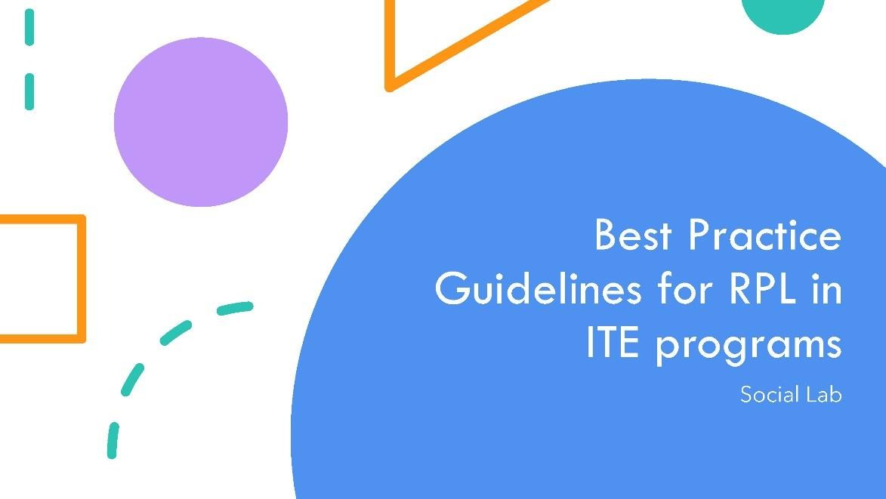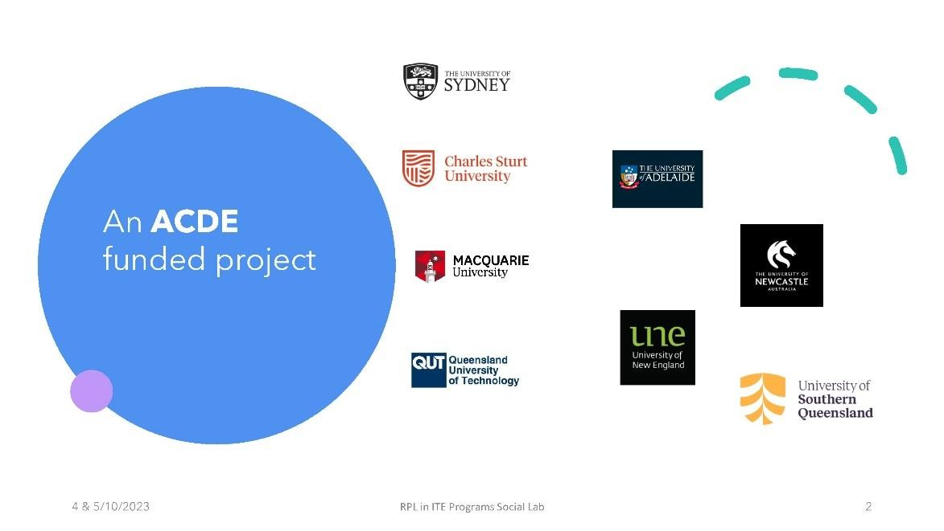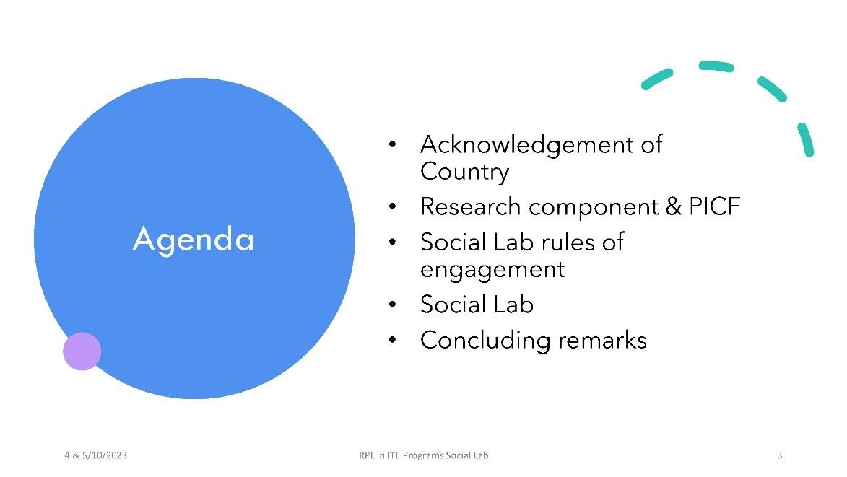

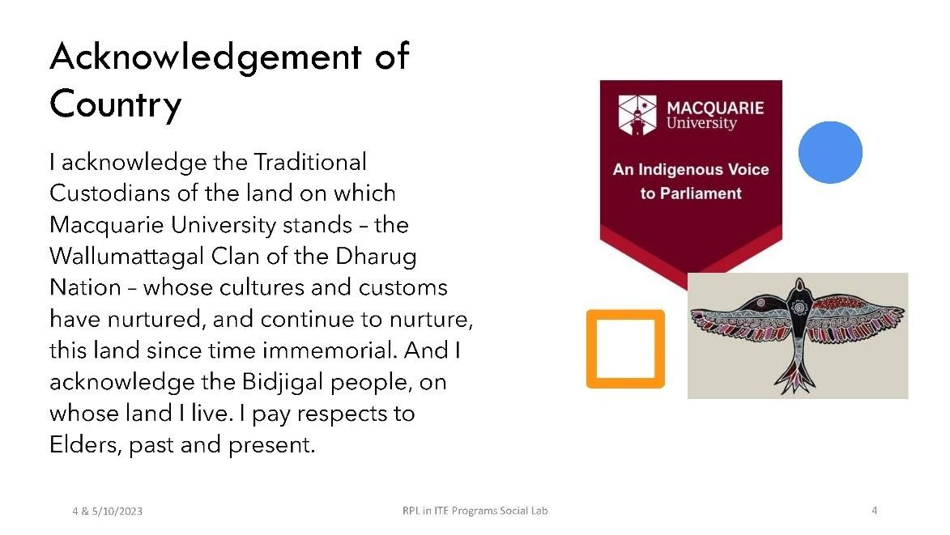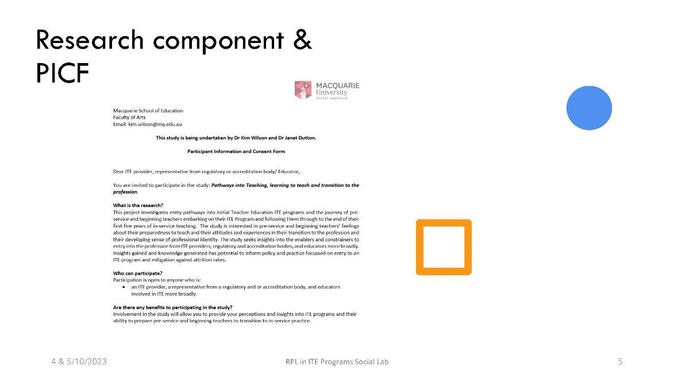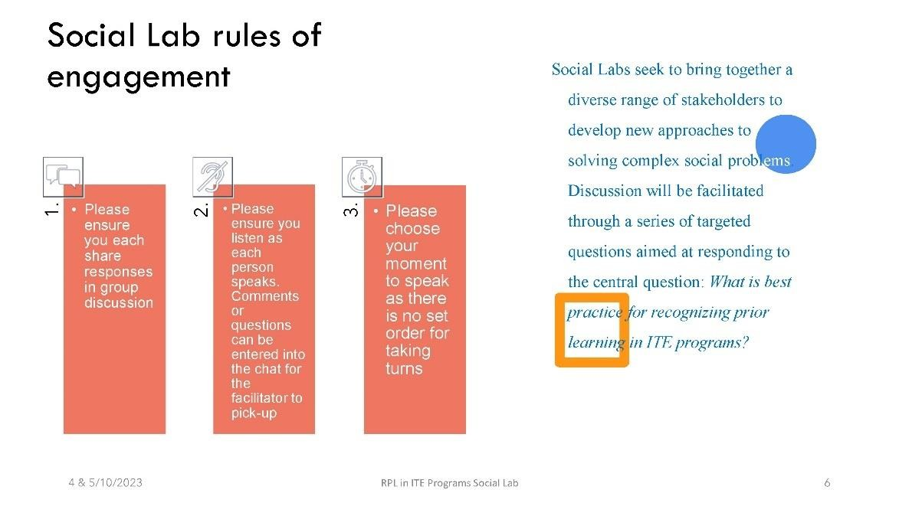

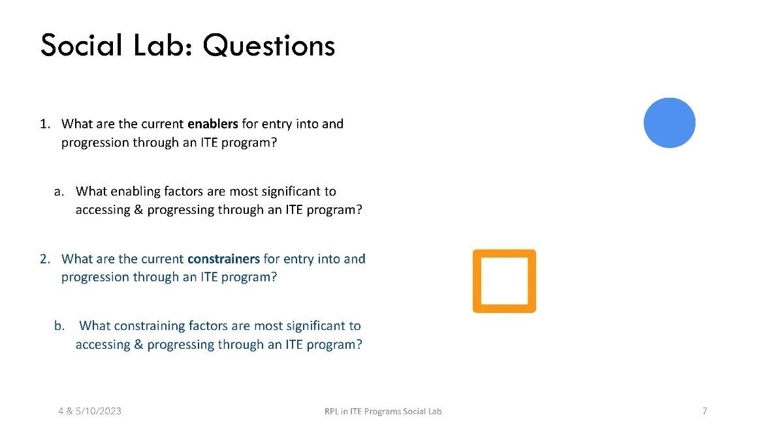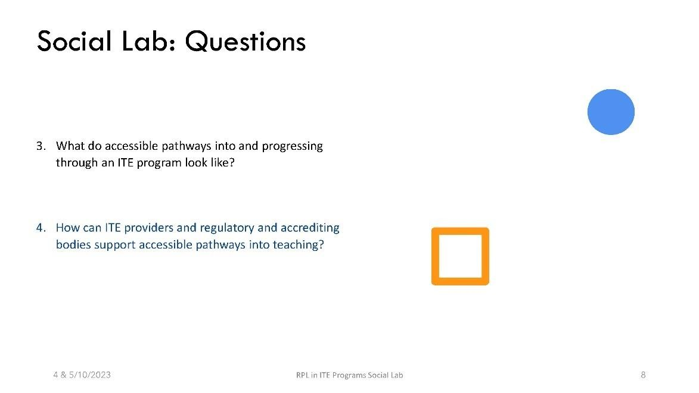

Appendix H: The Final Social Lab Template
Name | Description | Files | References
ACCESSIBLE PATHWAYS IDEAS | Q4: How can ITE providers and regulatory and accrediting bodies support accessible pathways into teaching?
Wellbeing Support | For example, Foundation Studies (in e.g., Academic Writing) – any academic assistance (other than mentoring) that helps students undertake their formal study program.  Wellbeing/ mental health courses or support offered by universities. | 2 | 8
Administrative support for implementation | Any reference to requiring administrative support to enable student progression through degree (including the enrolment process) | 1 | 9
Enrolment process | Assistance for enrolling in ITE degree including real person interaction. | 2 | 10
Consistent approach | Any mention of consistent approach across states & universities | 3 | 34
AITSL alignment | Reference to AITSL and its role in RPL | 1 | 21
Flexible degree structure | Flexibility in unit offerings; multiple sessions throughout the year (i.e., more than 2 semesters); Online &  F2F delivery modes | 2 | 16
Micro-credentials | Units broken into micro-modules to assist with RPL process | 2 | 9
RPL experience | ITE experience with RPL to be easy, equitable and transferable | 2 | 40
Funding | Accessible pathways require budget | 1 | 1
Paid placements for PEx | Paid professional experience (PEx) placement. | 2 | 3
PEx funding | Universities used to receive funding for PEx placements – call for return of this | 1 | 2
Regulation & accreditation | Conditional (or similar – each state calls it something different e.g., ‘Special Authority’) accreditation that facilitates an income. | 1 | 1
Research | Need for research on the topic of RPL | 1 | 1
Scholarships | Scholarships to attract students into ITE degrees | 2 | 3
National Capstone Assessment | A National Capstone Assessment (could be used to credit RPL for degree progression) | 1 | 7
National Guidelines for RPL | National guidelines for awarding RPL upon entry & progression through degree (Incl. max. credit) | 3 | 22

 | Guidelines mapped to AQF levels and National ITE Outcomes with – may include a standard with named degrees (e.g., ‘Nursing degree’) mapped to Subject Content (e.g., ‘Biology’ teaching subject major).
National ITE Outcomes | Provision of National Outcomes that all ITE providers map their Courses to & that may allow greater flexibility in Unit content to facilitate greater program flexibility. | 2 | 4
Portfolio (Port) | Portfolio mentioned as either a way to demonstrate RPL for entry or as a way of demonstrating teaching standards met through Paid in-school Work.  National Guidelines & worked exemplars. | 1 | 16
Teacher internship program | Future ideas around paid PEx, UK (United Kingdom) model etc. | 2 | 15
University autonomy | Need to maintain each universities’ independence | 1 | 1
CONSTRAINERS | Q2: What are the constrainers for entry into and progression through an ITE program?
Band 4-5 requirements | Band 4/ 5 requirements for degree progression/ entry (NSW only?) | 1 | 7
Financial Cost | Reference to unpaid PEx making completion of degree challenging OR perceived that it encourages potential applicants from applying for entry.  Lack of income whilst completing PEx/ academic study  Course fees  LANTITE costs | 2 | 16
Lack of Flexibility | Any reference to lack of flexibility in academic study or PEx that makes completion of ITE degree difficult. Include University structures here. | 2 | 13
Lack of Mentoring | Issues around impact of teacher shortage/ 4th year teachers being required to mentor other less experienced ITE students. | 2 | 3
Lack of RPL Credit - Entry | Lack of Credit for Higher Education formal study and/ or relevant Work experience. Work experience credit can include lack of teaching related credit OR lack of credit for subject content.  Includes references to evidentiary burden of mounting a case for RPL.  Includes difficulty of determining RPL. | 2 | 16
Difficulty in determining RPL | Difficulty in awarding RPL when the applicant’s prior study or work experience partially aligns with Unit outcomes and content. NESA subject requirements make it difficult to allow, for example, an applicant with a nursing degree to gain credit to become a biology teacher. | 3 | 29
Lack of RPL CreditProgression | Lack of Credit for Paid in-school Work completed during the life of the degree. | 1 | 3

Lantite (LAN) | Any reference to LANTITE stopping access to or completion of ITE degree (in terms of completing an English and Mathematics exam) | 2 | 18
Lantite changes | Changes to LANTITE that may hinder ITE entry or progression | 2 | 13
Maintaining degree integrity | Desire to award RPL whilst maintaining degree veracity | 3 | 23
Mentoring by teachers | ITE students need mentoring by in-school teachers | 1 | 3
Teaching aptitude and ability | Can students be assessed for teaching suitability? | 2 | 2
Multiple School PEx requirements | Mention of the requirement to complete PEx in more than one school across life of degree (may be mentioned for particular contexts e.g., rural/ remote) | 2 | 4
Paid in-school Work | Negative impact of Paid in-school Work (i.e., working in a conditionally accredited role). Includes comments about release from PISW. | 2 | 13
Release from PISW | Some students have difficulty being released from PISW in order to complete PEx placement. | 2 | 2
Requirements of State Accreditation body & regulatory demands | See references to NESA (or similar according to state jurisdiction), AITSL Standards etc.  Include references to how these requirements reduce flexibility in degree program & unit offerings. | 3 | 31
Inconsistent regulation requirements | Lack of regulatory requirements across states | 2 | 8
Lack of communication to university | Universities do not know which students have authority to teach (whilst completing studies) | 1 | 3
Workload | PISW combined with study is a high workload | 1 | 1
ENABLERS | Q1: What are the enablers for entry into and progression through an ITE program?
Autonomy Voice | ITE students have a sense of autonomy/ agency in how they structure their degree program or how they organize their study/ work balance etc. | 1 | 3
Financial Support | Scholarship for ITE degree completion and/ OR paid professional experience (PEx) placement.  OR, conditional (or similar – each state calls it something different e.g., ‘Special Authority’) accreditation that facilitates an income. | 3 | 21
Flexibility (Flex) | Flexibility in unit offerings; multiple sessions throughout the year (i.e., more than 2 semesters); Online &  F2F delivery modes | 2 | 11
LANTITE | LANTITE assists ITE students’ progress through their degree | 1 | 1
Outreach | Secondary School outreach programs that show students what Uni looks like or how to access entry etc. | 0 | 0
Alternatives to ATAR | Alternatives to needing an ATAR to access university. | 1 | 1
Seeing themselves at university | Students ‘seeing themselves’ as university students (identity development?) | 1 | 1
Personalisation | Mention of personal contact OR a real person answering email queries/ face-to-face inquiries etc. It may also sweep in follow-up care (re: enrolment) OR contact from a Uni Mentor or Course or Unit Convenor etc. Mentoring: Any form of informal or formal mentoring support for ITE students. Any mention of 'looking after' students, 'place of belonging' or approach to individualising/differentiating for students | 3 | 17
Mentoring (Men) | Formal or informal mentoring support for students | 2 | 3
RPL Credit-Entry | Credit for HE (Higher Education) formal study and/ or relevant Work experience. Work experience credit can include teaching related credit OR credit for subject content. | 3 | 57
RPL Credit-Progression | Credit for Paid in-school Work completed during the life of the degree. | 1 | 2
School-University partnership | Strong School-university partnerships might enable ITE students to complete their degree | 3 | 5
Teacher need |  | 1 | 3
Wellbeing Support | For example, Foundation Studies (in e.g., Academic Writing) – any academic assistance (other than mentoring) that helps students undertake their formal study program. Wellbeing/ mental health courses or support offered by universities. | 3 | 7
OTHER
Comments and attitudes from participants |  | 0 | 0
Impact of teacher shortage | Interplay of pressure to grant RPL, may reference degree integrity, linked to teacher supply issues | 2 | 9
LANTITE | Imagining an improved LANTITE to support ITE students & teaching profession | 2 | 5
Paid placements vs university course completion | Conflict of paid placement with university course completion | 2 | 12
Pathway reflections | Imagining new & innovative solutions to pathways into teaching, granting RPL & ITE training. | 2 | 10
RPL |  | 3 | 29
UK model (apprenticeship) |  | 1 | 4
Comments on terminology differences | Noting difference in terminology across states. | 1 | 10
Enablers and constrainers intertwine | Comments linking the enablers and restrainers | 3 | 10

Appendix I: Examples of evidence of Formal, Informal, and Non-formal Learning that may be used for RPL in ITE
Recognition of Prior Learning (RPL) evaluates an individual's previous learning experiences to decide if credit should be awarded. This assessment encompasses formal, informal, and non-formal types of learning. The Australian Qualification Framework (2013) Glossary of Terminology provides definitions on these forms of learning.
- Formal learning – learning that takes place through a structured program of learning that leads to full or partial achievement of an officially accredited course.
- Informal learning – learning gained through work, social, family, hobby or leisure activities and experiences. It is not organised or structured in terms of objectives, time or learning support.
- Non-formal learning – learning that takes place through a structured program of learning but does not lead to an officially accredited qualification.
The table below provides an overview of examples of Formal, Informal, and Non-formal learning relevant to RPL for ITE (N.B. sections of the table are adapted from NESA (2022) documentation)
Table 5 Examples of Formal, Informal, and Non-formal learning relevant to RPL for ITE.
Type of Learning |  | Examples relevant to ITE | Considerations
Formal Learning |  | Undergraduate degree in related field. | Or components of degree
 |  | Postgraduate qualifications in related field. | Or components of qualification
 |  | Accredited teacher training courses | Or components of courses
 | Informal learning | Length of employment. | Timeframes of employment at any business or company relevant to the industry that relates to the Discipline Knowledge.
 |  | Conference attendance record. | May include conferences with a focus on identified discipline knowledge
 |  | Interview notes. | Transcripts of interviews about identified discipline knowledge may be used.
 |  | Professional reading logs and reflection. | May include journals relating to professional readings that the applicant has maintained with critical reflections and/or the transfer of ideas to improve practice.
 |  | Procedure documentation for evaluating programs used in previous professional experience. | May include templates produced by the applicant with completed samples of colleagues' implementation.
 |  | Strategic goal documents. | Must demonstrate the applicant's contribution where goals were collaboratively determined, such as, for the workplace planning or policy and evidence of the applicant's role during implementation.

Reflections by colleagues after  taking part in professional learning delivered by the applicant. | Should outline the impact of the professional learning on the practice of the participant.
Analysed client feedback and survey data. | May be based on programs, projects, and processes, as well as client engagement initiatives.
Analysed client feedback and survey data. | May be based on perceptions about workplace priorities, initiatives, programs, projects, and processes, as well as client engagement initiatives.
Client interview notes. | May show preparations for client interviews as an example of effective communication. Should illustrate the outcome(s) of the meeting and future directions.
Peer feedback. | May include feedback from colleagues outlining the impact of the applicant's personal and/or professional experience on their own practice.
Diary of practice and reflection. | May be excerpts from daybooks or professional journals and evidence-based ideas for future planning.
Resources constructed and shared with colleagues. | May include hands on resources, smart notebook files, computer-based games and tasks, booklets etc. Must be clearly linked to Discipline Knowledge.
Meeting minutes or notes. | May include notes prepared by the applicant prior to a meeting, formal meeting minutes published after the meeting and/or applicant reflections/contributions or proposed actions based on discussions during a meeting with colleagues.
Screenshots of online blogs, wikis, discussion forums. | Must demonstrate a specific aspect of the Discipline Knowledge points and illustrate authentic engagement by the applicant in discussions.
Itineraries and planning documents for events. | Must demonstrate how the applicant has taken responsibility for workplace systems and legislative requirements to ensure client/colleague wellbeing and safety.
Communication with providers. | Should illustrate the outcome(s) of the meeting and future directions.
Communication with colleagues. | Should illustrate the outcome(s) of the meeting and future directions.
Community partnerships and  engagement notes and meeting logs. | Should illustrate the outcome(s) of the meeting and future directions.
Professional reading journal. | May include full references of articles, the purpose of the reading, critical reflection,
Performance review feedback to and from colleagues.
May be drawn from professional or supervisory observation sessions

and evidence of impact on professional practice.
 | Action research project documentation. | Must include evidence of impact of the initiative on subject content knowledge
 | Participation in professional associations. | May include details of how the applicant participated and what the impact was on the practice of others.
 | Planning notes for professional development organised for colleagues and delivered by experts. | May include a needs analysis and follow up.
 | Professional development workshops/forums delivered or attended. | May include extracts of relevant slides from PowerPoint presentations and/or evidence of resources developed.
 | Analysis of professional development workshops/forums delivered. | May include feedback/evaluations from participants and personal evaluation of the initiative.
Non-Formal Learning | Short courses related to teaching skills.  Online courses or workshops on education topics.  Seminars or conferences on teaching methodologies.  Professional development programs not leading to formal qualifications.

References
Andersson, P. (2021). Quality in validation from a Nordic perspective. European Journal of Education, 56(3), 380-390.
Atesok, Z. O., Komsuoglu, A., & Ozer, Y. Y. (2019). An evaluation of refugees’ access to higher education: Case of Turkey and Istanbul University. Journal of International and Comparative Education (JICE), 119-136.
Australian Department of Education (2024) Australian Universities Accord Final Report. The Australian Government.
Australian Institute for Teaching and School Leadership (2015). Accreditation of initial teacher education programs in Australia, AITSL, Melbourne.
Australian Qualifications Framework Council (2013). Australian Qualifications Framework (2nd ed.) Australian Qualifications Framework Council. https://www.aqf.edu.au/framework/australianqualifications-framework
Ball, S., Maguire, M., & Braun, A. (2012). How Schools Do Policy: Policy Enactments in Secondary Schools. Routledge.
Barter, D. (2020). Maynooth University: Submission to the HEA Research on Mature Student Participation in Higher Education.
Baumeler, C., Engelage, S., Hämmerli, C., & Salzmann, P. (2023). Recognition of prior learning in professional education from an organisational perspective. International Journal of Lifelong Education, 42(2), 208-221.
Bourke, T. & Mills, R. (2022). How teacher educators do policy: Enacting primary specialisations. In T.
Bourke, D. Henderson, R. Spooner-Lane, & S. White (Eds.), Reconstructing the Work of Teacher Educators: Finding Spaces in Policy Through Agentic Approaches – Insights from a Research Collective (pp. 31-50). Springer.
Cizek, G. J. (2012). Setting performance standards: foundations, methods, and innovations. Routledge, New York
Department of Education (2022) National Teacher Workforce Action Plan. Available online:
https://www.education.gov.au/teaching-and-school-leadership/consultations/nationalteacher-workforce-action-plan
Duvekot, R. C. & Doorlag, K. (2020). Dialogical Validation in Dutch Teacher Training. In R.C. Duvekot,
A. Karttunen, M. Noack & L. Van den Brande (Eds), Making Policy Work: Validation of Prior Learning for Education and the Labour Market (pp. 269-278). European Centre Valuation of Prior Learning & Bertelsmann Stiftung.
Duvekot, R. C., Karttunen, A., Noack, M. & Van den Brande, L. (Eds). (2020). Making Policy Work: Validation of Prior Learning for Education and the Labour Market. European Centre Valuation of Prior Learning & Bertelsmann Stiftung.
European Centre for the Development of Vocational Training (Cedefop), European Training
Foundation, United Nations Educational, Scientific and Cultural Organization (UNESCO),
UNESCO Institute for Lifelong Learning. (2019). Global inventory of regional and national qualifications frameworks 2019: volume II: national and regional cases. UNESCO.
Fenton P. & Goggin D. (2020). Facilitating Educational Opportunities for Pilots using Cohort RPL. In R.C. Duvekot, A. Karttunen, M. Noack & L. Van den Brande (Eds), Making Policy Work: Validation of Prior Learning for Education and the Labour Market (pp. 137-146). European Centre Valuation of Prior Learning & Bertelsmann Stiftung.
Jackson, J. (2020). Every educator matters: Evidence for a new early childhood workforce strategy for Australia. Mitchell Institute, Victoria University.
Lake, D., Fernando, H., & Eardley, D. (2016). The social lab classroom: wrestling with-and learning from- sustainability challenges. Sustainability: Science, Practice, & Policy, 12(1), 76–87.
Maurer, M. (2021). The ‘recognition of prior learning’ in vocational education and training systems of lower and middle income countries: An analysis of the role of development cooperation in the diffusion of the concept. Research in Comparative and International Education, 16(4), 469-487.
McKenzie, F., 2015. The System Shift Initiative – The story of a Social Lab seeking better outcomes for Australian children. Australian Futures Project.
Mikulec, B., Howells, A., Mihajlović, D., Turiman, P., Ellias, N. N., & Douglas, M. (2022). National Qualifications Frameworks as A Policy Instrument for Lifelong Learning in Ghana, Malaysia, and Serbia. International and Comparative Studies in Adult and Continuing Education, 81.
NSW Education Standards Authority (2018) NSW Supplementary Documentation: Subject Content Knowledge Requirements. Retrieved from https://www.nsw.gov.au/sites/default/files/202301/subject-content-knowledge-requirements-policy.pdf.
NSW Education Standards Authority (2022) Lead Teacher Evidence Guide. Retrieved from https://educationstandards.nsw.edu.au/.
Osman, R., Castle., J (2001). The recognition of prior learning: early lessons, challenges, and promise. SAJHE 15 (1) 54-60. ISSN 1011 3487.
Shelembe, T. N. V. (2021). A practice framework to enhance the implementation of recognition of prior learning: A case study of the Faculty of Health Science at the Durban University of Technology. PhD thesis. Durban University of Technology.
Stuart, L., & Gorman, D. (2015). The experiences of Indigenous health workers enrolled in a Bachelor of Nursing at a regional Australian university. AlterNative: An International Journal of Indigenous Peoples, 11(1), 29-44.
Taylor, E. V., Lalovic, A., & Thompson, S. C. (2019). Beyond enrolments: a systematic review exploring the factors affecting the retention of Aboriginal and Torres Strait Islander health students in the tertiary education system. International Journal for Equity in Health, 18(1), 1-19.
Tertiary Education Quality and Standards Agency [TEQSA]. (2021) Threshold Standards. Retrieved from www.teqsa.gov.au
Tertiary Education Quality and Standards Agency [TEQSA]. (2021) Guidance note: Credit and recognition of prior learning. Retrieved from https://www.teqsa.gov.au/guidesresources/resources/guidance-notes/guidance-note-credit-and-recognition-prior-learning Walsh, A., O'Kelly, J., & Kenny, M. (2020). Spanning Third-Level Institutions and Boundaries: The Higher Education Institutions Further Education and Training (HEI FET) Forum. Adult Learner: The Irish Journal of Adult and Community Education, 111, 120.
Werquin, P. (2021). Recognition of prior learning in France: Where have the RPL-ready applicants gone? European Journal of Education, 56(3), 391-406.
Williams, M. (2019). Developing twenty first century skills in VET. Victorian Department of Education and Training.

