


Accessing the Inclusion Support Portal as an Inclusion Support ECEC User – SIP only
  - Task Card

Who will need this task card?
The Inclusion Support Portal (IS Portal) is a web-based application that manages all early childhood education and care services’ (ECEC) interactions with the Inclusion Support Program (ISP).
This task card is intended for service representatives in ECEC services who require access the IS Portal to develop and manage the services Strategic Inclusion Plan (SIP), including Care Environment Plans.
This role does not allow the user to apply for Inclusion Development Funding (IDF) streams, to access information about children, IDF cases or claims information.

What is this task card for?
This Task Card provides information and a step-by-step guide to support service provider representatives to request access to the Inclusion Support Portal.

Contents
User Options 3
Authorised Access Delegate 3
Inclusion Support ECEC User 3
Inclusion Support ECEC User – SIP Only 3
Gaining IS Portal Access 3
PRODA 3
Logging in to PRODA 4
Requesting access to the IS Portal 6
Activating your access 11
Logging into the IS Portal 11
Finalising an access request initiated by your employer 14

User Options
Anyone seeking access to the Inclusion Support Portal (IS Portal) is referred to as a user. There are three user roles available to early childhood education and care (ECEC) service representatives.

Authorised Access Delegate
This role is for ECEC service representatives who are required to manage access to the Inclusion Support Portal for other users in the service.
Services are encouraged to have more than one Authorised Access Delegate.
Note: To develop and manage their services Strategic Inclusion Plan (SIP) and to apply for IDF, an Authorised Access Delegate will also need to have access to the IS Portal in the role of Inclusion Support ECEC User.

Inclusion Support ECEC User
This role is for ECEC service representatives who need to access to the Inclusion Support Portal to be able to develop and manage their services Strategic Inclusion Plan (SIP), including Care Environment Plans, and apply for IDF.

Inclusion Support ECEC User – SIP Only
This role is for ECEC Educators who need to access to the Inclusion Support Portal to be able to develop and manage the services SIP, including Care Environment Plans.
This role does not allow the user to apply for IDF streams, to access information about children, IDF cases or claims information.

Gaining IS Portal Access
Gaining access to the Inclusion Support Portal requires each user to:
- Have a Provider Digital Access (PRODA) account; and
- Gain permission to act on behalf of the service provider.

PRODA
PRODA is an online identity verification and authentication system that provides secure access a range of Australian Government online services, including the Inclusion Support Portal (IS Portal).
Users from ECEC services who already have a PRODA account, for accessing the Child Care Subsidy System (CCSS) or other government online services, will use the same PRODA account to request access and login to the IS Portal.
Users without a PRODA account must first visit the Services Australia website to register for a PRODA account.
Once a user has a PRODA account they can login and lodge a user access request.

Logging in to PRODA
- Access your PRODA account via the PRODA login page.

If you have a PRODA account, enter your PRODA username and password and click Login. Proceed to Step 2.
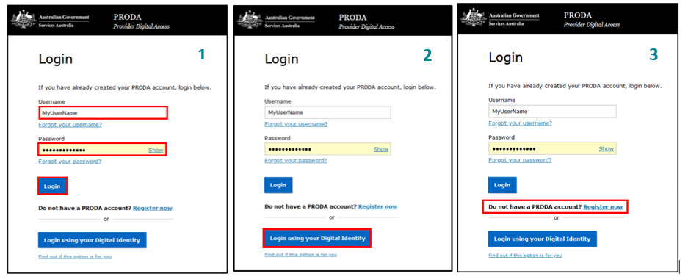
If you have connected your Digital Identity to your PRODA account, click Login using your Digital Identity. Proceed to step 4.

- A passcode will be sent to the email account or mobile phone number you provided when setting up your PRODA account.
On the 2-step verification page, enter the passcode and click Next.
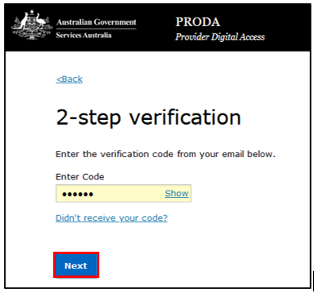
- If you are a new PRODA user, you must first consent to PRODA’s terms and conditions before progressing.
On the Terms and Conditions page, read the terms and click I agree to consent.
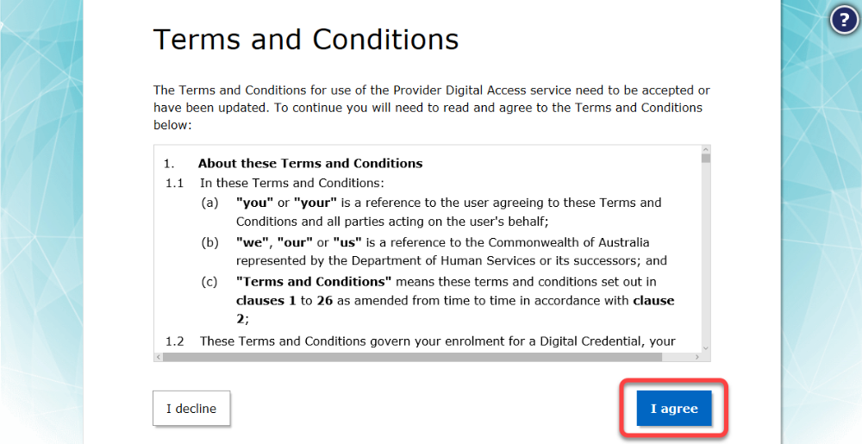
After successfully logging in to PRODA, a page of available services is displayed.
- Select the Child Care Inclusion Support Portal button.
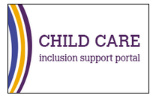
The Portal entry point page will be displayed.
If you are a new user who has not yet been granted access to the IS Portal, only the My portal access section of this page will be visible.
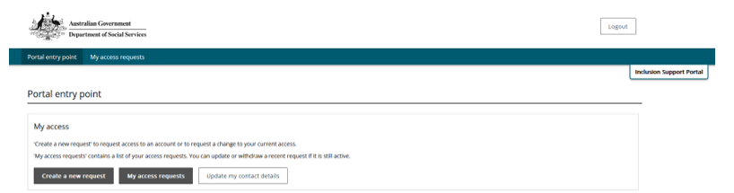
If you are a user who has previously been granted IS Portal access, the page will display available accounts.
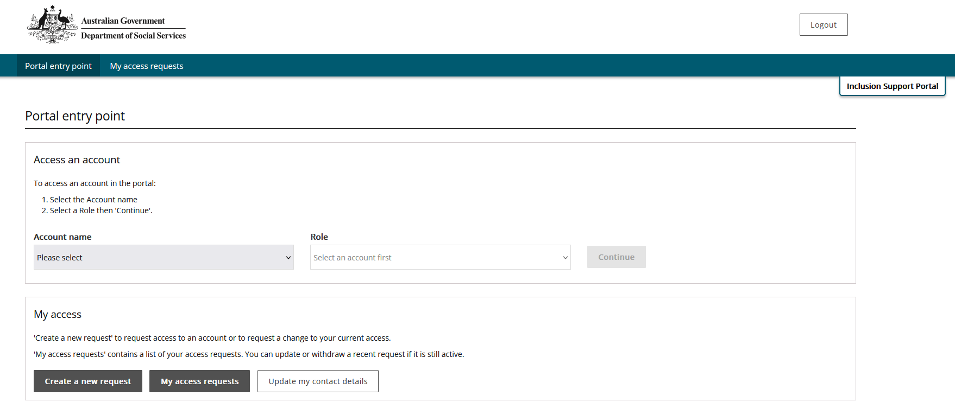

Requesting access to the IS Portal
If you have not previously accessed the IS Portal or you if need to add or change your user access, an access request must be submitted.
Your services Authorised Access Delegate manages the approval of access requests on behalf of your service provider.
- To request access to the IS Portal as an Authorised Access Delegate please refer to the Task card Requesting access to the Inclusion Support Portal in the role of Authorised Access Delegate resource document.
- To request access to the IS Portal in the role of Inclusion Support ECEC user please refer to the Task card Accessing the Inclusion Support Portal the Role of Inclusion Support ECEC User.
- Authorised Access Delegates can request IS Portal user access for other people. Please refer to the Task Card: Authorised Access Delegates - Managing Access to the Inclusion Support Portal.

Request IS Portal user access in an Inclusion Support ECEC User – SIP Only role
- To request user access, login to PRODA and access the Child Care Inclusion Support Portal.
- On the Portal entry Point page, select Create a new request.

The Request to create/update my access page is displayed.
- Read over the information on the page and select I am ready to request access.
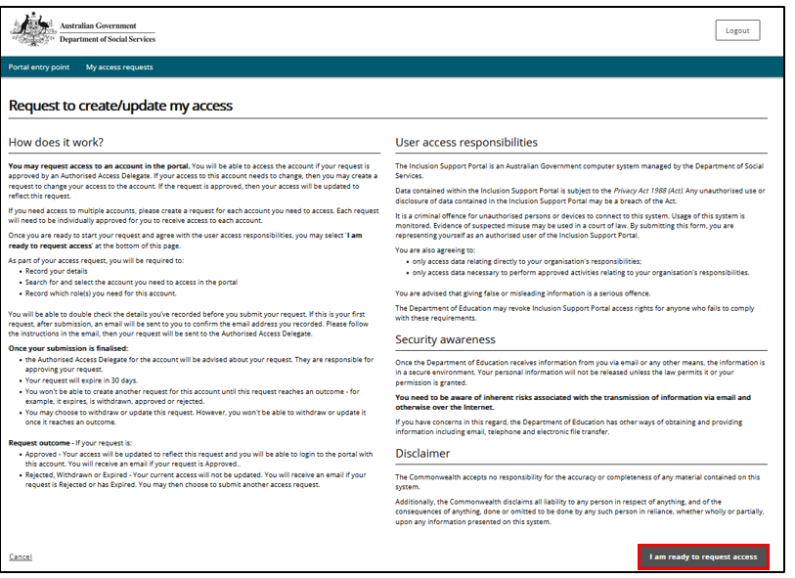
The Record your details page will open.
- Review the details and, if not already listed, add your Phone number. Select Next.
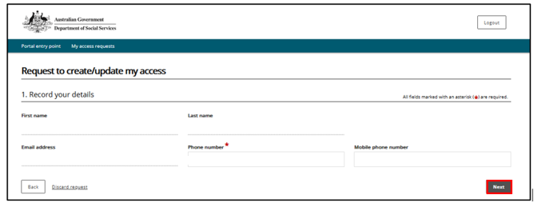
The Search for and select the organisation’s account page will open.
To find the service provider you work for, it is recommended to search by ABN only.
For larger service providers it can be helpful to search by ABN and Postcode.
Note: If you work for more than one employer, or at different service locations for the same employer, you must complete a separate access request for each situation.
- Enter details and click Run search.
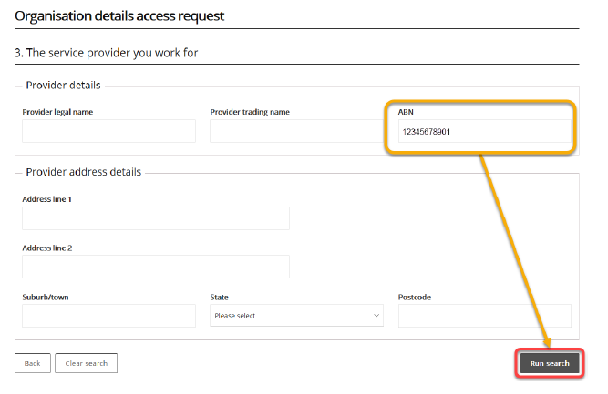
- Select your service provider from the list of results.
The Access to roles page will open.
- Select the Inclusion Support ECEC User- SIP Only role and click Next.
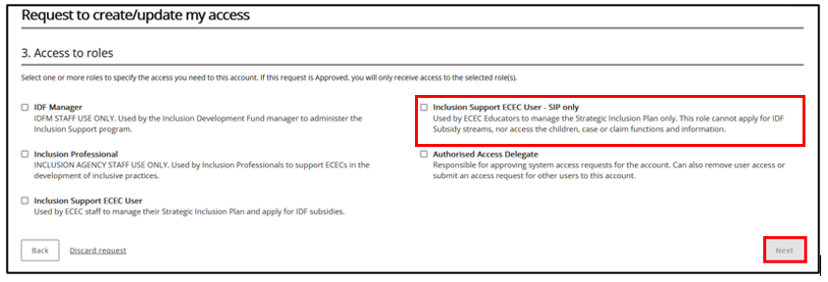

- On the Request summary access request page, review your entries. Click Submit to continue or click Back to edit.
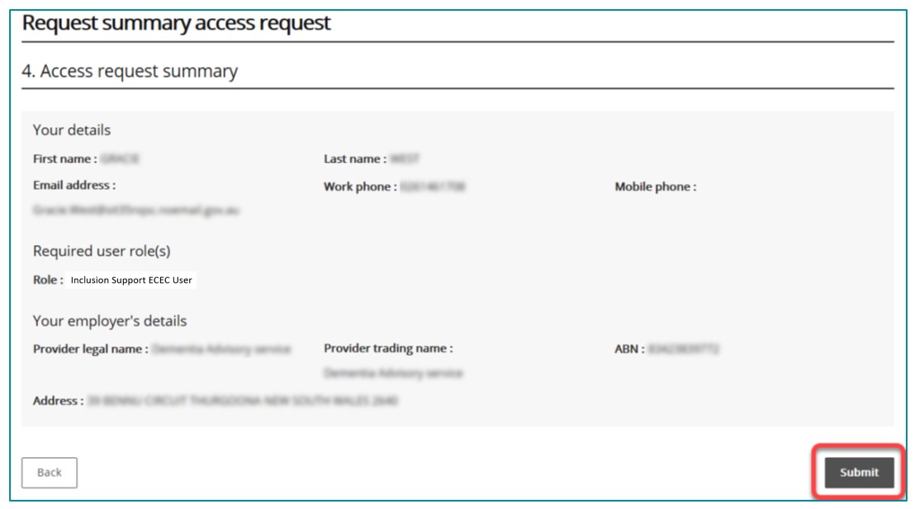
If you have previously accessed the IS Portal in a different user role, you will not need to verify your email address. Finish your access request by following Step 12.
If you are a new user, your email address must be verified before your request can proceed. Continue with Step 9.
- Access your nominated email account and locate the verification email sent to you.
Important: This email contains a token associating your request with your email address and your PRODA ID. If you do not click the link provided in the email and log into PRODA, your email address will not be verified, and the request cannot be processed.
- From the opened email, click Confirm my email address.
Clicking the link opens a browser and takes you to Department of Social Services (DSS) account selection page.
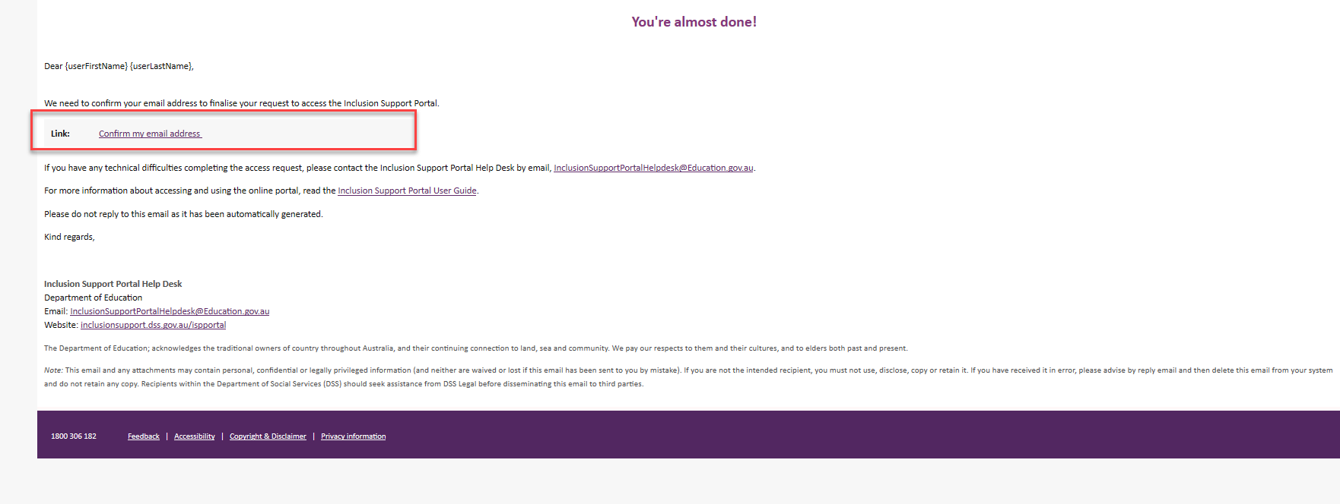
- Select PRODA.
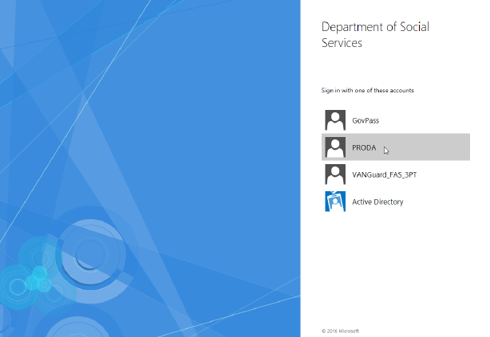
- Log into PRODA as described in the Logging into PRODA section of this task card.
When you have successfully logged in, you are taken to the Finish access request page.
- Read Next Steps and click Finish.
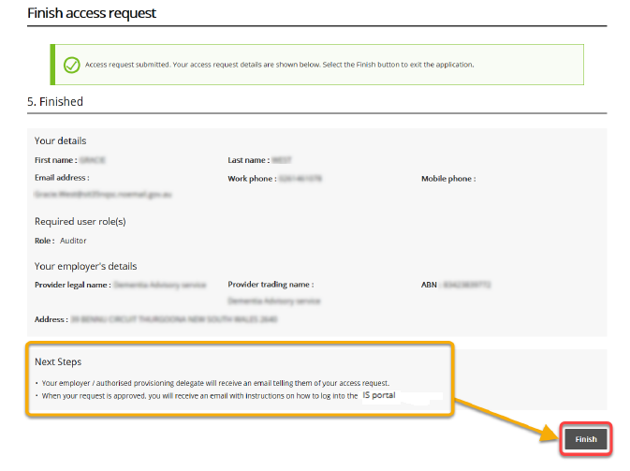
After clicking Finish, you will automatically leave the portal and an email notification will be sent to Inclusion Support Portal Help Desk.
After your request is reviewed by the Inclusion Support Portal Help Desk, you will receive another email telling you whether your request was approved or denied.
- If approved, you may log into the Inclusion Support Portal in your approved role.
- If access has been denied, speak with your services Authorised Access Delegate.
- If you do not receive a confirmation email, contact your provider’s Authorised Access Delegate or the Inclusion Support Portal Help Desk at inclusionsupportportalhelpdesk@education.gov.au.

Activating your access
After your access request has been approved by the Inclusion Support Portal Help Desk, you may
begin using the IS Portal.
- Open your approval email.
- Click activate your access.
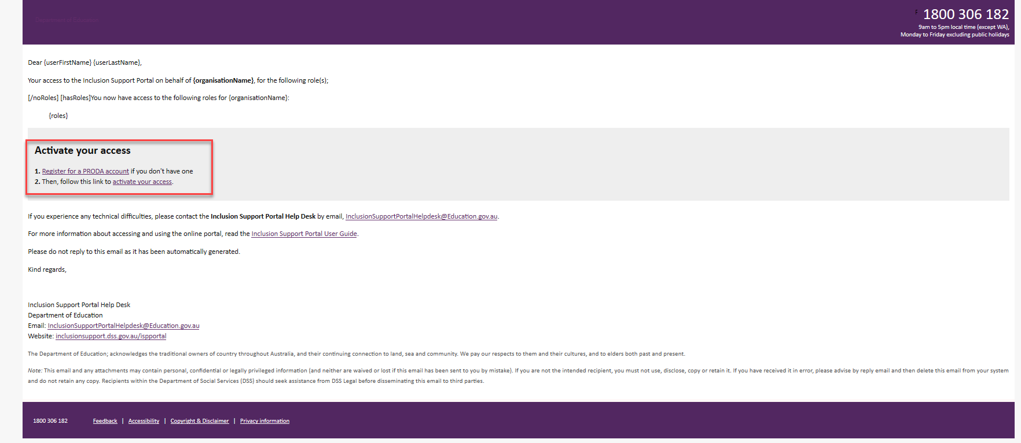
Clicking the link opens a browser and takes you to the Inclusion Support Portal. Follow the steps below to login to the IS Portal.

Logging into the IS Portal
After initially activating you access (refer to page 10), the IS Portal can then be accessed via the PRODA login.
- Login to your PRODA account and select the Inclusion Support Portal tile. Refer to the Logging to PRODA section of this task card for assistance.

When your identity is verified, the Portal entry point page is displayed.
- Select your employer from the Provider name dropdown list.
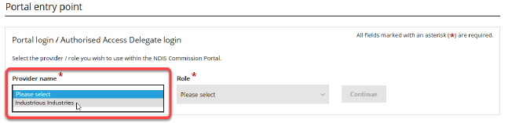
- Using the Role dropdown option, select the role of Inclusion Support User – SIP Only and click Continue.
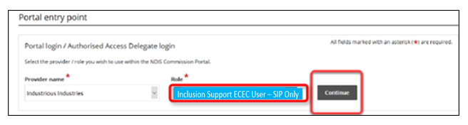
The Inclusion Support Portal entry page will open.
- Read the User Agreement then click I agree to proceed to the IS Portal.
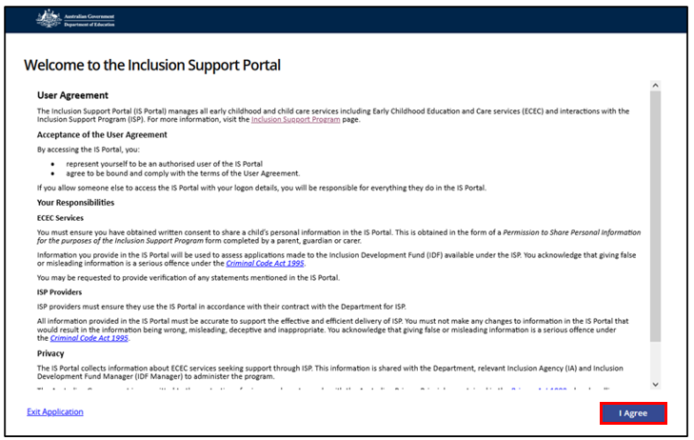
The Inclusion Support Portal homepage dashboard page will be displayed.
Note: You can return to the Portal Entry Point page to log in with a different user role or for a different organisation by clicking Change role/Manage access at the top of the screen.
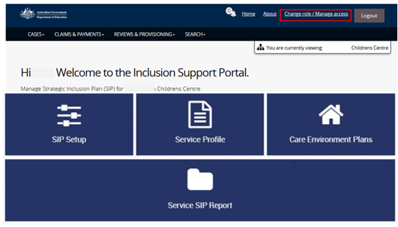

Finalising an access request initiated by your employer
Sometimes an access request may be submitted for you by your employer via their Authorised Access Delegate or the Inclusion Support Program Help Desk. If that is the case, the access request is automatically approved, but you must finalise the request before you can use the IS Portal.
This involves responding to an email notification, confirming your PRODA account and formally agreeing to the terms and conditions of portal use.
- From the opened email, click Finalise Inclusion Support Portal access.
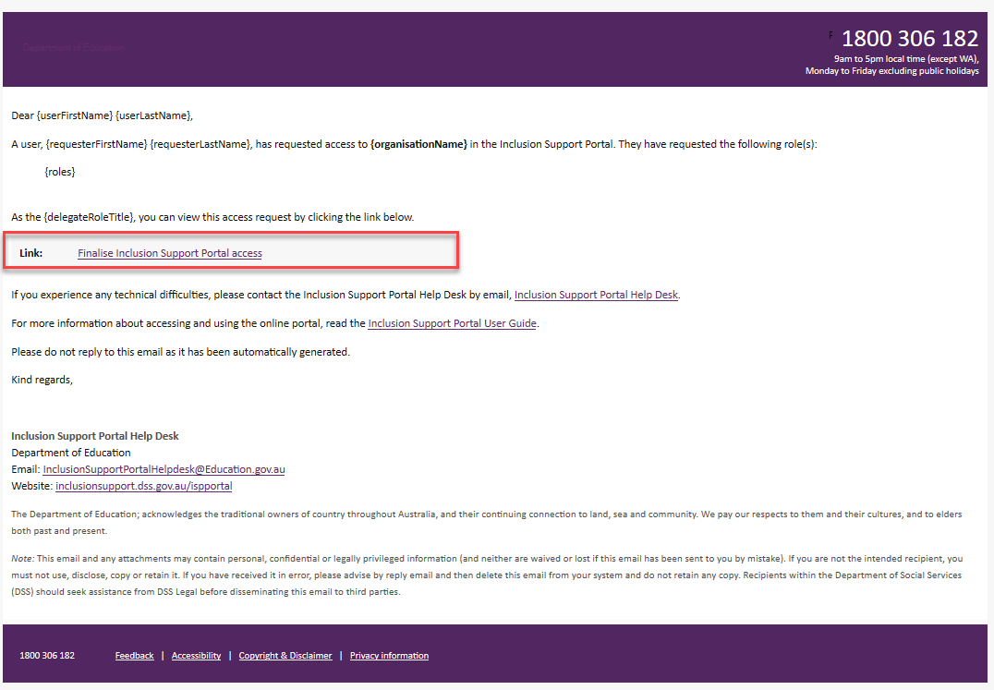
Clicking this link opens a browser and takes you to the Department of Social Services (DSS) account selection page.
It is important that you click the link from the email as it contains a token that will connect the access request with your PRODA account. Without this connection, the request can’t be finalised.
- On the Department of Social Services account selection page, select PRODA.
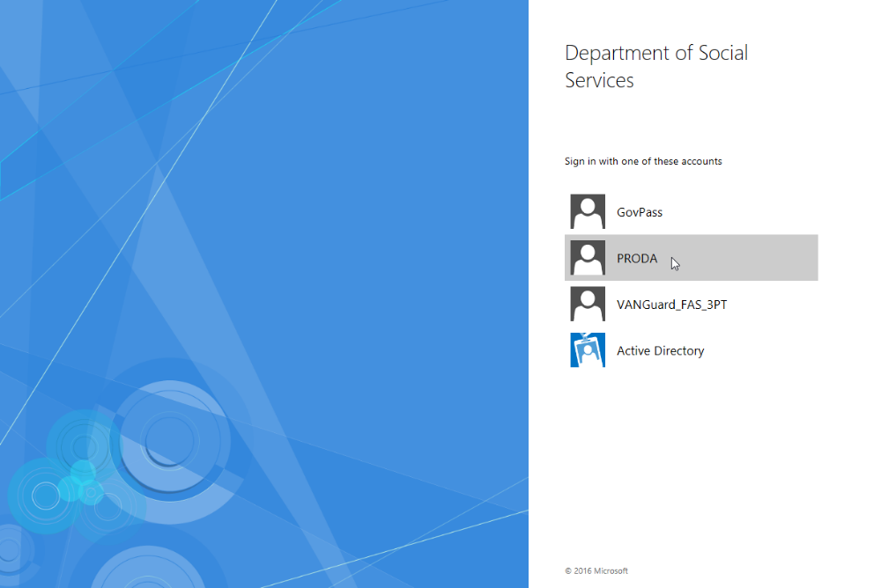
- Login to your PRODA account as described at the Logging to PRODA section of this task card. After authentication, you will be taken to the Portal’s Terms and Conditions page.
- Tick the Acknowledgement to accept.
- Then select Continue.
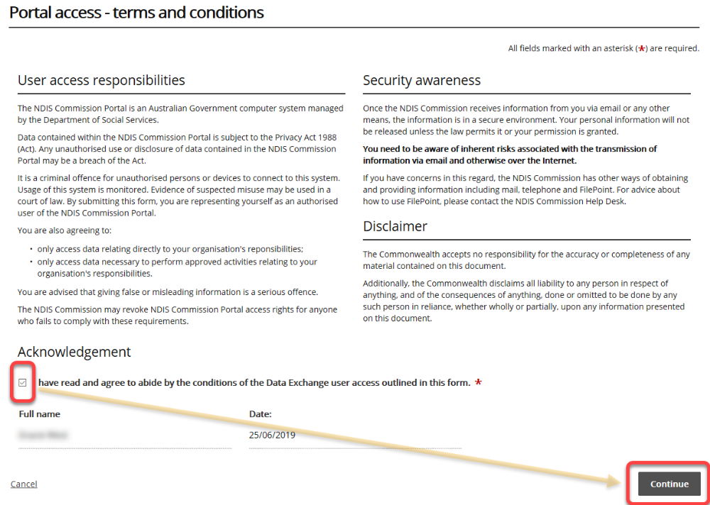
- If this is your first time accessing the portal, Identity Manger (IDM) will need to configure your account. This process may take a few minutes.
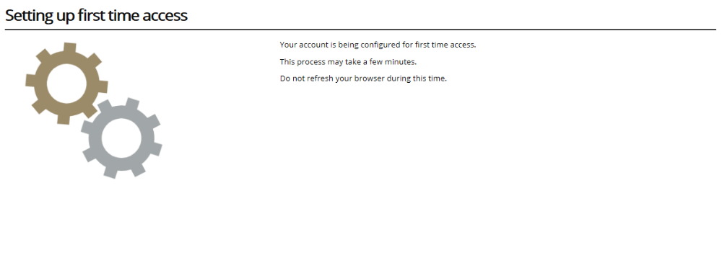
When setup is complete, the Portal entry point page is displayed.
- Follow the steps to log into the ISP Portal.

