MEMORANDUM OF UNDERSTANDING

ON COOPERATION IN HIGHER EDUCATION RESEARCH BETWEEN

THE GOVERNMENT OF AUSTRALIA, AS REPRESENTED BY THE DEPARTMENT OF EDUCATION

AND

THE GOVERNMENT OF COLOMBIA, AS REPRESENTED BY THE MINISTRY OF SCIENCE, TECHNOLOGY AND INNOVATION

The Government of Australia, as represented by The Department of Education and the Government of Colombia, as represented by The Ministry of Science, Technology and Innovation (hereinafter referred to singularly as "Participant" and collectively as "the Participants"):

Desiring to strengthen cooperation in higher education and research in higher education institutions for the economic and social development of each country:

Have reached the following understanding:

**I: OBJECTIVE AND FRAMEWORK**

1. The objective of this Memorandum of Understanding (hereinafter the "Memorandum") is to promote cooperation between the Participants in higher education and research in higher education institutions on the basis of reciprocity and mutual benefit.

**II: SPECIFIC AREAS OF COOPERATION**

1. The Participants, in accordance with their own laws, policies, rules and regulations, will foster cooperation activities in the fields of higher education, research in higher education institutions, and researcher mobility, particularly with regard to:
   1. The exchange of information, subject to the national laws of Australia and of the Republic of Colombia on access to information, including on:
      1. Policies, systems and standards in both countries for research in higher education institutions;
      2. Programs and strategies that enhance the mobility of Australian and Colombian research students, academics and researchers; and
      3. Existing financial support mechanisms for research and other assistance that facilitates the movement of research students, academics and researchers between Australian and Colombian higher education and research institutions.
      4. Policies and practices to promote scientific and research integrity, and governance of research ethics.
   2. Encouraging and facilitating the development of research cooperation between interested higher education and research institutions, hereafter referred to as cooperating partners, and increasing understanding and awareness of the research and higher education systems, policies and programs of both countries;
   3. The development of inter-governmental cooperation through consultations between the Participants in order to identify priority research fields and activities of mutual interest;
   4. Identifying opportunities and working together to design strategies to promote research collaboration between higher education institutions and enhance student, researcher, and academic mobility between the two countries.

**Ill: INFORMATION AND COMMUNICATIONS**

1. For the purposes of adequately coordinating and following up on cooperation activities developed under this Memorandum, the Participants designate the following agencies:

**For Colombia**

* Ministry of Science, Technology and Innovation of Colombia - STI Directorate for Vocations and STI Training

**For Australia**

* The Australian Government Department of Education- International Division

**IV: COSTS**

1. The Participants, as well as any cooperating partners, will decide and be responsible for their own costs in connection with all matters relating to the implementation of this Memorandum of Understanding.

**V: PROTECTION OF INTELLECTUAL PROPERTY**

1. The Participants will take the necessary measures to protect the intellectual property of the other Participant within the framework of this Memorandum in accordance with the national legislation and international conventions in force in their respective country.
   1. To the extent that the Participants wish to assign intellectual property privileges during the term of this Memorandum, the Participants will work in good faith to take appropriate steps to do so in line with the Participants' applicable domestic law.

**VI: AMENDMENT**

1. This Memorandum may be amended by the mutual written consent of the Participants. A Participant that wishes to amend the Memorandum will notify the other in writing, including all relevant details.

**VII: DISPUTE SETTLEMENT**

1. Any dispute or conflict that may arise between the Participants in connection with the interpretation or application of this Memorandum will be resolved amicably through direct

interaction and cooperation. Such disputes or conflicts will not be referred to any national or international tribunal or third party for settlement.

**VIII: DURATION AND EFFECT**

1. This Memorandum will come into effect on the date it has been signed on behalf of both Participants for a period of five (5) years. It will be automatically extended for successive periods offive (5) years, unless either Participant informs the other in writing, at least six (6) months in advance, of its intention not to extend the Memorandum.

**VIII: TERMINATION**

* 1. Either Participant may terminate this Memorandum by giving prior notice to the other Participant, at least six (6) months in advance. Termination will not affect the validity of any activities that have been developed by the Participants. The Participants will consult to determine how any outstanding matters should be dealt with.
  2. This Memorandum represents the entire understanding between the Participants and does not create any legally binding rights or obligations.

The undersigned, being duly authorised by their respective governments, have signed this Memorandum of Understanding.

/2c.>'2 7->

Signed at Canberra on and Bogota on 2.2-?,w""' -in twooriginals, each in the

English and Spanish languages, all texts being equally valid. In the event of any divergence of interpretation, the English text will prevail.

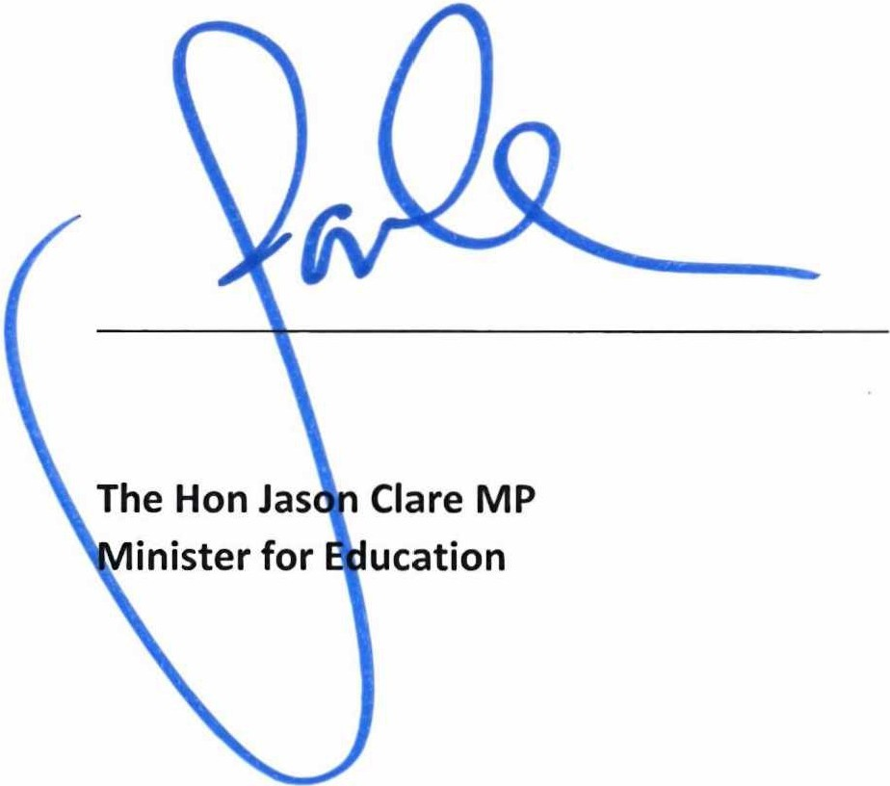FOR THE GOVERNMENT OF AUSTRALIA, AS REPRESENTED BY THE DEPARTMENT OF EDUCATION



FOR THE GOVERNMENT OF COLOMBIA, AS REPRESENTED BY THE MINISTRY OF SCIENCE, TECHNOLOGY AND INNOVATION

Angela Yesenia Olaya Requene Minister of Science, Technology and Innovation of Colombia