

# Summary report on consultation about changes to the Disability Standards for Education 2005

This report gives a summary of the feedback the Australian Government Department of Education (the department) received through a public consultation on possible changes to the Disability Standards for Education 2005 (the Standards). The main possible change is to include and clarify that most early childhood education and care and outside school hours care service (ECEC) providers in Australia must follow the Standards. The consultation was in response to Recommendation 12 of the [2020 Review of the Standards](https://www.education.gov.au/disability-standards-education-2005/2020-review-disability-standards-education-2005). Recommendation 12 is that by 2023, the Australian Government will prepare draft amendments to the Standards to incorporate ECEC for sector consultation. Other possible minor or technical changes to the Standards and a change to simplify the Guidance notes on the Standards were also explained in the consultation.

[Consultation was open from 31 January 2025 to 28 February 2025](https://www.education.gov.au/disability-standards-education-2005/consultations/disability-consultation-ecec) and people could give their views by completing an online survey or providing a submission. The consultation was open to everyone with feedback encouraged from people and organisations who engage with the Standards and the ECEC sector.

### Who we heard from

We received 146 responses from people and organisations including parents and carers of children with disability, people with disability, state and territory governments, ECEC providers and educators, First Nations stakeholders, disability organisations, legal professionals and other stakeholders across the education sector. The chart below shows who completed the survey or sent a submission.

States and territories education officials were consulted separately through the Early Childhood Policy Group. State and territory education ministers and Attorneys-General were also asked to comment.

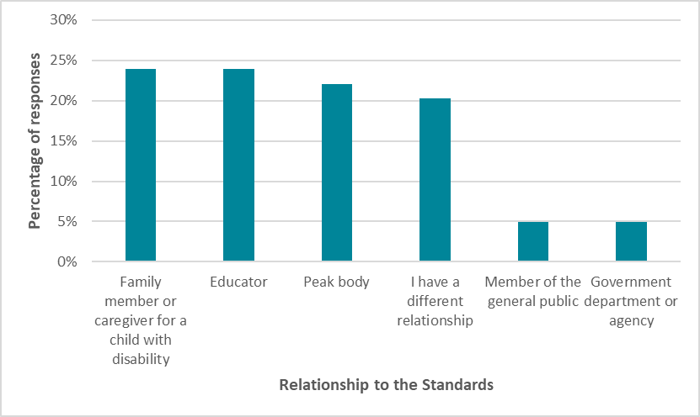

### We asked

We asked two questions about how we were planning to change the Standards to include ECEC services. The questions were:

1. Does the draft definition of an educational early childhood service accurately describe the types of ECEC services most suited to be included in the Standards, such as:
   1. Child Care Subsidy approved providers under the National Family Assistance Law?
   2. Other ECEC services approved under a law of a state or territory who are also required to deliver an education program based on an approved learning framework?
2. Are there any other types of ECEC services that you think should be included in the Standards?

### You said

Overall, the responses received were positive and supportive of the change to include ECEC services in the Standards. Similar benefits were mentioned across feedback from both individuals and organisations. The benefits identified included strengthened accountability increased awareness and clearer guidance to ECEC services about meeting their obligations under the *Disability Discrimination Act 1992* (Cth)(DDA). That this would advance equity and access and support best practice for children with disability.

Peak bodies and providers said the change would prevent segregation and promote inclusion by helping to create a consistent, fair, and inclusive educational environments.

Parents and caregivers commented that the obligations for ECEC services to support children with disability would be more visible which would help improve access to and the delivery of services for children with disability.

It was suggested that the Standards should include additional types of ECEC services that were not covered in the draft definition:

* all recipients of Australian Government funded programs
* all types of providers or programs in the ECEC sector, no exclusions
* transition programs from ECEC to school
* occasional care and non-subsidised or community-based early childhood programs
* playgroups
* early intervention services
* services that give instruction in a particular activity such as Auslan

People also suggested other changes to the draft Amendment Standards such as:

* to be clearer on the new term ‘educational early childhood service / provider’
* to explicitly name the service types in the Standards, such as outside school hours care
* some minor word changes to make the amendments clearer
* to be clear on an individual’s responsibilities in the changes

Four organisations and one anonymous submission were supportive of the policy for ECEC services to be inclusive of children with disability but did not agree with the suggested change. The reason for their views included concern about the adequacy of the Standards to provide the same level of legal protections as the *Disability Discrimination Act 1992*, the change should not occur unless ECEC services have access to a similar level of disability specific funding available to schools and concerns that it would increase red tape for ECEC services.

#### Other comments on the change

People also commented on ways to help implement the proposed change.

##### ECEC educators’ understanding of inclusive education and the Standards

People said proactive education and information would help ECEC providers to understand and meet their obligations to support the necessary changes and make sure there is continued inclusion of children with disability in ECEC services. Professional learning should specifically how to make reasonable adjustments in ECEC settings.

##### Data and compliance monitoring

People said improved data collection and reporting would help to make sure the changes make a difference. Also, the department should evaluate the outcomes of including ECEC in the Standards.

Some suggestions on ways to do this were to have routine audits and evaluations, set up more compliance measures and to explain the evidence ECEC services will need to show they are meeting their obligations.

##### Examples and understanding of reasonable adjustments

There was a call for accessible information on the legal obligations which include descriptions and examples of reasonable adjustments in ECEC settings. Case studies were suggested as a helpful way to show examples of ECEC services working with families and caregivers. It was also raised that clear information on what the concept of unjustifiable hardship means in practice would be an important part of implementation.

##### Funding and resources

Financial, staff and facility development were raised as important resourcing matters to be considered when implementing the change. The resourcing needs of small providers to continue to provide adjustments to support a wide range of needs for children with a disability was also mentioned.

People suggested more disability professionals in ECEC settings would be beneficial. The importance of specialist Aboriginal and Torres Strait Islander staff in order to support First Nations children with disability was also raised.

People commented that there would be costs to make buildings and facilities accessible for children with disability. An accessible learning environment is important for all children to engage and take part fully in the education programs they attend.

### Next steps

The department will review the consultation feedback to prepare final draft amendments for the Australian Government to consider. We will make sure ECEC services are informed of the final amendments and the timing for the implementation of the change.

The department is developing new guidance and training materials to assist staff in building their knowledge of how to apply the Standards. This includes new e-learning courses on the Standards for ECEC and OHSC educators, leaders and support staff.

ECEC providers should continue to make sure they are meeting their obligations under the *Disability Discrimination Act 1992* while change to the Standards are considered.

We thank all those who gave feedback as part of this process.