

# How to view the worker retention payment in the Provider Entry Point

Task card for early childhood education and care (ECEC) providers and services

Follow these steps to view worker retention payments in the [Provider Entry Point](https://proda.humanservices.gov.au/prodalogin/pages/public/login.jsf?TAM_OP=login&ERROR_CODE=0x00000000&URL=%2Fmga%2Fsps%2Foauth%2Foauth20%2Fauthorize%3Fscope%3Dopenid%26state%3DalN0hw9ovD%26client_id%3DGTzCa6CRNfBsRTdfljBa%26redirect_uri%3Dhttps%253A%252F%252Fbusinessonline.humanservices.gov.au%252Fmga%252Fsps%252Foidc%252Frp%252Fchildcaresubsidy%252Fredirect%252Fproda%26response_type%3Dcode&OLDSESSION=) (PEP). If you use a third-party software, contact your software provider for assistance.

If you need more help, contact the Child Care Subsidy Provider Helpdesk on:

* 1300 667 276 9 am to 5 pm AEST Monday to Friday
* [CCShelpdesk@education.gov.au](mailto:CCShelpdesk@education.gov.au) anytime.

**Step 1:** Log in to the [PEP](https://proda.humanservices.gov.au/prodalogin/pages/public/login.jsf?TAM_OP=login&ERROR_CODE=0x00000000&URL=%2Fmga%2Fsps%2Foauth%2Foauth20%2Fauthorize%3Fscope%3Dopenid%26state%3DalN0hw9ovD%26client_id%3DGTzCa6CRNfBsRTdfljBa%26redirect_uri%3Dhttps%253A%252F%252Fbusinessonline.humanservices.gov.au%252Fmga%252Fsps%252Foidc%252Frp%252Fchildcaresubsidy%252Fredirect%252Fproda%26response_type%3Dcode&OLDSESSION=) and select your service.

**Step 2:** On the PEP landing page, find the **Payments** tile and select **More details**.

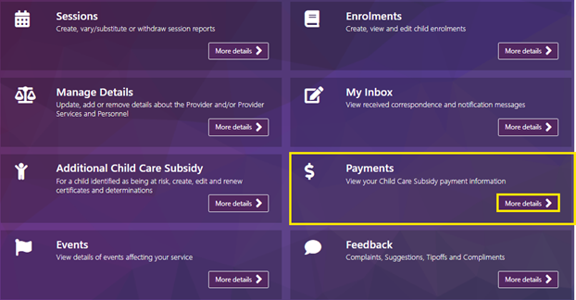

**Step 3:** Under **Actions**, select **View** next to the payment you want to check.

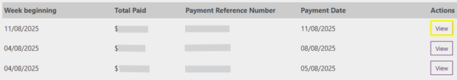

**Step 4:** Look for **ECEC Worker Retention Payment** under the **Payment for** column.

