


HELP Debt Reduction Program for Very Remote Teachers

Applicant Portal User Guide

Table of Contents
1 Introduction 3
1.1 Background 3
1.2 Notes 3
2 Application Process 4
2.1 Overview 4
2.2 Prerequisite 5
2.3 Access to the portal 5
2.4 Registration 6
2.5 Welcome page 7
2.6 Set up your profile 7
2.7 Portal dashboard 10
2.8 Add your employment details 12
2.9 Editing personal details 14
2.10 Starting a new application 15
2.11 Submit an application 16
2.12 Submit an application (employment details) 17
2.13 Submit an application (confirmation) 18
2.14 After submission 18

Introduction

Background
The Applicant Portal is available to submit your application for the Higher Education Loan Program (HELP) Debt Reduction Program for very remote teachers.
Implemented on 1 January 2019, there are two types of assistance available:
- waivers of indexation on outstanding HELP debt and
- reduction of accumulated HELP debt.
Both types of assistance are available to teachers who are/were teaching in a very remote area of Australia at:
- a primary or secondary school
- a centre-based day care service
- a preschool.
Further details on the program are available at: Reduction of Higher Education Loan Program (HELP) debts for teachers in very remote areas.

Notes
All personal information listed on the screens in this document are fictitious, except the name and address of the “Christmas Island Daycare Centre” in Figure 12, 13 and 14.

Application Process

Overview
To submit an application, there are three main steps to follow:
- Login to the Applicant Portal with your myID account.
- Register your personal and employment details and attach your:
- Statement of Service (SoS)
- Australian Taxation Office (ATO) HELP Debt Statement
- Academic transcript
- Submit your application by selecting the relevant employment locations.

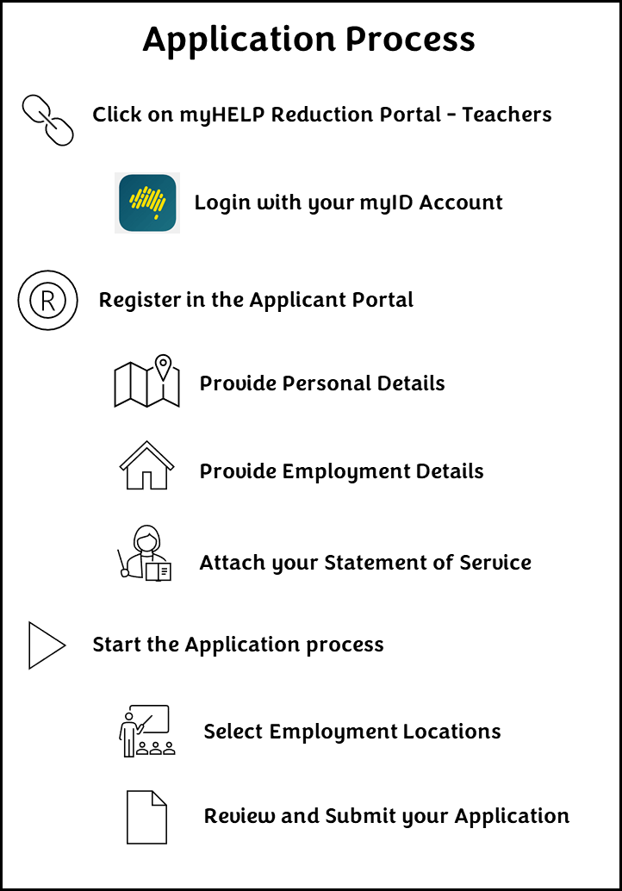
Figure 1 VRT Applicant Portal - application process

Prerequisite

Step 1
You must have a myID account to access the Applicant Portal. The Australian Government uses ‘myID’ (previously known as ‘myGovID’) as a secure way for people to prove their identity when accessing online government services. To set up a myID account, visit myID.

Access to the portal

Step 2
Go to the myHELP Reduction Portal. On this page you will see two options – one for ‘Medical and Nurse Practitioners’ and one for ‘Teachers’. Click on the ‘Continue with Digital Identity’ button in the ‘Teachers’ section.

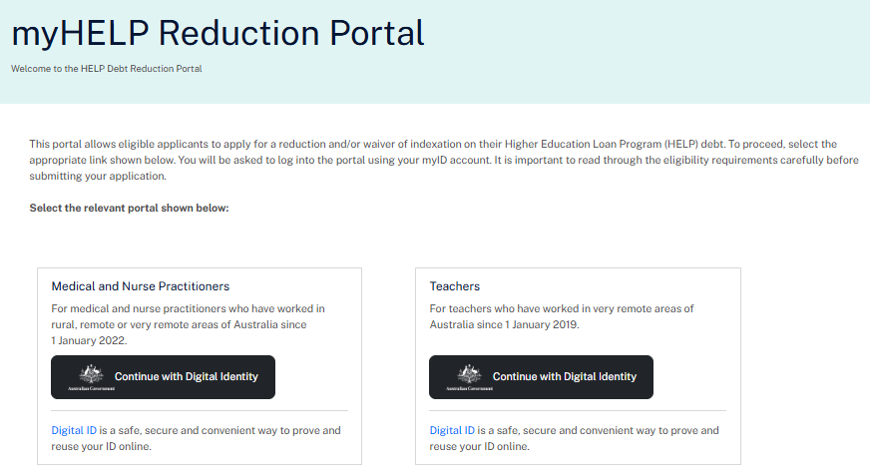
Figure 2 Landing page for the myHELP Reduction Portal

Registration

Step 3
Most of the fields on the registration page will be pre-populated with information sourced from your myID account. This includes your given name, family name, date of birth and email address. You will need to complete the following tasks before selecting the ‘Continue’ button.
- Enter your 9-digit Tax File Number.
- Read the Privacy Notice and select the checkbox to accept it.
- Read the Terms and Conditions and select the checkbox to accept it.

The Applicant Portal will match your data i.e. family name, date of birth and Tax File Number with the tertiary study records we hold. If the family name does not match, but there is a record for your Tax File Number and date of birth, it will assume you have changed your family name and ask for the name used at the time you studied your course. The system will also check if you have a valid Commonwealth Higher Education Student Support Number (CHESSN), eligible qualification and HELP debt associated with your course. If the system does not allow you to progress, you can email the department for further assistance.

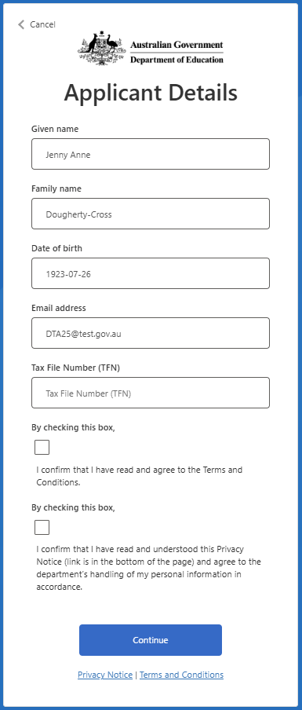
Figure 3 Registration page for the myHELP Reduction Portal

Welcome page

Step 4
After successfully registering, the ‘Welcome’ page will list the steps required to submit your application. Click on the ‘User Guide’ link to access guidance material. Click the ‘Get started’ button to set up your profile.
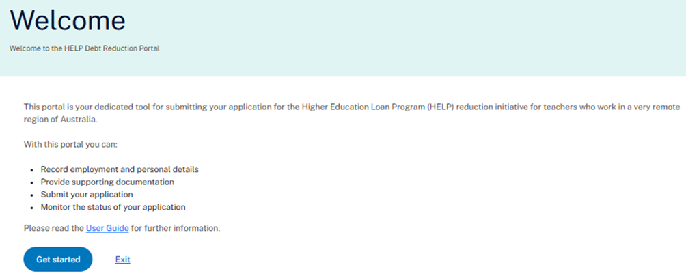
Figure 4 Welcome page for the myHELP Reduction Portal

Set up your profile

Step 5
On the ‘Set up your Profile’ page, the following fields are compulsory:
- Title
- Phone number
- Contact address – a list of suggested addresses will display once you start entering your address. If your address is not listed, contact us for further assistance
- Teacher registration state – the state you are currently registered in as a teacher
- Teacher registration number (TRN) – the number that confirms you are a registered teacher with the relevant state/territory regulatory authority
- Compulsory attachments – Statement of Service, Academic Transcript and ATO HELP Debt Statement.
Compulsory attachments
To avoid delays in processing your application, the following documents must be uploaded with your application:
- Statement of Service: You must provide an SoS from each employer. This is usually issued by the relevant state or territory education department that shows your employment history for the period you are claiming.
- If you teach at an independent school or in early childhood education, you may instead provide a letter from your principal. The letter must be on official letterhead, signed and dated, and cover the period you are claiming.
- It must include:
  - your full name
  - your position title
  - name and address of school, centre-based day care or pre-school
  - whether you were full-time, part-time or casual (a breakdown is required if you worked in a several different roles)
  - your FTE if you were part-time
  - exact start and end dates of employment
  - the number of days worked if you were a casual teacher.

- Australian Taxation Office (ATO) HELP Debt Statement: You must provide a current ATO HELP Debt Statement in PDF form. A PDF can be downloaded from ATO Online Services in your myGov account.

  - Log in to myGov.
  - Click on Services.
  - Select the Australian Taxation Office.
  - In ATO Online Services, scroll down to loan accounts.
  - Select your HELP loan account.
  - Click the filter button and a new screen will appear. In the From date field type in 01/06/2018 and in the To date type in today's date. Then click the Filter button in the bottom right corner.
  - Click the print friendly version button at the top of the screen and save as a PDF.

- Academic transcript/statement of results: You must provide an academic transcript/statement of results from your university confirming completion of your initial teacher education qualification.

Your Commonwealth Higher Education Student Support Number (CHESSN) will be pre-populated. Your Unique Student Identifier (USI) may also be pre-populated if you have one.
Find out more about CHESSNs and USIs on the StudyAssist website.

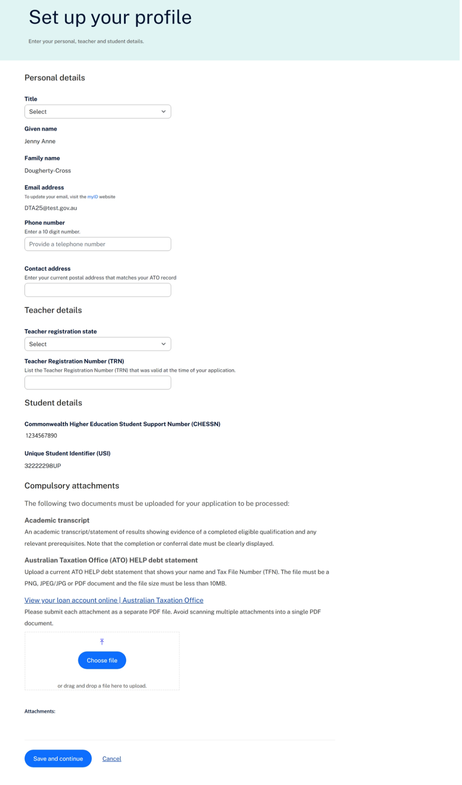

Figure 5 Set up your profile page (Personal details) on the myHELP Reduction Portal

Portal dashboard

Step 6
After setting up your personal details in the Applicant Portal, you will see the dashboard for managing your application(s).
The ‘Overview’ tab will be displayed after you have entered your personal details. You must provide the relevant employment details in the ‘Profile’ tab before you can start your application.

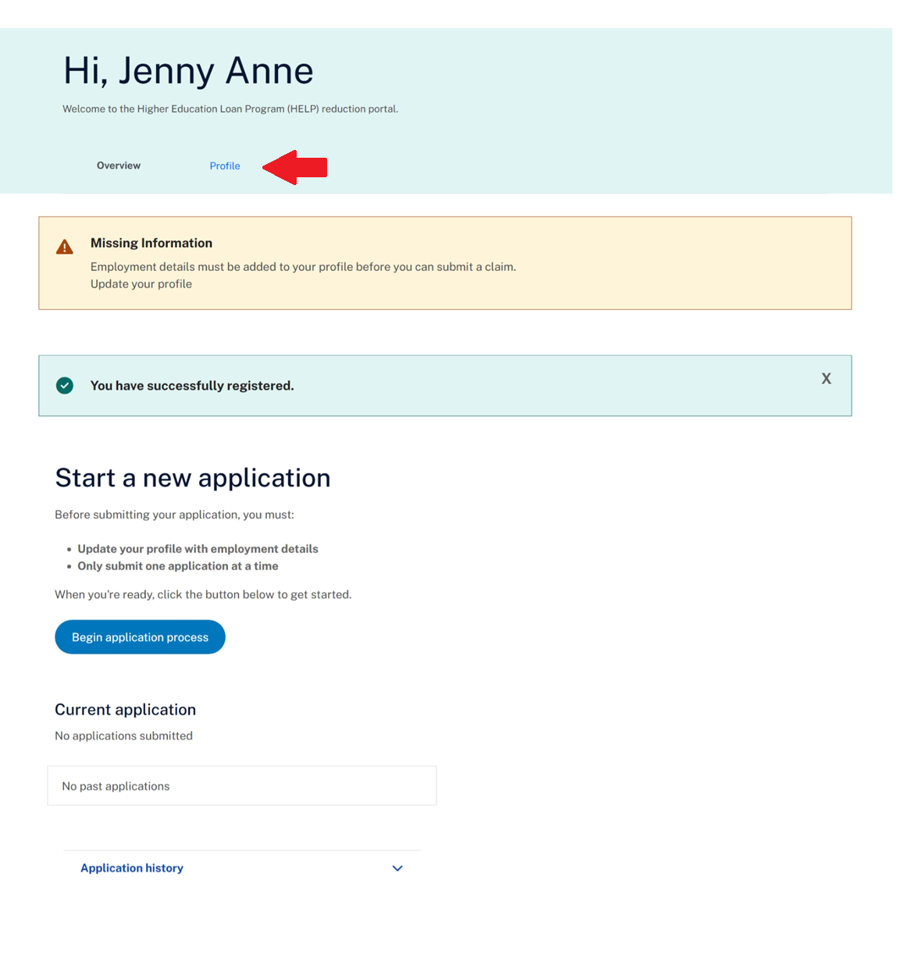
Figure 6 Dashboard (Overview) on the myHELP Reduction Portal

Step 7
On the ‘Profile’ tab, select the ‘Add a new employment period’ button to add your employment details.
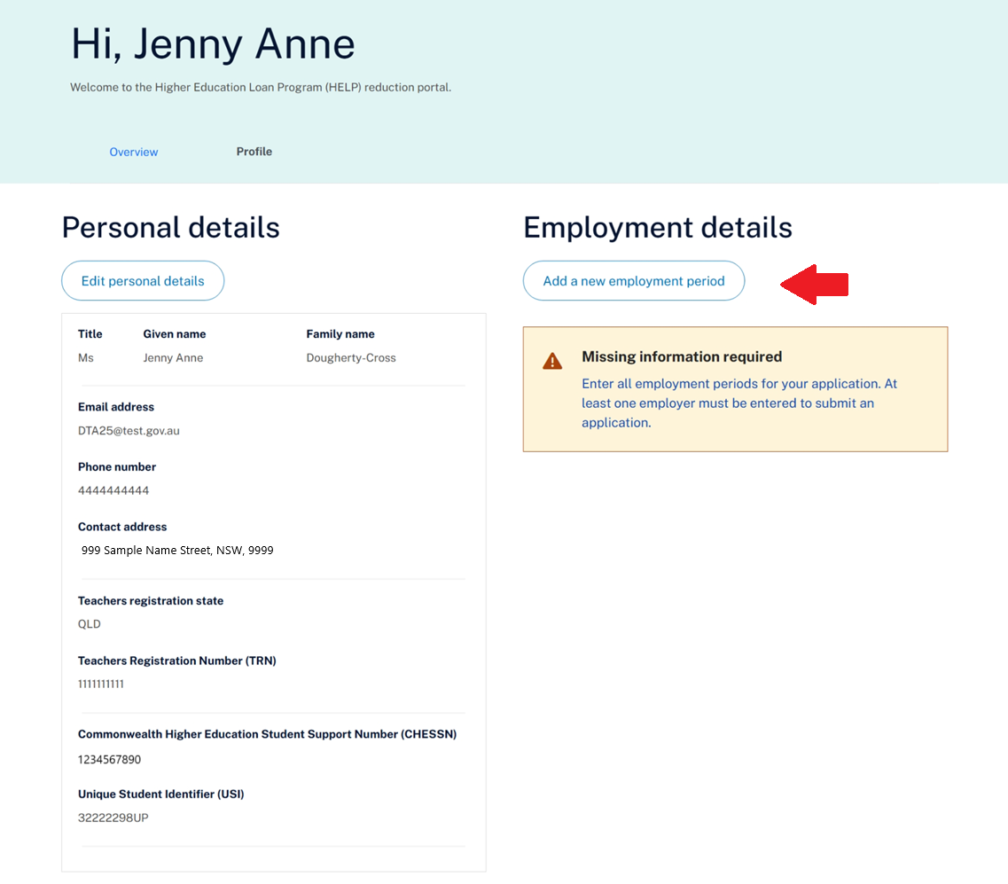
Figure 7 Dashboard (Profile) on the myHELP Reduction Portal

Add your employment details

Step 8
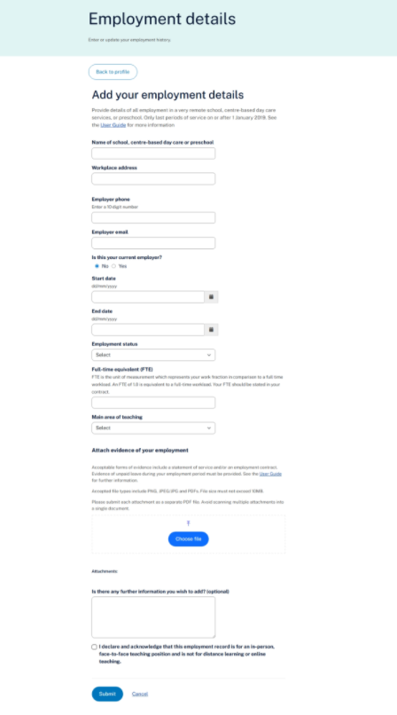

Figure 8 Employment details page on the myHELP Reduction Portal

The ‘Employment details’ page allows you to enter your work history at a school, preschool, or centre-based day care located in a very remote area of Australia. Each entry must reflect a single period of eligible employment.
  - Name of school, centre-based day care or preschool: From the drop-down list, select the organisation where you worked. The address will automatically appear in the <Workplace address> field.
NOTE: If your organisation does not appear in this drop-down list, check if it’s included on the Very remote schools list. If you believe your organisation is in a very remote area, click on the ‘Enter address manually’ button and complete the required fields. Alternatively, you can contact us for further clarification.
  - Employer phone: Enter a 10-digit number i.e. (03) 9999 9999 would be entered as 0399999999.

  - Employer email: Enter your employer’s email address.

  - Is this your current employer? If you select ‘Yes’, the End Date will default to the current date.

  - Start date / End date: Select the calendar symbol to find the correct date or alternatively enter the date in the format dd/mm/yyyy, for example 4 January 2020 would be entered as 04/01/2020.

  - Employment status: Select from the drop-down list i.e. full-time or part-time. Casual roles are not eligible to be submitted via the Applicant Portal. If you are/were a casual employee, you will need to submit your application using the application form.

  - Full-time equivalent (FTE): Enter your Full Time Equivalent (FTE) value while working at the school. Enter the value as a decimal (e.g. 1.0 for full-time, 0.6 for 3 days/week). This figure helps calculate the eligibility duration.

  - Attach evidence of your employment: Attach a statement of service or a letter from your employer on official letterhead providing evidence of your employment that supports the full period applied for in your application. The statement must include the following:
- Your full name
- Your position title
- Name of school, centre-based day care or preschool
- Exact start and end dates of employment

- Is there any further information you wish to add? Add additional information if required. This field is not compulsory.

- Declare the employment is for a face-to-face teaching position and not a distance or online teaching position.

- Click on the ‘Submit’ button and you will be returned to the dashboard. Enter any additional employment periods if relevant.
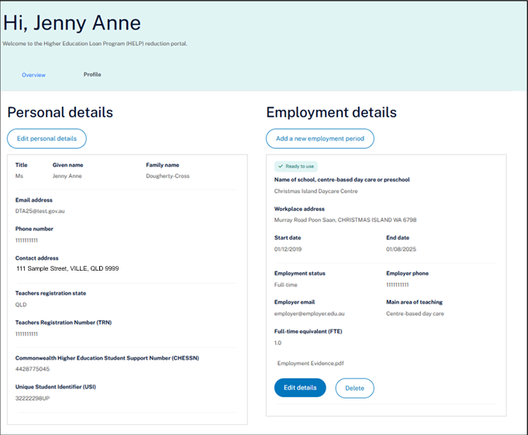
Figure 9 Dashboard with employment data on the myHELP Reduction Portal

Editing personal details
You can update your personal details at any time by selecting the ‘Profile’ tab.

Starting a new application

Step 9
To start a new application, select the ‘Begin application process’ button on the ‘Overview’ tab on the dashboard.
If you already have an application saved as a draft, you must continue or update this draft application rather than start a new application.
If you have previously submitted an application and its currently ‘under review’, you must wait until it is processed before starting a new one. It must have a status of Approved or Rejected for a new application to be submitted.
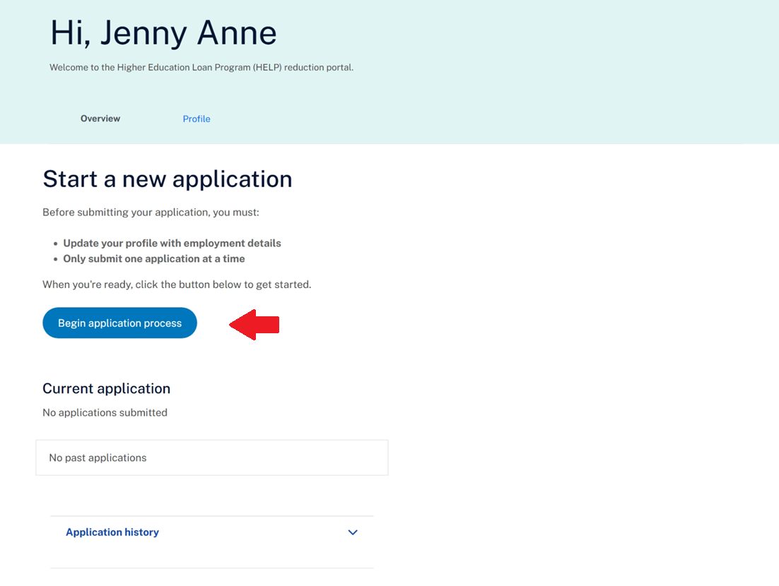
Figure 10 Dashboard (Overview) on the myHELP Reduction Portal

Submit an application

Step 10
Select the ‘Continue button’ to progress your application. If you select the ‘Cancel’ button, you will return to the dashboard and your application will be saved as a draft.

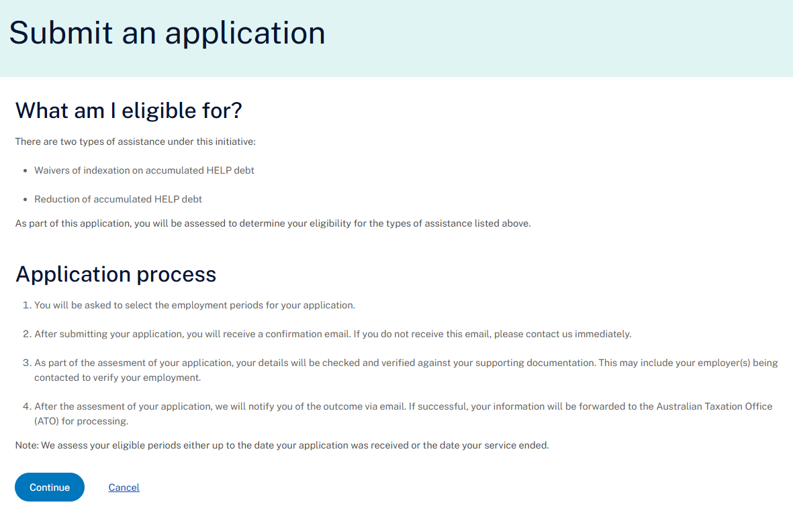
Figure 11 Submit an application screen on the myHELP Reduction Portal

Submit an application (employment details)

Step 11
The ‘Employment details’ page will display all the employment locations you have entered at Step 8. If you want to include an employment location in your application, choose the ‘Select’ checkbox.

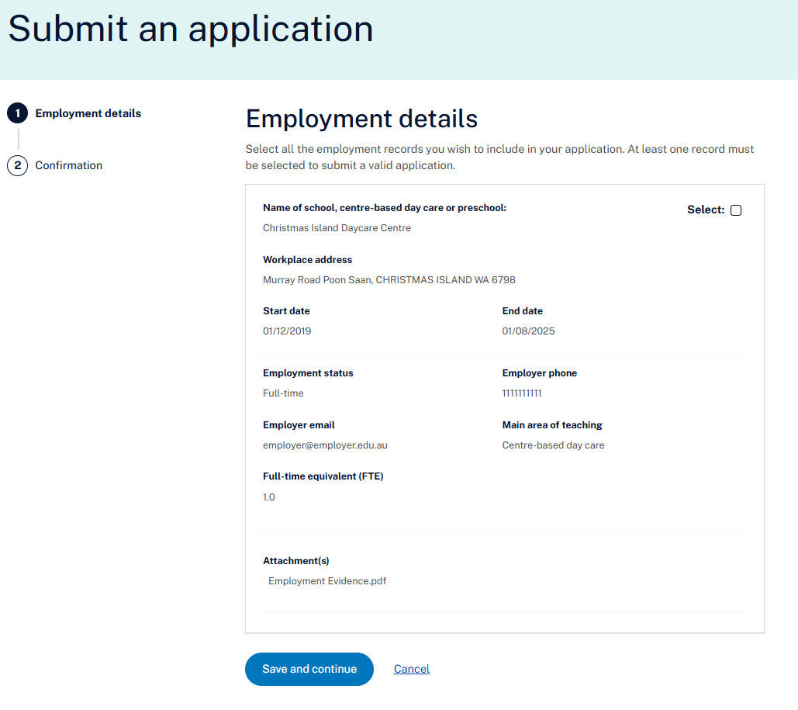
Figure 12 Employment details section when submitting an application on the myHELP Reduction Portal.

Submit an application (confirmation)

Step 12
To submit your application, select the checkbox to confirm your understanding and acceptance of the declaration and select ‘Submit Claim’. If you have found an error or wish to delay submitting your application, click on the ‘Cancel’ button and you will be returned to the dashboard.
Note: It is important that you read all the details on this page carefully as mistakes will delay the processing of your application.

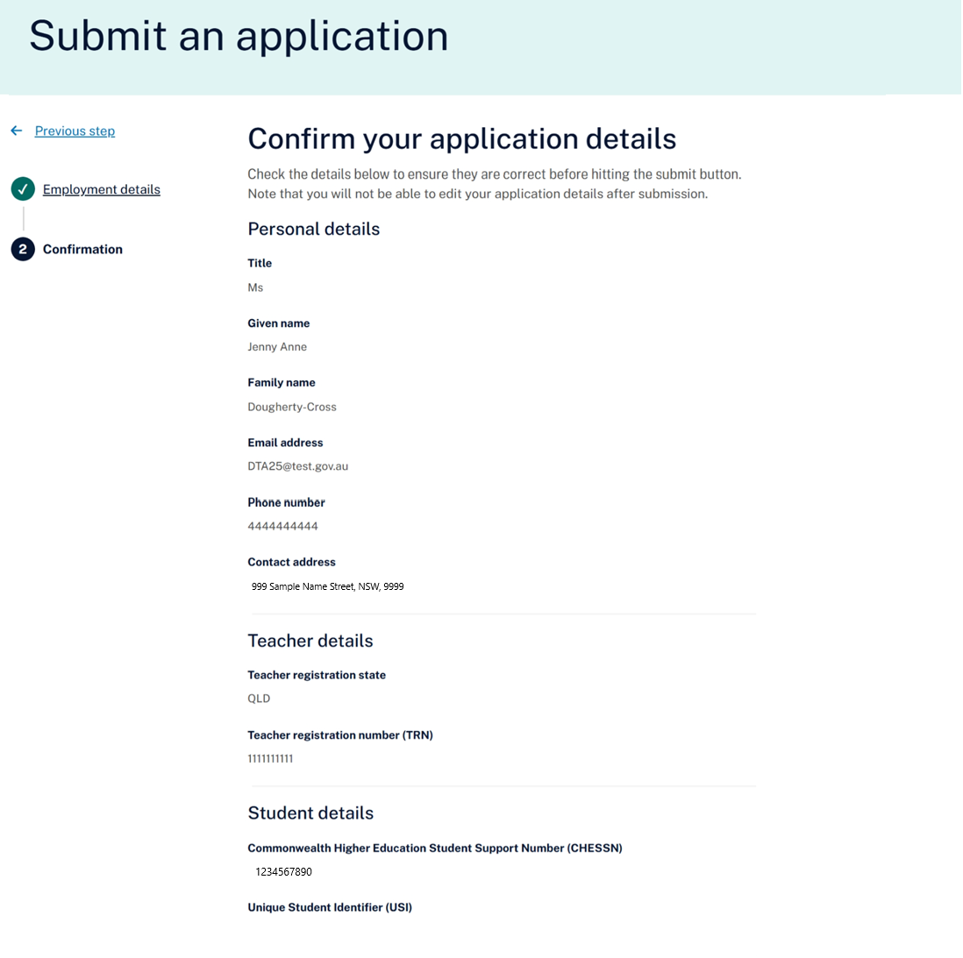
Figure 13 Confirmation screen (Part A) on the submit an application screen.

After submission

Step 13
C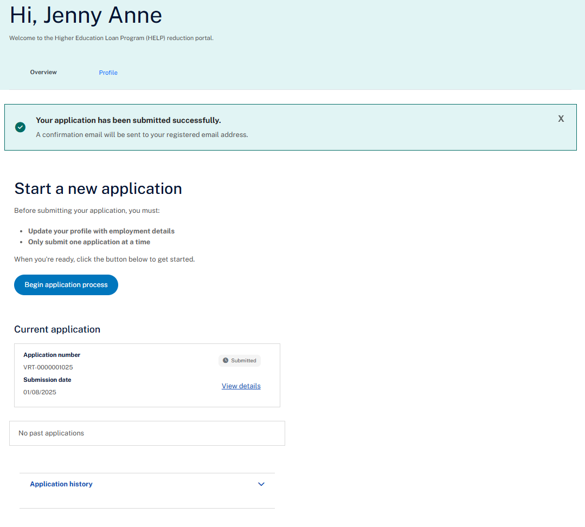
Figure 14 Dashboard (Overview) showing successful submission of your application.

Once you have successfully submitted your application, you will receive confirmation on the ‘Overview’ tab on the dashboard. You will also receive an email receipt confirming your application has been received.
The submitted application will be visible in the ‘Current application’ section.
When your application is being processed, the status of your application will change to Review in Progress. After submitting your application, it can no longer be changed in the Applicant Portal.
Depending on the stage of your application, the status may be displayed as any of the following:
- Saved as Draft - you have started the application process but have not submitted the application for processing.
- Submitted - you have submitted the application for processing.
- Review in Progress - your application is being processed.
- Request for Further Information - you have been asked to provide additional information for your application.
- Approved - your application is approved.
- Rejected - your application is not approved.
To sign out of the portal, click on down arrow in the top right corner and select ‘logout’.
If you need to change any information in your application after it has been submitted, contact the Department of Education.

