

Very Remote Teachers (VRT) HELP Debt Reduction & Indexation Measure

Applicant Portal User Guide

Version 3.0

**Table of Contents**

1 Introduction 3

1.1 Background 3

1.2 Eligibility 3

1.3 Notes 3

2 Application Process 4

2.1 Overview 4

2.2 Prerequisite 5

2.3 Access to the Portal 5

2.4 Registration 6

2.5 Welcome Page 7

2.6 Set up your Profile 7

2.7 Viewing the Home Page (Overview) 9

2.8 Viewing the Home Page (Profile) 10

2.9 Add your Employment Details 11

2.10 Editing Personal Details 13

2.11 Starting a New Application 14

2.12 Submit an Application 15

2.13 Submit an Application (Employment Details) 16

2.14 Submit an Application (Confirmation) 17

2.15 After Submission 19

# Introduction

## Background

The Applicant Portal is your tool for submitting your application for the Reduction of Higher Education Loan Program (HELP) debts for teachers in very remote areas of Australia.

The Very Remote Teachers (VRT) Higher Education Loan Program (HELP) debt reduction and indexation waiver measure was implemented in 2019, with the first teachers becoming eligible for HELP debt reductions on 01 January 2019.  There are two types of assistance under this initiative:

* waivers of indexation on accumulated HELP debt and
* reduction of accumulated HELP debt

​​​Both types of assistance are available to teachers who are/were teaching in a very remote area of Australia, based on the Australian Bureau of Statistics (ABS) Remoteness Structure, at any of the following:

* a school providing primary or secondary education
* a centre-based day care service
* a preschool

Further details on the program are listed on the Australian Government Department of Education (DoE) website here: [Reduction of Higher Education Loan Program (HELP) debts for teachers in very remote areas - Department of Education, Australian Government](https://www.education.gov.au/higher-education-loan-program/reduction-help-debts-teachers-very-remote-areas)

## Eligibility

To be eligible for either type of assistance, teachers must meet the following requirements:

1. **Work Location**: Have been employed in a face-to-face teaching position in a school, preschool or centre-based day care service in a very remote area of Australia during their application period. A very remote area is determined using the ABS Remoteness Structure. Information on the ABS Remoteness Structure, along with how remoteness is determined, can be found on the [Australian Bureau of Statistics](https://www.abs.gov.au/websitedbs/D3310114.nsf/home/remoteness+structure) website. The lists of very remote schools, preschools and centre-based day care services can be found on the [Reduction of HELP debts for teachers in very remote areas](https://www.education.gov.au/higher-education-loan-program/reduction-help-debts-teachers-very-remote-areas) web page.
2. **Work Period:**
   1. To be eligible for a reduction of accumulated HELP debt teachers must have completed a minimum of four years (1400 days) of teaching full-time, or the pro-rated part-time equivalent in a four to six-year period.  This work needs to be performed on or after 01 January 2019.
   2. To be eligible for a waiving of indexation teachers need to have been working in a very remote area for any period of time on or after 14 February 2019.  Their indexation will be calculated on a pro-rata basis.
3. **HECS-HELP Debt**: Teachers must have incurred a HECS-HELP debt and/or FEE-HELP debt (excluding pre-2005 debt) in relation to their completed initial teaching qualification. The term initial teacher education qualification refers to the first teacher education qualification obtained that satisfies the minimum academic requirements for registration as a teacher by an authority of a state or territory. Note that teachers must have an outstanding HELP debt on 1 Jan 2019 or the commencement date of their employment if after this date.

## Notes

All personal information listed on the screens in this document are fictitious except the name and address of the “Christmas Island Daycare Centre” in Figure 12, 13 and 14.

# Application Process

## Overview

To submit an application, there are three main steps to follow:

1. Login to the Applicant Portal with your myID account.
2. Register your personal and employment details. Remember to attach the following documents to your application:

* ATO HELP Debt Statement
* Academic transcript
* Statement of service / letter from your employer.

1. Submit your application by selecting the relevant employment locations.

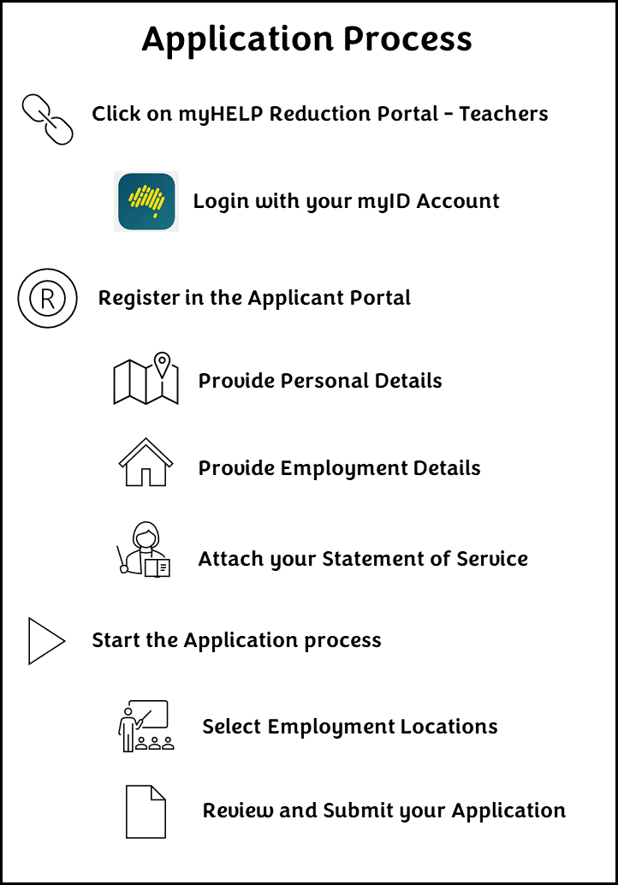

**Figure 1 VRT Applicant Portal - Application Process Diagram**

## Prerequisite

### Step 1

You must have a myID account to access the Applicant Portal. The Australian Government uses ‘myID’ (previously known as ‘myGovID’) as a secure way for people to prove their identity when accessing online government services. To obtain a myID account go to the website: [https://www.myid.gov.au](https://www.myid.gov.au/)

## Access to the Portal

### Step 2

Go to the [myHELP reduction](https://myhelpreduction.gov.au/) link on the Department of Education website i.e. [www.myhelpreduction.gov.au](http://www.myhelpreduction.gov.au). The myHELP Reduction Portal landing page will be displayed as shown below. You should save this link to your desktop. On this page you will see two sections – one for medical & nurse practitioners and one for teachers. Click on the ‘Continue with Digital Identity’ button in the ‘Teachers’ section.

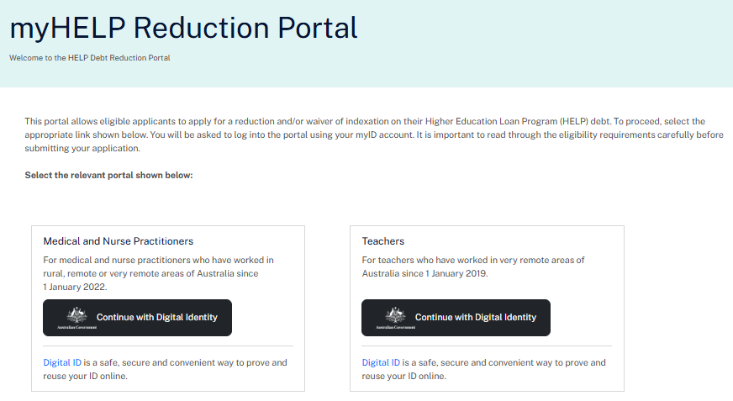

**Figure 2 Landing Page for the myHELP Reduction Portal**

## Registration

### Step 3

The Registration page will now be displayed as shown below. Most of the fields on this page will be pre-populated with information sourced from your myID account. This includes your given name, family name, date of birth and email address. Complete the following tasks before hitting the ‘Continue’ button.

1. Enter your 9-digit Tax File Number.
2. Read the Privacy Notice and select the checkbox to accept it.
3. Read the Terms and Conditions and select the checkbox to accept it.

The Applicant Portal will match your data i.e. family name, date of birth and Tax File Number with our records. If the family name does not match, but there is a record for your Tax File Number and date of birth, it will assume you have changed your family name and ask for the name used at the time you studied your course. The system will also check to see if you have a valid CHESSN, eligible qualification and HELP debt associated with your course. If the system does not allow you to progress email [teacher-veryremotehelp@education.gov.au](mailto:veryremotehelp@education.gov.au) for further assistance.

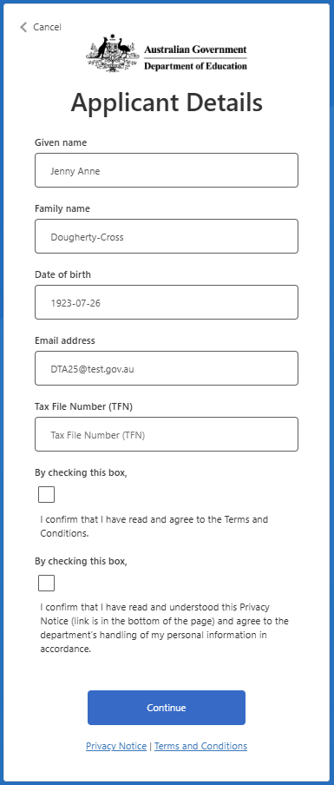

**Figure 3 Registration Page for the myHELP Reduction Portal**

## Welcome Page

### Step 4

After successfully registering, the Welcome page will be displayed. It will list all the steps required to submit your application. Click on the User Guide link to access the same guidance material you are reading now. Now, hit the ‘Get started’ button to set up your profile.

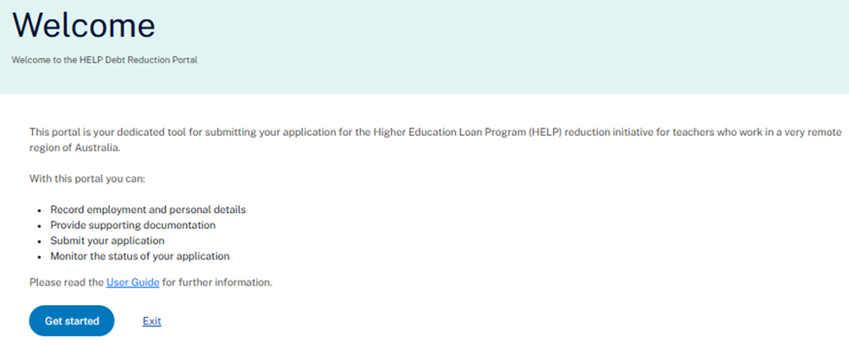

**Figure 4** **Welcome Page for the myHELP Reduction Portal**

## Set up your Profile

### Step 5

On the Set up your Profile page shown below, the following fields are compulsory:

* Title
* Phone number
* Contact address
* Teacher registration state
* Teacher registration number (TRN)
* Compulsory attachments – Academic Transcript and ATO HELP Debt Statement.

**Phone number**: Provide your contact number so that you can be reached for any questions regarding your application. You can enter a 10-digit mobile number or a landline number. For a landline number enter the area code as the first two digits, and then your number.

**Contact address:**  When you start entering your address a list of suggested addresses is displayed. Select your address from this list. If your address is not listed contact us for further assistance by emailing [teacher-veryremotehelp@education.gov.au](mailto:veryremotehelp@education.gov.au).

The **Teacher registration state** must indicate which state you are currently registered in as a teacher.

The **Teacher registration number** is your teacher registration number for the specified state/territory and confirms you are a registered teacher with the relevant state/territory regulatory authority.

To avoid delays in processing your application the following documents must be uploaded with your application:

* **Australian Taxation Office (ATO) HELP debt statement:** Your ATO HELP debt statement must show your name and Tax File Number (TFN). This can be accessed on the ATO portal through your MyGov account. Information on how to access your ATO HELP debt statement can be found at the ATO website: [View your Loan Account Online](https://www.ato.gov.au/individuals-and-families/study-and-training-support-loans/view-your-loan-account-online)
* **Academic transcript/statement of results:** Your academic transcript or statement of results must show evidence of a completed eligible initial teacher education qualification and any relevant prerequisites. Thecompletion or conferral date must be clearly displayed.

Your Commonwealth Higher Education Student Support Number (CHESSN) will be pre-populated on this page. If you have a Unique Student Identifier (USI) it may also be pre-populated if it is recorded in our database.

Find out more about CHESSNs and USIs on the StudyAssist website at: <https://www.studyassist.gov.au/starting-study-basics/your-usi-chessn>.

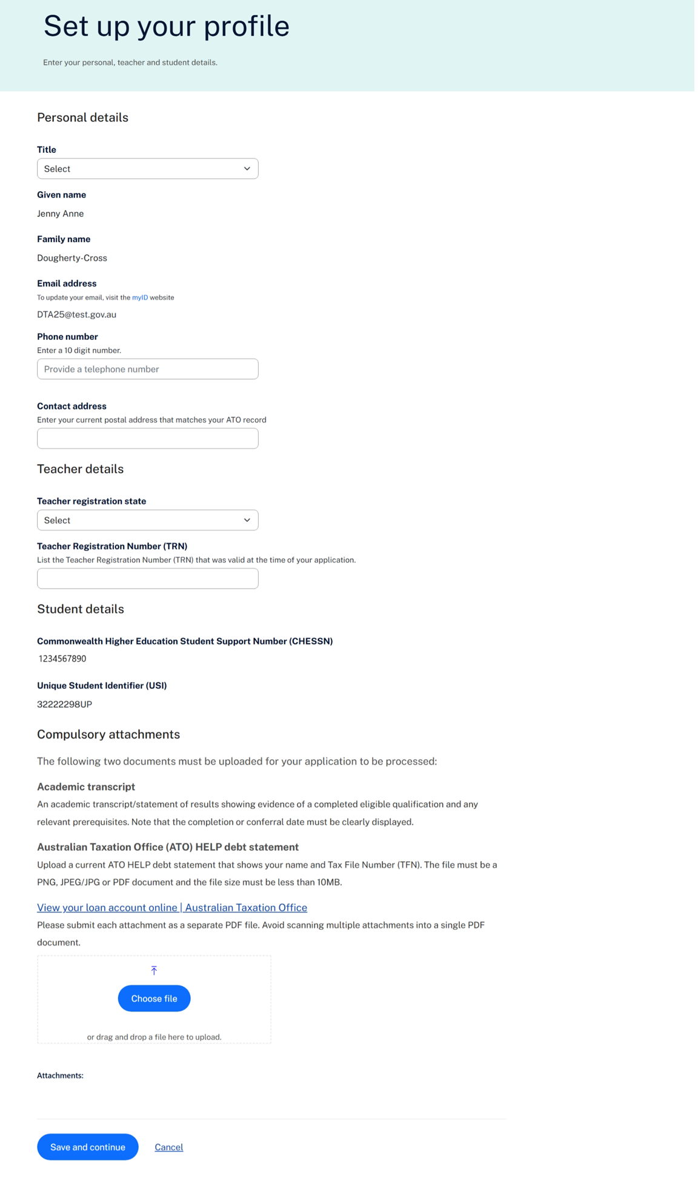

**Figure 5 Set up your Profile Page (Personal Details) on the myHELP Reduction Portal**

## Viewing the Home Page (Overview)

### Step 6

After setting up your personal details in the Applicant Portal you will land on the Home Page (Overview). This page serves as your dashboard for managing your application(s).

There are two tabs on the Home Page – Overview and Profile. The Overview tab shown below will be displayed **after** you have entered your personal details. Remember that you must provide the relevant employment details in the Profile tab before you can start the application process. Click on the Profile tab as shown by the red arrow in the diagram below.

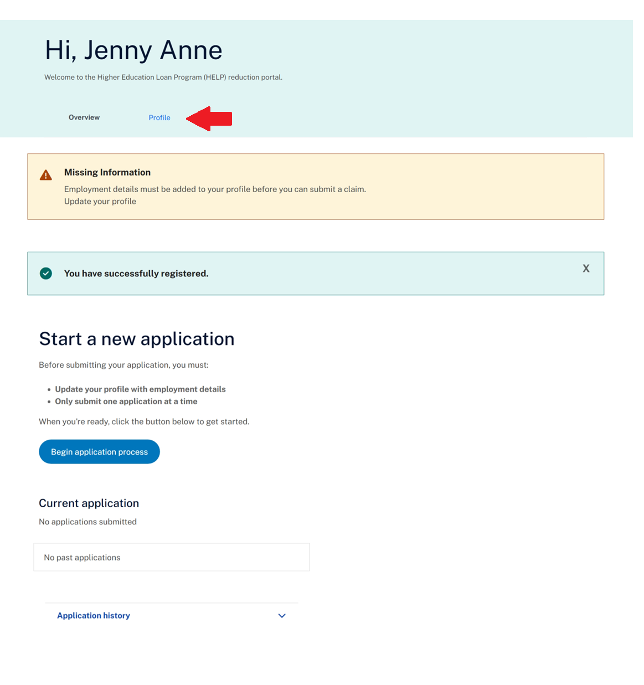

**Figure 6 Home Page (Overview) on the myHELP Reduction Portal**

## Viewing the Home Page (Profile)

### Step 7

On the Profile tab hit the “Add a new employment period” button to add your employment details.

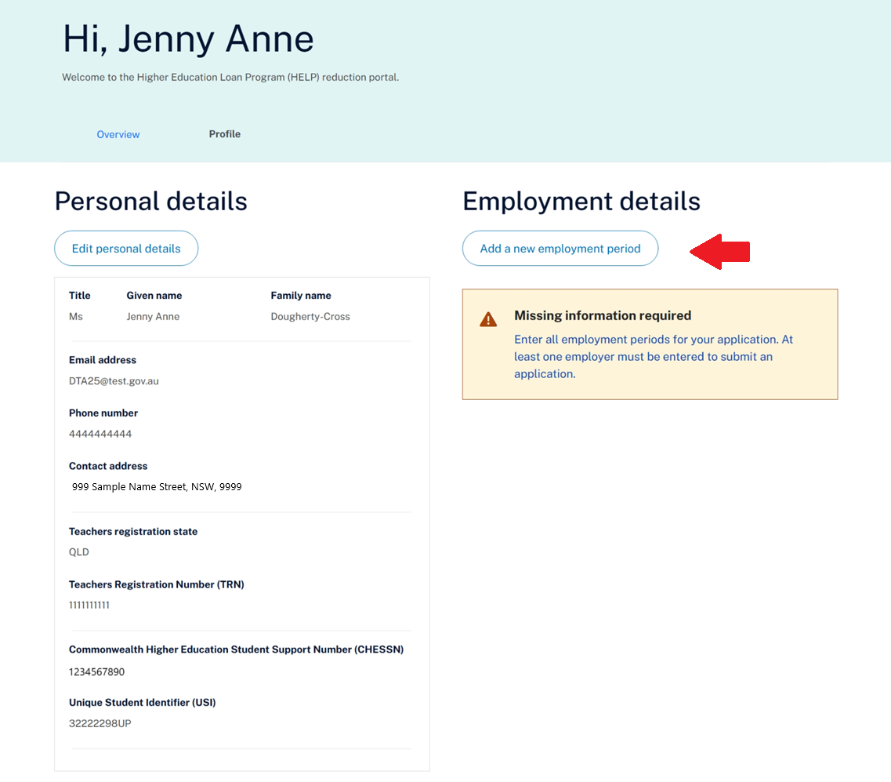

**Figure 7 Home Page (Profile) on the myHELP Reduction Portal**

## Add your Employment Details

### Step 8

**Figure 8 Employment Details Page on the myHELP Reduction Portal**

The Employment Details page shown in Figure 8 above allows you to enter and submit your work history at a school, preschool, or centre-based day care located in a very remote area of Australia. Each entry must reflect a single period of eligible employment.

* 1. **Name of school, centre-based day care or preschool**: From the drop-down list, identify the organisation where you worked. The address will automatically appear in the <Workplace address> field.

NOTE: If your organisation does not appear on this drop-down list check here: [Very remote schools list - Department of Education, Australian Government](https://www.education.gov.au/higher-education-loan-program/resources/very-remote-schools-list) to see whether it is considered to be in a very remote area of Australia. If you believe your organisation is in a very remote area, enter the name and workplace address and then click on the ‘Enter address manually’ button and complete the required address fields. Alternatively, you can contact us on: [Teacher-VeryRemoteHelp@education.gov.au](mailto:Teacher-VeryRemoteHelp@education.gov.au) for further clarification.

* 1. **Employer phon**e: Enter a 10-digit number i.e. (03) 9999 9999 would be entered as 0399999999.
  2. **Employer email**: If we need to clarify details for your application this email address will be used.
  3. **Is this your current employer?** If you select ‘Yes’ the End Date will default to the current date.
  4. **Start date / End date:** Select the calendar symbol to find the correct date or alternatively enter the date in the format dd/mm/yyyy for example the 4th January 2020 would be entered as 04/01/2020.
  5. **Employment status:** Select from the drop-down list i.e. full-time or part-time. Casual roles are not eligible to be submitted via the Applicant Portal. If you are/were a casual employee, you will need to submit your application using the PDF file on the Department of Education website.
  6. **Full-time equivalent (FTE):** Enter your Full Time Equivalent (FTE) whilst working at the school. Enter your FTE value as a decimal (e.g. 1.0 for full-time, 0.6 for 3 days/week). This figure helps calculate the eligibility duration.
  7. **Attach evidence of your employment**: Attach a statement of service or a letter from your employer on official letterhead providing evidence of your employment that supports the full period applied for in your application. The statement must include the following:
* Your full name
* Your position title
* Name of school, centre-based day care or preschool
* Exact start and end dates of employment

1. **Is there any further information you wish to add?** Specify any additional information about your application for the Department of Education staff to consider. Note that this field is not compulsory.
2. Declare the employment is for an in-person, face-to-face teaching position and not a distance or online teaching position.
3. Hit the ‘Submit’ button and you will be returned to the Home Page (Profile) screen. Enter any additional employment periods in the same manner. After hitting the ‘Submit’ button the Home Page (Overview) screen will be displayed with the following message:



**Figure 9 Home Page (Overview) Message Displayed on the myHELP Reduction Portal**

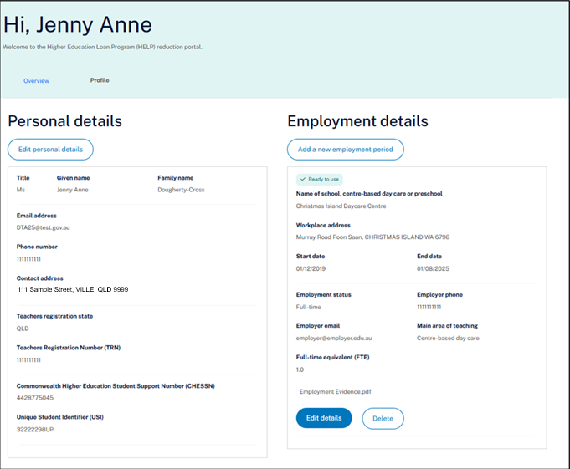

**Figure 10 Home Page (Overview) with Employment Data on the myHELP Reduction Portal**

## Editing Personal Details

If you need to update your personal details from when you registered go to the Home Page and select the Profile tab. Figure 5 will be displayed.

## Starting a New Application

### Step 9

Select the ‘Begin application process’ button on the Overview tab on the Home Page as shown in the figure below.

Note: if you already have an application saved as draft or under review you must wait until it is processed before starting a new one. It must have a status of **Approved** or **Rejected** for a new application to be submitted.

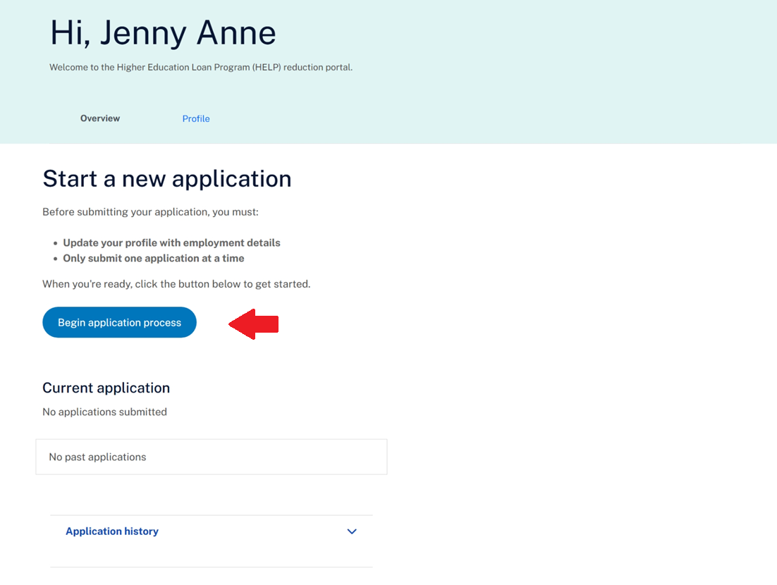

**Figure 11 Home Page (Overview) on the myHELP Reduction Portal**

## Submit an Application

### Step 10

Select the ‘Continue button’ to progress your application. Alternatively select the ‘Cancel’ button to return to the Home Page and your application will be saved with a DRAFT status.

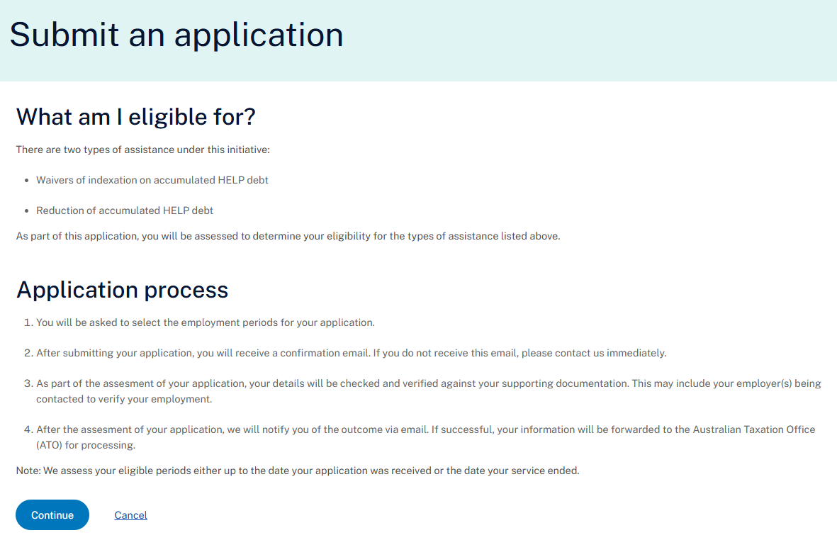

**Figure 12 Submit an Application Screen on the myHELP Reduction Portal**

## Submit an Application (Employment Details)

### Step 11

This page will display all the employment locations you have entered at Step 8. Mark the ‘Select’ checkbox as shown in the figure below if you want to include an employment location in your application.

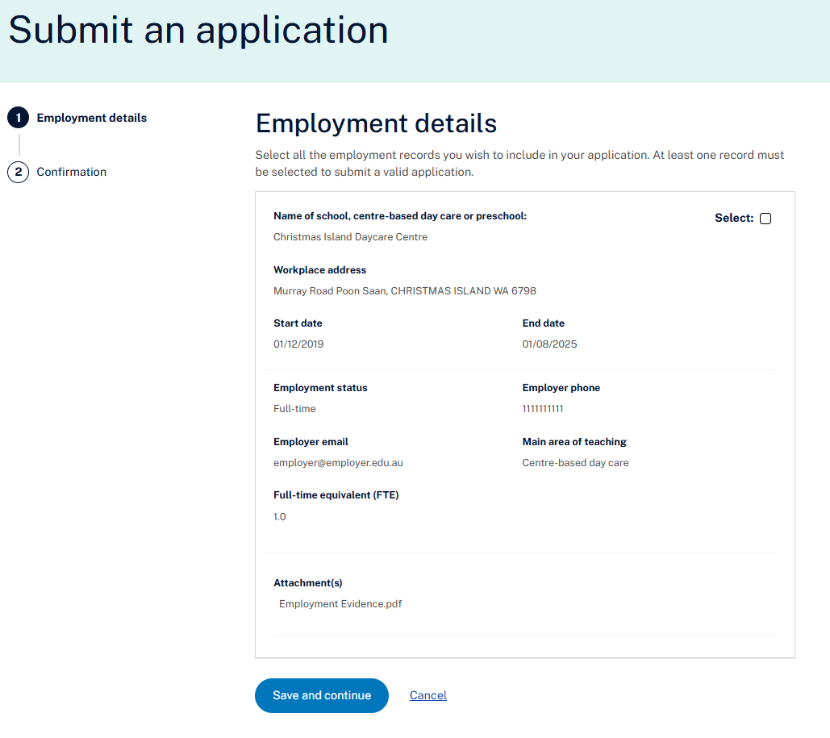

**Figure 13 Employment Details Section when Submitting an Application on the myHELP Reduction Portal.**

## Submit an Application (Confirmation)

### Step 12

It is important that you read all the details on this page carefully as mistakes will delay the processing of your application.

At the bottom of the page select the checkbox to confirm your understanding and acceptance of the declaration. Then hit the ‘Submit Claim’ button to submit your application. If you have found an error or wish to delay submitting your application hit the ‘Cancel’ button and you will be returned to the Home Page.

Confirm your application details before submission of your application.
This shows Part A of the 'Submit an Application" screen.

**Figure 14 Confirmation Screen (Part A) on the Submit an Application Screen.**

Confirm your application details before submission of your application.
This shows Part B of the "Submit an Application" screen.

**Figure 15 Confirmation Screen (Part B) on the Submit an Application Screen.**

## After Submission

### Step 13

C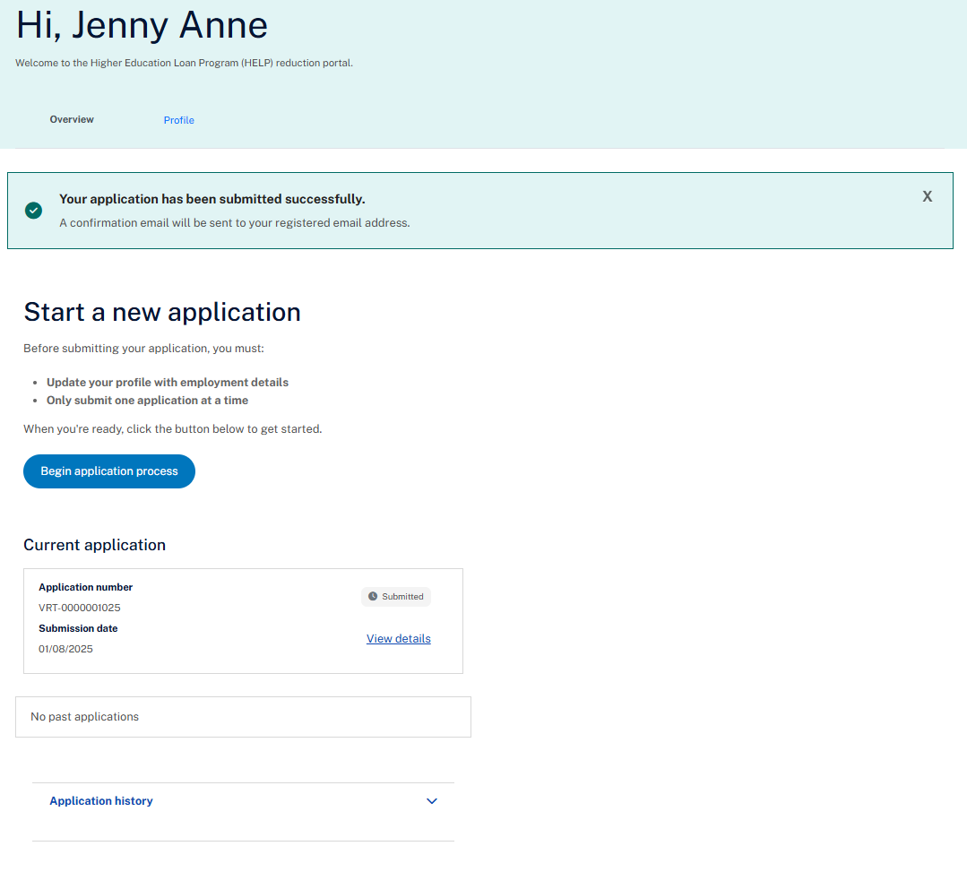

**Figure 16 Home Page (Overview) Showing Successful Submission of an Application.**

Once you have successfully submitted your application you will receive confirmation on the Home Page – Overview tab. You will also receive an email receipt confirming the submission has been received.

The submitted application will be displayed in the “Current application” panel. You can see the application number and submission date and see the details (in read only format) of the submitted application.

When your application is being processed, the status of your application will change to **Review in Progress**. After submitting your application your application can no longer be changed in the Applicant Portal.

Depending on the stage your application is at, the status could be displayed as any of the following:

* **Saved as Draft** - Displayed when you have started the application process but have not submitted the application for processing.
* **Submitted** - Displayed when you have submitted the application for processing.
* **Review in Progress** - Displayed when the application is being processed.
* **Request for Further Information** - Displayed when you have been requested to provide additional information regarding your application.
* **Approved** - Displayed when your application is approved.
* **Rejected** - Displayed when your application is not approved.

To logoff from the portal go to the top right-hand corner of the screen where your name is displayed. Click on the down arrow and the ‘logout’ option will be displayed.

If you need to change any information about your application after it has been submitted contact the Department of Education at [teacher-veryremotehelp@education.gov.au](mailto:teacher-veryremotehelp@education.gov.au) for guidance. Thank-you for your application.