


HELP Debt Reduction Program for Very Remote Teachers
  - Applicant Portal User Guide

Contents
1. Introduction 3
1.1 Background 3
1.2 Notes 3
2. Application Process 3
2.1 Overview 3
2.2 Compulsory evidence 3
2.3 myID account 5
2.4 Access to the portal 5
2.5 Registration 6
2.6 Set up your personal details 8
2.7 Navigate to employment details 9
2.8 Add your employment details 10
2.9 Progress your new application 12
2.10 Complete and submit your application 14
2.11 After submission 16
2.12 Sign out 17

1. Introduction

1.1 Background
This guide explains how to use the Applicant Portal to submit an application for the HELP Debt Reduction Program for Very Remote Teachers.

Further information about the program is available at: HELP Debt Reduction Program for Very Remote Teachers

1.2 Notes
All personal information listed on the screens in this document are fictitious.

2. Application Process

2.1 Overview
There are five main steps to submit your application.

Step 1 | Prepare and save all your supporting evidence as you will need to upload these documents into the Applicant Portal.
Step 2 | Log in to the Applicant Portal with your myID account and complete the registration page.
Step 3 | Set up your profile and attach your:  - Academic transcript for your initial teaching qualification, and  - Australian Taxation Office (ATO) HELP Debt Statement.
Step 4 | Add your employment details by selecting the relevant employment locations and attach your Statement of Service (SoS) or employer letter.
Step 5 | Review and submit your application.

2.2 Compulsory evidence
To avoid delays in assessing your application, the following documents must be uploaded with your application:

- Statement of Service (SoS):
You must provide a SoS from each employer showing your employment history for the period you are claiming. This is usually issued by the relevant state or territory education department and shows your complete employment history.

If you teach at an independent school or in early childhood education, you may instead provide a letter from your principal. The letter must be on official letterhead, signed and dated, and cover the period you are claiming.
The SoS or letter must include:
- your full name
- your position title
- name and address of the school, centre-based day care or pre-school
- whether you were full-time, part-time or casual (a breakdown is required if you worked in a several different roles)
- if you are/were part-time, your FTE (e.g. 0.8 or 0.5)
- if you are/were casual, the number of days worked as a casual teacher
- exact start and end dates of employment.
You can only apply for service you have completed.
The end date of the period which you are claiming will be the employment end date listed on your SoS/letter or the SoS/letter issue date if still currently employed.
TIPS for your employment evidence
  - Please do not submit an employment contract as it does not include details of your past service history.
- Australian Taxation Office (ATO) HELP Debt Statement:
You must provide a current ATO HELP Debt Statement in PDF form. A PDF can be downloaded from ATO Online Services in your myGov account.
- Log in to myGov.
- Click on Services.
- Select the Australian Taxation Office.
- In ATO Online Services, scroll down to loan accounts.
- Select your HELP loan account.
- Click the down arrow next to the word “Filter” below the Download button and additional filter options will appear. In the ‘From date’ field type in 01/06/2018 and in the ‘To date’ type in today's date. Then click the ‘Filter’ button in the bottom right corner.
- Click the print friendly version button at the top of the screen and save as a PDF. The statement must show your full name, Tax File Number and full HELP loan transaction history.
Note: In ATO Online Services, an automatic filter is applied to your HELP Debt Statement for the last 24 months. You must make sure you adjust the filter and generate a statement for your entire HELP debt history.

TIPS on your ATO HELP Debt Statement
- Make sure your statement shows your full HELP debt history by adjusting the filters as needed.
- Export your statement as a PDF from ATO Online Services. Excel and Word files are not accepted.

- Academic transcript
You must provide an academic transcript from your university confirming completion of your initial teacher education qualification.
The transcript must show:
- your full name
- all course units, including any credited prior study, recognition of prior learning, or advanced standing
- conferral or course completion date.
TIPS on your Academic transcript
- Make sure it covers your complete study history.
- Make sure it's an ‘Official’ transcript.

Contact your higher education provider if you need assistance.

2.3 myID account
You must have a myID account to access the Applicant Portal. The Australian Government uses myID (previously known as ‘myGovID’) as a secure way for people to prove their identity when accessing online government services. To set up a myID account, visit myID.

2.4 Access to the portal
Go to the myHELP Reduction Portal.
On this page you will see two options – one for ‘Medical and Nurse Practitioners’ and one for ‘Teachers’.
Select ‘Continue with Digital Identity’ button in the ‘Teachers’ section (Figure 1) and then select ‘myID’ (Figure 2).

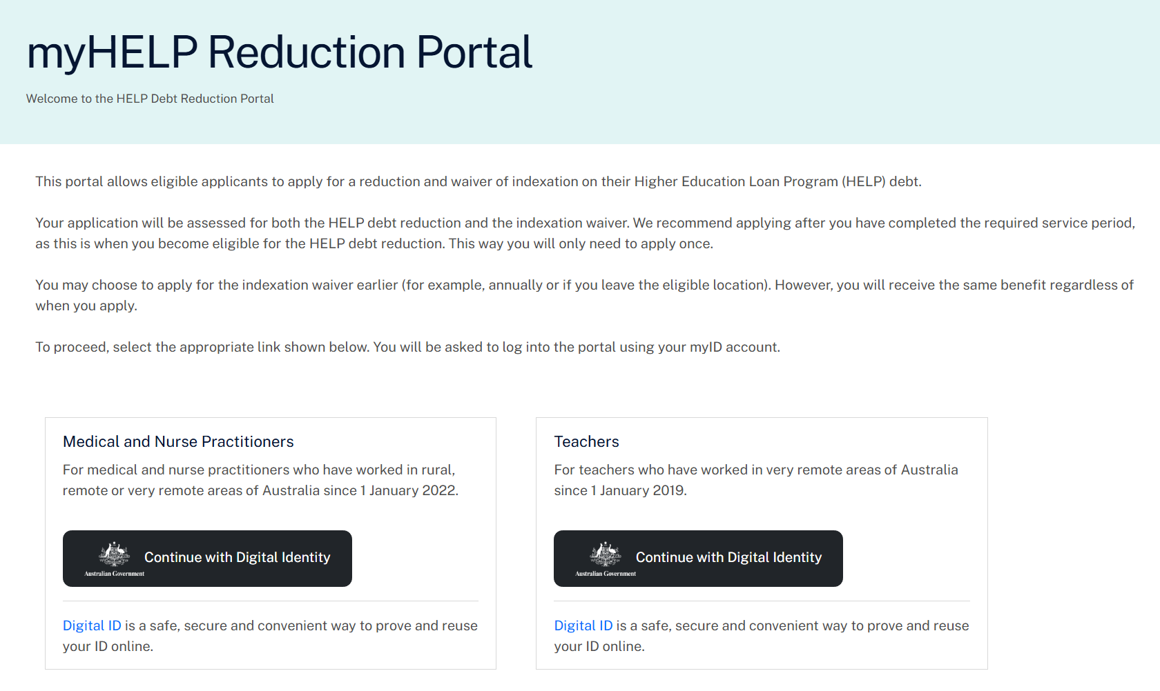
Figure 1. Landing page for the myHELP Reduction Portal

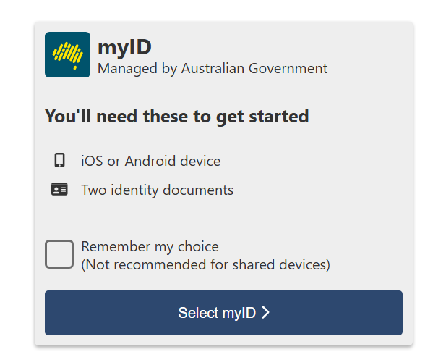
Figure 2. myID

2.5 Registration
Most of the fields on the registration page will be pre-populated with information sourced from your myID account (Figure 3). This includes your given name, family name, date of birth and email address.
Before selecting ‘Continue’, enter your 9-digit Tax File Number, read the Privacy Notice and Terms and Conditions, and select the checkboxes to accept them.
The portal will use your family name, date of birth and Tax File Number to match your records with the tertiary study records held by the department.
If your details don’t match
- If your family name doesn’t match, but your Tax File Number and date of birth match a record, the portal may ask for the name you used when you studied your qualification.
- If the portal doesn’t allow you to progress, email the department for further assistance.

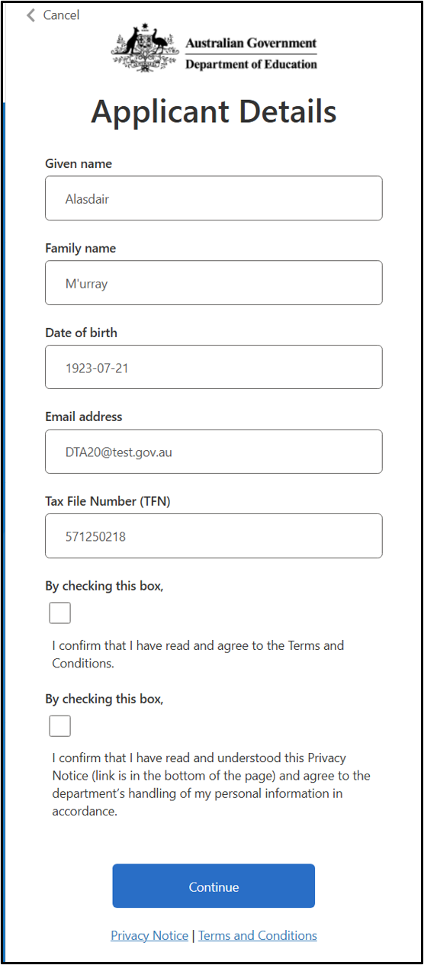
Figure 3. Registration page for the myHELP Reduction Portal

After successfully registering, the ‘Welcome’ page will list the steps required to submit your application. Select ‘Get started’ to set up your profile (Figure 4).

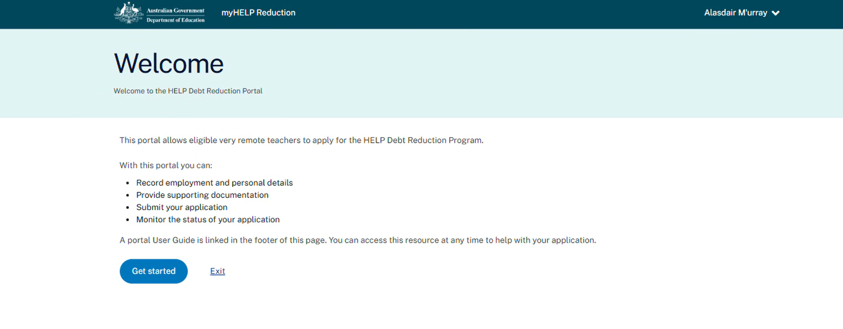
Figure 4. Welcome page for the myHELP Reduction Portal

2.6 Set up your personal details
Several fields will auto populate into the ‘Set up your Profile’ page (Figure 5).
You will be required to enter the following information:
- Title
- Phone number
- Contact address - When you start typing your address, a filtered address list will appear. If your address is not listed, you may manually enter your address.
- Teacher registration state - The state you are currently registered in as a teacher.
- Teacher registration number (TRN) - The number that confirms you are a registered teacher with the relevant state/territory regulatory authority.
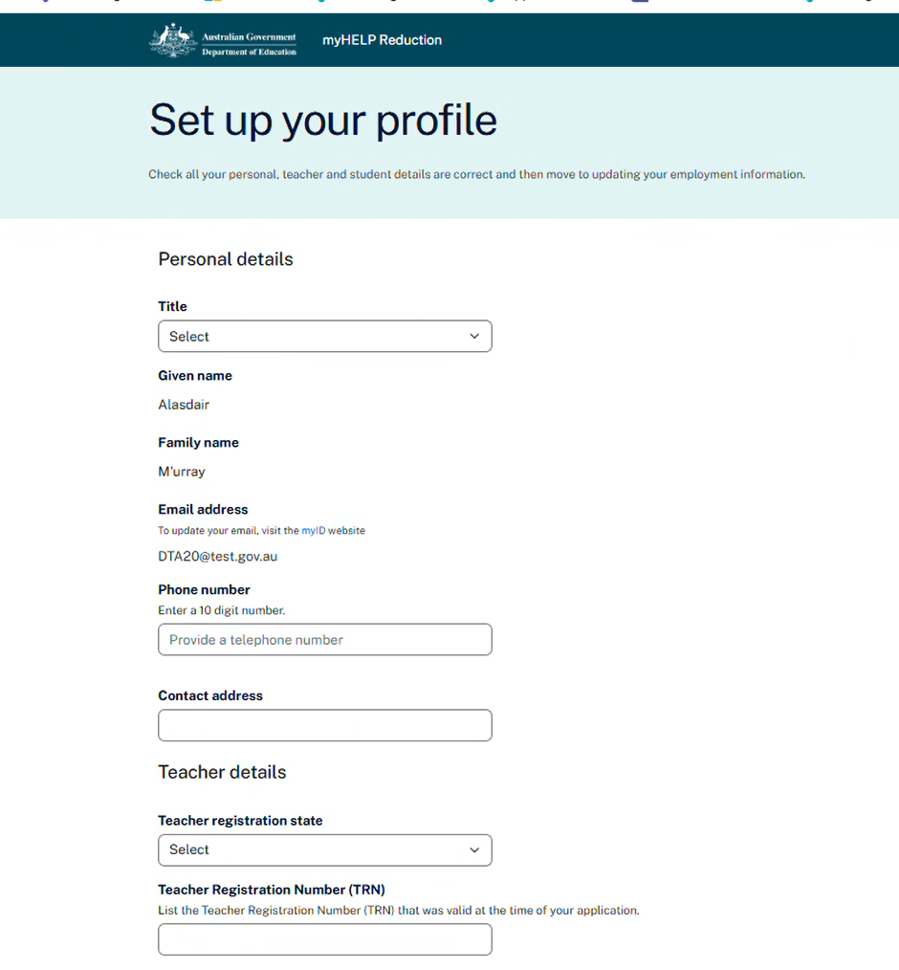
Figure 5. Set up your profile page (Personal details)

On your ‘Profile’ page, upload your academic transcript and ATO HELP Debt Statement (Figure 6). The Statement of Service or employer letter is uploaded later on the ‘Employment details’ page. Click on ‘Save and continue’ button (Figure 6).

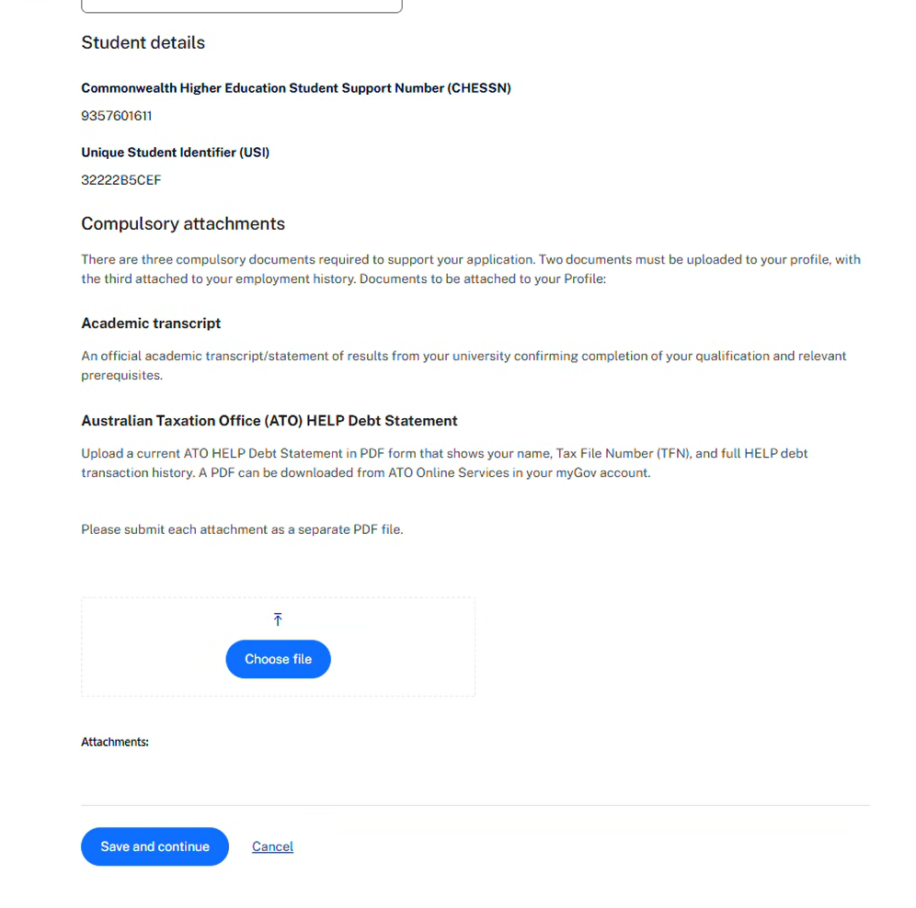
Figure 6. Upload evidence on your profile page

Once you have completed this section and selected ‘Save and close’, you will be directed to a dashboard where you have the option to switch between the ‘Overview’ and ‘Profile’ tabs.

A pop-up message will display on the dashboard after you enter your personal details prompting you to add your employment details.

Select the ‘Profile’ tab to go to the ‘Employment details’ screen (Figure 7).

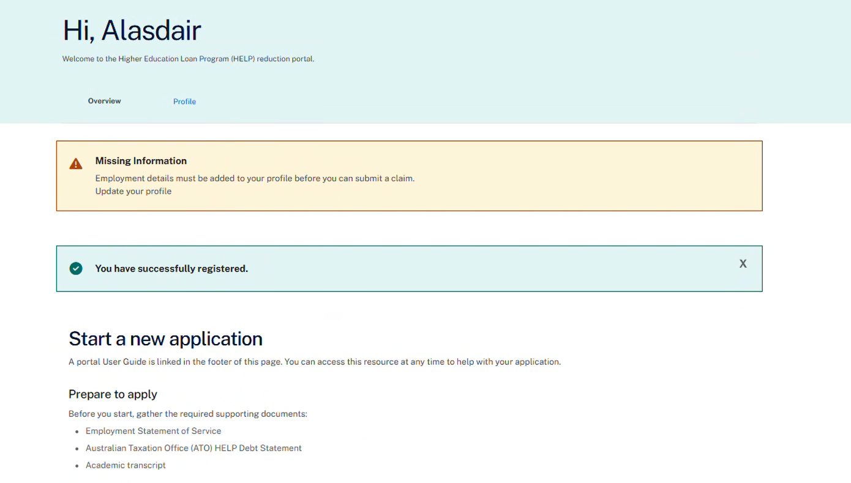
Figure 7. Dashboard select Profile to direct you to Employment details

2.7 Navigate to employment details
To enter your employment details, select ‘Add a new employment period’ (Figure 8).

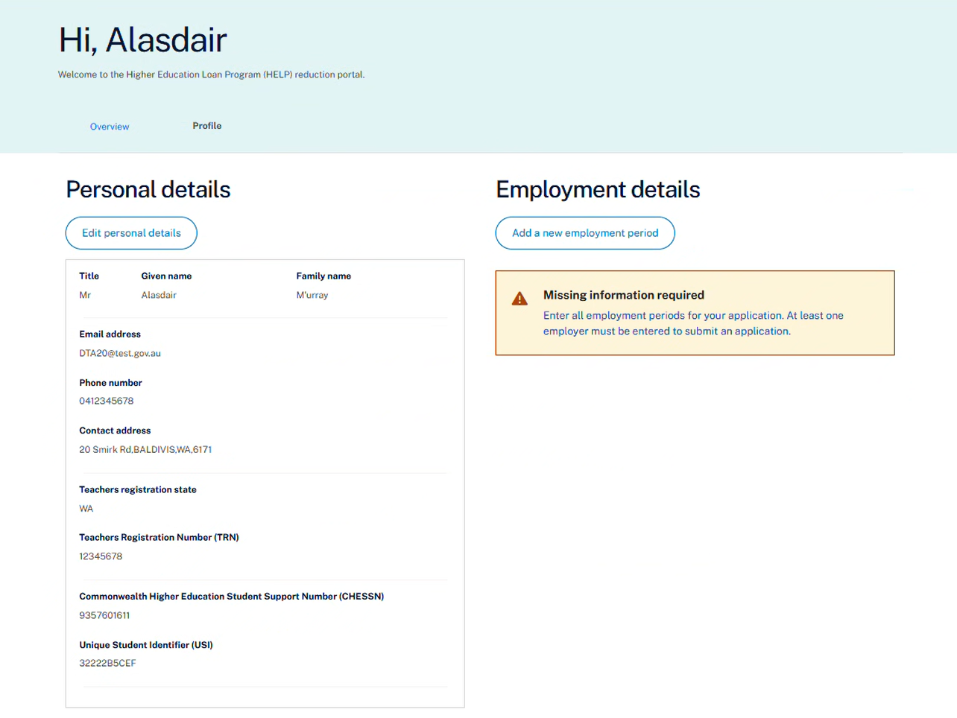
Figure 8. Navigate to the employment details screen

2.8 Add your employment details
The ‘Employment details’ page allows you to enter your work history at a school, preschool, or centre-based day care located in a very remote area of Australia (Figure 9).

You must enter an employment details record for each period of eligible employment. After you create your application, you will be able to select any employment periods you added at this step.

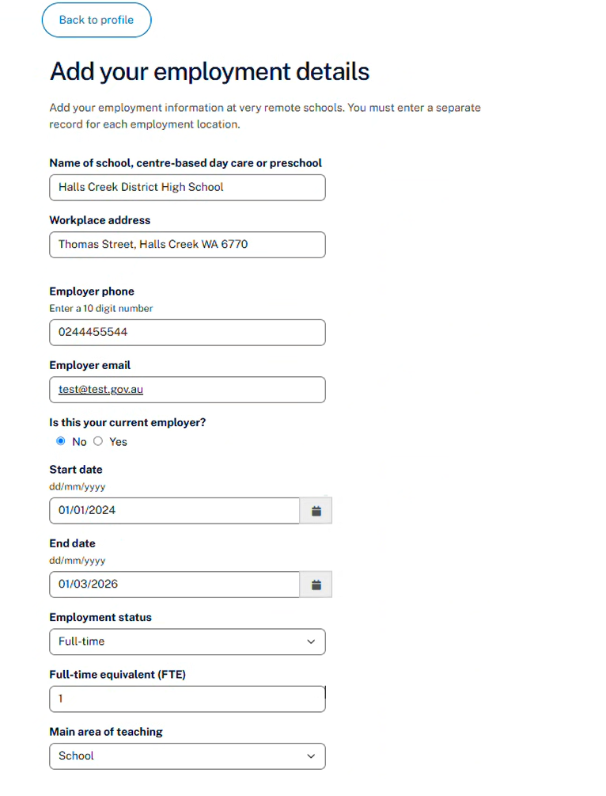
Figure 9. Add your employment details

TIPS for entering details correctly:
- Name of the school, centre-based day care or preschool: From the drop-down list, select the school where you worked. The address will automatically appear in the <Workplace address> field.
- If your school does not appear in this drop-down list, check if it’s included on the Very Remote Schools List.
- If your school is not listed in the Very Remote Schools List, you can check if it is classified as very remote on the ABS Remoteness Structure map. Information on how to check if your school is eligible is available on the program website.
- Once you have confirmed the school is very remote, select ‘Enter address manually’ button and complete the required fields.
- Employer phone: Enter a 10-digit number i.e. (03) 9999 9999 would be entered as 0399999999.
- Employer email: Enter your employer’s email address.
- Is this your current employer? If you select ‘Yes’, the End Date will default to the current date.
- Start date / End date: Select the calendar symbol to find the correct date or use dd/mm/yyyy if entering dates manually.
- Employment status: Select from the drop-down list i.e. full-time or part-time. If you are employed in a casual capacity, select ‘part-time’.
- Full-time equivalent (FTE): Enter your Full Time Equivalent (FTE) value while working at the school. Enter the value as a decimal (e.g. 1.0 for full-time, 0.6 for 3 days/week).
- Attach evidence of your employment: Attach a SoS or letter from your employer that supports the full period applied for in your application.
- Is there any further information you wish to add? This field is not compulsory however, you can add in any notes about your employment that may be relevant to your application.
- Declare the employment is for a face-to-face teaching position and not a distance or online teaching position.
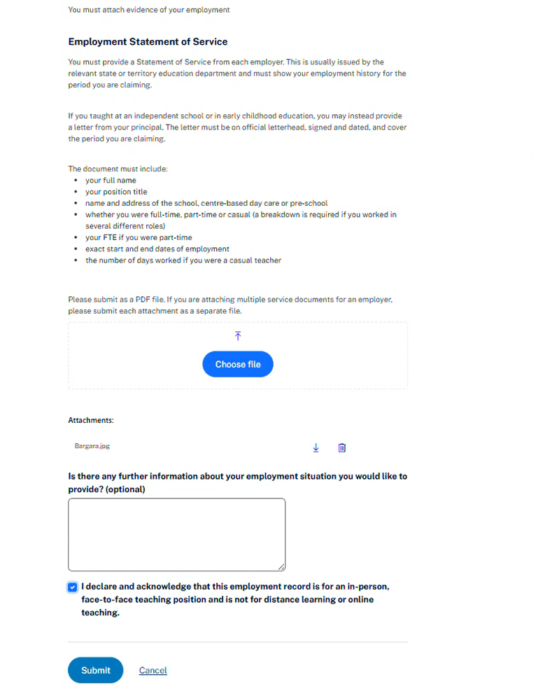
Figure 10. Declare and submit employment details

Select ‘Submit’ (Figure 10) and you will be returned to the dashboard.

To enter additional employment periods, return to the ‘Profile tab’, select ‘Add a new employment period’ and repeat the same process.

2.9 Progress your new application
After successfully entering an employment period/s and selecting ‘Overview’, you will receive a confirmation that the information has been updated (Figure 11).

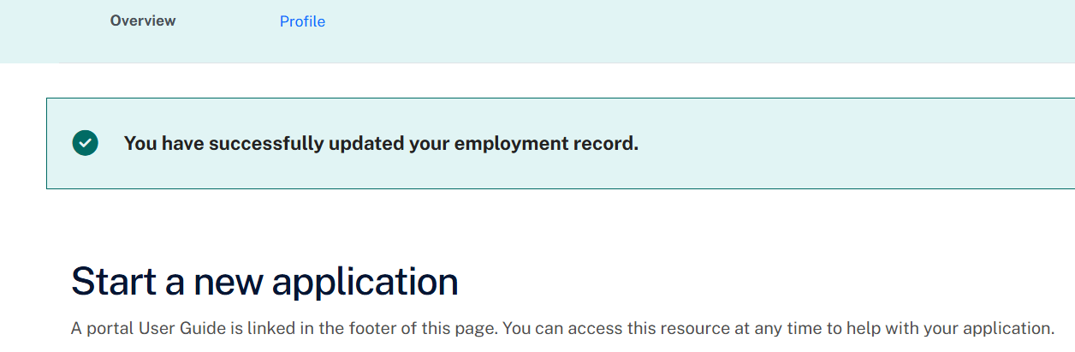
Figure 11. Redirection to the dashboard

The ‘Start a new application’ page will list the steps required to submit your application and list any previous applications under ‘Application history’ (Figure 12).

Select ‘Begin application process’. This creates a new application.

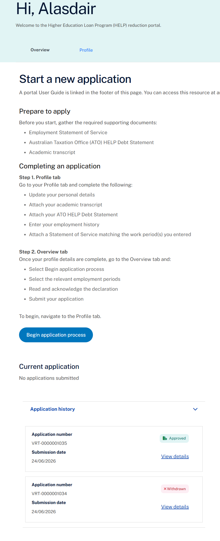
Figure 12. Progress a new application

2.10 Complete and submit your application
This is the final step to submit your application and supporting evidence to the Department of Education.

Read the ‘Application process’ information, then select ‘Continue’ (Figure 13).

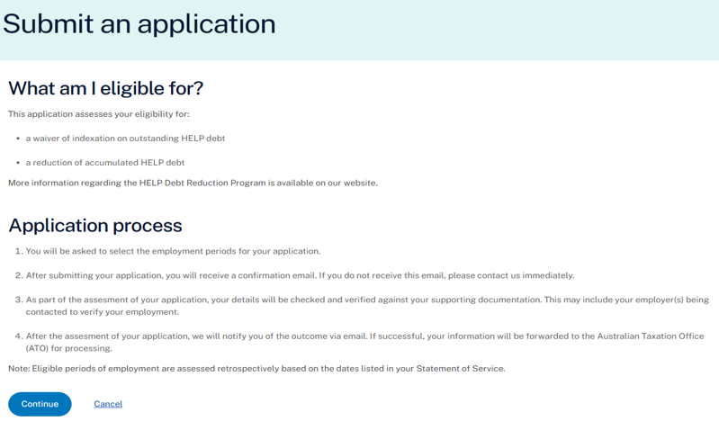
Figure 13. Submit an application screen

On the ‘Employment details’ page, select the checkbox for each employment period you want to include in your application (Figure 14). Select ‘Save and continue’ to progress.

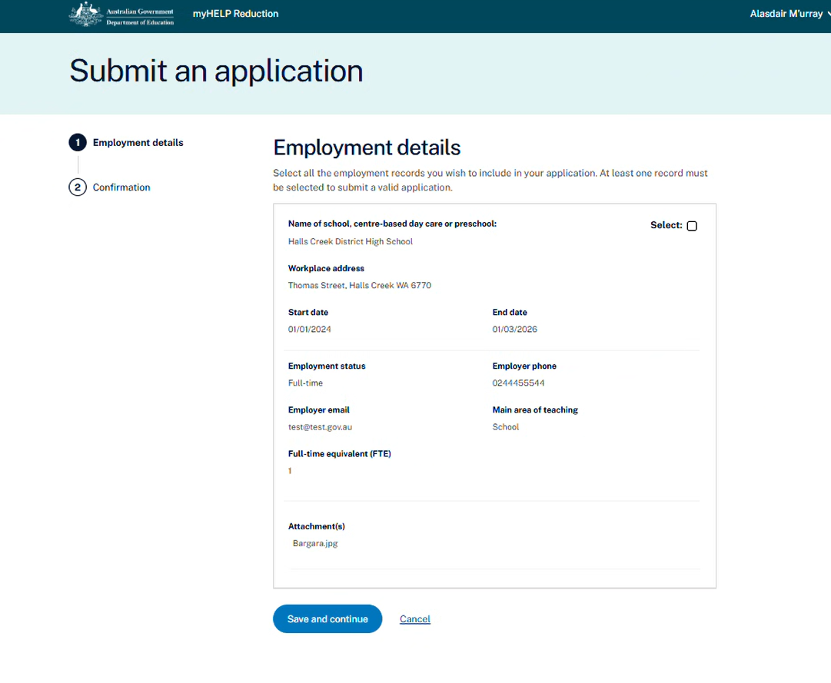
Figure 14. Select employment periods

On the ‘Confirm your application details’ screen (Figure 15), it is important that you read all the details on this page carefully as mistakes will delay the assessment of your application. If you find an error or don’t want to submit yet, select ‘Cancel’ to return to the dashboard. Your application will be saved as a draft.

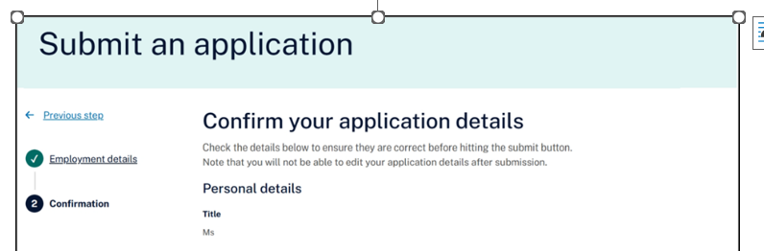
Figure 15. Confirmation screen (Part A) on the submit an application screen.

To submit your application, select the checkbox to confirm your understanding and acceptance of the declaration, then select ‘Submit Claim’ (Figure 16).

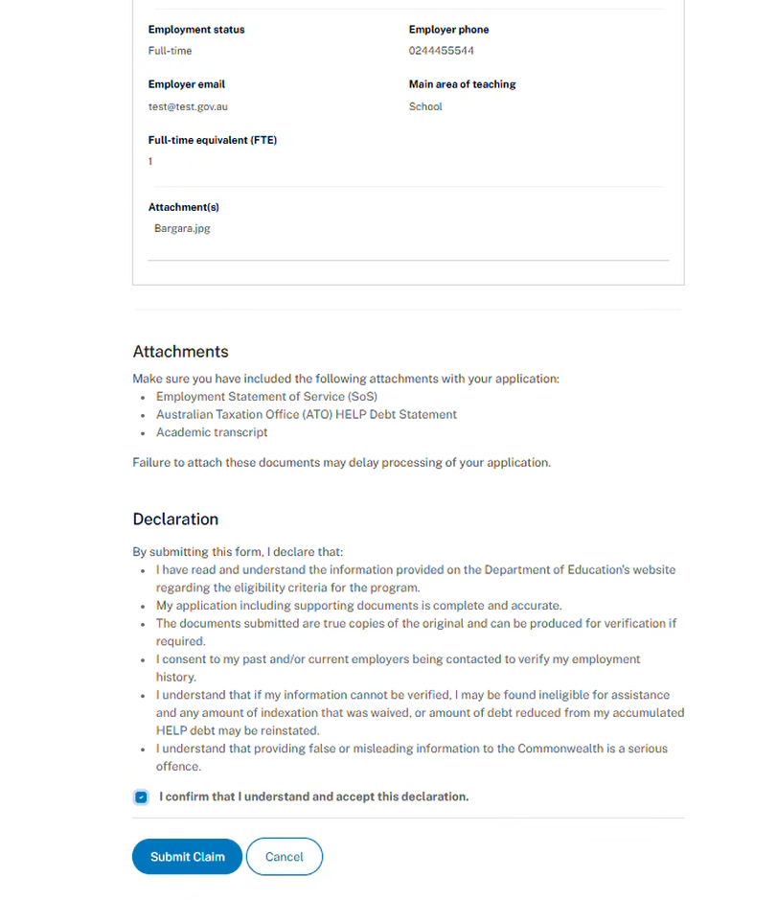
Figure 16. Confirmation screen (Part B) on the submit an application screen.

After submitting, you will see confirmation that your application has been successfully submitted (Figure 17). The ‘Current application’ section will show an application number, the status ‘Submitted’ and the submission date. You will also receive an email receipt confirming your application has been received.

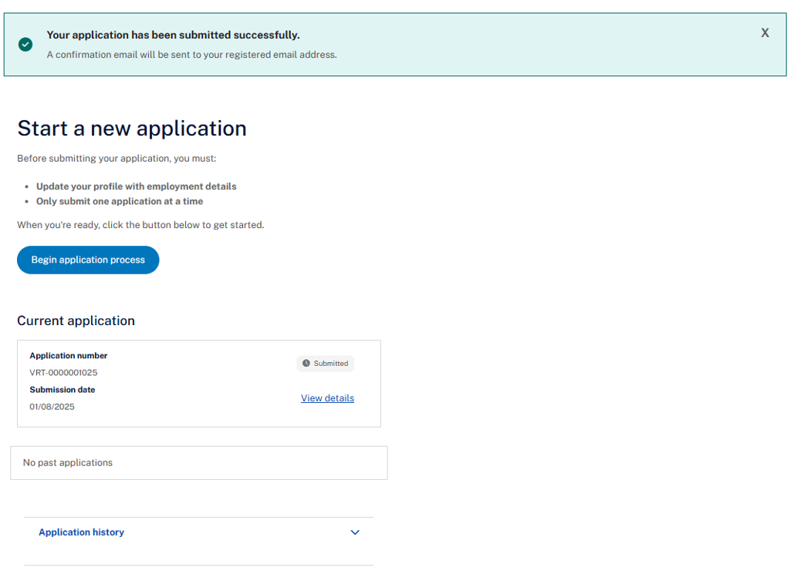
Figure 17. Successfully submitted screen
You can view the details of any application submitted by clicking on the ‘View details’ link. The status of this application can be viewed underneath the ‘Application number’ on this screen (Figure 18).

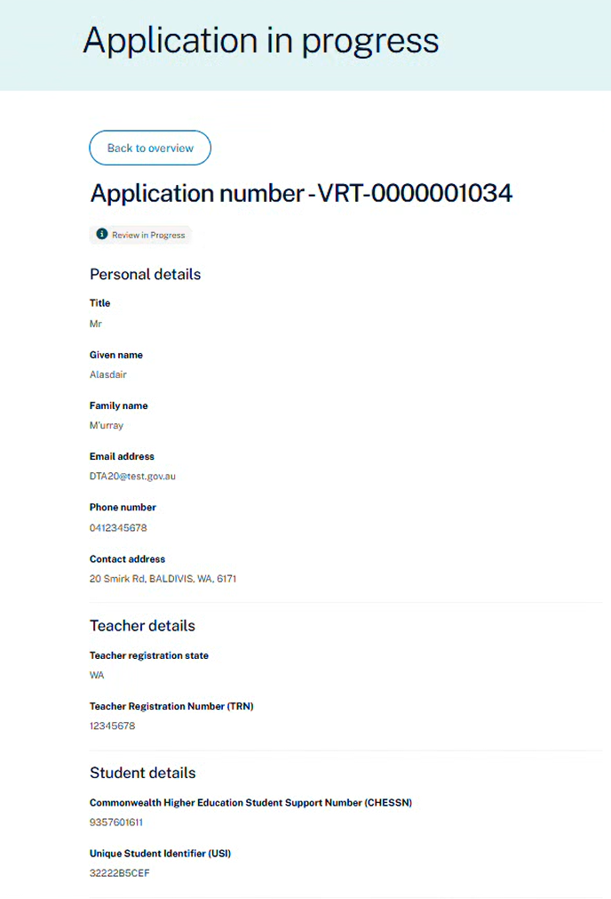
Figure 18. Dashboard (Overview) showing successful submission of your application.

2.11 After submission
After submitting your application, it can no longer be changed in the Applicant Portal.

If you need to change any information in your application after it has been submitted, contact the Department of Education.

Depending on the stage of your application, the status may be displayed as any of the following:
Saved as Draft | You have started the application process but have not submitted the application. You can continue to edit all information.
Submitted | You have submitted your application to the Department of Education for assessment.
Review in Progress | Your application is being assessed.
Request for Further Information | Your application is incomplete and we require further information to support your application.
Approved | Your application has been approved.
Rejected | Your application was not successful.

If you already have an application ‘saved as a draft’, you must continue or update this draft application rather than start a new application.

If you have previously submitted an application and its currently ‘under review’, you must wait until it is processed before starting a new one. It must have a status of Approved or Rejected for a new application to be submitted.

2.12 Sign out
To sign out of the portal, select the down arrow in the top right corner and select ‘logout’.

