Decorative only



Decorative report





Decorative only

|  |  |  |
| --- | --- | --- |
| **EARLY LEARNING**  **TEACHING PILOT:**  **SUMMARY REPORT** | University of Melbourne logo |  |
|  |

**Data collection**

A range of data were collected over 2022 - 2023 at participating early learning services including:

Interviews with parents and caregivers, teachers, educators, school principals and the CEO Surveys with participating teachers and educators Coaching records

Child literacy assessments

Child numeracy assessments

Preschool room observations of teaching practice (CLASS).

**Background**

This report provides an overview of findings from the evaluation of the Early Learning Teaching Pilot (ELTP) conducted by the University of Melbourne in partnership with the Commonwealth Department of Education in 2022-2023. The ELTP professional learning model included training and coaching for teachers and educators in explicit instruction and literacy and numeracy teaching strategies. The ELTP aimed to strengthen children’s literacy and numeracy learning in the year prior to school. The evaluation explored the impact of the ELTP model for participating teachers, educators and children.

Two services in the Northern Territory and one service in Victoria participated in the ELTP. Of the 101 children and families, matched numeracy and literacy assessment data across two timepoints in 2023 were available for 70 children. Of these, 25 children (36%) identified as Aboriginal or Torres Strait Islander, 32 children (46%) identified as female and 38 children (54%) identified at male. The mean age of children at time 1 was 4.5 years old.

**ELTP participants**

**101**

**CHILDREN**

**&**

**FAMILIES**

**16**

**STAFF MEMBERS**

**3**

**SERVICES**

**Staff perspectives**

Staff at the three services participated in online surveys and interviews with the UoM evaluation team to discuss their experiences participating in the project. Participating teachers and educators identified aspects of the professional learning that supported them in their work with children, including:

Coaching and practical teaching & assessment support Video examples of teaching practice

Ongoing literacy and numeracy teaching and assessment support

Access to in-person modelling of explicit instruction strategies

Easily accessible professional learning materials (including summary information for new staff) Streamlined documentation requirements

Supportive leadership team & time for team planning Partnerships & knowledge sharing with other services Opportunities for self and peer observations & feedback.

***“I found it really useful and   
practical ... the way I saw it was an   
ongoing PD, where you're always   
learning, and then trying to   
implement it."***

***“We have a great support system here...knowing that you have that support there does make it a little bit easier”***

***“I really thrive off people   
making observations of me   
and giving me constructive   
feedback.”***

**Family perspectives**

Family and community aspirations for children’s learning included:

Building children’s literacy and numeracy skills

Nurturing children’s cultural identity and connection to community

Supporting children’s use of English and First Language/s through two-way learning

Developing children’s social and emotional competence Supporting children’s confidence and independence in preparation for the transition to school

Promoting children’s kindness toward others

Supporting the continuity of children’s learning between Preschool and home.

Families and community members attending each of the three services contributed to group discussions about their aspirations for children’s learning in the years prior to school and beyond. These discussions were transcribed and thematically analysed to identify common themes.

**Page 1**

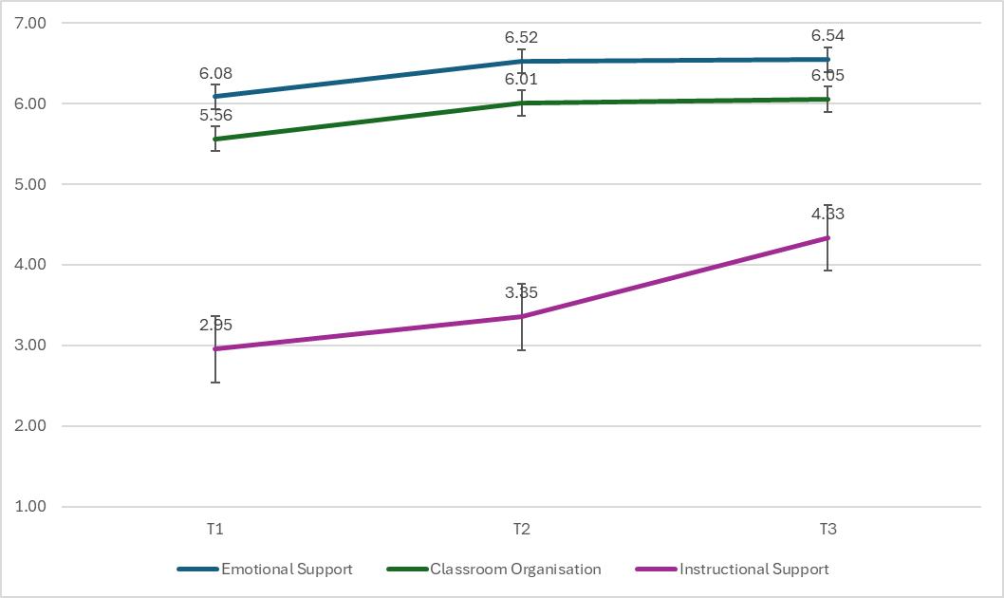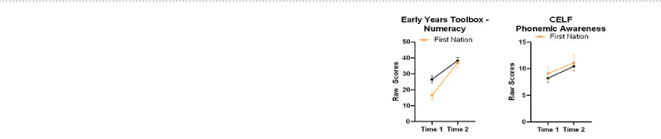

**Figure 1. *Average CLASS domain scores at times 1 - 3.***



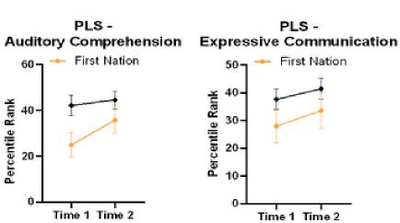

**Figure 1. *Changes in numeracy and literacy outcome scores between the start and end of 2023 by Aboriginal and/or Torres Islander status***

.

**EARLY LEARNING**

**TEACHING PILOT:**

**SUMMARY REPORT**

**Room observations**

The CLASS observational tool was used at three time points in 2023 to measure changes in teaching practices in three domains: Emotional Support, Classroom Organisation, and Instructional Support. Findings showed that average scores for Emotional Support and Classroom Organisation were in the high range at time 3, while the average score for Instructional Support was in the moderate range. Statistically significant changes in mean domain scores were observed between time 1 and time 3. The mean score for Instructional Support at time 3 is higher than the average scores found in a large-scale Australian study (Tayler et al., 2016) and importantly, above the level required to make a significant positive impact on children’s outcomes (Burchinal, et al., 2010).

**Children’s learning assessments**

The following play-based assessments were used to measure children’s numeracy and literacy growth at two timepoints in 2023: the Early Years Toolbox numeracy assessment tool, the Clinical Evaluation of Language Fundamentals-Preschool 3 Phonological Awareness subscale, and the Preschool Literacy Scale 5. Changes in mean standard scores were compared. There was evidence of a statistically significant improvement in children’s numeracy and phonemic awareness scores between the two time points. Although not statistically significant, there was also a trend that children’s scores increased for the more complex domains of expressive communication and auditory communication, as measured by the PLS. These patterns remained after accounting for differences in language background and service. For the Numeracy and Auditory Comprehension measures, there was a general pattern that children who identify as Aboriginal and Torres Strait Islander experienced greater growth in learning scores across the two time points compared to children who did not identify as Aboriginal and Torres Strait Islander. When literacy data available for ELTP participating children in their first year of school (2024) was examined, the growth observed in 2023 was maintained into their first year of schooling.

**Conclusion**

The results synthesised in this report present a very encouraging picture that demonstrates the value of the ELTP model in positively impacting teachers’ and educators’ confidence and teaching practices. The corresponding positive growth in children’s emergent literacy and numeracy outcomes across the year further verifies the positive impact of the ELTP.

**References Acknowledgements**

Burchinal, M., Vandergrift, N., Pianta, R., & Mashburn, A. (2010) Threshold analysis of association between child care quality and child outcomes for low income children in pre-kindergarten programs. Early Childhood Research Quarterly, 25, 166–176.

Tayler, C. (2016). The E4Kids study: Assessing the effectiveness of Australian early childhood education and care programs - Final report to the Partner Organisations of the Effective Early Educational Experiences (E4Kids) study. Melbourne Graduate School of Education: The University of Melbourne.

Our team wishes to thank all parents, carers, children, teachers, educators, leaders, Elders and service staff for their support of this project and generosity in sharing their experiences. We are very grateful to have had the opportunity to get to know the participants and their children. We hope all children have had a successful transition to school and wish them all the best on their continued learning journeys.

**Page 2**