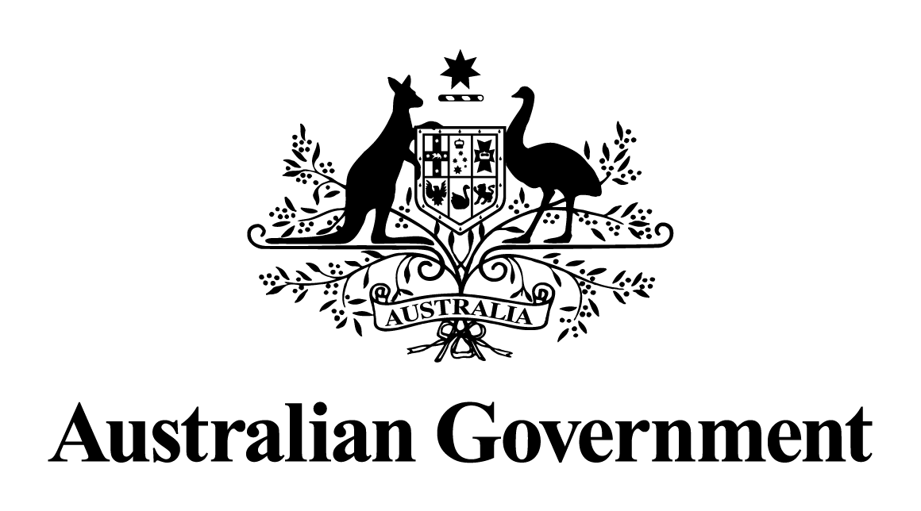

Australian Government response to the

Senate Education and Employment Legislation Committee report:

Better and Fairer Schools (Funding and Reform) Bill 2024 [Provisions]

August 2025

**Overview**

On 18 November 2024, the Senate Education and Employment Legislation Committee (the Committee) released its inquiry report on the Better and Fairer Schools (Funding and Reform) Bill 2024 (the Bill). The Committee’s report recommended that the Bill be passed and included three dissenting recommendations by the Australian Greens.

On 29 November 2024, the Bill received Royal Assent, after passing both the House of Representatives and the Senate without amendment on 26 November 2024.

The *Better and Fairer Schools (Funding and Reform) Act 2024* (the Funding and Reform Act) amended the*Australian Education Act 2013*and enabled the Australian Government to lift its share of funding to public schools above 20 per cent of the Schooling Resource Standard (SRS). The Funding and Reform Act allows the Australian Government to deliver on the school funding and reform agreements signed with state and territory governments, supporting all public schools to be on a pathway to full and fair funding.

This government response is a response to the Committee’s report and the dissenting recommendations from the Australian Greens.

Response to the Committee’s report

**Recommendation** 1

The committee recommends that the bill be passed.

**Response**

The Australian Government **agrees** with this recommendation. The Bill was passed on 26 November 2024 and received Royal Assent on 29 November 2024.

Response to the Australian Greens’ dissenting report

**Recommendation 1**

That the Australian Government fully fund public schools in 2025 by lifting the Commonwealth contribution to the Schooling Resource Standard to a minimum of 25 per cent.

**Response:**

The Australian Government **agrees-in-principle** to this recommendation.

All public schools across Australia are on a pathway to 100 per cent of the Schooling Resource Standard.

All states and territories, except for the Northern Territory, have signed the *Better and Fairer Schools Agreement 2025‑2034 – Full and Fair Funding* (the Full and Fair Funding Agreement). The Full and Fair Funding Agreement provides an additional 5 per cent of the SRS for public schools, lifting the Australian Government’s contribution from 20 per cent to 25 per cent of the SRS by no later than 2034.

For the Northern Territory, the Australian Government will contribute 40 per cent of the SRS for public schools by 2029 through the *Better and Fairer Schools Agreement 2025‑2034* (the BFSA).

**Recommendation 2**

That the Australian Government remove the ability of States and Territories to count non‑core education expenditure towards their Schooling Resource Standard contributions.

**Response:**

The Australian Government **agrees-in-principle** to this recommendation.

The Full and Fair Funding Agreement removes the ability of states and territories to continue to claim the 4 per cent provision for indirect school expenditure. This will take place by the end of 2034, and jurisdictions will be required to replace the provision with recurrent funding on eligible expenses.

**Recommendation 3**

That the Australian Government review funding arrangements for Australian schools, with particular regard for the adequacy of the Schooling Resource Standard in meeting the increasingly complex needs of school children across Australia.

**Response:**

The Australian Government **agrees-in-principle** to this recommendation.

The Better and Fairer Schools Agreements include National Enabling Initiatives, which are specific reform activities that require collaboration between the Commonwealth and states and territories who are party to the agreement. Through these initiatives, parties have agreed to conduct a review of the Schooling Resource Standard base and loading calculation methodology. The review is due to be completed by no later than mid-2029.