**3-4 July 2025**

**Early Childhood Care and Development Policy Partnership**

**Meeting Ten Outcomes**

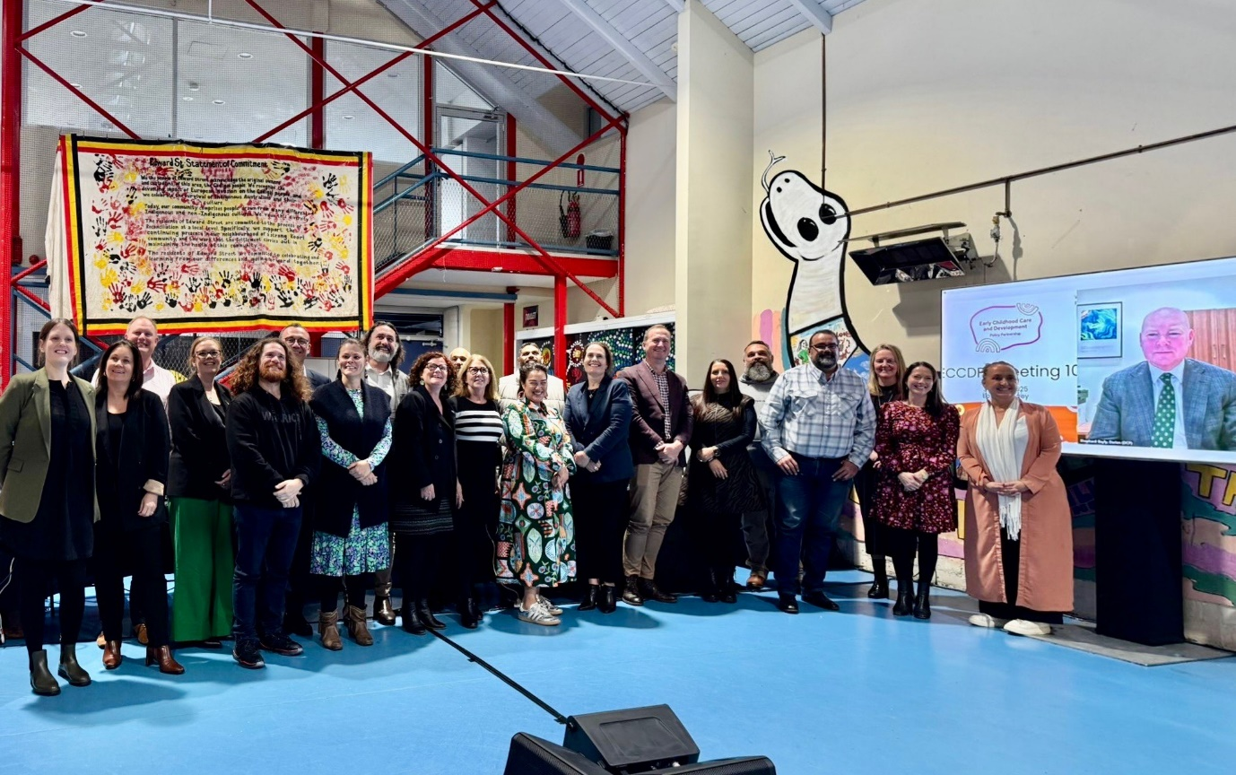

Members of the Early Childhood Care and Development Policy Partnership on the lands of the Gadigal People in Eora/Sydney

The Early Childhood Care and Development Policy Partnership (the ECCDPP or Partnership) held its tenth meeting on Gadigal Country in Darlington, Sydney on 3-4 July 2025. The meeting was on the lands of the Gadigal People. The meeting opened with a Welcome to Country by Yvonne Weldon from Metropolitan Local Aboriginal Land Council, who reflected on the history and strength of First Nations communities across more than 65,000 years.

The meeting was co-chaired by Catherine Liddle, CEO, SNAICC – National Voice for our Children (SNAICC) and Kylie Crane, Deputy Secretary, Early Childhood and Youth Group, Australian Government Department of Education (the department).

The meeting was attended by Aboriginal and Torres Strait Islander independent and peak body representatives and representatives from Australian State, Territory and Commonwealth governments. A full list of attendees is located from page 5.

**Presentation on Early Childhood Care and Development policy landscape in New South Wales**

New South Wales (NSW) representatives provided an overview of the local early childhood care and development operating context. John Leha, Chief Executive Officer, NSW Child, Family and Community Peak Aboriginal Corporation (AbSec), presented on the organisation’s priorities and alongside Natalie Riley from Burrun Dalai, provided an overview of the Tamworth Coalition of Aboriginal Community Controlled Organisations (TACCO), and the historic *Mara Ngali Partnership Agreement* (“our two hands”) signed between TACCO and the Tamworth Regional Council. John reflected on how the National Agreement on Closing the Gap (National Agreement) is enabling place-based collaboration across all three levels of government, but that these agreements need to be complemented with adequate investments for Aboriginal Community Controlled Organisations (ACCOs). Dr Paul Gray also reflected on the importance of having robust relationships between the NSW Government and Aboriginal and Torres Strait Islander organisations and noted opportunities to strengthen collaboration.

Ray Ingrey, President of the NSW Aboriginal Education Consultative Group (AECG) outlined some of the AECG’s priorities and policy focus, including advocating for the National Skills Agreement to be formally linked to the National Agreement on Closing the Gap.

Mark Barraket, Deputy Secretary, Early Childhood Outcomes, NSW Department of Education provided an overview of the NSW Government’s 5-year First Steps Strategy, which is in the process of being refreshed in partnership with the Aboriginal Early Childhood Advisory Group. The Strategy refresh will focus on expanding ACCOs to deliver services directly to their communities. Mark also noted that workforce development will be a key focus for the NSW Government over the next 4 years. Stuart Malcher, Executive Director, NSW Department of Communities and Justice also presented to the Partnership on Child Protection System reforms currently underway as part of a $1.2 billion package announced in the NSW 2025-26 budget handed down in June of this year.

**Progressing the Partnership’s Priorities**

The Partnership’s priorities are the agreed policy reform areas on which the Partnership will focus its work and shared decision-making activities. The priorities aim to drive concrete action to advance the safety, development and wellbeing of children and to meet Closing the Gap targets 2, 3, 4, 12 and 13 and the cross-cutting area of disability. A full list of [priorities can be found here](https://www.snaicc.org.au/our-work/closing-the-gap/early-childhood-care-development-policy-partnership/).

Supporting Aboriginal and Torres Strait Islander children and families with disability (Priority 4B)

To progress Priority 4B, members agreed to Terms of Reference for a research project and the next steps to commission the project. The research will focus on the collection of accurate and culturally appropriate data in relation to Aboriginal and Torres Strait Islander children and parents with disability and/or developmental delay who encounter child protection systems. This research will allow governments, community and Aboriginal and Torres Strait Islander organisations to better understand how Aboriginal and Torres Strait Islander children and parents with a disability come into contact with child protection systems and provide evidence to better support those children and families to stay safely together. The project will also develop culturally safe assessments to improve the identification and response to people with disability in the child protection system.

Other ECCDPP Priorities

The Partnership noted progress updates on the other ECCDPP priorities, including government member updates on significant strategic policy, regulatory or legislative developments in each jurisdiction relating to the Partnership’s scope and priorities.

**Forward planning and Year 3 Workplan**

Members agreed the Partnership’s Year 3 Workplan, which outlines the direction and key activities and outputs for the 2025-26 financial year. The workplan strengthens the ECCDPP’s focus on priorities relating to the child and family services and health sectors and is in alignment with the Joint Council on Closing the Gap (Joint Council) focus on Closing the Gap Target 12 (address the over-representation of Aboriginal and Torres Strait Islander children in out-of-home care).

Members also agreed a set of draft recommendations to be made to Joint Council in November 2025, which will be finalised out of session. The Year 3 Workplan will be published on the department and SNAICC websites.

**Presentation and discussion of 2024 Australian Early Development Census results**

Members heard a presentation from Associate Professor Yasmin Harman-Smith, The Kids Research Institute, on the national release of the 2024 [Australian Early Development Census](https://www.aedc.gov.au/) (AEDC) on 13 June 2025. Members discussed the results with reference to the Partnership’s remit and priorities. While outcomes for Aboriginal and Torres Strait Islander children showed relative resilience compared to declining national trends, members noted that progress towards Closing the Gap Target 4 (increase the proportion of Aboriginal and Torres Strait Islander children assessed as developmentally on track in all five AEDC domains) remains off track.

Members discussed the importance of strengthening early supports, improving engagement with AEDC data across early childhood and care (ECEC) settings and addressing barriers to access highlighted in the research, such as cost-of-living pressures. Members considered the broader implications of the AEDC results for contact with child protection systems, noting the interconnectedness of Closing the Gap Targets 4 and 12, and the need for child and family services to respond to the AEDC findings. Members noted that stronger connections between ECEC services and schools, improved data literacy and access to affordable culturally safe disability assessments play an important role for improving outcomes, with the Priority 4B research project supporting this work.

**Overview of ECCDPP-funded projects**

Members noted progress updates on 3 key projects being implemented by SNAICC under the Partnership grant: the Data Lake project, which aims to strengthen data capability in the sector; the Youth Voice project, which is focused on embedding the voices of children and young people; and the Shared Decision-Making Guidance project.

Members heard a presentation from Katrina Fanning AO PSM, Coolamon Advisors, on the Shared Decision-Making Guidance project. Members discussed the approach to the project, which seeks to broaden Priority Reform 1 of the Closing the Gap and provide practical guidance for governments to self-evaluate their performance in shared decision-making and identify areas for improvement in relation to early childhood care and development policy.

**ECCDPP Evaluation**

Following member agreement at Meeting 8 (November 2024) to the scope and procurement process for the evaluating the Partnership’s first term of operation, Yamagigu Consulting Pty Ltd (Yamagigu) was engaged in June 2025. Yamagigu representatives attended the meeting to outline the draft project plan for the evaluation and potential options for engagement to shape the final plan. The final evaluation report is due in November 2025.

**ECCDPP Member workshop with Safe and Supported Implementation Coordination Committee Workshop: Progressing shared priorities**

While ECCDPP members were together on 4 July 2025, they participated in a workshop with the Safe and Supported Implementation Coordination Committee (ICC), a shared decision-making mechanism responsible for implementing actions under the associated action plans.

The workshop provided an opportunity to join up work across the two forums and coordinate progress on the overlapping priorities of *Safe and Supported* and ECCDPP.  The workshop explored high impact strategies to transfer resources to Aboriginal and Torres Strait Islander community-controlled child and family services. It also discussed priority actions that require focus to make progress on reducing the over-representation of Aboriginal and Torres Strait Islander children in out-of-home care.

The Partnership and ICC have agreed to continue to work together to coordinate work, progress actions, and present to Joint Council in November 2025 and on actions to support the ACCO sector.

**Next meeting**

The Partnership will meet again in September 2025 to continue progressing the Partnership’s priorities.

**Attendees/Apologies**

|  |  |
| --- | --- |
| **Name** | **Representing** |
| **Coalition of Peaks representatives** | |
| **Catherine Liddle** | SNAICC – National Voice for our Children (SNAICC) |
| **Donnella Mills** (online) | National Aboriginal Community Controlled Health Organisation (NACCHO) |
| **Neville Atkinson** | Victorian Aboriginal Education Association Incorporated |
| **Lisa Coulson** | Tasmanian Aboriginal Centre |
| **Tennille Lamb** | First Peoples Disability Network |
| **Kylie Degenhardt** (proxy forSharron Williams) (online) | South Australian Aboriginal Community Controlled Organisation (SAACCON) |
| **Independent Aboriginal and Torres Strait Islander representatives** | |
| **Darcy Cavanagh** | Independent representative |
| **Paul Gray** | Independent representative |
| **Garth Morgan** (online) | Independent representative |
| **Joanne Della Bona** (apology) | Independent representative |
| **Elizabeth Cox** (apology) | Independent Representative |
| **Government representatives** | |
| **Kylie Crane** | Commonwealth Government, Department of Education |
| **Mark Barraket** | New South Wales Government |
| **Mathew Lundgren** | Victorian Government |
| **Tania Porter** (day 1 only) | Queensland Government |
| **Margaret Collard** (proxy for Melanie Samuels) | Western Australia Government |
| **Bec Curtin** (proxy for Kim Little) | South Australia Government |
| **Clare Wiseman** (proxy for Peter Whitcombe) | Tasmania Government |
| **Nicole Moore** | Australian Capital Territory Government |
| **Karen Broadfoot** (online) | Northern Territory Government |
| **Partners** | |
| **Muriel Bamblett** (apology) | SNAICC – National Voice for our Children (SNAICC) |
| **John Leha** | CEO of AbSec – NSW Child, Family and Community Peak Aboriginal Corporation |
| **Letitia Hope** | Commonwealth Government, Department of Social Services |
| **Ali Jenkins** (proxy for Julie-Ann Guivarra)(online) | Commonwealth Government, National Indigenous Australians Agency |
| **Stuart Malcher** | New South Wales Government |
| **Simone Corin** | Victorian Government |
| **Ron Weatherall** (online) | Queensland Government |
| **Rebecca Bope** (proxy for Raechelle Lee) (online) | Western Australia Government |
| **Darian Shepard-Bayly** (proxy for Jackie Bray) (online) | South Australian Government |
| **Chris Simpson** | Australian Capital Territory Government |
| **Aderyn Chatterton** | Northern Territory Government |

**Additional Participants at Joint ECCDPP-ICC Workshop**

**Implementation Coordination Committee (ICC) Members**

Jacqueline Hrast, ICC Co-Chair, Commonwealth Government, Department of Social Services

Emily Devine, Commonwealth Government, Department of Social Services

Jacqueline McGowan-Jones, Western Australia Government, Commissioner for Children and Young People

Jess Walpole, Western Australia Government

Silvia Lapic, Australian Capital Territory Government

Wendy Moore, Tasmanian Aboriginal Centre  
Natalie Brown, Our Booris, Our Way (online)

Shanti Croisdale Victorian Aboriginal Child and Community Agency (online)

Helena Wright, Queensland Aboriginal and Torres Strait Islander Child Protection Peak (online)  
Ashum Owen, Wakwakurna Kanyini (online)

Nairana Coleman, Wakwakurna Kanyini (online)