

# Task card – How to Report Vacancies in the Provider Entry Point (PEP)

How to report vacancies in the Provider Entry Point

Logging In 3

Vacancies 3

Vacancies by Age 5

General Availability 7

Weekend Vacancies 8

## Overview

This task card outlines how to report vacancies in the Provider Entry Point (PEP) to meet your reporting obligations under Family Assistance Law (FAL).

Under FAL you are required to report vacancies for each day of the following week by 8am AEST/AEDT each **Friday**

You can find instructions on how to report:

* Vacancies by Age
* General Availability
* Weekend Vacancies

Find more [task cards](https://www.education.gov.au/early-childhood/provider-tool-kit#toc-task-cards) for the PEP on our website.

If you need further assistance, contact the Child Care Subsidy Provider Helpdesk on 1300 667 276 from 9 am to 5 pm AEST or [via email](mailto:CCSHelpdesk@education.gov.au) anytime.

**Note:** Only certain special characters can be used in the PEP:

* full stop (.)
* comma (,)
* hyphen (-)
* slashes (/, \)
* apostrophe (‘).

All other special characters will cause an error in the system.

## Logging In

Step 1

Log in to the [Provider Entry Point (PEP)](https://proda.humanservices.gov.au/prodalogin/pages/public/login.jsf?TAM_OP=login&ERROR_CODE=0x00000000&URL=%2Fmga%2Fsps%2Foauth%2Foauth20%2Fauthorize%3Fscope%3Dopenid%26state%3DalN0hw9ovD%26client_id%3DGTzCa6CRNfBsRTdfljBa%26redirect_uri%3Dhttps%253A%252F%252Fbusinessonline.humanservices.gov.au%252Fmga%252Fsps%252Foidc%252Frp%252Fchildcaresubsidy%252Fredirect%252Fproda%26response_type%3Dcode&OLDSESSION=).

## Vacancies

Step 1

Navigate to the homepage of the service where you want to report vacancies.

It is important that you are in the appropriate service context for the vacancies you will be reporting.

Select the **Manage Details** tile.

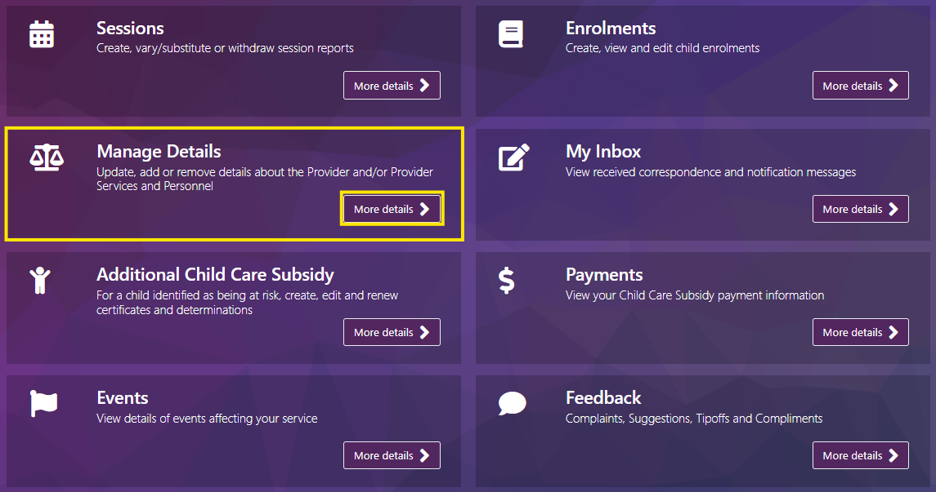

Step 2

Under the **Business Details** heading select **Vacancies offered**

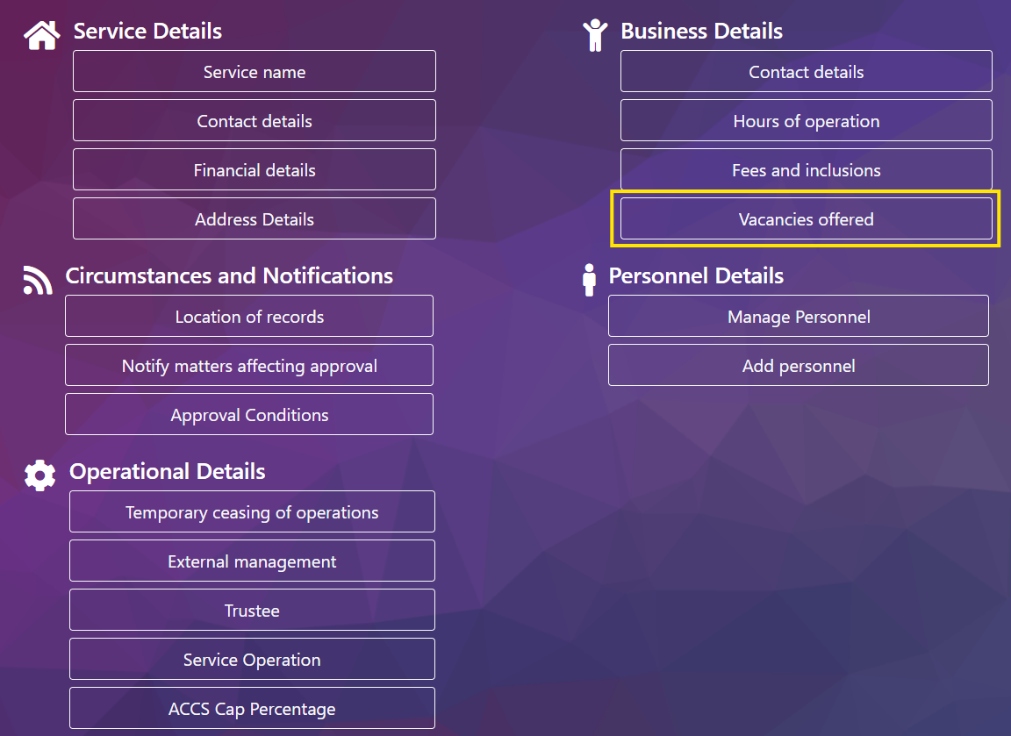

Step 3

Enter the date for the week you are reporting vacancies.

***Note –*** *You can report vacancies for the current week and one week ahead. Vacancy information cannot be backdated for past weeks.*

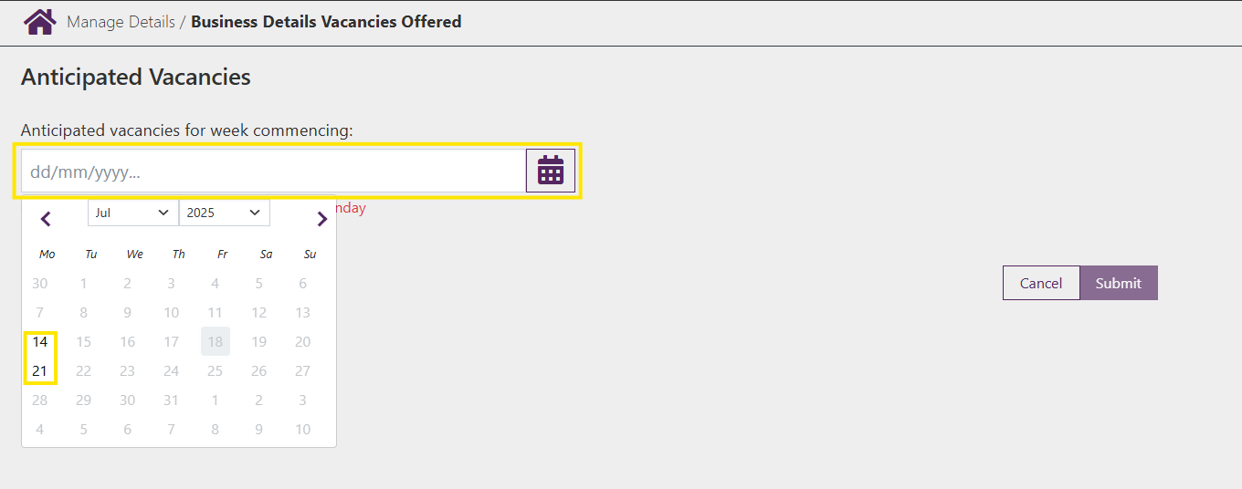

## Vacancies by Age

You can report vacancies to display on Startingblocks.gov.au by **Age Group.** This will mean that vacancies will display per age group and as either casual or permanent.

Step 1

For each day select either **Yes** or **No** if vacancies exist and select **Advanced**

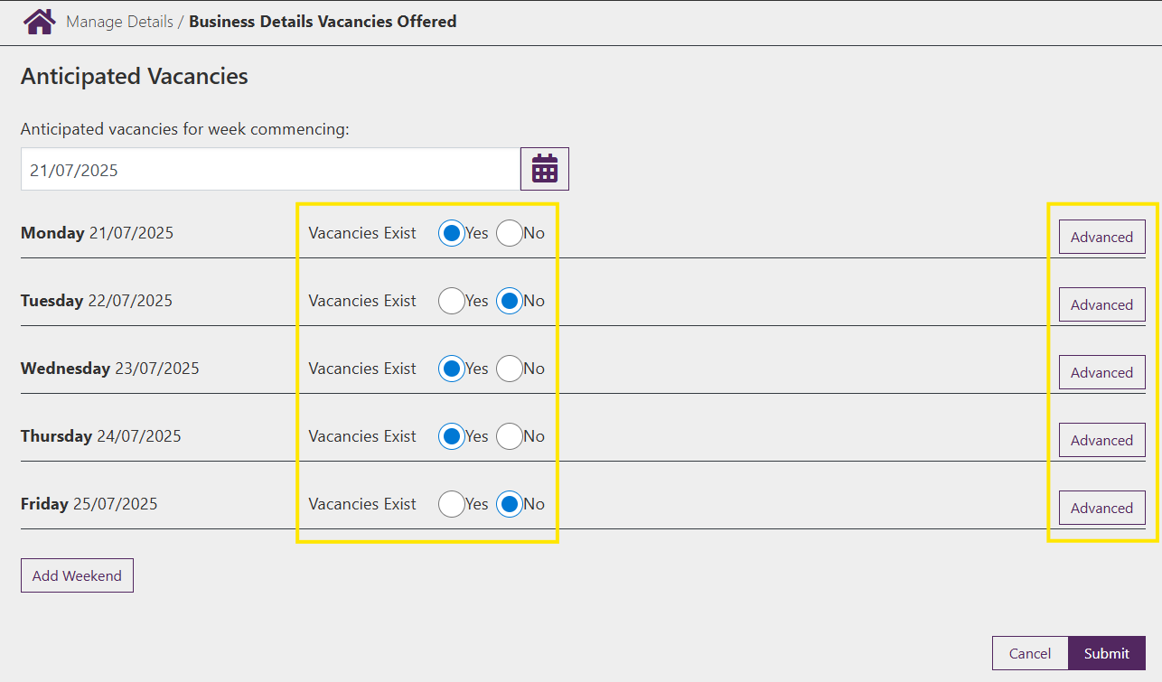

Step 2

Select available vacancies for each relevant **Age Group** and **Session**

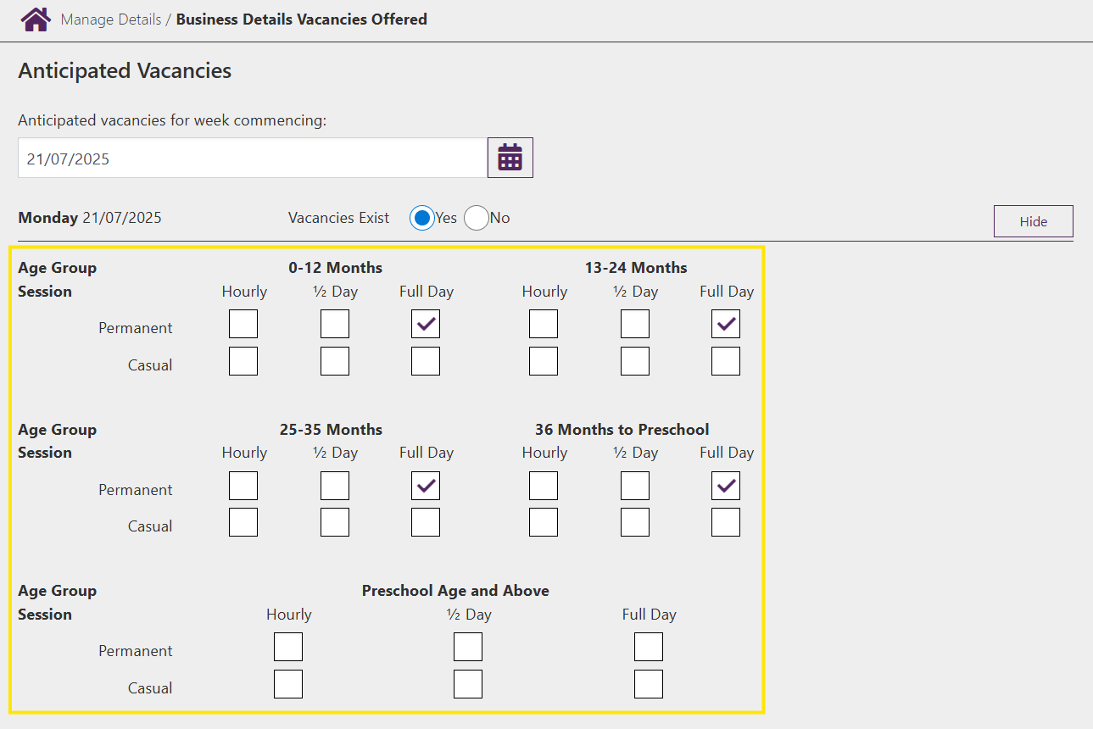

Step 3

Complete the above step for all relevant days and select **Submit** to submit vacancies

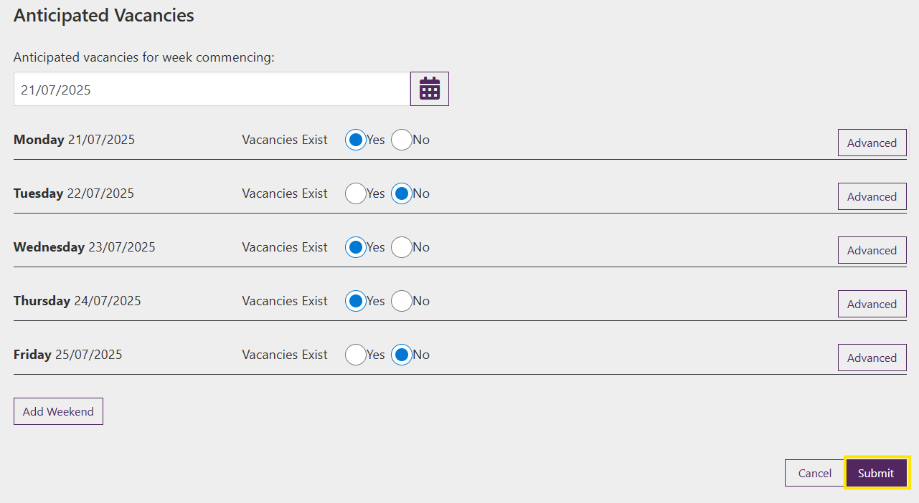

Step 4

You will receive a receipt confirming the submission of vacancy information. Select either **Return Home** to return to the **Service home page** or **Continue** to return to the **Manage Details** page.

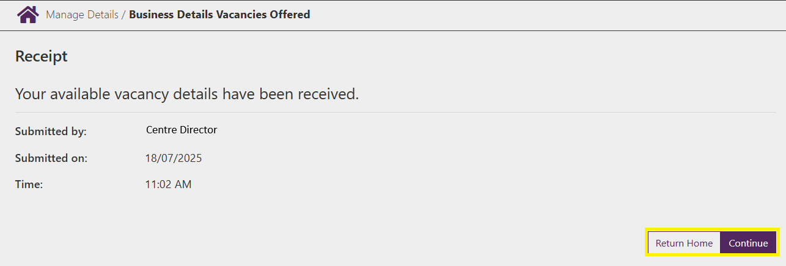

## General Availability

You can report vacancies to display on Startingblocks.gov.au as **General Availability.** This will mean that vacancies will display as only yes or no per day and not the ages or session type.

Step 1

For each day select either **yes** or **no** if vacancies exist

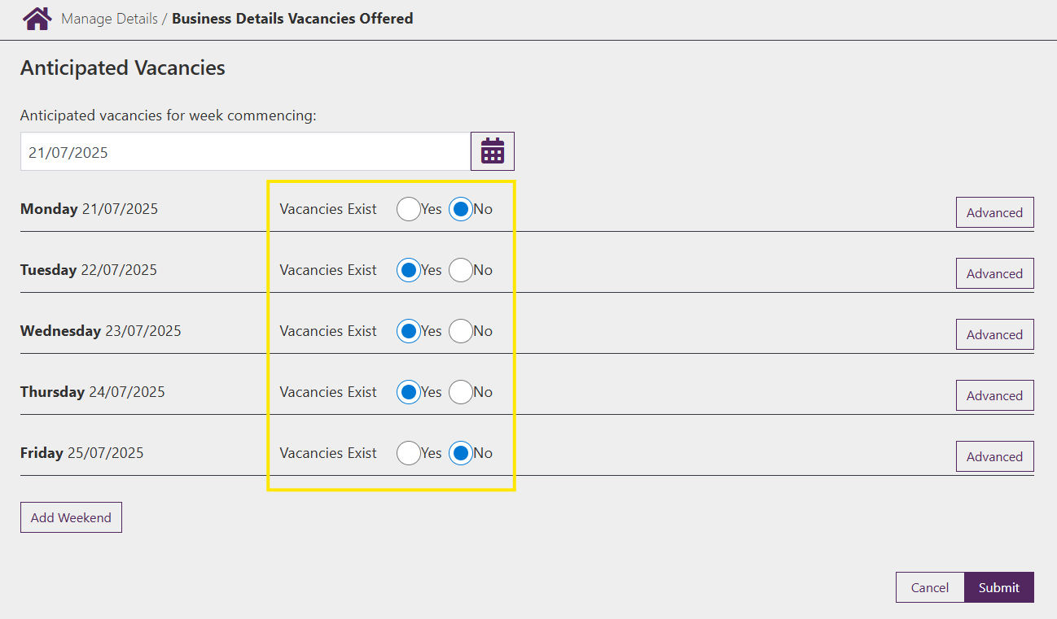

Step 2

Select **Submit** to submit vacancies

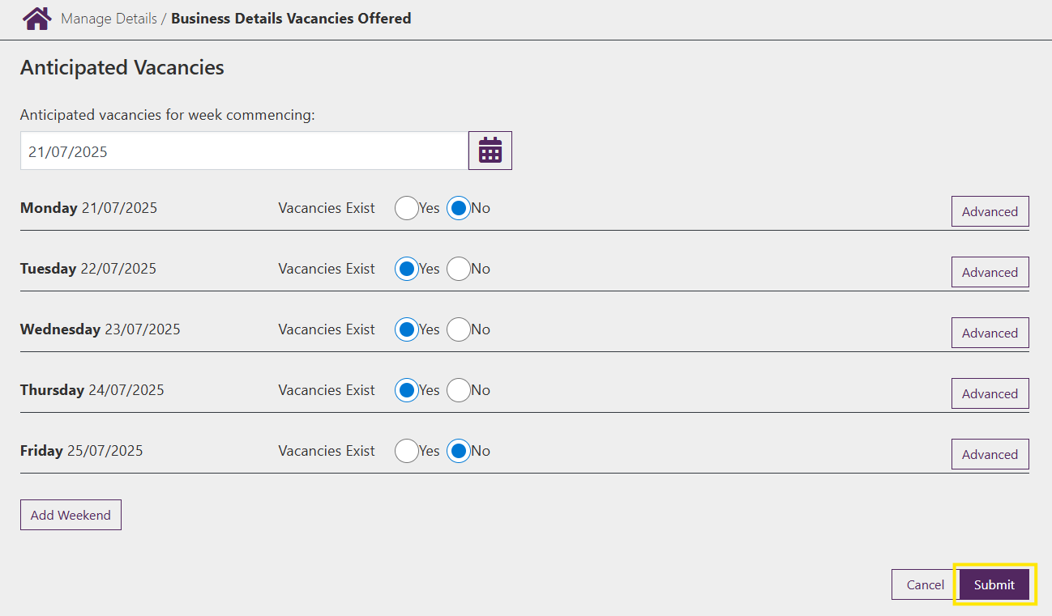

Step 3

You will receive a receipt confirming the submission of vacancy information. Select either **Return Home** to return to the **Service home page** or **Continue** to return to the **Manage Details** page.

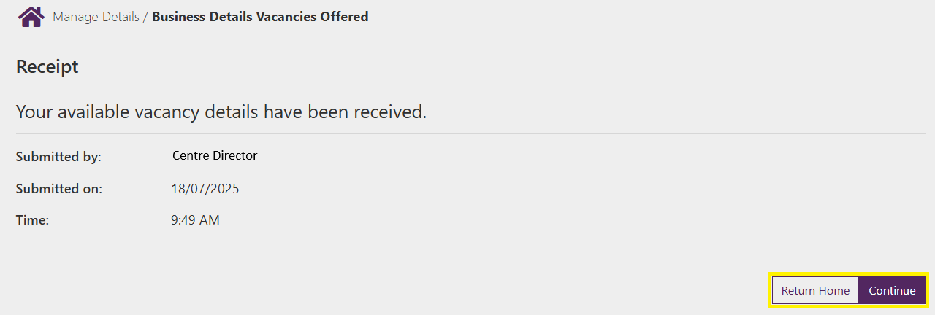

## Weekend Vacancies

Step 2

From the **Anticipated Vacancies** page, select **Add Weekend**

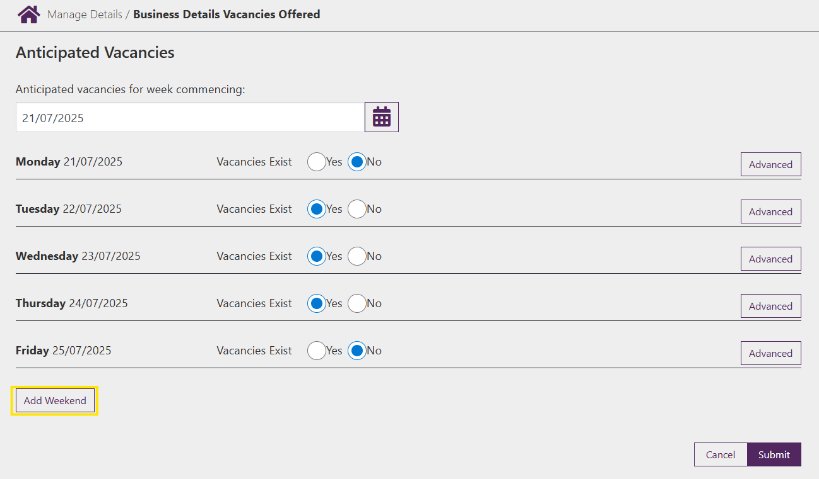

Step 3

From here follow the same above steps for either **Age Group Vacancies** or **General Availability** and select **Submit** to submit vacancies.

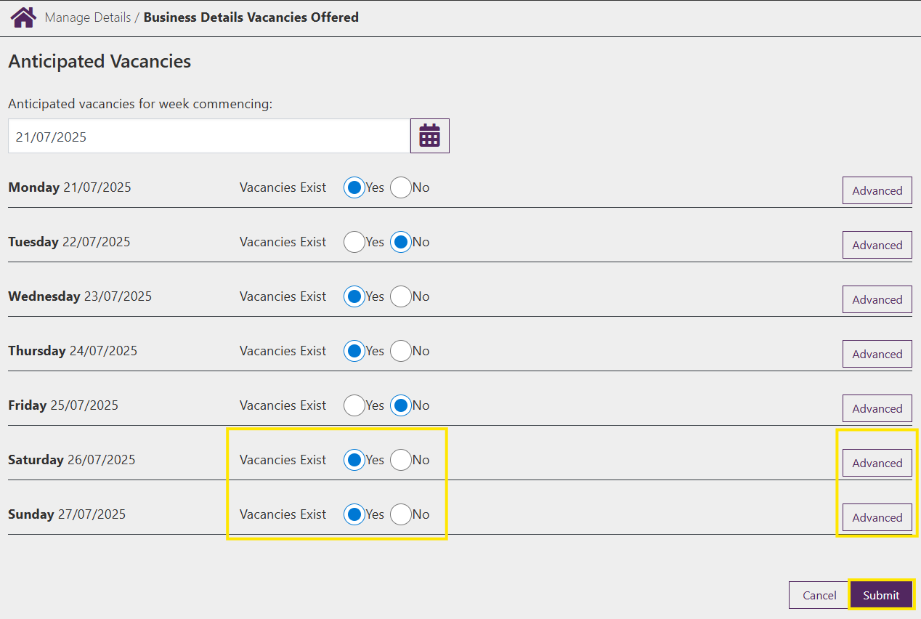

Step 4

You will receive a receipt confirming the submission of vacancy information. Select either **Return Home** to return to the **Service home page** or **Continue** to return to the **Manage Details** page.

