

# Task card – How to Update Fees in the Provider Entry Point (PEP)

### How to update fees in the Provider Entry Point.

Overview 1

Logging In 2

Fee and Inclusion Details 4

Website Details 6

## 

## Overview

This task card outlines how to update your service fees in the Provider Entry Point (PEP) to meet your reporting obligations under Family Assistance Law (FAL).

Under FAL you are required to report your fees within 14 days of:

* receiving CCS approval (or opening the service if that occurs at a later date)
* changing your fees
* twice a year – after the end of the financial year and calendar year, including reporting no change in fees.

Find more [task cards](https://www.education.gov.au/early-childhood/provider-tool-kit#toc-task-cards) for the PEP on our website.

If you need further assistance, contact the Child Care Subsidy Provider Helpdesk on 1300 667 276 from 9 am to 5 pm AEST or [via email](mailto:CCSHelpdesk@education.gov.au) anytime.

**Note:** Only certain special characters can be used in the PEP:

* full stop (.)
* comma (,)
* hyphen (-)
* slashes (/, \)
* apostrophe (‘).

All other special characters will cause an error in the system.

## Logging In

Step 1

Log in to the [Provider Entry Point (PEP)](https://proda.humanservices.gov.au/prodalogin/pages/public/login.jsf?TAM_OP=login&ERROR_CODE=0x00000000&URL=%2Fmga%2Fsps%2Foauth%2Foauth20%2Fauthorize%3Fscope%3Dopenid%26state%3DalN0hw9ovD%26client_id%3DGTzCa6CRNfBsRTdfljBa%26redirect_uri%3Dhttps%253A%252F%252Fbusinessonline.humanservices.gov.au%252Fmga%252Fsps%252Foidc%252Frp%252Fchildcaresubsidy%252Fredirect%252Fproda%26response_type%3Dcode&OLDSESSION=).

## Fees and Inclusions

Step 1

Navigate to the homepage of the service where you want to update fees.

It is important that you are in the appropriate service context for the fees you will be submitting.

Select the **Manage Details** tile.

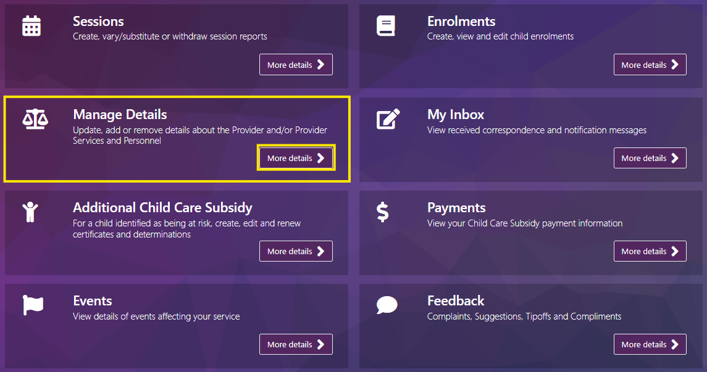

Step 2

Select **Fees and inclusions.** From here you can select to update your fees as either detailed fees and inclusions or a link to your fee schedule on your business website.

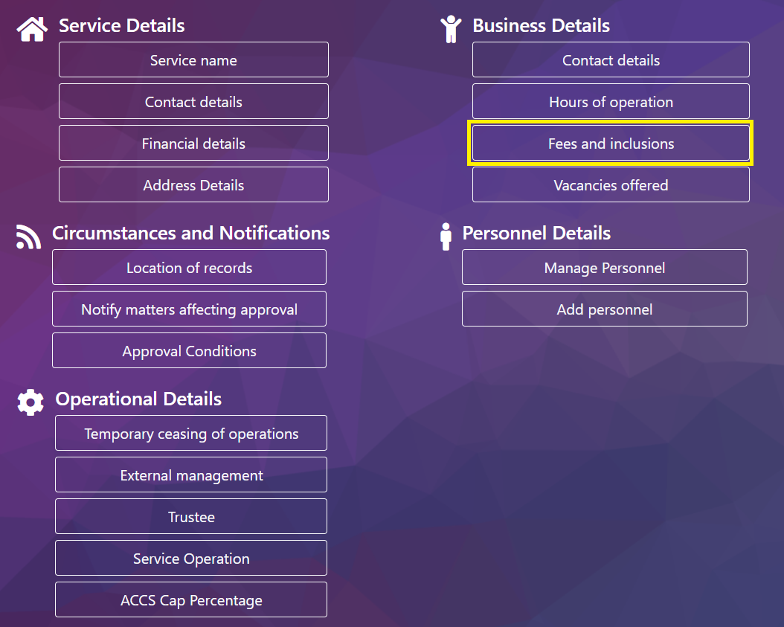

## Fee and Inclusion Details

Step 1

Select **Fee & Inclusion Details** and enter the **Date of event** – this is the date that the fees will be in effect.

***Note –*** *Fees cannot be backdated, the date of event must be either the day of submission or a future date.*

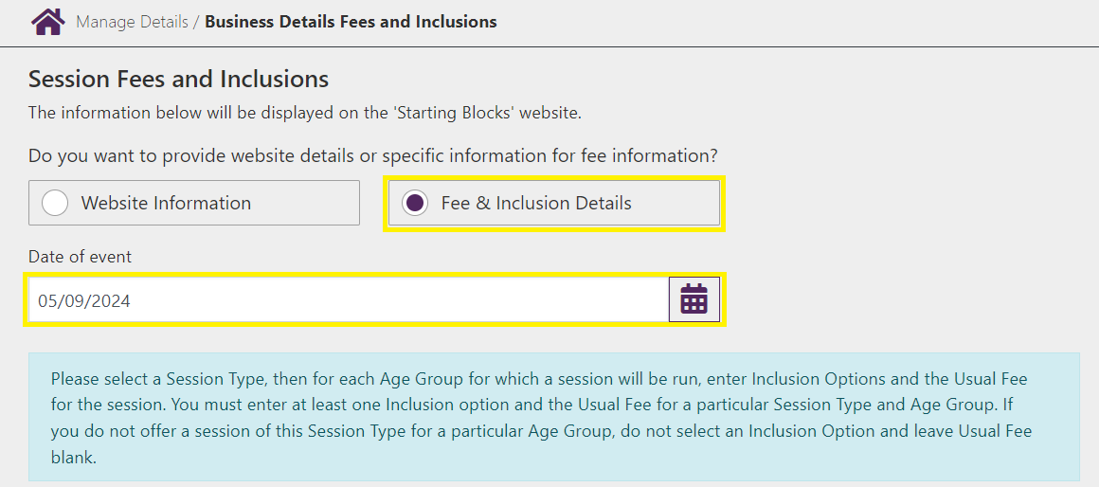

Step 2

Select the **Session Type,** tick the relevant inclusions and enter the **Usual Fee.** Complete this for all session types then select **Submit.**

***Note –*** *To report no change, update the date of event to the date of submission and select* ***Submit***

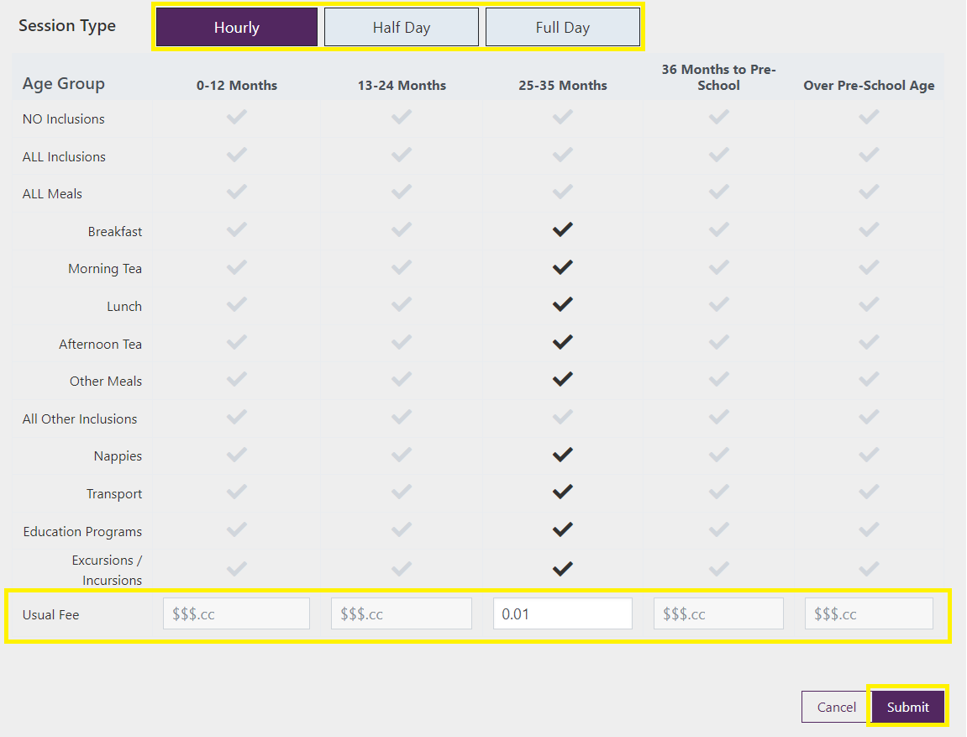

Step 3

You will receive a receipt confirming the submission of fee information. Select either **Return Home** to return to the **Service home page** or **Continue** to return to the **Manage Details** page.

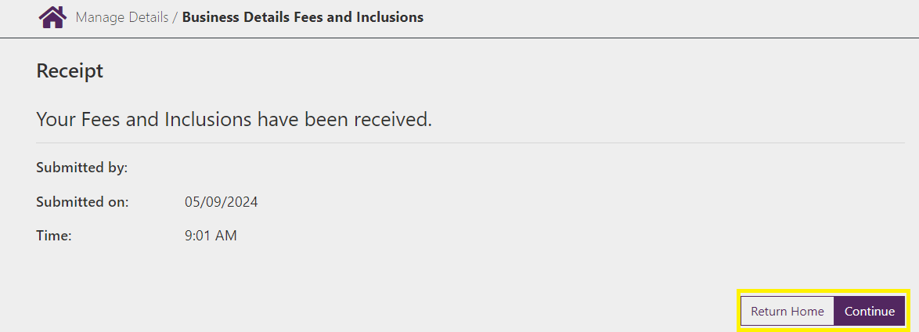

## Website Details

Note

Fees reported via URL are not displayed on StartingBlocks.gov.au. To ensure your fees are displayed, please submit detailed fees and inclusions. Including your detailed information helps parents choose the best early childhood education and care for their family.

Step 1

Select **Website Information** and enter the **Date of event**, this is the date that the fees will be in effect. Enter the full URL into the **Child Care Service Website** field and select **Submit.**

***Note –*** *To report no change, update the date of event to the date of submission and select* ***Submit***

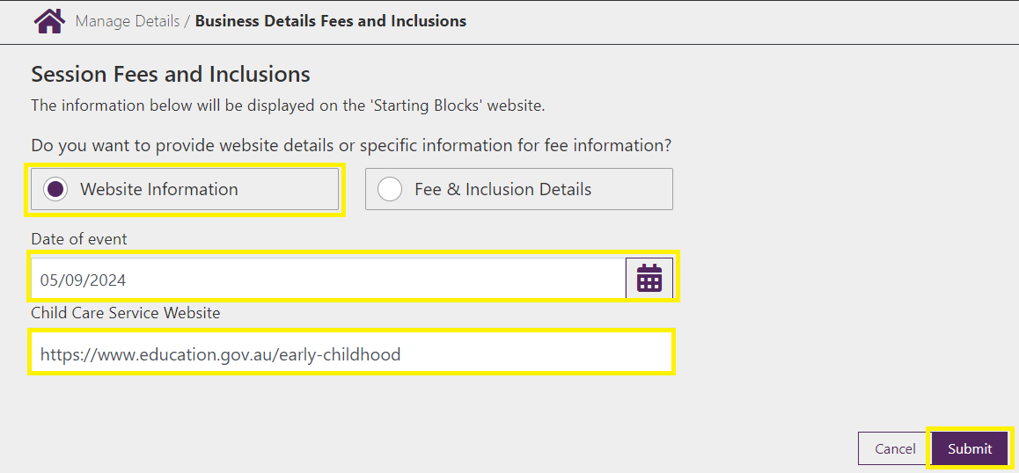

Step 2

You will receive a receipt confirming the submission of fee information. Select either **Return Home** to return to the **Service home page** or **Continue** to return to the **Manage Details** page.

