

# Task card – How to Update Service Business Details in the Provider Entry Point (PEP)

How to update business details for the Service in the Provider Entry Point

Overview 1

Logging in 3

Service Name 3

Contact Details 7

Financial Details 9

Address Details 11

## Overview

This task card outlines how to update:

* Service Name
* Service Contact Details
* Service Financial Details
* Service Address Details

This task card is for providers that use the Provider Entry Point (PEP). If you use third-party software, contact your software provider for help.

Find more [task cards](https://www.education.gov.au/child-care-package/provider-tool-kit#toc-task-cards) for the PEP on our website.

If you need further assistance, contact the Child Care Subsidy Provider Helpdesk on 1300 667 276 9am to 5pm AEST or [via email](mailto:CCSHelpdesk@education.gov.au) anytime.

**Note:** Only certain special characters can be used in the PEP:

* full stop (.)
* comma (,)
* hyphen (-)
* slashes (/, \)
* apostrophe (‘).

All other special characters will cause an error in the system.

## Logging in

Step 1

Log in to the [Provider Entry Point (PEP)](https://proda.humanservices.gov.au/prodalogin/pages/public/login.jsf?TAM_OP=login&ERROR_CODE=0x00000000&URL=%2Fmga%2Fsps%2Foauth%2Foauth20%2Fauthorize%3Fscope%3Dopenid%26state%3DalN0hw9ovD%26client_id%3DGTzCa6CRNfBsRTdfljBa%26redirect_uri%3Dhttps%253A%252F%252Fbusinessonline.humanservices.gov.au%252Fmga%252Fsps%252Foidc%252Frp%252Fchildcaresubsidy%252Fredirect%252Fproda%26response_type%3Dcode&OLDSESSION=).

Step 2

On the homepage select “More details” in the “Manage Details” field in the PEP.

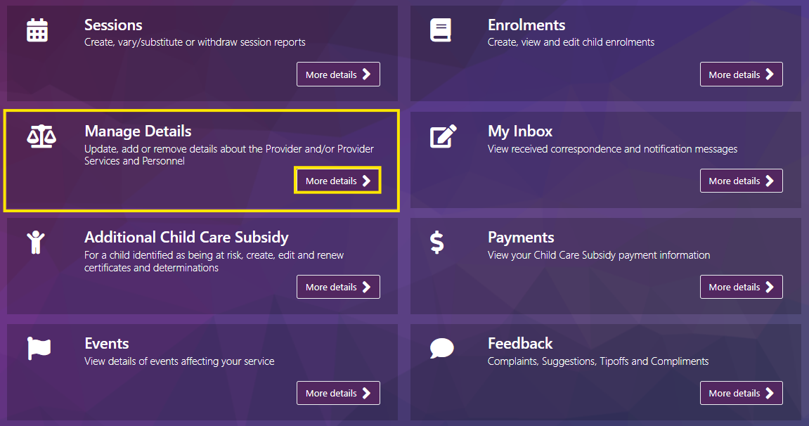

## Service Name

Step 1

Under the **Service Details** heading select **Service name**

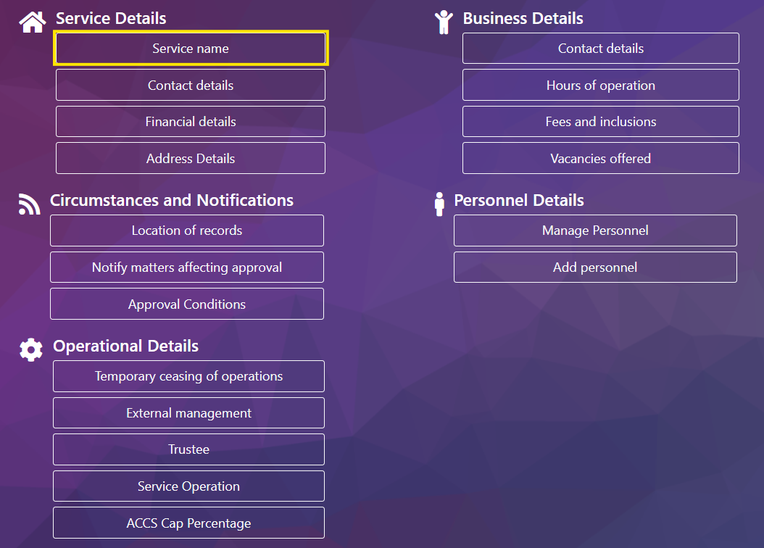

Step 2

Select **Add new name**

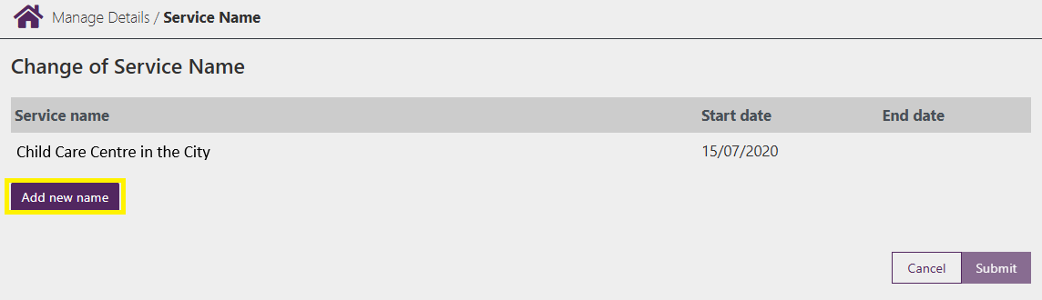

Step 3

Complete the below fields:

* **Full name of Service:** Enter the new name details here.
* **Start date:** This is the date for the new name to take effect.
* **End date:** Optional field if there is a known date that the name will change
* **Evidence required:** You are required to provide evidence of the name change. To add evidence of the name change, select **Upload**

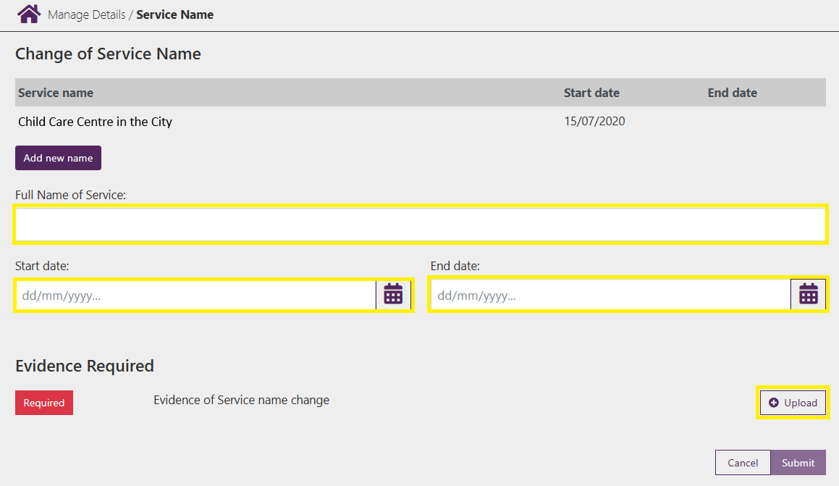

Step 4

Select **Choose File** and upload your evidence.

***Note –*** *Evidence must be in either PDF, PNG, TIFF or JPG format and the combined total for all uploaded files cannot exceed 10MB*

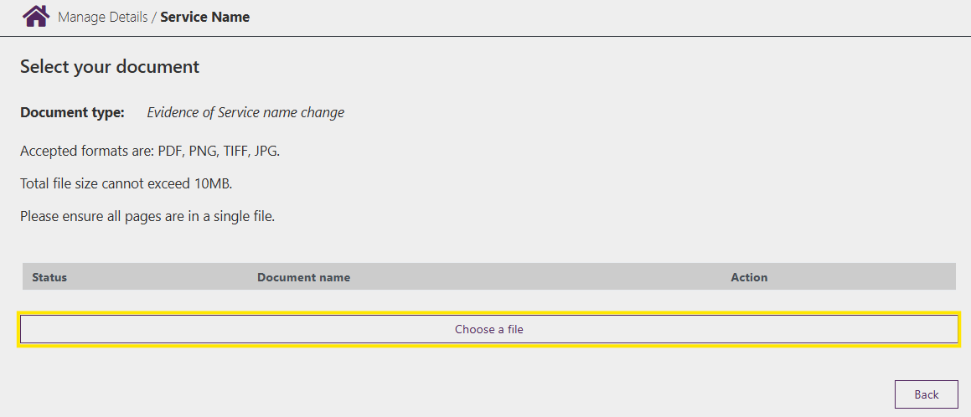

Step 5

Once uploaded the **Status** will update and the file name will be displayed.

If you have additional documents to upload, select **Choose a file** and complete the same steps.

To remove a file, select the **Bin** under **Action**

Once complete select **Back**

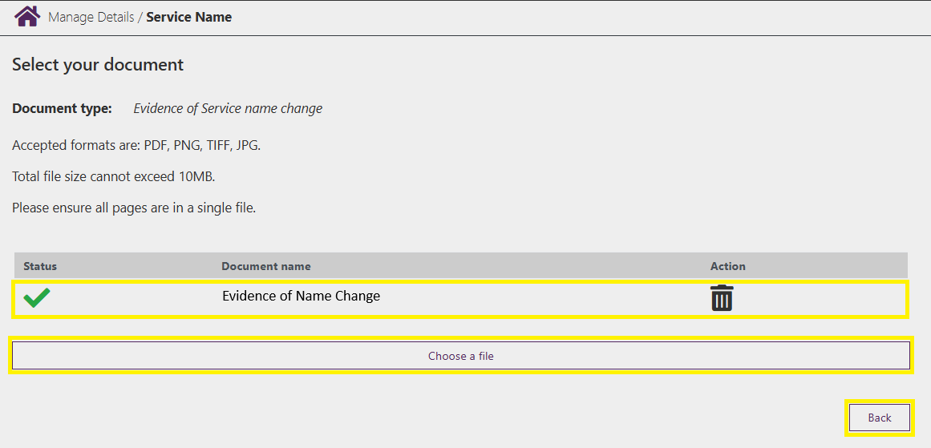

Step 6

Review the information and select **Submit** to submit the change.

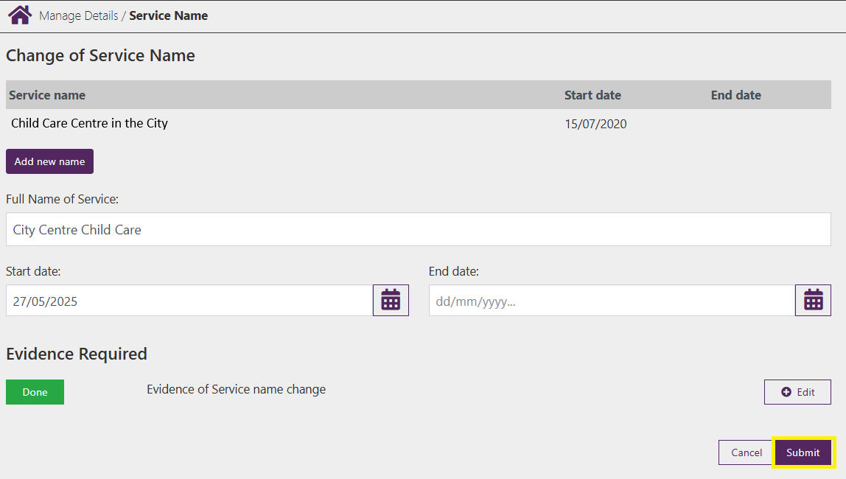

Step 7

You will receive a receipt confirming the submission of the new name. Select either **Return Home** to return to the **Service home page** or **Continue** to return to the **Manage Details** page.

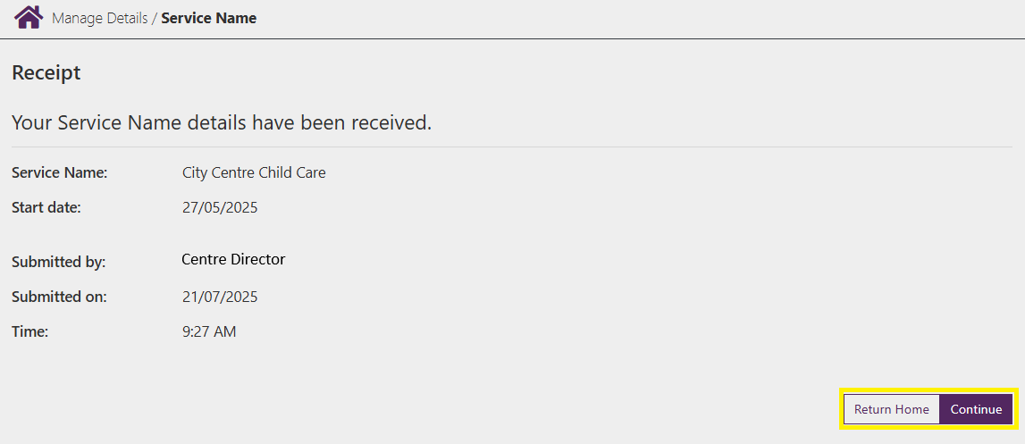

## Contact Details

Step 1

Under the **Service Details** heading select **Contact details**

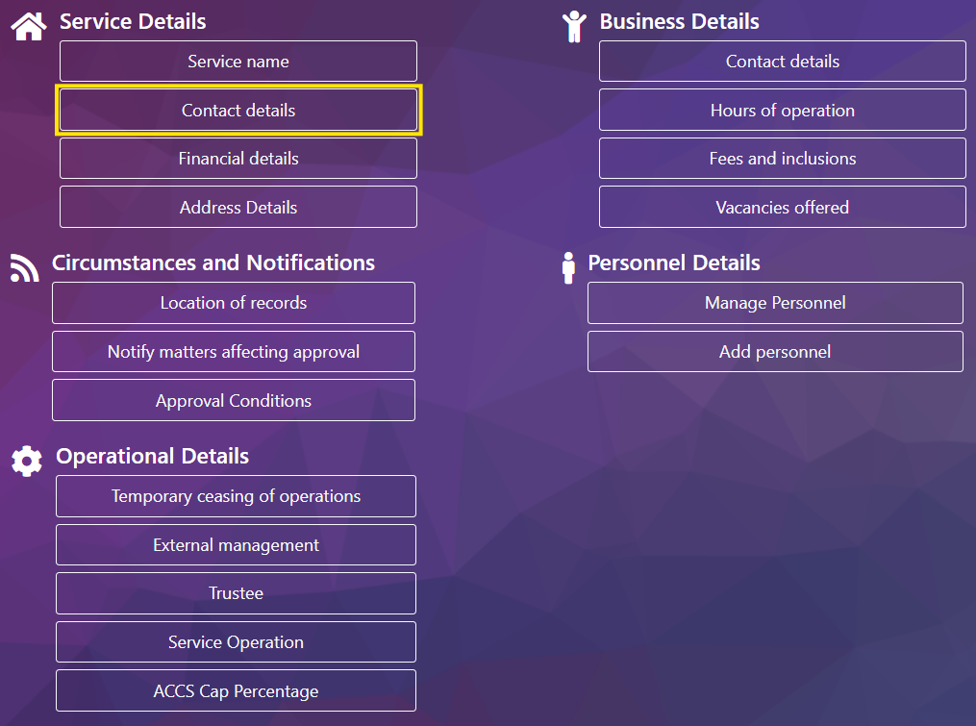

Step 2

To update the phone numbers, enter the relevant numbers and the date they will apply from.

***Note –*** *You must have at least one current phone number submitted.*

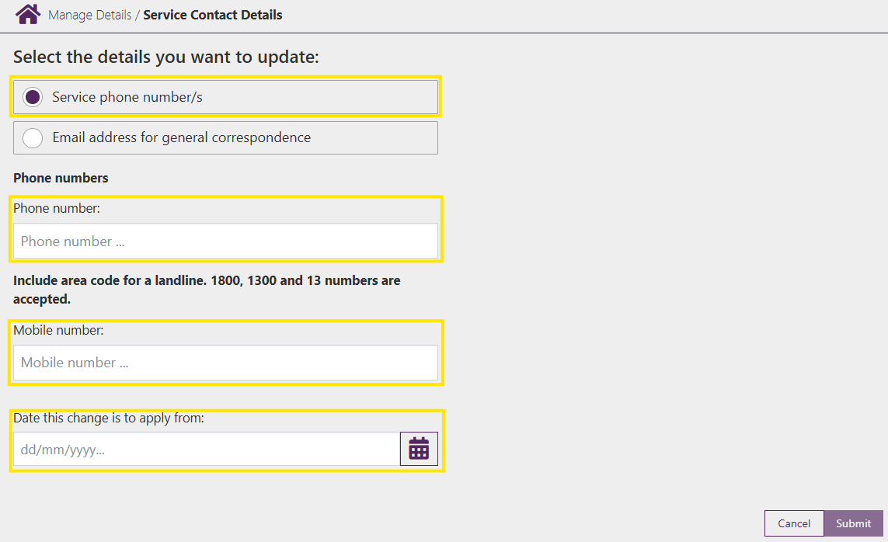

Step 3

To update the email address and the website details, enter the relevant address’ and the date they will apply from

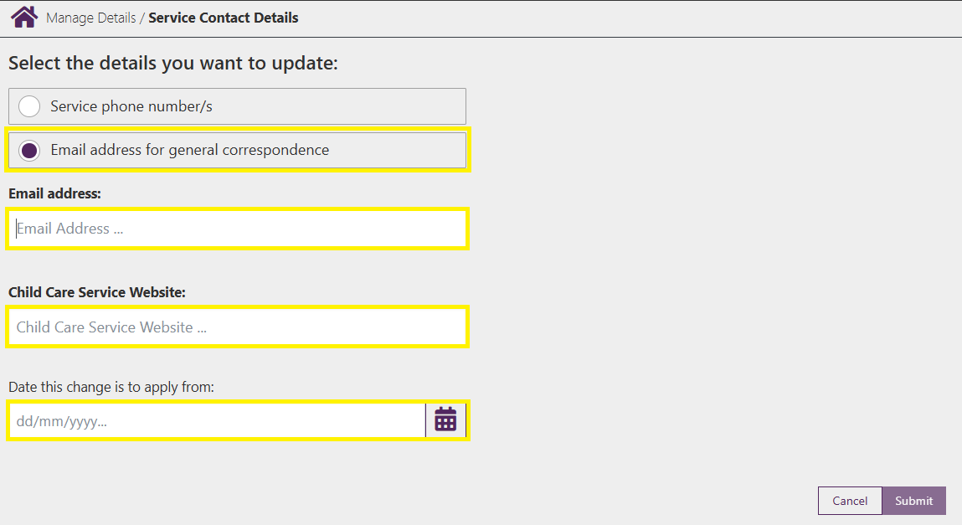

Step 4

Review the information and select **Submit** to submit the change.

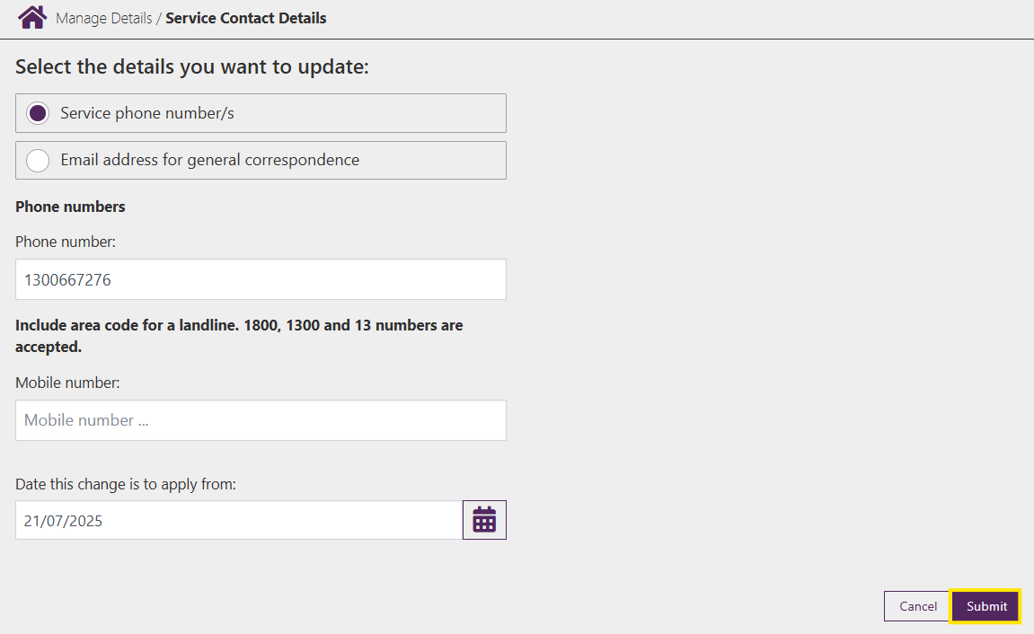

Step 5

You will receive a receipt confirming the submission of the new contact information. Select either **Return Home** to return to the **Service home page** or **Continue** to return to the **Manage Details** page.

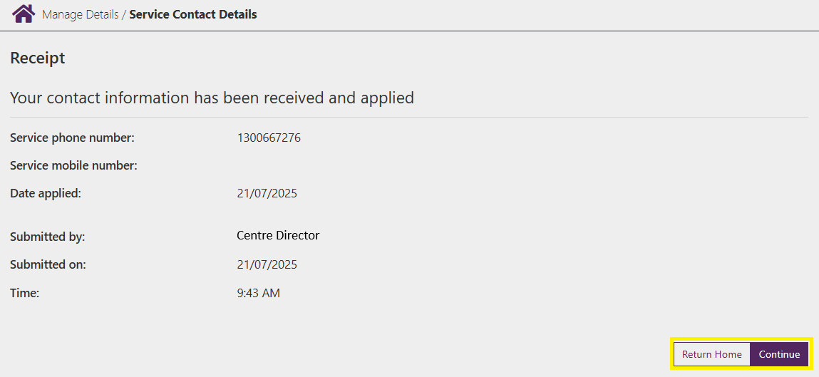

## Financial Details

Step 1

Under the **Service Details** heading select **Contact details**

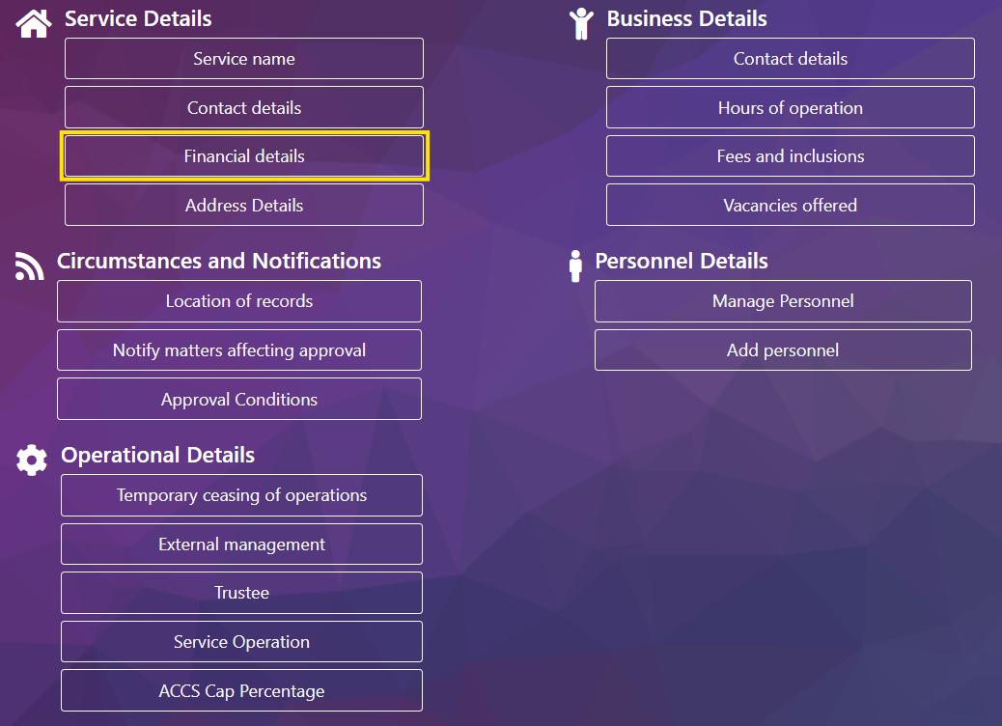

Step 2

Enter the new **BSB, Account Number** and **Account Name** and select **Submit** to submit the details

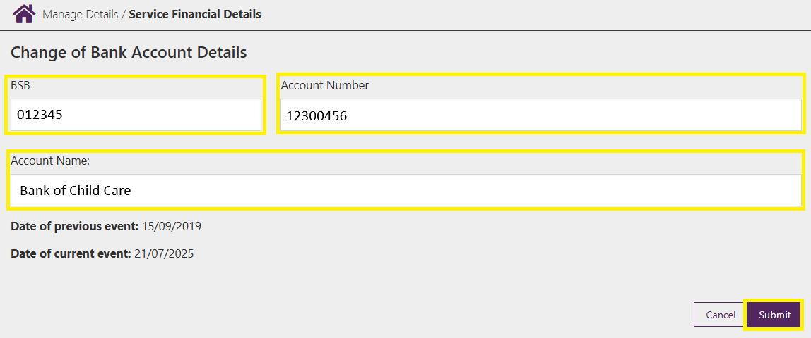

Step 3

You will receive a receipt confirming the submission of the new bank account details. Select either **Return Home** to return to the **Service home page** or **Continue** to return to the **Manage Details** page.

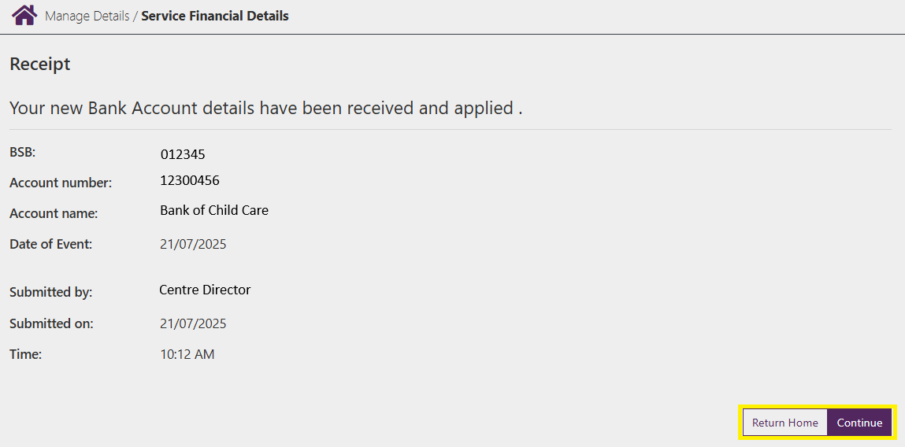

## Address Details

Step 1

Under the **Service Details** heading select **Address details**

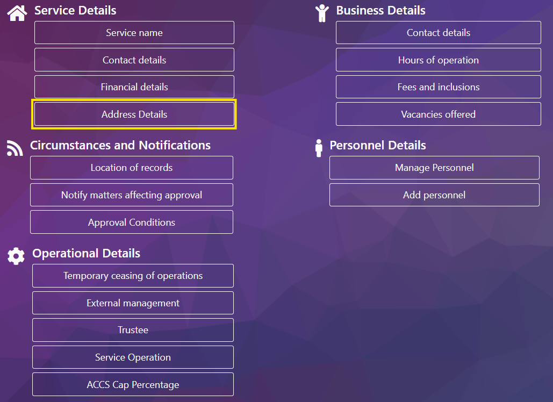

Step 2

Select **Add new address**

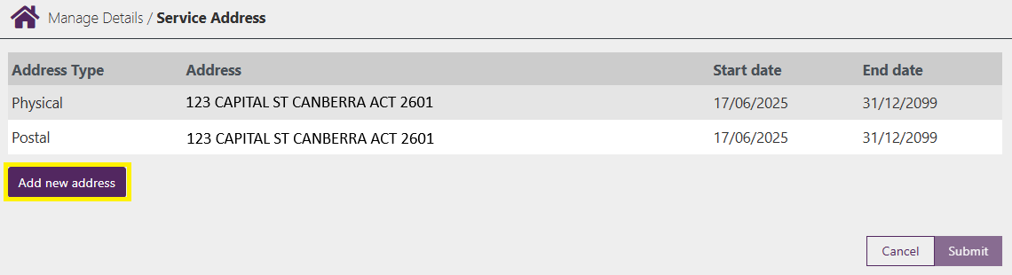

Step 3

Enter the new address details and the **Start date** and the **End** **date** if known.

Select **Upload** to add the new address Service Approval evidence issued by the State/Territory Regulatory Authority.

***Note –*** *If your postal address is the same as your postal address select* ***Yes*** *under the question* ***Is Postal address the same as Physical address*** *and the address details will be automatically filled.*

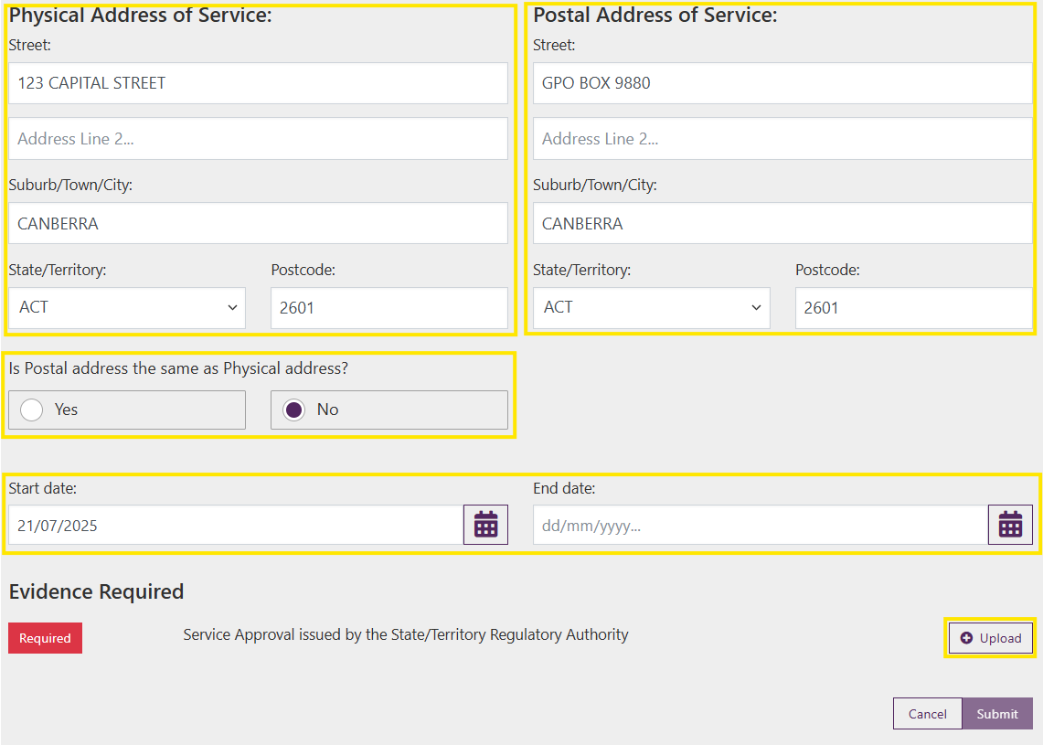

Step 4

Select **Choose File** and upload your evidence.

***Note –*** *Evidence must be in either PDF, PNG, TIFF or JPG format and the combined total for all uploaded files cannot exceed 10MB*

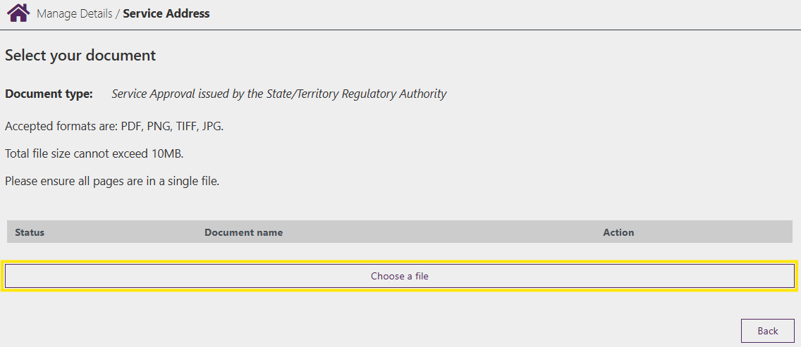

Step 5

Once uploaded the **Status** will update and the file name will be displayed.

If you have additional documents to upload, select **Choose a file** and complete the same steps.

To remove a file, select the **Bin** under **Action**

Once complete select **Back**

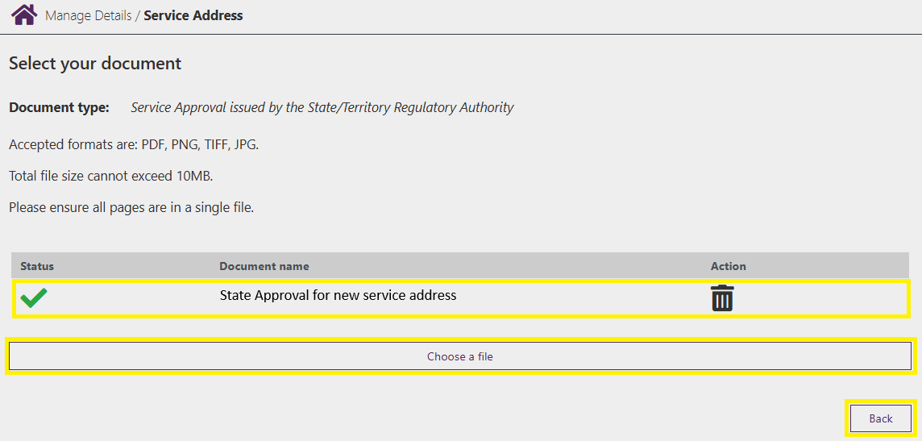

Step 6

Review the information and select **Submit** to submit the change.

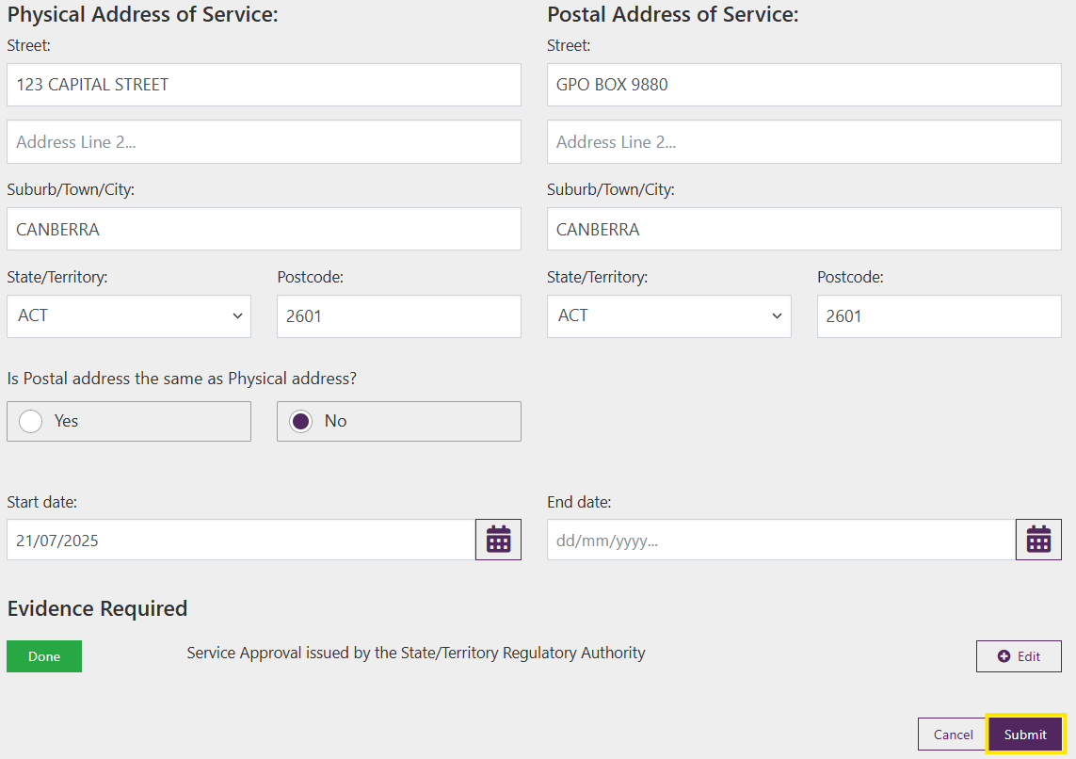

Step 7

You will receive a receipt confirming the submission of the new address. Select either **Return Home** to return to the **Service home page** or **Continue** to return to the **Manage Details** page.

