

# Task card – How to Update Provider Business Details in the Provider Entry Point (PEP)

How to update business details for the Provider in the Provider Entry Point

Task card – How to Update Provider Business Details in the Provider Entry Point (PEP) 1

Overview 1

Logging in 3

Provider Name 3

Contact Details 6

Financial Details 9

Address Details 12

## Overview

This task card outlines how to update:

* Provider Name
* Provider Contact Details
* Provider Financial Details
* Provider Address Details

This task card is for providers that use the Provider Entry Point (PEP). If you use third-party software, contact your software provider for help.

Find more [task cards](https://www.education.gov.au/child-care-package/provider-tool-kit#toc-task-cards) for the PEP on our website.

If you need further assistance, contact the Child Care Subsidy Provider Helpdesk on 1300 667 276 9am to 5pm AEST or [via email](mailto:CCSHelpdesk@education.gov.au) anytime.

**Note:** Only certain special characters can be used in the PEP:

* full stop (.)
* comma (,)
* hyphen (-)
* slashes (/, \)
* apostrophe (‘).

All other special characters will cause an error in the system.

## Logging in

Step 1

Log in to the [Provider Entry Point (PEP)](https://proda.humanservices.gov.au/prodalogin/pages/public/login.jsf?TAM_OP=login&ERROR_CODE=0x00000000&URL=%2Fmga%2Fsps%2Foauth%2Foauth20%2Fauthorize%3Fscope%3Dopenid%26state%3DalN0hw9ovD%26client_id%3DGTzCa6CRNfBsRTdfljBa%26redirect_uri%3Dhttps%253A%252F%252Fbusinessonline.humanservices.gov.au%252Fmga%252Fsps%252Foidc%252Frp%252Fchildcaresubsidy%252Fredirect%252Fproda%26response_type%3Dcode&OLDSESSION=).

Step 2

On the homepage select “More details” in the “Manage Details” field in the PEP.

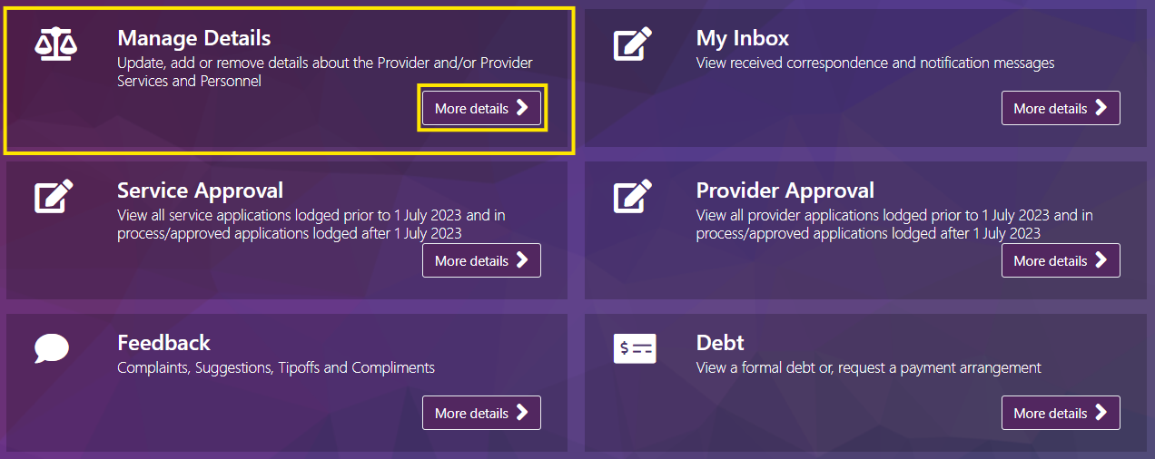

## Provider Name

Step 1

Under the **Provider Details** heading select **Provider Name**

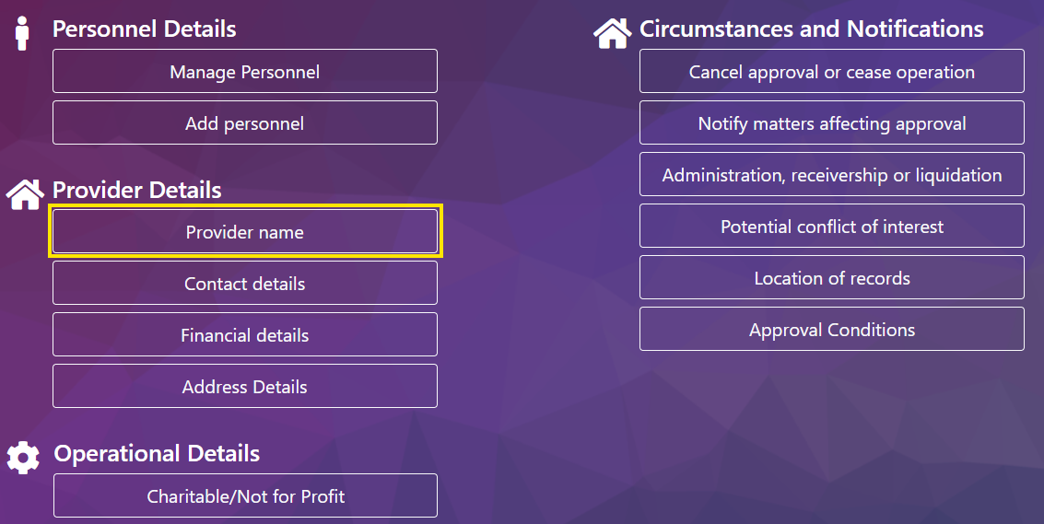

Step 2

Select **Add new name**

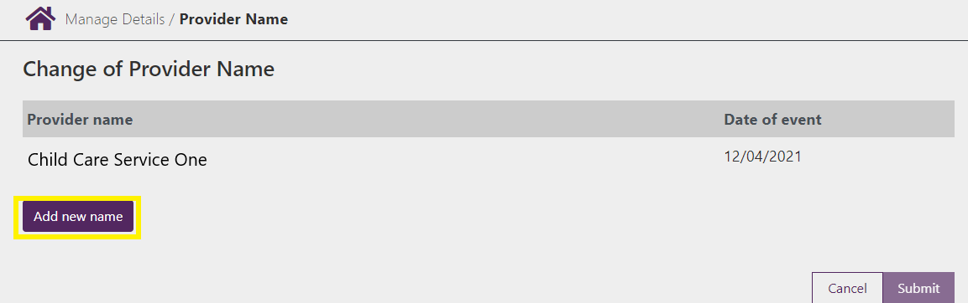

Step 3

Complete the below fields:

* **Full name of Provider:** Enter the new name details here.
* **Date of event:** This is the date for the new name to take effect. Name changes cannot be backdated beyond 28 days.
* **Evidence required:** You are required to provide evidence of the name change. To add evidence of the name change, select **Upload**

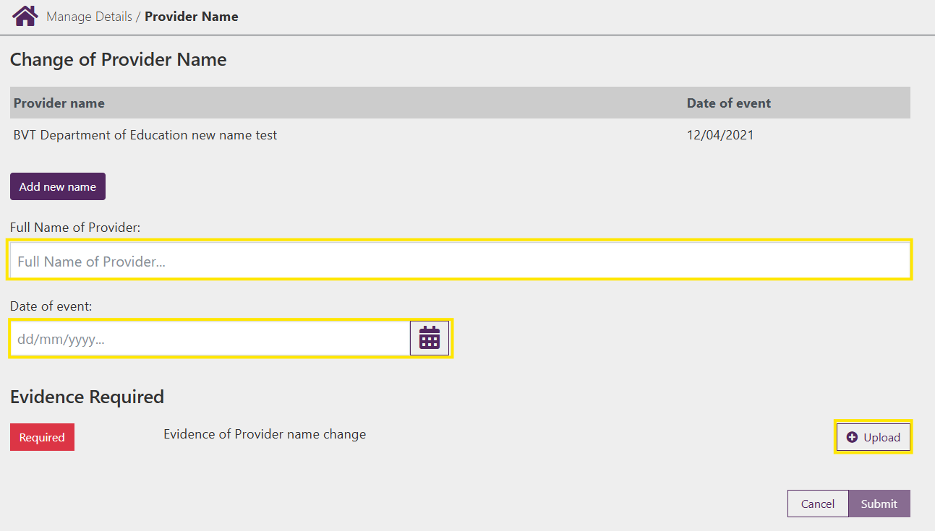

Step 4

Select **Choose File** and upload your evidence.

***Note –*** *Evidence must be in either PDF, PNG, TIFF or JPG format and the combined total for all uploaded files cannot exceed 10MB*

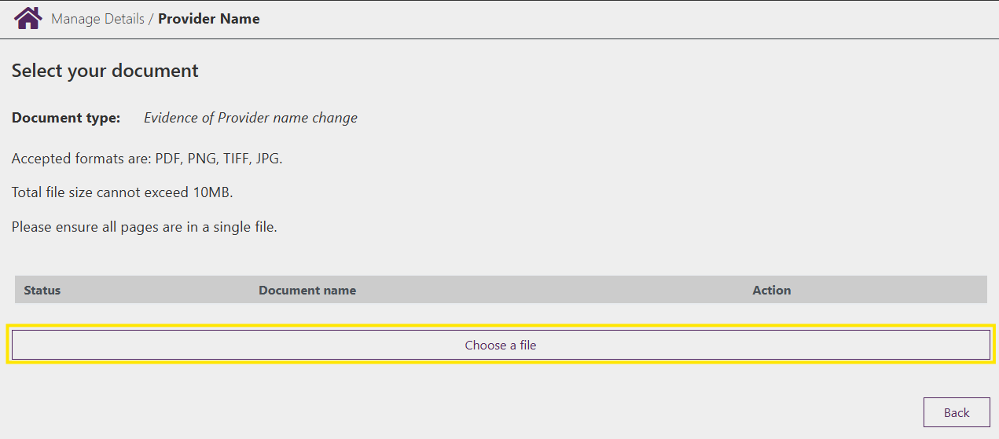

Step 5

Once uploaded the **Status** will update and the file name will be displayed.

If you have additional documents to upload, select **Choose a file** and complete the same steps.

To remove a file, select the **Bin** under **Action**

Once complete select **Back**

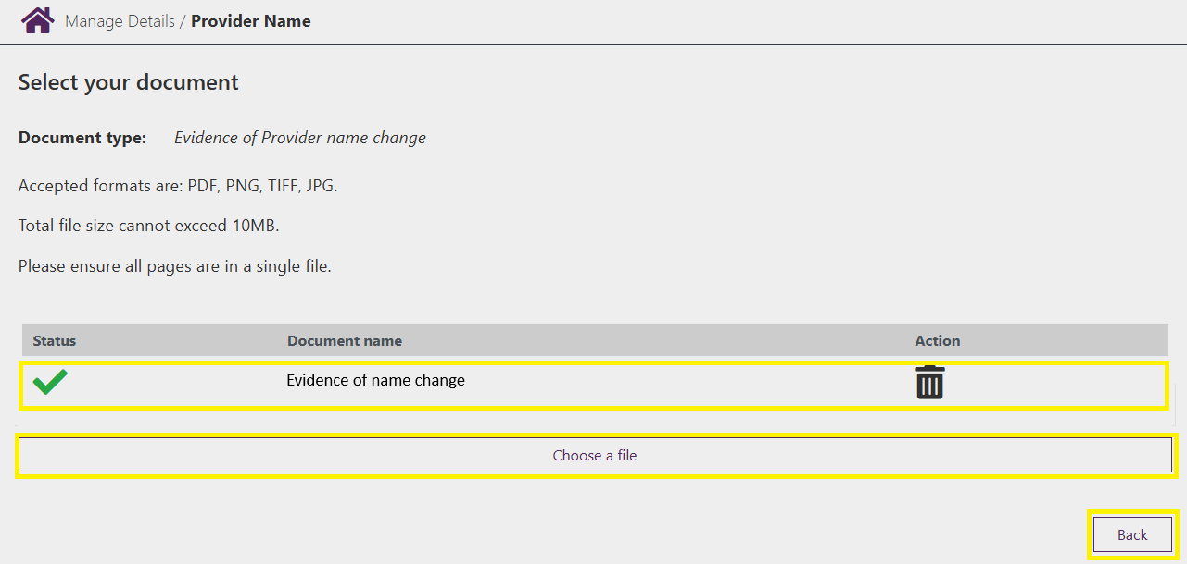

Step 6

Review the information and select **Submit** to submit the change.

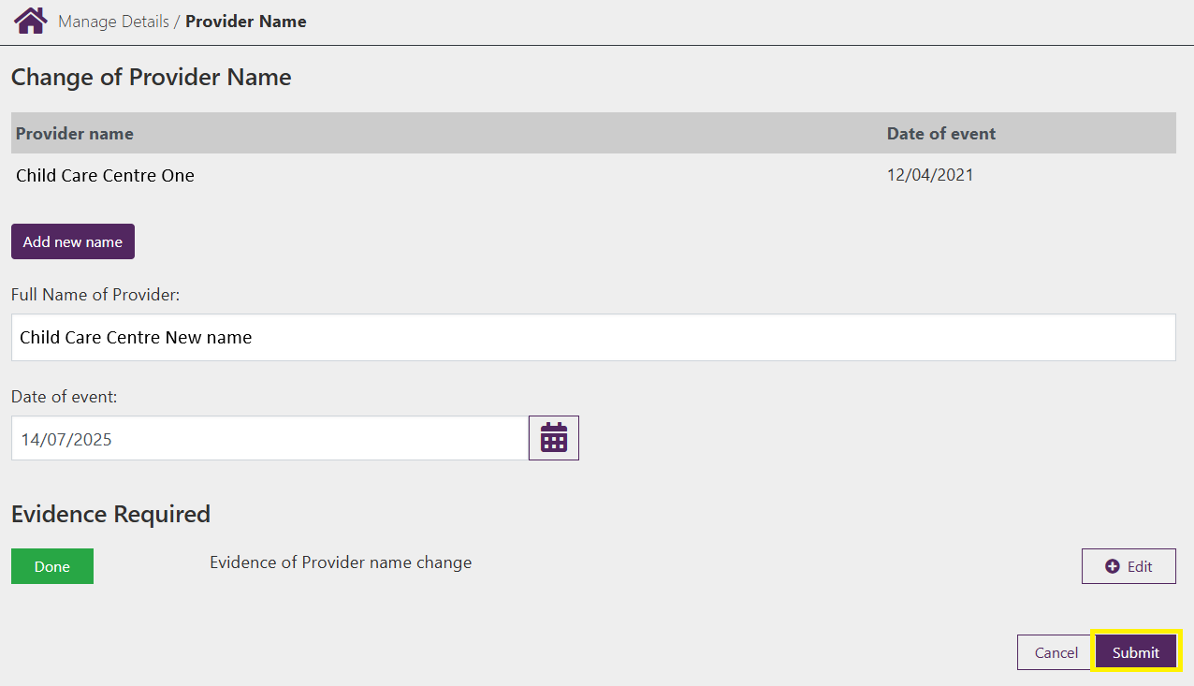

Step 7

You will receive a receipt confirming the submission of the new name. Select either **Return Home** to return to the **Provider home page** or **Continue** to return to the **Manage Details** page.

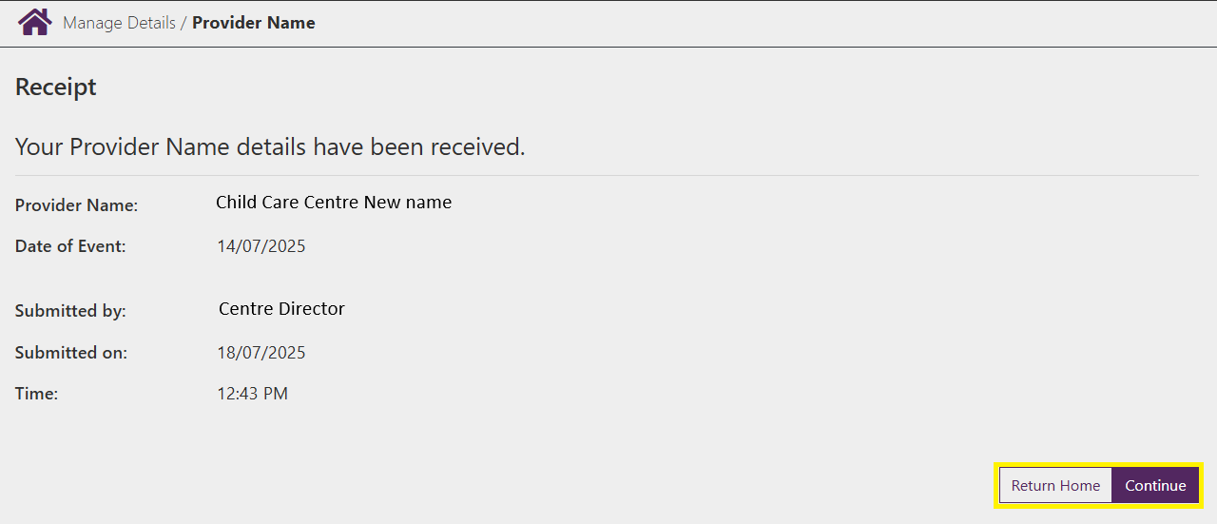

## Contact Details

Step 1

Under the **Provider Details** heading select **Contact details**

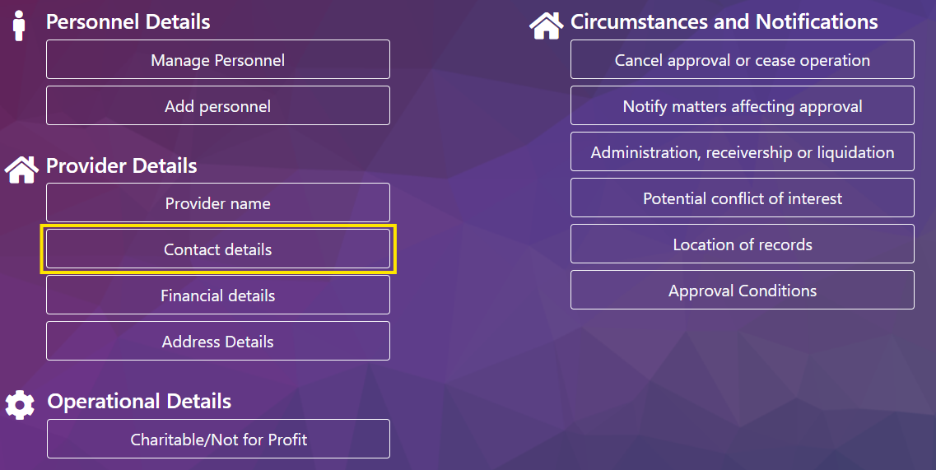

Step 2

To update the phone numbers, enter the relevant numbers and the date they will apply from.

***Note –*** *You must have at least one current phone number submitted.*

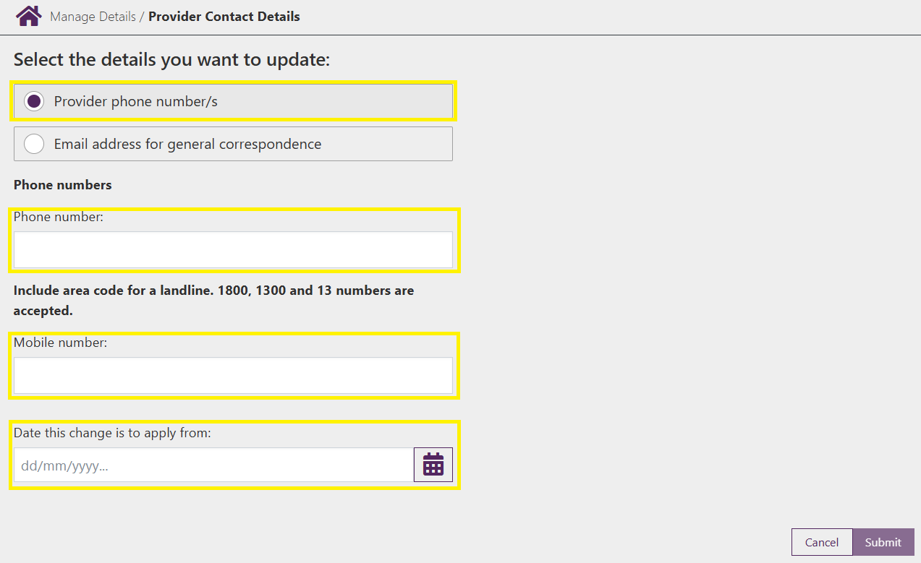

Step 3

To update the email address, enter the relevant email address and the date it will apply from.

If the email address is only to be submitted for the Provider select **Provider Only,** if you would like the email address to be listed against all services under the Provider select **All Services**

Screenshot of the email address page with the email address heading, email address and start date fields highlighted.
The options for apply the change to all services or provider only is also highlighted

Step 4

Review the information and select **Submit** to submit the change.

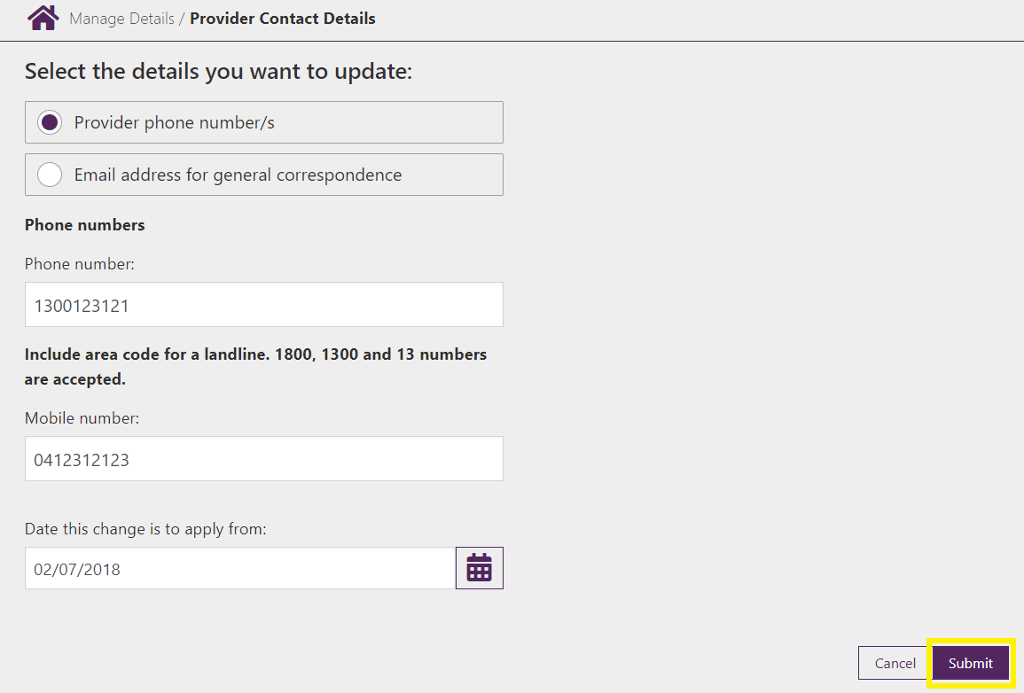

Step 5

You will receive a receipt confirming the submission of the new contact information. Select either **Return Home** to return to the **Provider home page** or **Continue** to return to the **Manage Details** page.

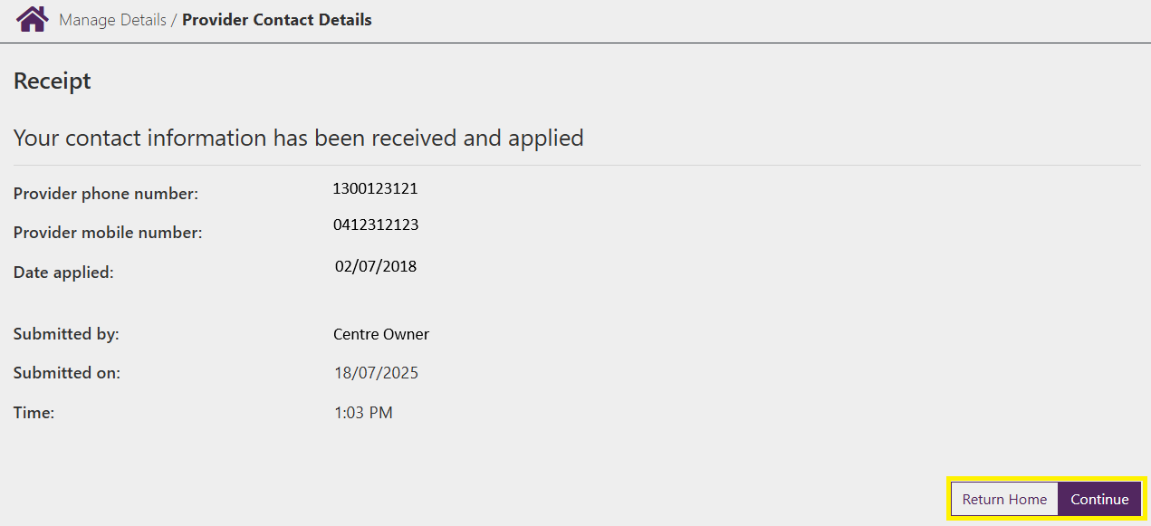

## Financial Details

Step 1

Under the **Provider Details** heading select **Financial details**

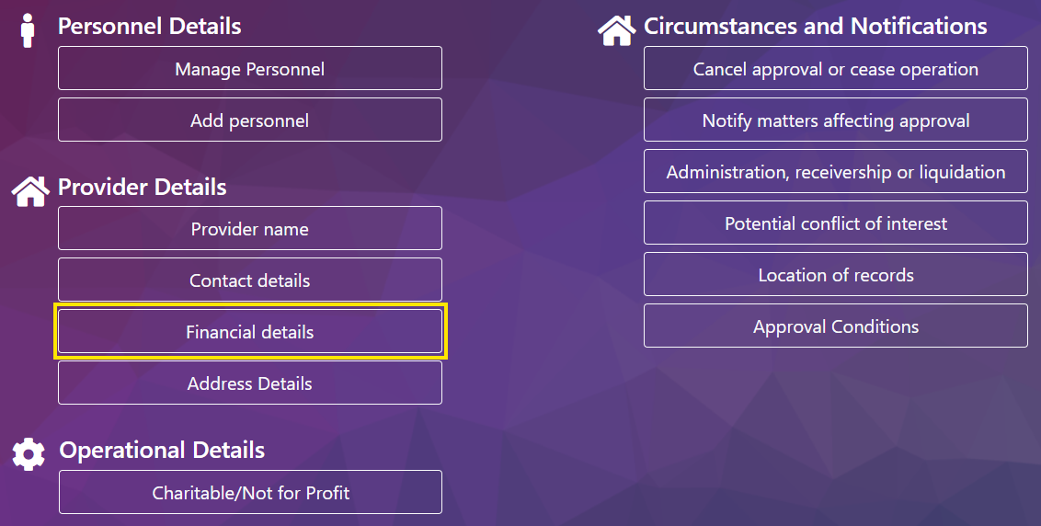

Step 2

Enter the new **BSB, Account Number** and **Account Name**

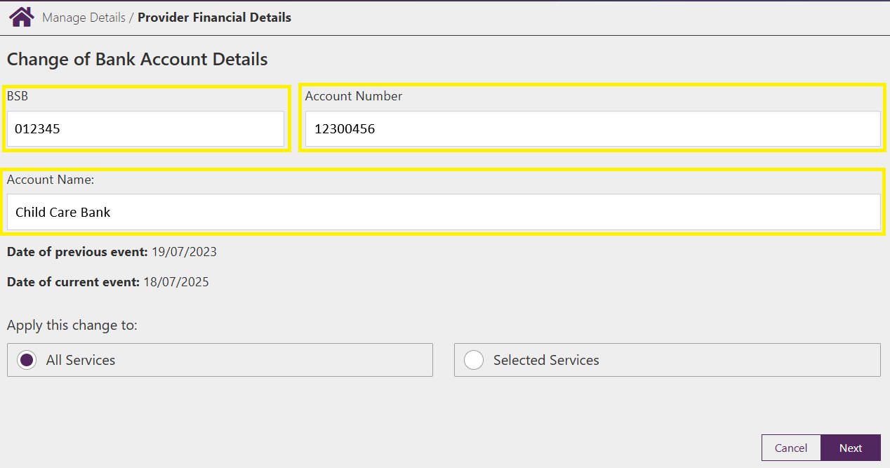

Step 3

The details can be applied to **All Services** or **Selected Services** only.

* If you select **All Services** continue to the next page by selecting **Next**.
* If you select **Selected Services** select the services to update using the tick box next to the service name and then selecting **Next**

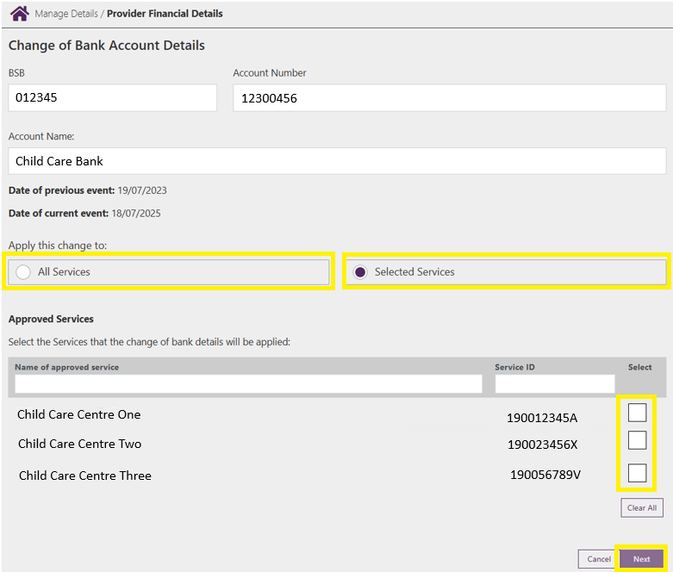

Step 4

In the summary, check to ensure that details are correct then select **Submit** to confirm the changes. If the changes are incorrect select **Back** to update the details as required

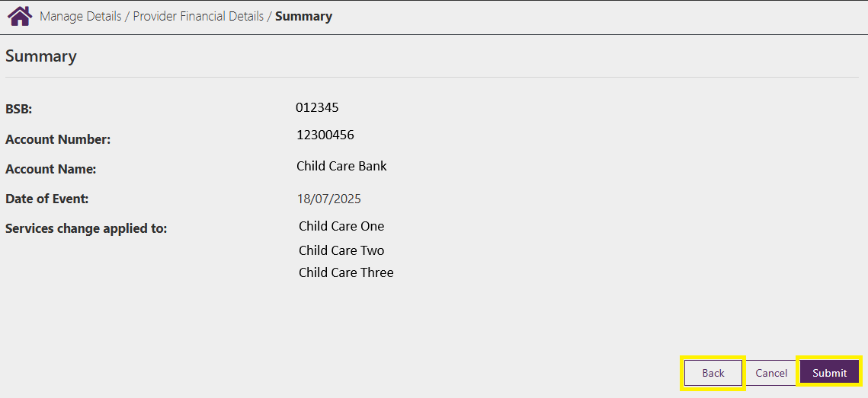

Step 5

You will receive a receipt confirming the submission of the new bank account details. Select either **Return Home** to return to the **Provider home page** or **Continue** to return to the **Manage Details** page.

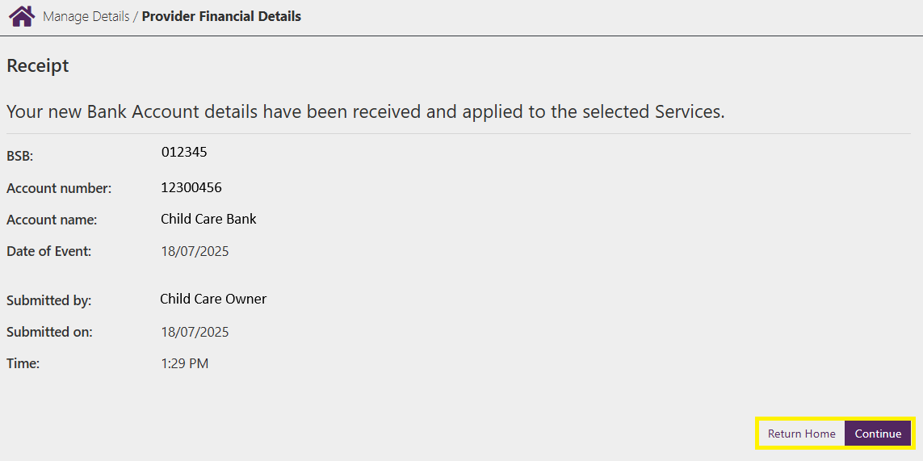

## Address Details

Step 1

Under the **Provider Details** heading select **Address details**

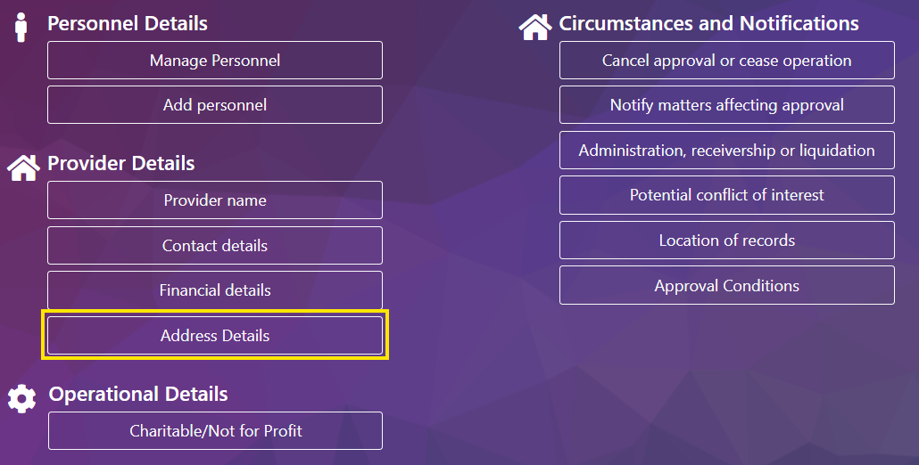

Step 2

Select **Add new address**

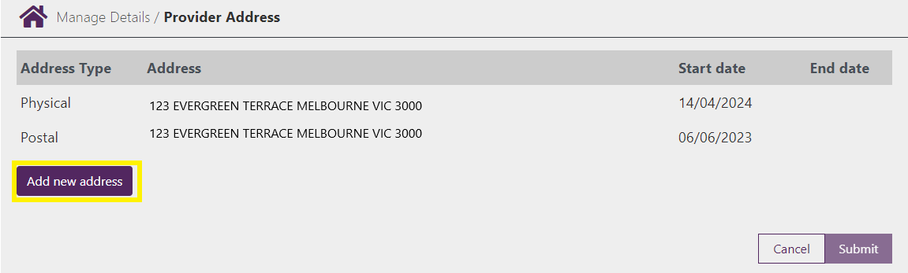

Step 3

Enter the new address details and the **Start** date. If an **End** is known, also enter it here, then select **Submit** to submit the change

***Note –*** *If your postal address is the same as your postal address select* ***Yes*** *under the question* ***Is Postal address the same as Physical address*** *and the address details will be automatically filled.*

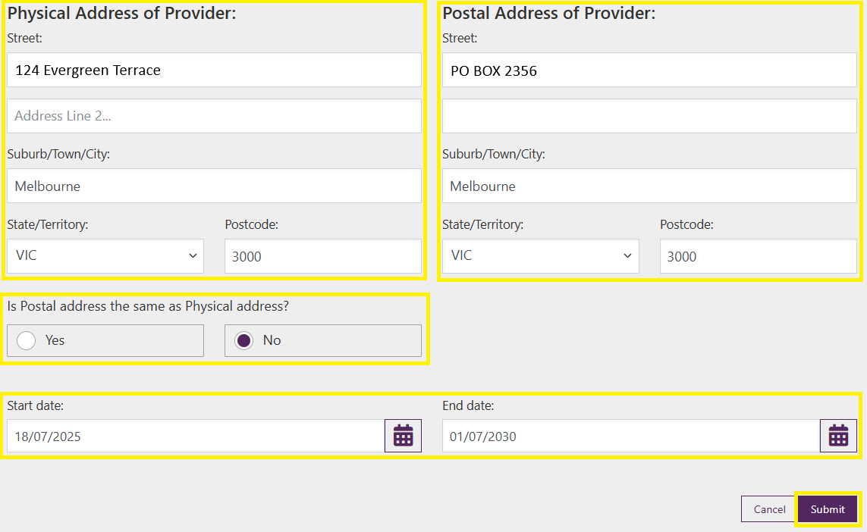

Step 4

You will receive a receipt confirming the submission of the new address details. Select either **Return Home** to return to the **Service home page** or **Continue** to return to the **Manage Details** page.

