

# Brief User Guide

Visual Analytics using Power BI

Contents

Navigating Power BI Reports 3

Using Power BI Reports 8

Extracting Charts and Tables from Power BI reports 12

Blank Visuals 13

## Navigating Power BI Reports

1. When a Power BI report is opened a home screen will appear, with a list of all pages within the report. Click on the page names to navigate to a section.

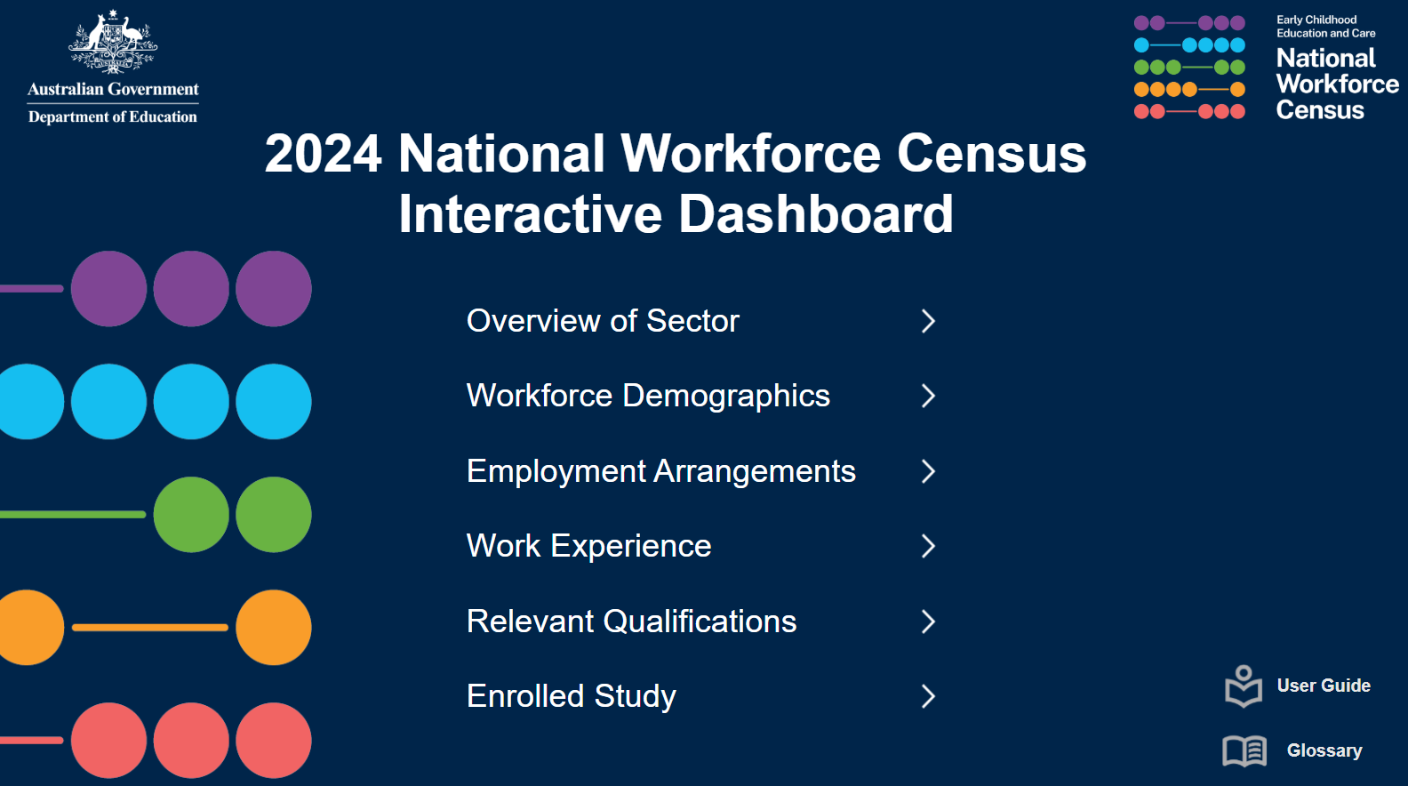

1. Some pages contain multiple reports. By clicking different reports, different breakdowns will be displayed on the selected report.
2. Each page has a navigation pane at the bottom of the page. Click the buttons on the navigation pane to navigate to a different page.

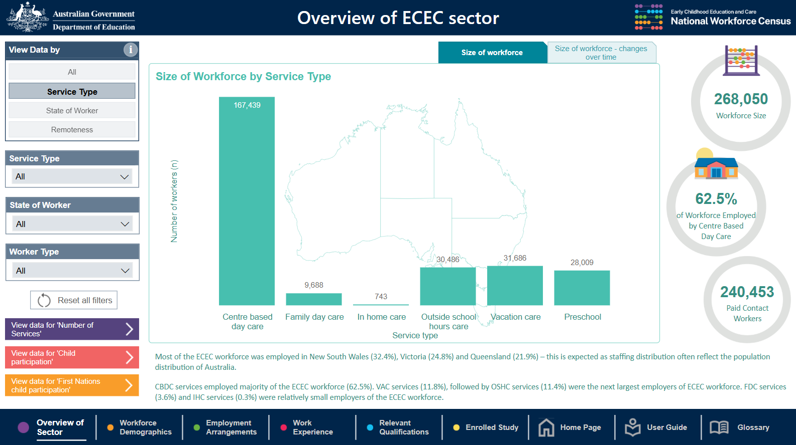

**3**

**2**

1. A more detailed user guide is available on the User Guide page.
2. Click the navigation buttons located on the bottom left side of the page to navigate through the User Guide.

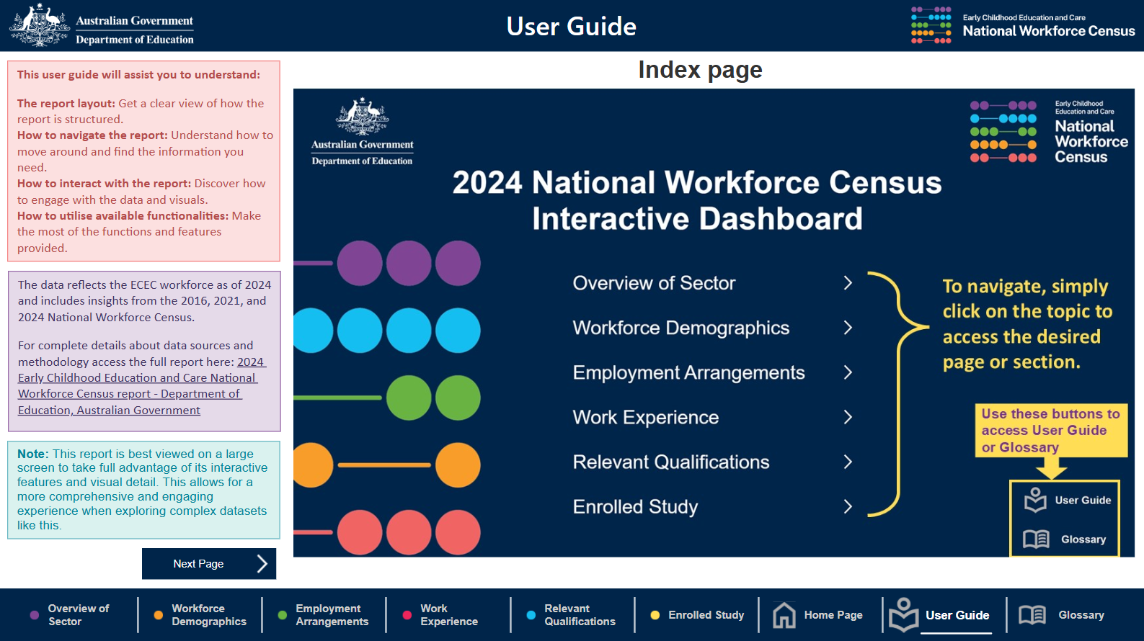

**5**

**4**

1. Some pages contain information icons. Hover over the icons to view additional information.

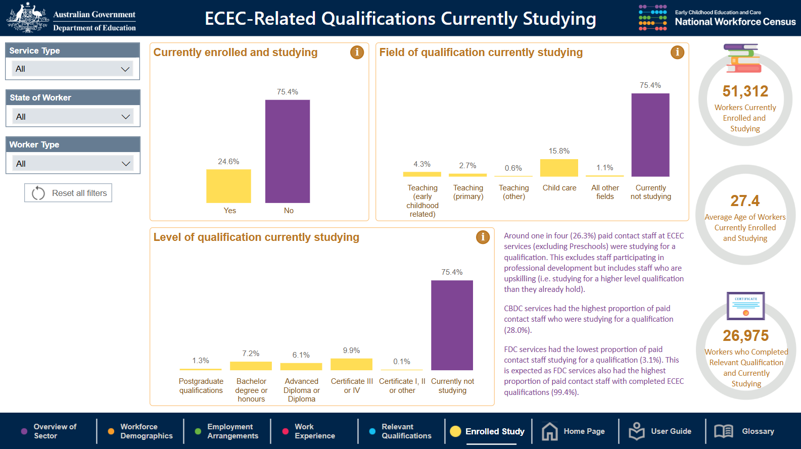

1. Definitions are available in the Glossary. Scroll down the page to view more definitions.

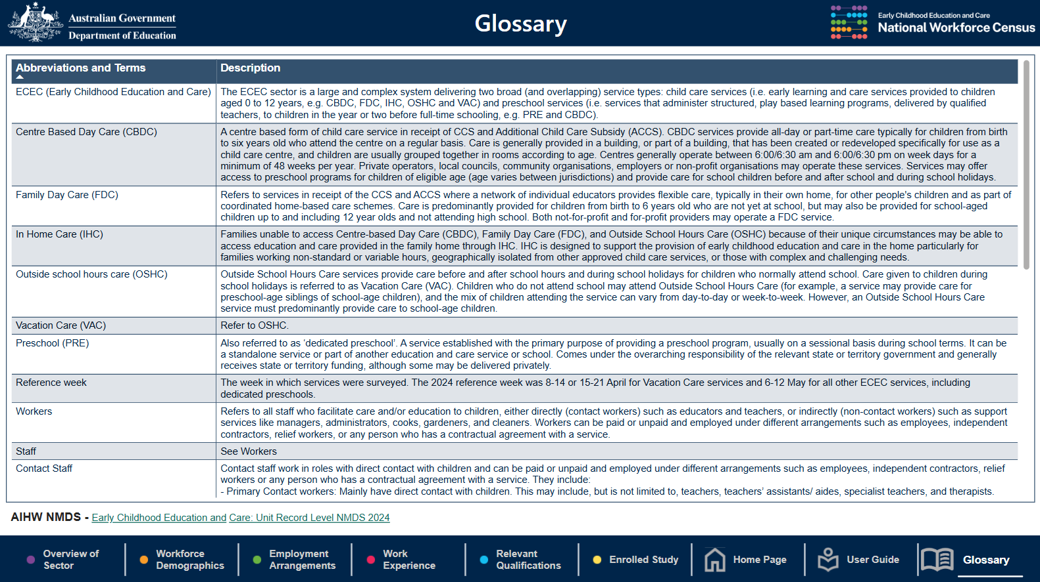

## Using Power BI Reports

1. Below is a typical example of what a Power BI report page may look like, including charts at the centre of the page, filters on the left, buttons to access related reports on the bottom left, key statistics on the right and summary text. Note, the summary text does not change when filters are applied.

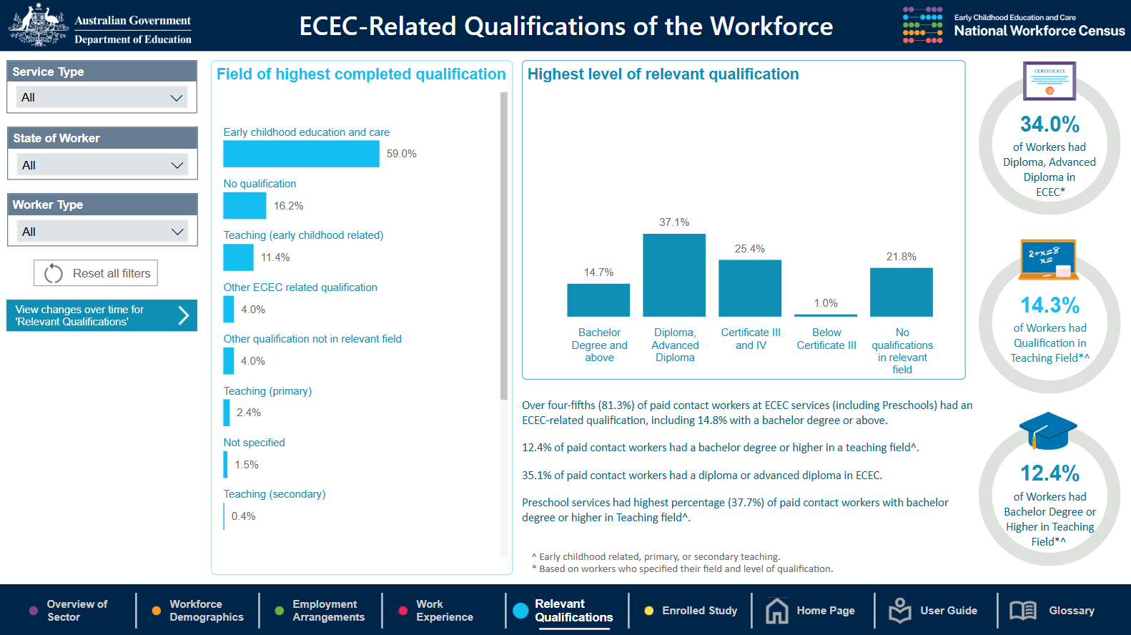

1. On some pages you may need to use a scroll bar to see all the data



1. Some pages contain additional charts that can be viewed by clicking on a tab above the chart.



1. Individual charts can be made larger by selecting ‘focus mode’. To achieve this, hover your cursor over the target chart and then click on the focus mode button in the top right corner. The chart will expand to the whole windowpane. To return the original view, click on ‘< Back to Report’.

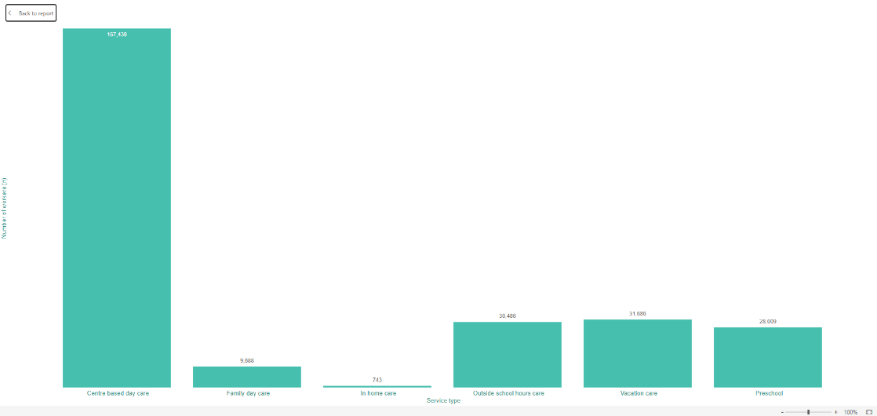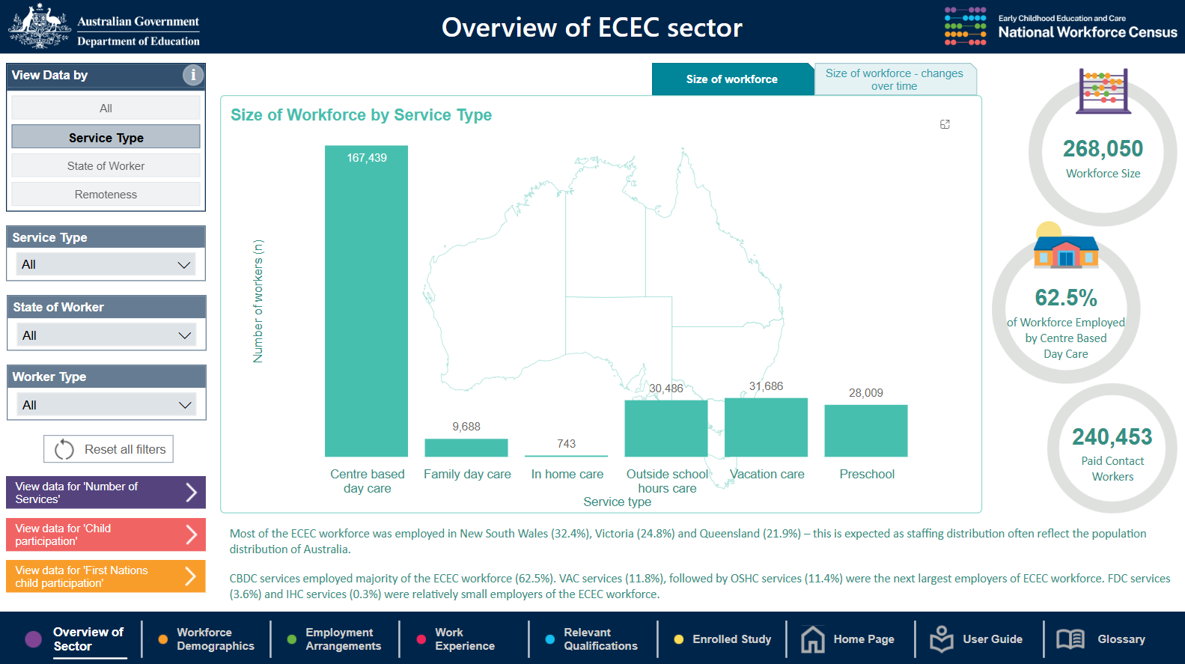

1. By hovering your cursor over the bars in the bar charts, exact numbers can be displayed. This function works on line charts too.

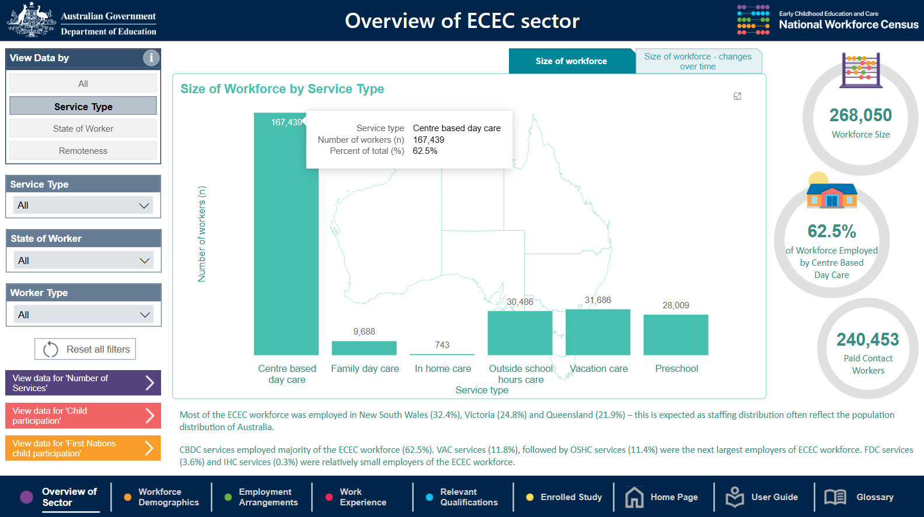

## Extracting Charts and Tables from Power BI reports

1. The data displayed in charts can be viewed in table form. To achieve this, right click on the target chart and select ‘Show as a table’. To return to the report, select ‘Back to report’.

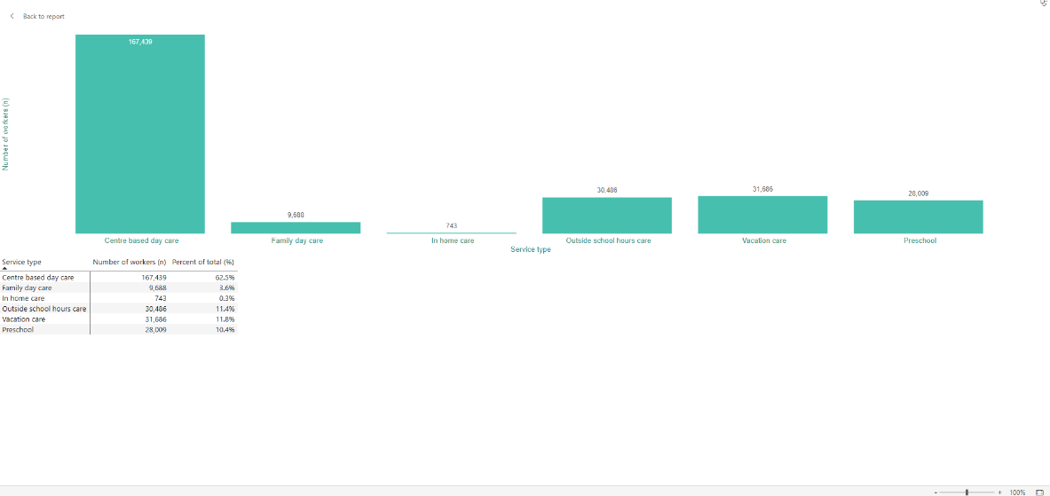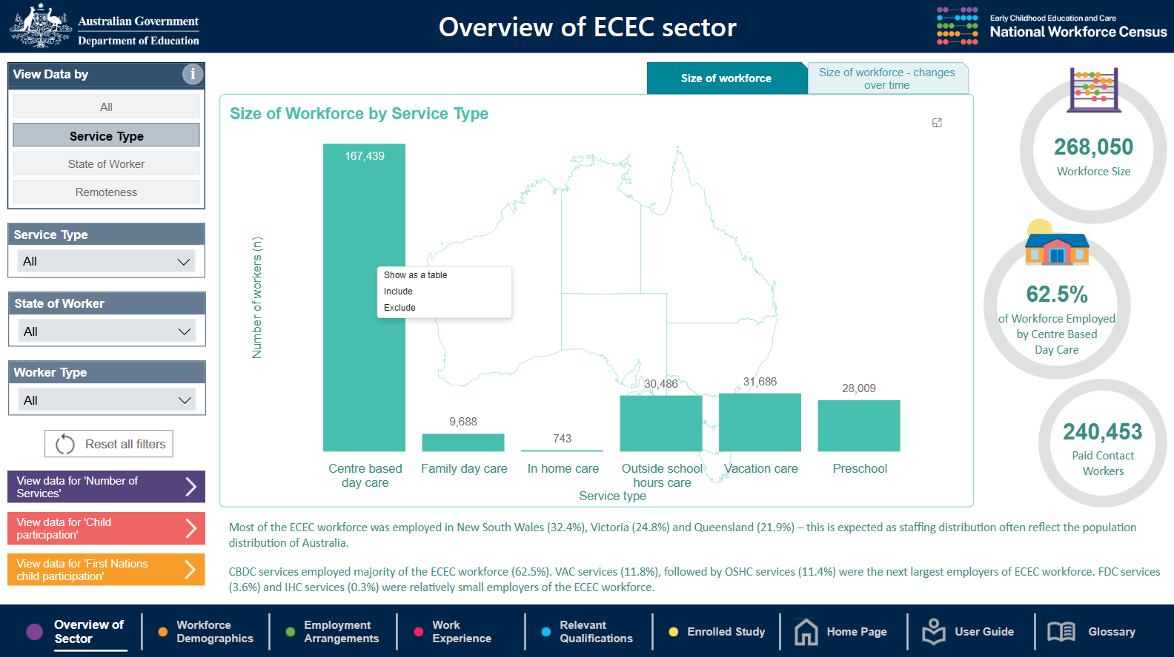

1. It is recommended that the ‘Snipping tool’ (or similar) is used to copy and paste charts and tables as pictures if required. It is best to use the focus mode option (described previously) before snipping for the best resolution. A picture of the filters can also be snipped, so that a record is maintained of what filters were applied to the data.

## Blank Visuals

1. When multiple filters are applied, blank visuals may be displayed. This may be due to one of two reasons: (1) no data is available for the combination of filters selected, (2) counts of less than 5 (<5) are not displayed to ensure confidentiality. For example:

