

Summary findings

Review of targeted programs to support people in regional and remote areas to complete Early Childhood Education and Care qualifications

July 2024

**Disclaimer**

We prepared this report solely for the Department of Education’s use and benefit in accordance with and for the purpose set out in our engagement letter with the Department of Education dated 16 January 2024. In doing so, we acted exclusively for the Department of Education and considered no-one else’s interests. ​​

We accept no responsibility, duty or liability:​​

* to anyone other than the Department of Education in connection with this report​​
* to the Department of Education for the consequences of using or relying on it for a purpose other than that referred to above.​​

We make no representation concerning the appropriateness of this report for anyone other than the Department of Education. If anyone other than the Department of Education chooses to use or rely on it they do so at their own risk. This disclaimer applies:​​

* to the maximum extent permitted by law and, without limitation, to liability arising in negligence or under statute; and​​
* even if we consent to anyone other than the Department of Education receiving or using this report.​​

© 2024 Scyne Advisory. All rights reserved.​

## 

## Targeted programs review: ​ Focus Area 2-1of Shaping Our Future

## The Australian Department of Education commissioned Scyne Advisory to conduct a review of programs to support people in **regional and remote areas to enrol in and complete Early Childhood Education and Care (ECEC) qualifications.** This review was a key action under Focus Area 2-1 of *Shaping Our Future: 10-year National Children’s Education and Care Workforce Strategy* (September 2021).

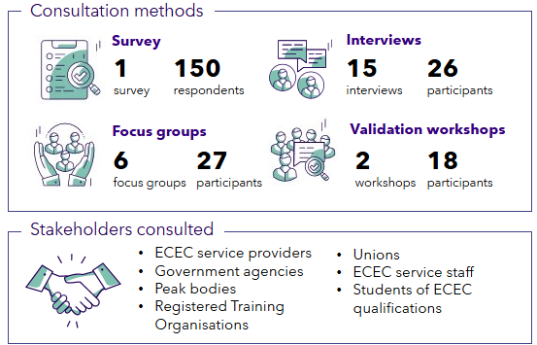

Source: *ECEC targeted programs review: Better Practice Case Studies Report*

***Shaping Our Future*, FA2-1:** *Review and develop targeted programs to support studies and placements for* ***specified groups\**** *of potential educators and teachers*.​  
*For this review, the specified group is people in regional and remote areas.

​ Five key ‘success factors’ and three ‘enablers’ for designing better practice programs were identified

The success factors are key to designing effective or ‘better practice’ programs to support people in regional and remote areas to complete ECEC qualifications. They are underpinned by three ‘enablers’ which are required to support long-term program delivery and sustainability. The success factors and enablers are based on stakeholder feedback and desktop research.

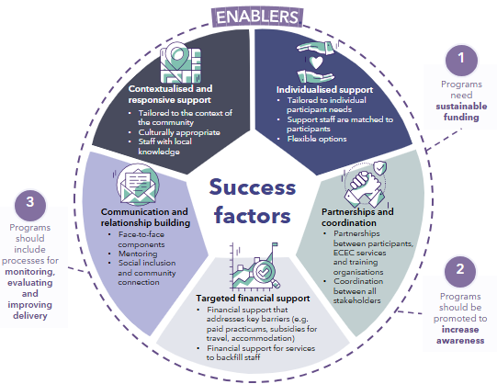Source: *ECEC targeted programs review: Success Factors Report*​

Four program models were developed to inform future program design​

Four stages of an ECEC career were identified based on stakeholder consultation and desktop research. The program models below intend to address the key needs of people in regional and remote areas throughout these career stages. The program models incorporate the success factors, enablers and other elements of better practice programs identified in the research. ​

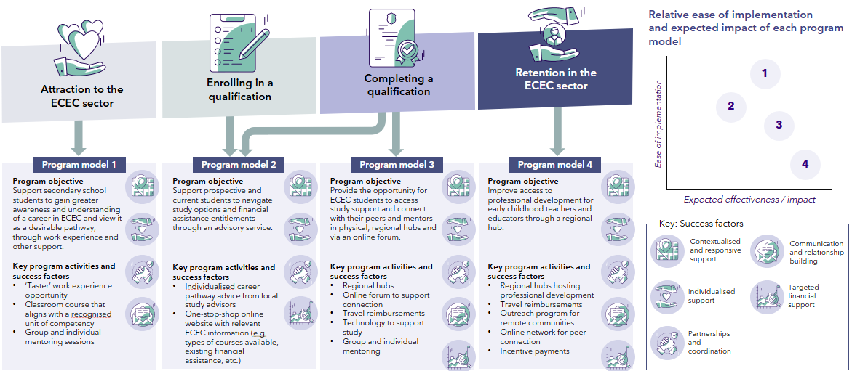 Source: *ECEC targeted programs review: Success Factors Report*​