

# Task card – how to vary and withdraw sessions in the Provider Entry Point

How to vary and withdraw session reports in the Provider Entry Point weekly and child overview

Overview 1

Logging in 3

Varying session reports weekly overview 3

Varying session reports child overview 7

Withdrawing session reports weekly overview 10

Withdrawing session reports child overview 14

## Overview

This task card outlines how to:

* view session reports
* vary session reports
* withdraw session reports

This task card is for providers that use the Provider Entry Point (PEP). If you use third-party software, contact your software provider for help.

Find more [task cards](https://www.education.gov.au/child-care-package/provider-tool-kit#toc-task-cards) for the PEP on our website.

If you need further assistance, contact the Child Care Subsidy Provider Helpdesk on 1300 667 276 9am to 5pm AEST or [via email](mailto:CCSHelpdesk@education.gov.au) anytime.

**Note:** Only certain special characters can be used in the PEP:

* full stop (.)
* comma (,)
* hyphen (-)
* slashes (/, \)
* apostrophe (‘).

All other special characters will cause an error in the system.

## Logging in

Step 1

Log in to the [Provider Entry Point (PEP)](https://proda.humanservices.gov.au/prodalogin/pages/public/login.jsf?TAM_OP=login&ERROR_CODE=0x00000000&URL=%2Fmga%2Fsps%2Foauth%2Foauth20%2Fauthorize%3Fscope%3Dopenid%26state%3DalN0hw9ovD%26client_id%3DGTzCa6CRNfBsRTdfljBa%26redirect_uri%3Dhttps%253A%252F%252Fbusinessonline.humanservices.gov.au%252Fmga%252Fsps%252Foidc%252Frp%252Fchildcaresubsidy%252Fredirect%252Fproda%26response_type%3Dcode&OLDSESSION=).

## Varying session reports weekly overview

Step 1

From the PEP landing page, select **More details** in the **Sessions** tile.

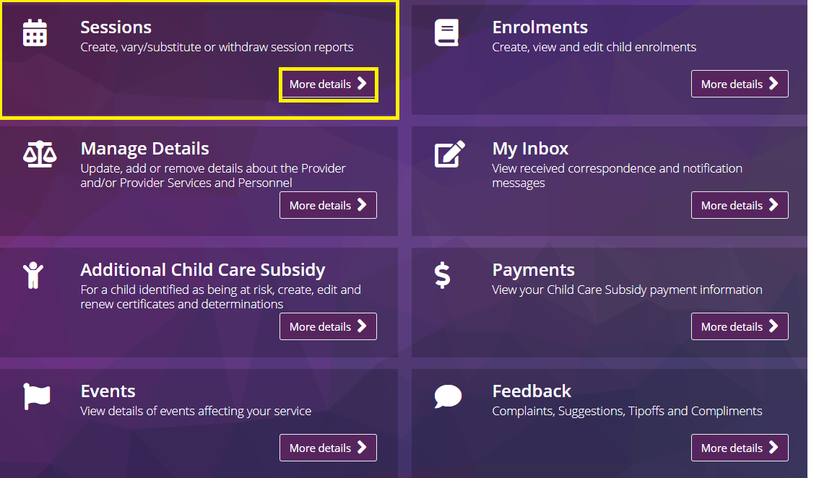

Step 2

Under **Weekly Overview** locate the relevant week and select **View**

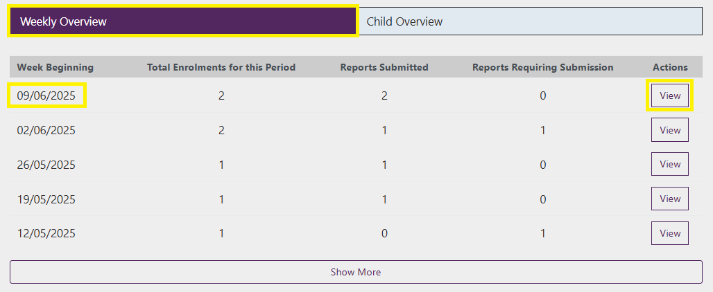

Step 3

Locate the relevant day using the day tabs and locate the child either by searching their name or from the list.

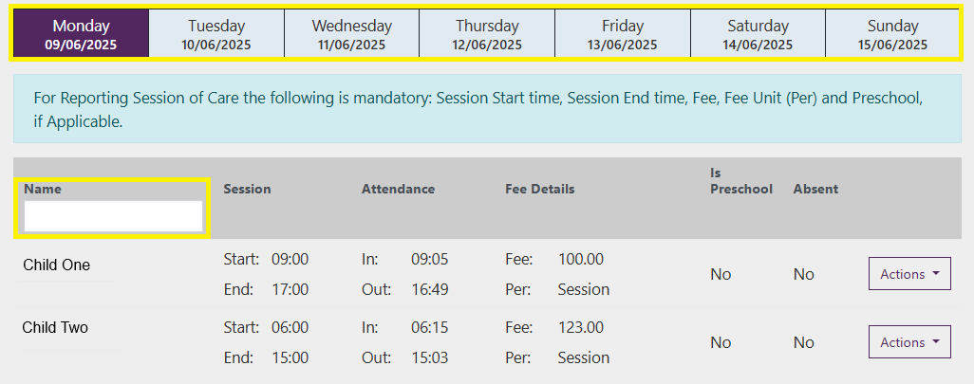

Step 4

Select **Actions** and select **Vary Report**

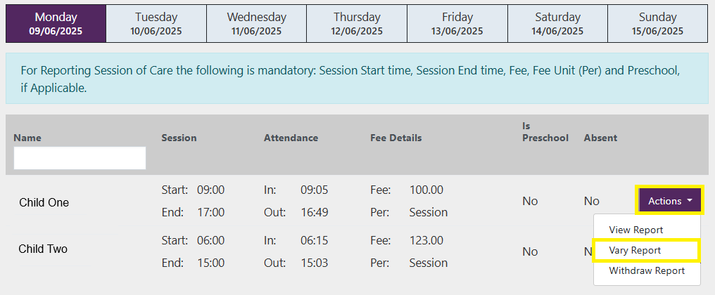

Step 5

If you are varying reports within 28 days you will be required to select a **Reason for variation.**

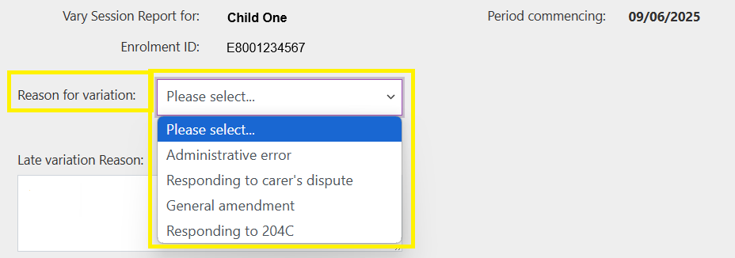

If you are varying sessions beyond 28 days you must also include a **Late variation Reason.**

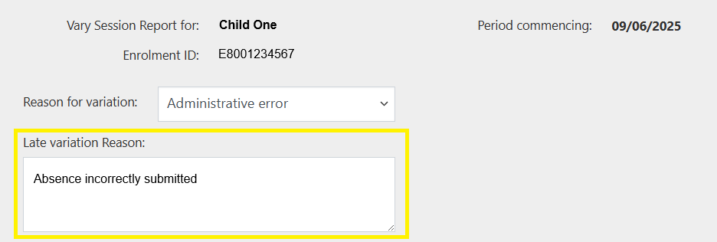

Step 6

All submitted sessions for the week will display. Locate the relevant session and update the fields as required.

Note - When resubmitting or varying a session report update the prescribed discount amount if it is known to be inaccurate.

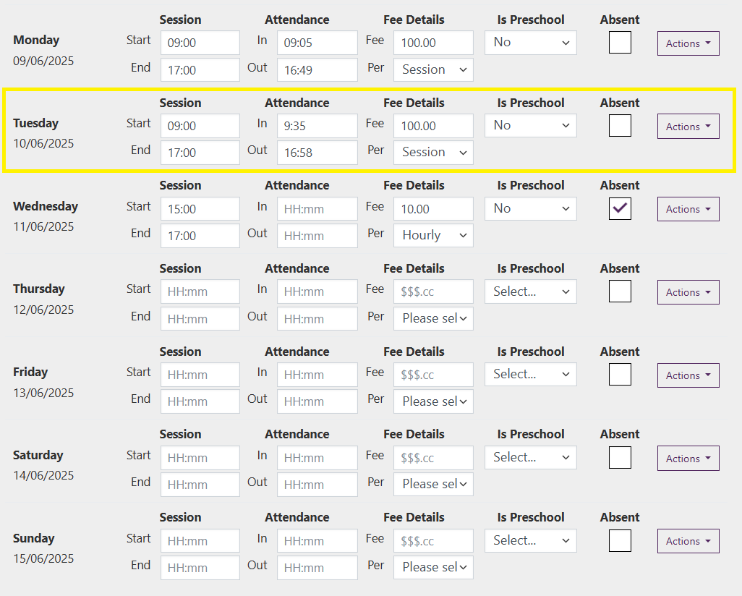

Step 7

Once you have completed the changes select **Submit**

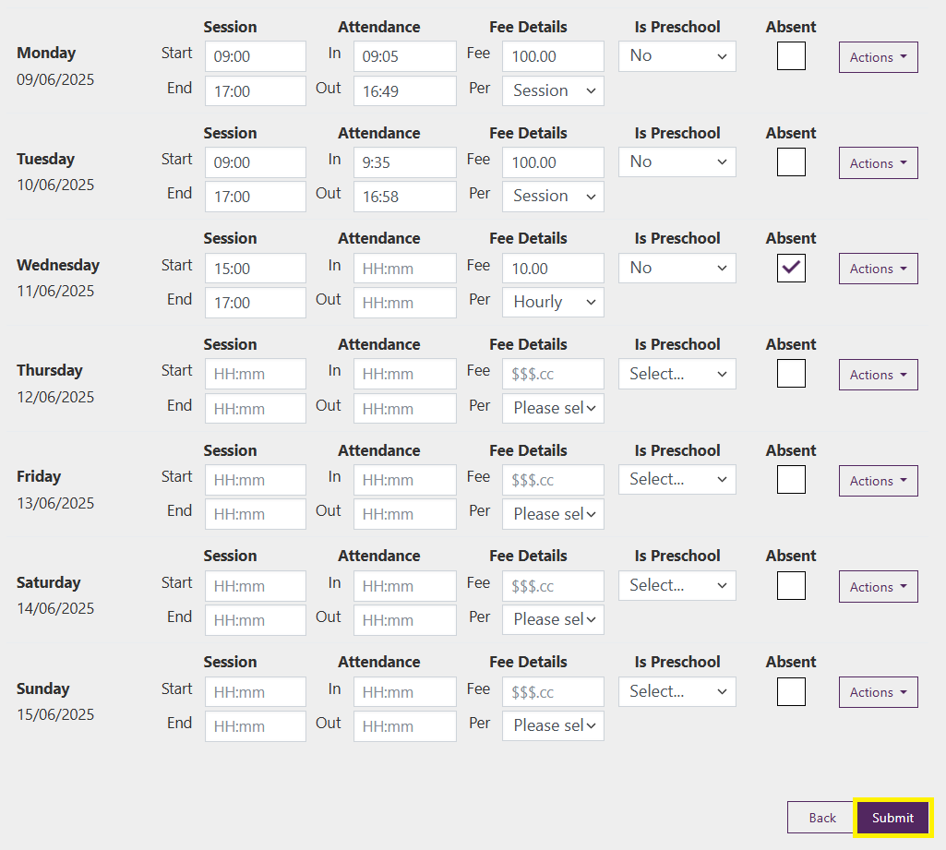

Step 8

A receipt will be generated confirming the submission. Select **Return Home** To return to the homepage

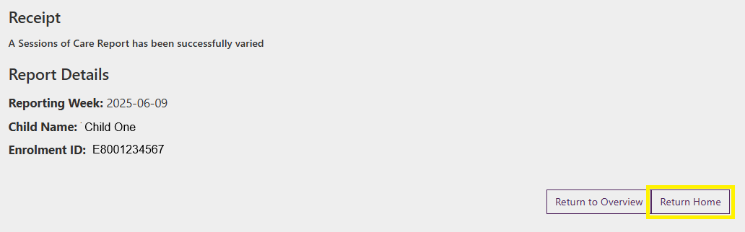

## Varying session reports child overview

Step 1

From the PEP landing page, select **More details** in the **Sessions** tile.



Step 2

From the **Child Overview** select the relevant week and locate the child in the list or by using the search and/or filter options.

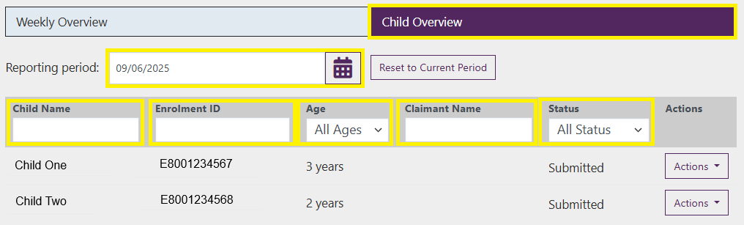

Step 3

Select **Actions** and select **Vary Report**

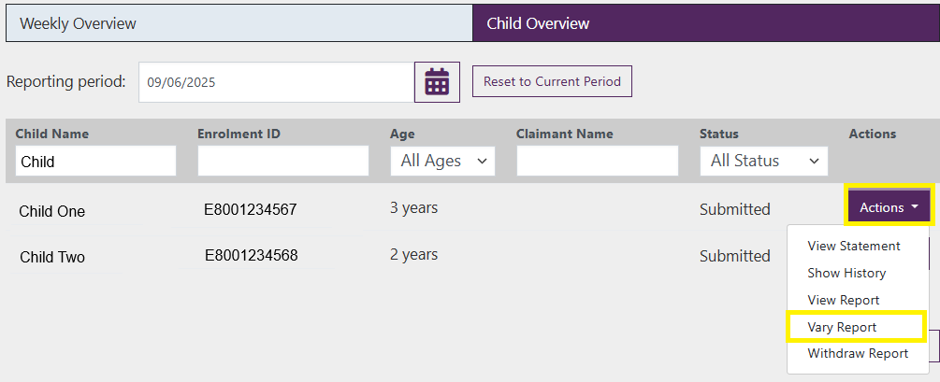

Step 4

If you are varying reports within 28 days you will be required to select a **Reason for variation.**



If you are varying sessions beyond 28 days you must also include a **Late variation Reason.**



Step 5

All submitted sessions for the week will display. Locate the relevant session and update the fields as required

Note - When resubmitting or varying a session report update the prescribed discount amount if it is known to be inaccurate.



Step 6

Once you have completed the changes select **Submit**



Step 7

A receipt will be generated confirming the submission. Select **Return Home** To return to the homepage



## Withdrawing session reports weekly overview

Step 1

From the PEP landing page, select **More details** in the **Sessions** tile.



Step 2

Under **Weekly Overview** locate the relevant week and select **View**



Step 3

Locate the relevant child either by searching their name or from the list.

*Note: You can select any session within the week as all sessions will be withdrawn*



Step 4

Select **Actions** and select **Withdraw Report**

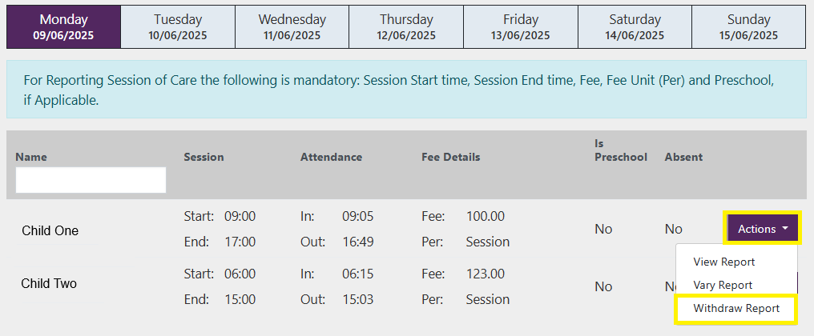

Step 5

If you are withdrawing reports within 28 days you will be required to select a **Reason for withdrawal.**

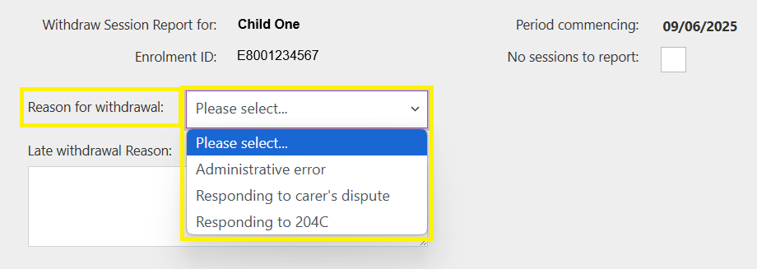

If you are withdrawing sessions beyond 28 days you must also include a **Late withdrawal Reason.**

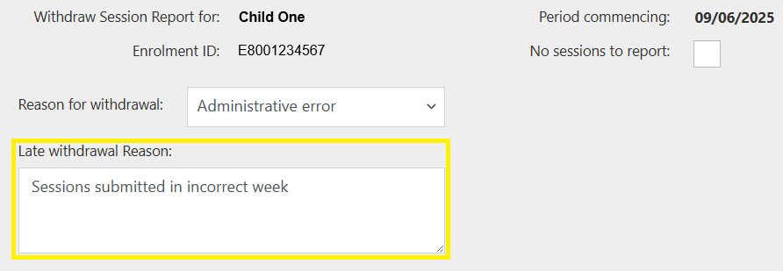

Step 6

Once all fields are completed select **Submit**

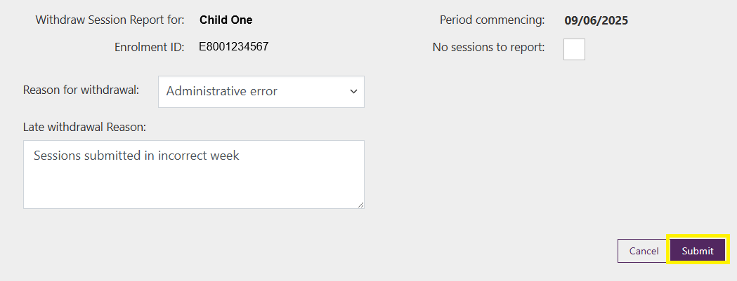

Step 7

A receipt will be generated confirming the withdrawal. Select **Return Home** to return to the homepage.

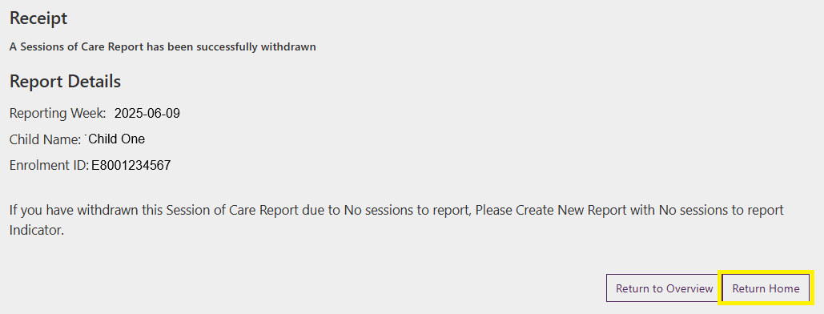

## Withdrawing session reports child overview

Step 1

From the PEP landing page, select **More details** in the **Sessions** tile.



Step 2

From the **Child Overview** select the relevant week and locate the child in the list or by using the search and/or filter options.



Step 3

Select **Actions** and select **Withdraw Report**

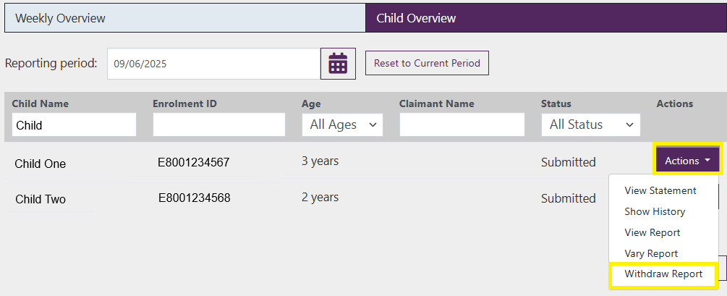

Step 4

If you are withdrawing reports within 28 days you will be required to select a **Reason for withdrawal.**



If you are withdrawing sessions beyond 28 days you must also include a **Late withdrawal Reason.**



Step 6

Once all fields are completed select **Submit**



Step 7

A receipt will be generated confirming the withdrawal. Select **Return Home** to return to the homepage.

