

# Task card – How to view session reports in the Provider Entry Point

How to view session reports in the Provider Entry Point weekly and child overview

Overview 1

Logging in 3

Viewing session reports weekly overview 3

Viewing session reports child overview 5

Viewing session report history 8

## Overview

This task card outlines how to:

* view session reports
* View session report history

This task card is for providers that use the Provider Entry Point (PEP). If you use third-party software, contact your software provider for help.

Find more [task cards](https://www.education.gov.au/child-care-package/provider-tool-kit#toc-task-cards) for the PEP on our website.

If you need further assistance, contact the Child Care Subsidy Provider Helpdesk on 1300 667 276 9am to 5pm AEST or [via email](mailto:CCSHelpdesk@education.gov.au) anytime.

**Note:** Only certain special characters can be used in the PEP:

* full stop (.)
* comma (,)
* hyphen (-)
* slashes (/, \)
* apostrophe (‘).

All other special characters will cause an error in the system.

## Logging in

Step 1

Log in to the [Provider Entry Point (PEP)](https://proda.humanservices.gov.au/prodalogin/pages/public/login.jsf?TAM_OP=login&ERROR_CODE=0x00000000&URL=%2Fmga%2Fsps%2Foauth%2Foauth20%2Fauthorize%3Fscope%3Dopenid%26state%3DalN0hw9ovD%26client_id%3DGTzCa6CRNfBsRTdfljBa%26redirect_uri%3Dhttps%253A%252F%252Fbusinessonline.humanservices.gov.au%252Fmga%252Fsps%252Foidc%252Frp%252Fchildcaresubsidy%252Fredirect%252Fproda%26response_type%3Dcode&OLDSESSION=).

## Viewing session reports weekly overview

Step 1

From the PEP landing page, select **More details** in the **Sessions** tile.

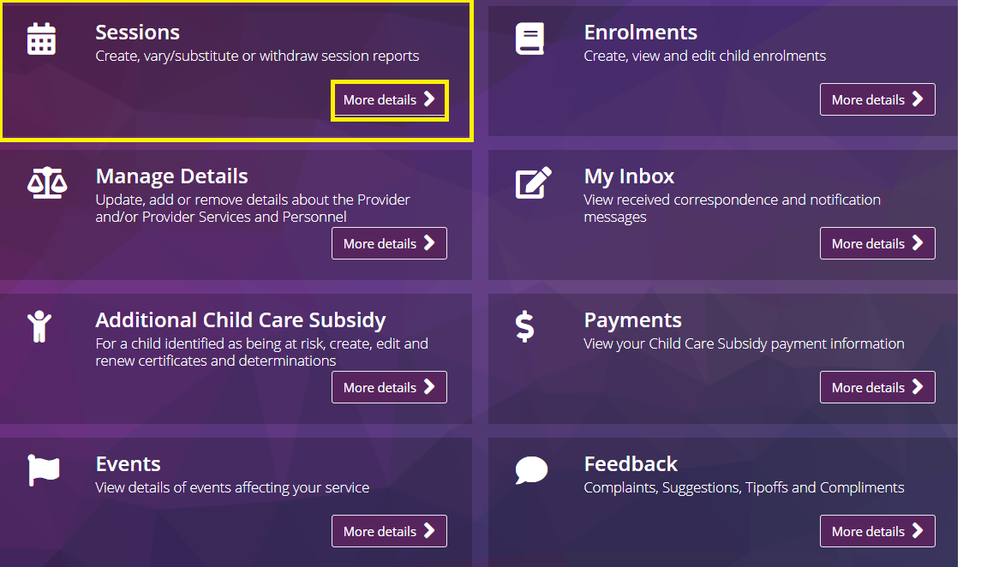

Step 2

Under **Weekly Overview** locate the relevant week and select **View**

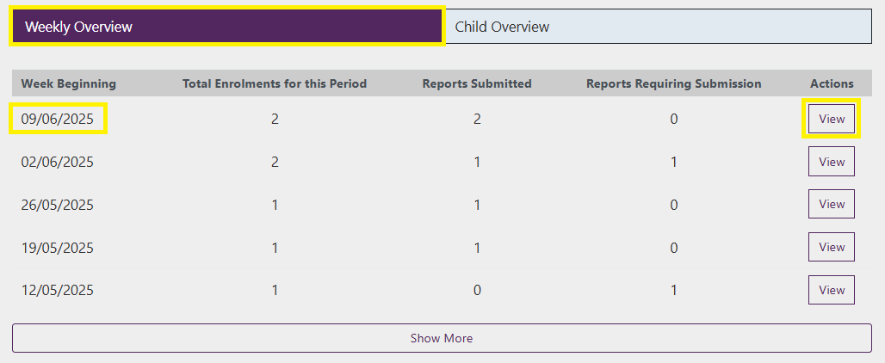

Step 3

Locate the relevant day using the day tabs and locate the child either by searching their name or from the list.

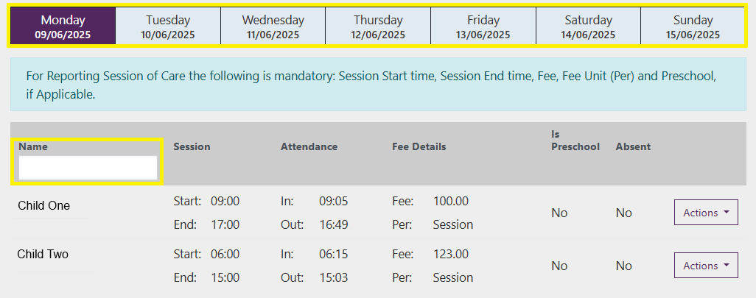

Step 4

Select **Actions** and select **View Report**

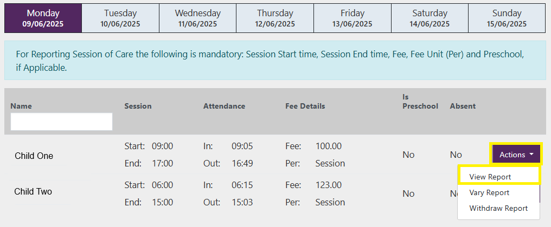

Step 5

All submitted sessions for the week will display. Once you have reviewed these select **Cancel** to return to the sessions home screen.

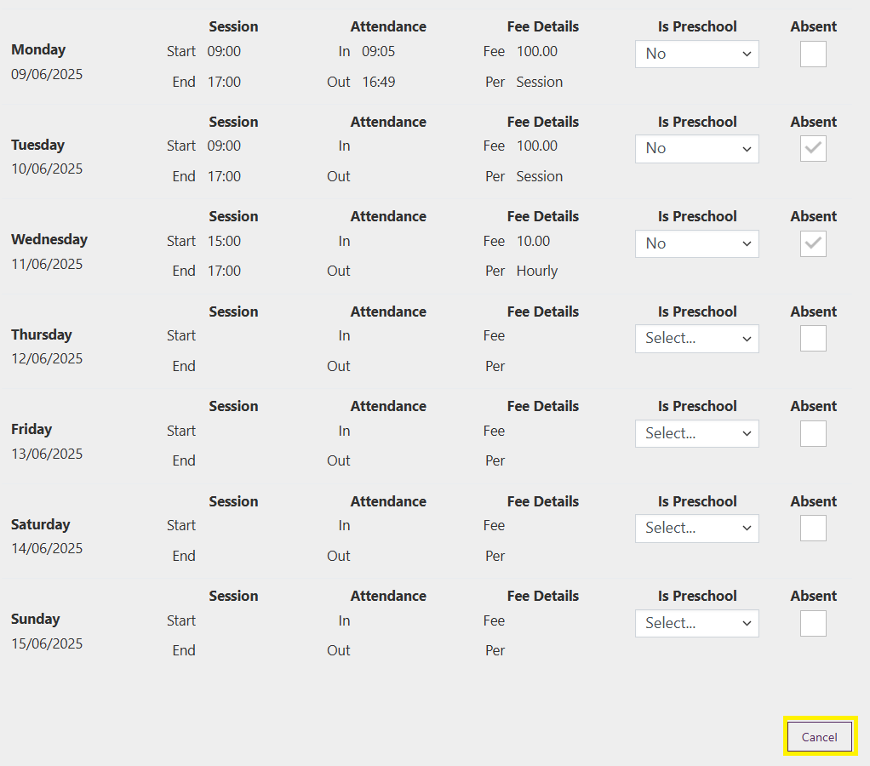

## Viewing session reports child overview

Step 1

From the PEP landing page, select **More details** in the **Sessions** tile.



Step 2

Under **Child Overview** select the relevant week and locate the relevant child in the list or by using the search or filtering options

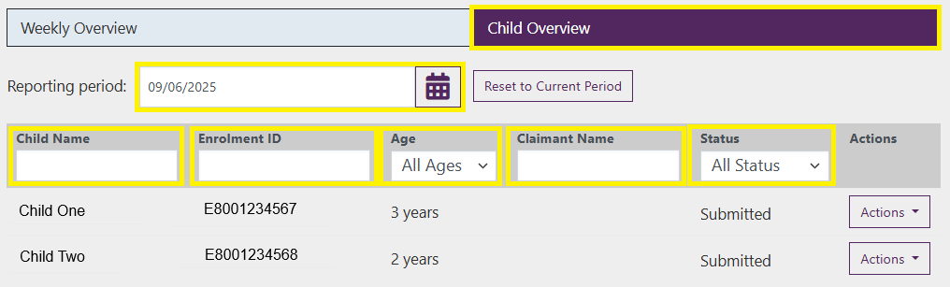

Step 3

Select **Actions** and select **View Report**

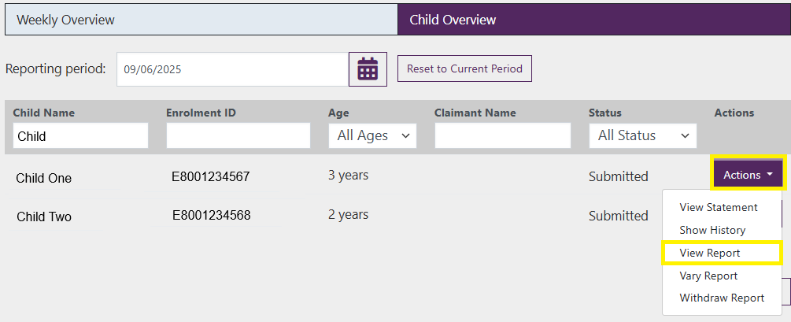

Step 4

All submitted sessions for the week will display. Once you have reviewed these select **Cancel** to return to the sessions home screen.



## Viewing session report history

Step 1

From the PEP landing page, select **More details** in the **Sessions** tile.



Step 2

Under **Child Overview** select the relevant week and locate the relevant child in the list or by using the search or filtering options



Step 3

Select **Actions** and select **Show History**

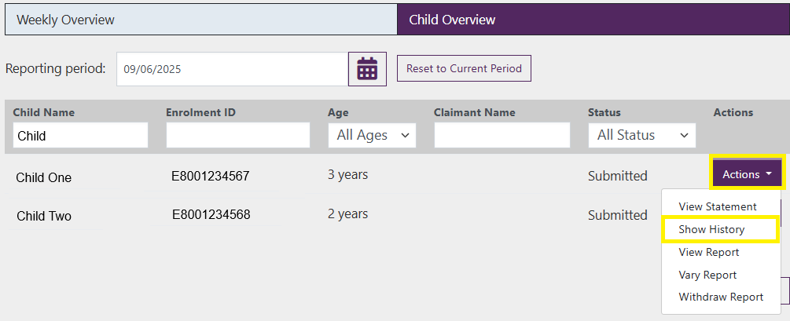

Step 4

All submissions for the week will display, including the submission date, status and reason for change and late change.

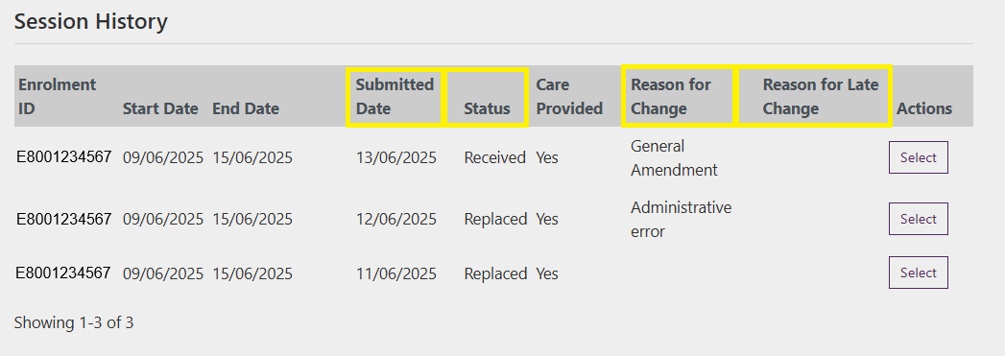

Step 5

To view a submission, select the **Select** option to expand and view the session details.

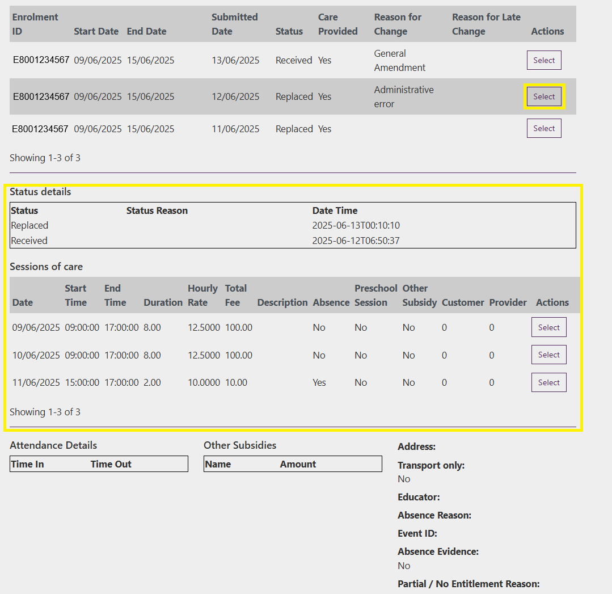

Step 6

To view details for a specific session, select the **Select** option. This will generate additional information specific to that session.

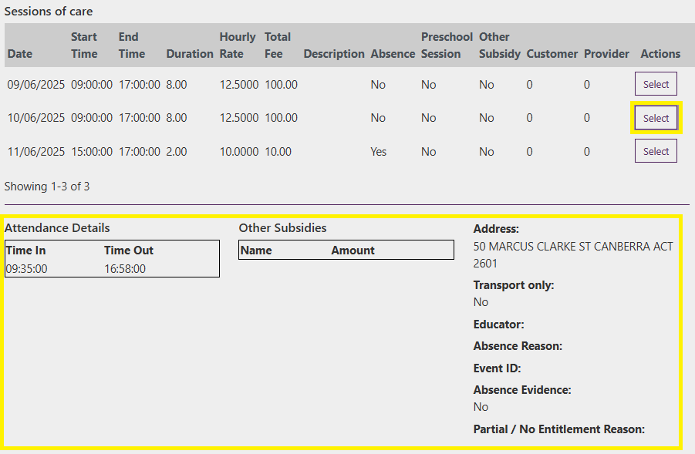

Step 7

Select **Back** to return to the **Child Overview** page

